INDEXICAL PHOTOGRAPHS AND FALSE MEMORIES

Luisa Paige Jones

Submitted in partial fulfilment of the requirements for the degree of

BA (Hons) Photography in the Arts

University of Wales Trinity St David, Swansea

December 2018

Word count:
List of contents
Page 2

Page 3

Page 4

Page 6

Page 10

Page 12

Page 17

Page 21

Page 24

Page 28

Page 31

Page 34

Page 36
List of illustrations
Summary of topic
Introduction
Chapter One: Personal history-family album
Chapter Two: Selected memory- family album
Chapter Three: Relics- Family album
Chapter Four: (Un) expected families
Chapter Five: True photographs and false memories
Chapter Six: Taryn Simon
Chapter Seven: Forgotten history
Chapter Eight: History repeated
Conclusion
Bibliography

1
List of Illustrations

Figure (1) Family portrait, 15/06/2011 page 7
Figure (2) Me and my mother, 08/09/1997 page 10
Figure (3) Christmas day 25/12/2004, page 10
Figure (4) Gemma and Karl’s wedding day 15/08/2005, page 12
Figure (5) My senior prom 03/07/2014, page 13
Figure (6) Nan one month after being battered 1984, page 17
Figure (7) Nan and Brian in bed NYC 1983, page 17
Figure (8) Jimmy Paulette and Misty in a taxi 1991, page 18
Figure (9) The innocents 2002, page 25
Figure (10) The Bunker hill monument 1998, page 27
Figure (11) I’m turning into a spectre before your very eyes and I’m going to haunt you 1992, page 31

2

Summary of Topic

In this dissertation I want to develop my exploration of how a photograph is considered a subjective representation of reality, regarding the decisive moment i.e. The eye behind the camera having seen the reality surrounding the moment captured. I’ll be looking at how these ideas correspond to a fundamental need for remembrance and preservation and how photographs or albums post a question between reanimation and preservation of the original. I’ll be addressing the idea of how domestic photographs function as relics and project time as narratives which reflect the past, not necessarily the way it was but the way we choose to remember it. In spite of manipulation, subjectivity and visual framing; we still rely on what we see in a photograph to fundamentally support our memories, especially when it comes to domestic photographs and family albums. Our private memories are inextricably linked to the way our personal history is represented in photographic form.

3
INTRODUCTION
INDEXICAL PHOTOGRAPHS AND FALSE MEMORIES

In my dissertation I’ll be exploring the topics of Indexical photographs and False memories. My question is: How much can photographs tell us about our past or even memory? If photographs and memory alone are unreliable for an exact reality, why are they so important to us?

My selected research evolves around the term ‘Indexical photography,’ for example: Iconic and indexical features of a photograph often come together to illustrate “indexicallity” that ensures its dissimilar iconic contents and realism. A photograph is a witness to events which pass by at speed, with lack of observation, our memory may be unable to apprehend. This concept will conduct through most of my research supporting my dissertation and the idea how indexical photographs can create false memories. I’ll be discussing my personal history and how my own domestic family albums aren’t reliable resources for remembering my past. Each chapter analyses photographic representations of history and history through memories. My first chapter, Personal history- My Family albums, I’ll be analysing my relationship to the photographs in my family album and reflecting my process to Nan Goldin’s photography and documentation of her personal life. In later chapters I’ll be referencing from contemporary texts such as Lisa Saltzman’s book Making Memory Matter, Walter Benjamin and his essay The work of art in the age of mechanical reproduction. Saltzman and Benjamin acknowledge the relationships between time and memory and the effect on people widely.
4
I’ll identify research that tests the theory of false memories through Indexical photographs using a Case study:
True Photographs and False Memories, Conducted by Psychologists Kimberly A. Wade, Maryanne Garry, J. Don Read and Stephen Lindsay 2002.
In my final chapters I’ll be reflecting the theory of Indexical photographs and false memories with an artist whom works with criminal case studies of people who have been falsely accused of serious crimes. I’ll be discussing works from Taryn Simon and her project, The Innocents, 2002 and acknowledging quotes from John Berger- Understanding a photograph, 2013 which have relevance to my question.

5
1
PERSONAL HISTORY- MY FAMILY ALBUMS
Photographs I will discuss are moments from significant events of my life which I have remembrance of. Since I first started to explore the concept of how a domestic photograph possesses memorabilia of a lived moment, I’ve discovered that these photographs aren’t completely reliable when representing my history. From the moment the event was recorded to the present moment of looking at the photograph, there is an abyss or a sense of false remembrance. Personal photo albums are narratives of our past which can comfort us in times of need, even if they do not reveal what really happened.

6

Figure (1) Family portrait

Are domestic photographs reliable representations of our personal history? Referring to Figure 1 Family Portrait, I find that this photograph isn’t a reliable representation of my reality as it doesn’t explore the domestic events of my home life. I find that candid photography captures a more relaxed aura especially in family albums as they captivate true emotion, exploring the concept of staged photography it’s the decision of the photographer to paint a picture of positivity using the common saying: “cheese” or “smile for the camera.”

7
Regarding my memory of this event, I recall moments of comical debate and explosive disagreements. The photograph in itself demonstrates a sense of family stability and happiness, regarding this thought it’s also the only family portrait that shows us presented in this way. I find that this photograph is particular is an example of an unreliable photograph regarding representations of my personal history. I was fourteen when the photograph was taken and studying the photo I can recall moments before, during and after the photo was taken. In particular I recall my brother having a tantrum for not being involved in more photos and that my mother had to be persuaded to be photographed. When re-evaluating my family archives, I find that we visually see a positive picture of the past and remember the recorded events fondly, even though reality may have been very different. From this observation I can see that personal photographs fail to tell the complete truth and there is nothing in the images themselves that reveal the complicated history and loss which testifies destruction, you may have lived but was not photographically captured. If a stranger were to look through photographs of myself, they would find no evidence of traumatic moments from my past. I can’t say that I’d suffered from trauma as such to the extremes of violation or abuse but more on the topic of minor mental trauma for example: Divorce, family destruction and deceased loved ones. These events aren’t necessarily captured photographically. Distinctive memories like these come from the visual aid of photography but I feel a greater attachment to candid shot photos considering they express true emotion. I want to discuss how memory is affected, regarding progression in time and the idea of creation of false memories. Do photographs tell the whole truth? It does not really matter when it comes to family albums.

8
What matters is that they convey a sense of self; they remind us where we came from, who we are or who we were. We’re spontaneously objected to a nostalgic remembrance and grief for the passing of good times, we become selective of what we choose to remember from good times over the bad. We become our own editors in selecting images and events which represent our lives, I find that the majority of the images show myself and my mother together or myself and my brother as my dad was usually the eye behind the camera.

9
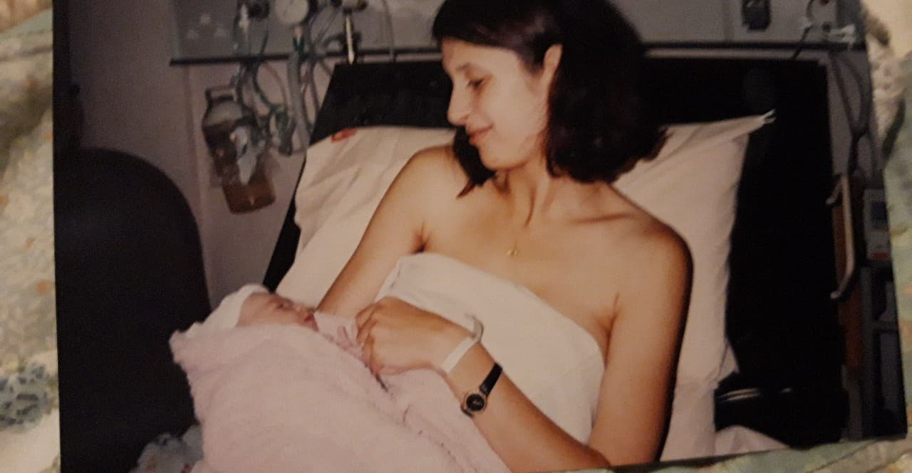
2
Figure (2) Me and my mother

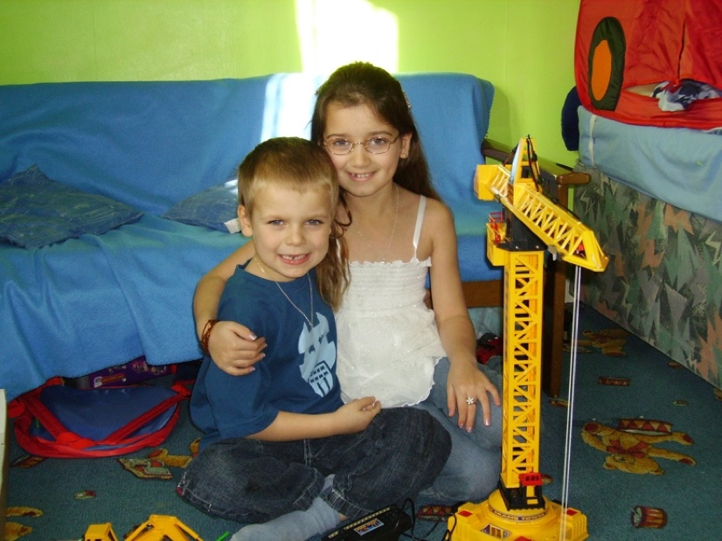
Figure (3) Christmas Day

10
Referencing from figure 3 This photograph scrutinises the innocents of childhood as
my dad (Karl) photographs us playing with my brothers first electronic crane, we were asked to smile for the camera and within this moment we voluntarily have our arms around each other. I was seven years old, photographed playing with my five-year-old brother on Christmas day 2004. Out of all the moments recorded of myself and my brother, I believe that it holds the greatest sense affection. With regards of the countless arguments and fights I had with him over the ungodly of times, I loved him unconditionally. Its these moments of recollection they bring a sense of appreciation and meaning to my life. Photographically there are only photographs of myself and my brother showing the happiest memories, only realising that there aren’t any photographs of tearful arguments or physical contact.

Exploring the concept of how time affects an image regarding these Personal history- family history, I can say that they possess a sense of desolation. Regarding the term, true photographs and false memories, photographs can do more than illustrate our past events but using figurative text, for example text written on the back. They can cause a distortion in your own recollected memories, I’ve admired Pedro Meyers collaborative thinking post memory and what truth a photograph holds. An article written by Scott Rosenberg published his interview with Pedro Meyers,
titled You can’t believe your eyes founded on Wired.com. Photographer and thinker Pedro Meyer developed discussion with the following statement: “It isn’t trustworthy simply because it’s a picture,” He followed up with “It is trustworthy if someone we trust made it.” He suggests remarks about the ability to edit and highlights moments of his interview thus regarding the truths to a photograph.
11
His thinking responds to my question in are photographs reliable representations of our past? His work considers
how every image is unreliable and how photography is made irrelevant in advertisement and us as people have grown a sense of false judgment to what we do and don’t believe. We are smart enough to judge false advertisement in the food and fashion industry, what we see. Isn’t wat we get.

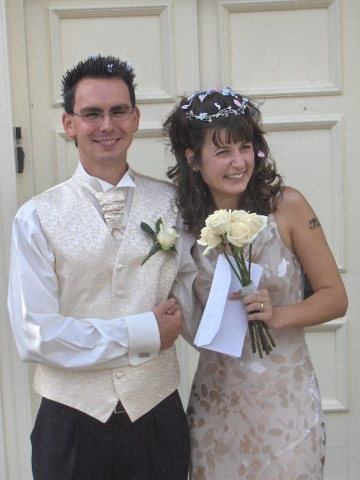
3

12

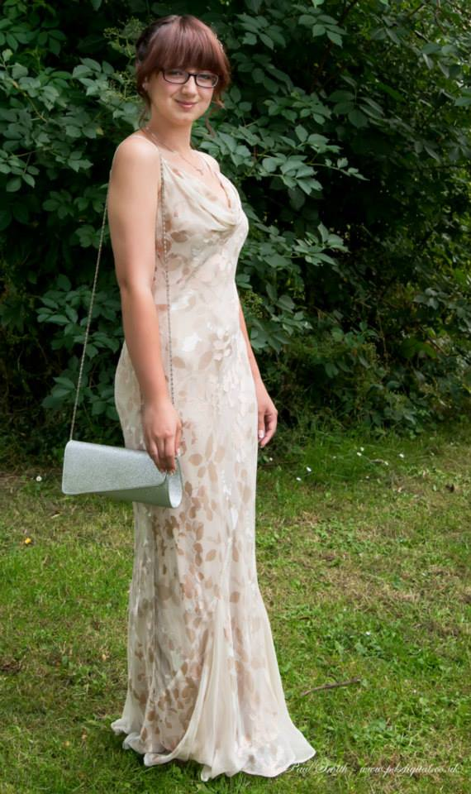

Figure (5) My Senior Prom

There’s one day in particular which moved me greatly, referencing from figure 4 my parents wedding day dated 15th august 2005. I was eight when they married, and it was the most photographed and celebrated event of my childhood, it was a girl’s dream to see her mother marry but the photos behold a greater sense of melancholic emotion. This collection of photographs represents an important hurdle in my life both in the moment and long term, I recall several memories of the day without the visual aid of photographs.
13
I remember the way my mother looked when she had the dress on with dolled up hair and makeup. The photographs demonstrate the happiest moments and even the lowest such as, poorly timed shots of exhausted expressions, emotional tears and tantrums. Their wedding day was like a surreal reinvention of what I knew, every other day surrounding, we’d have a part to play and moments together when neither parents were working. I find that my view on the photographs then differ from what they are now, with time I find that there’s an abundance of memory. For six years they were happily married until 2011. With complications through communication and divide soon led to a separation. I find that the divorce was the only minor trauma I had which impacted my life, at the age of fourteen I was old enough to understand but not enough to find it relatable. The separation of their marriage was a difficult process considering there were new changes. I believe that these photographs held a begrudging representation for what is truth and how this sense of loss created melancholic remembrance.
I’ve been reading Regarding lost time by Katja Haustein 2012, she analyses contemporary artists whom express their acknowledgments on memory and progression in time. One artist in particular, Walter Benjamin discusses his theory on how time affects a photograph regarding the location of it and whom possesses it. A passage in her book discusses Benjamin’s photographic description of the dialectical image quoted in German and English translation, Haustein analyses his thinking quoted below.

14
Benjamin sought to find an explanation for historical cognition, in the former he searches for a formula for the act of remembering one’s self. The photographic metaphor shares with the image of excavation the idea of remembering as searching in the dark, the potential unavailability of the memory images and their storage in an archive of fragmented and deformed residues of the past.
6 -Katja Haustein, Regarding lost time

We are so used to photography that we no longer consciously able to register the seconds surrounding what happened. We over look photographs and forget what memorabilia they hold with exception of traumatic events; when for example, the person or loved one photographed was familiar to us and is now distant. In such circumstances the photograph proves more traumatic than most memories because it states a confirmation as if by prophecy had by passed. Although covering the sense of loss, the memory of unification and integrity stands strong. After the separation I was given the opportunity to view things from a different perspective and that although this abrupt ending my parents’ marriage happened, the idea of independency was beneficial. Growing up I developed a sense of greater understanding for what surrounded me. I continued my studies and became immersive in photography and family history. I have memories of important events following the years after the divorce, but I recall the moments of time photographs were taken. My years in high school were standard and I recall few memories even with the aid of photographs,

6 Katja Haustein, Regarding lost time, Walter Benjamin (Lagenda, 2012), pp 76-77

15
events such as my netball tournaments, graded drama performances and my senior prom stand out the most with or without the aid of photos. Referencing from figure 5, you can see that I’m wearing my mother’s wedding dress which she’d kept for me for my senior prom, 3rd July 2014.
This photograph represents my thinking of reinvention of my irrelevant memories.
The dress is a relic of my mother’s history and is reinvented into mine, regarding memory this photograph idolizes the idea of immortality through memory. Physical memorabilia or inheritance, in my case the dress, beholds a legacy. The relationship that I share with my mother, see figure 2 is a foundation of reliving and sharing our memories, documented through photography I’ve been closest to and idolized her. I’d hope to see my own daughter wearing this dress thus continuing my legacy. I believe that the figure 5 tells a story for both mine and my mother’s history.

Expanding my thinking about photography and irrelevant memories I’ve studied works from Nan Goldin and her project (Un) Expected families. She discusses how her photography has illustrated her path in her career and reflects on her past. There’s one quote in particular that strikes me the most, “I used to think that I could never lose anyone if I photographed them enough. In fact, my pictures show me how much I’ve lost.” This is sourced from Sleek magazine, article Nan Goldin: ‘My pictures show me how much I lost’ Published in 2016.

16
4
(Un) expected families
Following my visuals from Personal history- My family album, I’ve taken interest in Nan Goldin’s works and how she demonstrates the concept of family and trauma.
Her work poses a sense of trauma, true photographs and profound moments.
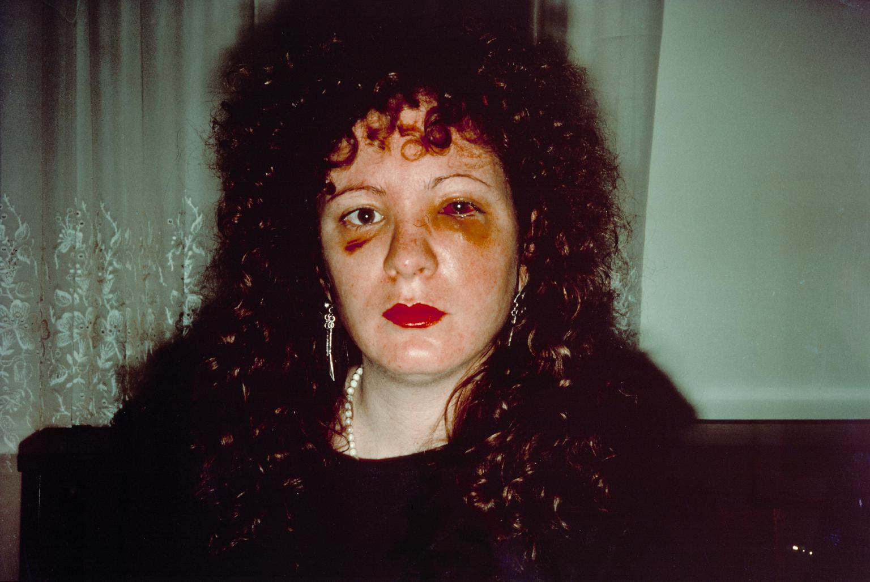

Figure (6) Nan one month after being battered
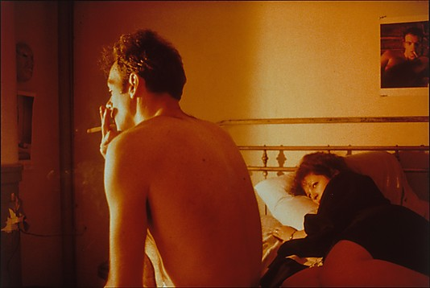

Figure (7) Nan and Brian in bed, New York city

17

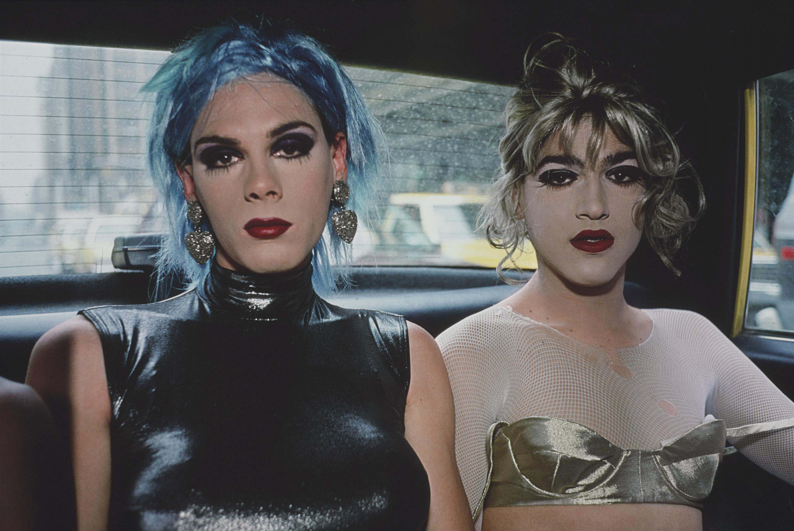

Figure (8) Jimmy Paulette and Misty in a taxi, New York City

Exploring the theme of what truths domestic photographs hold, how traumatic moments aren’t recorded photographically and how trauma persists through memory.
I’ve found that Nan Goldin’s work provokes these themes as she records everything we tend to avoid when documenting our own lives. Referencing from figure 7 Nan one month after being beaten 1984, this photograph demonstrates the pure integrity of violent actions that nan withstood before taking the photo and reflects past moments of trauma in her life. The intensity of her glooming stare into the camera reflects a sense of strength but also pure helplessness, the contrast between the blood shot black eye and voluptuous lipstick inspired thousands. Reflecting on my works, I’ve decided that Nan Goldin explores the motives that we subjectively avoid photographing such as, violent incentives, abuse and trauma.

18
At the age of thirteen she moved away from her home in Boston following the death of her older sister after taking her own life and traumatic circumstances within her biological family. Figure 7 demonstrates contrast to the physical damage that she offers the camera, but she also appears well groomed, remarking a sense of emotional crisis, burden and independency. Having lived a begrudging past, Goldin’s works exposes her delicate past through emotionally moving photos of herself and friends she’d created family.
Figure 8 Nan and Brian in bed 1983, this photo was shot a year before figure 7, this photograph evokes her own passionate romance as she lays on the bed gazing at her lover, Brian. I perceive a sense of longing and resignation as he’s turned away from her, the idea of falseness and betrayed intimacy is shown within this moment. My thinking is why she chose to photograph this scene and how she responds to her personal chapters which revolve around sex, drugs, aids and death. Her famous body of work The ballad of sexual dependency became a cultural icon of that time,
demonstrating the paraphernalia of daily life which was transformed into weighty images of deprivation. Figure 9 Jimmy Paulette and Misty in a taxi, shot 1991, initially expresses themes of nostalgia and expression through freedom or free movement. Undermining this iconic duo and collection of work The ballad of sexual dependency, Goldin quoted,

There is a popular notion that the photographer is by nature a voyeur, the last one to be invited to the party. This is my family, My friends– Nan Goldin 10

19
Photography as a means to create an intimate visual diary that would reveal a world that most people would have never been able to look at– Nan Goldin 11

This image in particular demonstrates her dependency on the idea of stating freedom. She documented drag queens as friends rather than visualising the performance side of drag. This was a far cry from the glamorous stance drag queens put on for performance, instead this image demonstrates a look of boredom and an exemptuous sense. These men achieved the unknown and Goldin flourished the idea of being un-titled, as of during the 70’s drag was new and bold. These people were her family and her photographs express a reign in her new-found freedom.
Reflecting her work to my question is that she captured exactly what we avoid documenting in our domestic albums, her legacy expresses loss and death but expressed through ambiguous and bold images which represent the value of her life.

10, Nan Goldin, The Ballad of sexual dependency, https://artofcreativephotography.com/ -about-nan-goldin, Page 2
11, Nan Goldin, The Ballad of sexual dependency, https://artofcreativephotography.com/ about-nan-goldin, Page 4

20

5
True photographs and false memories

taken an insight to a case study which tests the theory of Indexical photographs and false memories and how this idea creates conflict in modern society.” True Photographs and False Memories,” An article published March 1st, 2004, department of psychology, D Stephen Lindsay, Lisa Hagen, J Don Read, Kimberly A Wade and Maryanne Garry. (corresponding author: D Stephen Lindsay, University Victoria BC V8W 3P5, Canada.)

A group of memory and trauma-oriented psychotherapists advised clients to review old family albums to cue suspected “forgotten and/ or repressed” memories of childhood indicating physical abuse or trauma. Old photos cue the long-forgotten memories, but when combined with other suggestive influences, they may contribute to false memories. Psychologists selected 45 undergraduate students to work on a task to analyse this theory. The task was to remember three school -related childhood events. Provided by their parents, where two true memories and one not genuine. Selected at random assignment, 23 students were also given their school photos from the years of the recalled events to trigger memory cues. Predicted was that the rate of falsely implicated memories would raise dramatically higher with the photos provided compared to the students who didn’t have photos. The memories provided by the parents, the students had none or minimal memory of such but were asked to remember and retell.

21
By the end of this study, fifty percent of the students had created false memories from the photographs and were able to respond with detailed recollection such as where and how the fictional events took place. Phycologists Kimberly A. Wade explains how there are three reasons to why this was possible and refers them to “Hymans three stages.” First, the subject must accept that the possibility of the suggested event is true. Faith in photography goes a long way in asserting this stage. People tend to believe that photographs are truthful representations of reality, i.e. If there is a photograph of the event, then it must have happened.

Second, the subject must be able to create an image in their minds eye and invent a corresponding storyline. Photographs are especially potent in this capacity because they contain a vast amount of detail and thus emotions would be consistent with the suggested event. In other words, if we imagine it, it can be true. Third and finally, an easily generated image is more likely to trigger the creation of a false memory than an intricate one. -Wade et al. “A picture is worth a thousand lies” using false photographs to create false childhood memories.

The movement of the piece through space mimics the movement of memory through time. We cannot be in two places at once, as we move from one place to the next, our memories move too and change according to our surroundings and influences. 12

22
One case study in particular was used to support and identify the effect of an indexical photographs and implications of false memories, the study in question used a fictional ride in a hot air balloon. The image was handed to every participant, Half the subjects managed to create detailed accounts of the false event.

Phycologists speculated that, the provided photograph was accepted as authoritative evidence that the false event has occurred and in doing so, planted the seed of a false memory- Maryanne Garry and J. Don read.

In reality this process of elimination and projective memories are often conducted for legal purposes. For example, Witnesses’ can be persuaded into giving false testimonies, and in order to prove whether or not the eyewitness’s testimony is 100 percent reliable. As proven from the above experiment, like photography, memory is unreliable. This process was highly conducted during the 1980’s and 1990’s to support testimonies from eye whiteness’s. However, with this method being as unreliable as the made-up truth, using today’s technology the invention of digital photography provided access to photo editing and software which allows anyone to alter images.
There is a common issue which causes wrongful conviction for mistaken identification.
For example, A victim or eyewitness may identify a suspect of perpetrator through law enforcements use of photography and/ or line ups. This procedure relies on the assumption of visual memory and recollection of the event.
12 - Urban Memory, History and amnesia in the modern city. By Mark Crinson 2005.

22
Compositions of sketches, mugshots, polaroid’s and line ups but difficulty is that the eyewitness’s memory can change. Through speculations the mind is unable to distinguish temporally between two memories, which in a sense means the innocent person may be identified as the perpetrator even though they may have never set foot through the crime scene. Between the time of which the event happened and the time which the eye witness is questioned adds to uncertainty of remembering wat the suspect looked like.

This however is nothing new to law enforcement and authorities, but the identification procedure may excel to an extent where they are unable to tell right from wrong to the point the witness feels their own judgment is unreliable thus the refusal to press charges.
Despite this fallibility, eye witness testimonies and photographs remain the strongest form of evidence to prove what happened in the particular situation.

23
6
Taryn Simon

Taryn Simon explores the issue where people are wrongly convicted of crime based on an eyewitness testimony and strongly addresses the question of how photography functions as a credibility to their memory of the event/ crime. Regarding my researched case study ‘True photographs and false memories’ a project titled ‘The innocents’ demonstrates how photographs can play tricks on the mind and create false allegations to what an eyewitness remembers. Her work illustrates how the mind is unable to distinguish temporally between the two memories, which means that an innocent person may be identified as the perpetrator even though they had never set foot in or near the scene of the crime.

In her work ‘The innocents’ she brings the wrongfully accused perpetrator into the scene of the crime so that they’re initially there for the first time. In these outcomes fiction becomes reality through the mistaken identification, thus reflecting an uncomfortable fact onto her purposed audience.

24
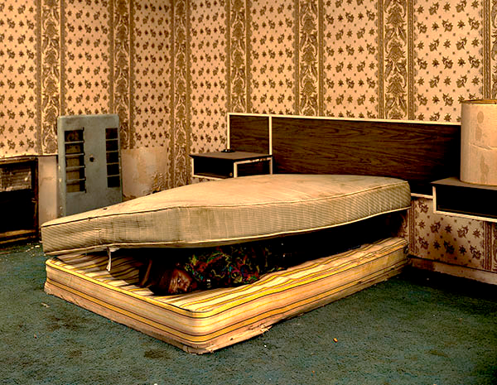
Figure (9) Taryn Simon The innocents - Scene of arrest, The royal inn. Larry Mayes case.

Referencing from figure 13 I’ve studied how Taryn Simon produced dramatic photographs which demonstrate the complete disregard for victims prosecuted from serious crimes. I find her work truly inspiring as she exploits the innocents of these people in misleading settings but accurately testify the crime and allegations.
2002 Larry Mayes, Scene of arrest, The Royal Inn, Garry. This visually moving piece was constructed by Taryn Simon showing the moment were Indiana police found Mayes hiding beneath a mattress in this room and served eighteen years and five months of an eighty-year sentence for Rape, Robbery and unlawful Deviate conduct.

25
After being wrongfully accused in 1980 October 6th he was sentenced to jail to pay for a crime he didn’t commit. During investigation it was discovered that the prosecutor
was shown two arrays of eight to twelve photographs each from which were photos of the defendant, whom she identified as the attacker. About a month later after questioning she identified another individual from a line up, James Hill. When asked at trial to explain her error, the prosecutor testified that immediately prior to the line-up she’d been told to concentrate on her memory of the time she’d seen the faces of her assailant/ attacker. It’s documented that while recalling the occurrence she became over whelmed and had to leave the room. Returning to the line-up, the time between recalling the event and leaving had effect on identifying the correct convict. This case study is one of thousands of wrongly prosecuted people due to the concept of false memories and the indexical effect of photographs. This penalizes modern photography and the concept of what remains true. I idolize how her work illustrates how quickly we unknowingly preach judgment from the first image we see, the fact that we choose to believe our own lives and false memories however we choose to perceive the world from a different perspective. How can we tell the truth from the amount of falseness which surrounds us?
Take the fashion industry for example, the invention of airbrushing and manipulating imagery in the fashion and advertisement industry. People choose to be more judgmental for what they see as photography is becoming more like a painting and the truth is less aware visually. As viewers and consumers of digital photography images we’ve become more aware of the boundary between what’s fiction and what is truth.
Contradicting this statement is that we choose to believe what we want to believe, as humans we depict the good from the bad. Not just in our own lives and our own history
26
but the world that surrounds us. We live in our own versions of disgrace and avoid negativity every day, as consumers and non-believers we mould our own happiness.
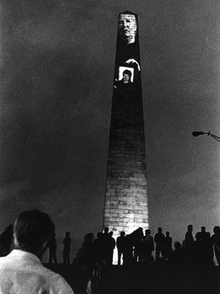
Figure (10) Krzysztof Wodiczko, The bunker hill monument project

27
7
forgotten history
Exploring the theme of indexical photography and projecting the past and memory I’m researching Lisa Saltzman, she states in her briefing from Making Memory Matter,
“There’s an explanation of how memory and visual culture are conjoined. History has experiences and events which are mindfully collective, and we relate through personal happenings or trauma.” -Lisa Saltzman

Saltzman explores artists, works and demonstrates traditional sculpture, memory and preeminent forms of visual representations. (preeminent- surpassing all others; very distinguished in some way compared to another subject.) She pays particular attention to an artist called, Krzysztof Wodiczko. I’ve been studying his project The bunker hill monument and how art is used to exploit remembrance through forgotten lives and a silenced town during the 1990’s. His work explored a comparison between art and culture studying memory and trauma.

Known for his powerful silhouetted images of radical violence in American history. She focuses on a piece “Bunker hill monument projection 1998” produced by Krzysztof Wodiczko and presented in a town called Charlestown where the highest murder and crime rates in Boston were reported. The Bunker hill project is a combination of imperatives of oral history and use of techniques and technologies such as video recording and projection. The artwork was set out to provide the towns victims with “a Voice.”
28
He focused on the survivors of domestic abuse, who prior to his investigation whom had suffered in silence. He captured only images of their hands to preserve their dignity, he provided a voice and their stories were heard.
Photographs consisted of hand gestures such as fiddling with wedding rings, offering candles, wringing a rag, holding a cigarette and pulling petals off a flower. September 24rd 1998, a Saturday night the Krzystof Wodiczko projection which featured interviews with mothers from Charlestown- Boston USA, His performance piece was running half an hour at a time between 8 and 10pm with sound and moving image. Fundamentally there isn’t any recorded footage of this monumental display to work from apart form still images in black and white and edited in colour. The women spoke their minds for the first times after living years in silence hushed by their partners and authorities. I’ve found this of inspiration as Mr. Wodiczko expanded his knowledge to involve those who felt they had no authority for a voice, He walked the streets of Charlestown visiting housing at night and spoke with the suffering residents.
He shared elements of his own work to explain his own tragedy and loss, including the loss of his mother whom he lost a week after his own birth. He shared previous works, most significantly he invited the mothers to view his video that he had projected onto the Tower of the 14^{th-} century City hall in Cracow, Poland in 1996. This video featured woman whom had suffered from domestic abuse and inexplicable violence. Only their hands were visible. One woman held a candle. Another peeling a potato with the same knife her drunk and disorderly husband threatened her and her son with, however once reported their case was left unsolved and followed years in silence. His Cracow projection was remained untitled however in his words,

29
Not the city of culture, but of the city of pain. - Krzysztof Wodiczko

The women of Charlestown, Boston would have been understandably sceptical of Wodiczko’s proposal. Having been interrogated by a man nor from Boston him-self nor hold a sense of their community so how would he understand their loss. In Charlestown, Wodiczko sought to restore voice and visibility to those families whose losses had been compounded by their fundamental inability to seek justice for the murders of their sons and brothers, the possibility of testimony lost to a reigning culture of silence. Even though the stories of Charlestown Boston were shortly lived, the affect from this visual display took place months after and the support to those suffering families heightened.

Referring back to my question, ‘How photographs tell us about our past or even memory and If photographs and memory alone are unreliable for an exact reality? I find that the bunker hill monument demonstrates a public projection of those lives which had been lost along with the time which had passed. Bunker hill monument affected thousands of people as his work highlighted the memory of the lives which had been lost and forgotten, Krzysztof Wodiczko himself explored the concept of protectionary emotion through the concept of indexical photography and remembrance. Through domestic photographs I enjoy studying the emotion and integrity that’s held in that single moment of time, unless explained or lived only the eye behind the camera would have more recollection of that event and moments surrounding that moment in time.

30
8
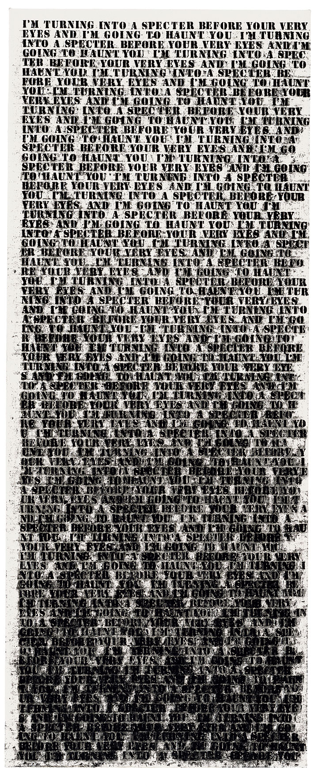
History repeated

Figure (11) “Glen Ligon- I’m turning into a spectre before your very eyes and I’m going to haunt you.”

31
Lisa Saltzman discusses this piece of work produced by Glenn Ligon, figure 15, I’m turning into a spectre before your very eyes and I’m going to haunt you, 1992.

A vertical canvas sized at roughly human scale written with stencilled black letters densely covering the canvas, the words are fragments of library text, taking from the writings of James Baldwin, Zara Neale Hurston and Jean Genet. Boldly repeating the title, I’m turning into a spectre before your very eyes and I’m going to haunt you. The figure progressively bleeds into a haunting dialect, as you read the art work carefully analysing any changes to the writing. It’s surprisingly dark from the mid-section down, the artist made a slight but crucial alteration to Genet’s original text, transforming the original third-person voice into the first person. Inspiring the viewer, a sense of curiosity about the identity of the speaker, Ligons method also suggests the complexities involved representing racial identity in either paint or words.
I’ve selected this piece as it controversially reminds me of the world we live in today. ‘I’m turning into a spectre before your very eyes and I’m going to haunt you’ This piece is obsessive and repetitive, I feel a familiar agitation to this as I do with advertisement and consumerism from today’s world. The work progresses a sense of abstraction and lost dialect, there’s a form of indexicallity and poses the audience to question further because of the unknown.
I’m inspired by the way Ligon shows that historical documents can allow memory of disturbed past and of that which emerges. Those memories haunt the present in their constant movement between the collective and the individual. In true fashion he imposes the idea of self-reflection and power through history and the present.

32
Using official slave narrative, he brings himself to the past and recreates it in the present. Generally, these series of works are initially projective and manipulative, and his work becomes a medium that re-meditates the memory of slavery.
Regarding both Glenn Ligons and Krzysztof Wodiczko’s works they reanimate forgotten history through contemporary art, they recall forgotten memory through the loss of lives.

33
9
Conclusion

To re-address the title of my dissertation directly, how much can photographs tell us about our past or even memory?

When reflecting on our personal archives we recall a sense of loss through remembrance, a photograph is a witness to the events of our lives which pass by at uncountable speed. Our memory may not be able to apprehend these moments truly. Photographs are potent in this capacity as they contain vast amounts of detail, thus emotions would be consistent with the suggested event.
In other words, if we imagine it, it can be true.
If photographs and memory are so unreliable for an exact reality, why are they so important to us? The moment the event was recorded to the present moment of looking at the photograph, there is a sense of false remembrance. Personal photo albums are narratives of our past which can comfort us in times of need, even if they do not reveal what really happened. With the new age of digital development, photographers have access to manipulating and changing details of the event. The ability to bend perspective and touch up images to make them more attractive, with the idea of manipulation, we have more of a succumbed sense of falsehood and integrity to question the photograph.

34
Acknowledging the perspective on new technologies in the digital world, the idea of how we store photographs is changing the way we value our memory of our personal history. The comparison between film photography and digitalised we soon lose the value of those lived moments. In today’s modern process of documenting our history we have options to often store these photos on digital devises such as mobile phones, laptops and memory sticks, thus making them easily re-discoverable and with the concepts of social media it’s now easier than ever to re live and share our personal history.
I’d like to end my dissertation with this final quote-

“The irony of photography is that it that it is just as vulnerable to distortion as any other record.”

35
10

Bibliography

Berger, John
[2013] Understanding a photograph, Penguin classics

Berger, John
[2008] Ways of seeing, Penguin Modern classics

Batchen, Geoffrey
[2006] Forget me not: Photography and remembrance, Princeton Architectural press

Batchen, Geoffrey
[1999] Burning with desire: The conception of photography, MIT Press; New edition

Goldin, Nan
[2000] The other side, Zurich, Switzerland

Goldin, Nan
[2004] Nan one month after being battered (accessed: October 15th 2018) https://www.tate.org.uk/art/artworks/goldin-nan-one-month-after-being-battered-p78045

Goldin, Nan
[2004] Misty and Jimmy Paulette in a taxi, NYC (accessed: October 15th 2018) https://www.tate.org.uk/art/artworks/goldin-misty-and-jimmy-paulette-in-a-taxi-nyc-p78046

Goldin, Nan
[2004] Nan and Brian in bed, NYC 1983 (accessed: October 15th 2018) https://www.moma.org/collection/works/101659

Haustein, Katja
[2012] Regarding lost time: Photography, identity and affect in Proust, Benjamin and Barthes, Legenda main

36
Meyer, Pedro
[1995] You can’t believe your eyes (accessed: October 12th 2018) https://www.wired.com/1995/12/meyer/

Raiford, L
[2009] Photography and the practices of critical black memory (accessed: November 2nd 2018) https://www.jstor.org/stable/25621443?seq=1#page_scan_tab_contents

Simon, Taryn
[2002] The innocents (accessed: November 19th 2018)
https://www.moma.org/collection/works/164438?artist_id=41212&locale=en&page=1&sov_referrer=artist

Saltzman, Lisa
[2006] Making memory matter: Strategies of remembrance in contemporary art, originally published

Ligon, Glenn
[2011] Glenn Ligon in New York I’m turning into a spectre before your very
eyes and I’m going to haunt you (accessed: November 28th 2018) https://www.metropolism.com/en/reviews/22619_glenn_ligon_in_new_york

Wade A K, Garry M, Read J, Lindsay S
[2002] ‘True Photographs and False Memories’ (accessed: October 21st 2018) https://www.ncbi.nlm.nih.gov/pubmed/15016285

Wodiczko, Krzystof
[1998] The bunker hill monument projection display (accessed November 18th 2018) https://www.pinterest.co.uk/pin/47921183513416737/

37

