GREEN PRACTICES IN THE HOSPITALITY INDUSTRY
ASSIGNMENT 2: REPORT
Student Name: Florin Matache
ID: 2126293
Lecture name: Kathryn Roberts
BMIH5006

Executive Summary
The executive summary highlights the critical issues of greenwashing in corporate sustainability practices, using The Savoy Hotel as a case study. It emphasizes the discrepancy between proclaimed eco-friendly initiatives and actual environmental performance, underscoring the importance of transparency and accountability. The report advocates for rigorous self-evaluation coupled with alternative assessment methods to combat greenwashing effectively. Integration of green technology and collaborative partnerships are proposed as strategies to enhance sustainability efforts. By addressing these challenges, companies can uphold credibility, foster genuine environmental stewardship, and contribute to a more sustainable future.

TABLE OF CONTENTS
Introduction 4
Accusations of Greenwashing 4
Potential Greenwashing Practices 5
Self-Evaluation of Sustainability Practices 6
Purpose of Self-Evaluation in Companies 6
Integration of 'Green' Technology and Sustainability Efforts 6
Alternative Evaluation Methods Beyond Self-Assessment 6
Conclusion 6
Reference List 7

Introduction
The report takes a gander at the specific issue of greenwashing inside corporate sustainability practices, inspecting potential fascinating strategies used by affiliations. It jumps into the significance of self-assessment in seeing sustainability endeavors, looks at the blend of green technology, and prescribes elective assessment strategies to fight greenwashing.

Accusations of Greenwashing
The Savoy, London, has been named an issue of greenwashing, a model wherein affiliations misrepresent or contort the level of their customary activities ensuring they are more sensible (TheSavoyLondon, 2024). These charges come from the saw sound peculiarities between the motel's affirmed eco-fittingness in the advancing and the reality of its standard show. Rivals fight that The Savoy could feature the standard drives and the affirmations from it in the bound time materials and get down on the practices that have no relationship with sustainability (Tanveer et al. 2024). The housing could show sheets showing the steps it takes to reduce water use, for instance, energy-persuading lighting and towel reuse. In the interim, it could have excused impacts like high energy use from warming, ventilation, and cooling structures (cooling) or awkward waste affiliation practices. Also, partners wonder going to the validness of the sustainability affirmations or awards that The Savoy has achieved, confiding in them to be surface or token executions rather than an authentic commitment to standard stewardship. This weakness is an immense piece of the time achieved by when licenses don't have perfect, heightened gauges or free confirmation strategies.
Moreover, the anomalies between the housing's conveyed sustainability objectives and its constant show data harm the motel's legitimacy in any serious typical issue (Floričić, 2020). For example, should The Savoy set solid obsessions for non-practical power source results decline and as such excusal to reveal any reports on the total they have hacked down their transmissions or put assets into release help strategies, partners could investigate the level of its liabilities. Greenwashing of The Savoy is for the most part a show that straightforwardness, responsibility, and value in sustainability are colossal rudiments. To re-attempt trust and show legitimate normal stewardship, The Savoy ought to welcome extra insidious great and direct sustainability practices, which ought to be figured out from resolve practices and quantifiable outcomes.
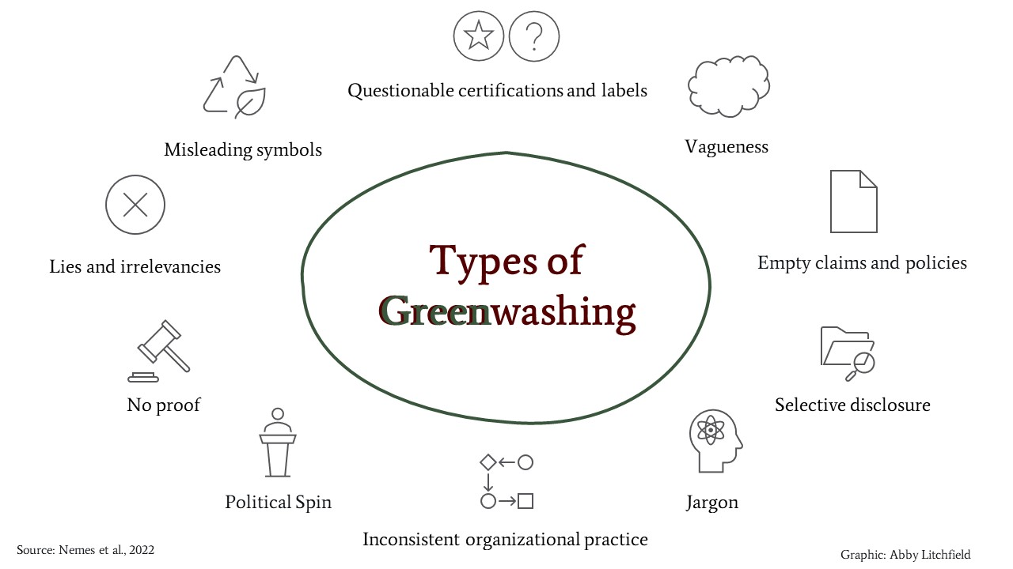
Figure 1: Types of Greenwashing
(Source: Yousaf et al. 2021)

Potential Greenwashing Practices
The Savoy, London, faces serious assessment, for greenwashing anticipated the premises, despite various things decisions to reuse towels by the visitors as a sustainability measure. Despite how the mission is viewed as eco-obliging, the intellectuals fight that it very well may be a simply delegated activity that would truly mask the other more critical standard issues in the background, like high energy use of cooling frameworks or wasteful waste association (Modica et al. 2020). The discussion that is in the long run consolidating towel reuse raises the more prominent issue in regards to whether the business being suggested nonchalantly offers fundamental void talk with gigantic sustainability endeavors or is truly given to these endeavors and meanwhile features the need of clear and complete normal practices planned to stay away from any cases of greenwashing.

Self-Evaluation of Sustainability Practices
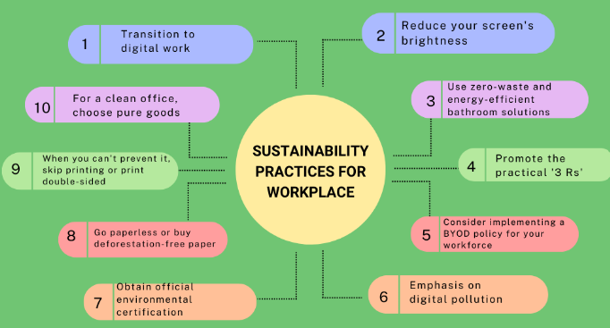
Figure 2: Sustainability practices
(Source: Čermáková et al. 2020)
In evaluating its sustainability practices, the company conducts a thorough examination of its environmental initiatives, aiming to ensure transparency, accountability, and genuine commitment to sustainable principles. The self-evaluation process encompasses various aspects of the company's operations, including energy consumption, waste management, water usage, and carbon emissions (Čermáková et al. 2020).
To begin with, the company evaluates its energy efficiency measures such as renewable energy use, energy-efficient technologies implementation, and thermal regulation of heating, ventilation, and air conditioning systems. Through energy consumption. By looking at patterns and identifying opportunities for improvement, the company minimizes its carbon footprint and makes operating sustainable.
The second indicator evaluates the collection of waste management practices to ascertain the efficiency of recycling programs, waste reduction techniques, and safe disposal processes (Tripathi et al. 2020). The company looks into the waste generation rates, recycling rates, and landfill diversion efforts paramount to developing waste minimization and a circular economy approach.
Besides this, the organization evaluates its water saving techniques such as low-flow toilets, drip irrigation and water re-cycling. The company is developing water usage trends and the implementation of water conservation through which it will reduce water usage and preserve this basic resource.
Moreover, the organization reviews actions, including carbon offset programs, emission reduction targets, and transportation efficiency measures, that reduce greenhouse gas emissions (Lamb et al. 2021). The Savoy aims at making transport more sustainable and emission-reducing technologies are implemented to reduce the environmental impact and to contribute to climate change mitigation projects.In general, the self-audit allows the company to discover capabilities, vulnerabilities, and opportunities to advance.

Purpose of Self-Evaluation in Companies
Companies engage in self-evaluation of their sustainability practices for several reasons, driven by the need for accountability, improvement, and competitive advantage:
- Transparency and Accountability: Self-evaluation is a means to transparency outcome with knowledge of the company's environmental performance available to consumers, investors and oversight (Heimstädt and Dobusch, 2020). It manifests the company’s stance on socially responsible business practices as well as being accountable for its environmental impact.
- Identification of Strengths and Weaknesses: Self-evaluation plays a crucial role in identifying the strengths and control factors in the sustainability initiatives of a company. Through the evaluation of performance metrics and environmental indicators, firms can name the areas of success and those ones that need improvement. Thus, this knowledge will bring about the initiative of devising such practices that aim at helping to achieve efficiency and overcome any insufficiency.
- Compliance and Risk Management: Self-evaluation enables the businesses to confirm the adherence to the environmental laws and codes (Polden, 2022). Through the monitoring of their environmental performance, companies can early detect possible compliance issues, and prevent the consequential effects of non-compliance, which can be fines, legal liability, and reputation damage.
- Cost Savings and Efficiency Gains: Organizational sustainability practices can be considered for improvements, which will help to achieve cost savings and efficiency. Through a highly efficient resource utilization, waste minimization reduction, and energy efficiency, organizations can substantially cut their operating costs and significantly increase their profits with minimal negative impact on the environment.
- Enhanced Stakeholder Relationships: Self-evaluation shows a company’s seriousness about building allies’ interests, such as customers, employees, communities and investors (Jiang et al. 2020). Through their participation in sustainability audits and the public sharing and reporting on the results, companies can gain the trust of people, develop and cultivate relationships, and become known as responsible corporate entities.
- Competitive Advantage: Sustainability risk management through self-assessment of sustainability practices can give an advantage among competitors by differentiation of companies in the marketplace. Enterprises showing these traits: superior environmental performance, innovation, and sustainability commitment are being paid attention to in the eyes of the consumers, investors and business partners which offers a better brand loyalty, market share and financial performance.

Integration of 'Green' Technology and Sustainability Efforts
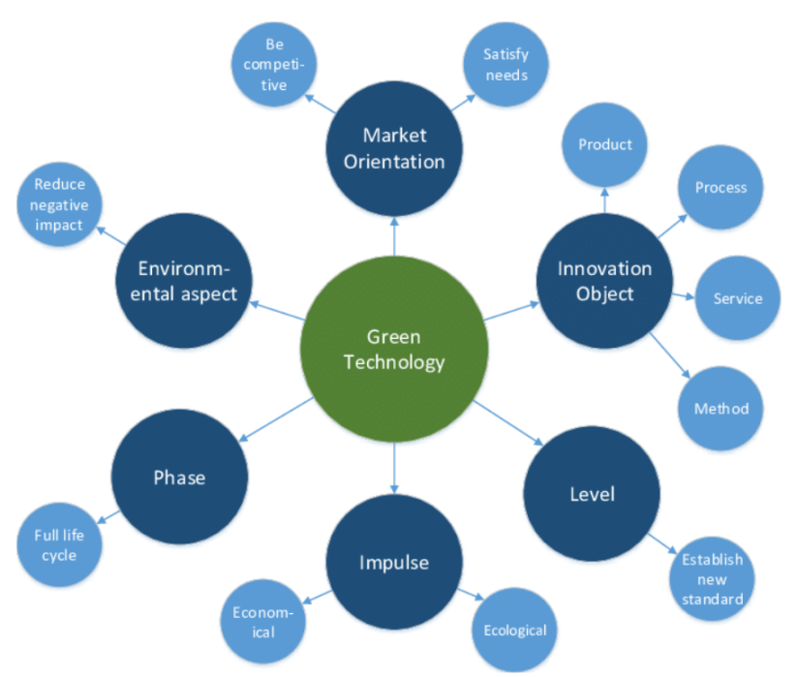
Figure 3: Green technology
(Source: Halkos and Gkampoura, 2020)
- Renewable Energy Sources: The Savoy uses renewable energy sources including solar panels or wind turbines in the operation to realize both flow reduction of the fossil fuels and carbon emission (Halkos and Gkampoura, 2020). Thanks to the embracement of renewable energies, the hotel helps create a "green"-based power system.
- Energy-Efficient Lighting and Appliances: The Savoy has replaced its energy-inefficient lighting and appliances with energy efficient models as a result of that their electricity consumption has reduced which also reduce their environmental impact. LED lighting, for instance, is more energy efficient than incandescent bulb still can give plenty light for both guests and workers.
- Smart Building Systems: The hotel has built-in intelligent building technologies to ensure an effective use of energy, which enhanced operating efficiency (Froufe et al. 2020). These systems employ sensors and automation that control temperature, cooling and lighting depending on occupancy and environmental conditions hence wastage of energy which is minimized hence guest comfort is enhanced.
- Water Conservation Measures: The Savoy has installed water-saving measures to ensure water is conserved and managed sustainably like low-flow fixtures and water recycling systems. The hotel effectively takes part in preserving the freshwater resources and minimizing the environmental impact of its operations through reducing water usage.
- Waste Reduction and Recycling Programs: The hotel has devised waste reduction and recycling programs to cut down the landfill waste and promote closure cycle (Zamri et al. 2020). Through separating waste streams, composting of the organic matter, and recycling paper, plastic, glass and metal The Savoy is able to lower its environmental impact and use up resources in a wise manner.
Sustainability Impact of Green Technology:
- Reduced Environmental Footprint: Green technology implementation at The Savoy has led to significant reduction in carbon footprint as it enables energy saving, reduced water consumption, and less waste generation. These projects are in alignment with the sustainable development goals and illustrate the hotel being an environmentally responsible organization (Klemeš et al. 2020).
- Cost Savings and Operational Efficiency: The green technology investments being made have in turn created cost savings and operational efficiency improvements in The Savoy. Energy-efficient measures and waste reduction strategies help cut down the utility expense amount and hence disposal costs. Thus, financial sustainability is achieved.
- Enhanced Reputation and Guest Satisfaction: The transition to sustainable technology confers to companies like The Savoy an image of a socially-responsible and eco-green establishment (Lestariet al. 2023). The increase in eco-friendly accommodation options is important in attracting guests, and as such, The Savoy's sustainable practice of implementing green technologies is beneficial in engaging the guests' satisfaction and loyalty.

Alternative Evaluation Methods Beyond Self-Assessment
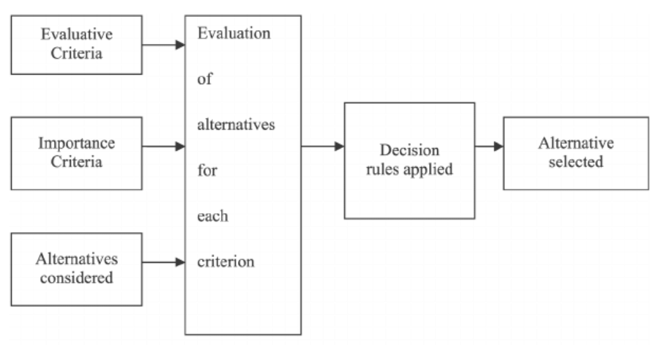
Figure 3: Alternative evaluation methods
(Source: Okazakiet al. 2021)
- Third-Party Audits and Certifications: Audits are being conducted independently and as such, they provide verification of the hotel’s environmental performance and compliance to the accepted standards such as ISO 14001 for environmental management systems or LEED certification.
- Stakeholder Engagement and Feedback: The Savoy may act with stakeholders such as guests, employees, suppliers and local communities to collect information. Hence information that will help develop sustainability practices of the hotel can be acquired by the Savoy. Upon conduct of surveys, holding focus groups and engaging in dialogue sessions, the hotel has a chance to know the stakeholder perception, identify avenues of improvement and show a responsive attitude to the raised issues (Okazakiet al. 2021).
- Benchmarking and Industry Comparisons: The Savoy could benchmark their sustainability performance against industry competitors and best practices to know their own position compared to other players and to detect possible for future improvements. Compared to sustainability leaders, a comparison analysis gives the hotel the opportunity to learn and adopt novel strategies, introduce impressive targets and improve its competitiveness and environmental impact.
- Lifecycle Assessments and Environmental Impact Studies: The Savoy can perform a lifecycle analysis and environmental impact studies, focusing on the full lifecycle environmental impacts of its operations, products, and services. The assessment of both upstream and downstream environmental effects helps the hotel to pinpoint and then prioritize on what to target across the whole value chain (Bjørnet al. 2020).
- Partnerships and Collaborations: The Savoy Hotel it could develop alliances and collaborations with environmental organizations, education institutions as well as industry bodies to exploit knowledge and experience, sharing best practices and speed the process of progressing towards sustainability. Collaborative efforts, like joint research, knowledge sharing forums, and collective impact platforms, strengthen Savoy’s innovativeness and collective impact.
- Continuous Monitoring and Reporting: The Savoy can embed reliable performance monitoring and reporting systems that capture and track key performance indicators, environmental indicators, and progress of sustainability targets. It is through the regular reporting that the level of accountability, transparency, and communication with the internal and the external stakeholders are ensured. Such an approach creates trust and engagement (Vitolla et al. 2020).

Conclusion
The combating of greenwashing in the corporate sustainability practices must be always a priority which contributes to the upkeep of credibility and dedication to the real environmental stewardship. The case of The Savoy positively illustrates the role of transparency, accountability and adherence to sustainable policies. By conducting self-reflection, companies are able to recognize their shortcomings and work towards improvement in countering that. Alternatively, a mixed evaluation approach that includes self-assessment along with, say, third party audits or engagement of stakeholders will make the system more credible and result in better management of the environment. Combined with green technologies and collaborative partnerships, the journey to a more sustainable future is greatly enhanced and the business like The Savoy is on the front-line leading this charge for change.

Reference List
Bjørn, A., Chandrakumar, C., Boulay, A.M., Doka, G., Fang, K., Gondran, N., Hauschild, M.Z., Kerkhof, A., King, H., Margni, M. and McLaren, S., (2020). Review of life-cycle based methods for absolute environmental sustainability assessment and their applications. Environmental Research Letters, 15(8), p.083001.
Čermáková, J., Slabová, M. and Rolínek, L., (2020). Self-evaluation of the level of key competencies for Industry 4.0. In 16 th Annual International Bata Conference for Ph. D. Students and Young Researchers (p. 75).
Floričić, T., (2020). Sustainable solutions in the hospitality industry and competitiveness context of “green hotels”. Civil Engineering Journal, 6(6), pp.1104-1113.
Froufe, M.M., Chinelli, C.K., Guedes, A.L.A., Haddad, A.N., Hammad, A.W. and Soares, C.A.P., (2020). Smart buildings: Systems and drivers. Buildings, 10(9), p.153.
Halkos, G.E. and Gkampoura, E.C., (2020). Reviewing usage, potentials, and limitations of renewable energy sources. Energies, 13(11), p.2906.
Heimstädt, M. and Dobusch, L., (2020). Transparency and accountability: Causal, critical and constructive perspectives. Organization Theory, 1(4), p.2631787720964216.
Jiang, W., Wang, A.X., Zhou, K.Z. and Zhang, C., (2020). Stakeholder relationship capability and firm innovation: A contingent analysis. Journal of Business Ethics, 167, pp.111-125.
Klemeš, J.J., Van Fan, Y., Tan, R.R. and Jiang, P., (2020). Minimising the present and future plastic waste, energy and environmental footprints related to COVID-19. Renewable and Sustainable Energy Reviews, 127, p.109883.
Lamb, W.F., Wiedmann, T., Pongratz, J., Andrew, R., Crippa, M., Olivier, J.G., Wiedenhofer, D., Mattioli, G., Al Khourdajie, A., House, J. and Pachauri, S., (2021). A review of trends and drivers of greenhouse gas emissions by sector from 1990 to 2018. Environmental research letters, 16(7), p.073005.
Lestari, R., Panjaitan, E.H.H. and Putra, P., (2023). Improving Guest Satisfaction Through Integrated Marketing Communications: A Study of Shared Value Creation in the Hospitality Industry. Remittances Review, 8(4).
Modica, P.D., Altinay, L., Farmaki, A., Gursoy, D. and Zenga, M., (2020). Consumer perceptions towards sustainable supply chain practices in the hospitality industry. Current Issues in Tourism, 23(3), pp.358-375.
Okazaki, S., Plangger, K., Roulet, T. and Menéndez, H.D., (2021). Assessing stakeholder network engagement. European Journal of Marketing, 55(5), pp.1359-1384.
Polden, D.J., 2022. Compliance Leadership. In Routledge Handbook of Risk Management and the Law (pp. 389-402). Routledge.
Tanveer, M.I., Yusliza, M.Y. and Fawehinmi, O., (2024). Green HRM and hospitality industry: challenges and barriers in adopting environmentally friendly practices. Journal of Hospitality and Tourism Insights, 7(1), pp.121-141.
TheSavoyLondon, (2024). Home Page [Online], Available at: The Savoy Hotel in London | Luxurious 5 Star Hotel | The Savoy (thesavoylondon.com) [Accessed on 20th Feb, 2024]
Tripathi, A., Tyagi, V.K., Vivekanand, V., Bose, P. and Suthar, S., (2020). Challenges, opportunities and progress in solid waste management during COVID-19 pandemic. Case Studies in Chemical and Environmental Engineering, 2, p.100060.
Vitolla, F., Raimo, N. and Rubino, M., (2020). Board characteristics and integrated reporting quality: An agency theory perspective. Corporate Social Responsibility and Environmental Management, 27(2), pp.1152-1163.
Yousaf, Z., Radulescu, M., Sinisi, C.I., Serbanescu, L. and Paunescu, L.M., (2021). Harmonization of green motives and green business strategies towards sustainable development of hospitality and tourism industry: Green environmental policies. Sustainability, 13(12), pp.65-92.
Zamri, G.B., Azizal, N.K.A., Nakamura, S., Okada, K., Nordin, N.H., Othman, N., Akhir, F.N.M., Sobian, A., Kaida, N. and Hara, H., (2020). Delivery, impact and approach of household food waste reduction campaigns. Journal of Cleaner Production, 246, p.118969.

