Student name | Alexandru-Marian Dima
Student ID | 1914253
Proposed research title | Exploring the strategies for promoting online stores in the pandemic period/post-pandemic period
Name of the university | University of Wales Trinity Saint David in London
Submission date | 08/01/2022

Exploring the strategies for promoting online stores in the pandemic period/post-pandemic period
Declaration
I do hereby declare that the dissertation titled “Exploring the strategies of promoting online stores in the pandemic period/post-pandemic period” is my own and has been submitted as a part of my ongoing coursework.
Signed: Alexandru-Marian Dima
Abstract
The introduction chapter is the key to a better assessment of the aim, objectives and research questions. The chapter also defined the clear scope of the research and how it might be relevant to the market as well. A Literature review has been conducted in this study. Several themes have been drawn from research objectives to critically evaluate the literary findings. Relevant theories and models have been presented to discuss the various themes generated from credible authors’ works. A literature gap area has also been identified in this chapter along with highlighting key findings associate with online store promotion for organisational growth. The present study has followed the epistemological philosophy, coupled with a positivist paradigm. For this study, the researcher undertook a survey of a randomly sampled respondent pool, comprising 25 people working in different areas, all of them using online and traditional shopping. In the data collection and analysis step, the researcher presented a thorough analysis of the data obtained from the participants. This analysis has been used to identify key aspects of online shopping promotion following the pandemic. The last chapter defines and concludes the overall research and thus links all the objectives with the analysis of chapter 4. It also gave some vital recommendations by identifying all the key limitations of the research.

Acknowledgements
I acknowledge the success of this dissertation to the support received from my lecturers and teachers. I would also like to thank the survey participants for their active interest and participation in the study.

Table of contents
Chapter 1: Introduction 9
1.1: Introduction 9
1.2: Background of study 9
1.3: Problem Statement 10
1.4: Aims, Objectives, Research Questions, Hypothesis, Propositions 10
1.5: Rationale/Importance of the Research 12
1.6: Methodology (sources, population, sample, measuring instrument, data collection, data analysis) 12
1.7: Scope of the Study/Demarcation (International, national, geographic area) 12
1.8: Structure of the Dissertation 13
1.9: Summary of Chapter 1 13
Chapter 2: Literature Review 15
2.1: Introduction 15
2.2: Base theory of the sub-discipline/different background aspects of the concept 15
2.3: Theoretical frameworks/models, and related research issues 17
2.4: Previous studies and lessons learnt 19
2.5: Gaps identified to situate own research 20
2.6: Summary of Chapter 2 20
Chapter 3: Research Methods and Methodologies 21
3.1: Introduction 21
3.2: Philosophical position of the research 21
3.3: Paradigm position of the research 22
3.4: Position of Research Approach 22
3.5: Methodological stance of the Research 22
3.6: Stance of the Research Strategy and Design 23
3.7: Research Sample and Population 23
3.8: Data Collection and Data Analysis Tools/Techniques 23
3.9: Ethical Consideration of the Research 23
3.10: Summary of Chapter 24
3.11: Timescale and activity chart 24
Chapter 4: Data Analysis and Discussions (1700) 26
4.1: Introduction 26
4.2: Analysis and Discussions of your findings/data (supporting tables/figures/exhibits/diagrams/sample of transcript/interpretation/validity and reliability of the data) 26
4.3: Summary of Chapter 4 45
Chapter 5: Conclusion, Limitations and Recommendations 46
5.1: Introduction 46
5.2: Conclusions on each research issue/objectives/proposition (based on the results in Chapter 4) 46
5.3: Conclusions on the research problem 46
5.4: Summary of the research findings and outcomes 47
5.5: Original Contribution of the Research (i.e.: management, academia, scholars) 47
5.6: Limitations of the Research 47
5.7: Recommendations/Areas for further/future research 47
5.8: Summary of Chapter 48
References 49
Terms of Glossary 53
Appendix 54

List of tables
Table 1: Age of participants 21
Table 2: Gender of participants 22
Table 3: Participants living area 23
Table 4: Employment status of participants 23
Table 5: Household Income 24
Table 6: Marital Status 25
Table 7: Online shopping during Covid 19 26
Table 8: Use of coupons for shopping 27
Table 9: Coupons received during the purchase 28
Table 10: Ease of online shopping 29
Table 11: Ease of searching 30
Table 12: Use of physical or online stores 32
Table 13: Comparative attractiveness of online shopping 34
Table 14: Preferred payment method 34
Table 15: Speed of delivery of online products 35
Table 16: Impact of COVID-19 on online shopping behaviour 36
Table 17: Intensity of online shopping following the pandemic 37
Table 18: Where do participants find fair deals? 38
Table 19: Most time spent on 39

List of Figures
Figure 1: Online purchases of customers in the UK since 2020 9
Figure 2: Structure of dissertation 13
Figure 3: Technology Acceptance Model 18
Figure 4: Online sales in the retail sector 19
Figure 5: Saunders’ Research Onion 21
Figure 6: Activity List 24
Figure 7: Gantt Chart 25
Figure 8: Age of participants 26
Figure 9: Gender of participants 27
Figure 10: Participants living area 28
Figure 11: Employment status of participants 29
Figure 12: Household Income 30
Figure 13: Marital Status 31
Figure 14: Online shopping during Covid 19 32
Figure 15: Use of coupons for shopping 33
Figure 16: Coupons received during the purchase 34
Figure 17: Ease of online shopping 35
Figure 18: Ease of searching 36
Figure 19: Use of physical or online stores 37
Figure 20: Favourite brands of participants 38
Figure 21: Comparative attractiveness of online shopping 39
Figure 22: Preferred payment method 40
Figure 23: Speed of delivery of online products 41
Figure 24: Impact of COVID-19 on online shopping behaviour 42
Figure 25: Intensity of online shopping following the pandemic 43
Figure 26: Where do participants find fair deals? 44
Figure 27: Most time spent on 45

Chapter 1: Introduction

1.1: Introduction
Covid-19 has impacted international business and thus companies in the retail sector have to shift their focus to get more online stores. According to Taher (2021), with the help of online stores during and after the pandemic the retail sector can reach a wide range of customers as well. This chapter will focus on the background, rationale and problem statement of the research topic. Furthermore, the chapter will also highlight the aim, objectives and research questions alongside with hypothesis and propositions. The chapter will be concluded with the scope of the research and structure of the dissertation with an introduction to the methodology.

1.2: Background of the study
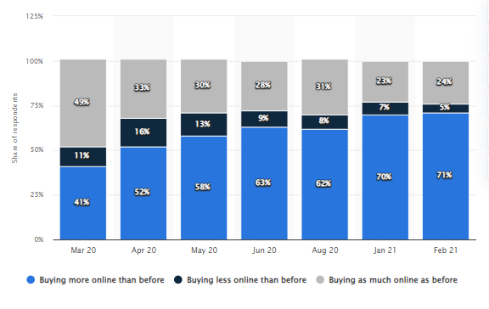

Figure 1: Online purchases of customers in the UK since 2020
(Source: Statista, 2021)
Covid-19 has been one of the grave incidents that the world has faced due to the optimal change in the economy. For the retail sector as the supply chain has been suffering, physical stores are not in the right condition to cater for the essential needs of customers. As mentioned by Nanda et al. (2021), due to lockdown the customers are unable to get their supplies from the physical stores and which leads them to purchase online. The sudden change in customer behaviour and their demand from online stores made the retail companies realise the essentiality of online presence and e-commerce. As the data shows, 71% of the customers in the UK have been purchasing through online platforms since 2021 (Statista, 2021). As consumers are more inclined to online purchase the essentiality of online stores has been undeniable. By incorporating new online stores retail companies might have widened their reach in the UK market.

1.3: Problem Statement

As Covid-19 changed consumer behaviour and thus they now have the tendency to the online purchase, promotion of these stores is essential. According to Kim (2020), with the help of these online stores, the supply chain to the customers can be maintained and thus by doing that companies might ensure customer satisfaction. It cannot be denied that online store companies might use it as a secondary income stream despite having physical stores.

1.4: Aims, Objectives, Research Questions, Hypothesis, Propositions
1.4.1 Aim
The primary goal of this research is to establish applicable techniques for boosting the adoption of online stores for supplying effective services and commodities to their effective consumers in post-Covid19 scenarios.
1.4.2 Goals
- Determine the significance of internet commerce in pandemic scenarios
- To determine the requirement for internet retailers during Covid-19 pandemics.
- Identifying the influence of online stores on the organization's sales recommending applicable tactics for marketing online stores and channels
1.4.3 Inquiries
- What role do online businesses play in pandemic situations?
- What is the necessity for internet retailers during a Covid-19 pandemic?
- What is the influence of online shops on the organization's sales? What methods should be proposed for advertising online stores and channels?
1.4.4 Hypothesis
H₀- The pandemic and post-pandemic era has affected the promotion strategies of online stores in the retail sector.
H₁- Pandemic and post-pandemic era has not affected the promotion strategies of online stores in the retail sector.
1.4.5 Proposition
It is possible that the pandemic and post-pandemic era has impacted the promotional strategies of online stores in the retail sector.

1.5: Rationale/Importance of the Research
The issue of the research that has been identified is that the strategies that are being required for the expansion of the online stores and use their reach out to customers after Covid-19. As mentioned by Susmitha (2021), with the help of online stores, especially after the covid-19 companies in any of the sectors might increase their exponential growth in the international market. In 2022, 27% of retail sales in the UK are being formulated with online stores which are higher than 20% in 2021 (Statista, 2022). With the help of precise strategies for boosting online sales, retail companies might get all the crucial segments of growth. After 2020 and the second wave of Covid-19 it can be clear that companies are waiting for more online purchases.
From the data of the UK market, it can be said that within one year of the pandemic, online retail sales have increased up to 47% and one-fourth of the retail sales are from online channels (Statista, 2022). The research signifies the impact of online stores on the retail sector and the overall view of the impact of Covid-19 as well. With the research, it can also be identified the required promotion strategies of online stores to boost sales in the UK market.

1.6: Methodology (sources, population, sample, measuring instrument, data collection, data analysis)
The source that has been used for the data collection is the survey of people that are working in different areas and do online shopping or traditional shopping. In this research, the target population is working in different areas and the sample size is 25. With the MS Excel sheet, all the survey questions are formed and used as measuring instruments. The data collection and data analysis method that is being considered is the primary quantitative.

1.7: Scope of the Study/Demarcation (International, national, geographic area)
With this study, the overall scenario of online stores in the retail sector can be identified. By doing that the overall impact of the online stores on the business and ways to promote the stores can be evaluated as well. The research has a scope in the specific geographic area as well and it can impact the local e-commerce business..

1.8: Structure of the Dissertation

Figure 2: Structure of dissertation
(Source: created by the learner)

The first chapter of the dissertation focuses on the background of the study alongside the rationale. The second chapter defines the literature review which is based on the objectives. The methodology of the research has been discussed and discussed in the third chapter alongside the ethical considerations that are being used throughout the research. In the fourth and fifth chapters, a detailed analysis has been done with the concluding aspect of suitable recommendations.

1.9: Summary of Chapter 1
It can be concluded that the chapter mainly focuses on the background of the research topic and all the essential problem statements. With the help of online stores, the retail sector might have the upper hand in sales for the foreseeable future. By incorporating relevant promotional strategies from the retail sector, online stores might be the essence of e-commerce in the UK market. All the vital objectives alongside the scope of the research have been discussed thoroughly in this chapter and thus also highlight the hypothesis of the research.

Chapter 2: Literature Review

2.1: Introduction

A literature review is the most important chapter for obtaining literary findings from relevant authors. Research objectives and questions will be used to form the themes to cover the importance and usefulness of online stores during Covid-19 and post-Covid -19 times. Several theories and models will be reviewed to review the literary findings critically. Gaps in the research will also be identified and summarised in this chapter.

2.2: Base theory of the sub-discipline/different background aspects of the concept
Concept of online stores
Online stores are a simple concept of having a virtual store built online which performs the same duty of selling products as a physical store. However, an online store is identified through logos and symbols associated with a company and one can surf the internet to access the store virtually. As per the view of Bonnin (2020), augmented reality is one tool that is highly integrated into online store services. Online stores are one of the latest business concepts that have been adopted by organisations to combat Covid-19 and ease the concerns of a pandemic. A major restriction of the pandemic was physical distancing which led to a limitation in travel and physical movement. It led to stores being closed as buyers could no longer visit the store to make a purchase.
However, online stores provide the opportunity for consumers to use the internet and search for products online to make an online purchase. On the contrary, Anwar et al. (2020), stated that the atmosphere and emotional feeling buyers get with a physical store influence their buying decision. It is essential for online stores to have a design, logo and music that build a connection with customers to not just visit the page but also search for desired products. Online stores are also highly addictive as buyers constantly get reminded of their favourite items that they wish to purchase.
Need for online stores during Covid-19
Covid-19 required businesses to abide by social distancing protocol which was the cause of the closing down of organisations. Online stores are needed to help firms sustain the pandemic heat and continue with sales. It also helps buyers to purchase needful items without breaking Covid-19 protocols. As per the opinion of Neger and Uddin (2020), during the pandemic online shopping was still setting in as a business practice. It was still the beginning phase of online purchase behaviour which led to poverty as a large number of stores and businesses got shut.
Online stores are needed to combat Covid-19 limitations as it provides easy delivery and monetary transaction to complete the purchase process. Utilising online stores is a convenient way of business operation that does not compromise during pandemic situations. In the UK the leading online stores of retail firms include Tesco, Sainsbury’s, ASDA, Ocado and so on (Statista, 2022). It is evident that online stores have been integrated by leading retail brands in the UK which is a reflection of the need for online stores for all retailers.
Importance of online stores in pandemic
Online stores are important during the pandemic as buyers can continue to purchase without facing health risks associated with Covid-19. It also benefits firms to sustain business operations without running in extreme loss. According to Akram et al. (2021), digitalisation has helped businesses to take care of customer well-being and health during a pandemic. However, as per Topolko Herceg (2021), customers who spend more time online are likely to buy online. The importance of online stores is significant during and after the pandemic to help both buyers and sellers. Even during post-pandemic times, customers addiction and connection with online shopping have not been reduced. Customers automatically spent more time online which is an opportunity for online stores to flourish in sales.
Impact of online stores in pandemic situations
The impact of online stores has been useful to combat the issues of the pandemic. Businesses have faced extreme loss and the lives of consumers also got affected. Online store facilities helped both buyers and business owners to sustain their livelihood. In the opinion of Wang and Na (2020), natural disasters disrupt the normal market environment. On the other hand, in the view of Naseri (2021), the new normal business practice through online stores has lowered the general volume and density of business sales.
However, the impact of the online store has been mostly positive on buyers as they get to conveniently search for and purchase products. It also impacted the global reach of organisations as buyers across geographical boundaries can make a purchase.

2.3: Theoretical frameworks/models, and related research issues
Online stores can be integrated by accepting technology, as online services are driven by technology and technical tools. It becomes highly necessary for organisations to have acknowledgement and sufficient awareness about technology for the integration of online storage facilities. However, a new idea takes time to suffice to its proper execution form after acceptance from the people associated with it. According to Bharadwaj and Deka (2021), Roger's Diffusion of Innovation theory focuses on the spreading of an innovative business idea for the acceptance of the idea in the business community. In order to combat Covid limitations, it is the diffusion of the innovative idea of using the online platform for communication and distribution channels to continue sales.
A key limitation of Covid has been a physical movement which is combatted by online business features as sales can be continued online. Therefore, the idea of an online store is essentially promoted for business integration for organisational growth. However, in the view of Fauzi et al. (2021), Davis developed the Technology Acceptance Model (TAM) to understand the acceptance level of information and technology among people. The acceptance of an online store's idea goes through phases where first, the firms need to inform their employees about the new venture. Employees need to be aware and trained to be able to serve customers online during Covid and post-pandemic situations.

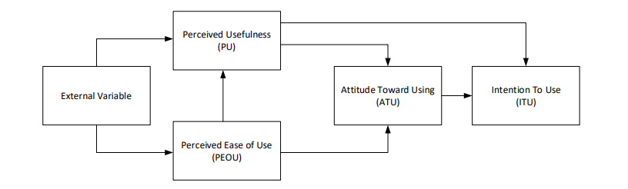

Figure 3: Technology Acceptance Model
(Source: Fauzi et al., 2021)
The importance and impact of online stores are significant during the Covid-19 era. Easy search, delivery and after-sales services through quick feedback are provided by online stores. As per Ancey (2020), the determinism theory of technology simply believes in the sheer determinism of accepting the effectiveness of technology in operations.
2.4: Previous studies and lessons learnt
Relevant strategies for promoting online stores and channels
According to Grewal et al. (2021), the retail industry is dynamically changing with various customer trends generating every day. Fast delivery, easy search online and purchasing process without physical movement are enabled by online promotion of online channels which needs to be practised. Social media is one such popular platform for online business communication that can be used to promote online stores.
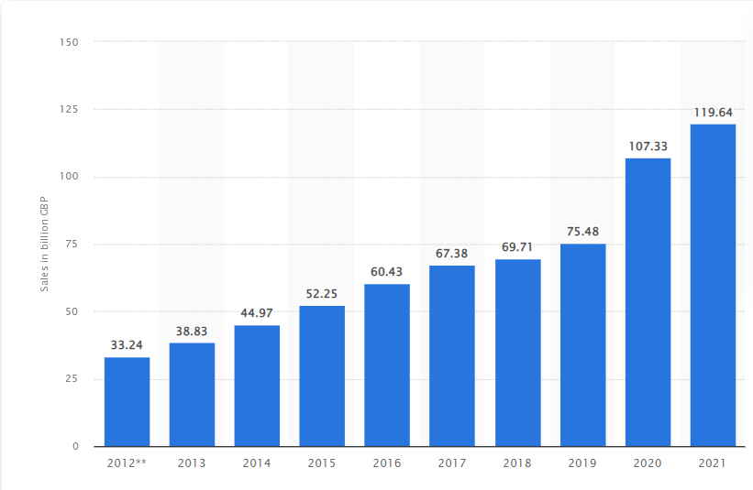

Figure 4: Online sales in the retail sector
(Source: Statista, 2022)
In the retail sector, sales through online channels generated an amount of 120 Billion British pounds in the year 2021 (Statista, 2022). It implies that the online space is a useful strategy to follow for promoting online store integration in businesses. Adverts in online stores can be presented or marketed on social media and Google. However, print media can be used to post ads about new online stores with official website links given. It becomes important for organisations to utilise digital marketing for promoting online communication channels and stores. Bizhanova et al. (2019) suggest that web-based platforms such as Google Ads and SEO (Search Engine Optimisation) can help promote online channels so that they can be well integrated.
2.5: Gaps identified to situate own research

The literature review chapter has focused on the positive aspects of online stores. Financial concerns with the online integration of stores along with a digital transformative move causing disruption in small firms have not been covered. The literature also misses focusing on the various skills required to integrate online stores into organisations.

2.6: Summary of Chapter 2
In this chapter, several theories and models have been used to discuss the various themes. The importance and need for online stores during pandemic situations have been critically reviewed. Recommendations to promote online store integration in organisations have also been discussed. Findings from this chapter can be useful to draw the research conclusions and final outcomes to meet objectives.

Chapter 3: Research Methods and Methodologies

3.1: Introduction
Research methodology is one of the most crucial components of scientific research that describes the various methods and processes implemented in it. These methods commonly follow the framework described as Saunders’ research onion and may be categorised as research philosophy, paradigm, approach, strategy, design, data collection and analysis among others (Al-Ababneh, 2020). The following chapter will provide the reader with a comprehensive idea about the key methods used in the present study, accompanied by supporting rationale.
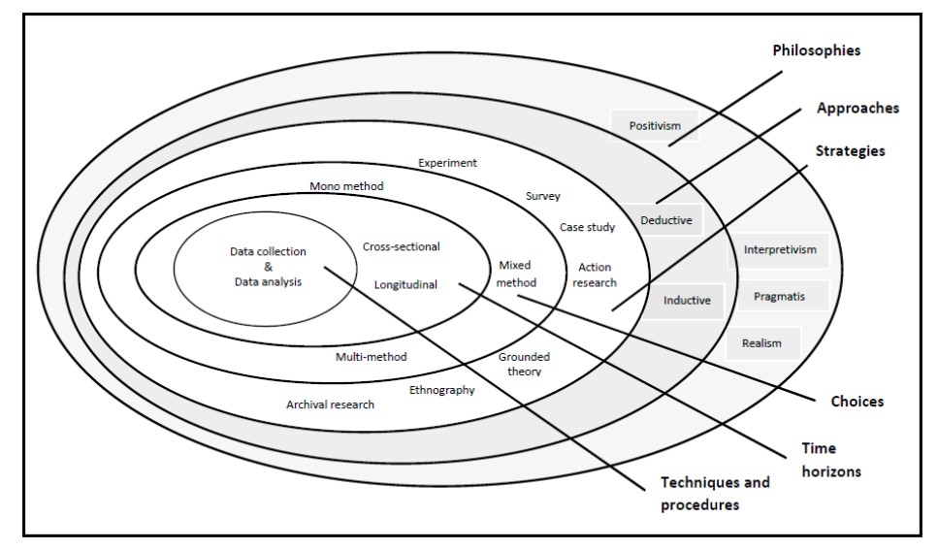

Figure 5: Saunders’ Research Onion
(Source: Al-Ababneh, 2020)

3.2: Philosophical position of the research
Research philosophy refers to the key assumptions that drive a particular scientific study. In the present study, the researcher has implemented the Epistemology philosophy of research. It exclusively focuses on what constitutes irrefutable knowledge and how it is created (Moon et al., 2021). The key advantage of following epistemological philosophy in research enables the objective evaluation of available data sources and enhances the credibility of findings. Thus, for this study, epistemology appeared to be the most suitable alternative. Another common research philosophy is Ontology, which strives to interpret the diverse nature of knowledge (BRM, 2023).

3.3: Paradigm position of the research
The research paradigm refers to the theoretical framework that guides how a scientific enquiry is undertaken (Kekeya, 2019). In the present study, the researcher has implemented positivism as the chosen research paradigm. Under the positivism paradigm, the researcher follows a deductive approach to answering the research questions, by utilising objective and quantifiable data (Park et al., 2020).However, an undue emphasis on objectivity leads to the summary rejection of interpretative insight into a phenomenon, preventing an in-depth understanding of the phenomenon under study. Nevertheless, the objectivity of this research paradigm is the key reason for its implementation in the present study. Other common alternative research paradigms are interpretivism and pragmatism, which accommodate human interpretation (Kekeya, 2019).

3.4: Position of Research Approach
The research approach refers to a general plan of action to facilitate the seamless completion of the study (BRM, 2023). For the present study, the researcher has implemented the deductive approach. In this approach, scientific inquiry is undertaken to either establish or dismiss pre-formed theories or hypotheses (Peters and Fontaine, 2020). This approach was chosen as it restricts the scope of the study to the most significant aspects of the phenomenon identified during a preliminary literature review. However, there is a risk of omitting some other aspects of the phenomenon due to the restricted scope of such studies. A contradicting research approach, which was deemed unsuitable for the study, is the inductive approach which enables the development of novel theories upon analysis of an exhaustive dataset (Patel and Patel, 2019).

3.5: Methodological stance of the Research
Research methods are the systematic processes implemented in the scientific study of a particular phenomenon (BRM, 2023). These methods can be classified based on various factors including the nature, application or data collection methods of a study. The present study implemented descriptive and quantitative research methods. These methods facilitate the description of an existing phenomenon with the help of quantifiable data, which serve the purpose of the present study.

3.6: Stance of the Research Strategy and Design
Research strategy and design serve as the general framework for what needs to be done to answer the key research questions. Seeing how the present study strives to collect irrefutable insight into the phenomenon of online promotion during the pandemic, it followed a conclusive research design. In this design, the researcher utilises reliable data sources to generate practicable findings (BRM, 2023). For this purpose, the researcher has used an online survey, using Google Forms, to obtain popular insight into the phenomenon and generate suitable findings about the promotion of online stores.

3.7: Research Sample and Population
Research population refers to the entire group of individuals that a researcher could investigate for obtaining suitable insight into the phenomenon under study. The process by which a few of these subjects are chosen for participating in a study is known as sampling (Bougie and Sekaran, 2019). For the present study, the population comprises people from different areas of work, from which 25 were selected by implementing a simple random sampling technique. In this sampling approach, all members of a population have an equal probability of being included in a study and the participants are selected without any inherent biases (Bhardwaj, 2019).

3.8: Data Collection and Data Analysis Tools/Techniques
Data collection and analysis are the most crucial aspects of a scientific study. For the present study, the researcher has used primary data, collected through an online survey. The information so obtained is analysed quantitatively to identify patterns underlying raw empirical data sets with the help of MS Excel. Primary data is original information included in research collected upon direct interaction with human participants and significantly contributes to the overall originality of a study (Pandey and Pandey, 2021). The information obtained from pre-existing data sources to obtain additional insights into a phenomenon is referred to as secondary data (Pandey and Pandey, 2021). The present study does not use secondary data.

3.9: Ethical Consideration of the Research
The key ethical apprehensions encountered during the study include threats to data security and fair treatment of survey participants. To address the data security concerns, the researcher stored anonymised data on secure online servers, following the provisions of the Data Protection Act of 2018 (legislation.gov.uk, 2023). Additionally, the researcher followed the provisions of the Equality Act of 2010 to ascertain fair and equitable participation (legislation.gov.uk, 2023).

3.10: Summary of Chapter
The above chapter provides a comprehensive look at the various methods and processes implemented in the present study. It follows an epistemological philosophy and the positivist paradigms of research. Additionally, the study was conducted as deductive and conclusive quantitative research. Digital tools like Google Forms and MS Excel were used to collect and analyse the primary data used in the study. Key ethical concerns were addressed by following the relevant provisions of key pieces of legislation.

3.11: Timescale and activity chart
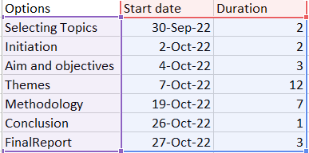

Figure 6: Activity List
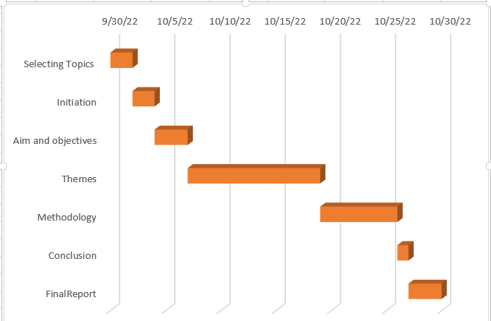

Figure 7: Gantt Chart

Chapter 4: Data Analysis and Discussions

4.1: Introduction
Data collection and analysis represent the most crucial component of a study as it is during this step that the researcher obtains reliable data from suitable sources and interprets them to uncover underlying patterns and correlations (Gupta and Gupta, 2022). The following chapter presents the data collected from the chosen primary sources, followed by their thorough analysis to help answer the key research questions.

4.2: Analysis and Discussions of your findings/data (supporting tables/figures/exhibits/diagrams/sample of transcript/interpretation/validity and reliability of the data)
Primary data – survey
- What is your age?
Options | Number of Respondents | Percentage | Total number of participants
18-24 years old | 16 | 64 | 25
25-34 years old | 3 | 12 | 25
35-44 years old | 2 | 8 | 25
over 45 years old | 1 | 4 | 25

Table 1: Age of participants

Figure8: Age of participants
Analysis: From the above-represented data, it is apparent that the majority of the participants belonged to the age group of 18 to 24 years old, constituting 64% of the respondents. This indicates that online shopping mostly intrigues younger individuals. Thus, online shopping promotion in the post-pandemic era may be designed to target this particular demographic group.
- What is your gender?
Options | Number of Respondents | Percentage | Total number of participants
Male | 18 | 72 | 25
Female | 6 | 24 | 25
Prefer not to say | 1 | 4 | 25

Table 2: Gender of participants

Figure9: Gender of participants
- Where do you live?
Options | Number of Respondents | Percentage | Total number of participants
Big city | 8 | 32 | 25
Medium city | 10 | 40 | 25
Small City | 4 | 16 | 25
City | 3 | 12 | 25

Table 3: Participants living area

Figure10: Participants living area
- What is your current employment status?
Options | Number of Respondents | Percentage | Total number of participants
Self-employed | 7 | 28 | 25
Employed, Student | 3 | 12 | 25
Student | 2 | 8 | 25
Employed | 11 | 44 | 25
Unemployed, Student | 1 | 4 | 25
Unemployed | 1 | 4 | 25

Table 4: Employment status of participants

Figure 11: Employment status of participants
Analysis: According to the data represented above, the majority of the participants, comprising 44% of the respondents, enjoyed full-time employment. The next majority group constituted self-employed individuals, representing 28% of the respondents. Some of the participants were also students employed, thereby depicting a profound diversity of opinions represented in the study findings.
- What is your household income?
Options | Number of Respondents | Percentage | Total number of participants
£26-£32k | 2 | 8 | 25
£19k-£25k | 3 | 12 | 25
over £45k | 3 | 12 | 25
below £18k | 10 | 40 | 25
£33-£45k | 6 | 24 | 25
£33-£45k, over £45k | 1 | 4 | 25

Table 5: Household Income

Figure 12: Household Income
Analysis: From the data represented above, it is evident that a majority of the participants, comprising 40% of the respondents hailed from low-income households with an average income below £18,000. Another 24% of the respondents, however, belonged to a fairly high-income bracket with an average income ranging from £33,000 to £45,000. This indicates that online shopping is a common occurrence observed in both low-income and high-income families. The profound participation of individuals from low-income households might enable the identification of some features that can enhance online shopping behaviour among low-income families.
- What is your marital status?
Options | Number of Respondents | Percentage | Total number of participants
In domestic partnership | 5 | 20 | 25
Single (never married) | 15 | 60 | 25
Married | 4 | 16 | 25
Widowed | 1 | 4 | 25

Table 6: Marital Status

Figure 13: Marital Status
- Did you do online shopping during COVID-19?
Options | Number of Respondents | Percentage | Total number of participants
Yes | 23 | 92 | 25
No | 2 | 8 | 25

Table 7: Online shopping during Covid 19

Figure 14: Online shopping during Covid 19
Analysis: According to the data represented above, it is evident that during the pandemic, online shopping was highly popular, with a substantial majority of 92% of the respondents engaged in it. The key reason behind the alarming increase in the rate of online shopping must have been the restricted mobilisation opportunities due to the nationwide lockdowns. Thus, the pandemic is evidently a major force impacting overall online shopping tendencies. It emphasises the significance of promotions for online stores so that they can sustain the economic benefits they experienced during the pandemic.
- Did you use coupons or discount codes for your purchases during COVID-19?
Options | Number of Respondents | Percentage | Total number of participants
Yes | 17 | 68 | 25
No | 8 | 32 | 25

Table 8: Use of coupons for shopping

Figure 15: Use of coupons for shopping
Analysis: From the above data, it is evident that a majority of the survey participants, comprising 68% of participants use coupons for online shopping purposes. Coupons can serve as a suitable means of business promotion. They serve as material incentives for customers to procure desired goods at discounted prices. However, 32% of the participants did not use coupons for online shopping, indicating the availability of a significant promotional opportunity..
- Did you receive coupons or discount codes after or during your purchase?
Options | Number of Respondents | Percentage | Total number of participants
Yes | 15 | 60 | 25
No | 10 | 40 | 25

Table 9: Coupons received during the purchase

Figure 16: Coupons received during the purchase
Analysis: As depicted in the data representation provided above, it is observed that a majority of the survey respondents, constituting 60% of the participants have received coupons upon undertaking online purchases. However, a significant proportion of the respondents, comprising 40% of respondents did not receive promotional coupons. This indicates that despite the probable economic benefits of using coupons as promotional means, this approach to online sales promotion is left significantly underutilised. Online stores can ensure the return of customers by providing them with coupons everytime they procure something from their stores. It will not only promote sales but also enable customer retention.
- How easy/hard did you find online shopping?
Options | Number of Respondents | Percentage | Total number of participants
Easy | 7 | 28 | 25
Very easy | 14 | 56 | 25
Very Hard | 3 | 12 | 25
Normal | 1 | 4 | 25

Table 10: Ease of online shopping

Figure 17: Ease of online shopping
Analysis: According to the data representation depicted above, it may be inferred that a majority of the survey participants find online shopping to be very easy, representing 56% of the total respondents. Additionally, another 28% of the participants find online shopping to be easy. Thus, for promoting the business interests of online stores, companies might benefit by highlighting the ease of using online sales platforms. Additionally, they must enhance the ease of using their online platforms to further enhance online consumption activities. By making their platforms easier to use, companies might be able to attract the remaining 12% of the population who usually find online shopping to be very hard.
- How easy/hard did you find to search for what you needed during the lockdown? Please explain the answer chosen in the previous question.

Options | Number of Respondents | Percentage | Total number of participants
Easy | 9 | 36 | 25
Very easy | 10 | 40 | 25
Very Hard | 1 | 4 | 25
Normal | 5 | 20 | 25

Table 11: Ease of searching

Figure 18: Ease of searching
Analysis: According to the data presented above, it is observable that a majority of the participants, constituting 40% of the survey participants found it very easy to search for their desired products on online search platforms. Their observation was further substantiated by another 36% of the respondents. However, some of the respondents observed that despite being able to search for desired goods quite easily, not all products would be available at the selected stores and that the delivery would often be delayed, especially due to travel restrictions imposed due to the lockdowns. People especially struggled to find suitable purchase options for clothes and apparel where the fit of the product was a major concern. Thus, online stores dealing with such products must find suitable ways to address these concerns to enhance their overall online sales.
- During COVID-19 did you do more online shopping or did you prefer to go to the physical stores?
Options | Number of Respondents | Percentage | Total number of participants
Online shopping | 15 | 60 | 25
Both | 8 | 32 | 25
Physical Stores, Both | 1 | 4 | 25
Physical Stores | 1 | 4 | 25

Table 12: Use of physical or online stores

Figure19: Use of physical or online stores
Analysis: Based on the above data representation, it is evident that the majority of the survey participants, constituting 60% of the respondents preferred online shopping as opposed to going to physical stores. However, a cumulative percentage of 36%of respondents used both online and physical stores to meet their consumption needs. Thus, online stores must make active efforts to promote their businesses as people who used physical stores during the pandemic, are likely to shift to physical stores once the lockdown is lifted. However, as a substantial majority of the respondents preferred online shopping, active investments in online shopping promotions may prove significantly beneficial.
- Name one or more of your favourite online shopping websites/apps

Figure 20: Favourite brands of participants
- Do you consider online shopping more attractive than physical shopping?
Options | Number of Respondents | Percentage | Total number of participants
Attractive | 6 | 24 | 25
Normal | 7 | 28 | 25
Very Attractive | 9 | 36 | 25
Not Attractive | 3 | 12 | 25

Table 13: Comparative attractiveness of online shopping

Figure 21: Comparative attractiveness of online shopping
Analysis: As per the data presented above, a majority of the survey participants find online shopping to be more attractive than shopping from physical stores, constituting 36% of the respondents. Their observation is supported by another 24% of the participants, which indicates that the online store must highlight this feature to increase its online profitability.
- What is your favourite payment method?
Options | Number of Respondents | Percentage | Total number of participants
Apple Pay | 11 | 44 | 25
Card | 10 | 40 | 25
Bitcoin | 1 | 4 | 25
Cash | 3 | 12 | 25

Table 14: Preferred payment method

Figure 22: Preferred payment method
Analysis: In the above-represented data, it is observable that a majority of the participants use Apple Pay as the preferred mode of online payment, while another 40% use cards for the same purpose. This indicates that online stores must seek to provide these two payment options to encourage online shopping among potential customers. Bitcoins are a potential form of digital payment which are yet to attain desirable popularity among the general populace. Thus, focusing on this payment method might not be beneficial.
- Did you find the shipping of the products ordered online fast?
Options | Number of Respondents | Percentage | Total number of participants
Fast | 9 | 36 | 25
Normal | 10 | 40 | 25
Very Fast | 5 | 20 | 25
Very Slow | 1 | 4 | 25

Table 15: Speed of delivery of online products

Figure 23: Speed of delivery of online products
Analysis: According to the data depicted above, a majority of the participants, constituting 40% of the respondents find the delivery speed of digitally-procured products to be normal while another 36% find it fast. Thus, online stores must focus on further enhancing the speed of delivery of products to promote overall sales.
- Do you think that your way of online shopping changed after the COVID-19 restrictions have been lifted?
Options | Number of Respondents | Percentage | Total number of participants
Yes | 10 | 40 | 25
No | 9 | 36 | 25
Maybe | 6 | 24 | 25

Table 16: Impact of COVID-19 on online shopping behaviour

Figure 24: Impact of COVID-19 on online shopping behaviour
Analysis: Based on the data depicted above, it is observed that COVID-19 significantly impacted online shopping behaviour among customers as 40% of the participants, constituting the majority group, opined so. However, a profound uncertainty about the perceived popularity of online shopping following the pandemic is prevalent.
- Do you do more online shopping than you did before COVID-19?
Options | Number of Respondents | Percentage | Total number of participants
Yes | 11 | 44 | 25
No | 5 | 20 | 25
Same as before | 8 | 32 | 25
No, Same as before | 1 | 4 | 25

Table 17: Intensity of online shopping following the pandemic

Figure 25: Intensity of online shopping following the pandemic
Analysis: As per the data presented above, it is observed that the majority of the survey participants, constituting 44% of the respondents have witnessed an increase in their online shopping behaviour due to the pandemic. Thus, the promotion of online stores might be beneficial in sustaining this increased economic performance.
- Do you consider that you can find more deals/discounts online or in physical stores?
Options | Number of Respondents | Percentage | Total number of participants
Online | 13 | 52 | 25
Physical stores | 3 | 12 | 25
Online, Physical stores, Both | 1 | 4 | 25
Both | 8 | 32 | 25

Table 18: Where do participants find fair deals?

Figure 26: Where do participants find fair deals?
Analysis: According to the above data, a majority of the respondents, constituting 52% of the respondents find more deals and discounts on online platforms. Thus, online stores must use this technique to promote their overall sales.
- Where do you think you spend the most?
Options | Number of Respondents | Percentage | Total number of participants
Online stores | 15 | 60 | 25
Delivery Apps | 2 | 8 | 25
Physical stores | 8 | 32 | 25

Table 19: Most time spent on

Figure 27: Most time spent on
Analysis: According to the above data, the majority of the respondents which is 60% are preferring online stores for their purchasing. Apart from that 32% are preferring physical stores and only 8% are opting for delivery apps. Thus, it can be said that companies need to promote and use online stores more.

4.3: Summary of Chapter 4
It can be concluded that with the survey data that has been precisely collected, the companies in the retail sector need to focus on online stores and the use of digital marketing. By doing that the retail sector might gain the benefit of the market for a longer period of time.

Chapter 5: Conclusion, Limitations and Recommendations

5.1: Introduction
The last chapter that will be included within the research is the conclusion, limitations and recommendations. In this chapter, all the objectives will be mentioned with their primary essentiality in the research. Furthermore, the research problem and limitations of the research will be discussed in this chapter. The chapter will be concluded with recommendations that are essential for the research for the future prospect.

5.2: Conclusions on each research issue/objectives/proposition (based on the results in Chapter 4)
To identify the importance of online stores in pandemic situations
This objective has been defined by chapter 4 and the data shows that the trend of preferring all online stores is high. With the help of online stores, the retail sector might have the upper hand in the market.
To identify the need for online stores in Covid-19 pandemic times
From the data collected in the survey, it can be said that the need for online stores after and during the pandemic is huge. Almost 60% of the respondents prefer online stores defining their needs of them.
To identify the impact of online stores on the sales of the organisation
This objective has been thoroughly covered in the survey and analysis of chapter 4. During the pandemic, almost 92% of the respondents moved to the online store segments and thus got all the purchased items on a regular basis.
To recommend relevant strategies for promoting online stores and channels
From the analysis of chapter 4 it can be said that the companies need to focus more on delivering to families and in the retail, sector add fitting measurements for the clothing.

5.3: Conclusions on the research problem

The research problem that has been considered here in the research is to formulate promotional strategies for boosting online stores during and after the pandemic. It can be said that by doing that the companies might have the benefit of generating revenues and thus getting ahead in the UK retail sector. Apart from that with the promotional strategies, the essentiality of online stores can be increased among customers as well.

5.4: Summary of the research findings and outcomes
It can be concluded that the research that has been conducted with 25 people might have all the aspects of the customer behaviour during the pandemic. From the data, it can be said that consumers have changed their purchasing path to online stores. Online sales have increased during the pandemic and after Covid-19 it has continued to do so. Apart from that the research also signifies all the crucial parts of customer behaviour and thus essential changes that have happened due to the pandemic.

5.5: Original Contribution of the Research (i.e.: management, academia, scholars)
The contribution of the research in the management sector is significant and that is the reason why it is so crucial. In the management section, this research might help the retail sector to invest in online stores and thus create more opportunities in the long term. The management of the companies also can identify the essentiality of customer behaviour and learn about the change that occurred during the pandemic.

5.6: Limitations of the Research
Although with a survey of 25 people from different areas, all the essential information for the research has been collected. However, the research does not emphasize the implementation of the promotional strategy of online stores. The research also lacks focus on the challenges that are being faced due to the implementation. Apart from that the research could have used secondary research as well for backing up the primary survey data regarding the online stores in the retail sector.

5.7: Recommendations/Areas for further/future research
Recommendation 1: Inclusion of secondary research
The first recommendation that has been considered for the research is the inclusion of secondary research. According to Largan and Morris (2019), secondary research is the key to gathering all the key data that has been already scoured. With the help of secondary research, the overall conduction of the data collection can be more authentic and fulfilled.
Recommendation 2: Inclusion of interviews and data from a rural area
With the survey, the overall view of the research can be presented and that is the reason why it has been chosen. However, the inclusion of interviews and data from the rural area can bring some of the major assessments from the research. It can be said that by including the interview the personal view on the promotional strategy and thus the impact of Covid-19 on the online stores.

5.8: Summary of Chapter
In this chapter, all the aspects of the data collection have been mentioned through the research objectives. The chapter has also included all the crucial sources which are the original sources that are being recommended.

References
Akram, U., Fülöp, M.T., Tiron-Tudor, A., Topor, D.I. and Căpușneanu, S., 2021. Impact of digitalization on customers’ well-being in the pandemic period: challenges and opportunities for the retail industry. International Journal of Environmental Research and Public Health, 18(14), p.7533.
Al-Ababneh, M.M., 2020. Linking ontology, epistemology and research methodology. Science & Philosophy, 8(1), pp.75-91.
Ancey, C., 2020. Bedload transport: a walk between randomness and determinism. Part 2. Challenges and prospects. Journal of Hydraulic Research, 58(1), pp.18-33.
Anwar, A., Waqas, A., Zain, H.M. and Kee, D.M.H., 2020. Impact of music and colour on customers’ emotional states: An experimental study of online store. Asian Journal of Business Research, 10(1), pp.104-125.
Bharadwaj, S. and Deka, S., 2021, December. Behavioural intention towards investment in cryptocurrency: an integration of Rogers’ diffusion of innovation theory and the technology acceptance model. In Forum Scientiae Oeconomia (Vol. 9, No. 4, pp. 137-159).
Bhardwaj, P., 2019. Types of sampling in research. Journal of the Practice of Cardiovascular Sciences, 5(3), p.157.
Bizhanova, K., Mamyrbekov, A., Umarov, I., Orazymbetova, A. and Khairullaeva, A., 2019. Impact of digital marketing development on entrepreneurship. In E3S web of conferences (Vol. 135, p. 04023). EDP Sciences.
Bonnin, G., 2020. The roles of perceived risk, attractiveness of the online store and familiarity with AR in the influence of AR on patronage intention. Journal of Retailing and Consumer Services, 52, p.101938.
Bougie, R. and Sekaran, U., 2019. Research methods for business: A skill building approach. John Wiley & Sons.
BRM, 2023. Ontology. [Online] Available at: https://research-methodology.net/research-philosophy/ontology/ [Accessed 4 January 2023]
BRM, 2023. Research Approach. [Online] Available at: https://research-methodology.net/research-methodology/research-approach/ [Accessed 4 January 2023]
BRM, 2023. Research Design. [Online] Available at: https://research-methodology.net/research-methodology/research-design/ [Accessed 4 January 2023]
BRM, 2023. Types of Research Methods. [Online] Available at: https://research-methodology.net/research-methodology/research-types/ [Accessed 4 January 2023]
Fauzi, A., Wandira, R., Sepri, D. and Hafid, A., 2021. Exploring students' acceptance of google classroom during the covid-19 pandemic by using the technology acceptance model in West Sumatera Universities. Electronic Journal of e-Learning, 19(4), pp.pp233-240.
Grewal, D., Gauri, D.K., Roggeveen, A.L. and Sethuraman, R., 2021. Strategizing retailing in the new technology era. Journal of Retailing, 97(1), pp.6-12.
Gupta, A. and Gupta, N., 2022. Research methodology. SBPD Publications.
Kekeya, J., 2019. The commonalities and differences between research paradigms. Contemporary PNG Studies, 31, pp.26-36.
Kim, R.Y., 2020. The impact of COVID-19 on consumers: Preparing for digital sales. IEEE Engineering Management Review, 48(3), pp.212-218.
Largan, C. and Morris, T., 2019. Qualitative secondary research: A step-by-step guide. Sage.
legislation.gov.uk, 2023. Data Protection Act 2018. [Online] Available at: https://www.legislation.gov.uk/ukpga/2018/12/contents/enacted [Accessed 4 January 2023]
legislation.gov.uk, 2023. Equality Act 2010. [Online] Available at: https://www.legislation.gov.uk/ukpga/2010/15/contents [Accessed 4 January 2023]
Moon, K., Cvitanovic, C., Blackman, D.A., Scales, I.R. and Browne, N.K., 2021. Five questions to understand epistemology and its influence on integrative marine research. Frontiers in Marine Science, 8, p.574158.
Nanda, A., Xu, Y. and Zhang, F., 2021. How would the COVID-19 pandemic reshape retail real estate and high streets through acceleration of E-commerce and digitalization?. Journal of Urban Management, 10(2), pp.110-124.
Naseri, R.N.N., 2021. Issues And Challenges Of Online Shoppingactivities On The Impact Of Corona Pandemic: A Study On Malaysia Retail Industry. Turkish Journal of Computer and Mathematics Education (TURCOMAT), 12(10), pp.7682-7686.
Neger, M. and Uddin, B., 2020. Factors affecting consumers’ internet shopping behavior during the COVID-19 pandemic: Evidence from Bangladesh. Chinese Business Review, 19(3), pp.91-104.
Pandey, P. and Pandey, M.M., 2021. Research methodology tools and techniques. Bridge Center.
Park, Y.S., Konge, L. and Artino, A.R., 2020. The positivism paradigm of research. Academic Medicine, 95(5), pp.690-694.
Patel, M. and Patel, N., 2019. Exploring Research Methodology. International Journal of Research and Review, 6(3), pp.48-55.
Peters, B.G. and Fontaine, G. eds., 2020. Handbook of research methods and applications in comparative policy analysis. Edward Elgar Publishing.
Statista, (2021). Percentage change in online purchases due to the coronavirus (COVID-19) pandemic in the United Kingdom from March 2020 to February 2021. [Online] Available at: https://www.statista.com/statistics/1230225/changes-in-online-buying-among-uk-consumers-since-covid-19/ [Accessed 4 January 2023]
Statista, 2022. E-commerce in the United Kingdom (UK) - statistics & facts. [Online] Available at: https://www.statista.com/topics/2333/e-commerce-in-the-united-kingdom/#topicOverview [Accessed 4 January 2023]
Statista, 2022. Retail trade in the UK - statistics & facts. [Online] Available at:https://www.statista.com/topics/8671/retail-trade-in-the-uk/#topicOverview [Accessed 4 January 2023]
Statista, 2022. Top online stores in the United Kingdom in 2021, by e-commerce net sales [Online] Available at: https://www.statista.com/forecasts/870307/united-kingdom-top-online-stores-united-kingdom-ecommercedb [Accessed 4 January 2023]
Statista, 2022. Value of online retail sales in the United Kingdom (UK) from 2012 to 2021 [Online] Available at: https://www.statista.com/statistics/315506/online-retail-sales-in-the-united-kingdom/ [Accessed 4 January 2023]
Susmitha, M.K., 2021. Impact of COVID 19 on E-Commerce. Journal of Interdisciplinary Cycle Research, 12(9), pp.1161-1165.
Taher, G., 2021. E-commerce: advantages and limitations. International Journal of Academic Research in Accounting Finance and Management Sciences, 11(1), pp.153-165.
Topolko Herceg, K., 2021. Impact of COVID-19 pandemic on online consumer behavior in Croatia. CroDiM: International Journal of Marketing Science, 4(1), pp.131-140.
Wang, H.H. and Na, H.A.O., 2020. Panic buying? Food hoarding during the pandemic period with city lockdown. Journal of Integrative Agriculture, 19(12), pp.2916-2925.

Terms of Glossary
Consumer behaviour
Data collection
Epistemology
Online promotion
Online shopping
Online store
Positivism
Primary data
Survey

Appendix
Survey Questionnaire
- What is your age?
- What is your gender?
- Where do you live?
- What is your current employment status?
- What is your household income?
- What is your marital status?
- Did you do online shopping during COVID-19?
- Did you use coupons or discount codes for your purchases during COVID-19?
- Did you receive coupons or discount codes after or during your purchase?
- How easy/hard did you find online shopping?
- How easy/hard did you find to search for what you needed during the lockdown? Please explain the answer chosen in the previous question.
- During COVID-19 did you do more online shopping or did you prefer to go to the physical stores?
- Name one or more of your favourite online shopping websites/apps
- Do you consider online shopping more attractive than physical shopping?
- What is your favourite payment method?
- Did you find the shipping of the products ordered online fast?
- Do you think that your way of online shopping changed after the COVID-19 restrictions have been lifted?
- Do you do more online shopping than you did before COVID-19?
- Do you consider that you can find more deals/discounts online or in physical stores?
- Where do you think you spend the most?

