MANAGEMENT ACCOUNTING
STUDENT NAME: MARILENA RALUCA BOTANOIU
Module code: LCBB5002
Executive Summary
The report of the study defines the management accounting factors, budgeting system of the company Amana Ltd. in this case, it can be seen that Amana Ltd is running their budgeting by facing some difficulties. Along with this, it has been found that organization is have take necessary step to sales 50% of products through online marketing system. In this report the budgetary system of the company has been briefly defined.

Table of Contents
Introduction 4
Part A 4
Part B 9
Conclusion 12
Reference List 13
Bibliography 14

Introduction
Management accounting is an important element of the business as it gives accurate data to the management to excise the effective source of business. Management accounting is also known as cost accounting and is also a set branch accounting that measures and analyzes the interpretation of the scouting information. The report of the study defines the management accounting system of the England-based Company Amana Ltd. The original budget and actual budget of the company have been determined through the phase of management accounting. Further, necessary analysis and summarization have been done in this report based on the outcome of the original budget, flexed budget, and variances.

Part A
i. Displaying the report of the Original budget, flexed budget, and variance
Report of the Original Budget
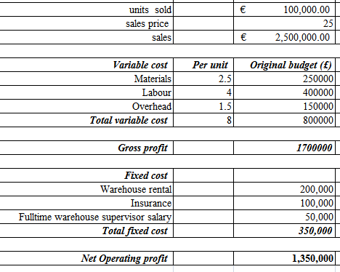
Figure 1: Original Budget
(Source: Self-Created)
The original budget defines the consolidated budget of the company by generating the activity of the different aspects of cost. Here, in this report, the original budget of the company Amana Ltd has been defined. The company makes the budgetary policy by keeping in mind to protect the environment instrument to promote sustainable development. The net operating profit of the original budget has been estimated to be £ 13,50,0000 by considering the total variable cost and total fixed cost of the business.

Report of the Flexed budget
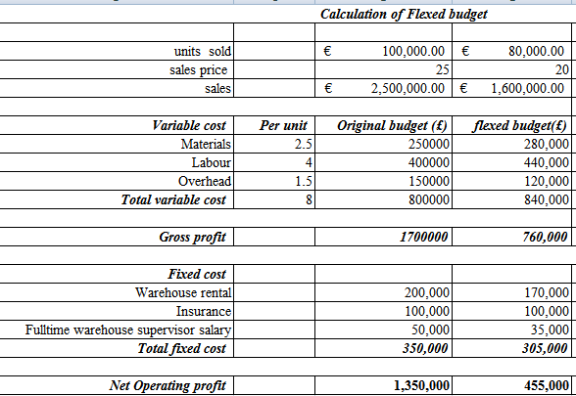
Figure 2: Flexed Budget
(Source: Self-Created)
Flexed defines the amount of actual revenue earned by the company, the revenue of the certain expenses defines the comparitablit of the business. Amana Ltd has approached the mode of flexed budget for approaching the value of total revenue of the company. The net operating profit for the flexed budget has been estimated at around £ 4,55,000 based on the total fixed cost and total variable cost of the company.
Report of the Variances
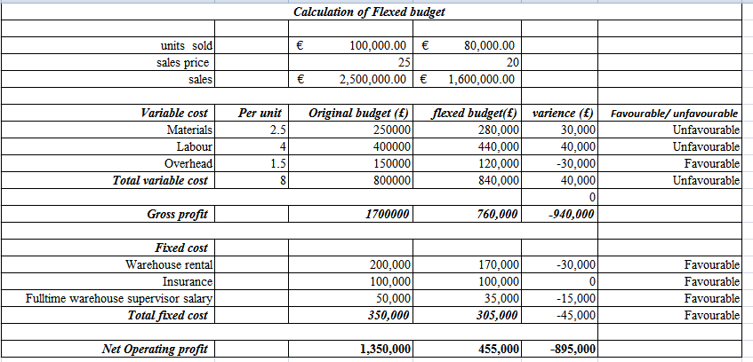
Figure 3: Variance
(Source: Self-Created)
Variance is the statistical approach the company has taken to define the economical approach of the business. The variance of the business determines the reliance performance of the company based on the financial data. The variance of the business is defined by the net operating profit which is stated as around £ -45,000.
ii. The performance of Amana Ltd during the year 2020
Analysis of the Original Budget
The above-shown figure defines the original budget of Company Amana Ltd, the company estimates the cost of materials of around £ 2,50,000. The original labor as per variable cost estimation of the business has been estimated at around £ 4,00,000. Whereas the original budget overhead of the business has been stated as around £ 1,50,000. Thus, the total outcome of the original budget for the variable cost of the business has been estimated at around £ 8,00,000. The warehouse rental for the original budget of the fixed cost has been estimated to be £ 2,00,000. The insurance for the original budget of the fixed cost has been estimated to be £ 1,00,000. The company makes the budgetary policy by keeping in mind to protect the environment instrument to promote sustainable development (Alabdullah, 2019, p. 100). The full-time warehouse supervisor's salary as per the original budget of the fixed cost has been estimated to be £ 50,000. The net amount of fixed cost for the original budget has been estimated at around £ 3,50,000. The operating net profit of the company Amana Ltd for the original budget is stated as around £ 13,50,000.
For the profit of the business the original budget has to be a reasonable cost, thus the outcome of the variance will have a favorable balance. The company is having an effective mode of cost estimation for the preliminaries of the profit (Zakirova et al. 2020). Generating a favorable balance will help to emphasize the business in other countries and regions.
Analysis of the Flexed budget
As per the above-shown figure, the Valuation of the flexed budget of the proposed company Amana Ltd has been defined. As per the flexed budget, the cost estimation of the materials is stated around £ 2,80,000. The flexed labor cost estimation of the business has been estimated at around £ 4,40,000. On the other hand, the flexed budget overhead of the business has been stated at around £ 1,20,000. Thus, the total outcome of the flexed budget of the business has been stated as around £ 8,40,000. The warehouse rental for the flexed budget of the fixed cost has been estimated to be £ 1,70,000. The insurance for the flexed budget of the fixed cost has been estimated to be £ 1,00,000. The full-time warehouse supervisor's salary as per the flexed budget of the fixed cost has been estimated at £ 35,000. The net amount of fixed cost for the flexed budget has been estimated at around £ 3,05,000. The operating net profit of the company Amana Ltd for the flexed budget is stated as around £ 4,55,000.
The original budget has been prepared by the company itself, based on the availability of the past performance of the business. The original budgetary system needs to be below the low compliance cost of the affectional budgeting system (Abdusalomova, 2019, p. 2). If the cost of the ultimate original budget becomes high then the actual cost will enhance more and thus the company will suffer from an excess amount of loss.
Analysis of the Variances
As per the above-shown figure, the variance of the fixed cost of the company Amana Ltd has been transparently defined. The variance of the variable cost has been calculated by the original budget deducted from the fixed budget. The variance of the material cost is stated at around £ 30,000, for the labor cost is stated at around £ 40, 000. The cost of the overhead shows a negative outcome of £ -30,000. The reason for the negative outcome is because of the high amount of the original budget as compared to the flexed budget. Hence, the outcome of the variance is estimated at around £ 40,000. The warehouse rental for the variances of the fixed cost has been estimated to be £ -30,000. The insurance for the flexed budget of the fixed cost is null and the full-time warehouse supervisor's salary as per the flexed budget of the variances has been estimated to be £ -15,000. The net amount of fixed cost for the variance has been estimated at around £ -45,000. The operating net profit of the company Amana Ltd for the flexed budget is stated as around £ -8,95,000.
The variance shows the outcome of the statistical data based on the variances, here in this case there are two variances: original budget and flexed budget. The cost estimation of the original budget is high and the flexed budget is low (Johnstone, 2020, p. 2). Therefore, the outcome of the variance shows an unfavorable balance. Hence, Amana Ltd needs to strategize the business and make the budget at low compliance cost.
iii. Recommendation as a CEO of Amana Ltd
Recommendation on the original budget
It is recommended that these effective cost budgets will help the business to achieve the goal and proposed the actual budget of the project. It is to suggest the original budget estimation of Amana Ltd deterring the financial capability of the company. It is to suggest that the company needs to propose its original budget at a compliance cost. As the compliance cost helps the business to incur less amount of expenses.
Recommendation on the flexed Budget
The cost estimation of the flexed budgetary system is based on the reluctant activity of the aligned business activity. Thus, it is recommended that the company Amana Ltd need to segregate and merchandise the flexed cost of the business. It is to suggest the company have a maximum amount of flexible budget. The management of the company Amana ltd needs to strategize the flexed budget for deterring the profitable balance of the variance.
The flexed budgetary relies upon the overall business activity, originally the total review of the business. The estimation of the flexed budget has been set based on the overall activity of segregating the accounting information. Thus, it is recommended that the company need to fixed the amount of the flexed budget high as per the segment of the original budget. Further, it is suggested the company is having a negative outcome because of the high variance cost of the original budget, thus the cost needs to be downgraded.
Recommendation on the variances
It is recommended that the company Amana Ltd need to have a favorable;e balance of the balance in its business. Thus, it is to suggest the business organization can gain the favorable business by less expensive than the suggestive budget. The variance always varies upon the affectionate cost rate. Hence, it is recommended that the organization need to reduce the amount of the original budget and increase the value of flexed budget to determine the positive value of variances.

Part B
Analysis of the decision-making process of the company for transmitting into online business
The company Amana Ltd has decided to make changes in the formation of the business and taking a big decision for the transmission of the traditional business into an online platform. Management accounting is one of the economic entities for a complex multidimensional system (Asiaei et al. 2022, p. 3). The company has decided to operate on the online platform in the United Kingdom, United States, and Europe to gain a large number of customers for the expansion of the business. The approach of an online platform is always an appropriate decision for a company to grow.
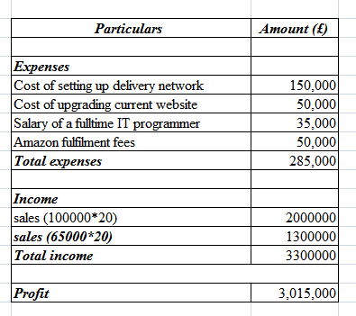
Figure 4: Cost Estimation for the Online Business
(Source: Self-Created)
The above-shown figure defines the value of the cost estimation of the business to operate on the online platform. The estimated cost for the online business shows the expense of setting up delivery networks, upgrading the current website, remuneration of the IT programmer, and the fees of amazon fulfillment. The estimated cost for setting up the delivery network stated around £ 1,50,000. The estimated cost for upgrading the website has stated at around £ 50,000, the salary of the IT programmer's expenses is estimated at £ 35,000, and the Amazon fulfillment fees have been stated at around £ 50,000. Therefore, the total amount of expenses for the online operation of the business has been estimated to be £ 2,85,000.
The generated income for the function of the online business has a set of scales and guarantees of sales. The generated income from the guarantee of sales has been estimated to be £ 20,00,000 whereas for the sales it has been stated around the set of £ 13,00,000. Hence, the net amount of income for the online business has been estimated to be £ 30,15,000.
Profitability of the Online business
The analysis of the cost estimation however shows a favorable balance and a profitable amount for the online business function. The company Amana Ltd transparently displays the profitable business as the income of the business is much higher than the incurred amount of the expenses. The net income for the online business of the company Amana Ltd has been around £ 30,15,000, whereas the incurred expenses are around £ 2,85,000. The conceptualization of management accounting defines the overall concept of cost accounting (Rikhardsson et al. 37, p. 218). The company is making 50% of its sales through the mode of online based on the streamlining of the business activity.
The decision that the company took to propose the business in the online mode via the mode of Amazon became worthwhile. The accounting information and tools are necessary for the informative to control the activities of the firm (Maheshwari et al. 2021, p. 2). As compared with the traditional model of business where the company has the outcome of the variance in unfavorable balance. On the other hand, the business is having a worthwhile income as per the necessary cost estimation. Having a profitable business will help the company Amana Ltd to expand the infrastructure of the business and to go beyond its limit.
Recommendation
The optimization for the expansion of the new business has been defined with the formation of a new business set-up. It is to recommend that the company in its traditional mode of business need to the several changes. The company needs to make improvements in business forecasting and budgeting to strategize the original budget of the business. The budget has been estimated to define, plan, organize and well establish the overall financial structure of the company. The budget of the company Amana Ltd defines the financial structure of the company that is capable of transmitting its business in the online mode. Here, find a favorable inter-connection between the application of the environmental management accounting system and the environmental performance of the company.
Henceforth, it recommends that although the company is capable of having a profitable business on the online platform. Therefore, not only the 50% of sales the company needs to transmit its whole business in the online mode. The extension of the business is more income-generating as per the going concern and the perfect cost estimation by the company. Amana ltd has taken the alternative approach for selling the product directly to Amazon. The level of competition on the platform of Amazon is consistently high, thus souvenirs of Amana need to be considered. The company Amana Ltd has taken precautions and maintained their infrasture in the mode of online business and re-established their cost estimation as per the online market valuation.
The company is having a profitable business in its succession of the budget, as the cost estimation of the overall budget is optimum with the concern of the expenses. It is recommended that the effective rate of cost determine the value of the company so that in the future the company will be able to gain profit or not with its effective cost budget system. Management accounting is also known as management costing. It values the budget for the affection of the cost rate for the sustainable growth of the company. The envelope budget and zero budget strategy will be appropriate for the offline business model of the company Amana Ltd. In this way, the cost of the expenses will be at a minimal rate and the company can have a profitable business on the traditional platform as same as the online business model.

Conclusion
The conclusion of the report defines the management accounting as per the above-discussed analysis of the company Amana Ltd. The company is deciding on the transformation of the business from traditional to online. Although the company is having a better business approach and also has a profitable business as compared with the offline mode. As per the original budget and flexed budget, the outcome of the variances has been of unfavorable balance. Whereas, in the mode, online the income getting from the company is larger than the incurred expenses. Hence, it can be concluded that the business decision of migrating from traditional to online is becoming worthy of the company Amana Ltd.

Reference List
Book
Maheshwari, S.N., Maheshwari, S.K. and Maheshwari, M.S.K., 2021. Principles of Management Accounting. Sultan Chand & Sons.
Journal
Abdullah, T.T.Y., 2019. Management accounting and service companies' performance: Research in emerging economies. Australasian Accounting, Business and Finance Journal, 13(4), pp.100-118.
Abdusalomova, N., 2019. PROBLEMS OF MANAGEMENT ACCOUNTING AND WAYS TO SOLVE THEM. International Finance and Accounting, 2019(3), p.2.
Asiaei, K., Bontis, N., Alizadeh, R. and Yaghoubi, M., 2022. Green intellectual capital and environmental management accounting: Natural resource orchestration in favor of environmental performance. Business Strategy and the Environment, 31(1), pp.76-93...
Johnstone, L., 2020. A systematic analysis of environmental management systems in SMEs: Possible research directions from a management accounting and control stance. Journal of Cleaner Production, 244, p.118802.
Rikhardsson, P. and Yigitbasioglu, O., 2018. Business intelligence & analytics in management accounting research: Status and future focus. International Journal of Accounting Information Systems, 29, pp.37-58.
Zakirova, A., Klychova, G., Ostaev, G., Zalilova, Z. and Klychova, A., 2020. Analytical support of management accounting in managing sustainable development of agricultural organizations. In E3S Web of Conferences (Vol. 164, p. 10008). EDP Sciences.

Bibliography
Alvarez, T., Sensini, L., Bello, C. and Vazquez, M., 2021. Management accounting practices and performance of SMEs in the Hotel industry: Evidence from an emerging economy. International Journal of Business and Social Science, 12(2), pp.24-35.
faith Chichen, H. and Abdullah, T.T.Y., 2021. Does Environmental Management Accounting Matter in Promoting Sustainable Development? A study in Iraq. Journal of Accounting Science, 5(2), pp.114-126.
Hanh, H.T. and Huy, D.T.N., 2021. Better Accounting Management in Real Estate Firms with Digital Transformation and Software-A Case in Vietnam. Management.
Hendriarto, P., 2021. Relevance between transfer pricing and taxpayer compliance and marketing accounting management efficiency. Linguistics and Culture Review, 5(S4), pp.2066-2077.
Hörisch, J., 2021. The relation of COVID-19 to the UN sustainable development goals: implications for sustainability accounting, management and policy research. Sustainability Accounting, Management and Policy Journal.
Rojanapanich, A., 2021. Factors to Success in Accounting Management Business of Saving and Credit Cooperative in Thailand. Review of International Geographical Education Online, 11(5), pp.383-392.\
Schaltegger, S., Christ, K.L., Wenzig, J. and Burritt, R.L., 2022. Corporate sustainability management accounting and multi‐level links for sustainability–A systematic review. International Journal of Management Reviews.
Zakirova, A., Klychova, G., Ostaev, G., Zalilova, Z. and Klychova, A., 2020. Analytical support of management accounting in managing sustainable development of agricultural organizations. In E3S Web of Conferences (Vol. 164, p. 10008). EDP Sciences.

