WAYS OF PERCEIVING
ASSIGNMENT 2: IMAGINED SPACE

TITLE: THE DEATH OF INDIVDUALITY IN FAVOUR OF MASS COMMERCIALISATION

Georgia Hatton:1700811 (PRODUCT DESIGN)

08.05.2018

The death of individuality in favour of mass commercialisation- An Imagined Exhibition

My imagined exhibition shall be an ode to the death of individuality in the favour of mass commercialisation. Based in the Swansea’s Mission Gallery the exhibition shall concentrate on various themes such as the influence of technology on modern design, the shift away from artisans and towards large scale designers, disposability and the way all of the previous changes have affected the way we consume products as a society. The exhibition shall be a free open space which show cases insights into how the design industry has come to be in the homogenised state that it is. Throughout the exhibition, alongside my chosen artists, there shall also be independent artisans show casing historical crafting techniques to give context to how modern advancements have changed the relationship we have with the craft of products.

In the modern age, there has been a loss of individuality within the field of design, over emphasis on mass production and hyper commercialisation has induced the death of creativity and the rise of uniformity. The use of modern technologies and computer aided design has subsequently filtered out the unique influence of the designer in favour of creating a mass of uninspired products that are guaranteed to be a commercial success. The success of a product is now become only a reflection of how well it does commercially and the revenue it produces as a result, rather than the craftsmanship and unique representation of a designers own personal style. Additionally, the wide adoption of Fordism (Chandler, D. ; Munday. R, 2011) and the introduction of large-scale mechanized mass production has taken away the human connection and uniqueness of production, a product is now no longer a reflection of the designer’s creativity but more a uniform solution to a brief that shows no character.
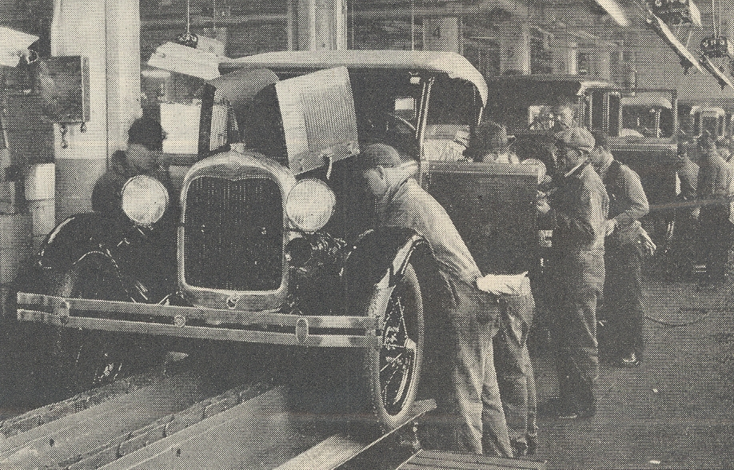

Literary digest, Ford Motor Company assembly line, 1928

As the design business is becoming increasingly more commercialised, Computer aided design (CAD) packages such as solid works and fusion 360 have been introduced to streamline the process and increase productivity. With the use of computers, designers are no longer required to hand draft drawings or produce real models as the computer-generated versions have the potential to be far more technically detailed, however it has removed a large proportion of human influence away from the design process. The reliance on computer aided design methods influences the designer’s capacity for creative thinking as they are restricted to the ability of the packages, additionally it has largely reduced the human ability to make mistakes and find alternative solutions as the programmes used project models which are consistently accurate. Thus, the outputs produced are largely similar as they are a product of the CAD package rather than the designers own ability, consequently further contributing to the lack of individuality within of modern design. John Ruskin, a notable art critic, deplored the “machine” as he believed that the mass production of designs using technology eliminated” the dialogue between artisan and material” (Raizman, D. 2003, p107) and made the products dull and easy as once things were made uniform they lost the individuality of their handmade counterpart.

the dawn of the disposable era has pushed the consumer market away from independent creators and instead towards design giants such as IKEA. The Scandinavian brand sells a light and airy ideal of modernity and domestic simplicity which has appealed to all social groups regardless of income since the 50’s. IKEA’s chuck out your chintz (1996) campaign encouraged British housewives to throw away perfectly good quality furniture which was deemed out dated and replace it with Ikeas “fast fashion furniture” (Zargani, L. 2007) that was easy practical and cheap. This shift in attitudes has made homes homogenised spaces filled with the same furniture as next door and essentially fashioned out the idiosyncrasies of British style. This disposable attitude has become increasingly common and further contributes to the lack of individualism in the field of design as cheap mass-produced alternatives become more favourable over high quality crafted products.

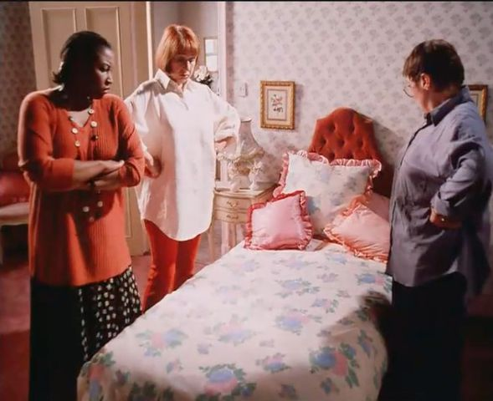

IKEA, Chuck out your chintz, 1996

The rapid creation of new products is a key driver of the modern consumer culture. “The term “consumer culture” refers to cultures in which mass consumption and production both fuel the economy and shape perceptions, values, desires, and constructions of personal identity.”
(Singh, P., R., 2011). the consumer culture has changed societal beliefs greatly as now emphasis is far more commonly placed on the material items we possess rather than the individuals that we are. The Barbara Kruger graphic print untitled (1987) draws attention to this shift in societal attitudes and the way we consume. The text “I shop therefore I am” is a parody of René Descartes philosophical proposition of ‘cogito ergo sum’ translating as “I think therefore I am” (Descartes, R. 1911). this was proposed as a fundamental truth of knowledge, however now in the modern day, Kruger suggests that there is no longer any importance in knowledge or truths as the consumer culture is far more influential over the way people reflect on self-worth.

Barbra Kruger, Untitled, 1987

Unfortunately for a large proportion of society, the culture of consumerism has become second nature, a hopeless cycle of entrapment where the only products that are openly available to us is whatever is currently trendy. Damien Hirsts sculptural installation The Acquired Inability to Escape (1990) addresses the topic of entrapment within our contemporary condition which relates to the concurrent theme of the exhibition. Hirst’s installation is comprised of two chambers one of which containing an office chair and desk with a packet of silk-cut cigarettes and an ash tray on top the other is empty. The piece addresses how we as a society are now a slave to our contemporary condition and are, like the desk and chair, trapped in a claustrophobic space. The installation can be interpreted to address the lack of ability to escape a negative cycle despite the possibility of movement to other habits, this can be related to the modern preference of disposability and mass-produced items over potentially better quality artisanal products due to its familiarity.

Damien Hirst, The Acquired Inability to Escape, 1990

The entire exhibition shall be used to challenge people’s perception of consumerism and to potentially persuade them into making a greater conscious effort to preserve the individualism within design. Furthermore, all art works displayed will hopefully confront the way that society looks for products, swaying them back to traditional craftsmanship so that the human connection with the products we surround ourselves with is preserved.
Exhibition Layout
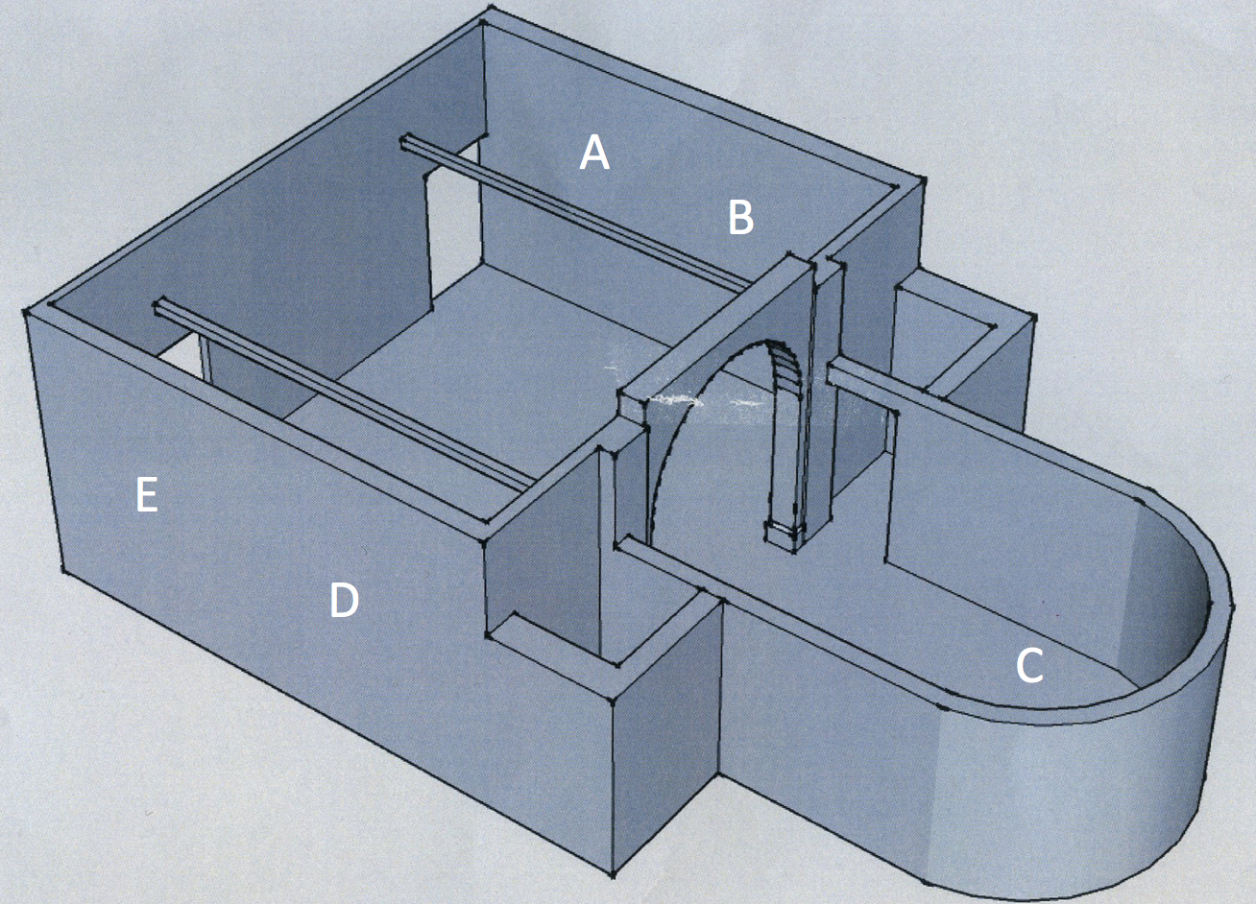

A.The image of the ford production line, a reminder of the birth of mass production.

B. ‘Chuck out your chintz’ advert to be played on constant loop, this will show the start of the change in societal attitudes towards ‘fast fashion’

C. As previously detailed. Throughout the exhibition, alongside my chosen artists, there shall also be independent artisans show casing historical crafting techniques to give context to how modern advancements have changed the relationship we have with the craft of products

D. Barbra Kruger, Untitled, 1987.

E. The Acquired Inability to Escape (Damien Hirst) to be placed in the corner. A bleak metaphor for entrapment, especially within fashion trends.
Bibliography:

Chandler, D. ; Munday. R, (2011), Fordism, Oxford University Press

Descartes, René (1911). The Philosophical Works of Descartes, rendered into English. Translated by Elizabeth S. Haldane and G.R.T. Ross. Cambridge University Press.

Hill, M. (2018), ‘Ingvar Kamprad, IKEA & Antiques’, [Online] Available: https://markhillpublishing.com/ingvar-kamprad-ikea-antiques/ [ 30.4.2018]

Manchester, E. (2009) ‘The Acquired Inability to Escape, [Online] Available: http://www.tate.org.uk/art/artworks/hirst-the-acquired-inability-to-escape-t12748 [30.4.2018]

Raizman, D. (2003) History of Modern Design: Graphics and Products Since the Industrial Revolution, Laurence King Publishing

Roberts, J; Wye, D. (2004) ‘Artists and Prints: Masterworks from The Museum of Modern Art’ [Online] Available: https://www.moma.org/collection/works/64897 [ 30.4.2018]

Singh, P.,R., (2011) ‘Consumer Culture and Postmodernism in Postmodern Openings’ [online] Available: http://postmodernopenings.com/wp-content/uploads/2011/04/6-Consumer-Culture-and-Postmodernism.pdf [1.5.2018]

Zargani, L. (2007) Armani speaks out on furniture, fast fashion, Vol.193(82), WWD publishing

