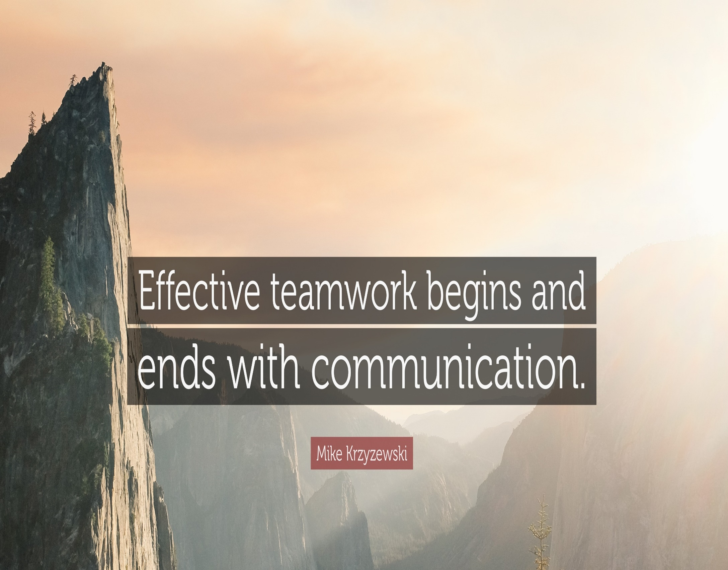
Francisco Javier Torres Mata (2020187)
Effective Team Working and Communication (BMSW4002)
Lecturer: Timothy Hopkins.
CeHE Skill for the workplace. Assessment 1-Jun 2021-Term 2.
Index

- Introduction…………………………………...1

- Models of communication…………………2-5

2.1 Shannon-Weaver……………………….....2
2.2 Schramm………………………...………....3
2.3 Berlo…………………………………….…..4

- Communication skills…………………….....5

3.1 Verbal……………………………………….5
3.2 Nonverbal………………………………..…6
3.3 Listening…………………………………...6
3.3.1 Active listening…………………………...6
3.3.2 Empathetic listening………………...........7

4. Conclusion………………………………….....7

5. References……………………………...…8

- Introduction.

A lot of changes happends in the last decade but communication has been used from the beginning of the human life and everyone can see the importance, and the speed, that communication is acquiring in these times, thanks to globalization and the common staging of the world. We can define communication as the act of give, receive and share information by words talked, wrote, read or listened and is probably the most important life skill. In other words, it is the bridge between one person with each other through an interchange of information and understanding of each other.
Good communication is essential to understand and be understood in all areas, especially in teamwork where, by definition, a group of people come together and work, cooperating and seeking the same goal: sharing ideas, looking for solutions and understanding different points of view. The flow of information in a team has to be continuous, from botton to top (vertical, horizontal and diagonal communication between differents hierarchies), flowing as clearer and easier as we can, avoiding difficult words and hard to understand sentencies. Everyone of them must keep informed and updated constantly for the sake of the effectivity on cooperation. For this, it is necessary to develop critical thinking (learn to listen from their reality in addition to ours) which will serve as a tool to understand the message that is transmitted to us, taking into account who and in what situation. Only in this way can we analyze and evaluate what has been said with a broader perspective. Dialogue implies discussion, being the discussion of ideas necessary to argue in a solid way the why of these, in order to reach agreements that benefit everyone. That means a good team worker understands the importance of building a human relationship and does not strive to impose their ideas but to enrich them through the contributions of all team members and they recognize when someone contributes winning ideas.
In this report we can see de different models of communication and the different types of communication skills. Showing the prior studies as well, comparing them with known cases of study and some events based on own experiences.

-1-

2. Models of communication

2.1 Shannon-Weaver.

Shannon-Weaver model is known as the 'mother of all models', based on prior attempts to stablish a model of communication (Schramm and Berlo). It was developed by two engineers of Bell Telephone Labs called Claude Shannon and Warren Weaver (1949), who were dedicated to maximizing the efficiency of telephone cables and radio waves.
This simple lineal model has five main components involved:
Sender (information source), encoder (transmitter), channel, decoder (reception), receiver (destination). Then, based on the decoded message the receiver gives their feedback . Being important for them to take the noise as the principal factor which affect the communication flow.
The case of study of Pedro and Maria is a good example to apply this model, where Pedro misunderstood Maria when she called him at work. The noise in his construction work, and probably the rush, does not allow him to get the right message from his wife, hearing kitchen instead of chicken. This mistake happens frequently, for example in my job, when there is a crowded event, we have to go far from it because otherwise we cannot get right the message to coordinate between us. The solution is not always the same, in Pedro and Maria and in my case, it could have been avoided by a feedback/confirmation about what we understood or stay away from noise.
I remember a busy day at work, bartending, when was imposible to have an information from my manager. The bar was crowded, and two clients were asking me for a drink at once. The caos in that situation made me leave the bar and speak with him out of that noise.
We can take this case to explain Shannon-Weaver model in a simple way with the diagram bellow:


-2-

This model gives less importance to the feedback (retroactively introduced) and focuses on the physical noise, affecting the channel, emphasizing encoding and decoding the message.

2.2 Schramm.

Wilbur Schramm, a former Iowa University professor, is considered the founder of the field of communication studies. In 1954 he proposed this model of communication paying special attention to coding and decoding processes. He also emphasizes that the communication is incomplete unless and until the sender receives a feedback from the recipient.
In this Schramm´s model theory we can see a circular model (interactive) between sender (encoder/interpreter/decoder) and a receiver (decoder/interpreter/encoder) sending a message in both ways (feedback/response). Where sender and receiver are interchangeable, feedback is immediate, and noise can be solved through ongoing clarifications.
The professor and the village people are a good example of this model, were the professor used a different code that the village people, using a high level language and having a different interpretation as result. Another good example is when in my work (events assistant) I try to listen to a speech in a medical conference, there is not a chance for me because they use professional language which I am not familiar. Only if we are both using the same code we can successfully communicate.
In the diagram bellow we can see this is an interactive model and the differences with the prior one:
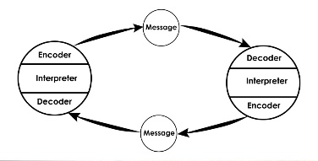
This model is focus on the code as principal factor of a good communication and the consequence of many situations, for example when someone speaks with you using slang, you have to live in his neiborhood in order to understand them.

-3-

2.3 Berlo.

David Berlo (1960), a psychologist doctorated in communication, wrote a textbook called 'The process of Communication' which still used today, stablishing the Berlo's model of communication (SMCR).
With this model, he takes into account the emotional aspect of the message, giving huge importance to the cultural, social, technological and language used.
Berlo's model has only four main components: Sender, message, channel, and receiver, but there are several factors that could impact the effectiveness of communication, thus every single one must be explained in order to understand it.
- • Sender/Source: Communication skills, attitude, knowledge, social system, culture.
- • Message: Content, elements, treatment, structure, code.
- • Channel: Hearing, seeing, touching, smelling, tasting.
- • Receiver: Communication skills, attitudes, knowledge, social system, culture.
The case of study of the professor and village people can be perfectly explained, as well, with this model; Where the village people were in a different level of the language, the professor used a high level, unintelligible for the village's people due the difference of status, cultural and social differences between them. In my experience in hospitality, I can see these misunderstandings every single day with costumers, even staff; All related to status, cultural background, etc... specially here in London and its cultural wealth. How everyone has their own way to say things, their own gestures and vocabulary.
This lineal model looks simple but it takes to many variables as we can see with the diagram bellow:

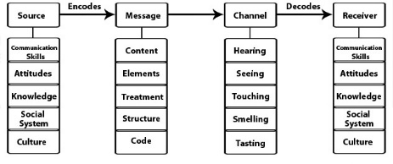
-4-

Berlo´s model develops the idea from Aristotle that, the receiver, is who hold the key for an effective communication. Giving a lot of importance to the social background and culture, as a critical variable of communication; not considering noise or the need for feedback.
We can see this, as well, in the difference between British and American english for example (biscuits vs cockies) , or Spanish in Spain or South America; A lot of expressions have different meanings.

3. Communication skills
Communications skills are more that only speak, is how we speak, how we express it and how we listen. All these factors together affect to communication when they say different things, failing in the fact of communicate properly. Some skills we need are:
- Clarity (message easily lo understand).
- Empathy (try to take the other person´s perspective).
- Sincerity (be yourself).
- Relaxation (don´t panic)
- Eye contact (when you are listening and speaking, be 100% in the conversation)
- Appearance.
- Posture.
- Volume, speed, tone… of voice.
Any communication has to be clear, concise and appropiate. We have to pay closer attention in order to excell in our jobs, avoiding misunderstands and errors.

3.1 Verbal communication.
Verbal communication is not only oral communication, but as well written communication is also verbal. It reffers to words.
Verbal communication at work is going from bottom to top in hierarchies, taking place between bosses and subordinates, co-workers, employees, clients, customers, speakers and their audience, teachers, and students. As well as at differents situations: one-on-one discussions, group meetings, presentations, trainings sessions, presentations, reports, internal communicates between differents departments, … and in different channels: Mails, emails, circulars, reports, meetings, memorandums, and others internal communications.
-5-

3.2 Non-verbal.
This is the things we communicate with our face and body lenguage. Non-verbal communications are very important, we transmit more information with ours gestures and tone of voice that we think. Is fundamental to learn to control how we act, and how the people see us when we are having a communication, strengthening what we want to say for a successful delivering of the message. For example, when you say an important information, but there is not eye contact ant the tone of voice is low; it could seem less important and lose the listener attention.
Remember:
- Non-verbal communication is body language (facial expressions, movement of your head, gestures, …), voice (tone, volume, speed, …) and eye contact.
- To be a good non-verbal communicator, even if you are shy, is only practice, practise, practise.

3.3 Listening
Listening is the other 50% of communication. Iy is important in life, but, vital when we are speaking about job and companies of any size. Listening is the ability to receive and interpretate, with precision, in a communication. It is is concious effort to understand and assimilate the information.
The average person remembers between 25% and 50% of what they hear. (Crockett, 2011). Usually, we tend to focus on the main points of the information, that is why, speakerwise, the message has to be clear, conciss and short as possible.

3.3.1 Active listening
Active listening means the intention, focus, reflection and summaraising of the listener. With these four steps we can get accurately the message.
As example when someone ask you to do something: First you predispose to listen (avoid noises and interruptions even interventions).Second you listen carefully and focus on what he is saying.Third you must reflect it back, in the same way he said, to clarify what he is asking for. And then, you summarize the main points to ensure the message is clear and he was fully understood.

-6-

3.3.2 Empathetic listening
Empathy is neccesary in listening because if you can deep understand the speaker situation, and the motives, that involve that conversation for the speaker side, you can clearlier see his point of view and properly understand him.There is no preparation for this. Is more like a brain state: calmed but active and open minded. You wil come to conclusion any time in the conversation but have to let it go and focus on what he wants to communicate. Explore the intends, make sure you understand, make inner thinking, control your reaction (mood is important) and you will success an empathetic communication.
(Senge, 2006)

4. Conclusion.
Communication has a big importance in our lifes, family, friends, that we have to take care of in order to have better relationship with the world. Specially at work, where we have to do it with more people, co-operating to reach specifics goals. Having the right attitude, respect for everyone, the concioussnes of diferents states of mind of the people around you, and this guide (with practice, practice, practice), we´ll have a much better environment and reach a high level of satisfaction and happiness wherever we go.
We must be aware about the barrier of communication, just to have it present we can find some of them here:
- Phisical distractions.
- Different status.
- Semantic.
- Poor understanding (personal ability).
- Cultural.
- Poor choice of communication channel.
- …
We can summarice them in three categories:
- Barriers to reception.
- Barriers to understanding.
- Barriers to acceptance (prejudies and conflit between sender and receiver)

-7-

I would like to thank all, University of Wales Trinity and David, and my lecture Thimoty (Effective team working and communication module, BMSW4002_LON) for their support and the opportunity to learn and thrive personally and professionally with them in this period. As well as the people refferenced without which this report would not have been possible.

5. References.

Communication Theory. 2021. Shannon and Weaver Model of Communication. [online] Available at: <https://www.communicationtheory.org/shannon-and-weaver-model-of-communication/> [Accessed 20 August 2021].

Doyle, A., 2020. List of Verbal Communication Skills Employers Seek. [online] The Balance Careers. Available at: <https://www.thebalancecareers.com/verbal-communication-skills-list-2059698> [Accessed 20 August 2021].

Lh3.googleusercontent.com., 2021. Effective teamwork begins and ends with communication. [online] Available at: <https://lh3.googleusercontent.com/20WnBM_ejn7V4j6UqSZoHr7WkIy1PxtXl7MDARj0qndME-hz-aK8ie7zOxUKLhxaBjj22A=s152> [Accessed 25 August 2021].

Treasure, J., 2017. How to be heard. 1st ed. Coral gables, USA: Mango publishing group, p. Chapter 3.

Young, I., 2015. Practical empathy: For Collaboration and Creativity in Your Work. 1st ed. Rosenfel Media.

J -8-

