

BA BUSINESS MANAGEMENT
ASSESSMENT-1
Module name: Introducing the modern workplace.
Module code: LCBB4003
Module Lecturer: Dr Hoang Dang Nguyen
Assignment title: Organizational structure and culture
Student name: Ramanpreet Kaur
Student ID: 2216790
Submission date: 24 April 2023

Table of content:
Introduction
Description of Tesco company
Definitions of Organisational structure, culture, and performance
Relation between organisational structure and culture and performance
Current organisational culture and structure and performance of Tesco plc
Employee motivation
Conclusion
References

Introduction: In this report, learners will discuss the organisational culture and structure of Tesco plc, which is a very well-known company in the UK, and the relation between the organisational culture and performance of the organization. Moreover, this report will also discuss how this company motivates the employees, that means what kind of theories and framework a company applies to improve its performance and achieve success. These factors are very important for every company to achieve success.

Description of Tesco company: Tesco is the leading multinational retailer company. This company has more than 345000 employees. The main agenda of this company is to provide healthy and sustainable food with affordable prices to the customers and help the people to enjoy a better life. Tesco was founded by Jack Cohen in 1919. The first store was opened in 1929 in North London. The store sold most of the dry goods and the first branded product of the Tesco company ‘Tesco tea’. The company focuses on three main areas, packaging of the goods, quality, and healthier options for individuals. Moreover, there is a significant increase in sales especially after pandemic. In 2022, the total revenue was £61.344 billion.in addition to this, now, there are 2,832 Tesco retail stores in the UK, and it is a number one multinational retailer in the world. (Tesco Plc, 2023)
Definitions of organisational structure, culture, and performance:
Organisational structure: An organisational structure is a framework that specifies how specific tasks are managed in the firms to achieve a realistic and strategic objective. These activities involve rules and regulations, responsibilities, and duties. The information flow between corporate divisions is also governed by organisational structure. Moreover, organisational structure includes centralization or decentralization, functional, divisional, flat, and matrix designs. These structures give a visual representation to the company of how it is shaped and how the company can achieve its goal. Additionally, a clear organisational structure clarifies each employee’s responsibility and how it fits into the system of the firms. (Kenton,2022)
Organisational culture: An organisational culture determines a firm’s personality and character and leads to improved performance. Organisational culture is made up of common values, beliefs, and presumptions about how people should communicate, behave, and make decisions according to their choices. It also includes assumptions about how work should be done. In addition to this, understanding of organisational culture is important for effective leadership. A knowledge of the firm’s culture will help managers and executives implement strategy and complete their goals. (Wong, 2020)
Performance: performance is an organisation’s capacity to achieve its objectives and maximize outcomes. Depending on the firm, its aim, and the market, organisational performance may be viewed subjectively. Every organization wants to develop continuously, and it is crucial that a firm’s performance is correlated with the employee’s distinctive performance of the group working at the level of the Organisation. (Contu,2020)
Relation between organisational structure, culture, and performance
When analyzing the purpose and pattern of people’s behaviour at work, organisational structure and culture are among the concepts with the best analytical and descriptive power. Organisational structure and culture’s effects on other leadership facets are frequently researched independently. Furthermore, agreement between the two organisational components improves performance since the structure and culture of the organisations have an indirect impact on one another. Organisational culture affects the chosen management style, employee reward system, and other aspects of relationships between people. (Reasearchgate.net,2023) Additionally, it also affects organisational learning, firm strategy, and the prevailing leadership style. This has an impact on all organisational procedures as well as the organisation’s performance. On the other hand, organisational structure is impacted by organisational culture. Culture affects senior management’s frame of reference, which in turn impacts organisational structure, with its assumptions, values, and norms. (Altay et.al.,2018, p.5). So, organisational culture and structure have an impact on a company’s performance and operations.
Current Organisational structure and culture of Tesco Plc:
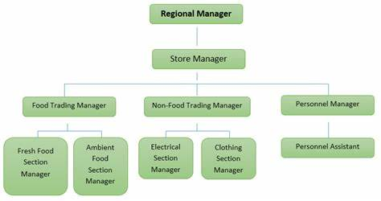
Tesco follows a decentralized, hierarchical, and product-based structure.

Decentralization structure: the Organisation structure is decentralized when the lower levels of a company have decision-making authority. It typically occurs when company has numerous locations, and the senior managers and head officers unable to check every area. Tesco operates in several different nations in Asia and Europe in addition to having a sizable number of outlets in the UK. Because of this, it would be challenging for the board and committees to govern operations at every location. Certain stores are control by store managers and the regional managers are in charge of specific localities. (StudySmarter UK, n.d.)
Hierarchical structure: Tesco’s organisational structure is hierarchical in terms of its top management and leadership positions. There are several levels of management and leaders. The organisational structure of the firm comprises three levels of management: top, middle, and base. Employees perform various tasks and then give report to the managers. (StudySmarter UK, n.d.)
Product based organisational structure: Tesco follows this structure as well. The managers of Tesco are then divided into groups according to the locations that managers will cover. Regional managers are in charge of each area because they have to check every moment in the firms. If there is any problem, managers can oversee it efficiently. Additionally, each region has store managers who covers the certain store inside that region. (StudySmarter UK, n.d.)
Organisational culture of Tesco: Tesco prioritises three values which shows its organisational culture: customers, community, and planet. These values help the company to grow in the market. (Tesco,2022)
Customers: customers are the top priority of every business. Customers are one of the three values of the Tesco because Tesco seeks to comprehend what its customers needs and wants and try to fulfil all the requirements of the customers and gain the people’s trust. Tesco helps the customers as much as possible and treat people how they want to be treated. (Tesco Plc,2023)
Community: communities are one of the retailer’s core beliefs. There are other ways that Tesco benefits communities in addition to providing different kind of products which includes food, clothing etcetera. In addition to this, by doing charity and promoting inclusivity in the work, company contributes to the development of the community. (Tesco plc,2023)
Planet: Tesco Plc says that the planet is yet another one of their fundamental business functions. The company’s goal, which focuses on sustainability, is to modify activities so as to have a less of an influence on the environment. This is particularly true of its supply chain, the primary force affecting the planet. A healthier way of life is also supported and promoted by firm. (Tesco plc,2023)
Another value of the Tesco company is feedback for the Tesco’s corporate culture which is very crucial in order to know about the how their business is going. How people feel about their services. Whether they are happy or not with the services. Tesco also do surveys for the employees to get to know about their views. In this way, company will be aware about the issues like on which part they have to improve. In addition to this, Tesco include diversity and inclusion. It creates the good environment for the people to collaborate with the people from diverse cultures and nations. So, the firms organisational culture helps the company to keep going and achieve the goals. (Schosser,2022)
Organisational structure and culture have an enormous impact on the company’s performance. Tesco has good opportunities that make it easier for the managers to do work productively because of the good organisational structure and culture. Moreover, work runs very smoothly because they have a different manager for different sections. So, Tesco’s unique structure and core principles define how to direct the business functions on a daily basis and achieve their objectives efficiently. (StudySmarter UK, n.d.)
Motivation
Motivation is the method that used to motivate, focus, and sustain someone’s efforts in order to achieve a goal (Robbins and Coulter ,2020). Employees motivation is especially important to improve the performance of organisation. There are many methods to motivate the employee at works. For example, by creating good environment at workplace. So, they can feel safe, secure, and confident at work. Another method is that leaders can give positive feedback to the employees, give rewards and promotion to the individuals that motivates to the employees to keep do work productively and efficiently (Wong,2020). Organisations use some theories to motivate the employees at work. Tesco uses Maslow and Herzberg theory (Daoudi, n.d.).
Maslow theory:

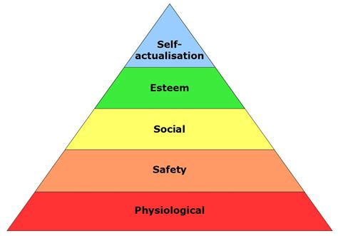

1. Physiological needs: Tesco provides good amenities for the employees such a Tesco provide lockers to the workers to put their personal things in lockers. They provide good payments to the workers. (Daoudi, n.d.)
2. Safety needs: Tesco provides contracts for the employees, health insurance. (Daoudi, n.d.)
3.Social needs: Tesco provides discounts or many other offers to their employees on gym membership and theme parks. Moreover, Tesco empowers the employees to work as a team. So, they can socialize with each other. (Daoudi, n.d.)
4.Self-esteem: Tesco gives respect to the workers because of their hard work. Tesco treats everyone equally. In addition to this, Tesco also celebrates achievements. (Daoudi, n.d.)
5. Self- actualization: Tesco provides opportunities for the workers to increase their skills and talents and produce productive work and achieve the objective. (Daoudi, n.d.)

Herzberg (the two-factor theory):
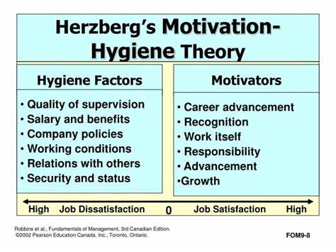

Tesco is focusing on the hygiene factors and facilitating the customers satisfaction satisfiers, which can be seen by motivating the employees, recognition, and personal growth initiatives as a factor of encouragement, meeting the security, social needs, and giving the chance to the workers to participate in the organisation’s decision making. More importantly, Tesco is putting this theory into practice by conducting an annual survey to evaluate worker happiness, which gives the employees a chance to provide their opinions about the work and company. That helps the company to know about their performance and about the views of the workers. As a result, the surveys help Tesco in determining what it should be providing for its staff to maintain their motivation (Daoudi, n.d.).

Conclusion: Based on the above analysis, it can be concluded that organisational structure and culture is very important to give shape to organisations because organisational structure and culture both have an impact on the performance of the company. In this report, the learner provides a current organisational structure and culture of Tesco. Moreover, this report also provided information about motivation and how Tesco motivates their staff by using Maslow and Herzberg theory. All these practices assist the firm to achieve its objectives.

REFERENCES:
Altay, N, Gunasekaran, A., Dubey, R. And Childe, S.J., (2018). Agility and resilience as antecedents of supply chain performance under moderating effects of organisational culture within the humanitarian setting: a dynamic capability view. Production Planning and Control,29(14), pp.1158-1174. https://www.tandfonline.com/doi/abs/10.1080/09537287.20181542174
Contu, E.G. (2020). Organisational performance-Theoretical and practical approaches; study of students’ perceptions. Proceedings of the international Conference on Business Excellence,14(1), pp.398-406. Doi: https://doi.org/10.2478/picbe-2020-0038.
Daoudi, T.(n.d.). the applied motivation theories in TESCO. www.academia.edu. [Online] Available at: https://www.academia.edu/14236459/the_applied_motivation_theories_in_TESCO. Accessed: 18 April 2023)
https://tse1.mm.bing.net/th?id=OIP.C_yL77C6T-f_vAfB8u6CgAHaD6&pid=Api&P=0
https://tse3.mm.bing.net/th?id=OIP.fH8uOxvZ6HESid3gtbnJQAHaFL&pid=Api&P=0
Kenton, W. (2022). Organisational structure for companies with examples and benefits. (Online) Investopedia. Available at: https://www.investopedia.com/terms/o/organizational-structure.asp. (Accessed :7 April 2023)
Researchgate.net. (2023). Researchgate.net. [Online] Available at: https://www.researchgate.net/publication/288469770_The_mutual_impact_of_organizational_culture_and_structure_ (Accessed: 10 April 2023)
Robbins, S., and Coulter, M. (2020) Management, Global Edition.15th Ed. Pearson.
Schosser, A. (2022). 5 Lessons from Tesco’s Corporate Culture. [Online] www.retorio.com. Available at: https://www.retorio.com/blog/5-lessons-from-tescos-corporate-culture. Accessed: 20 April 2023.
StudySmarter UK. (n.d.). Tesco Organisational Structure: Overview, Chart And Advantages.[Online]Available at: https://www.studysmarter.co.uk/explanations/business-case-studies/tesco-organisational-structure/. Accessed: 11 April 2023
Tesco Plc (2023). Tesco PLC.(Online) Tesco plc. Available at: https://www.tescoplc.com/. Accessed: 7 April 2023.
Tesco (2022). Culture/ Tesco Careers. [Online] Tesco-Careers.com. Available at: https://www.tesco-careers.com/explore-our-world/our-culture/. Accessed: 11 April 2023.
Tesco PLC (2023). Core Purpose and Values. [Online] Tesco PLC. Available at: https://www.tescoplc.com/about/how-we-do-business/core-purpose-and-values/. Accessed: 11 April 2023.
Wong, K. (2020). Organizational Culture: Definition, Importance, and development. [Online] Achievers. Available at: https://www.achievers.com/blog/organizational-culture-definition/. Accessed: 7 April 2023.
Wong, K. (2020). How to Motivate Employees: 13 Simple Ways. [Online] Engage Blog. Available at: https://www.achievers.com/blog/how-to-motivate-employees/. Accessed:18 April 2023.

