NAME: Deirdre Gould

STUDENT NUMBER: 1809630

MODULE TITLE: Distinctiveness and
Regeneration
CODE: BMSP4005

ASSIGNMENT 1

INTRODUCTION
(htt)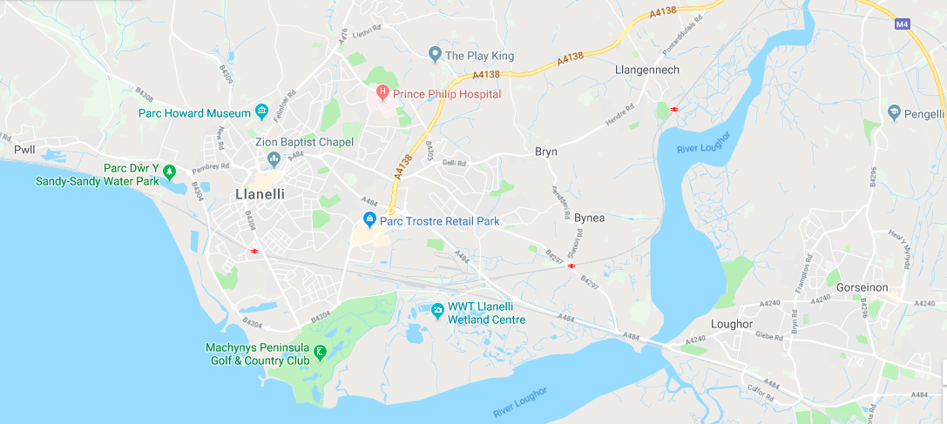

Llanelli was once an Arable land which had large estates, Stradey and Mansell that controlled the tenant farmers and smaller family run farms before the start off the industrial revolution in Great Britain. People would be living a sustain life influenced by the seasons and the weather. People would rotate crops in open fields barley, wheat every 3 years.
In 1700 the accepted date for the start off the Agricultural Revolution the horse-drawn seed drill sowed the seeds in neat rows was invented by Jethro Tull (1674-1741) at the cost off 18shillings and 2pennies.
The coal seams below the large estates were leased out and exported coal to France via the sea hence “sea coal” interpreted as coal mined for seaborne export trade. With a huge increase in demand for coal due to industrial revolution off the development off steam engines and associated machinery, Llanelli was left behind due to having a reputation as the wild west of wales.
Soon many people were not able to sustain a living from farming in Llanelli, as more machinery and vast technological developments were taking over the way people lived. Many people then migrated into towns looking for work.

Industrial Revolution
“The impact of the industrial revolution and the changes wrought to both society and the landscape of not just Llanelli, but to the whole of Great Britain cannot be underestimated as over the course of 150 years both were to change beyond all recognition” (Hannam.J, 2019).
Llanelli being known for its high quality of coal which was made during the carboniferous period 300 million years ago. Boggy land between land and sea more plant matter (peat) gets made as the dead plant matter would sink to the bottom of the sea. Eventually the forests and swamps get dried up and lignite is formed. It then gets buried over time with more layers of sand, clay and other forms of materials it then compresses over time and heats up because of it being buried deeper nearer the centre of the earth, which over time turns harder and darker. The lignite turns into sub-bituminous coal, then bituminous coal and finally anthracite coal.

(htt1)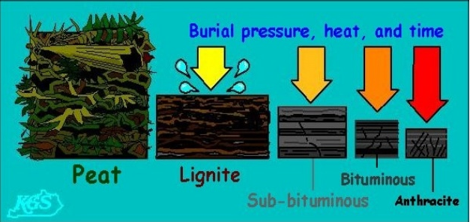

By 1750 Llanelli begins to take advantage of the technology with the discovery of coke by Abraham Darby 1709 which is used to smelt iron. The steam powered pump developed by Thomas Newcomen 1712, which the Rees family in Bynea installed in their mines to allow deeper digging and access to the larger seams of coal. The tramroad which linked a pithead at a quay is constructed enabling a faster and more efficient transporting, exporting of coal from Llanelli.
In 1805 Chauncey Townsend has legal proceedings against him due to him and his agents gaining the first lease in Llanelli but worked against the area with the more he owned. He did this by befriending large landowners and then by doing the bare minimum requirements within the conditions off the lease agreement the less productive it became. He owned coalmines in England which flourished. Alexander Raby in 1797 who held iron, copper and coal interests in both England and Wales moved to Llanelli. He built a modern industrial complex including the sinking of 3 mines, worker cottages, resident for himself and his main agent. His actions resulted in many moneyed industrialists and entrepreneurs to Llanelli with endless opportunities to develop and make money from its natural resources. The expansion of transport the railway canals and tramroads linking the mines extra.
Charles Nevill who had knowledge of the area from his work in Swansea, and his son arrived in Llanelli 8 years after Alexander Raby. They were happy to lend money to others to start and develop mines, with the knowledge that should they fail to repay the mines would be taken for payment. Within 24 years of arriving the Llanelly Copperworks Company owned or held most off the coal district. The company continued to grow and dominate and in 1837 Richard Nevill maintained management and it grew and flourished, diversifying into copper works and improving the docks, developing yellow metal manufacturing and converting the Cambrian copperworks into a lead smelting and silver extraction works. From then on Llanelli thrived.

DECLINE and REGENERATION 20th CENTURY
By 1920 over 271,000 men worked in over 620 mines in Wales but soon the oil power came in 1936 then by the 1980’s nearly all the coalmines are closed leaving a vast unemployment issue.
In 1947 the nationalised Steel Company in Wales was being forced to produce more products with bigger profits. The company decided to create two new tinplate works one at Trostre and the other at Felindre.
Construction started in 1947 when around 12,000 men were unemployed due to post world war 2 in Llanelli. Due to the marshland that was apparent on where the site in Llanelli was to be built a new framework had to be devised. As the traditional material would have been timber and with that being in short supply. Anderson-type air raid shelters were rolled flat and pressed into panels, so the steel was attached to the timber frame. This was the first steel panel framework system was made this way in the world. In 1951 production started and in 1980 British Steel decided to start to close Felindre, even though their production was more than Trostre. Then in 1989 the production from Felindre stopped.
“Over this time, Trostre Works has remained a leading supplier of high-quality light gauge steels supplying over 50 countries worldwide. Substantial investment in new plant and technology, people, training and research and development, keeps Trostre at the forefront of European tinplate production.” (brochure, 2006).

In 1980’s the Wildlife Wetland Trust founded by Sir Peter Scott started to work on a site in Trostre. “Llanelli Wetland Centre is a 450-acre mosaic of lakes, scrapes, pools, streams and lagoons adjoining the salt marshes and shore of the scenic Burry Inlet” (reserve, 2019).

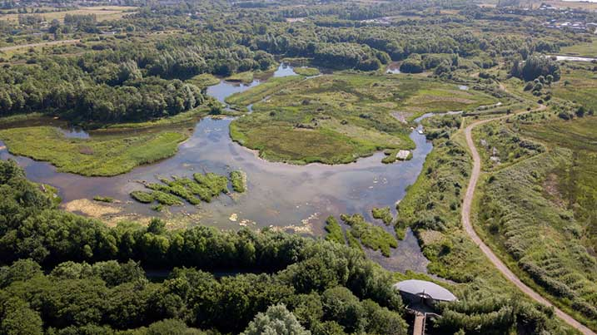 (reserve n. ).
With its vast range off different wild life species of plant life and animal life to view close or from afar in a beautiful inhabitant environment. From insects to fish and birds either living here or the thousands of migrating birds that visit every year, it is a thriving business that is expanding every season.

CONCLUSION
From the 1700,s to now Llanelli has been one of the best industrial thriving towns with vast employment, to a poverty town with unemployment on the up and up. It has a few well-established tourist attraction facilities and a famous rugby team the Scarlets. From once being once known as the wild west with unpolluted air within a farming community to having pollution pumping out off the industrial machinery and the farming community disappearing, it has the potential of thriving again sustainably.

Bibliography
(n.d.). Retrieved from https://www.wwt.org.uk/uploads/images/2019-01-24/1548340195-llanelli-aerial-717x403.jpg
(n.d.). Retrieved from https://www.wwt.org.uk/uploads/images/2019-01-24/1548340195-llanelli-aerial-717x403.jpg
brochure, C. v. (2006, june friday). Retrieved from Llanelli history: https://web.archive.org/web/20110114144144/http://www.llanelli-history.co.uk/corus-2%20Works.htm
Hannam.J. (2019). The Roots of Modern Llanelli.
reserve, n. (n.d.). Retrieved from https://www.wwt.org.uk/uploads/images/2019-01-24/1548340195-llanelli-aerial-717x403.jpg
reserve, N. (2019). nature reserve wetlands Llanelli. Retrieved from https://www.wwt.org.uk/wetland-centres/llanelli/wildlife/nature-reserve/#

