MANAGING PEOPLE
ANCA VASILE
ID UWTSD-2018716

Executive summary
The concerned report based on the post-pandemic situation of the retail organization in the context of employees working style. The flexible working system is the most important thing that guides to improve the working structure of the organization that increases the business productivity as well as employee performances. Implementation of the inclusion practice among the employees in the workplace guides to improve the organization culture that include the positive attributes towards the work culture. Inequality within the workplace has a great impact on organizational progression of the retail industry that affect the employee retention rate. The Human Resource management of a retail organization should play an initiative for mitigating the issues of the organization.

Table of Contents
Introduction 3
Case overview 3
Importance of Flexible working system 3
Effect of Diversity and inclusion on the work environment 4
The role of Human Resources in promoting diversity in the workplace 6
Inequality within the workplace and its impact on organizational progression 7
Impact of Flexible working system on inequality at work 8
The role of Human Resources in addressing the concerns of inequality in the workplace 9
Conclusion 10
References 11

Introduction
Human resource management is a vital aspect of the organization that contributes to stimulating organizational progression. However, an individual employee's developmental skills and problem-solving attributes are taken as a major aspect of the people manages mental system. Greggs is one of the leading supermarkets in the UK that deals with the food and beverage industry. John Gregg in Gosforth in the UK founded the organization in 1939. Flexible working systems, organizational culture along with improved strategies serve to be effective in stimulating employee performance. The current study focuses on addressing the impact of flexible working systems and the impact of diversity on organizational performance and productivity.

Case overview
The concerned report sheds light upon the situation of a retail organization that consists of more than 1000 employees in different retail stores. In the current situation, Greggs has run its business with more than 2000 retail stores in more than 14 different countries all over the world. In the post-pandemic situation, the retail organization is going to implement a diversity and inclusion strategy to mitigate the differences among the employees that guide to increase the business productivity and the level of organizational culture. The role of Human Resource Management is very important for the application of diversity and inclusion within the workplace as well as managing an unequal work environment. The friendly working system strategy of Greggs guides to increase the employee retention rate from 3.12% to 5.63%. The number of employees of Greggs was also increased from 18564 in 2020 to more than 20000 in the current situation (Greggs, 2018). In these circumstances, the employers of the retail organization want to provide “Work from Home” facilities either for part of the week or all week for their employees.

Importance of Flexible working system
Greggs consists of inclusive organizational cultures along with a friendly and respectful working environment. The authority of Greggs believes that working flexibility increases the employee's motivation and makes them energetic. The flexible working system initially has the primary ability to attract a higher level of working skill, however, due to this particular skill, the business is initially able to retain and attract more diverse skilled employees to the organization. In this “flexible working system,” they can have the predominant power to reduce the recruitment cost. However, due to this specifically mentioned working system, job satisfaction and employees' daily performance are primarily increased (Leroy et al. 2018). The positive energy and motivation of employees reflect on their performances that lead to an increase the business productivity. Appreciation for hard working and incentives will guide Greggs's work culture more motivated and focused on the organizational objectives.Thus, flexible working time can have the power to boost the working employees' morale and encourage them to give their 100% towards the work. This particular agreement primarily consists of two different types of components, such as,
- It can initially give the opportunity to choose where the individual employees want to work from, which can be “work from the office” (WFO) or “work from home” (WFH).
- Initially creating the proper work schedule, which can primarily save individual employees valuable office hours time and make them more productive.
- Non-executive as well as executive directors of Greggs always consult their business strategy with the workers and other subordinates as well.

Effect of Diversity and inclusion on the work environment
The diversity in the workplace of the retail organization guides the recognition of the emotion and working style of the employees that helps to increase the performance of employees along with business productivity. After implementation of the inclusion practice in the work environment, Greggs makes the organizational culture more strong and the internal communication system level increases. According to the recent research, on the retail industry in the UK by the ACAS commission, it is disclosed that the implication of diversity strategizing in the work environment the business productivity was increased by more than 26.4% from the previous situation (Chams and García-Blandón, 2019). Multiple types of diversity are seen in the workplace such as internal and external diversity that influences the performances and the working structure of a retail organization.
Organizational diversity maintains an effective communication level among the employees that makes them energetic as well as motivated. As Greggs deals with more than 2000 stores in different regions of the organization then the inclusive cultural practice assists in easy communication as well as adjustment with other employees along with the higher management team (Greggs, 2018). Apart from that, the diversity strategy had a great impact on the employee retention rate which increased to around 12.6% (Khan et al. 2019). The internal along with external performances of the retail industry in the UK has been greatly influenced because this industry relies on conventional wisdom. In order to mitigate the situational decrease in the industry performance, the organization has taken several strategies and structural innovations. As stated by Dirani et al. (2020), diversifying strategy in context to the employees can boost the business productivity by more than 35%.
Diversification within the workplace guides the enhancement of the decision-making process along with problem-solving skills. As per the perception of Werner (2021), the retail industry should implement a “Cognitive Diversity Theory” that guides the management of the different working styles of employees that can be effective in handling any difficulties in terms of workforce management as well as communication issues within the workplace. The inclusive organizational practice makes the work environment healthier and makes the employees motivated as well as energetic, which affects the business productivity or the annual revenue. For that purpose, the annual revenue collection of Greggs is increased to £117.5 million from £96.8 million (Greggs, 2018). It is seen that around 55% of the retail employers expect to provide work from home facilities to the employees for part of the week, as they face difficulties to come in the workplace during the pandemic situation due to the outbreak of COVID 19.
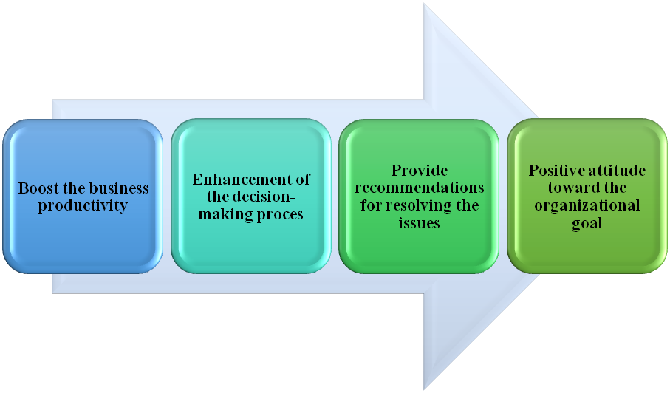
Figure 1: Effect of Diversity and inclusion on the work environment
(Source: Leslie, 2019)
The implication of the inclusion management style in the workplace of a retail organization guides to acknowledge their differences and provide effective recommendations for resolving the issues of employee differences. As opined by Leslie (2019), “Schema Theory” is an important theory for implementing the inclusion practice among the employees in the workplace. As per this theory, the retail employers celebrate the cultural and social differences among employees by arranging meetings for communicating about the organizational goals along with measuring the progress of the organization. As per recent research that was conducted by the ACAS commission it is seen that after implication of this theory by retail organizations more than 12.8% of business progress can be seen so that this organization will be beneficial for this inclusive theory. The diversity and inclusive practice creates a positive attitude towards fulfilment of the organizational goal among the employees.

The role of Human Resources in promoting diversity in the workplace
The role of Human Resource management of a retail organization in promoting diversity starts with making an effective decision in the context of employees' satisfaction and acknowledging their situation and emotion. The most burning problem of the retail organization in the UK in the post-pandemic situation is managing people in the workplace (Sakdiyakorn and Wattanacharoensil, 2018). The principal role of “Human Resource Management” in the retail industry includes making awareness among the employees of inclusive cultural practices. The HRM of Greggs mainly focuses on the training for cultural improvement as the employees of the organization belong to multiple arrays of regions. In the COVID 19 pandemic situation, the employees mostly suffered due to district lockdown within the country boundary.
Implementation of “Social Identity Theory” in the workplace of a retail organization the Human Resource Management team should categorize the employees according to their social background by observing their similar work attitudes and characteristics. Apart from that, from the point of view of Yong et al. (2020), this theory provides a positive attribute to the work cultures and widespread the common belief that resolve the negativity. Gamification is one of the most important HRM strategies that Greggs has implemented into the business process that increases the communication system, and services for employee management development (Stuerzenhofecker, 2020). “Justification-Suppression Model” is another important theory of diversity that increases the value of inclusive practice in the workplace as well as enhances the organizational behaviour by increasing the internal communication level among the employees. According to Chams and García-Blandón (2019), staff working from a comfortable zone can increase the self-productivity by more than 31%, which affects the business production of a retail organization.
As a Human Resources Manager of a Retail organization, it is very important to adopt different flexible working practices for the employee benefits that guide to increase the business productivity. Diversity and inclusion in the workplace in the context of flexible working practice guides to improve the employee's retention rate. The Human Resources Management team of the retail organization guides to follow the process of the “Justification-Suppression Model” that indicates to hire all types of employees relied on their strength and uniqueness of employees. Apart from that, according to Khan et al. (2019), the concerned model suggested enlightening the accomplishment of staff in the context of maintaining working cultures. Besides this, hosting multiple events and activities of the employee guides boosts the performance of the employees.
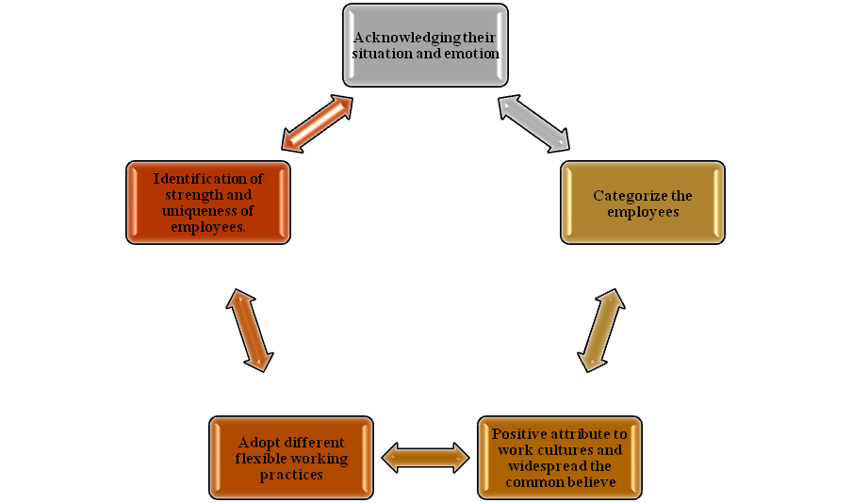
Figure 2: The role of Human Resources in promoting diversity in the workplace
(Source: Mousa et al. 2020)
As per the recent research conducted by the ACAS commission in the context of the post-pandemic effect on the retail industry in the UK, it is disclosed that around 49% of the retail employers expect an increase in the volume of staff in terms of work from home facilities remotely all over the week. As opined by Mousa et al. (2020), the human resource management of the retail organization should focus on making a bridge for mitigating the cultural gap that affects the communication skills. Every retail store of Greggs deals with a different type of customer and employees belonging, to have their individual cultures, language, and values. The UK-based stores of Greggs mainly deal with more than 60% of the British and French people so the food items and the way of communication are quite different from the other Greggs stores (greggs, 2022). It is seen that practicing good manners with the employees will be beneficial for dealing with foreign customers as well as colleagues of other retail stores.

Inequality within the workplace and its impact on organizational progression
Inequality in the workplace is mostly seen in the context of gender discrimination, inequality in terms of promotion, and unique pay level. Among 20000 employees of Greggs, more than 6000 workers belong to different countries rather than the UK so the organization has faced several problems in managing the employees. Organizational inequality in the retail organization in the UK refers to the unique style of treatment that relate to gender, sexuality as well as complexion. As stated by Sakdiyakorn and Wattanacharoensil (2018), inequality among the staff of the workplace guides to an increase in the income gap of the employees in the context of health status as well as the social class of the organization staff. Inequality is the most significant cultural issue of Greggs and for that reason, the employee retention rate decreased to 4.2% from 5.1% in the year 2021. Apart from that, physical or mental disabilities can also be a great cause of inequality within the workplace that affects the performances of the employees and the productivity of the retail organization (Mousa et al. 2020). Mostly three types of inequality are seen in the organization like income, promotional, and health inequality that negatively impacted the performance of the retail store and hampers the customer's service system.
The inequality among the employees of a retail organization has a propaganda effect on the performances of the employees and their mentality toward the organizational objectives. Apart from that, cultural and religious discrimination is also seen in its food items. Greggs mainly produces non-vegetarian products a total of 78% food products as per the demand of the customer (Greggs, 2022). Furthermore, the context inequality in the organization has an immense effect on the internal communication level as well as team unity (Tompos and Ablonczy-Mihályka, 2018). The skills and security are also affected by the economic inequality among the employees. The employee retention rate of the organization can be reduced with the inequality practices among the employees.
The emotion, cognition, and behaviour of the employees can also be affected by the inequality practices among the employees. According to Cletus et al. (2018), inequality practices among the employees of an organization guide to a decrease in the context of business productivity promotion and organizational behaviour. On the other hand, as per the point of view of Hatipoglu and Inelmen (2018), for sustainable development of the organization is affected greatly by the inequality practices among the employees. In contrast, in the current situation, Greggs has transferred its focus point from non-vegetarian food to vegan food, which increased the sales revenue by more than 15% (Dhontand Stoeber, 2020). The annual revenue of Greggs is also affected by this strategy which increased to around £1,229.7 in 2021 million from nearly £1,144.2 million in 2019. The impact of inequality practices among the employees can be seen in terms of sexual harassment, increased social mobility, and individual performances of the employees.

Impact of Flexible working system on inequality at work
Workplace flexibility can be manually beneficial for an individual professional organization. However, this specifically mentioned "flexible working system" could initially help to archive the actual gender priority. The principal impact of the flexible working system guides mainly seen in the working structure, well-being of employees as well as business productivity. Increasing the flexible working system of Greggs has a great impact on the food production system as well as the sales process. According to Times and Gardiner (2021), it can be primarily symbolized that the professional transaction towards the "fourth industrial revolution" is derivatively marked by the aspects of the "Covid 19" pandemic. According to Arakelyan (2020), the employees who are spending time with their families and derive express better well-beings of life. . The sales process of Greggs was increased from 13.5% to £1,167.9m in 2021 by implementing the strategy of the flexible working system. Apart from that, the business production of Greggs was also enhanced by more than 27.2%, which add £114.2m to the annual revenue of the organization (Lambie‐Mumfordand Sims, 2018). However not only spending time with the family, thus the flexible working system can improve the work productivity and working schedules.
The HRM of Greggs has arranged more than 8 training sessions in 2021 for addressing the communication gap among the employees. The training session of Greggs mainly focuses on the employee's motivation and increasing the adjustment level by making them aware of inclusive cultural practices (Grove et al. 2018). As per the report, it can derivatively be shown that, as per the flexible working system, more than 67% of women all over the globe prefer to work from home, rather than work from the office. As opined by Kumar and Aithal (2019), flexible working can primarily be used as a positive working capability in the aspects of spanning resources, which can be useful for the office employees, specifically for the woman, who can primarily balance their professional working life as well as their personal life also.

The role of Human Resources in addressing the concerns of inequality in the workplace
In Greggs, a powerful and great business organization primarily need a quality-based “human resource management” team. According to Carnevale and Hatak (2020), the specifically mentioned team can also be responsible for the employee's developmental procedure; however, the HRM team idolizes the employee’s requirement procedure and the selection procedure. The HRM of Greggs has taken the strategy of different religious ceremony within the organization to realize the value of different staff culture that affects the employee’s work efficiency by around 11.7% (Soegoto, 2021). The HRM department of an organization is initially responsible for hiring the most skilful and eligible is candidates for the different types of office roles. HRM management is responsible for multiple aspects of an organization's development, such as,
- Allow the employees to primarily measure their actual expectations for each promotional based on pay grades, which can initially give the employees a clear image of the organization's actual salary structure (Olson et al. 2018).
- Looking into an individual organization’s promotional history, and primarily decided which employees are promoted and who is not match the criteria to be promoted.
- Employees getting their salary on time with the incremental factor are also the HRM department's primary work.
- Looking into the initial matter of stock awards, employees' annual bonuses and employees' retirement packages are taken care of by the HMR management team.

Conclusion
The "flexible working system" can primarily cause individual employees' isolation. The employees who have a flexible working schedule initially do not commute to the office on a regular basis. Greggs always valued their staff in context to their cultural and emotional state so the job satisfaction level of the Greggs’s employees is very high. Hence, it is concluded that flexible work can initially save communication or travelling expenses and money. Thus, actual expenses of the professional working cloth and eating the proper meal outside of the office can primarily reduce due to the flexible working system. Hence, in a current scenario, employees' and employers' professional relationships are extremely important, which can lead a specified company to move forward progressively, that is the reason employees are now gaining extreme amounts of respect for programming a particular company.

References
Book
Grove, H., Clouse, M. and Schaffner, L.G., 2018. Digitalization impacts on corporate governance. Journal of governance & regulation, (7, Iss. 4), pp.51-63.
Journals
Arakelyan, A., 2020. DevOps in large organizations: managing people, processes and implementations (Doctoral dissertation, Politecnico di Torino).
Carnevale, J.B. and Hatak, I., 2020. Employee adjustment and well-being in the era of COVID-19: Implications for human resource management. Journal of Business Research, 116, pp.183-187.
Chams, N. and García-Blandón, J., 2019. On the importance of sustainable human resource management for the adoption of sustainable development goals. Resources, Conservation and Recycling, 141, pp.109-122.
Cletus, H.E., Mahmood, N.A., Umar, A. and Ibrahim, A.D., 2018. Prospects and challenges of workplace diversity in modern day organizations: A critical review. HOLISTICA–Journal of Business and Public Administration, 9(2), pp.35-52.
Dhont, K. and Stoeber, J., 2020. The vegan resistance. The Psychologist, 34(1), pp.24-27.
Dirani, K.M., Abadi, M., Alizadeh, A., Barhate, B., Garza, R.C., Gunasekara, N., Ibrahim, G. and Majzun, Z., 2020. Leadership competencies and the essential role of human resource development in times of crisis: a response to Covid-19 pandemic. Human Resource Development International, 23(4), pp.380-394.
Greggs, T., 2018. On the Nature, Task and Method of Theology: A Very Methodist Account. International Journal of Systematic Theology, 20(3), pp.309-334.
Hatipoglu, B. and Inelmen, K., 2018. Demographic diversity in the workplace and its impact on employee voice: The role of trust in the employer. The International Journal of Human Resource Management, 29(5), pp.970-994.
Khan, N., Korac‐Kakabadse, N., Skouloudis, A. and Dimopoulos, A., 2019. Diversity in the workplace: An overview of disability employment disclosures among UK firms. Corporate Social Responsibility and Environmental Management, 26(1), pp.170-185.
Kumar, P.M. and Aithal, P.S., 2019, October. Importance of time as resource in managing organizations. In Proceedings of National Conference on Recent Advances in Technological Innovations in IT, Management, Education & Social Sciences ISBN (No. 978-81, pp. 941751-6).
Lambie‐Mumford, H. and Sims, L., 2018. ‘Feeding hungry children’: the growth of charitable breakfast clubs and holiday hunger projects in the UK. Children & Society, 32(3), pp.244-254.
Leroy, H., Segers, J., Van Dierendonck, D. and Den Hartog, D., 2018. Managing people in organizations: Integrating the study of HRM and leadership. Human Resource Management Review, 28(3), pp.249-257.
Leslie, L.M., 2019. Diversity initiative effectiveness: A typological theory of unintended consequences. Academy of Management Review, 44(3), pp.538-563.
Mousa, M., Massoud, H.K. and Ayoubi, R.M., 2020. Gender, diversity management perceptions, workplace happiness and organisational citizenship behaviour. Employee Relations: The International Journal.
Olson, E.M., Slater, S.F., Hult, G.T.M. and Olson, K.M., 2018. The application of human resource management policies within the marketing organization: The impact on business and marketing strategy implementation. Industrial Marketing Management, 69, pp.62-73.
Sakdiyakorn, M. and Wattanacharoensil, W., 2018. Generational diversity in the workplace: A systematic review in the hospitality context. Cornell Hospitality Quarterly, 59(2), pp.135-159.
Soegoto, F.A., 2021. Product Development using SWOT Analysis. International Journal of Entrepreneurship &Technopreneur (INJETECH), 1, pp.1-10.
Stuerzenhofecker, K., 2020. Pluralising practical theology: international and multi-traditional challenges and opportunities. Practical Theology, 13(1-2), pp.123-136.
Timis, D. and Gradinaru, G.I., 2021. Managing People During An Educational Global Crisis. In Proceedings of the INTERNATIONAL MANAGEMENT CONFERENCE (Vol. 15, No. 1, pp. 311-319). Faculty of Management, Academy of Economic Studies, Bucharest, Romania.
Tompos, A. and Ablonczy-Mihályka, L., 2018. The sustainability of cultural diversity in the workplace: Cultural values and intercultural mindset. European Journal of Sustainable Development, 7(1), pp.298-298.
Werner, J.M., 2021. Human resource development: talent development. Cengage Learning.
Yong, J.Y., Yusliza, M.Y., Ramayah, T., Chiappetta Jabbour, C.J., Sehnem, S. and Mani, V., 2020. Pathways towards sustainability in manufacturing organizations: Empirical evidence on the role of green human resource management. Business Strategy and the Environment, 29(1), pp.212-228.
Websites
greggs (2022). About the Greggs. Available at: https://order.greggs.co.uk/home-page [Accessed on 23rd April 2022]

