

Student name: Flor de Maria Galindo Manuel de Killick
Student ID: 2124309
Module name: Changemakers: Creativity and Value Creation.
Module code: BMHP5014
Lecturer name: Dr Diola Bijlhout
Assessment: Component 1

Contents:
- Introduction
- Elevator Pitch
- Blog
- Conclusion
- References

- Introduction
As a health and social care professional, and for my project on healthy habits and lifestyles, I decided to write a blog to communicate my ideas about how to enhance awareness on the health of women with uterine cancer through advice on changing their unhealthy lifestyles. This blog will support me in informing them about the most recent innovative health advances, allowing me to gain followers and potential clients. I will also be able to network with other health experts, which will serve as a platform to sell my healthy food magazine.
In addition, I will use Elevator Pitch to carry out a health campaign with the aim of promoting and improving the health of women with uterine cancer called "Healthy habits and prevention will keep you smiling". This campaign will also serve as a platform for me to find investors to help me continue selling my magazine, which specialises in healthy food. The objective of this magazine is to solve or at least improve health problems and offer a better quality of life to all those who suffer from this disease or simply want to lead a healthy life.
I chose these two artefacts because they will help the audience understand my project and give me the confidence to express my goals and inspirations.

- Elevator Pitch
Women who are mothers, daughters, sisters, aunts, or wives and are strong, creative, thoughtful, and inspiring However, to serve others, we forget about ourselves and neglect our annual health checks. Uterine cancer is the fourth most common cancer in women in the UK, with approximately 9,700 new cases diagnosed each year. England and Wales have had a 72% survival rate for 10 years or more. (Cancer Research, UK, 2023). In 2020, more than 417,367 cases of uterine cancer were detected in women around the world. With a percentage of 2%. (Cancer.Net, 2022).
My name is Flor de Maria, and I am a health and social care professional who graduated from UWTSD in 2021. I have a lot of experience giving "healthy lifestyle" conferences to anyone who wants to change their life. To fight and prevent cervix and uterine cancer, the solutions we provide aim to improve health through healthy habits and a nutritious diet. I would like to present the campaign "Healthy habits and prevention will keep you smiling" today.
This campaign is very important because it will raise awareness and educate people about the importance of preventing uterine cancer and, if it has already been diagnosed, how to overcome and fight the disease in addition to medical treatment, as well as the significance of incorporating a healthy diet and lifestyle habits into our daily lives.
Our campaign is unique because we have the best certified professionals as well as our monthly nutritional magazine at a reasonable price, detailing step by step how to begin making a life change, particularly for women suffering from this disease. We concentrated not only on providing solutions but also on staying in touch with people and monitoring their progress.
I would like to ask you some questions: How do you maintain your health? Have you ever considered how your body manifests itself in everything you consume? Or how does eating processed foods cause illness?
Let me tell you a little bit about this disease, how it manifests itself, what the initial symptoms and diagnosis are, and how to prevent it with a simple test and a healthy diet.
The cervix is in the reproductive system. Abnormal cells begin to grow uncontrollably due to certain changes in the body, and cancer begins to develop in the cervix. This disease is a serious problem for women because at first there are no symptoms, and they do not realise it until it is advanced. However, a Pap smear every year can help prevent this disease. (NHS inform, 2023). Eating fruits, vegetables, and other nutritious foods, as well as exercising, are also recommended. The most common cause of this disease is the human papillomavirus. Heavy bleeding is one of the symptoms, even if you do not have your period. But do not lose hope. If you have this disease, you will fight it with a healthy diet and lifestyle. You will also need to receive medical treatment for your health to improve. As I mentioned earlier, you can find information on how to prevent or treat the disease in our LIFEISLOVE magazine. That is why we concentrated on selecting the best diets that are simple to prepare and affordable. Our best nutritionists, who are experts in the most recent innovative advances, provide all advice. The magazine is also available on our APP.
Thank you for attending our presentation today, and we hope that you will join this campaign so that we can support other women and tell them that they are not alone and that they can count on our emotional and nutritional support. Also, if you want to become a part of our company, you can become a shareholder “Investing in health is a win-win business".
If you invest your money in our nutritional magazine, you will benefit from excellent profits. If you are interested or have any questions, please tell us, or you can email us at lifeislove@healthcare.uk. Flor de Maria, Healthcare Advice. Phone 07772567810

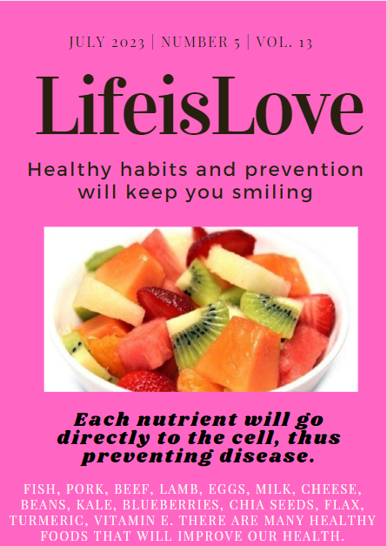
Example of my magazine

- Blog
Healthy Diet and Lifestyle Advice during uterine cancer
"Positive thoughts, more smiles"
My name is Flor de María, and I am a health and social care professional with 10 years of experience providing guidance on healthy lifestyle modifications. Please contact me on my professional page. if you have any questions.
https://www.global/healthalcareadvise.co.uk
Survival from cervical cancer has increased in the UK over the last 40 years (Cancer Research UK, 2020). This is because advances in health care have allowed the best promotion and prevention efforts to be established, allowing patients, especially women, to be fully informed about how to take care of their health. Unfortunately, some women remain extremely vulnerable and require additional support to receive proper medical care. Some have not yet been diagnosed and have an inadequate diet due to their culture and traditions, so they need additional care and advice to improve their diet, work on their emotions, and receive preventive care.
3.1 Health advice and promotion "LIFEISLOVE magazine"
My plan is to manage many social networks where patients can access my health advice that will help them recover. I will also promote the sale of my nutritional magazine. This project aims to provide modifications health advice so that they can change their habits and have healthy lifestyles. "If we avoid stress, eat healthy, and exercise, we will make a big difference." (Peeke, 2009). We may follow up with patients or people who read my blog to remind them to follow the treatment of their doctor and my health advice. In addition, we will organise groups on WhatsApp to invite patients to cook or take online classes, as well as provide spiritual support and teach them what kind of food to choose.
How they will recover their physical and mental well-being
- Study and be creative.
- Just relax.
- Spend some time in nature.
- Have new friends.
- Keep your physical health.
- Sleep enough.
(Mind, 2020)
In addition, having a healthy weight is essential. However, if you are overweight, replace your unhealthy lifestyle with a new and better one. Here are five ways to achieve this:
1. Do not drink sugary.
2. Do exercise because it burns calories and will help you build muscle.
3. Reduce time on your computer.
4. Consume small amounts of food.
5. Eat five servings of fruits and vegetables every day. Fruits and vegetables provide more than just vitamins and minerals. They are also high in fibre, so they fill you up. And eating fruits and vegetables makes you less likely to overeat. (Gavin, 2021).

3.2 Prevention and Recommendations to improve your health
You can access the information by clicking on the videos. "Do not give up."
- Have a smear test:
- It is very easy to do.
- It can save your life.
2. Yoga:
- Reduce stress.
- Sleep better.
- Avoid indigestion.
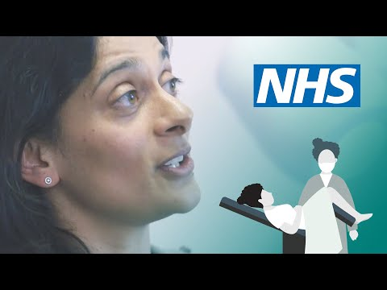


YOGA FOR BEGINNERS UK FLOW CLASS | WELL WITH HELS. (Well With Hels, 2020).

Cervical screening: what to expect | NHS (NHS, 2016).

3. Walk:
- Lose weight.
- Increase your energy.
- Strengthens the heart.
4. Eat health:
- Reduces the risk of some cancers.
- Stimulates immunity.
- Strengthens the bones.


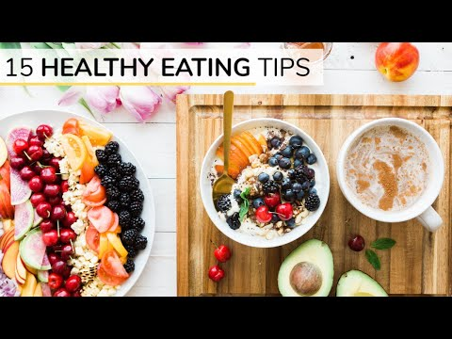

5 Surprising Health Benefits of Walking (And Why You Should Do It Everyday) - According To Science. (Hulme, 2020).

BEGINNERS GUIDE TO HEALTHY EATING | 15 healthy eating tips. (Clean & Delicious, 2017).

6. Emotional Support:
- You face problems.
- Speak freely and confidently.
- You let go of the emotional charge.
5. Provide Mental Health Support:
- It will help improve physical health.
- They will have some friends and work.
- The quality of life could be improved.


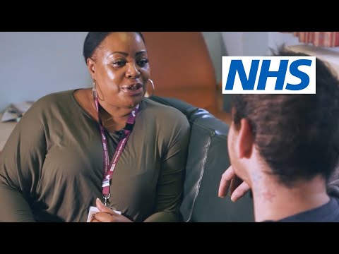

NHS Frontline: Mental Health Rehabilitation | NHS. (NHS, 2018).
How to help someone in need of emotional support. (ClearPointCounsellor, 2013).

7. Sleep for 8 hours:
- It will improve the mood.
- It will protect the heart.
- Reduces depression.



How To Sleep Better For Good Health: Matthew Walker | Bitesize. (Chatterjee, 2021).

3.3. Write in the blog with your expectations.
As you have watched the videos, you can prevent and lead a healthy lifestyle by making the decision to improve your health practices. How do you feel now that you have read my blog? Are you considering making changes in your life?
3.4. Scientific recommendations from Professor Cohen and educational psychologist Jefferies:
Cohen and Jefferies (2018) define the "Combination of Six" as a set of six lifestyle changes. Each is mutually beneficial, and the combination of all six results in the greatest success in improving cancer care. Making positive behavior changes as part of a lifelong process is what healthy living entails.
- Emotional and practical support: It will improve the quality of life of the patient and enable them to live longer life.
- Relaxation techniques, such as guided imagery, meditation, and yoga, can help reduce stress and maintain physical and mental health.
- Get enough sleep: Getting 7-8 hours of sleep each night will improve your health, skills, memory, concentration, mood, weight management, and other areas.
- Exercise regularly to reduce fatigue, decrease weight, and increase muscle mass. Also, avoid sitting or lying down for long periods of time.
- Eat right: A healthy diet can help you avoid the side effects of cancer, recover faster, and improve your overall health. It will also help healthy people reduce their future risk of cancer.
- Avoid surrounding yourself with toxins, such as cigarette smoke, asbestos, and dry-cleaning chemicals, which can increase your risk of cancer and other diseases. (Clemente, 2022).
Book "Mix of Six" Anti Cancer Living
If you are interested, you can buy it on Amazon.

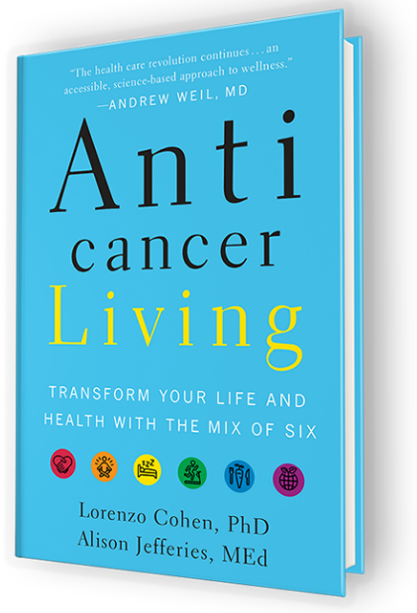

(Cohen and Jefferies, 2018)

3.5. Follow us on our social media



Follow us on:



Contact us on:





4407772567810

- Conclusion
My project will benefit society because it will help promote healthy habits and lifestyles by reducing the risk of disease in women and in the community. Women suffering from uterine cancer can also improve their mental and physical well-being if they follow my innovative recommendations.

- References

- NHS, (2016) Cervical screening: what to expect | NHS [video]. Available at: https://www.youtube.com/watch?v=Afdmh8E5K6M (Accessed: 11 March 2023).
- Well With Hels, (2020) YOGA FOR BEGINNERS UK FLOW CLASS | WELL WITH HELS [video]. Available at: https://www.youtube.com/watch?v=lkDtYf4wWo4 (Accessed: 11 March 2023).
- Steven, H. (2020) 5 Surprising Health Benefits of Walking (And Why You Should Do It Everyday) - According To Science [video]. Available at: https://www.youtube.com/watch?v=eY2FkUwmsb0 (Accessed: 11 March 2023).
- Clean & Delicious, (2017) BEGINNERS GUIDE TO HEALTHY EATING | 15 healthy eating tips [video]. Available at: https://www.youtube.com/watch?v=jwWpTAXu-Sg (Accessed: 11 March 2023).
- NHS, (2018) NHS Frontline: Mental Health Rehabilitation | NHS [video]. Available at: https://www.youtube.com/watch?v=Rg9RsIQRzL8 (Accessed: 11 March 2023).
- Rangan, Ch. (2021) How To Sleep Better For Good Health: Matthew Walker | Bitesize [video]. Available at: https://www.youtube.com/watch?v=QSU4CbYknqc (Accessed: 12 March 2023).
- ClearPointCounsellor, (2013) How to help someone in need of emotional support [video]. Available at: https://www.youtube.com/watch?v=1GQCFXWtxEw (Accessed: 12 March 2023).
- Savio, C. (2022) Lorenzo Cohen and Alison Jefferies On How We Survived Cancer. [Online]. Available at: https://medium.com/authority-magazine/dr-lorenzo-cohen-and-alison-jefferies-of-i-survived-cancer-and-here-is-how-i-did-it-69ffa39dd421 (Accessed: 13 March 2023).
- Cancer Research UK (2023) Uterine cancer statistics. [Online]. Available at: https://www.cancerresearchuk.org/health-professional/cancer-statistics/statistics-by-cancer-type/uterine-cancer (Accessed: 5 April 2023).
- Cancer.Net (2022) Uterine Cancer: Statistics. [Online]. Available at: https://www.cancer.net/cancer-types/uterine-cancer/statistics#:~:text=Worldwide%2C%20an%20estimated%20417%2C367%20people,cancers%20occur%20in%20the%20endometrium (Accessed: 5 April 2023).
- Anticancer Living (2018) Anti cancer Living. [Online]. Available at: https://anticancer-living.com/ (Accessed: 5 April 2023).
- NHS inform (2023) Cervical cancer. [Online]. Available at: https://www.nhsinform.scot/illnesses-and-conditions/cancer/cancer-types-in-adults/cervical-cancer (Accessed: 12 April 2023).
- Mid (2020) How to improve your mental wellbeing. [Online]. Available at: https://www.mind.org.uk/information-support/tips-for-everyday-living/wellbeing/wellbeing/ (Accessed: 12 April 2023).
- Cancer Research UK (n.d) Cervical cancer survival statistics. [Online]. Available at: https://www.cancerresearchuk.org/health-professional/cancer-statistics/statistics-by-cancer-type/cervical-cancer/survival (Accessed: 12 April 2023).
- Peeke, P. M. (2009) "Reduce Stress with Diet and Exercise", Pamela Peeke [blog]. 21 September. Available at: https://www.healthywomen.org/your-wellness/self-care--mental-health/reduce-stress-diet-and-exercise (Accessed: 12 April 2023).

