The module title: Marketing Essentials BMIH4005
Lecturer’s name : Scott James
Student name : Alina Cristina Ionita
Student id : 2246123

Table of Contents
Introduction 3
Situational Analysis of Hilton Hotel 3
Company 3
Customers 3
Competitors 3
Collaborators 4
Climate 4
Marketing Mix 4
Objective 5
Strategy 5
Tactics 6
Action 6
Control 7
Conclusion 7
References 8
Appendix 9

Introduction
The purpose of this study is to make a marketing plan for the Hilton Hotel, which is situated in London, the United Kingdom's city. Hilton Worldwide (formerly Hilton Worldwide Holdings Inc.) is an American global leisure company that runs and sells various hotels and resorts. In May 1919, Conrad Hilton started the company, and Christopher J. Nassetta is now the CEO. The main office of Hilton is in the US city of Tysons, in the state of Virginia (Stories From Hilton, 2023). This study will analyse the situational analysis of Hilton hotels which will cater 5Cs of Hilton hotels.

Situational Analysis of Hilton Hotel
The 5C Analysis is a marketing tool that looks at the surroundings of a business. In addition to putting you in danger of various external situations, it may also show you the most important factors for success (Corporate Finance Institute, 2020).

Company
One of the company's strengths is that it is known around the world and has a firm name (Research-Methodology, 2016). One of the company's problems is that there are often data breaches at work, and the company's sales are continuously down for a couple of years. There are chances to grow by entering new countries and taking advantage of the growing interest in outdoor travel. Costs are increasing, and there is a lot of competition in the United Kingdom.

Customers
Hilton may divide customers into groups based on their lifestyle, hobbies, views, and attitudes to give them more personalised experiences and services. Hilton may target business visitors, tourists, people who want luxury, or people who want to save money, depending on their needs and hobbies.

Competitors
Hilton could use perception placement maps to look at how its competitors position themselves and find ways to stand out. Other hotels in the hospitality business include Holiday Inn, Best Western, and Four Seasons (Visual-paradigm.com, 2023). Hilton needs to know what its unique value offering is and be able to tell its target market about it.
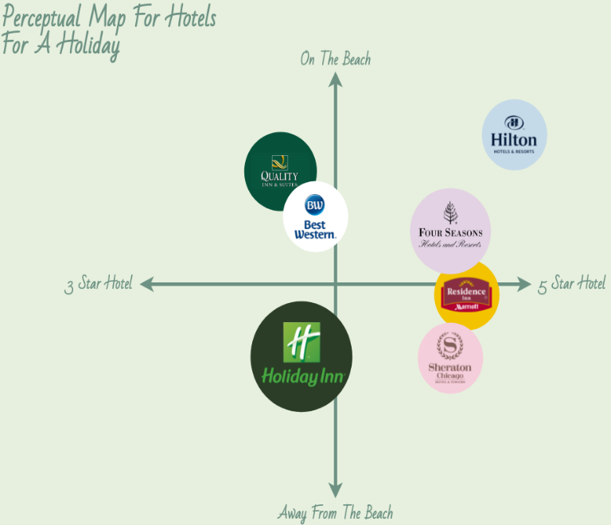
Figure 1: Perceptual map of Hilton Hotel
Source: (Visual-paradigm.com, 2023)

Collaborators
By working with planes and tour companies, Hilton can reach more people and get more bookings. Having trustworthy ties with partners and providers ensures that the standard is the same everywhere and makes it easier to enter new markets.

Climate
A PESTLE study looks at the big things in the world that affect Hilton. Laws, visa rules, and the political security of the host country are all political issues that affect the hotel business. Economic factors include GDP growth, exchange rates, and how much customers spend on relaxation and vacations. For example, changes in travel tastes and national norms can affect how people act. Sustainability and climate change affect how Hilton does business, but technological advances affect the company's cost structure and customer experience (MBA Skool Team, 2021). There are rules about data privacy, buyer safety, and jobs, among other things.

Marketing Mix
Hilton has a lot of different hotel names and services it can give to a wide range of customers. Pricing plans should consider market demand, how rivals price their products, and ways to control income. Partnerships and delivery networks that work well offer a wide range of booking and available choices. Promoting should be mostly about building brand recognition and doing internet marketing to reach the right people.

Objective
Specific: The goal is to get people to book only through the Hilton website and not through any other way.
Measurable: The goal of getting 10% more straight bookings is doable.
Achievable: Based on the market, the resources available, and the skills available, the goal is realistic and can be reached in the next six months.
Relevant: Hilton Hotels' overall business goals and marketing plan calls for them to get more direct bookings.
Time-bound: The goal sets a time limit of six months to grow direct meetings by 10%.

Strategy
As discussed above, Hilton is facing data breaching issues that cause poor reviews and sales of the business. The management of Hilton can improve these issues by adopting the Ansoff matrix in the business model.
Market development: Hilton could reach more people by focusing on new places and types of customers. This could mean putting more effort into neglected areas or groups of people (Jobber and Ellis-Chadwick, 2020). Hilton could do focused marketing in places where its brand could be more well-known to improve its brand's image and bring in new customers.
Product development: Hilton might change its services and goods to keep up with changing customer tastes. This could mean adding new parts, changing the ones that are already there, or working with nearby sites to offer unique experiences. Hilton could improve its image and get good feedback if it made its products better and more valuable.
The management of Hilton has to make some changes in services due to reduce data breach issues. In addition, management will improve its networking system to improve this issue. Management should also implement a low-price strategy in its business to attract customers toward the business.

Tactics
For a couple of years, sales of the Hilton hotel have been going down in an unfavourable position for management. The company want to increase its sales through different marketing channels. The company will use a communication marketing mix strategy to resolve this issue using different marketing channels.
Advertising: Hilton will offer its services, bring attention to special discounts or packages, and increase brand recognition via the use of various advertising mediums such as television, newspapers, and the Internet.
Social media marketing: Through the use of social media platforms like Facebook, Instagram, Twitter, and LinkedIn, Hilton is able to communicate with its audience (Smith and Zook, 2020). This involves entertaining information, addressing queries and comments from consumers, conducting events or giving away rewards, and displaying user-generated content.
Website optimisation: It should be easy to navigate the Hilton website and look and feel excellent on mobile devices. It must offer a lot of information about the hotel's features, amenities, and rooms, as well as online booking options for those things. The website may also feature client reviews, which would make the website more trustworthy.
Event Sponsorship: Hilton may collaborate with similar events or organisations to increase brand awareness and attract a certain kind of client. Hilton can demonstrate that it is a high-quality hotel brand and establish positive relationships with those who attend the event by providing financial support for the event (Bowie et al., 2017).

Action
Marketing activities | Week 1 | Week 2 | Week 3 | Week 4
Advertising
Social media marketing
Website optimisation
Event Sponsorship
Through these marketing channels, the management of Hilton can improve and overcome its issues that will directly impact the business's overall performance. These channels are helpful because approximately all multinational companies use these channels to increase their sales.

Control
The unique selling proposition (USP) is the thing that makes the top inn's product different from similar products with similar prices. When compared to its competitors, a product may use small-batch processes. If the business offers a service instead of a product, its unique selling point could be that it comes to the customer instead of making them come to the office (Kotler et al., 2020). Using "USP" and "unique selling position statement" is also fine.
How to measure
- The client wants to use the services again as soon as possible.
- Services offered by competitors are better.
- Companies use the same methods as rivals.

Conclusion
In some situations, the marketing plan's tactics and techniques are expensive and take a lot of time. People expect them to bring in money and make money over time. Hilton Hotel needs to make an investment right away to ensure the company's long-term success, growth, and revenue and keep its customers interested and happy. In addition to using these marketing methods and strategies, the company should do market studies regularly to understand current and future trends in the business.

References
Bowie,D. Buttle,F. Brookes,M & Mariussen,A (2017), Hospitality Marketing. 3rd ed, Routledge, London
Corporate Finance Institute (2020). 5C Analysis. [online] Corporate Finance Institute. Available at: https://corporatefinanceinstitute.com/resources/management/5c-analysis-marketing/.
Jobber, D. and Ellis-Chadwick, F (2020), Principles and practice of marketing. 9th ed. London:
Kotler, P., Armstrong, G., Harris, L. and He, H., 2020. Principles of marketing. 8th European ed, London: Pearson Education Limited.
MBA Skool Team (2021). Hilton PESTLE Analysis. [online] MBA Skool. Available at: https://www.mbaskool.com/pestle-analysis/companies/18162-hilton.html.
‌Research-Methodology (2016). Hilton SWOT Analysis - Research-Methodology. [online] Research-Methodology. Available at: https://research-methodology.net/hilton-swot-analysis/.
Smith PR & Zook ZE (2020) Marketing Communications. 7th ed, Kogan Page, London
Stories From Hilton. (2023). The Story of Hilton | Stories From Hilton. [online] Available at: https://stories.hilton.com/history.
Visual-paradigm.com. (2023). Perceptual Map For Hotels | Perceptual Map Template. [online] Available at: https://online.visual-paradigm.com/diagrams/templates/perceptual-map/perceptual-map-for-hotels/.
‌

Appendix

Slide 1

Slide 2

Slide 3

Slide 4

Slide 5

Slide 6

Slide 7

Slide 8

Slide 9

References
Jobber, D. and Ellis-Chadwick, F (2020), Principles and practice of marketing. 9th ed. London:
Kotler, P., Armstrong, G., Harris, L. and He, H., 2020. Principles of marketing. 8th European ed, London: Pearson Education Limited.
‌Research-Methodology (2016). Hilton SWOT Analysis - Research-Methodology. [online] Research-Methodology. Available at: https://research-methodology.net/hilton-swot-analysis/.
Smith PR & Zook ZE (2020) Marketing Communications. 7th ed, Kogan Page, London
Swan, S. (2022). How to use the SOSTAC® planning model and the RACE Framework. [online] Smart Insights. Available at: https://www.smartinsights.com/digital-marketing-strategy/sostac-plan-example/.

