2026
Assessment 1
Project Proposal Report

Module NaMe: Changemakers, Creativity and Value creation
Module Code: ACCA 5033
Student NAME: luciano dias dos santos
Student ID: 2335472
Lecturer:
Trinity saint david University of Wales (London Campus)

Table of Contents
Introduction 2
Main Body 2
Task 1 2
Ideation and Innovation 2
Innovation 2
Ideation 2
Research 3
Task 2 3
Project Scope 3
Proposed Solution 3
Research tools, Technologies and Resources 3
Task Schedule 3
Project timeline 3
Risk Assessment 4
Task 3 4
Development Method 4
Design 4
Conclusion 4
Reference 4
Appendices 4

Introduction
In today’s digital world, students use the internet every day for studying, communication, and social media. While technology makes life easier, it also creates new risks such as phishing, weak passwords, and unsafe browsing. Many students are not fully aware of these dangers, which can lead to serious problems like data loss or hacked accounts.
This project focuses on improving online safety awareness by creating a simple and practical guide for students. The idea is based on research from trusted sources and aims to help students understand common online risks and learn how to protect themselves.
The project explores cybersecurity in the education context and shows how simple actions can make a big difference in staying safe online. By providing clear information and useful tips, this project aims to support students in becoming more responsible and secure internet users.

Main Body

Mind Map

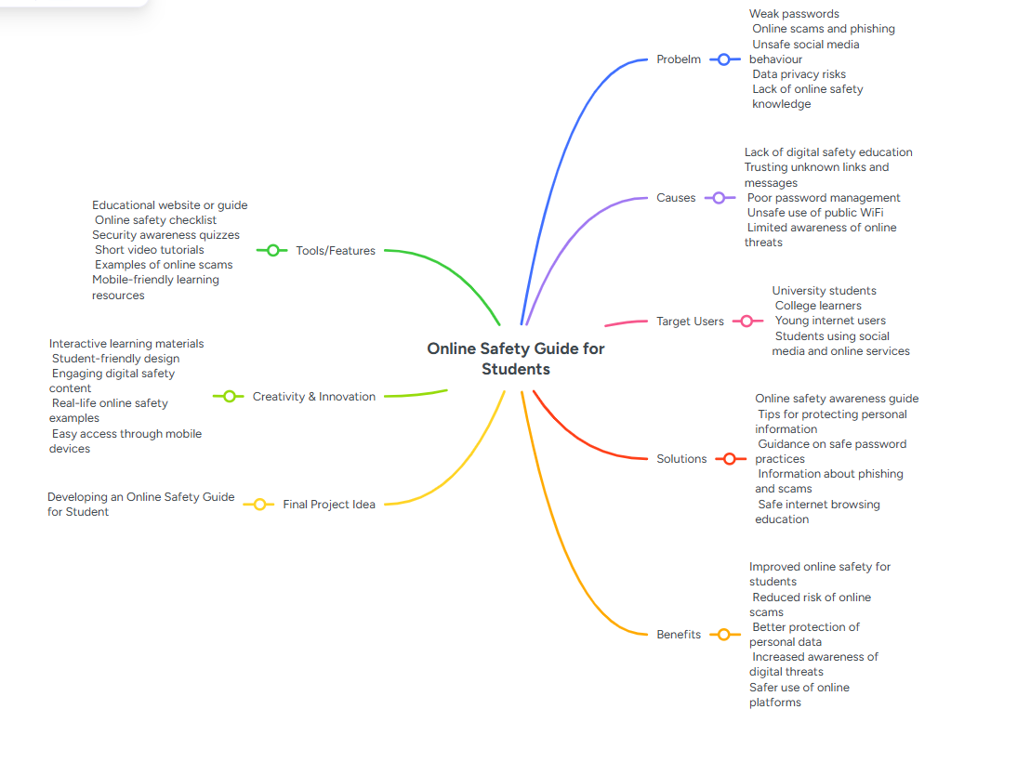
PROBLEM
The main problem identified is that many students are not aware of online risks.
They often use weak passwords, click on unknown links, and can become victims of phishing attacks.
CAUSES
The causes of these problems include lack of cybersecurity education, unsafe use of public Wi-Fi, and trusting unknown sources online.
TARGET USERS
The target users of this project are students who use the internet daily for studying, social media, and communication.
SOLUTION
The solution is to create an online safety guide that provides simple and practical advice on how to stay safe online.
BENEFITS
The benefits of this project include increased awareness, better protection of personal data, and reduced risk of cyber-attacks.
TOOLS/FEATURES
This project includes tools like an online guide with safety tips, checklists, and short videos. It will help student understand online risks in a way and be easy to use on mobile phones.
CREATIVITY INNOVATION
This project is creative because it uses simple and interactive content to make learning easier. It includes real-life examples and a design that is easy for students to understand .
FINAL PROJECT IDEA
The final idea is to create an online safety guide for students.
It will help them learn how to stay safe online and protect their personal information.
This project is about creating an online safety guide for students. I got this idea by researching online safety topics and looking at different websites such as ncsc, Cyber Aware, Kaspersky, Norton, and UK Safer Internet Centre. These sources helpd me understand common online problems like phishing, weak passwords, and unsafe social media use. Based on this, I decided to create a simple guide to help students safe online and protect their personal information.

Task: 1

Ideation and Innovation
This project is based on the idea of creating an online safety guide for students. I chose this topic because nowadays students spend a lot of time online for studying, communication, and social media, but many of them are not fully aware of the risks. From my research, I noticed that students often use weak passwords, click on unknown links, and can easily become victims of phishing attacks [1]. This shows that there is a real need to improve cybersecurity awareness among students.
Innovation is very important in today’s world because technology is always changing the way people live, work, and communicate. New technologies bring many benefits, but they also create new risks. In the case of cybersecurity, innovation helps protect users from threats such as hacking, phishing, and data theft. For example, technologies like two-factor authentication, antivirus systems, and secure networks are used to improve online safety[2]. These technologies are used in many areas such as education, banking, and social media, showing how important cybersecurity is in different industries
In the education sector, technology is widely used for online learning platforms, emails, and cloud storage. However, this also means that students are more exposed to cyber risks. This is why innovation in cybersecurity is important to protect users and their personal data. My project connects with this idea by focusing on helping students understand these risks in a simple and practical way.
The ideation process for this project started by researching different sources such as NCSC, Cyber Aware, Kaspersky, Norton, and UK Safer Internet Centre. These sources helped me understand common online problems such as phishing, weak passwords, and unsafe use of public Wi-Fi[3]. Based on this research, I decided to create a project that provides a simple solution to help students stay safe online.
The project idea is to develop an online safety guide that explains how students can protect themselves when using the internet. To understand this better, it is important to look at the history of cybersecurity. In the past, cybersecurity was mainly used by companies and governments, but today it is important for everyone because almost all daily activities are connected to the internet. Over time, cybersecurity has developed to include tools such as encryption, secure passwords, and user awareness training[4, pp. 178–191].
Cybersecurity is used in different countries and industries such as education, finance, healthcare, and business. In each of these areas, protecting data is very important. For example, banks use strong security systems to protect customer information, while schools need to protect student data. This shows how cybersecurity is important in many different contexts.
The impact of cybersecurity on the industry is very significant because it helps prevent data breaches and cyber-attacks. However, there are also some challenges, such as the cost of implementing security systems and the lack of user awareness. Many people do not follow safe practices even when security tools are available.
This project will contribute to the modern world by helping students improve their online safety and become more responsible users. The positive impact includes better protection of personal information and reduced risk of cyber-attacks. On the other hand, one limitation is that users need to be willing to learn and apply the advice given.
There are also challenges in implementing this project, such as making the content simple and engaging for students. Another challenge is ensuring that the information is always up to date because cyber threats are constantly changing.
The stakeholders of this project include students, educational institutions, and society in general. Students will benefit by becoming more aware of online risks, schools will benefit by having safer students, and society will benefit from improved digital safety.
To support this project, I used different research sources including Google Scholar and trusted cybersecurity websites. These sources were selected because they provide reliable and up-to-date information about online safety. Using these sources helped me build a strong foundation for my project idea.
Overall, this project is based on real problems identified through research and offers a practical solution. The online safety guide aims to educate students and help them protect their personal information in a simple and effective way[5].

.

Task: 2
Project Scope and Proposed Solution
This project focuses on cybersecurity within the education sector, specifically on students who use the internet daily. The chosen technology is cybersecurity, which plays an important role in protecting users from online threats such as phishing, hacking, and data theft[6]. In today’s digital world, students are constantly connected through online learning platforms, social media, and communication tools, which increases their exposure to cyber risks.
In many organisations, especially schools and universities, cybersecurity is used in different departments such as IT services, administration systems, and online learning platforms. These systems store sensitive information like student data, login details, and academic records, which makes them a target for cyber-attacks. Because of this, cybersecurity is very important to ensure that information is protected and systems are secure.
There are many benefits of cybersecurity in this context. It helps protect personal data, reduces the risk of cyber-attacks, and increases trust in digital systems. For students, it also helps them understand how to behave safely online. However, there are also some drawbacks. For example, implementing cybersecurity systems can be expensive, and sometimes users find security measures complicated or inconvenient. Also, even with strong systems in place, human error remains a major problem, as many users still click on unsafe links or use weak passwords.
Looking at the future, cybersecurity will continue to grow and become even more important. With the increase of online learning and digital platforms, students will depend even more on technology. This means organisations will need stronger security systems and better education for users. New technologies such as artificial intelligence and automated security systems may help improve protection[7], but user awareness will still be essential.
The proposed solution for this project is to create an online safety guide designed specifically for students. The motivation behind this idea comes from the research I conducted, which showed that many students lack basic knowledge about online safety. My expectation is that this guide will help students understand common risks and learn simple ways to protect themselves.
This guide will include practical advice such as creating strong passwords, recognising phishing messages, and using safe browsing practices[8]. It will also include checklists and short videos to make the content more engaging and easier to understand. The goal is to provide a solution that is simple, clear, and useful in real-life situations.
To develop this project, I used different research tools and resources. I used Google Scholar to find academic articles related to cybersecurity and student awareness. I also used trusted websites such as NCSC, Kaspersky, and Norton because they provide reliable and up-to-date information. These sources were selected based on their credibility and relevance to the topic.
To ensure the information is trustworthy, I compared different sources and checked if they provided similar information. This helped me confirm that the data used in the project is accurate and reliable.
The technologies planned for this project include creating a simple website or digital guide that is mobile-friendly. This is important because most students use their phones to access information. The guide may also include videos, images, and interactive content to improve user experience.
For the task schedule, I will divide the project into stages. First, I will conduct research and collect information. Second, I will design the structure of the guide. Third, I will develop the content, including text, tips, and visuals. Finally, I will review and improve the guide based on feedback.
The project timeline will follow a simple structure. In the first week, I will focus on research. In the second week, I will work on design and planning. In the third week, I will develop the guide. In the final week, I will review and make improvements.
There are also some risks involved in this project[9]. One risk is lack of time, which can affect the quality of the work. Another risk is limited technical knowledge, which may make development more difficult. There is also a risk that the information may become outdated quickly. To reduce these risks, I will plan my time carefully, use simple tools, and rely on trusted and regularly updated sources.
Overall, this project aims to provide a practical and effective solution to improve online safety among students. By combining research, simple design, and useful content, the project can help students become more aware and protect themselves better in the digital world.

Task: 3
Development Method, Design and Conclusion
In this project, I will use the Waterfall development method. I chose this method because it is simple, clear, and easy to follow, especially for a project like this. The Waterfall model is a linear approach where each stage is completed before moving to the next one. This makes it easier to organise the work and understand each step of the project.
The first stage is the requirements stage, where I identify the problem and understand what the project needs to achieve. In this case, the main goal is to create an online safety guide that helps students understand online risks and protect themselves.
The second stage is the design stage. In this stage, I plan how the guide will look and how the information will be organised[10, pp. 1–39]. The design will be simple, clear, and easy to use, especially on mobile devices. The guide will include sections such as password safety, phishing awareness, and safe browsing.
The third stage is the development stage, where the actual content of the guide is created. This includes writing the text, creating checklists, and adding short videos or images to make the guide more interactive and engaging.
The fourth stage is the testing stage[11, pp. 20–40]. In this stage, I will review the guide and check if everything works correctly. I may also ask a small group of students to give feedback to see if the content is clear and useful.
The final stage is the deployment stage, where the guide is completed and ready to be used.
For the design part of this project, I will create a simple wireframe to show how the guide will look. The layout will include a home page with a title and introduction, followed by sections such as “Stay Safe Online”, “Create Strong Passwords”, and “Avoid Phishing”. Each section will have short explanations, tips, and examples. The design will be clean and easy to navigate so that students can quickly find the information they need.
Another design idea is to include visual elements such as icons and simple images to make the guide more attractive and easier to understand[12]. This is important because students are more likely to engage with content that is visually clear and not too complicated.
In conclusion, this project focuses on creating an online safety guide to help students improve their cybersecurity awareness. The project is based on real problems such as weak passwords and phishing attacks, which affect many students today. By using a simple development method and clear design, the project aims to provide practical solutions that students can use in their daily lives.
The project also highlights the importance of cybersecurity in modern society and how education can help reduce online risks. Although there are some challenges, such as keeping the information up to date, the overall impact of the project is positive. It helps students become more aware, responsible, and safe when using the internet.

Conclusion

In conclusion, this project focused on creating an online safety guide for students to help them understand and reduce online risks. Throughout the project, it became clear that many students are not fully aware of dangers such as phishing, weak passwords, and unsafe browsing. This shows the importance of improving cybersecurity awareness in a simple and practical way.
The project used research from reliable sources to identify common problems and develop a solution that is easy to understand and use. By creating a guide with tips, checklists, and simple explanations, the project aims to support students in protecting their personal information and using the internet more safely.
Overall, this project highlights how important cybersecurity is in today’s digital world and how education can help reduce online risks. Even though there are some challenges, such as keeping information updated, the project provides a useful and realistic solution that can benefit students in their daily online activities.

Reference

S. Livingstone, J. Davidson, J. Bryce, S. Batool, C. Haughton, and A. Nandi, “Children’s online activities, risks and safety: a literature review by the UKCCIS evidence group,” 2017.
W. Stallings, Effective cybersecurity: a guide to using best practices and standards. Addison-Wesley Professional, 2018.
M. Bada, A. M. Sasse, and J. R. Nurse, “Cyber security awareness campaigns: Why do they fail to change behaviour?,” 2019.

M. Bishop, Introduction to computer security. Addison-Wesley Professional, 2004.
J. R. Nurse, K. Adamos, A. Grammatopoulos, and F. Di Franco, “Addressing the EU cybersecurity skills shortage and gap through higher education,” 2021.
V. Tsoulis and A. Panagiotidis, “Professional development skills in online education,” pp. 20–40, 2023.
T. Matthews et al., “Supporting the digital safety of at-risk users: Lessons learned from 9 years of research and training,” vol. 32, no. 3, pp. 1–39, 2025.
C. Odo, “Strengthening cybersecurity resilience: The importance of education, training, and risk management,” 2024.
M. I. Mahaini and S. Li, “Cyber Security Researchers on Online Social Networks: From the Lens of the UK’s ACEs-CSR on Twitter,” presented at the International Symposium on Security and Privacy in Social Networks and Big Data, Springer, 2023, pp. 129–148.
S. Furnell and E. Stavrou, Cyber security and the digital student. in The Digital Student. Elsevier, 2026, pp. 169–195.
D. M. Zulqadri, A. Mustadi, and H. Retnawati, “Digital safety during online learning: what we do to protect our student?,” vol. 7, no. 1, pp. 178–191, 2022.
K. Thakur and A.-S. K. Pathan, Cybersecurity fundamentals: A real-world perspective. CRC Press, 2020.

