BA LEADERSHIP AND MANAGEMENT SKILLS FOR THE WORPLACE

MODULE NAME: PROJECT MANAGEMENT

MODULE CODE: LCLM5003

ASSIGNMENT TITLE: PART A- PART B- PART C

STUDENT NAME: ZIE ALAIN COULIBALY

STUDENT ID: 2429488

LECTURER NAME : XAVIER MATIENI

TABLE OF CONTENTS
ASSIGNMENT PART A : POSTER 4
ASSIGNMENT PART: B CRITICAL REFLEXION 5
INTRODUCTION 5
DESCRIPTION 5
FEELINGS 5
EVALUATION 5
GOOD ACTION 5
WRONG ACTION 5
ANALYSIS 6
CONCLUSION 6
ACTION PLAN 6
ASSIGNMENT PART C: PROJECT MANAGEMENT PLAN 7
1. INTRODUCTION 7
2. PROJECT DESCRIPTION 7
2.1 Project Title 7
2.2 Project objectives 8
3. SCOPE 8
3.1 In-Scope 8
3.2 Out-of-Scope 8
3.3 Scope Management Approach 9
4. WORK BREAKDOWN STRUCTURE (WBS) 9
5. QUAD CHART 9
6. GANTT CHART 10
7. IRON TRIANGLE 11
8. STAKEHOLDER INVOLVEMENT 12
8.1 Stakeholder Identification 12
8.2 Stakeholder Analysis 12
8.3 RACI MATRIX 14
8.4 Communication Engagement Strategy 14
9. ALLOCATION OF RESOURCES 15
9.1 Human Resources 15
9.2 Financial Resources 15
10. RISK ANALYSIS 16
11. CONCLUSION 16
12. REFERENCES 17

ASSIGNMENT PART A : POSTER
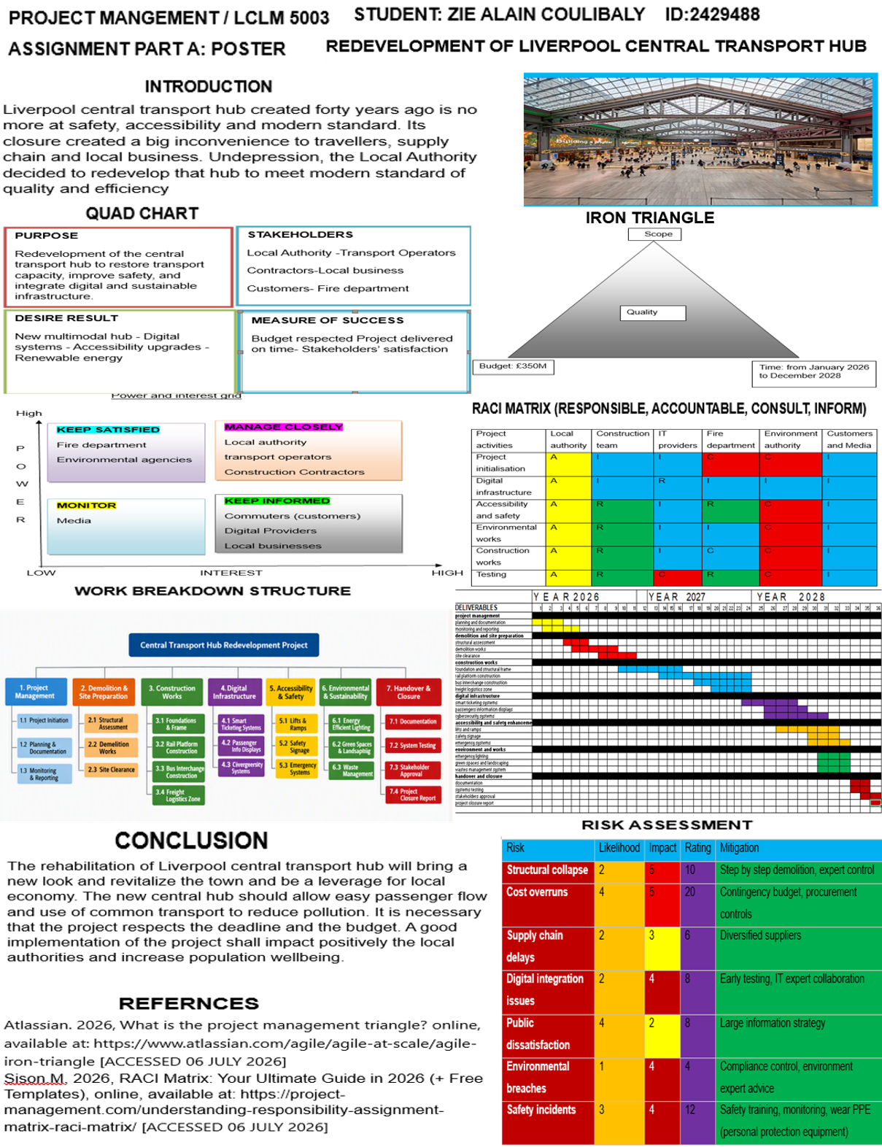

ASSIGNMENT PART: B CRITICAL REFLEXION

INTRODUCTION
One assignment that I have to do this year, in Project Management, is to conduct a critical reflection on a presentation that I hold in class in front of my peers and my teacher. In this refection, I will follow Gibbs reflective cycle (1988) to conduct my critical reflection. First, I will describe the situation, give my feelings that day, evaluate and analyse the fact and then give a conclusion follow by an action plan.
DESCRIPTION On the 18th of July, I was called for a poster presentation in class in front of my teacher and my peers, on the module: Project Management. The topic was to create a poster of a project to the redevelopment of Liverpool central transport hub which was no more at safety and modern standard requirements. The poster had to show the main key points of the project that I would have to explain.

FEELINGS
Before my presentation, I was confident and sure that I should remember all the details of each point of my poster. I arrived in classroom relax and ready. As I know, I am a person who is not ashamed to talk in public. I have been before in some association as general secretary, so I had the habit of talking in public.

EVALUATION

GOOD ACTION
I did not face the board every time during my presentation to read what was written. I was mobile trying to react with the public. I cover all the topic asked by the assignment guideline, my poster was clear and every frame was disposed in coherent order. The different titles were clearly evidenced.

WRONG ACTION
From my peers, I have been blamed for speaking very fast and I did not pronounce properly the words that created a misunderstanding of what I was saying. From my teacher, my dress was not appropriated for a presentation (a jean and t-shirt), I made some writing mistakes (gantt instead of guantt). And very important, my stakeholders analysis was not complete and my gantt chart too basic.

ANALYSIS
At my presentation, I was worrying about the time so I started speaking too fast though that it would have helped me expose my work in the right slot of time. The writing mistakes were due to the fact that I did not read my poster more time and even thought to check some mistakes before submitting. I went in class that day without thinking about my dress for the presentation, I dressed as a usual class lesson, I focused on the presentation only putting apart all detail around it.

CONCLUSION
Receiving this feedback from peers and teacher, I know now that some improvements had to be made to my work. Specially correct my writing mistakes, give more details to my stakeholders analysis to make it a little bit more complete.
ACTION PLAN For my future, from this feedback, three things went out that I have to keep constantly in mind: always read my writings to correct mistakes before sending it, keep calm when I am talking to pronounce correctly the words, and always adapt my dressing to the event.

ASSIGNMENT PART C: PROJECT MANAGEMENT PLAN

REDEVELOPMENT OF LIVERPOOL CENTRAL TRANSPORT HUB: REGENERATION PROGRAMME (2026–2028)

1. INTRODUCTION
The closure decision of Liverpool central transport hub in November 2025 created a big inconvenience to commuter mobility, goods transportation, and local economic activity. The central hub was the primary interchange for regional rail, bus, and merchandise operations, and its old and weak structural presented a long-standing deficiency in safety, accessibility, and digital infrastructure. The closure decision generated economic losses, public dissatisfaction, and mobility issues. Under political and citizens pressure, the Local Authority decided an urgent and coordinated redevelopment programme aligned with modern transport standards, environmental targets, and inclusive urban design principles.
The Project Management team work out an approach for delivering a suitable project programme tilted: Redevelopment and modernisation of Liverpool Central Transport Hub. The project plan demonstrates how the project management team will use project management methodologies, tools, and techniques to ensure successful delivery to stakeholders, including local authorities, transport operators, businesses, and the public.
The project management team will follow established project management frameworks, and UK government infrastructure delivery guidance. It will provide a structured plan covering project description and scope, work breakdown structure (WBS), quad chart, Gantt chart, stakeholder involvement, resource allocation, and risk analysis.

2. PROJECT DESCRIPTION
“A project description is crucial because it provides a clear and concise overview of the project's objectives, scope, and expected outcomes. It serves as a foundation for all stakeholders, ensuring that everyone involved has a common understanding of the project's goals and requirements.” (Malsam. W, 2023)

2.1 Project Title
Liverpool Central Transport Hub Redevelopment Project (LCTHRP)

2.2 Project objectives
The project objective is to design, build, and commission a modern, safe, accessible, and digitally enabled transport hub that restores capacity, great regional connectivity, and sustainable long‑term economic and environmental goals. The old and unsure parts will be replaced by modern facilities to be at UK safety and accessibility standards, with multimodal operations across rail, bus, freight, cycling, and micro‑mobility, and integrating digital infrastructure such as real‑time passenger information, smart ticketing.
The project further seeks to reduce carbon emissions through sustainable design, renewable energy systems, while reducing construction disruption and remodelling the hub to full operational capacity by 2028. The project provides a new structural framework and upgraded platforms, a modernised bus interchange and freight facilities, helpful digital systems, enhanced accessibility features, renewable energy installations, improved public waiting area, and handover documentation.

3. SCOPE
“Establishing the scope creates a shared understanding of the project’s intended outcomes. Project teams can understand the work needed to deliver expected outcomes, while stakeholders can recognize the project’s priorities and boundaries.” (White. A. 2026)

3.1 In-Scope
The project scope is to redevelop Liverpool central transport hub, make it more modern aligned with modern standard. It covers stakeholder engagement and public consultation, recruiting the best contractors based on experience and reputation, acquisition of new generation materials, and technology systems. and a full testing commissioning programme, and operational readiness activities. All works will be compiled with relevant UK building regulations, transport standards, and environmental legislation to ensure the central hub is safe, sustainable, and adequate for long‑term regional connectivity and inclusive urban access.

3.2 Out-of-Scope
The project explicitly excludes renewal of external road networks out of the immediate hub perimeter, long-term commercial development such as non-essential retail units, regional railway’s line improvements outside the station boundary, and any freight network expansion beyond the limits of the transport hub itself.

3.3 Scope Management Approach
Scope will be controlled through a formal Change Control Process that requires all modifications to be submitted as change requests. These modifications will be assessed for their cost, time, and risk impacts, and approved by the Project team manager before any adjustments are made. Once approved, updates will be inserted to the scope database and associated documentation. This structured approach ensures scope stability and prevents scope creep, a frequent driver of project delays and overruns.

4. WORK BREAKDOWN STRUCTURE (WBS)
“A work breakdown structure is a hierarchical decomposition of a project into smaller, more manageable components called work packages.
This framework helps project managers estimate costs, assign responsibilities, and track progress with greater precision throughout the project lifecycle.
Organizing tasks into a visual tree or outline ensures that no critical deliverables are overlooked during the planning phase.
Break your project down until each task is small enough to be accurately estimated and assigned to a single owner.” (Finch. G, 2026)

Level 1 –Liverpool Central Transport Hub Redevelopment Project
Work Breakdown Structure (WBS) diagram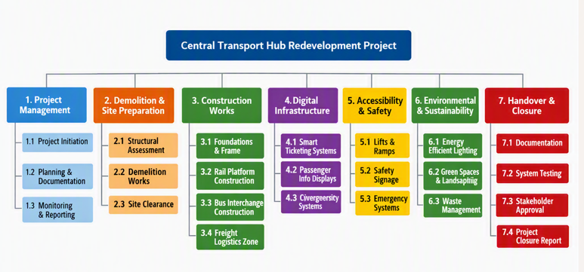

5. QUAD CHART
A quad chart is a visual and descriptive one-page summary of a project to explain what the project is about. It helps to structure an idea into manageable pieces to define what to do before starting. It is used to present a new project establishing the aim, the stakeholders, the desire result and the measure of success.
PURPOSE
Redevelopment of the central transport hub to restore transport capacity, improve safety, and integrate digital and sustainable infrastructure.

STAKEHOLDERS
Local Authority -Transport Operators
Contractors-Local business
Customers- Fire department
Environment agency

MEASURE OF SUCCESS
Budget respected Project delivered on time- Stakeholders’ satisfaction

DESIRE RESULT
New multimodal hub - Digital systems - Accessibility upgrades - Renewable energy

6. GANTT CHART
A Gantt Chart is a visual project management tool that represents tasks along a timeline using horizontal bars. Each bar represents a task duration, the beginning and the end of a task, and the status of progression. The Gantt Chart simplify the project planification and allow to follow tasks progress on a timeline.
Gantt Chart components
Deliverable List: which is a subdivision of all activities required to complete the project
Timeline: All the project duration divided into units (days/weeks/months)
Bars: Representation of each task’s duration

PROJECT GANTT CHART
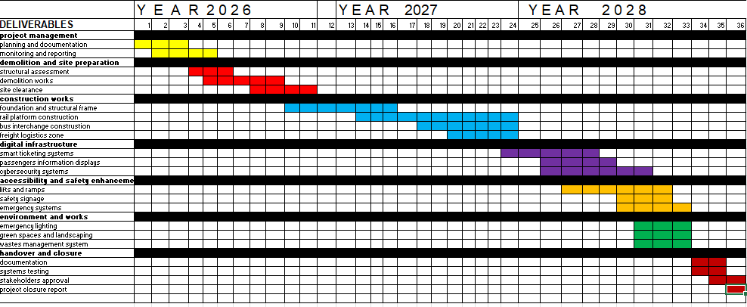

7. IRON TRIANGLE
“The project management triangle is a foundational model that defines the three core constraints governing every project: Scope (the work to be done), Time (the schedule available to do it), and Cost (the budget allocated to complete it). A change to any one constraint will affect the others, meaning no project manager can adjust one side of the triangle without consequence. Also called the iron triangle or triple constraint”. (Institute project management, 2026). The iron triangle is a visual design that show the three constraints that shape every project from the beginning to the end. These three constraints are interdependent.
Scope

Quality

Budget: £350M

Time: from January 2026 to December 2028

One peak on the Iron Triangle represents the amount of the budget which is three hundred seventy-five millions of Sterling. Necessary amount set up for completing the project. The second peak of the triangle represents the duration of the project: from January 2026 to December 2028. The third peak is the scope of the project, the guidance of the work to be done. The respect of all these peaks (the core of the project) result in quality project (in the middle of the triangle).

8. STAKEHOLDER INVOLVEMENT
A stakeholder is either an individual, a group of individual or an organization that is affected by the repercussion of a project or a business. Stakeholders can have an interest or power in the success of the project and can be in or outside the organization that is leading the project. Stakeholders are important because they can influence positively or negatively the good ongoing of the project with their decisions. A stakeholder can be a critical stakeholder or a key stakeholder, and their engagement is important for the project success.

8.1 Stakeholder Identification
Local Authority – project owner
Transport Operators (Rail, Bus, Freight) – operational stakeholders
Construction Contractors – delivery partners
Digital Providers – technology suppliers
Local Businesses – affected by disruption
Commuters and Residents – customers
Environmental Agencies – regulatory oversight
Fire departments- safety and fire prevention
Media

8.2 Stakeholder Analysis

Power and interest grid
High
MANAGE CLOSELY
Local authority
transport operators
Construction Contractors

KEEP SATISFIED
Fire department
Environmental agencies

P
O
W
KEEP INFORMED
Commuters (customers)
Digital Providers
Local businesses

E
MONITOR
Media
R

LOW INTEREST HIGH
A Power Interest Grid or Power Interest Matrix is a stakeholder management method based on stakeholders' power and influence in a project. It identifies each stakeholder's contribution using documentation, workshops, and business process maps, creating a stakeholder mapping grid to determine their power and interest (KnowledgeHut 2026).
The Power Interest Grid classify stakeholders, and their contribution in the project implementation based on impact, influence and involvement. using the Power Interest Grid managers can identify the right tools and action to involve stakeholders and which stakeholder to focus on for the project success.
In the current project, Local Authorities, transport operators and construction team must be managed closely because they have the power to deeply influence or impact the project and more interest in the project success for their revenue. Fire Department and Environmental Authorities must be kept satisfied because they have the power to influence the project for non-compliance of regulation but are not affected by the success or not of the project. Customers, digital providers and local business, keep informed on the ongoing of the project. Their interest on the project success is high for revenue income or mobility. The media have no power to impact on the project and no interest in the project success, so they must be monitored, they can be a good asset for the project.

8.3 RACI MATRIX
A RACI matrix is a project management tool that defines clear roles for each team member all along the projection duration. It useful to clarify responsibilities and role, avoid repeat work and improve communication and enhance accountability.
RACI stands for: Responsible, Accountable, Consulted, Informed
Project activities | Local authority | Construction team | IT providers | Fire department | Environment authority | Customers and Media
Project initialisation | A | I | I | C | C | I
Digital infrastructure | A | I | R | I | I | I
Accessibility and safety | A | R | I | R | C | I
Environmental works | A | R | I | I | C | I
Construction works | A | R | I | C | C | I
Testing | A | R | C | R | C | I

Responsible: the one responsible for the task to develop and complete the project.
Accountable: They review the work, confirm it meets the required standard
Consulted: their expertise is needed before starting the task
Informed: they do not make decisions or get consulted; they are just informed on the ongoing of the project.

8.4 Communication Engagement Strategy
The communication engagement strategy is used to determine the different channels of communication and frequency in which stakeholders will be kept updated on the project ongoing. The communication can be done by face-to-face meeting (F2F), by emails, report or video call based on a schedule frequency.

 | information channels
stakeholders | f2f meeting | emails | report | video call
Local Authority | Once in a week | No | Every two months | No
Constructor team | Every three days | If necessary | Every month | If necessary
IT providers | Every three days | If necessary | Evey month | If necessary
Fire Department | Once in the week | No | Every two months | If necessary
Environment Authority | Every two weeks | If necessary | Every two months | If necessary
Customers and Media | No | Every two weeks | Once every three months | No
Effective stakeholder communication engagement reduces resistance, improves decision-making, and enhances project success.

9. ALLOCATION OF RESOURCES

9.1 Human Resources
Project Manager | overall leadership
Engineering Team | structural, civil, mechanical
Digital Systems Team | IT, cybersecurity
Environmental Specialists | sustainability compliance
Accessibility Consultants | inclusive design
Contractors | construction delivery
Legal Team | contracts and compliance

9.2 Financial Resources
Estimated budget: £350 million Breakdown:
Demolition | £ 25 million
Construction | £ 200 million
Digital infrastructure | £ 50 million
Accessibility | £ 25 million
Environmental works | £ 35 million
Contingency | £ 15 million

10. RISK ANALYSIS
A risk assessment is the process of identifying what could go wrong during the project, giving a value from one to five on how likely this risk can happen and a value from one to five on the impact of that risk on the project, and then decide what to do about it.
Risk | Likelihood | Impact | Rating | Mitigation
Structural collapse | 2 | 5 | 10 | Step by step demolition, expert control
Cost overruns | 4 | 5 | 20 | Contingency budget, procurement controls
Supply chain delays | 2 | 3 | 6 | Diversified suppliers
Digital integration issues | 2 | 4 | 8 | Early testing, IT expert collaboration
Public dissatisfaction | 4 | 2 | 8 | Large information strategy
Environmental breaches | 1 | 4 | 4 | Compliance control, environment expert advice
Safety incidents | 3 | 4 | 12 | Safety training, monitoring, wear PPE (personal protection equipment)
Rating =likelihood x impact
It is very important to continue monitoring the risk, establish a monthly risk assessment review, keep an updated register of risk and a procedure for severe risk to reduce the likelihood of risk to happen.

11. CONCLUSION
The redevelopment of Liverpool Central Transport Hub is an important infrastructure project essential for rehabilitate transport capacity, enhance local economy, and deliver long-term urban sustainability. This Project Management Plan provides a structured and a large approach to managing the project from initiation to closure. The project must strictly follow the project management methodologies, establish a great stakeholder engagement, an effective and efficient resource allocation, and a proactive risk management, to have a total success and delivered the new edifice in time.
The plan shows how modern transport infrastructure can be delivered in conformity with safety, accessibility, digital innovation, and environmental objectives. It ensures that the regenerated hub will serve as a resilient, inclusive, and future-ready asset for the city and its residents.

12. REFERENCES
Ahsan, K., Ho, M. and Khan, M. (2013) ‘Recruitment and selection processes in project management’, International Journal of Project Management, 31(3), pp. 395–404. Association for Project Management (APM) (2021) APM Body of Knowledge. 7th ed. Buckinghamshire:
APM. Bryde, D. (2008) ‘Perceptions of the impact of project management performance’, International Journal of Project Management, 26(8), pp. 827–840. Flyvbjerg, B. (2014) ‘What you should know about megaprojects’, Project Management Journal, 45(2), pp. 6–19.
Geeksforgeeks. 2026, What is Gantt Chart in Project Management, online Available at: https://www.geeksforgeeks.org/business-studies/what-is-gantt-chart-in-project-management/ [Accessed: 13 august 2026]
Finch, G. 2026, Work breakdown structure (WBS): Definition and step-by-step guide,online. Available at: https://www.atlassian.com/work-management/project-management/work-breakdown-structure [Accessed: 13 august 2026]
Gibbs, G. (1988) Learning by Doing: A Guide to Teaching and Learning Methods. London: Further Education Unit (FEU), Oxford Polytechnic.
Government (2020) National Infrastructure Strategy. London: HMSO. Ward, S. and Chapman, C. (2003) ‘Transforming project risk management’, International Journal of Project Management, 21(2), pp. 97–105. Winch, G. (2010) Managing Construction Projects. 2nd ed. Oxford: Wiley-Blackwell.
Institute project management, 2026, Project Management Triangle: The Complete Guide 2026, online. Available at: https://projectmanagement.ie/blog/project-management-triangle/ [Accessed: 13 august 2026]
Kerzner, H. (2022) Project Management: A Systems Approach to Planning, Scheduling, and Controlling. 13th ed. New York: Wiley. Müller, R. and Turner, R. (2010) ‘Leadership competency profiles of successful project managers’, International Journal of Project Management, 28(7), pp. 437–448. Office of Rail and Road (ORR) (2023) Rail Infrastructure
KnowledgeHut 2026 What is Power Interest Grid? How to Use, Benefits, Examples, blog. Available at: https://www.knowledgehut.com/blog/project-management/power-interest-grid [Accessed: 13 august 2026]
Landau, P. 2025, What Is a Stakeholder? Definitions, Types and Examples, blog. Available at: https://www.projectmanager.com/blog/what-is-a-stakeholder [Accessed: 13 august 2026]
Malsam, W. 2023 How to Write a Project Description: A Quick Guide, online. Available at: https://www.projectmanager.com/blog/how-to-write-a-project-description-quick-guide [Accessed: 13 august 2026]
Riskwatch. 2026, What is a risk assessment? .online. Available at: https://www.riskwatch.com/what-is-a-risk-assessment/ [Accessed: 13 august 2026]
Safety Standards. London: ORR. Project Management Institute (PMI) (2021) PMBOK Guide. 7th ed. Pennsylvania: PMI. Raz, T. and Michael, E. (2001) ‘Use of risk management tools in project planning’, International Journal of Project Management, 19(1), pp. 9–17. UK
Sison,M . 2026 RACI 2026 RACI our Ultimate Guide in 2026 (+ Free Templates), online. Available at: https://project-management.com/understanding-responsibility-assignment-matrix-raci-matrix/ [Accessed: 13 august 2026]
White, A. 2026, How to define and create a project scope, online. Available at: https://www.phoenix.edu/articles/business/how-to-define-project-scope.html [Accessed: 13 august 2026]

