Dissertation – Proposal
LCBB6000
BA (Hons) Business Management
University of Wales Trinity Saint David (London Campus)

Student name: Valentin Masala
Student ID:2236548
Proposed research title -The future of work: Impact of AI and Automatizations in transforming warehouse operations and management logistic.
Name of the university- Trinity Saint David.
Submission date:20/08/2026.

Tables of Contents

Chapter 1: Introduction ……….……………………………………………………………………3
1.1. Introduction to the topic ……….………………………………………………………….3
1.2. Research Problem………………………………………………………………………. 3
1.3. Purpose of the research …………………………………………………………………..3
1.4. Proposed aim, objectives and research questions……………………………. 3
1.5. Significance of the topic………………………………………………………………. 4
Chapter 2: Literature Review………………………………………………………………….. 5
Chapter 3: Research Methods and Methodology……………………………………….. 6
3.1. Research Philosophy……………………………………………………………………………… 6
3.2. Approach to Theory Development…………………………………………………………. 6
3.3. Methodological Choice …………………………………………………………………………….6
3.4. Research Strategies………………………………………………………………………………… 6
3.5. Time Horizon………………………………………………………………………………….. 6
3.6. Data Collection and Data Analysis …………………………………………………………7
3.7. Time prospects of the research………………………………………………………….. 7
3.8. Ethical consideration of the research……………………………………………………… 7
Chapter 4: Conclusions and Recommendations…………………………………………………8
References and Bibliography……………………………………………………………………….. 9

Chapter 1: Introduction
Artificial intelligence (AI), robotics and automated systems are reshaping warehouse operations across the UK. Technologies such as autonomous mobile robots (AMRs), automated storage and retrieval systems (AS/RS), computer vision, predictive analytics and advanced Warehouse Management Systems (WMS) are improving speed, accuracy and cost efficiency. These tools support real-time inventory visibility, reduce human error, and enhance fulfilment performance (Wang, 2019). Recent studies show that automation is no longer optional but increasingly essential for competitiveness in retail, e-commerce and logistics.

1.2 Research Problem
Automation is increasingly taking over tasks once carried out by warehouse workers. Robots, automated conveyors and AI-driven systems now handle repetitive activities such as sorting parcels, inspecting stock, picking orders and packing goods. This shift means fewer people may be needed in routine, low-skill roles (Azadeh, De Koster and Roy, 2019). Although up to 52% of warehouse tasks could be automated by 2035, current adoption is only around 14% (London Economics, 2021), suggesting gradual change rather than sudden job loss. Managers therefore play a crucial role in supporting employees by redesigning roles, offering training and communicating clearly about how automation will affect work.

1.3 The aim and objectives of the Study
The goal of this study is to investigate how AI and automation are revolutionising warehouse operations and logistics management in the UK and will look at both the advantages and disadvantages of these technologies.
The objectives of this research are:
- To identify key AI and automation technologies used in warehouse operations.
- To analyse the benefits and drawbacks of AI and automation on warehouse efficiency, accuracy, costs, and safety.
- To evaluate how AI and automation impact employees' skills and wellbeing.
- To examine how AI and automation impact warehouse on logistics managers’ operations.
B. Research questions.
The study will respond to the following research questions:
- What are the key AI and automation technologies used in warehouse operations?
- What are the benefits and drawbacks of AI and automation on warehouse efficiency, accuracy, costs, and safety?
- How does AI and automation impact employees' skills and wellbeing?
- How does AI and automation impact warehouse on logistics managers’ operations?

1.5 Significance of the Topic
This study is significant since warehousing is an essential component of the UK's retail, industrial, e-commerce, and logistics sectors. The OECD estimates that when all forms of automation, including AI, are considered, approximately 27% of jobs in member countries are in high-risk occupations (OECD, 2023).

Chapter 2: Literature Review
This chapter critically reviews academic, industry and policy literature on artificial intelligence (AI), automation and warehouse transformation in the UK. The review focuses on four themes: automation technologies, operational impacts, workforce transformation and managerial implications.
AI and automation are reshaping warehouse operations through technologies such as autonomous mobile robots (AMRs), automated storage and retrieval systems (AS/RS), robotic picking arms, computer-vision systems and advanced Warehouse Management Systems (WMS). These systems improve speed, accuracy and inventory visibility, but their effectiveness depends on human–technology integration (Azadeh, De Koster and Roy, 2019). Government evidence supports this trend, with AI-enabled forecasting and digital twins becoming essential for competitiveness (Wang, 2019). Although up to 52% of warehouse tasks could be automated by 2035, current adoption remains far lower (London Economics, 2021).
Operational benefits include reduced travel time, faster picking and improved real-time decision-making (Zhen and Li, 2022). In addition, automation also reduces human error and workplace injuries, contributing to cost and safety improvements (OECD, 2023). However, risks such as system failures, cybersecurity threats and poor data quality remain significant (Centre for Data Ethics and Innovation, 2021). These tensions reflect the automation–augmentation paradox, where AI both substitutes and complements human labour (Raisch and Krakowski, 2021).
Few workforce impacts include declining manual roles and rising demand for digital skills, alongside concerns about job insecurity. Managers must therefore oversee automated systems, interpret data and lead organisational change. Overall, the literature highlights strong potential for automation but identifies gaps in workforce readiness and managerial capability.

Chapter 3: Research methods and methodology
3.1 Research Philosophy
This study adopts a pragmatic research philosophy, which prioritises practical solutions and methodological flexibility rather than strict adherence to positivist or interpretivist positions. Pragmatism is appropriate because the research investigates a real organisational issue—how AI and automation are transforming UK warehouse operations—and therefore benefits from combining numerical evidence with interpretive insights (Saunders, Lewis and Thornhill, 2019).
3.2 Theory Development Method
An abductive method will be used, which allows movement back and forth between current ideas and emergent secondary data. This approach is ideal for issues with fast technological development and where empirical patterns need to be understood using known ideas such as the automation–augmentation dilemma (Raisch and Krakowski, 2021) and socio-technical systems theory. Abduction promotes an ongoing process of theory and evidence comparison that enhances conceptual comprehension.
3.3 Method Pick
A secondary mixed-methods design was chosen and justified for three reasons. In addition, the literature on AI and automation in logistics is rich and reliable, with secondary evidence available in the form of government papers, industry analysis, university research, and statistical datasets. Following that, the study issues need quantitative trends (e.g., automation adoption rates, productivity indicators) and qualitative interpretation (e.g., worker implications, management adaptability). Therefore, mixed techniques provide for a more comprehensive understanding (Creswell and Plano Clark, 2018). Lastly, secondary mixed techniques are suited for proposal stage research when primary data collecting is not possible (Bell, Harley and Bryman, 2019).
3.4 Research Plan
The research strategy combines systematic literature review, document analysis, and statistical interpretation. Academic journals, government publications, ONS datasets and industry reports will be compared to identify patterns, contradictions and gaps (Snyder, 2019).
3.5 Time Horizon
Supported by secondary data collected over a longer period of time (from 2018 to 2026), the research uses a cross-sectional time frame. Without having to do primary longitudinal data collection, this method allows the researcher to examine present-day automation trends while also integrating previous data to enhance contextual knowledge.
3.6 Data Acquisition and Analysis
Data will be gathered from academic databases, government websites, industry publications and statistics sources. The selection criteria include accuracy, relevance, the publication date and methodological quality (Adams, 2014; Denscombe, 2012). Quantitative data will be examined for trends, and qualitative data will be theme-based interpreted.
3.7 Research Timeframe
The research will be completed within the module timeframe, with structured stages for literature review, analysis and proposal writing.
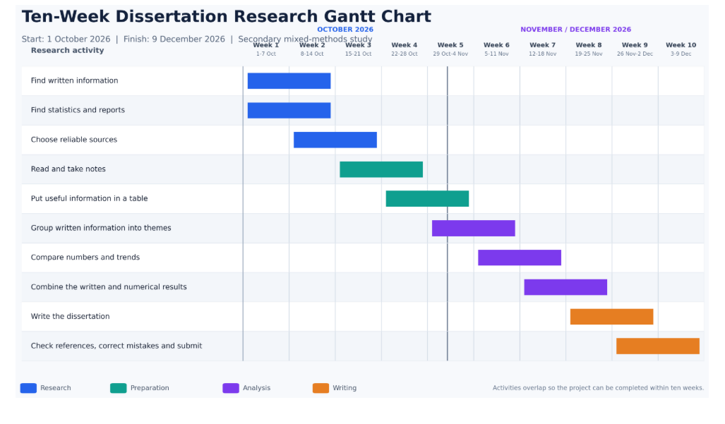
3.8 Moral Ideas
Only public secondary evidence will be used. Corrects Harvard referencing will credit all sources and statistics will be displayed unaltered. Academic and government evidence will be compared to commercially biased corporate data. In addition, the study will follow copyright, confidentiality, and data-protection rules.

Chapter 4: Conclusions
The first three chapters show that AI and automation are significantly reshaping UK warehouse operations, improving efficiency while creating challenges for workforce skills and managerial responsibilities. The literature highlights both benefits and risks, emphasising the automation–augmentation paradox and the need for responsible implementation. A pragmatic, secondary mixed-methods approach is justified as it enables analysis of operational trends and human impacts using credible academic, industry and government sources. Overall, the proposal establishes a solid foundation for investigating how warehouses can adopt automation effectively while supporting employees and managers through technological change.

Reference List
Adams, J. (2014) Research Methods for Business and Social Science Students. New Delhi: SAGE Publications.
Azadeh, K., De Koster, R. and Roy, D. (2019) ‘Robotized and automated warehouse systems: Review and recent developments’, Transportation Science, 53(4), pp. 917–945. Available at: https://doi.org/10.1287/trsc.2018.0873. (Accessed: 12 August 2026).
Bell, E., Harley, B. and Bryman, A. (2019) Business Research Methods. 5th edn. Oxford: Oxford University Press.
Centre for Data Ethics and Innovation (2021) AI Barometer Part 4: Transport and Logistics. Online. Available at: https://www.gov.uk/government/publications/ai-barometer-2021/ai-barometer-part-4-transport-and-logistics (Accessed 14 August 2026).
Creswell, J.W. and Plano Clark, V.L. (2018) Designing and Conducting Mixed Methods Research. 3rd edn. Thousand Oaks, CA: SAGE Publications.
Denscombe, M. (2012) Research Proposals: A Practical Guide. New York: McGraw Hill.
London Economics (2021) The Economic Impact of Robotics and Autonomous Systems (RAS) Across UK Sectors. BEIS Research Paper No. 2021/043. London: Department for Business, Energy and Industrial Strategy. Available at: UK Government report (Accessed: 24 July 2026)
OECD (2023) OECD Employment Outlook 2023: Artificial Intelligence and the Labour Market. Paris: OECD Publishing. Available at: https://doi.org/10.1787/08785bba-en. (Accessed: 27 July 2026)
Raisch, S. and Krakowski, S. (2021) ‘Artificial intelligence and management: The automation–augmentation paradox’, Academy of Management Review, 46(1), pp. 192–210. Available at: https://doi.org/10.5465/amr.2018.0072. (Accessed 1 August 2026).
Saunders, M.N.K., Lewis, P. and Thornhill, A. (2019) Research Methods for Business Students. 8th edn. Harlow: Pearson.
Snyder, H. (2019) ‘Literature review as a research methodology: An overview and guidelines’, Journal of Business Research, 104, pp. 333–339. Available at: https://doi.org/10.1016/j.jbusres.2019.07.039. (Accessed 11 August 2026).
Wang, Y. (2019) Understanding the Impact of Emerging Technologies on the Freight Sector. Future of Mobility: Evidence Review. London: Government Office for Science. Available at: UK Government report (Accessed: 24 July 2026).
Zhen, F. and Li, X. (2022) ‘AI-enabled optimisation in warehouse operations’, International Journal of Logistics Management, 33(2), pp. 455–472.

