

Module Name: Problem Solving and Decision Making

Student name: Maria Mahu
Student ID:2115144

Module code: BMSW4004
Lecturer name: Hossein Shokri

Submission date:03/09/2022

Table of Contents
Introduction 2
The complex problem in the workplace including its scope and impact 3
PESTLE analysis 3
SWOT analysis 4
Decision Making Technique-Plus-Minus-Interesting 4
Analyzation of the information on the identified problem using Fishbone. 4
Solutions to solve the problem 5
Implementation and monitoring of the solution 6
Communication of the plan to stakeholders 6
Personal Reflection 7
Conclusion 7
References 8
Appendix 9

Introduction
Organizational problem solving and consultation often are presented in business as a part of strategic management, management policy, organizational behaviour, and organizational development. (Ziegenfuss, 2002).
The purpose of the study is to describe a complicated problem in the workplace and its impact on the organisation. The problem has been identified and the collected information has been analysed to use the decision-making process in a better way. This study also includes a decision-making technique that I will use in evaluating a large range of solutions and selecting the most appropriate one. There is a plan added in the study to implement the solution. The process to communicate the plan to the stakeholders is also described in this study while assessing appropriate monitoring and reviewing techniques to make sure the solution is successfully implemented.

The complex problem in the workplace including its scope and impact
Oscar Cevallos works as a cleaner at Fasilcon Company. He has been providing his service at this company for more than 3 years and he is known as a very skilled person to all his colleagues. He was involved in a conflict last week with one of his colleagues. The guy with who he has the conflict is having an aggressive nature and he is also poor at communicating with others. He shouted at Oscar using rude words. Thus, the conflict occurred. Oscar is a hard-working and motivated employee who makes the best of his time management skills to finish the tasks on time. Because of his incredible effort for the betterment of the company, he has been offered bonuses at the end of the month. This has created a sense of jealousy in the mind of his colleague, and he ended up challenging Oscar in a fight. Oscar does not want to get involved in such fights and solve the conflict positively as he is a calm and timid person who likes to avoid conflicts. He is also aware of the fact that such conflicts can have a negative impact on the company. Such incidents can increase personal stress and anxiety. It also contributes to the reduction of the productivity of the company and job dissatisfaction of the employees. So, he is trying to avoid the situation. It creates a situation of failure of humiliation and harms the flow of work at the workplace.

PESTLE analysis
In my presentation I used Pestle analysis to evaluate micro-environmental factors and how they affect properly organization and his workers. It is one of the most used tools to analyses business evaluation purposes and evaluate the external business environment (Perera, 2017).
More description in Appendix (Slide 4).

SWOT analysis
SWOT Analysis is a business strategy tool that is used in assessing the process of comparing a company position and to develop decisive planning. This tool includes strengths, weaknesses, opportunities, and threats. There are both internal and external considerations build into the tool. "Strengths" and "weaknesses" are internally related. The former representing a facet of an organization/entity which lends it an advantage over the competition. (Teoli, 2022). Description in Appendix (Slide 5).

Decision Making Technique-Plus-Minus-Interesting
Plus: The employees may realize the importance of a calm environment in the company and look to stay calm in every situation. Their awareness will be increased, and they will be more motivated to work.
This will increase the knowledge, confidence of the workers and increase the stability of the company. A skilful workforce who agrees on one common decision will always look to solve issues by conversation and not by arguing with each other.
Minus: Lack of motivation, working under the pressure, unpaid training can create a discomfort between workers.
Interesting: Employees will be acknowledged for their efforts. This will create and maintain a great culture at the workplace.

Analyzation of the information on the identified problem using Fishbone.
To perform this analysis, the fishbone diagram is used here. Fishbone analysis is a tool to analyse the processes of a company and its effectiveness. (Abdulai, 2020).

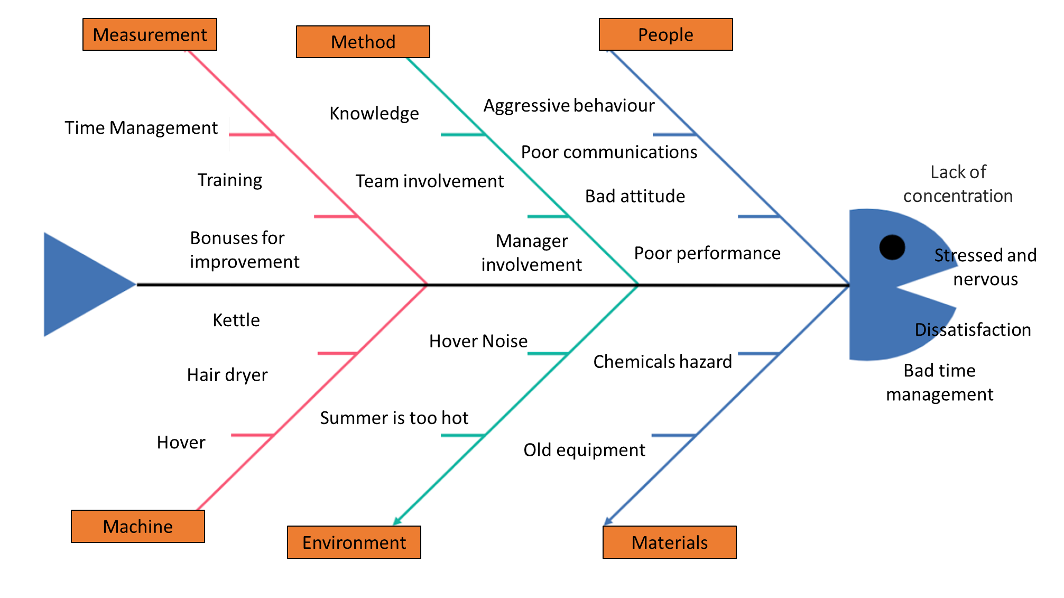
Image Source (Created by Owner)
Causes: Conflicts at the workplace are always harmful to the work environment and the company. Poor time management skills of the employees and the managers at a company, not having proper training of the employees, and not giving bonuses to them to acknowledge their effort is one of the prime reasons for conflicts in the workplace. Lack of knowledge of the employees as to how to behave and maintain a professional approach while working at an office, lack of collective efforts from all members of a team, and non-engagement of the manager in various events also cause conflict in an organization. The aggressiveness in the behaviour of the people of the company, the lack of good communication skills, negative attitude towards the work and co-workers, and poor performance can produce conflicts at the workplace. If a company does not upgrade to the latest technology and keeps using old equipment and the workers find it hard to continue working on those machines, this can create a situation of conflict also. If the workplace is situated in an environment where the weather is too hot or the surrounding is too noisy, it does not let the workers stay calm and conflict occurs. Sometimes, a heated argument can be formed over small things related to a hair dryer, hover, kettle, or some other machines.
Effects: Members of the workforce like Oscar, can go through immense stress and nervousness because of the conflicts. They can also have a lack of concentration while working. Their time management may get disrupted, and they may not have job satisfaction. These are the possible consequences of forming a conflict and heated arguments in the workplace which is damaging for the company and its business.
Due to the lack of knowledge and skills, his colleague created a conflict and chose to have a fight with Oscar. He is stressed and he cannot focus on his work due to the conflict. That's why he is unable to finish his task on time. This is harming Fasilcon Company also as the conflict has created a tense environment at the workplace and the employees including Oscar are demotivated to work.

Solutions to solve the problem
First solution: In every conflict is very important to be calm and to be able to control your emotions. Talking with persons who are involved in the conflict is a good way to process a solution. The people should be given an opportunity to understand the benefits of a non-conflicting culture in the workplace. They also should realize the bad effects of conflicts on the company. The leaders of the company can give rewards to the employees for maintaining a peaceful environment. Employees will have to control their emotions at the workplace. They should be told the benefits of being kind. Negotiating a possible solution and collaboration at the workplace may avoid conflict. They should be encouraged to compromise, and the involvement of the manager is always a must to avoid conflict.
Second solution: Using the LEEN model to resolve conflict can be another solution. At the learning stage, the employees should be asked to describe the situation properly. At the empathizing stage, the intensity of the conflict should be measured. At the explanation stage, the perspective of the managers/leaders should be explained. At the negotiation stage, the managers/leaders and the employees should agree on one decision and continue the further process. They should agree to have regular classes in the middle of working hours to improve their interpersonal skills. The second solution will help in their personal growth and increase the productivity of the company. As an alternative solution we ca use Kilman and Thomas conflict management style (Appendix Fig 1). Thomas and Kilmann’s Conflict Model is a powerful way of looking at conflict management. Conflicts are painful for individuals, and it is an important test of managerial skills. (Mishra, 2022).

Implementation and monitoring of the solution
While monitoring the process and progress of the plan, it needs to be checked if the steps of the plan are implemented in the correct manner and on time or not. It also needs to be checked if the outcomes of each step of the plan satisfy the desired result or not. Based on the result, the leaders of the company also need to revisit their thinking if there is any need to add extra time, or more tasks, or more resources to fulfil the goal. They also need to think about more actions that need to be taken.
While evaluating the solution, the leaders need to compare the present situation with the old situation before the plan was executed. An important part of the monitoring process is to involve team members who are implementing the change or are affected by it. They will be in a good position to pick up on any variations or problems and to provide feedback. Go to Appendix (Slide 11).

Communication of the plan to stakeholders
The employees are the biggest stakeholders of a company after the owners and leaders. The leaders must set objectives first and establish the method of communication whether they want to communicate using verbal methods or non-verbal methods before communicating to stakeholders to tell the conflict-resolving plan. In this case, a verbal method of communication will be very effective. After that, they must use the gathered data to make others aware of the possible effects of the plan. (Dlsweb, 2022).

Personal Reflection
In this section, I will describe my personal experience about my presentation as a part of my assessment of the module: Problem solving and Decision Making. The purpose of presentation skills is to help people deliver their message to the audience. Great presentation skills are one of the most worthwhile abilities in modern workplace culture. To reflect is not enough, you must analyse the situation, to understand what you do good and were you need improvements. Critical reflection is used increasingly in professional and academic contexts as a means of focusing our attention back onto our own experience. (Cottrell, 2017).
In my opinion I provided a good presentation because I thoroughly explored various aspects of great significance to be considered when analysing a business strategy, also I used diverse techniques and methods to solve my partner problem. When I asked my colleagues about my presentation, I received positive feedback which makes me feel happy. The teacher also gives me constructive feedback, he mentions that I should manage my time, also to pay more attention to my threats and opportunity from Swot analysis.
From the situation I have determinate that the time management is my threats because I run out of time when I presented. From this case I learned that in the future I should better organise my time management. Good time management will help me to achieve my goals faster and easier.
During the presentation I can’t control my self because of stress, he influences properly on my behaviour, for me was a big challenge to handle stress and to finish my presentation without any issues. The best way to improve my presentation skills is to practise speaking in front of other, to record my self-speaking and be confident and relaxed. Continuously setting SMART, short-term goals can help me to develop an effective presentation in the future.

Conclusion
Conflict is a serious problem in any workplace no matter how big or small the business is. There is a huge difference in productivity between a peaceful work environment and a place where conflicts happen regularly. Poor time management and dissatisfaction are the prime reasons for the conflicts. This problem can be addressed in a calm manner and a proper plan can solve the issue at the workplace to increase productivity. People in nearly every occupation and every walk of life must work and make decisions collaboratively. (David A, 2002).
In conclusion, it is necessary to say that decision making and problem solving are important components to manage a conflict in the workplace.

References
Abdulai, J. K. P. E. W. A. D. A., 2020. International Journal of Applied Information Systems, New York: Foundation of Computer Science (FCS).
Anon., 2022. Indeed Career Guide. [Online]
Available at: <https://www.indeed.com/career-advice/career-development/conflict-resolution-strategies> [Accessed 12 August 2022]. [Accessed 12 08 2022].
Anon., 2022. Junoon | Vocational Training for 20 High Demand Blue Collar Job Categories. [Online]
Available at: https://junoon.me/cleaning/challenges-faced-by-cleaners [Accessed 21 08 22].
Anon., 2022. Monitoring and evaluation. [Online]
Available at: https://www.dlsweb.rmit.edu.au/Toolbox/busadmin/topics/topic41/t41_02.htm
[Accessed 22 08 2022].
Cottrell, S., 2017. Critical Thinking Skills. s.l.:Bloomsbury Publishing Plc.
David A, S. a. T. C. L., 2002. How to Make Collaboration Work : Powerful Ways to Build Consensus, Solve Problems, and Make Decisions. San-Francisco: Berrett-Koehler Publishers, Incorporated.
Dlsweb, 2022. Monitoring and evaluation. [Online]
Available at: https://www.dlsweb.rmit.edu.au/Toolbox/busadmin/topics/topic41/t41_02.htm
[Accessed 22 08 2022].
Farooq, U., 2022. Marketing Tutor. [Online]
Available at: https://www.marketingtutor.net/pestle-analysis-of-the-hotel-industry/
[Accessed 25 08 2022].
Frost, S., 2022. How Employment Benefit Cuts Can Affect Morale. [Online]
Available at: https://smallbusiness.chron.com/employment-benefit-cuts-can-affect-morale-36849.html
[Accessed 20 08 2022].
Mishra, A., 2022. Thomas Kilmann Conflict Model. [Online]
Available at: https://managementweekly.org/thomas-kilmann-conflict-resolution-model/
[Accessed 02 09 2022].
Perera, R., 2017. The PESTLE Analysis, s.l.: Nerdynaut.
Pro, E., 2022. Managing Cinflict Constructively SWOT analysis&Matrix. [Online]
Available at: <https://embapro.com/frontpage/swotcase/11374-workplace-conflict>
[Accessed 22 08 2022].
Teoli, S. T. A. J., 2022. SWOT Analysis, s.l.: StatPearls.
TEST, H., 2022. Presentation Skills: Definition, How to Improve & Examples. [Online]
Available at: https://high5test.com/presentation-skills/ [Accessed 22 08 2022].
Ziegenfuss, J. T., 2002. Organization and Management Problem Solving : A Systems and Consulting Approach. London: SAGE Publications, Incorporated.

Appendix

Slide 1

Slide2

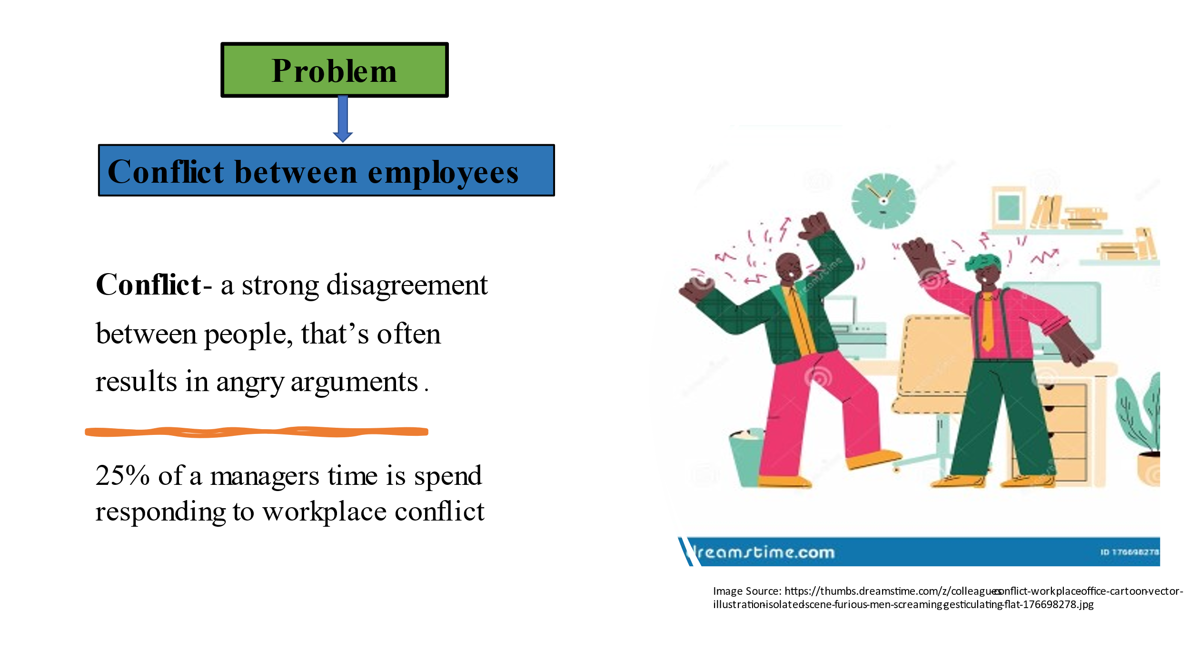

Slide 3

Slide4

Slide 5

Slide 6

Slide 7

Slide 8

Slide 9

Slide 10

Slide 11

Slide 12

Slide 13

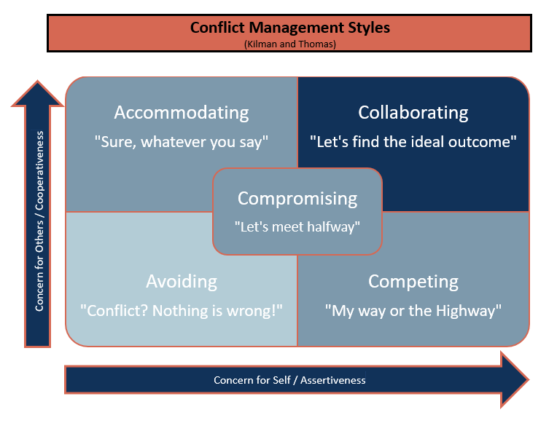

Fig 1.

