COURSE:BA BUSINESS MANAGEMENT
MODULE NAME:DATA HANDLING & BUSINESS INTELLIGENCE
MODULE CODE: LCBB5000
LECTURER NAME: Dr. XAVIER MATIENI
ASSIGNMENT 2
STUDENT NAME: PENKA MURDZHEVA
STUDENT ID:2122606

Table of Contents
Part 1 3
Part 2 8
Question 1: How many students are male and female? 8
Question 2: How many students qualify and do not qualify for reduced/free lunch? 9
Question 3: What are the mean and median of students who qualify and do not qualify for reduced/free lunch? 9
Question 4: What are the mean and median differences of students’ pre-test and post-test scores? 10
Question 5: Using the dataset Student_Score.csv provided in conjunction with SPSS, give a specific example of Clustering (ex. K-Means Clustering). Show your workings with screenshots and clearly explain your results. 10
Question 6: With real world (practical) examples, explain minimum 5 most common data mining and text mining methods for each that can be used in the contemporary business. 13
Question 7: Discuss the advantages and disadvantage of using SPSS and Excel using relevant practical examples and present your discussions in a table 17
References 18

Part 1
Determining the decline or increase of average room reservation price over the year ranging from 2017 to 2021 requires the use of several steps and functions in Excel. To assess data in a range of years, the first thing that must be performed is to order the data set available. To achieve that, the function SORT was used in Excel. The main purpose of a SORT function is to order data in a specific way (in this case, ascending order in terms of year) (Pan and Wiersma, 2013). It was initially used with the range of the cells of the whole dataset and selecting sorting them based on the year of arrival in an ascending order, so that the data set is ordered from 2017 to 2021. Then, additional sorting was implemented to sort the data based on month of arrival and specific date – also in ascending order. Completing this allows using the data in an ordered way and processing required actions accurately, so that results are validated and credible.
After sorting data, to determine whether the average price has increased or decreased over the year for the period 2017 to 2021, a trend analysis is performed. Also, the average prices per year in this period must be found and then compared. For this purpose, the function AVERAGE is used for the data in each year. The main purpose of this function in Excel is to find the arithmetic mean in a dataset (Pan and Wiersma, 2013). In this way, it has been found that the average price per year has changed within the period, being £90.05 in 2017, £106.45 in 2018, £101.78 in 2019, £105.43 in 2020 and £101.47 in 2021, as shown on the figure below. The chart has been created by using Insert -> Chart menu in Excel and selecting the most appropriate type of chart considering the type of data that must be presented. It is evident from the chart that the lowest average price has been in 2017 and the highest – in 2018. However, for the purposes of critical analysis, it should be noted that the data for 2017 available is not representing the whole year as it starts from the month of July.

Figure 1 – Average price per year
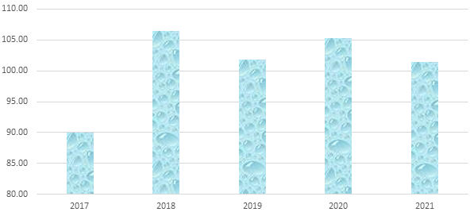
At the same time, the trend of changing average price within each year for the assessed period can also be assessed by creating a time-series graph, showing all data inputs regarding price for each annum. These are presented below. As evident, the average price per month has followed a different pattern every year. To calculate these values and be able to summarise and visualise the information in this way, the AVERAGE function has been used to find the mean price for each month within each year of the examined period. As evident, the largest fluctuation of the average price on a consecutive monthly basis has been observed in 2017.
Nevertheless, data from year 2017 appears to be incomplete. Therefore, too much reliance on 2017 data must be avoided. In addition, the monthly-based results indicate that the fluctuations follow a clear seasonal pattern. Winter months have the lowest prices, which can be explained by the low demand, whereas the summer period is associated with the highest prices due to the high demand. This information is quite important, as the company can relatively accurately predict the main demand and prices changes. Based on data, hiring, supplying and capacity-related decisions may be more accurate, as well.

Figure 2 – Price change monthly (2017-2021)
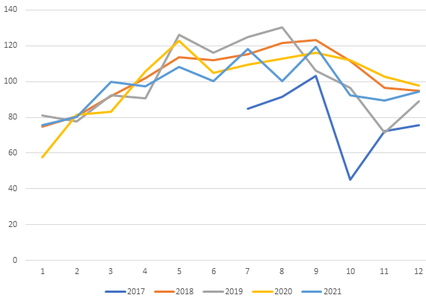
The analysis additionally considers price changes that are contingent upon the type of accommodation. The SORT function is employed to arrange the existing data based on the category of room type. The collection comprises seven distinct categories of rooms. After the re-ordering of the data according to room types, the AVERAGE function is utilised to compute the mean prices. The data suggests the presence of variations in pricing among different room categories. The room type that incurs the highest cost is identified as number six, exhibiting a mean price of £182.2. On the other hand, it is noteworthy that room type three exhibits the lowest cost with a value of £73.7. The observed disparity between the minimum and maximum price values is substantial and can be related to the specific characteristics of rooms, such as size, view, interior design features, comfort level and others.

Figure 3 – Mean price based on room type
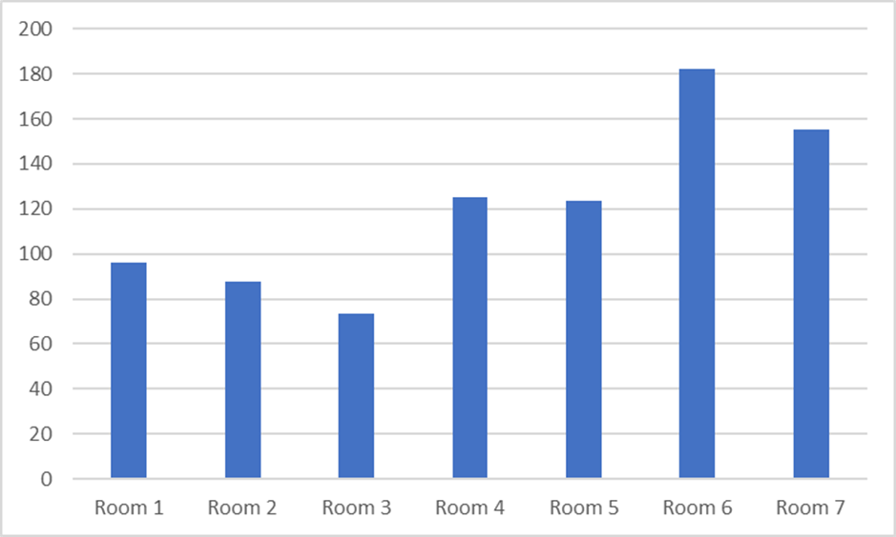
The concept of cancellation holds significant importance within the context of the commercial decision-making. The criterion holds significance in assessing the extent to which pricing influences the ultimate outcomes of every reservation. Thus, it is important to analyse whether too high price can somewhat affect the cancellation risk. The SORT and AVERAGE functions are once again employed to arrange the dataset based on the status of each entry, whether it is cancelled or not, and afterwards compute the average pricing for each group. Results indicate that the average price of a cancelled room is £110.7 against £100 for the group of uncancelled rooms. The observed fluctuations are applicable to all years - a key factor showing the validity of the experienced trends. Thus, the results clearly show that too high prices may lead to an elevated risk of cancellations.

Table 1 – Descriptive statistics findings about cancelled and not cancelled reservations
The analysis of the dataset provides important insights for a better decision-making process. There are important results regarding price trends, seasonality of earnings, revenue sources and factors affecting consumers’ choices. The information can be used for improving the performance of the company. Nevertheless, too much reliance must be avoided. This is the case due to the dominance of year 2018 in the dataset, as more than three-quarters of observations are based on 2018 data. This means that there might be changes in the actual trends and processes occurring in 2023. This is important because there is a 5-year gap between 2018 and 2023. Hence, observations from 2021 and 2022 must be prioritised. This is not considered in the current analysis. The company should also keep collecting new performance data and make appropriate changes based on the most contemporary trends.
In the current analysis of the dataset, data processing, analysis and presentation took place. Data pre-processing is associated with transforming raw data into useful information that can then be assessed better and more accurate (Mishra, 2023). It assists analysts to improve the quality, consistency and compatibility of data. It also helps eliminating or mitigating potential errors, allows for handling missing values, and orders data sets in formats that are then better and easier used for assessment (Mishra, 2023).
Filtering and sorting, which has been used in the task above, are also part of the functions implemented in data pre-processing. Some of the main advantages of Excel data pre-processing include provision of a good foundation for implementing data assessment, as well as the opportunity of integrating data across other Microsoft Office applications and platforms, facilitating seamless data transfer and collaboration (Mishra, 2023; Moudgil, 2023). Some of the basic functions used in data pre-processing in Excel include IF, IFERROR, LEFT, RIGHT, MID, FIND, COUNTIF, SORT and many more (Muralidhar, 2021).
Once data is pre-processed and ordered, it can be analysed and assessed according to the needs of the company or individual. As stated by Agarwal (2021), data analysis is related to the process of transforming and assessing raw data to obtain, usable, relevant and accurate information which is usually used for informed decision-making. Data analysis combines data collecting, organising, storage and the tools used to present findings, such as data visualisation (Agarwal, 2021). Through the process of data analysis, raw information bits are transformed into meaningful information which can then be used for informed decision-making.
Data visualisation is associated with the depiction of data graphically and in the form of various charts, figures and graphs (Agarwal, 2021). As seen in the report, Excel offers many different types of charts for visually presenting different types of data in the most appropriate way. Some examples of types of charts that are available to use in this program include column, line, pie, bar, area, scatter, stock, surface, radar and combo.
In conclusion, it can be stated that Excel is one of the most appropriate and useful tools and programs for data pre-processing, analysis and visualisation. Currently, there are more than 1.1 billion users of Excel around the globe which also supports the claim that it is a market leader in information processing and assessment for better decision-making (Indah, 2023).

Part 2

Question 1: How many students are male and female?
To reply to this question, the function COUNTIF has been used in the Excel dataset. This function is used for finding the number of specific value (in this case, in the form of a text value) in a particular dataset. The specific formula inserted in this case is shown below.
The number of female students is found by using =COUNTIF(H2:H2134,"Female"). The result is 1056 students.
The number of male students is found by using =COUNTIF(H2:H2134,"Male"). The result is 1077 students.

Question 2: How many students qualify and do not qualify for reduced/free lunch?
To find this result, the same function has been used as the one above.
The number of students who qualify for reduced/free lunch is found by using =COUNTIF(I2:I2134,"Qualifies for reduced/free lunch"). The result is 918 students.
The number of students who do not qualify is found by using =COUNTIF(I2:I2134,"Does not qualify"). The result is 1215 students.

Question 3: What are the mean and median of students who qualify and do not qualify for reduced/free lunch?
Arithmetic mean can only be used for numerical values, leading to the assumption that the question is regarding mean and median of students who, respectively, qualify or does not qualify for reduced/free lunch in terms of pretest and post-test scores. For this purpose, two formulas are used – AVERAGE IF and a conditional MEDIAN.
The mean of students who qualify for reduced/free lunch in terms of pretest and post-test scores are found as follows:
- =AVERAGEIF(I2:I2134,"Qualifies for reduced/free lunch",J2:J2134) -> result is 45.25
- =AVERAGEIF(I2:I2134,"Qualifies for reduced/free lunch",K2:K2134) -> result is 57.48
The mean of students who do not qualify is found as follows:
- =AVERAGEIF(I2:I2134,"Does not qualify",J2:J2134) -> result is 62.29
- =AVERAGEIF(I2:I2134,"Does not qualify",K2:K2134) -> result is 74.38
The conditional median values are found in the following way, shown below.
Median for pretest and post-test scores of students who qualify:
- =MEDIAN(IF(I2:I2134 = "Qualifies for reduced/free lunch",J2:J2134)) -> result is 44
- =MEDIAN(IF(I2:I2134 = "Qualifies for reduced/free lunch",K2:K2134)) -> result is 55
Median for pretest and post-test scores of students who do not qualify:
- =MEDIAN(IF(I2:I2134 = "Does not qualify",J2:J2134)) -> result is 62
- =MEDIAN(IF(I2:I2134 = "Does not qualify",K2:K2134)) -> result is 74

Question 4: What are the mean and median differences of students’ pre-test and post-test scores?
To answer this question, the functions AVERAGE and MEDIAN have been used for the dataset of pretest and post-test scores. Results are shown below.
- Mean of pretest scores is found by using =AVERAGE(J2:J2134). The result is 54.96.
- Mean of post-test scores is found by using =AVERAGE(K2:K2134). The result is 67.10.
- The median of pretest scores is found by using =MEDIAN(J2:J2134). The result is 56.
- The median of post-test scores is found by using =MEDIAN(K2:K2134). The result is 68.

Question 5: Using the dataset Student_Score.csv provided in conjunction with SPSS, give a specific example of Clustering (ex. K-Means Clustering). Show your workings with screenshots and clearly explain your results.
Clustering is a data analysis technique that involves the collection and aggregation of disparate data points based on shared characteristics. Clustering is a commonly employed technique in the domain of business intelligence for the purpose of identifying similarity among data. Therefore, the utilisation of clustering techniques proves beneficial in facilitating a more comprehensive study and enhancing the understanding of underlying trends. The K-means method comprises multiple consecutive stages that need to be executed in a specific order. Firstly, it is imperative to consider the centroids that have been randomly picked. The table presented below offers descriptive statistical measures pertaining to the groups. Hence, the identification of the initial centres of the two clusters is facilitated by the respective mean values for each of the two clusters under consideration.
Table 2 – Key characteristics of the two clusters
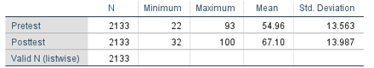
The second stage of the K-means algorithm involves the execution of iterative processes. Seven iterations are executed to optimise the placement of the centroids that already exist. The identification of new cluster centres is determined by the results obtained from the seven rounds.
Table 3 – Iterations history
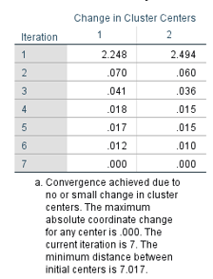
Thirdly, the K-means algorithm terminates its iterations depending on two criteria. The determination of iterations can be expressed in numerical terms, or alternatively, the process may cease when further calculations are deemed unnecessary (Garbade, 2018). The newly generated clusters are characterised by stabilised values. In this instance, the recently generated values are presented as follows. As evident, there is no need for additional iterations, since the zero value is already achieved.
Through the utilisation of a two-cluster analysis, it has been determined that cluster 1 displays pre-test and post-test scores of -0.878 and -0.886, respectively. In cluster 2, the pre-test score is measured as 0.764, while the post-test score is recorded as 0.772.
Table 4 – Final cluster centres
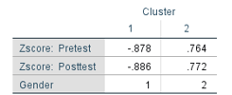
The graphic representation illustrates the data by presenting it in the form of two clearly identifiable clusters. Within cluster 1, the average values of pre and post test scores demonstrate a negative trend, while in cluster 2, the mean values exhibit a positive trend.
Figure 4 – Final centres of clusters
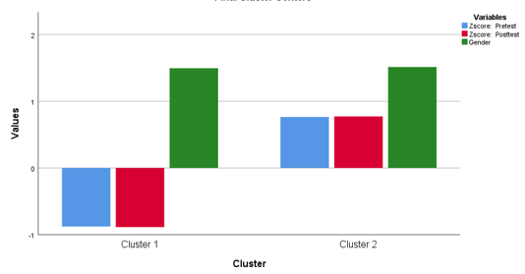
Thus, the clustering analysis provides new information, which has not been known before, to facilitate decision-making process.

Question 6: With real world (practical) examples, explain minimum 5 most common data mining and text mining methods for each that can be used in the contemporary business.
Text mining, which is also known as text analytics, is mainly used by contemporary business in two main ways, including analysing text that exists, such as customer reviews, and structuring text to be used in machine learning models to predict future events and occurrences (Jeor, 2023). The use cases of text analytics are shown below. As observed, text mining is widely used by organisations engaged in manufacturing, financial services, retail, legal services, healthcare, telecommunications, life sciences, insurance and many more (Jeor, 2023). The provided examples illustrate the importance of text mining for modern organisations and highlight its possible applications.
Figure 5 – Text mining use cases examples
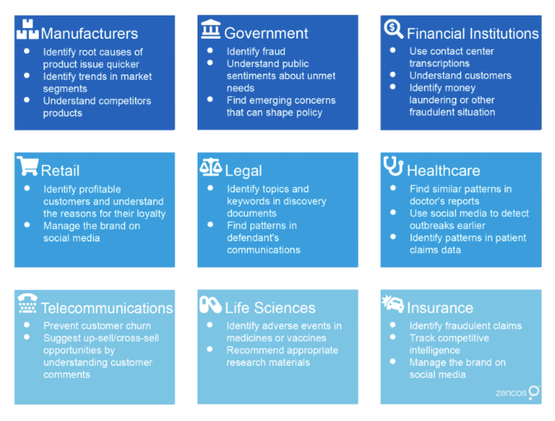
Source: Jeor (2023)
One of the most common applications of text mining is the analysis of customer feedback and reviews. Through using platforms like Fitbit, companies can get summarised and assessed customer feedback data which can later be integrated in decision-making, so that customer preferences and needs are fulfilled (Jeor, 2023). The platform can assess tens of thousands of reviews and feedback bits from official websites, social media networks and many other. This makes text mining crucial for businesses, especially when they operate at a larger scale and receive huge volumes of qualitative data that must be assessed.
Text mining is also very commonly used for assessing competitors’ performance, so that the position of the business against rivals can be evaluated. Companies like Zencos offer competitor performance analysis based on text mining using media reports and other information communicated by brands to the public (Jeor, 2023). Below is an example of text mining output using keyword for product malfunctioning and failed device installations for medical device manufacturers in US (Jeor, 2023). It illustrates the importance of text mining for assessing own and rivals’ performance.
Figure 6 - Text mining output example
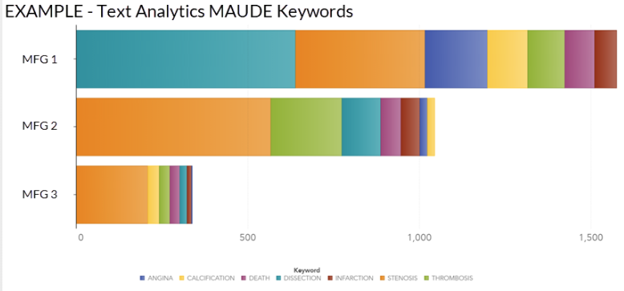
Source: Jeor (2023)
Data mining (a.k.a. knowledge discovery in databases) is the process of discovering patterns in large sets of data and data warehouses containing various types and formats of information (Software Testing, 2023). It is essential for contemporary businesses, especially the ones which operate with large pools of data sets. Some of the most common data mining tools used by companies nowadays include tree analysis, Bayes theorem assessment and many more.
One of the most illustrative examples of contemporary businesses using data mining for improving performance are telecommunications providers. These organisations often implement data mining tools and techniques to design their marketing strategies, as well as both attract and retain customers (Software Testing, 2023). They use large pools of data (e.g. billing information), data mining processes can identify and predict the customers who are likely to switch to a rival on the market. The company is then able to customise its marketing activities and customer service in a way that can decrease the probability of this occurrence (Software Testing, 2023).
Figure 7 – Data mining used by service providers exemplar framework
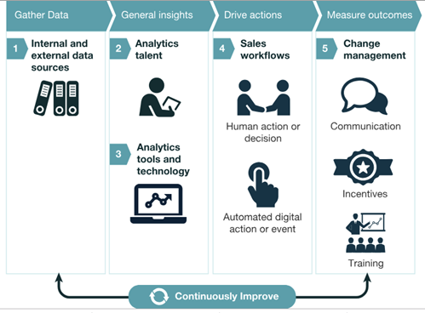
Source: Software Testing (2023)
Data mining is also commonly used by businesses in the retail industry. One of the most illustrative examples is companies assessing consumer choices based on analysing purchase history, so that they can make product, pricing and promotional decisions that would best fit their needs (Software Testing, 2023). An exemplar framework is presented below.
Figure 8 – Data mining in retail
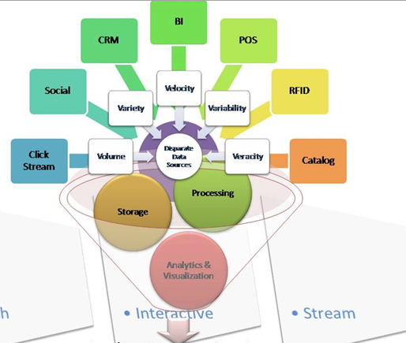
Source: Software Testing (2023)
Another trend in developing customer service and other functions of contemporary businesses through investing in high-quality data mining is the use of artificial intelligence. AI is commonly used by many organisations in various industries to improve customer service, as well as for marketing initiatives. However, AI works better and more effectively when it is fed with relevant patterns. These patterns come from data mining outputs (Software Testing, 2023). One of the real-life examples is Amazon which uses AI algorithms to recommend items of interest for purchase to platform’s users based on past purchasing history (Software Testing, 2023).

Question 7: Discuss the advantages and disadvantage of using SPSS and Excel using relevant practical examples and present your discussions in a table
The main differences between SPSS and Excel – two popular types of software – are presented in the following table. Thus, the information is succinct and identifies the main features and differences of the two choices.
Table 5 – Main differences between SPSS and Excel
Feature | SPSS | Excel
Usage | Mainly for statistical calculations and analysis of data | Mainly used for managing and storing data, but also offers data analysis and visualisation tools
Top benefits | - Speed  - Performance  - Usage of advanced devices | - Mitigation of data redundancy  - Easier to use and navigate  - Managing of large volumes of data
Business application | Mainly used by technical industries operating at a larger scale | Used by all sizes of businesses regardless of their industry and scale of operation
Computational tools | Allows different functions, such as data storage and data format | Allows different functions, including data analysis and visualisation
Manipulating data | Easy to obtain detailed insight from data storage | Easy to extract information from different data sources and transform it into input for decision-making
Software | Focused on statistical analysis | Focused on spreadsheet data manipulation and management
Adjusted from Pedamkar (2023)
It can be suggested that both programs are crucial for contemporary businesses, but the preference and weight of advantages would depend on the specific needs, resources and capabilities of the companies.

References
Agarwal, G. (2023) A Comprehensive Guide on Microsoft Excel for Data Analysis, [online] Available: https://www.analyticsvidhya.com/blog/2021/11/a-comprehensive-guide-on-microsoft-excel-for-data-analysis/ [Accessed: 2 August 2023]
Hati, S. (2023) Building Data Visualisation in Excel, [online] Available: https://www.knowledgehut.com/blog/business-intelligence-and-visualization/data-visualization-excel [Accessed: 5 August 2023]
Indah, K. (2023) Excel Users, [online] Available: https://earthweb.com/excel-users/#:~:text=There%20are%20somewhere%20between%201.1,Excel%20user%20count%20in%202023%3F [Accessed 3 August 2023]
Jeor, C. (2020) Text Analytics, [online] Available: https://www.zencos.com/blog/text-mining-examples-advanced-analytics/ [Accessed: 3 August 2023]
Mishra, N. (2023) Data Preprocessing in Excel, [online] Available: https://www.codingninjas.com/studio/library/data-preprocessing-in-excel [Accessed: 5 August 2023]
Moudgil, C. (2023) Data Cleaning and Preprocessing Techniques in Excel for Accurate Insights. [online] Available: https://www.linkedin.com/pulse/data-cleaning-preprocessing-techniques-excel-accurate-moudgil/ [Accessed: 5 August 2023]
Muralidhar, K. (2021) Essential Functions in Excel for Data Preprocessing, [online] Available: https://towardsdatascience.com/essential-functions-in-excel-for-data-preprocessing-140f002f3ca [Accessed: 1 August 2023]
Pan, D. and Wiersma, G. (2013) Excelling With Excel: Advanced Excel Functions for Collection Analysis. [online] Available: https://docs.lib.purdue.edu/cgi/viewcontent.cgi?article=1501&context=charleston [Accessed: 7 August 2023]
Pedamkar, P. (2023) SPSS vs. Excel, [online] Available: https://www.educba.com/spss-vs-excel/ [Accessed: 11 August 2023]
Schwabish, J. (2016) A Step-by-step Guide to Advanced Data Visualisation, [online] Available: https://policyviz.com/wp-content/uploads/woocommerce_uploads/2017/07/A-Guide-to-Advanced-Data-Visualization-in-Excel-2016-Final.pdf [Accessed: 8 August 2023]
Software Testing (2023) Data Mining Examples, [online] Available: https://www.softwaretestinghelp.com/data-mining-examples/ [Accessed: 5 August 2023]

