

Module: Managing Food & Beverage Operations

Managing Food & Beverage Operations of Hotel Novotel Birmingham Airport
Student ID :2126985
Name:Alexandru Matei
Table of Contents
Introduction 3
Main Body 4
Conclusion 7
References 8
Appendix 10

Introduction
The research presents a personal reflection on the operational, managerial, and customer service aspects of the Food and Beverage department. This study designs the hotel food and beverage operation and the offerings format of “Hotel Novotel Birmingham Airport”. Novotel Birmingham Airport is a new four-star hotel that is located directly opposite the terminal of Birmingham Airport in the UK (Accor, 2025). The structure was to suit business guests, provide easy transport access, and provide a friendly mood. The food and beverage (F&B) business of the hotel aims at targeting the restaurant and bar service. The hotel will also have room service and a 24-hour bar where customers may take drinks and snacks (Akhmedova, 2023). They are based on their philosophy of healthy and balanced menus with global flavours and sharing opportunities.

Figure 1: Profile of the Hotel Novotel Birmingham Airport
(Source: Purpleparking, 2025)
Breakfast buffet throughout the day (early morning, around 5:00 am) on working days with cooked food and continental food. The dining menu will include starters, such as seared scallops or goat cheese salad, main meals, sea bass fillet, etc. Vegetarian and vegan products are also available, as they are premised on the healthy concept of eating, which is promoted by the hotel brand. To work in this hotel, the research portrays the overall experiences through the working environment and the learning skills and applicable processes.

Main Body
My duty duration period at the Novotel Birmingham Airport had assisted me in understanding that the theory I learned could be put into practice in the actual work environment. I benchmarked my learning process on the example of Sarah Thompson, who is the F&B Supervisor. This enabled me to consider five skill areas, which include Engagement with literature skills, knowledge and understanding skills, cognitive and intellectual skills, practical skills, and transferable skills.
According to Ali et al. (2021), quality hospitality service is dependent on standards, expectations of the guests and consistency. Some other authors, such as Anderson (2025), explain how the performance of the service can be advanced in the case where employees are aware of the guest's requirements. I observed Sarah practising this by checking on the number of guests, allergies, and service plans. This real action was able to be compared with the Engagement with Literature Skills, which helped me to comprehend this action. I also realised that not all the staff members were trained on how to read operation manuals or guides. In my view, the hotel can be streamlined by giving written instructions or training manuals in an easy-to-read format to employees.
Operational knowledge can help managers build menus, inventory, employees, and workflow (Cahyono and Tjakraatmadja, 2022). These knowledge and Understanding Skills are what I saw Sarah do at the breakfast modification. She was tracking buffet, delegate jobs, and stock checking. This aligned with the theory that I acquired regarding forecasting and controlling operations. I noticed that the team was not necessarily utilising developed checklists. This meant that at peak times, there were minimal delays. More efficiency would be achieved through the proper use of standard operating procedures.
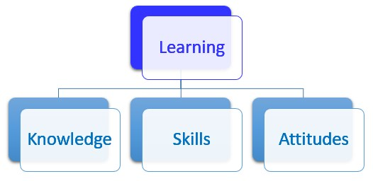
Figure 2: Learning format for hotel operation
(Source: Self-created)
As stated by Ho et al. (2023), critical thinking, problem-solving and analysis are essential for hospitality leaders to make decisions under uncertainties in a short period of time. I have witnessed this when the coffee machine broke down. Cognitive and Intellectual Skills were applied by Sarah as she assessed the situation and moved employees around so that a small queue was utilised. This showed that she has the capacity to solve problems. I also felt that the team was reliant on the decisions made by Sarah. The frontline employees can be taught to make more independent decisions to reduce the pressure on the supervisors (Colombari and Neirotti, 2023).
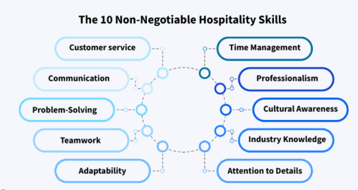
Figure 3: Practical Hospitality Skills
(Source: Self-created)
Customer service, communication, food handling and teamwork are practical hospitality skills that are taken to practice (Prakash and Kumar, 2024), shown in Figure 3. I monitored the ways employees welcomed the guests to the hotel, served them and handled their complaints in a courteous fashion. The case of assisting in clearing tables and even refilling items gave me a glimpse of the physical aspect of the job. I noticed that they have new employees who lack the fundamental training in service. The hotel is to receive more inauguration or short practice workshops to increase consistency.
As per Tian and Hebron (2024), the skills in hospitality and other industries are the capacity to work in a team. I saw these Transferable skills every day in working together in situations of great workloads and through short updates. I also learned Transferable Skills, which is the ability to remain calm when multitasking. There was slow communication between the service staff and the kitchen on other occasions. It can consist of a simple digital order system or a checklist that will make it hard to make mistakes (Bouwmans et al. 2024).
Being a member of the Food and Beverage department at Novotel Birmingham Airport, I would be able to use the specific theory in my hospitality function. I have dealt with two modules, such as "Hospitality Operations Management and Sustainability in Hospitality”. Thus, I have worked with Sarah Thompson, who demonstrates to me how skills are applied in day-to-day activities.
My knowledge and understanding skills helped me determine the system of operation. As a part of the lecture, I was able to acquire the information that planning, forecasting, and workflow organisation contribute to the quality of the service. My colleague Sarah ensured that the number of people and her group would receive was sufficient, and distributed the staff responsibilities and the time of food preparation. According to Reyes et al. (2023), in comparison with operation theory, it is defined that planned organisation of the operation reduces service delays. I used this information when I was helping with the replacement of pastries and juice stations based on the size of the guests. This allowed me to feel a part of the operations process.
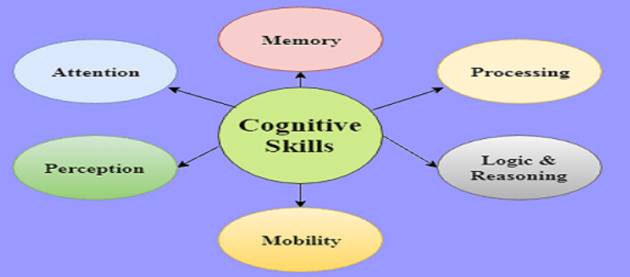
Figure 4: Cognitive and Intellectual Skills factors
(Source: Self-created)
Cognitive and Intellectual skills help me in problem analysis during the course of the service. The other concept that I acquired during the SERVQUAL model of creating guest satisfaction is reliability and responsiveness (Ali et al. 2021). Sarah had found the solution very fast to offer ready-made cereal boxes. Another thing I did was serve them to the guests and apologise politely. I knew that the quality of services is preserved by quick decision-making. This experience helped me notice a difference between the theory and the reality of the pressures of the actual service environments.
Overall, I have learned the interconnection of theory and practice, and I have identified the area of reforms that can assist in simplifying operations.

Conclusion
The research outlines the internship experience at Hotel Novotel Birmingham Airport, which has enabled me to understand the ways that my theory can be used in Food and beverage operations. I was able to see the application of knowledge and understanding skills, and cognitive and intellectual skills, by the supervisors and the staff in their everyday undertakings. Another area that I found to be of concern is the quality of services and models of sustainability in decision-making in the department. These activities, such as restocking, guest service, and problem-solving, made me gain confidence and have more insight into how things are going within the field. The experience has enabled me to bridge the gap between academic learning and the requirements of the actual workplace and career growth in the future.

References
Accor, 2025. Novotel Birmingham Airport. Available at: https://all.accor.com/hotel/1158/index.en.shtml. (Assessed on: 10.11.25)
Akhmedova, O., 2023. Organization of the food and beverage services in a hotel. Tourism and Hospitality in Conditions of Digital Economy: Problems and Perspectives.
Ali, B.J., Gardi, B., Othman, B.J., Ahmed, S.A., Ismael, N.B., Hamza, P.A., Aziz, H.M., Sabir, B.Y., Sorguli, S. and Anwar, G., 2021. Hotel service quality: The impact of service quality on customer satisfaction in hospitality. International Journal of Engineering, Business and Management, 5(3), pp.14-28.
Ali, B.J., Gardi, B., Othman, B.J., Ahmed, S.A., Ismael, N.B., Hamza, P.A., Aziz, H.M., Sabir, B.Y., Sorguli, S. and Anwar, G., 2021. Hotel service quality: The impact of service quality on customer satisfaction in hospitality. International Journal of Engineering, Business and Management, 5(3), pp.14-28.
Anderson, M., 2025. Understanding the Impact of Service Quality on Customer Loyalty in the Hospitality Industry.
Bouwmans, M., Lub, X., Orlowski, M. and Nguyen, T.V., 2024. Developing the digital transformation skills framework: A systematic literature review approach. Plos one, 19(7), p.e0304127.
Cahyono, F. and Tjakraatmadja, J.H., 2022. Digitalization in knowledge management systems for project and operational management in software development to increase efficiency. International Journal of Management, Entrepreneurship, Social Science and Humanities (IJMESH), 5(2), pp.181-200.
Colombari, R. and Neirotti, P., 2023. Leveraging frontline employees’ knowledge for operational data-driven decision-making: a multilevel perspective. IEEE Transactions on Engineering Management, 71, pp.13840-13851.
Ho, G.K., Lam, C. and Law, R., 2023. Conceptual framework of strategic leadership and organizational resilience for the hospitality and tourism industry for coping with environmental uncertainty. Journal of Hospitality and Tourism Insights, 6(2), pp.835-852.
Prakash, J. and Kumari, U., 2024. Integrating green hospitality into food safety practices among young professionals: A review. International Research Journal of Humanities and Interdisciplinary Studies, 5(3), pp.35-49.
Purpleparking. 2025. Novotel Birmingham Airport. Available at:https://www.purpleparking.com/airport-hotels/birmingham-hotels/novotel. (Assessed on: 10.11.25)
Reyes, J., Mula, J. and Díaz-Madroñero, M., 2023. Development of a conceptual model for lean supply chain planning in industry 4.0: multidimensional analysis for operations management. Production Planning & Control, 34(12), pp.1209-1224.
Tian, Q. and Hebron, D.E., 2024. Skill sets for the hospitality sectors: a review. Int J Multidiscip Res.

Appendix
- To gain superior working skills in day-to-day Food and Beverage service.
- To increase self-esteem and professionalism in the process of communicating with the guests.
- To establish the implementation of sustainability processes within the hotel services of the F&B processes.

All these were achieved in my placement. I also became acquainted with how the operations run, such as stocking, clearing tables and serving breakfast. The necessity to communicate with the guests on a daily basis and address minor issues in service increased my self-confidence. Waste monitoring and controlled production of food are other sustainability strategies that I have observed. Such experiences have enabled me not only to cross theory and actual work practice, but also to sharpen my skills to work within a team and solve problems.

