DIGITAL SURVEYING REPORT
PREPARED BY: SHALOM WILFRED JR. JOSEPH
STUDENT ID: 2113608
DUE DATE: 27/01/21

INTRODUCTION
The following report serves as a general overview of what surveying is and its uses and applications within the construction industry. Throughout this research piece, details will be given on the various types and forms of surveying, as well as the plethora of tools used within the field both historically and contemporarily. The importance of surveying in contemporary times have also been discussed and within the second half of the report, the term digital surveying will be explored in reference and relation to listed buildings within the UK.

DEFINITIONS
According to Merriam-Webster, Surveying may be defined as, “a branch of applied mathematics that is concerned with determining the area of any portion of the earth's surface, the lengths and directions of the bounding lines, and the contour of the surface and with accurately delineating the whole on paper.” (Merriam-Webster, 2022)
Also, according to Schofield and Breach, “Surveying may be defined as the science of determining the position, in three dimensions, of natural and man-made features on or beneath the surface of the Earth. These features may be represented in analogue form as a contoured map, plan or chart, or in digital form such as a digital ground model (DGM).” (2011, pp. 1)

IMPORTANCE OF SURVEYING
Surveying serves as an important factor within a construction development project. There are a magnitude of reasons why surveys must be conducted before any other major construction work is to be considered. Davis and Foote (1953, pp. 1), notes that the data that is acquired during the course of a survey may have a greater or lesser effect on the immensity of a building project. They go on to state that almost all privately and publicly issued surveys show usefulness during the initial stages of developing a project.
Although titled “5 Important reasons of Land Surveying”, Picket, Ray and Silver (2021) lists a few points that are applicable to all types of surveying on the reasons why surveying may be considered an important factor within a project’s development. Here are three summarized reasons:

- Financial Security: Surveying will provide you with crucial information that will help you assess whether or not a property is a worthwhile investment. Such as providing risk assessments that can save a potential loss through damages.

- Accurate Discoveries: Precise and reliable measurements of large areas can be taken with the technological conventions available to surveyors. This allows development teams to keep track of local ordinances and findings.

- Adhering to Local Rules and Regulations: Through surveying, one can determine the exact size and topography of an area. This data becomes important when local building codes, rules and regulations are to be enforced.

PRIMARY TYPES OF SURVEYING
Surveys can be placed in either one of two divisions. They are Plane Surveying and Geodetic Surveying. Factors such as: a site’s topographic area and geographic size, the distance and angle between two points on a site, as well as the survey’s reference to the earth’s curvature, can directly influence the division under which that survey falls.
The more common used division in the construction industry both historically and contemporarily is Plane Surveying. As noted by Kavanagh (2009, pp. 2), the better half of development projects are constructed within a very confined geographic size, therefore are generally assumed to be situated on a surface that possesses plane dimensions on all axes. Hence the term, Plane Surveying. This is as a result of completely disregarding the curvature of the earth’s oblate surface.
On the other hand, Geodetic Surveying is as a result of a larger than normal coverage area which will require more accuracy than that of a project utilizing plane surveying. Kavanagh and Mastin, (2012, pp. 5), coined that geodetic surveying is produced on a more extensive scale and was characterized as being highly reliable collated mathematical data and measurements. They went on to note some of the modern forms of geodetic surveying such as Satellite surveys which uses a combination of satellite imagery defining the topographical area of a site.
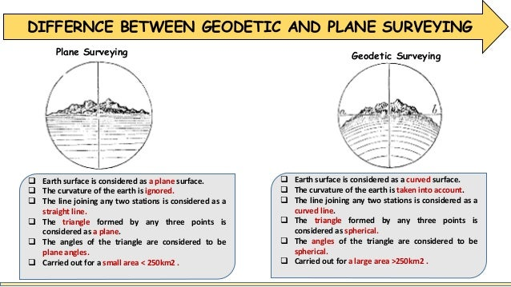
Figure 1 Depicts the differences between Geodetic and Plane Surveying

CLASSIFICATIONS OF SURVEYING
Furthermore, surveying can also be classified based on the purpose or nature of the intended development site. Here are a few surveys explained in detail that are based on purpose:

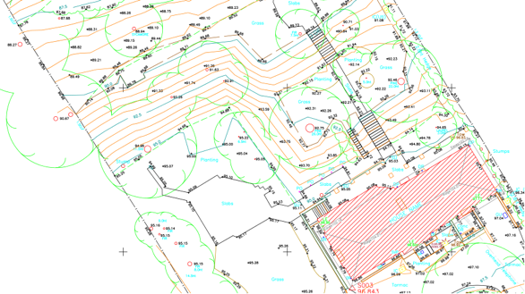
- Topographic Surveys: Banister and Raymond (1992, pp. 2), briefly describes Topographic Surveys as surveys which generate the natural and artificial features that can be utilized during site evaluation. They further went on to include elevation as a feature that is procured through topographic surveys. “Height information can be added either as spot heights, which are individual height points, or contours, which give a less detailed, but more visual, representation of the area. Frequently spot heights only are shown on plans.” (1992, pp. 2)
Figure 2 Topographic Survey of a House and Garden

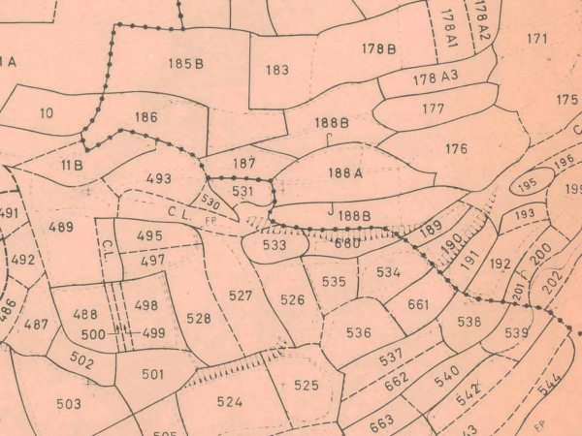
- Cadastral Surveys: Also known as Land or Boundary Surveys, are used to track and display the boundaries of both private and public land. As defined by Ghilani and Wolf, “Land, boundary, and cadastral surveys establish property lines and property corner markers.” (2010, pp. 11). The importance of Cadastral Surveys can be seen when employing local rules and regulations under which the execution of certain building protocols must be adhered to for legal purposes. Banister and Raymond (1992, pp. 3), confirms this and goes on to mention that property ownership can be seen registered under these plans.
Figure 3 Illustration of a Cadastral Survey

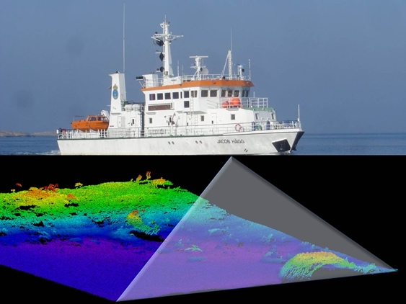
- Hydrographic or Marine Surveys: Just as Topographic Surveys, Hydrographic Surveys find the horizontal and vertical natural and artificial features of a specific geographic area. The difference is that hydrographic surveys are conducted under water or on the shoreside. On a hydrographic map or electronic chart, shorelines, maritime features, and water depths are usually depicted, as stated by Kavanagh and Mastin (2012, pp. 5). Ghilani and Wolf defines it as “Sea surveying is associated with port and offshore industries and the marine environment, including measurements and marine investigations made by shipborne personnel.” (2010, pp. 12)
Figure 4 Illustration of a Ship Performing A Hydrographic Survey

There may also exist surveys which are done through different methods available. Here is a brief overview of Surveys based on methods.

- Triangulation Surveying: The Intergovernmental Committee on Surveying and Mapping (ICSM) defines Triangulation Surveying as “Triangulation is a surveying method that measures the angles in a triangle formed by three survey control points.”
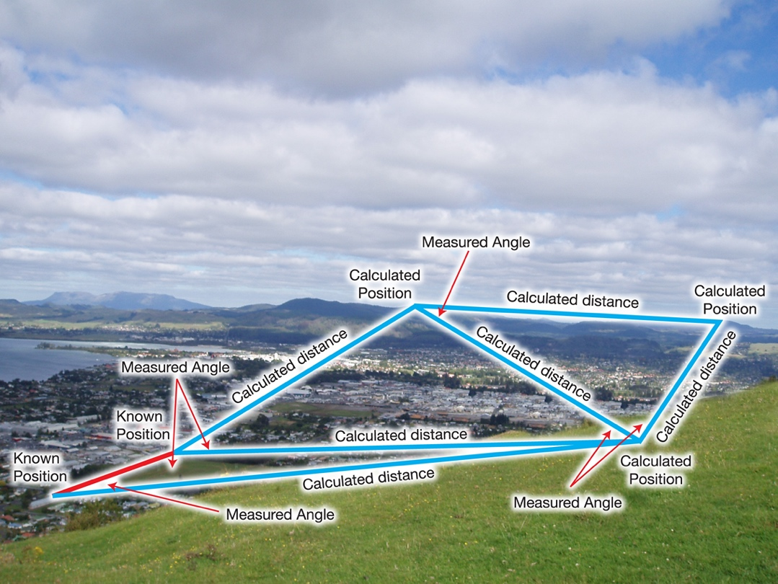
Figure 5 Triangulation Illustration

- Trilateration Surveying: This surveying method was used to measure only the sides of a triangle.
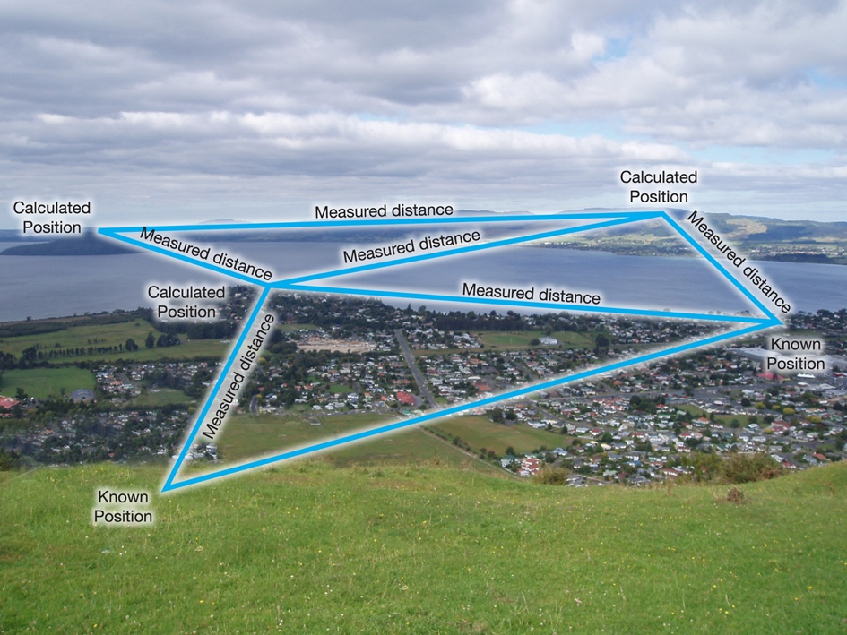
Figure 6 Trilateration Illustration

- Traverse Surveying: A traverse is a type of control survey commonly used in legal, mapping, and engineering surveys. Traverses are essentially a set of pre-determined stations that are connected by angle and distance.
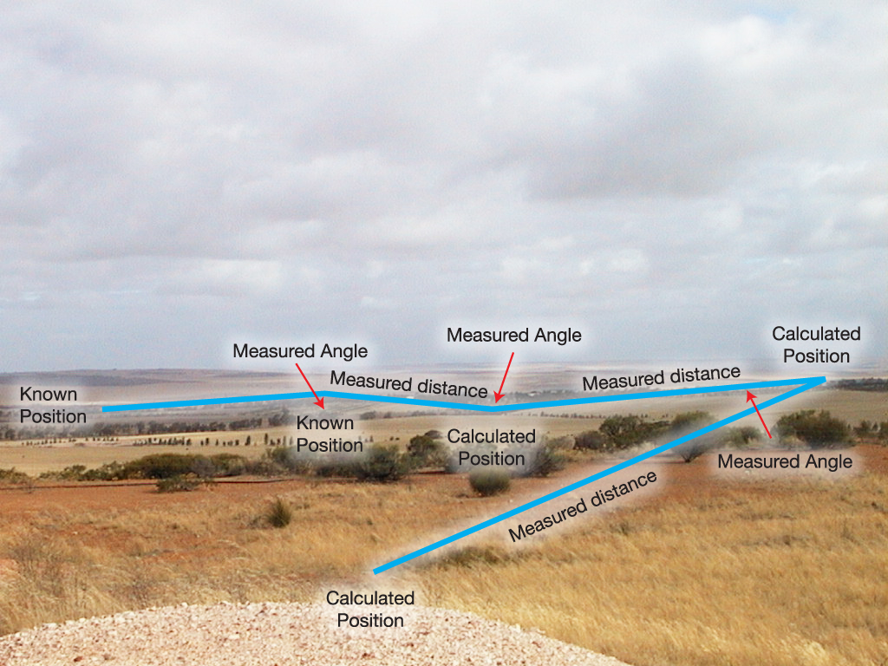
Figure 7 Traverse Illustration

Finally, Surveys can be based on equipment. Throughout time, there has been many technological advancements in the field of Surveying. Surveys based on Equipment can be categorized under either Traditional or Contemporary.

TRADITIONAL

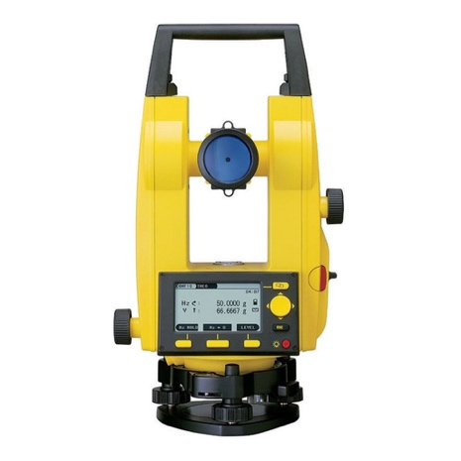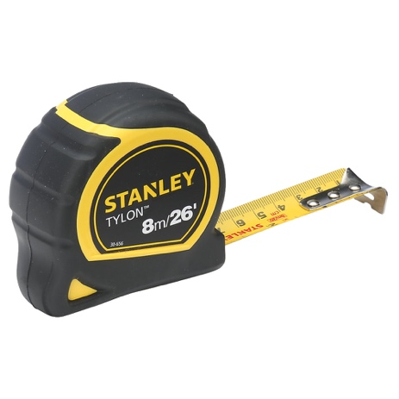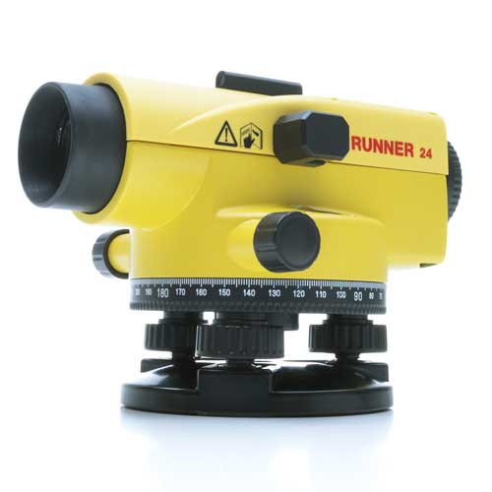
Figure 8 Theodolite, Measuring Tape and Dumpy Level (Left to Right)

CONTEMPORARY

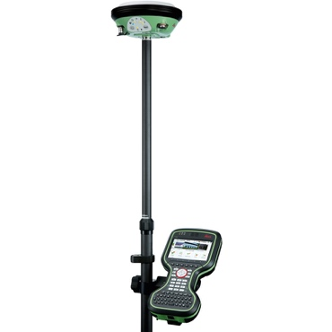
Figure 9 Laser Scanner, GPS Equipment and Drone/UAV (Left to Right)

DIGTIAL SURVEYING TECHNOLOGIES AND LISTED BUILDINGS

According to Historic England (n.d.), “Listing marks and celebrates a building's special architectural and historic interest, and also brings it under the consideration of the planning system, so that it can be protected for future generations.”

With reference to Historic England (n.d.), Buildings may be listed in either of the following categories by significance:


Figure 10 Grade I – Highest Significance

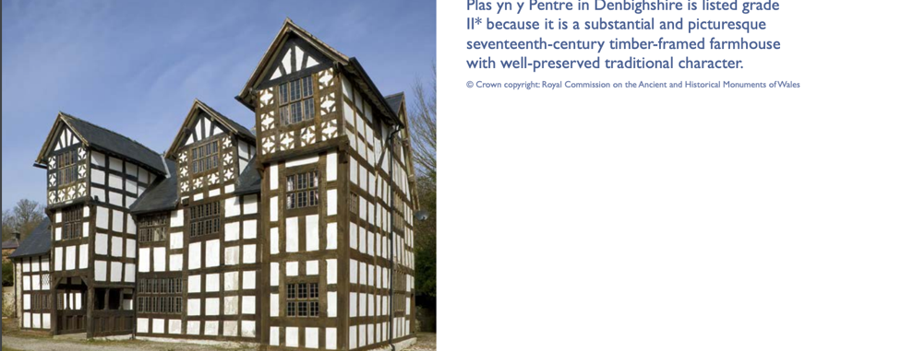
Figure 11 Grade II* - Higher Significance

Figure 12 Grade II – Moderate Significance

Through the Planning Act of 1999, a building or structure of special architectural or historic interest is recognised by law as being listed. But before listing, the building must be surveyed. The following stages represent the process by which buildings are surveyed.

- Preliminary Planning and Design: During this stage, historical data about the site location is allocated. This may include Risk assessments, Fire plans, Geographic data or ordinance surveys, Register plans and Building Drawings.

- Field Work: Within the contemporary era of surveying, technological advancements would have been made to more accurately define a building’s character or makeup. Here are a few ways, in detail, by which that is done.

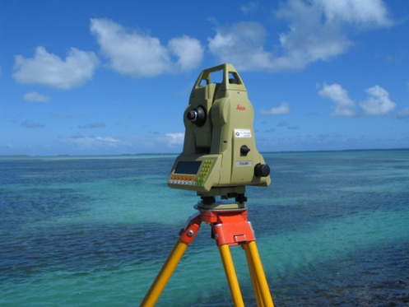
- Laser Scanning Applications: Teeuw, (2005, pp. 182) notes that a total station is a theodolite with distance measurement via laser or infrared beam, as well as internal and external electronic data logging. Because triangles can be constructed trigonometrically once you know one internal angle (between baseline and unknown point) and two edge lengths, these devices save the surveyor time from taking multiple measurements for each point location whose position needs to be known (the baseline and measured distance to unknown point).
Figure 13 Theodolite
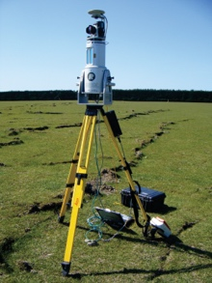
Also, according to Teeuw, (2005, pp. 183) Ground based lasers scan a horizontal and vertical field effectively from a stationary position. The system works similarly to a total station, except it scans a measuring beam across a field of view at regular intervals to create a 'cloud' of points that may be used to create a 3D surface of the imaged region. These systems are intricate and delicate pieces of machinery that, while robust by necessity, may be too heavy and fragile to move to a distant place.
Figure 14 Ground Laser Scanner

- Photogrammetric Applications: According to Wyoming Department of Transport (2018, pp. 3), Photogrammetry is the study of locating features on or above the earth's surface using pictures or digital photo images to get accurate measurements. The end result is a 3-D graphic representation of the terrain with the coordinates (X, Y, and Z) of a specific point, planimetric feature, or coordinate (X, Y, and Z) of a specific point. Kavanagh and Mastin (2012, pp. 375) coined that the cost savings for survey projects using aerial surveys instead of ground surveys can be considerable under the right circumstances. As a result, it's vital for the surveyor to be able to spot circumstances where aerial imagery could be useful.
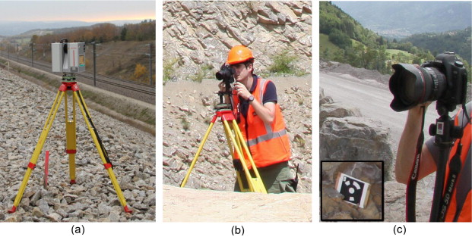
Figure 15 Laser Scanner and Two Canon Cameras (Left to Right)

A few Advantages of Photogrammetric Surveys provided by WYTOD:
- Aerial photography provides a lasting record of the conditions at the moment the image was shot.

- Photogrammetry can be employed in places that are difficult or impossible to reach by foot.

- It is not essential to conduct costly field work if information has to be re-surveyed or re-evaluated. In a timely manner, the image stereo model can be reloaded, measurements validated, and/or new information will be produced.

- Computing: This stage involves processing the data collected during the site observation and calculating/assessing the necessary work needed to be done as the final report approaches.

- Data Collection: During this stage, allocated data is represented in a way that is legible and clear for the viewer. This stage normally includes the Building Information Model or BIM.

- Final Report: This stage provides a conclusion of the allocated data and the pre-development project has been completed.

REFERENCES
(In order of appearance)

- Merriam-Webster. (n.d.). Surveying. In Merriam-Webster.com dictionary, Available at https://www.merriam-webster.com/dictionary/surveying. Retrieved January 10, 2022.
- Schofield, W., & Breach, M. (2007). Engineering Surveying, Sixth Edition (6th ed.) [E-book]. Butterworth-Heinemann.
- Davis, R. E., & Foote, F. S. (1953). Surveying Theory and Practice (4th) Fourth Edition (Fourth Edition). McGraw Hill.
- Hudson, K. (2021, September 22). 5 Important Reasons for Land Surveying. Pickett, Ray, and Silver. Retrieved January 10, 2022, from https://prs3.com/5-important-reasons-for-land-surveying/
- Kavanagh, B. (2009). Surveying with Construction Applications (7th Edition) (7th ed.). Pearson.
- Kavanagh, B., & Mastin, T. (2012). Surveying: Principles and Applications (9th ed.). Pearson.
- Ghilani, C. D., PhD, & Wolf, P. R. (2010). Elementary Surveying: An Introduction to Geomatics (13th ed.). Pearson College Div.
- Historic England. (n.d.). What are Listed Buildings? How England’s historic buildings are protected. Retrieved January 10, 2022, from https://historicengland.org.uk/listing/what-is-designation/listed-buildings/
- Teeuw, R. M. (2005). Field Techniques [E-book]. Expedition Advisory Centre, Royal Geographical Society (with IBG).
- Wyoming Department of Transport. (2018). Section VII - Photogrammetric Surveys [E-book]. JGOYEN.

