Name: Kimia Mansoory Kinevarsi
Student ID: 2242261
Module Name: Changemakers: Building your Personal Brand for Sustainable Employment
Module Code: BMHP5015
Lecturer: Caroline Salami
Submission date: 19/12/2025
Component 2

Table of Contents
Introduction 3
Analyse the Personal Employability Skills Required 4
Job Description and Person Specification 4
Key Employability Skills 5
Theoretical Frameworks 5
Evaluate Your Own Skills 6
Self-Assessment Methods 6
Experience and Reflection 6
Motivation and Development 6
Building a Personal Brand and Professional Identity 7
Action Plan and Timeline 8
Conclusion 9
References 10

Introduction
The chosen job role for this report is Mental Health Recovery Coordinator (Support Worker) within the voluntary and independent health and social care sector, as advertised by Apax on Indeed (Indeed, 2025). Mental Health Support Workers play a crucial role in supporting individuals experiencing mental ill-health to achieve recovery, maintain independence, and improve their overall quality of life. The role involves delivering person-centred care, supporting emotional wellbeing, managing risk, and working collaboratively with multidisciplinary teams.
I am interested in pursuing this role because it aligns strongly with my personal values of compassion, respect, and empowerment, as well as my academic background in health and social care. Mental health support work provides an opportunity to make a meaningful difference to vulnerable individuals while promoting dignity, equality, and recovery-oriented practice. In addition, this role represents a clear progression pathway within the mental health sector and supports my long-term aspiration to develop a career working with individuals who have complex mental health needs.
This report will analyse the personal employability skills required for the Mental Health Support Worker role, critically evaluate my own skills against these requirements, and present a structured action plan and timeline for development. It will also explore how I can build my personal brand, promote a professional identity, and develop professional networks to support successful employment within the health and social care sector.

Analyse the Personal Employability Skills Required

Job Description and Person Specification
The Mental Health Recovery Coordinator (Support Worker) role advertised on Indeed (2025) requires the provision of community-based support to adults with a range of mental health conditions, including anxiety, depression, and severe and enduring mental illness. Key responsibilities include delivering personalised support plans, promoting independence and recovery, monitoring mental wellbeing, managing and reporting risk, maintaining accurate records, and liaising with healthcare professionals, families, and external agencies.
The person specification highlights the importance of strong communication skills, emotional resilience, flexibility, safeguarding awareness, and a commitment to recovery-focused, values-based care. Employers also expect support workers to demonstrate professionalism, ethical practice, and the ability to work effectively within multidisciplinary teams.
Figure 1: Screenshot of Indeed job advert
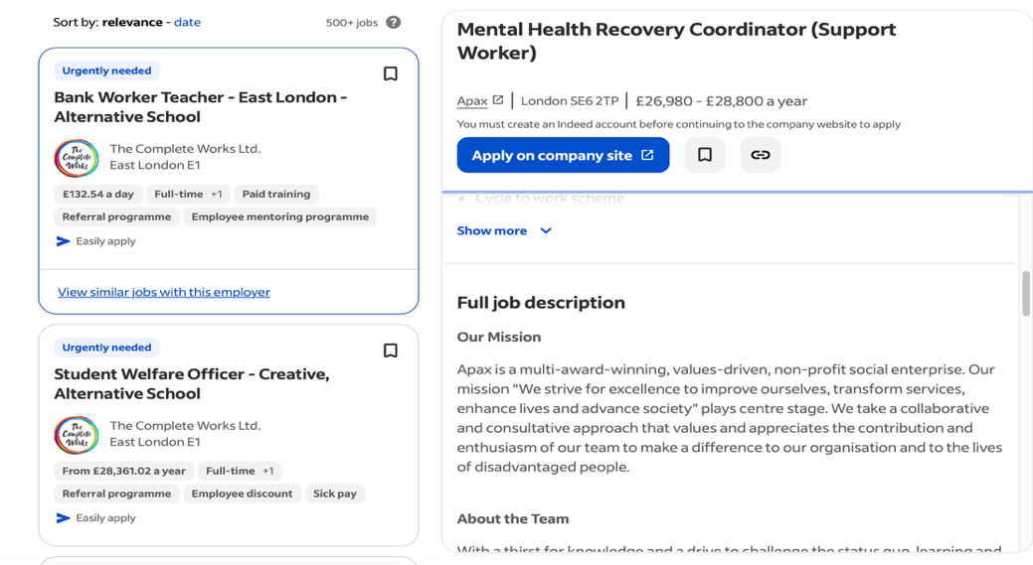

Key Employability Skills
Communication skills are fundamental to this role. Mental Health Support Workers must communicate effectively with individuals who may experience emotional distress, paranoia, or low motivation. Active listening, empathy, and clear written communication are essential when completing care plans, progress notes, and risk assessments. The Skills for Care Core Skills Framework identifies communication as a core requirement for delivering safe and person-centred care (Skills for Care, 2023).
Emotional intelligence and resilience are also critical employability skills. Support workers are often exposed to challenging behaviours, relapse, or crisis situations. The ability to remain calm, demonstrate empathy, and maintain professional boundaries reflects NHS values such as compassion, respect, and dignity (NHS England, 2022). For example, when a service user becomes distressed, a support worker may need to de-escalate the situation using reassurance and grounding techniques.
Teamwork and multi-agency working are central to effective mental health care. Support workers collaborate with nurses, social workers, psychiatrists, housing services, and voluntary organisations to ensure holistic and coordinated support. The 6Cs of Nursing—care, compassion, competence, communication, courage, and commitment—provide a useful framework for understanding professional behaviours required within multidisciplinary teams (Cummings and Bennett, 2012).
Digital literacy and organisational skills are increasingly important due to the use of electronic care records, digital risk assessment tools, and secure communication systems. Accurate documentation supports safeguarding, accountability, and continuity of care.

Theoretical Frameworks
The Employability Skills Framework highlights transferable skills such as adaptability, problem-solving, and professionalism, all of which are essential in dynamic mental health settings (Yorke and Knight, 2006). In addition, Kolb’s Experiential Learning Cycle explains how employability skills develop through experience, reflection, conceptualisation, and application in practice (Kolb, 1984).
The STAR model (Situation, Task, Action, Result) is commonly used during recruitment to assess competency-based skills, enabling candidates to demonstrate how they have applied their skills effectively in real-life situations.

Evaluate Your Own Skills

Self-Assessment Methods
To evaluate my suitability for the Mental Health Support Worker role, I completed a SWOT analysis and a skills audit, supported by academic feedback from lecturers. These self-assessment tools enabled me to compare my current skills and attributes with the requirements outlined in the job description.
My strengths include strong interpersonal communication skills, empathy, and a solid theoretical understanding of mental health, safeguarding, equality, and person-centred care developed through my health and social care studies. Feedback from lecturers has highlighted my reflective ability, ethical awareness, and commitment to professional values.
My areas for development include limited direct experience within acute mental health settings and reduced confidence in managing high-risk situations such as self-harm or crisis intervention. Although I understand these areas theoretically, further practical exposure is required to build confidence and competence.

Experience and Reflection
My academic studies have provided me with knowledge of mental health legislation, safeguarding procedures, and ethical decision-making. Group work and presentations have strengthened my teamwork, communication, and organisational skills. Using Gibbs’ Reflective Cycle, I can reflect on academic group work where conflicting opinions initially created challenges. Through reflection, feedback, and improved communication, I developed leadership and conflict-resolution skills, demonstrating adaptability and resilience (Gibbs, 1988).

Motivation and Development
Applying Maslow’s Hierarchy of Needs, my motivation to pursue this role aligns with esteem and self-actualisation needs, as supporting vulnerable individuals provides a sense of purpose, achievement, and professional fulfilment (Maslow, 1943). While I possess many foundational skills, I recognise the need to gain further practical experience, which informs the development of my action plan.

Building a Personal Brand and Professional Identity
Building a strong personal brand is essential within the competitive health and social care job market. My personal values include compassion, respect, accountability, and a commitment to reducing mental health stigma, all of which align with recovery-oriented and person-centred practice.
I plan to promote my professional identity through a tailored CV, a professional LinkedIn profile, and evidence of reflective learning and skills development. My LinkedIn profile will include a professional summary, education history, key skills, voluntary experience, and engagement with mental health-related content. A screenshot of my LinkedIn profile will be included to demonstrate a clear and professional online presence.

Figure 2: Screenshot of LinkedIn Profile

My Unique Selling Point (USP) is my strong academic foundation combined with reflective practice skills and genuine motivation to work in mental health. This aligns with the CareerEDGE Model, which identifies employability as a combination of experience, emotional intelligence, reflection, and self-efficacy (Dacre Pool and Sewell, 2007).
Professional networking is also crucial. Engaging with LinkedIn groups, mental health charities, and CPD events supports Social Capital Theory, which emphasises the importance of networks in accessing employment opportunities and professional development (Putnam, 2000).

Action Plan and Timeline
To achieve my goal of becoming a Mental Health Recovery Coordinator (Support Worker), I have developed a structured action plan informed by SMART goals and Bandura’s Self-Efficacy Theory, which highlights the importance of belief in one’s ability to develop skills through experience and effort (Bandura, 1997).
Short-term goals (0–12 months) include updating my CV and LinkedIn profile, completing CPD courses such as Mental Health First Aid and Safeguarding Adults, applying for voluntary roles within mental health charities, and attending mental health networking events.
Medium-term goals (1–3 years) include securing a paid role as a support worker or healthcare assistant, gaining experience in care planning, risk assessment, and crisis support, and engaging in regular supervision and reflective practice.
Long-term goals (3–5 years) include progressing into a full-time Mental Health Recovery Coordinator role and undertaking further qualifications such as a Level 5 Diploma in Health and Social Care.
Resources required include access to training, guidance from mentors or supervisors, and sufficient time for reflective learning. This action plan is realistic yet ambitious and supports continuous professional development.

Conclusion
This report has explored my aspiration to become a Mental Health Recovery Coordinator (Support Worker) and critically analysed the employability skills required for this role. The evaluation of my current skills demonstrates strong theoretical knowledge, effective communication, and clear motivation, alongside areas for development such as gaining practical mental health experience.
The action plan provides a structured pathway for developing these skills through targeted training, practical experience, networking, and reflective practice. Building a strong personal brand and professional identity further enhances my employability and readiness for work within the mental health sector.
This process has clarified my passion for supporting vulnerable adults and strengthened my commitment to recovery-oriented mental health care. Moving forward, I am motivated to continue developing my skills and professional identity to make a meaningful contribution to health and social care practice.
In addition, completing this report has increased my awareness of the importance of lifelong learning and self-reflection within professional practice. By engaging critically with employability frameworks and reflective models, I have developed a clearer understanding of how personal development, values, and professional standards intersect within mental health roles. This insight will support my ability to adapt to the evolving demands of the health and social care sector. Ultimately, this reflective journey has reinforced my confidence in pursuing a career within mental health support work and has provided a clear, realistic, and achievable pathway towards becoming an effective and compassionate Mental Health Recovery Coordinator.

References
Bandura, A. (1997) Self-efficacy: The exercise of control. New York: W.H. Freeman.
Cummings, J. and Bennett, V. (2012) Compassion in practice: Nursing, midwifery and care staff. London: NHS Commissioning Board.
Dacre Pool, L. and Sewell, P. (2007) ‘The key to employability: developing a practical model of graduate employability’, Education + Training, 49(4), pp. 277–289. https://doi.org/10.1108/00400910710754435
Gibbs, G. (1988) Learning by doing: A guide to teaching and learning methods. Oxford: Oxford Polytechnic.
Indeed (2025) Mental Health Recovery Coordinator (Support Worker) [online]. Available at: https://uk.indeed.com/q-mental-health-support-worker-l-london-jobs.html?vjk=7388766d1e92fec8&advn=3354994349286007 (Accessed: 05 December 2025).
Kolb, D.A. (1984) Experiential learning: Experience as the source of learning and development. Englewood Cliffs, NJ: Prentice Hall.
Maslow, A.H. (1943) ‘A theory of human motivation’, Psychological Review, 50(4), pp. 370–396. https://doi.org/10.1037/h0054346
NHS England (2022) NHS values and behaviours [online]. London: NHS England. Available at: https://www.england.nhs.uk/about/nhs-values/ (Accessed: 05 December 2025).
Putnam, R.D. (2000) Bowling alone: The collapse and revival of American community. New York: Simon & Schuster.
Skills for Care (2023) Core skills framework [online]. Leeds: Skills for Care. Available at: https://www.skillsforcare.org.uk (Accessed: 05 December 2025).
Yorke, M. and Knight, P.T. (2006) Embedding employability into the curriculum. York: Higher Education Academy.

