Saturday, 28 March 2026
Evaluating Delivery Efficiency Using Excel and SPSS.
Individual Report

Submission deadline - 2nd April 2026, before 14:00 (2 pm) Module name - data handling and business intelligence Student name - Ovidiu Florin Socel Lecturer’s name - Ihsan Ul Haq Student number – 2310644 Module code - LCBB5014
Contents
1. Introduction 2
2. Data Cleaning and Preparation. 3
3. Descriptive Statistics and Summary. 4
3.1 Excel and SPSS Exercises: Numerical Variables. 4
3.2 Analysis of Categorical Variables. 5
4. Trend Analysis and Visualisation. 7
5. Statistical Analysis using SPSS. 11
6. Insights and Recommendations. 17
7. References. 18

Evaluating Delivery Efficiency Using Excel and SPSS.

1. Introduction
The use of business intelligence and data handling for evidence-based decision-making means that organisations can turn their raw operational data into meaningful managerial insight, which is fundamental to data science (Kelleher and Tierney, 2018). In the case of delivery business, the analysis of the patterns of timing, indicators of customer service, traffic conditions and other operating variables is particularly important to improve efficiency and service quality (Sharda, Delen and Turban, 2018). In this report, the dataset for food delivery that has been taken into consideration consists of 11,399 records and 20 variables. The variables refer to the deployment person characteristics, delivery timings, weather conditions, road traffic density, type of vehicle, type of order, status of the festival, and the classification of the city. As a result, the dataset is useful for exploring whether operational and environmental factors affect delivery outcomes.
The report aims to analyse the dataset using Microsoft Excel and SPSS to ensure a practical insight concerning delivery performance and thus reflects the role of data-driven decisions in improving operational performance, Provost and Fawcett (2013). Four main objectives of the analysis. The dataset must be cleaned and prepared in Excel by identifying missing values, inconsistencies and formatting issues. Secondly, the main numerical and categorical variables will be summarised using descriptive statistics. The identification of trends and relationships, especially those related to delivery efficiency, will be the focus of visualisation. Using SPSS for statistical testing will be conducted to examine significant relationships among selected variables as evidence-based conclusions and recommendations. Application of statistical analysis tools, such as SPSS, systematises and tests relationships between variables. SPSS helps in the validation and evaluation of operational performance (Field, 2018).

2. Data Cleaning and Preparation.
The dataset was carefully cleaned and prepared in Microsoft Excel for analysis. During the business intelligence process, it is important to preprocess data because unclean data causes bias that is carried onto statistical analysis that follows (Knaflic, 2015; Bryman and Bell, 2015). The missing values were detected using Sort & Filter in Excel. Entries marked as NaN, invalid, or unverifiable locations were isolated by filtering every variable. Because of the lack of appropriate methods to accurately reconstruct these observations, cases were deleted listwise. In keeping with the recommended data cleaning procedures, deletion may be adopted when missing data is minimal in the overall data set and/or not systematic in nature and is unlikely to impact analytic outcomes (Pallant, 2020).
Moreover, there were also some inconsistencies in time related variable (Time_Ordered and Time_Order_picked). Many of the records were poorly formatted, which might jeopardise the computation of derived variables such as delivery time. The inconsistencies were addressed during coding using Excel Home → Number Format tools to ensure that all time values were zeroed in.
As a whole, the data cleaning techniques helped improve the integrity of our dataset, thereby ensuring that descriptive, trend and statistical analysis could be conducted on clean data.
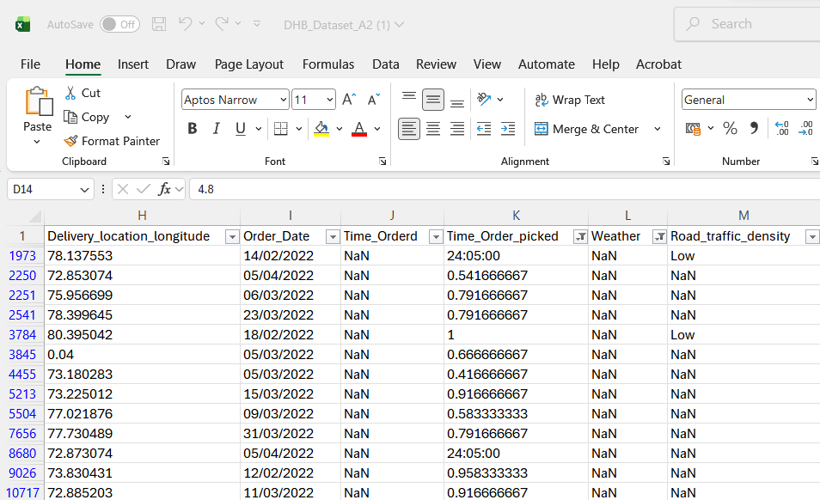

3. Descriptive Statistics and Summary.
Using Microsoft Excel and IBM SPSS Statistics, summary statistics were produced to describe essential numerical and categorical variables in the dataset. The data analysis process is essential in determining the central tendency and distribution of the sample before applying the inferential statistical analysis (Pallant, 2020).

3.1 Excel and SPSS Exercises: Numerical Variables.
Using PivotTables, Delivery_person_Age and Delivery_person_Ratings descriptive statistics were calculated in Excel. The first step included inserting the Pivot table in the dataset. The variables were dragged three times in the Values field. Accordingly, Value Field Settings were used so that each field was summarised by Average, Minimum, and Maximum.
Table 1: Excel PivotTable – Numerical Summary.

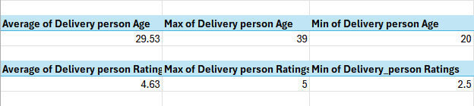
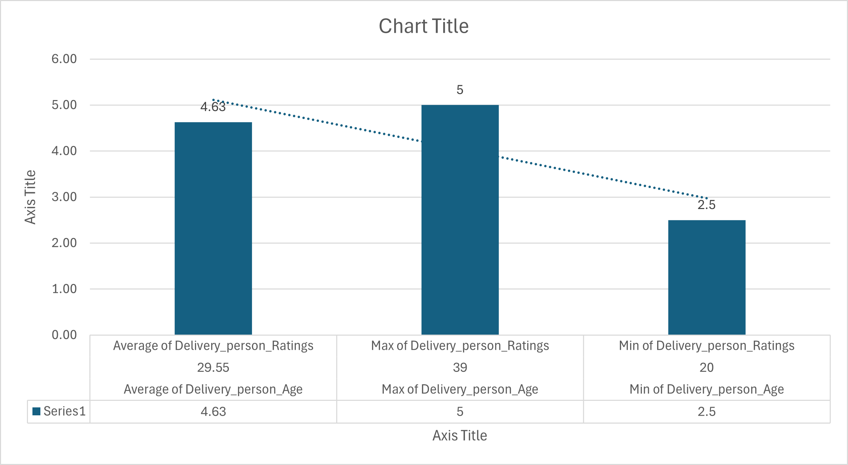
To create a visualisation of this table, the Clustered Column chart is created by selecting the PivotTable, Insert, Column Chart. The provided bar graph shows the average minimum and maximum of certain data points in a clear-cut manner.
In SPSS, the dataset was imported, and descriptive statistics were generated via Analyse → Descriptive Statistics → Descriptives (IBM Corp. 2023). The same variables were selected, and options for Mean, Min, and Max were switched on.
Table 2: SPSS Output – Numerical Summary.
Descriptive Statistics
 | N | Minimum | Maximum | Mean
Delivery_person_Age | 10908 | 15 | 50 | 29.52
Delivery_person_Ratings | 10892 | 1.0 | 6.0 | 4.633
Valid N (listwise) | 10892

3.2 Analysis of Categorical Variables.
In Excel, categorical variables like Weather, Road_traffic_density and others were analysed. In Rows, each variable was dropped, while an ID field was dropped in Values and summarised using Count.
Example Excel Frequency Table
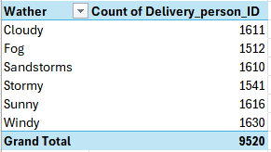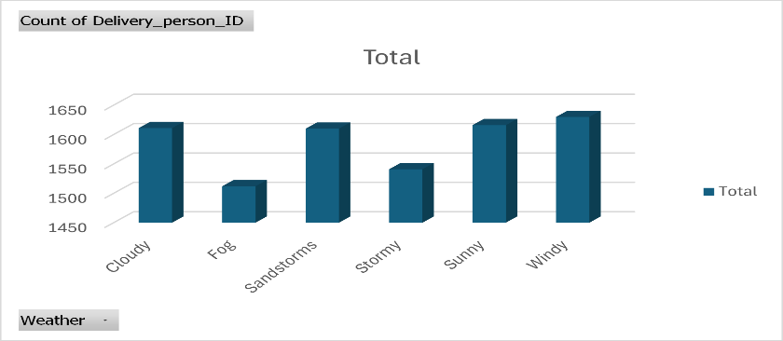

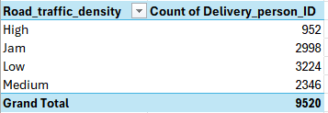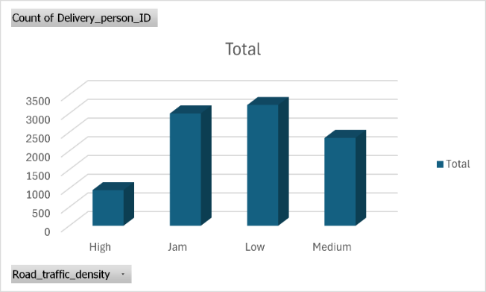
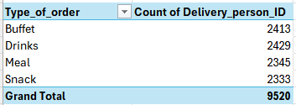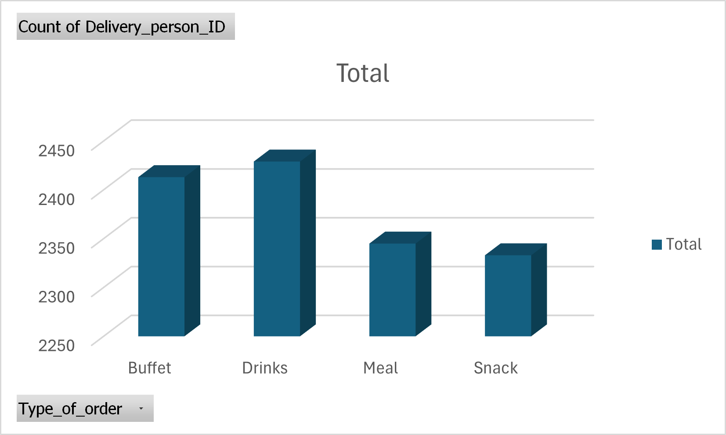
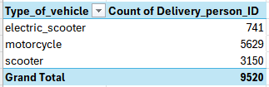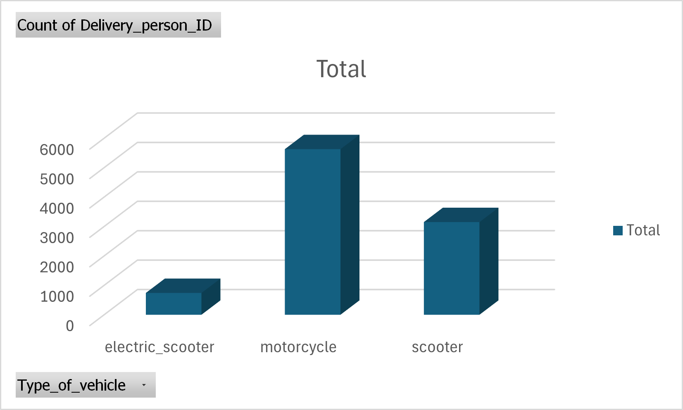
Bar charts were created from each PivotTable, using Insert → Bar Chart to visualise these distributions. The charts show that most deliveries take place during good weather and moderate traffic. Graphs of Types of vehicle and Types of order were made using a pie chart.
In SPSS, the option of Analyse → Descriptive Statistics → Frequencies was used for categorical analysis. This automatically generates frequency tables and bar charts. These outputs confirmed what we saw in Excel.

SPSS Descriptive Statistics
Weather
 |  | Frequency | Percent | Valid Percent | Cumulative Percent
Valid | Cloudy | 1611 | 16.9 | 16.9 | 16.9
Valid | Fog | 1512 | 15.9 | 15.9 | 32.8
Valid | Sandstorms | 1610 | 16.9 | 16.9 | 49.7
Valid | Stormy | 1541 | 16.2 | 16.2 | 65.9
Valid | Sunny | 1616 | 17.0 | 17.0 | 82.9
Valid | Windy | 1630 | 17.1 | 17.1 | 100.0
Valid | Total | 9520 | 100.0 | 100.0

4. Trend Analysis and Visualisation.
Visualisation of the dataset in Excel was useful in identifying crucial patterns across time and operational linkages affecting delivery performance. To study the trend, line graphs with trend lines for estimated delivery time and delivery ratings were created to illustrate this. The average delivery time chart, to an extent, fluctuated moderately with occasional slopes towards the upward side across some time intervals. The traffic delay and bad weather may lead to an increase in pollution at these places. On the other hand, deliverable ratings tend to have consistent patterns with only minor deviations. This indicates their relative consistency despite later delays. This suggests that although delivery speed varies, the service quality is perceived as acceptable. The reason could be that satisfaction with service is not only a matter of speed. It could also be reliability and communication (Hwang and Kim, 2019).

Delivery time trend data |  |  |  | Delivery rating trend data
Date | Avg. Delivery Time (mins) | 7-day Trend |  | Date | Avg. Rating | 7-day Trend
11-Feb | 39.02 | 39.02 |  | 11-Feb | 4.66 | 4.66
12-Feb | 82.66 | 60.84 |  | 12-Feb | 4.60 | 4.63
13-Feb | 36.07 | 52.58 |  | 13-Feb | 4.70 | 4.65
14-Feb | 85.68 | 60.86 |  | 14-Feb | 4.56 | 4.63
15-Feb | 36.94 | 56.07 |  | 15-Feb | 4.70 | 4.64
16-Feb | 83.20 | 60.59 |  | 16-Feb | 4.59 | 4.63
17-Feb | 38.29 | 57.41 |  | 17-Feb | 4.67 | 4.64
18-Feb | 81.66 | 63.50 |  | 18-Feb | 4.62 | 4.63
01-Mar | 38.24 | 57.15 |  | 01-Mar | 4.70 | 4.65
02-Mar | 82.04 | 63.72 |  | 02-Mar | 4.57 | 4.63
03-Mar | 37.51 | 56.84 |  | 03-Mar | 4.68 | 4.65
04-Mar | 84.04 | 63.57 |  | 04-Mar | 4.61 | 4.63
05-Mar | 38.18 | 57.14 |  | 05-Mar | 4.68 | 4.65
06-Mar | 83.50 | 63.60 |  | 06-Mar | 4.60 | 4.64
07-Mar | 41.53 | 57.86 |  | 07-Mar | 4.67 | 4.64
08-Mar | 85.58 | 64.63 |  | 08-Mar | 4.55 | 4.62
09-Mar | 39.35 | 58.53 |  | 09-Mar | 4.68 | 4.64
10-Mar | 80.38 | 64.65 |  | 10-Mar | 4.58 | 4.62
11-Mar | 40.07 | 58.37 |  | 11-Mar | 4.68 | 4.64
12-Mar | 86.77 | 65.31 |  | 12-Mar | 4.62 | 4.63
13-Mar | 37.64 | 58.76 |  | 13-Mar | 4.68 | 4.64
14-Mar | 83.50 | 64.76 |  | 14-Mar | 4.60 | 4.63
15-Mar | 40.28 | 58.28 |  | 15-Mar | 4.66 | 4.64
16-Mar | 85.38 | 64.86 |  | 16-Mar | 4.54 | 4.62
17-Mar | 38.31 | 58.85 |  | 17-Mar | 4.66 | 4.63
18-Mar | 84.73 | 65.23 |  | 18-Mar | 4.55 | 4.62
19-Mar | 39.52 | 58.48 |  | 19-Mar | 4.70 | 4.63
20-Mar | 82.28 | 64.86 |  | 20-Mar | 4.60 | 4.62
21-Mar | 39.58 | 58.58 |  | 21-Mar | 4.70 | 4.63
23-Mar | 84.28 | 64.87 |  | 23-Mar | 4.64 | 4.63
24-Mar | 39.26 | 58.28 |  | 24-Mar | 4.67 | 4.65
25-Mar | 83.16 | 64.69 |  | 25-Mar | 4.53 | 4.63
26-Mar | 38.99 | 58.15 |  | 26-Mar | 4.68 | 4.65
27-Mar | 88.65 | 65.17 |  | 27-Mar | 4.56 | 4.63
28-Mar | 38.90 | 58.97 |  | 28-Mar | 4.68 | 4.64
29-Mar | 81.51 | 64.96 |  | 29-Mar | 4.54 | 4.61
30-Mar | 36.56 | 58.15 |  | 30-Mar | 4.64 | 4.61
31-Mar | 82.49 | 64.32 |  | 31-Mar | 4.56 | 4.60
01-Apr | 38.19 | 57.90 |  | 01-Apr | 4.67 | 4.62
02-Apr | 82.43 | 64.10 |  | 02-Apr | 4.61 | 4.61
03-Apr | 40.11 | 57.17 |  | 03-Apr | 4.62 | 4.62
04-Apr | 87.23 | 64.07 |  | 04-Apr | 4.58 | 4.60
05-Apr | 37.14 | 57.74 |  | 05-Apr | 4.66 | 4.62
06-Apr | 85.98 | 64.80 |  | 06-Apr | 4.56 | 4.61
Average | 61.29 | 60.41 |  | Average | 4.63 | 4.63

Bar graphs illustrating average delivery time across various weather categories revealed the association between the weather pattern and delivery time. Results provide evidence that the delivery takes longer in stormy and rainy conditions than in clear or sunny conditions. To suggest that bad weather is positively correlated with longer delivery times may be due to a drop in visibility, drivers slowing down or taking greater care. As Boysen et al. (2018) showed in logistics literature, environmental conditions are a foremost determinant of transport efficiency.

Weather summary
Weather | Avg. Delivery Time (mins) | Orders
Sunny | 53.80 | 1616
Cloudy | 56.88 | 1611
Windy | 57.10 | 1630
Stormy | 62.05 | 1541
Fog | 63.34 | 1512
Sandstorms | 66.61 | 1610

Traffic density on the road is also assessed through bar graphs and scatter plots. The bar chart shows that the delivery times are much longer when traffic density is “High” and “Jam”. Moreover, deliveries are faster when traffic density is “Low”. The scatter plot further corroborates this connection, revealing a positive relationship between the intensity of traffic and the progress of delivery duration, with points rising as congestion increases. As traffic density is a key indicator of delivery performance variability, they cannot ignore its interaction with other operational variables.
Traffic summary
Traffic | Avg. Delivery Time (mins) | Orders
Low | 35.64 | 3224
Medium | 51.90 | 2346
High | 36.04 | 952
Jam | 99.84 | 2998

Comparative visualisations, such as grouped bar charts or pivot summaries of weather and traffic variables, highlight compounding effects. As an illustration, deliveries held during high traffic conditions under poor weather conditions have the longest delivery times, indicating an interaction effect. This emphasises the necessity of taking multiple environmental factors into account when evaluating logistics performance. The various visualisation tools provided by Excel, such as line graphs, bar graphs, and scatter plots, make a good analysis of the data to find the trends and dependencies. Through visual insights, decision makers use data as opposed to intuition by signposting out key operational constraints like environmental constraints, traffic constraints, etc. Organisations can carry out analysis and improve route planning, delivery schedules, and other aspects of efficiency.

5. Statistical Analysis using SPSS.
The statistical techniques evaluated in this chapter use the food delivery dataset for inferential statistical techniques using SPSS to study relationships in the dataset, whereby it tries to establish whether the chosen variables affect the delivery performance outcome or not. The analysis is based on three things: The hypothesis test, correlation and regression analysis. Statistics testing can recode categorical variables into numerical values for methodology consistency. *In particular, the weather conditions were grouped into good weather (1) and bad weather (2), while the density of road traffic was coded from the ordinal scale 1 (low) to 4 (jam). * Transformations are necessary to make the data conform to the assumption of parametric and non-parametric tests and enhance the reliability of the analysis (Field, 2018; Pallant, 2020).
Table 1. Numeric grouping used in the SPSS analysis
Variable | Code | Meaning
Weather | 1 | Good weather: Sunny, Cloudy
Weather | 2 | Bad weather: Fog, Stormy, Sandstorms, Windy
Road traffic density | 1 | Low
Road traffic density | 2 | Medium
Road traffic density | 3 | High
Road traffic density | 4 | Jam

In the first step hypothesis were tested using an independent samples t-test to analyse whether the ratings of delivery personnel differ significantly across weather. In SPSS, this was done via Analyse→Compare Means→Independent-Samples T Test (IBM Corp., 2023), with Delivery_person_Ratings being the test variable and the recoded weather variable being the grouping variable (groups defined as 1 and 2). This test applies when the aim is to compare mean differences between two independent groups that are measured on a continuous scale. (Field, 2018). According to the findings, t (5518.45) = 3.89, p < .001, there is a difference between weather conditions and ratings. Mean scores were relatively higher under good weather conditions (M=4.65; SD=0.37) than in bad weather (M=4.62; SD=0.30). In contrast, the effect size was notably small (Cohen's d = 0.09), indicating that whilst the difference was statistically detectable, it had a negligible practical effect. The difference between statistical and practical significance is relevant because a large enough sample will produce a p-value no matter how small the relationship is (Hair et al., 2019). Consequently, the weather by itself does not largely influence customer satisfaction in this data.

Figure 1. Mean delivery person rating by weather group code.
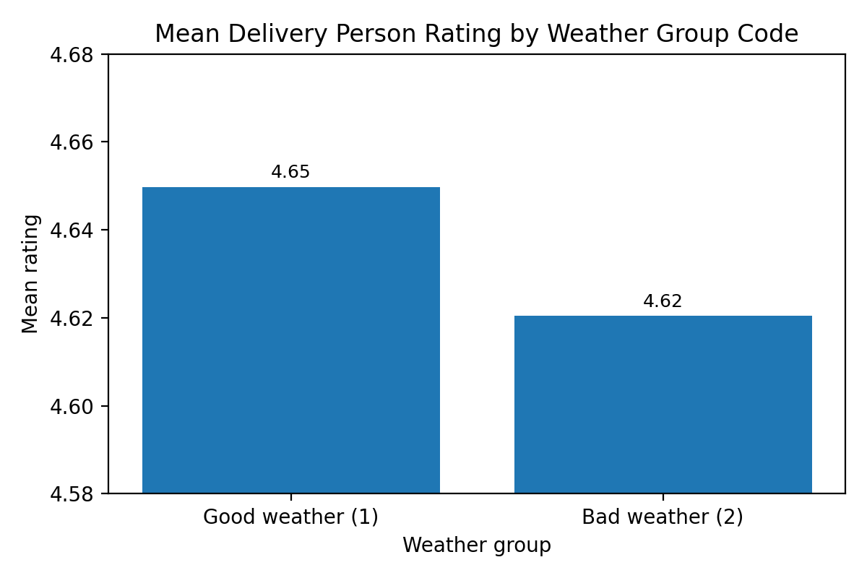
Tables 2 and 3. Hypothesis Testing. Delivery person rating by weather group code, T-Test.
Group Statistics
 | Weather_Diferent_Variables | N | Mean | Std. Deviation | Std. Error Mean
Delivery_person_Ratings | 1.00 | 3227 | 4.650 | .3697 | .0065
Delivery_person_Ratings | 2.00 | 6293 | 4.620 | .3045 | .0038

Independent Samples Test
 |  | Levene's Test for Equality of Variances |  | t-test for Equality of Means
 |  | F | Sig. | t | df | Significance |  | Mean Difference | Std. Error Difference | 95% Confidence Interval of the Difference
 |  |  |  |  |  | One-Sided p | Two-Sided p | Mean Difference | Std. Error Difference | Lower | Upper
Delivery Person Ratings | Equal variances assumed | 2.623 | .105 | 4.133 | 9518 | <.001 | <.001 | .0294 | .0071 | .0154 | .0433
Delivery Person Ratings | Equal variances not assumed. |  |  | 3.886 | 5518.447 | <.001 | <.001 | .0294 | .0076 | .0145 | .0442

The independent-samples t-test was opted for as this test is suitable for comparing mean differences of two independent groups with data that is approximately normally distributed, having a homogenous variance (Field, 2018).
In the second stage, the strength and direction of relationships between significant variables were analysed by the correlation method. To calculate correlations in SPSS, you need to click on Analyse, then Correlate and finally Bivariate. Next, to see whether your continuous variables correlate with each other, select Pearson correlation and for ordinal variables, select Spearman. A Pearson correlation was run to see if the delivery personnel's age and ratings had a linear relationship. Since both variables are continuous and approximately normally distributed, it displays a weak negative relationship (r = -0.102, p < .001). This suggests that as the age increases, there are lower ratings although they have less strength, thus their relationship is not meaningfully operational. To examine the relationship between traffic density and delivery distance, a Spearman correlation was used since the measurement scale of the traffic variable was ordinal, which violates Pearson's assumptions. The findings revealed a weak positive correlation (ρ = 0.225, p < .001), suggesting longer delivery distances are associated with greater traffic density levels. Though the relationships are statistically significant, their explanatory power is limited, suggesting caution is advisable with low correlation coefficients (Tabachnick and Fidell, 2019).
The restaurant coordinates, along with delivery coordinates, were used to compute delivery distance in SPSS. The initial step involved utilising the Compute Variable function to convert the variables Restaurant_latitude, Restaurant_longitude, Delivery_location_latitude, and Delivery_location_longitude into radians. The differences between the coordinates were calculated, and the result was input to the Haversine formula to calculate the distance in kilometres. The derived variable, Delivery_distance_km, was proactively created in advance in this process.
Table 4. Delivery distance km SPSS.
Descriptive Statistics
 | N | Minimum | Maximum | Mean | Std. Deviation
Delivery_distance_km | 9520 | 1.47 | 20.97 | 9.8020 | 5.60662
Valid N (listwise) | 9520

Figure 2. Scatter plot of delivery person age and ratings with fitted line.
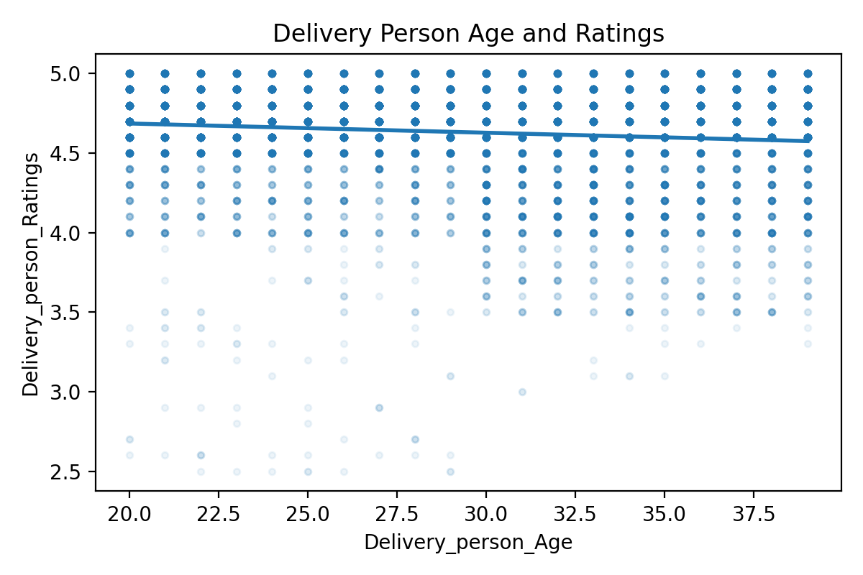

Figure 3. Mean delivery distance by road traffic density code.
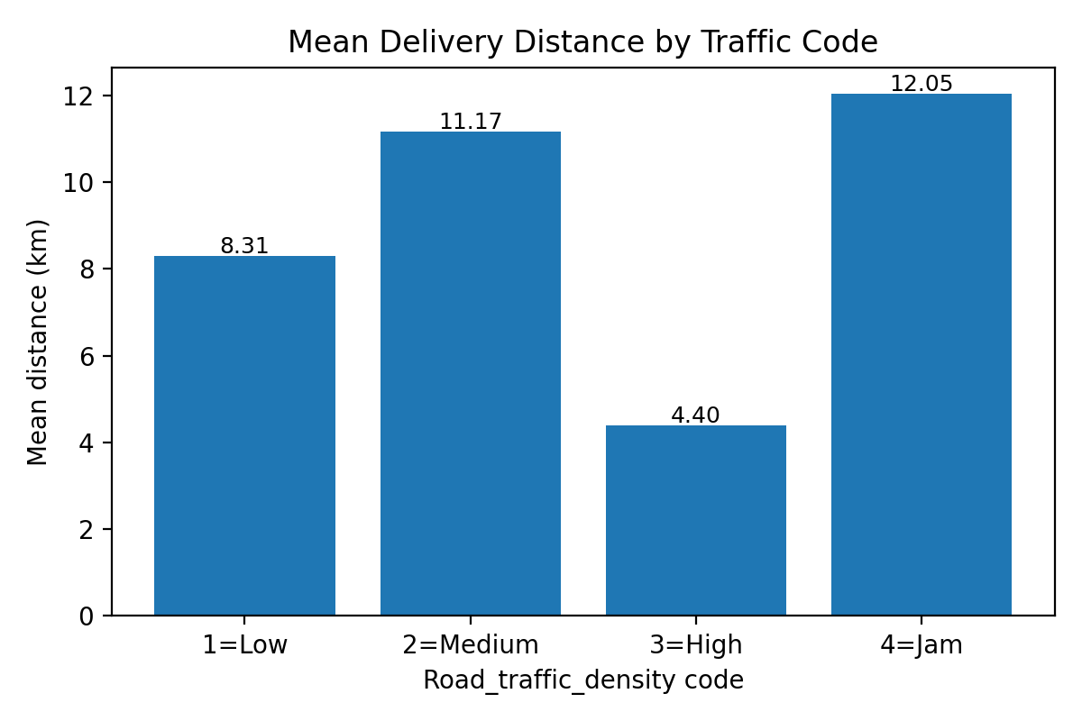
The last step is simply using linear regression to see whether the distance of the delivery predicts the estimated delivery time. In SPSS, this was done using Analyse → Regression→ Linear (IBM Corp, 2023) with Estimated_Delivery_Time as the dependent variable and Delivery_location_km as the independent variable. Through regression analysis, key predictors of the dependent variable and their impact on it are identified (Hair et al. 2019). The model revealed a substantial effect based on F-value 10102.35, p<.001, which determines the statistical significance of the percentage variance, significant at R2 .515. Based on a regression equation of Estimated Delivery Time = 13.65 + 4.72 (Distance), delivery time increases by 4.72 minutes per kilometre. The most powerful connection established in the analyses was that of distance as the most crucial operational factor influencing efficient delivery.
Figure 4. Regression plot of delivery distance and estimated delivery time.
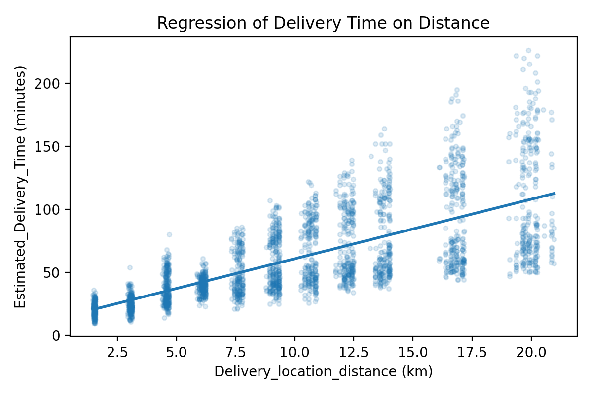

6. Insights and Recommendations.
An analysis of the dataset of food delivery reveals important findings regarding the determinants of delivery performance. Road medium is determined based on the operational condition. Finder delivery time is related to road traffic density. The above statement proved that road traffic density influences the delivery time significantly. The results from the regression analysis showed a significant increase in delivery duration with an increase in operational constraints, traffic and distance. Congestion was found to be the most critical operational constraint, reducing the efficiency of delivery operations. On the other hand, the weather did have a statistically significant effect on delivery ratings, although the effect size was minimal. In a similar line, correlation testing yielded weak correlations between the delivery personnel's age and their ratings. Hence, it means that this demographic factor does not matter much. According to Field (2018), performance is determined not by the operators themselves, but by operational and environmental variables.
Here are some actionable recommendations that can be suggested. To begin with, organisations should focus on route optimisation using live traffic data, which helps the drivers avoid congestion and deliver faster. Boysen et al. (2018) indicated last mile efficiency is better with dynamic routing. Second, organisations should implement adaptive delivery scheduling by revising estimated delivery dates based on predicted traffic and weather conditions. Thirdly, an efficient use of the type of vehicle, for example motorcycle or smaller vehicles in more congested urbanised areas, will result in less delay. In the end, implementation of contingency strategies which include buffer time and safety protocols can enable the overcoming of any kind of disruption because of adverse weather conditions.
Some limitations should be pointed out. The dataset is missing significant operational variables, which include driver experience, order preparation time, and real-time routing decisions, which can greatly impact delivery outcomes. Moreover, turning categorical data into numerical data serves a useful purpose, although it can also lead to a loss of information. Given the limitations of our research variables, future studies should consider utilising more sophisticated modelling approaches. Specifically, complex multivariate techniques such as multiple regression analysis, or even machine learning approaches, would yield more informative results (Hair et al., 2019; Pallant, 2020).

7. References.
Boysen, N., Schwerdfeger, S. and Weidinger, F., 2018. Scheduling last-mile deliveries with truck-based autonomous robots. European Journal of Operational Research, 271(3), pp.1085-1099.Available at: https://www.sciencedirect.com/science/article/abs/pii/S0377221718304776
Bryman, A. and Bell, E. (2015) Business Research Methods. 4th edn. Oxford: Oxford University Press. Available at: https://books.google.com/books?id=l7u6BwAAQBAJ
Hair, J.F., Black, W.C., Babin, B.J. and Anderson, R.E. (2019) Multivariate Data Analysis. 8th edn. Andover: Cengage Learning EMEA. Available at: https://www.cengage.uk/c/multivariate-data-analysis-8e-hair-babin-anderson-black/9781473756540/
Field, A. (2018) Discovering Statistics Using IBM SPSS Statistics. 5th edn. London: Sage. Available at: https://study.sagepub.com/field5e
Hwang, J. and Kim, H. (2019) ‘Consequences of customer satisfaction in food delivery services’, Journal of Retailing and Consumer Services, 48, pp. 72–79. Available at: https://doi.org/10.1016/j.jretconser.2019.01.001
IBM Corp. (2023) IBM SPSS Statistics for Windows, Version 29.0. Armonk, NY: IBM Corp. Available at: https://www.ibm.com/products/spss-statistics
Kelleher, J.D. and Tierney, B. (2018) Data Science. Cambridge, MA: MIT Press. Available at: https://mitpress.mit.edu/9780262535434/data-science/
Knaflic, C.N. (2015) Storytelling with Data: A Data Visualization Guide for Business Professionals. Hoboken, NJ: Wiley.
Available at: https://books.google.com/books?id=rRSRCgAAQBAJ
Pallant, J. (2020) SPSS Survival Manual: A Step by Step Guide to Data Analysis Using IBM SPSS. 7th edn. London: Routledge. Available at: https://www.taylorfrancis.com/books/mono/10.4324/9781003117452/spss-survival-manual-julie-pallant
Provost, F. and Fawcett, T. (2013) Data Science for Business. Sebastopol, CA: O’Reilly Media. Available at: https://www.oreilly.com/library/view/data-science-for/9781449374273/
Sharda, R., Delen, D. and Turban, E. (2018) Business Intelligence, Analytics, and Data Science: A Managerial Perspective. 4th edn. Harlow: Pearson. Available at: https://www.pearson.com/en-us/subject-catalog/p/business-intelligence-analytics-and-data-science/P200000001822
Tabachnick, B.G. and Fidell, L.S. (2019) Using Multivariate Statistics. 7th edn. Harlow: Pearson. Available at: https://www.pearson.com/en-us/subject-catalog/p/using-multivariate-statistics/P200000003097

