The Long Museum West Bund was designed by the famous Chinese architect Liu Yichun. This museum is the second one built in a collection of two, owned by the Chinese billionaire collectors Liu Yiqian and Wang Weis. The construction cost were $51.6 million with an overall project cost $65.2 million.
It was first opened to the Public in 2014 after an 18-month construction phase. When it was first opened, it was classed as China’s largest private museum. The long museum was designed and constructed by a Chinese Company called Atelier Deshaus.
Located on the banks of the Huang-pu River, Shanghai. The site that the museum is located on, was an old coal transporting dock. On this site an old coal hopper unloading bridge, dating back to the 1950s, was left as part of the design. The coal hopper is about 110 metres in length, 10 metres wide and 8 metres high and has been left as one of the main attractions as you approach the building. The site was also used as an underground parking complex, up until two years prior to the commencement of construction. This section has now been integrated into the building with the second storey still being used as a car parking area, and the upper floor being integrated into the main structure of the museum.
The project area is about 33,000 square metres on a site that was only 19,337 square metres
. 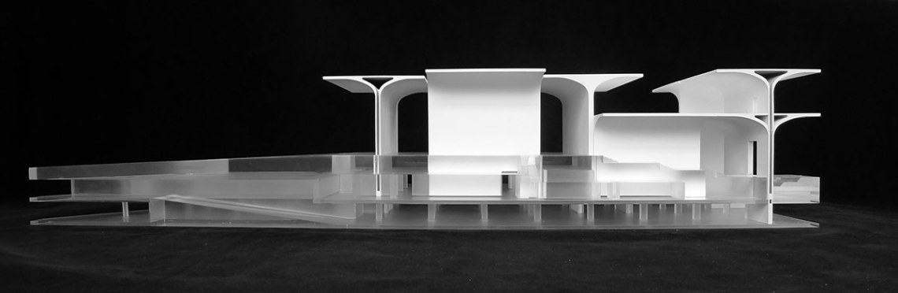

The London Shard.
The land the Shard now occupies was originally a 24-story concrete building purchased by Sellar Property Group in November 1998.
Sellar first envisioned a 400m high tower of 1.5 million square feet. At the first meeting of Sellar and famous Italian architect Renzo Piano he called the original plans “cold, arrogant, dark and divisive. Piano set about designing a better tower which was inspired by the church spires and sailing masts disappearing softly into the London sky.
Over 300 public meeting, 150 CGI renderings, covering every angle and meetings with English Heritage, St Paul’s Cathedral, Historic Royal Palaces to name but a few.
The final tower was reduced in height, but Sellar & Piano still managed to fit 30 acres of property onto a 1-acre site.
The idea for the tower was a vertical city, this design allows the building to live 24 hrs a day. The 309.6-meter scheme would consist of 95 stories, with a 200-room hotel, 6000 square feet of restaurants, 10 apartments plus office space.
The Shards foundations had to be structured around the existing piles from Southwark Tower, along with an old stair, elevator shaft and a ventilation shaft to the west, plus services.
New piles were designed to pass between the old ones, along with 3D finite element analysis to predict ground movement.
Adjustments had to be made to the size of the basement, this was achieved by using BIM to restructure the plant and Top-Down construction to make up for loss of time, allowing 23 stories of the 72 to be built before the basement was finished, this saved 3 months on the build.
The tower is effectively 3 separate structures, steel frame, post-tension concrete then a steel spire.
The team constructing this build MACE, along with engineers WPS Global used several firsts during construction, largest concrete pour, first use of a jump lift, first incline hoist in the world and the first crane to be supported on a slipform. (Timeline)
The Shard had up to 1450 people working on it. 95% of all construction materials were recycled, along with 20% of all steel used. The Shard achieved a BREEAM Excellent rating and brings in 1 million visitors to the viewing gallery each year plus the additional people using the new bus and rail station, thus generating local income and regenerating the South Bank.
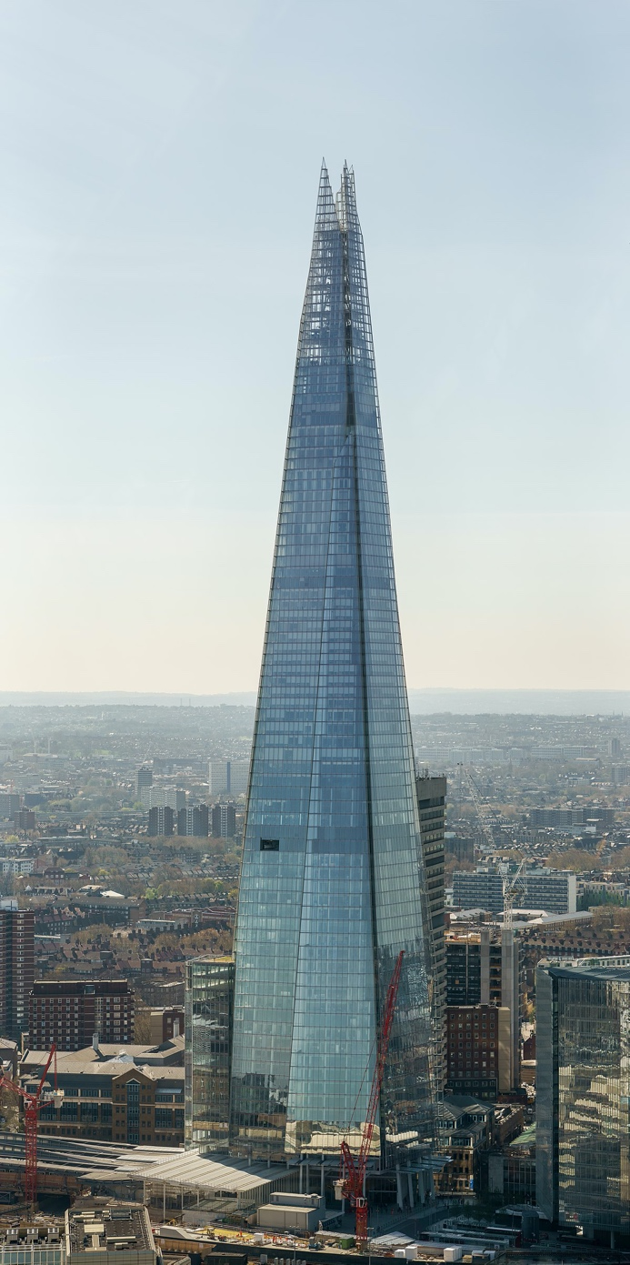

1.The frames likely durability depends on several different circumstances when it comes to concrete frame building. The first factor is the air quality and air pollution around the building. This can be a massive factor as it can cause early deterioration to tall concrete structures. There are five different ways that air pollution can seriously affect a concrete structure: deposition, abrasion, direct chemical attack, corrosion and indirect chemical attack. Although these are the major five, they have relatively low effects on concrete, due to its strength after 28 days. Something that does affect concrete over a long period of time is acid rain. Acid rain is caused when there's high pollution in a high humidity atmosphere. Over a long period of time this can be detrimental to the building structure. If Concrete is exposed to an excessive amount of acid rain this can lead to the different components in concrete breaking down, this will only happen over an exceedingly long period of time but it's something you have to watch out for when building concrete structures in humid places.
Another massive problem is the quality of concrete used, there are different qualities, and they are known as grades, different grades are used for different aspects of the construction industry. For a large structural building an RC grade of concrete would have been used, such as RC40/50 this would give a structural support of 50N/mm2 after 28 days.
The climate in shanghai is relatively mild with air temperatures not dropping below freezing in the winter and weather reaching mid 30s in the summer with lots of rain. The reason they have very wet summers due to its tropical climate, with high humidity.
Due to the high humidity and high levels of air pollution this combination is the perfect cocktail for acid rain.

Steel framed buildings are very different in composition to concrete, as streel is a lot more susceptible to acid rain and air pollution. This is due to steel having greater corrosive properties. Steel can receive a number of different treatments to assist in the prevention of rust and corrosion, these treatments extend the life expectance of the steel/building with coatings falling under the (rrosivity category) from C1(very low) to CX(extreme). Acid rain can impact on the life expectancy of steel by eroding away the protective coating, hence the rroitity category’s structure of coatings, with a C5 rating for the City of London.
The climate in London is relatively cold all year round with lows of -5 and highs of 25-28 degrees on average during the summer. This season is relatively dry with winters being very wet. This can play a big part on how quickly the steel starts to deuterate.
Acid rain does occur in London, but due to the London climate and lesser degree of pollution the environmental impact on the steel structures is lesser than that of a comparable city such as Shanghai.

2. Steel is produced by mining iron ore, this is a highly energy intensive, causing air pollution in the forms of nitrous oxide, carbon dioxide, carbon monoxide and sulphur, from diesel engines, generators, trucks and other heavy equipment, steel is an alloy consisting mostly of iron ore and -2% carbon. (The World Counts)
Heavy metals and acids escape the mines causing water prolusion and long-term ground contamination for decades.
This activity is the most energy consuming and CO2 emitting industrial activity in the world.
Steel requires 20 gigajoules of energy per ton produced, with up to ¾ of the energy coming from burning coal.
Coke used in the burning process emits naphthalene, which is carcinogenic. Water from coking is highly toxic containing ammonia, sulphides, ammonium and cyanide.
On average, 1.83 tonnes of CO2 are emitted for every ton of steel produced and is a major contributor to global warming. Steel production has increased 10-fold since 1950. (World Counts)
The by-product of steel production is slag or steel aggregates. This product comprises of silica, alumina, titanium (from iron sand) as well a calcium and magnesium oxides from other raw materials.
All steel slag products are rigorously tested prior to market release, ensuring they are suitable for the correct application/environment, such as low carbon concrete.

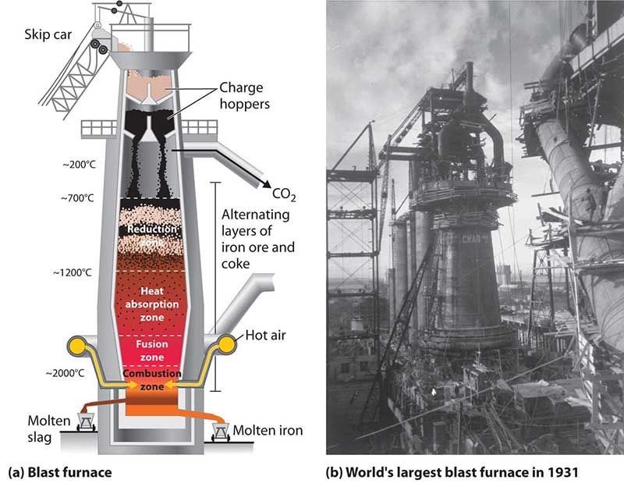

Concrete consists of 3 main products – Portland cement, aggregate (rock, sand or gravel) and water.
The concrete industry is one of the three largest producers of carbon dioxide, creating between 4 - 5% of the worlds man made emissions, of which 30% is from the use of energy and 70% is from burning, especially fossil fuels. (Sustainable Community Action)
During the production of concrete, CO2 is produced at two separate points: -
Firstly, a by-product of burning fossil fuels, primarily coal, to generate the heat necessary to drive the cement- making process.
Secondly, from thermal decomposition of calcium carbonate in the process of producing cement clinker, with temperatures reaching up to 1500 degrees Celsius. One of the main reasons for the excessively high heating is due to alite (Ca3SiO5), a mineral which gives concrete most of its initial strength, due to its ability to cure within hours of pouring.
When lime is produces, via calcium carbonate thermally decomposing, greenhouse gases are produced.
The CO2 produced from the manufacture of one tonne of concrete, with 14% cement content is estimated to be 410 kg/m3, reducing to 290kg/m3 with the addition of 30% fly ash, replacing the cement. (SCA)
CO2 emitted is proportional to the amount of cement used in a concrete mix, with 900kg of CO2 being emitted into the atmosphere for every tonne of cement manufactured. (Sustainable Community Action)

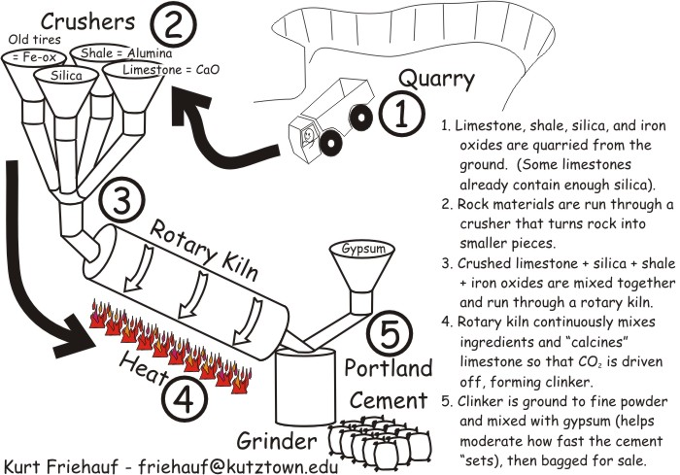

The by-products of concrete are: -
Cement Kiln Dust (CKD). This fine-grained dust, highly alkaline and removed from cement kiln gases by air pollution control measures. It is made of mainly calcium silicates, alumino-ferrites and aluminates, subject to the concrete properties. CKD can be reused in the cement production process, but each plant must evaluate the composition as it can vary structured on the material used during the initial production phase.
Surface Runoff. Concrete forms an impervious surface. When water runs off such a surface soil erosion and flooding can occur. Flooding relating to surface run off can collects other pollutants, thus further spreading contamination.
Urban Heating. Concrete is one of the primary causes of urban heat island effect. In some cities up to 30-40% of surface areas are asphalt, which directly affect the temperature. By using light coloured concrete, the heat can be reduced but not eliminated.

3. Steel framed structures are relatively easy to assemble, this is due to steel work mainly being used to form the skeleton of the frame. This can typically consist of upright pillars with beams in between, connecting to diagonal bracing making the frame structurally sound. Steel frames are usually bolted, welded or riveted/hot riveted, with hot riveted being the strongest form of bonding.
On the Shard the 12,500 tonnes of steel were bolted together mechanically by hand. The frame of the shard is rather complex due to the shape of the building tapering in at the top. This meant, further up the building, the size of the support columns could be reduced as they were not supporting as much structural weight.
Construction started with six-metre-thick support columns at the bottom of the building, these six metre columns went up to the hotel section of the building at the 40th floor. At this point, they change to three metre columns, these three metre columns continued up to the Spire, at which the steels were changed to 1.5 metre columns.
Due to the Shards location, it was exceedingly difficult and inconvenient to get materials on to the site. This led to heavy transportation into a built-up area with items being craned into place. Due to the shard's unusual shape this would make any external adaptions to the building extremely hard, also, as the Shard takes up the whole of the site this would make it practically impossible for any additional outbuildings or extensions.
The benefit of building with steel is ‘pound for pound’, it is a lot stronger than other materials, such as concrete, this is due to its density.

Concrete framed structures can also be relatively easy to assemble, this is because concrete can be poured off site or mass poured on site into preformed shutters. The Long Museum used abstract concrete pieces made off site, these were called ‘vaulted umbrellas’, which are a cantilever structure, consisting of large pieces of concrete shaped like a ‘T’.
They are made from a cast finished concrete surface, so the geometrical dividing lines can only be seen faintly. The umbrellas are independent to the walls, the walls connect to the existing column grid from the underground car park. The Concrete umbrellas were bolted and concreted together providing an almost invisible connection line. Due to the sheer size of the vaulted umbrellas, heavy transportation was required to deliver them to the construction site. The building sits on a large site this allows additional room for extending at a later date. As the Long Museum is a mass concrete structure additional sections added onto the budling should not be a problem, as long as these buildings do not interfere with any of the structural elements.

rrosivity category | Low-carbon steel Thickness loss (μm)ª | Examples of typical environments (informative only)
rrosivity category | Low-carbon steel Thickness loss (μm)ª | Exterior | Interior
C1  very low | ≤ 1.3 | - | Heated buildings with clean atmospheres, e.g. offices, shops, schools, hotels
C2  low | > 1.3 to 25 | Atmospheres with low level of pollution: mostly rural areas | Unheated buildings where condensation can occur, e.g. depots, sports halls
C3  medium | > 25 to 50 | Urban and industrial atmospheres, moderate sulphur dioxide pollution; coastal area with low salinity | Production rooms with high humidity and some air pollution, e.g. food-processing plants, laundries, breweries, dairies
C4  high | > 50 to 80 | Industrial areas and coastal areas with moderate salinity | Chemical plants, swimming pools, coastal ship and boatyards
C5  very high | > 80 to 200 | Industrial areas with high humidity and aggressive atmosphere and coastal areas with high salinity | Buildings or areas with almost permanent condensation and high pollution
CX  extreme | > 200 to 700 | Offshore areas with high salinity and industrial areas with extreme humidity and aggressive atmosphere and sub-tropical and tropical atmospheres | Industrial areas with extreme humidity and aggressive atmosphere

Reference list:
CTBUH
Ingenia online
Designing Buildings Wiki
Property Week
TheLongMuseum
Archdaily
Arts and Culter
Design boom

