

Blogs

Student name: Cristina Limbau
Student number: 2410885
Module name: Managing Projects in the Organisation (BMSW5009)
Lecturer name: Lan Zhang
Date: 19th of June 2026

University of Wales Trinity Saint David

Table Of Contents
Contents
Table Of Contents 2
Blog 1 3
Project Introduction and Team Role 3
Blog 2 4
Project Initiation and Scope 4
Blog 3 5
Stakeholder Analysis & Communication 5
Blog 4 6
WBS & Gantt Chart 6
Blog 5 7
Risks & self-evaluation 7
Reference List 8

Blog 1

Project Introduction and Team Role

For this project, my group decided to organise a Business Pop-Up Market to help students gain practical business experience. The event will allow students to showcase and sell products or services while developing skills in marketing, customer service and business management. The project sponsor is the University of Wales Trinity Saint David, as the event supports student development and entrepreneurship. Although choosing a project idea was challenging due to differing opinions within the group, we eventually agreed on a shared vision. This reflects the project initiation stage, where ideas are discussed and refined before moving forward (Edkins et al., 2013).
My main contribution to the team is organisation, communication and marketing. Through my experience in the beauty industry, I regularly manage appointments, communicate with clients and promote services, which I believe will help the project run effectively.
My Belbin results identified me as a Completer Finisher, with Resource Investigator as my second strongest role. This reflects my attention to detail and focus on quality (Belbin and Brown, 2022). However, my lowest score was Team worker, highlighting an area for improvement. Although the Belbin model helped me understand my strengths, it does not fully explain how team dynamics and conflict can influence behaviour. Overall, this project will help me develop stronger teamwork and project management skills.
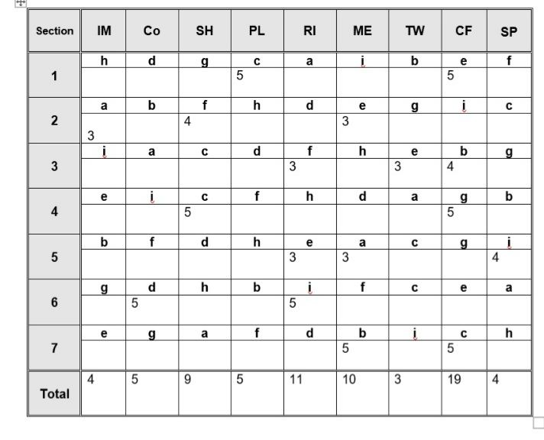

Blog 2

Project Initiation and Scope


During the project initiation stage, our group developed the Students Business Pop-Up Market into a more structured and realistic project. The aim is to organise a student-led market that gives students practical business experience while developing entrepreneurial skills. We wanted the project to provide a safe environment where students could test business ideas, interact with customers and gain a better understanding of marketing and sales. Establishing a clear aim helped the project direction and purpose (Heagney, 2022).
To support this aim, we created several objectives. These included planning and organising the event, providing opportunities for students to showcase their products or services, developing communication and customer engagement skills, and evaluating the event through feedback. Breaking the project into objectives made it easier to identify what needed to be achieved.
We also identified key deliverables, including promotional materials, social media content, the event itself and a feedback summary. To keep the project manageable, the scope was limited to planning, promoting and evaluating a single event, excluding future events and long-term employability. Using the Iron Triangle helped us assess whether the project was realistic by considering the available time, resources and expected quality of the project (Kidston and Holmes, 2015).

Blog 3

Stakeholder Analysis & Communication

Stakeholder analysis helped our group identify the people and organisations that could influence or be affected by our project. The main stakeholders included students, the project team, the sponsor, the local council, academic staff and the community. According to (Kujala et al., 2022), effective stakeholder engagement is important because different stakeholders have different interests, expectations and levels of influence.
The most important stakeholders were students, the project team and the sponsor. Students are the main target audience and will benefit from the opportunity to develop business and entrepreneurial skills. The project team has a high level of influence because we are responsible for planning and delivering the event. The university sponsor also has significant influence as it provides support and guidance throughout the project. Creating value for these stakeholders is essential for project success (Clegg, Skyttermoen and Vaagaasar, 2021).
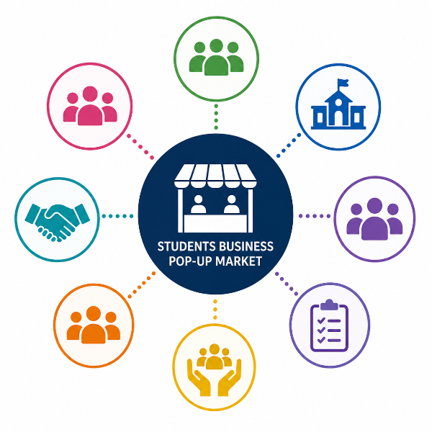

To communicate effectively, we planned to use different methods for different stakeholders. Students would receive updates through social media and posters before the event, while sponsors and the local council would be contacted through emails and meetings, with regular updates. The project team would communicate frequently through group chats and shared documents to monitor progress. One challenge was recognising that not all stakeholders require the same level of communication, making it important to prioritise communication based on their influence and interest.

Blog 4

WBS & Gantt Chart

To plan the Business Pop-Up Market effectively, our group used a Work Breakdown Structure (WBS) and a Gantt Chart. The WBS helped us divide the project into smaller and more manageable stages, including planning, venue selection, marketing, stakeholder management, event execution and post-event activities. Breaking the project down in this way made it easier to understand what tasks needed to be completed and how they contributed to the overall project goals. According to Su (2022), a WBS helps improve project organisation by structuring work into manageable components.
After creating the WBS, we used a Gantt Chart to organise tasks into a timeline and identify the sequence in which activities should be completed. This helped us visualise deadlines and ensure tasks were scheduled realistically. Bianconi (2024) highlights that Gantt Charts are useful for displaying project activities and timelines in a clear visual format.
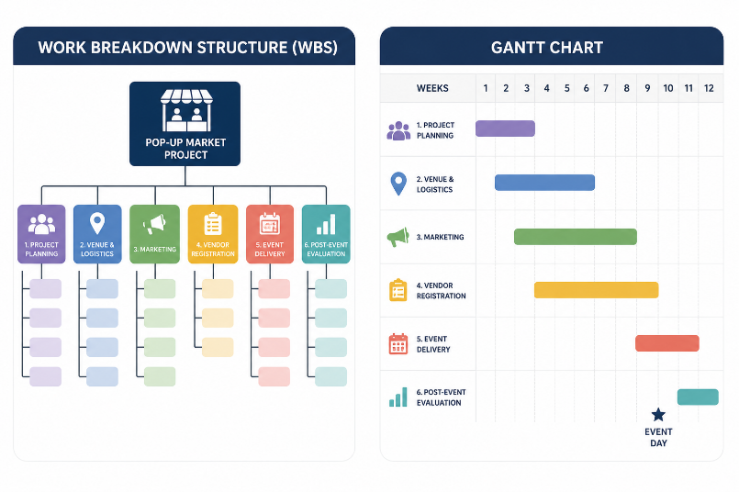

Although both tools were valuable, I found the WBS more useful because it provided a clearer overview of the work required. One challenge was developing the Gantt Chart, as it was difficult to estimate task durations and create a clear timeline. As a result, our initial Gantt Chart would benefit from further refinement to improve clarity and detail.

Blog 5

Risks & self-evaluation
This project allowed me to reflect on my strengths and weaknesses in relation to project management. One of my main strengths was organisation, as I helped ensure tasks were completed on time and that project activities remained structured. I also contributed to communication and marketing, areas in which I have developed experience through my work in the beauty industry. These skills helped me support the promotion of the Students Business Pop-Up Market and maintain communication within the team and with stakeholders.

Despite these strengths, I recognised areas that require improvement. During the early stages of the project, disagreements regarding the project idea created challenges withing the group. Although communication remained professional, differing opinions sometimes affected my decision-making and teamwork, which can negatively impact project progress if not managed effectively (Edwards, Serra and Edwards, 2025). Reflecting on this experience, I realise that I can become overly focused on my own approach when I believe it is most effective solution.

My self-development plan is to improve my teamwork, delegation and conflict-management skills by listening more actively to alternative viewpoints and encouraging greater collaboration. Developing these skills will help me become a more adaptable project manager and support my continued personal and professional growth (Magolda, 2023).

Reference List
- Belbin, M.R. and Brown, V. (2022) Team Roles at Work. 3rd edn. London: Routledge.
- Bianconi, F. (2024) ‘Gantt Charts’, in F. Bianconi (ed.) Data and Process Visualisation for Graphic Communication: A Hands-on Approach with Python. Cham: Springer Nature Switzerland, pp. 175–181. Available at: https://doi.org/10.1007/978-3-031-57051-3_13.
- Clegg, S.R., Skyttermoen, T. and Vaagaasar, A.L. (2021) Project management: a value creation approach. Thousand Oaks: Sage.
- Edkins, A., Geraldi, J., Morris, P. and Smith, A., (2013) ‘Exploring the front-end of project management’, Producation Planning & Control, 24(8–9), pp. 743–755. Available at: https://doi.org/10.1080/21573727.2013.775942 (Accessed: 4 June 2026).
- Edwards, P.J., Serra, P.V. and Edwards, M. (2025) Managing Project Risks. 2nd edn. West Sussex: John Wiley & Sons.
- Heagney, J. (2022) Fundamentals of Project Management, Sixth Edition. Nashville, UNITED STATES: HarperCollins Leadership. Available at: http://ebookcentral.proquest.com/lib/trinity/detail.action?docID=29731108 (Accessed: 3 June 2026).
- Kidston, P. and Holmes, G. (2015) Planning, Scheduling, Monitoring and Control: The Practical Project Management of Time, Cost and Risk. Princes Risborough, Buckinghamshire: Association for Project Management. Available at: http://ebookcentral.proquest.com/lib/trinity/detail.action?docID=6425572 (Accessed: 3 June 2026).
- Kujala, J. et al. (2022) ‘Stakeholder Engagement: Past, Present, and Future’, Business & Society, 61(5), pp. 1136–1196. Available at: https://doi.org/10.1177/00076503211066595.
- Magolda, M.B.B. (2023) Making Their Own Way: Narratives for Transforming Higher Education to Promote Self-Development. New York: Routledge. Available at: https://doi.org/10.4324/9781003445883.
- Su, Y. (2022) ‘WBS-Based Method in Teaching Management Information Project’, Journal of Computer Networks and Communications, 2022(1), p. 9623385. Available at: https://doi.org/10.1155/2022/9623385.

