SJIE6002

Exploring Literacy Barriers

Student Number - 1708393

Contents Page

- An overview of chosen learner and literacy resource/programme P3-4

- Reference to appropriate theoretical framework - P4-5

- An in depth critical evaluation of method - P5-6

- Evidence of observations in written or electronic form - P7-8

- A reflective log of case study - P7-11

- References – P12

“Children who have a good start to reading are likely to have accelerated progress throughout their attainment in school.” (Papen, 2015. p.3) This assignment explores the impact of using a specific literacy programme and if it offers children the skills that they require to be able to read and write to the best of their abilities.
School M is a community primary school that consist of 209 pupils from a nursery class to year six. The school uses a reading and writing programme called Read Write inc. This is taught from reception class, it aims to complete by year two, however many children still require this programme taught throughout their journey in key stage two. Read Write Inc, developed by Ruth Miskin (2017), is designed to create “fluent readers, confident speakers and willing writers”. The reading scheme developed by Ruth Miskin aims to teach phonics to children in the early years through a structured and systematic approach (Oxford University Press, 2017). It begins by teaching children letter sounds and supports them to blend them together to make words. It integrates phonics with comprehension, writing, grammar, spelling and handwriting.
The programme aims to support learners of all ability levels and backgrounds. For the purpose of this portfolio evidence is gathered from a year three child who started the programme in year one. The learner will be referred to as Child A. Child A has a statement for a speech and language disorder. He also receives free school meals which in Wales are available to families on low incomes. Thompson and Nicholson (1999) imply that children from low income families have lower levels of phonemic awareness than those from high income families.
Child A has made steady progress through RWI but has had some stalled progression that required additional support. He is also not at the expected level for his age as the programme aims be completed by year two. It is important to note that despite him not being at the expected level the school are positive that he has made progress considering additional needs and background.

It has been a subject of debate over many years the most effective way of teaching reading (Jolliffe, 2004) Phonics is one of many approaches of teaching children to read it uses an approach of linking letters or groups of letters to spoken sounds. (Waugh, Carter and Desmond, 2015). Alexander (2012) stressed that learning to read is a vital aspect to children’s education and if they struggle to read, they may struggle in other areas of the curriculum. Reading is a skill needed throughout our lives enabling us to read road signs, shop signs, timetables and filling in application forms. Gross (2013, p.4) portrays the immense skill using language takes by stating “Learning language is complex, so much so that no one has yet been able to programme a computer to do what we as human beings seem to do by magic.” Despite it being a skill that humans are born with, language can be influenced by a variety of factors.
Burhus Skinner (1957) was one of the earliest theorists that explored language development. Mcleod (2018) implied that Skinner believed that environmental factors influenced the development of language. Skinner accounted that children learned language based on reinforcement with a reward communication with others. The Read Write Inc. programme uses praise as a positive reinforcement. It has ‘praise phrases’ that are used within the sessions that children interact with by using actions. For example, the group teacher may say “give yourself a marshmallow clap” in turn the children clap as if they have sticky fingers. It seems to work as a positive reinforcement that Skinner explored despite there not being a reward such as stickers or prizes it is interactive with the children.
Another theorist that can be linked to the use of the RWI scheme is Jerome Bruner who developed the theory of scaffolding. Scaffolding can help children develop simple language to using more complicated language whilst decreasing adult support. This scaffolding approach is used in Read Write Inc sessions. After children begin to read, they carry out writing activities based on a book they have read several times that week. In the write about part of the lessons children are encouraged to share ideas of a topic they need to write about these ideas are fed back to the teacher and the teacher uses ideas to give examples of how they would be written before they children write. The work of Vygotsky is similar in stance within his theory he developed the Zone of Proximal development. Pound (2006, p.38) describes this as “the gap between what a child can do alone and what they can do with the help of someone more skilled or experienced.”
The support of sharing the children’s ideas to develop their writing seems to work positively it enables those who have creative writing ideas support those who lack in ideas. “Vygotsky rated children’s interaction between themselves as important. In his view, interaction benefits a child when they are helped by another child who knows more about the task.” (Pound, 2006 p.40). Pound also argued that the criticism of this approach could be that there in not enough emphasis on children’s own role in their development if they are to rely on the support of others. This can be observed within a Read Write Inc. session when the children who are less confident to speak will not share their ideas to the group and therefore regularly uses the ideas of others meaning they have little independence in the task.
Child A has made steady progress but has received additional support throughout some stages of the programme. Upon observing him within RWI sessions he seemed engaged and motivated. Hyson (2008) regards this as a sign a child is enjoying the lesson. The scheme is very repetitive following the same structure either teaching a new set of phonic sounds and or a new book and writing activity. This enables children including child A to know exactly what is expected of them, they know exactly what is happening each session. However, criticisms of this could be that the children and teacher could be bored from the same thing every lesson, despite Ruth Miskin (2017) promising that the scheme is a “fun way” for children to learn phonics. John (1996) commented that if children are enjoying lessons, they will feel more motivated. It is important to remember the five principles of RWI: pace, praise, purpose, participation and passion. The passion delivered by the teacher ensures that all children engage in the learning and are not as risk of becoming bored and lose interest.
Despite pace being one of the five principals of a RWI session which conveys the lessons need to be fast moving. It is important to be mindful that some children may not keep up with the pace of a lesson. It is vital to move at a fast pace to fit everything in as most aspects of the lesson even dictate the timings to spend on each part. It is questionable if this is compromising the quality of teaching and ensuring that children are understanding exactly what is being taught at speed. This is where assessing children on a regular basis usually every six to eight weeks enables us to see the gaps in a child’s learning and offer support in addition to the daily lessons.
The handbooks for delivering the scheme are very structured and strict lesson plans for each stage and book the children are at. An argument for this could be that it does not allow teachers to use skill and teacher boredom could form from the repetitive structure. A link has been reported between teacher boredom and repetitive structure. (Bentham and Hutchings, 2012). To resolve this, it may be beneficial to alternate teachers between ability level teaching groups as the early stage lessons differ to the lessons towards the end of the programme. This will enable teaching staff to teach not teach the same thing for long periods of time in addition to having a stronger awareness of the programme overall and how children progress through each stage.
The main criticism of this approach to teaching children to read and write is that more than half of the most common words in the English dictionary are not readable using a phonics approach (Dombey, 2010). Despite this criticism School M is happy with the progress of its learners using the programme and will continue to use it as an approach to teach children to read and write. Any learners identified as not making progress are supported through other means in order to achieve their full potential.
To develop the use of the literacy programme in the future it would be valuable for staff to share good practice through lesson observations. Invest in the termly development days with a RWI trainer, who supports staff teaching RWI also supports those learners who may not be making progress and also the assistance with data analysis. This would ensure a consistent approach of teaching is being delivered throughout the school and have a positive impact not only on pupil progress but teaching standards.
The National Literacy Trust (2017) reported “Children who enjoy reading and writing are happier with their lives.” This conveys the importance of ensuring the lessons are fun and that children find them enjoyable.

Child A’s overall progress from beginning to current date on the RWI scheme:
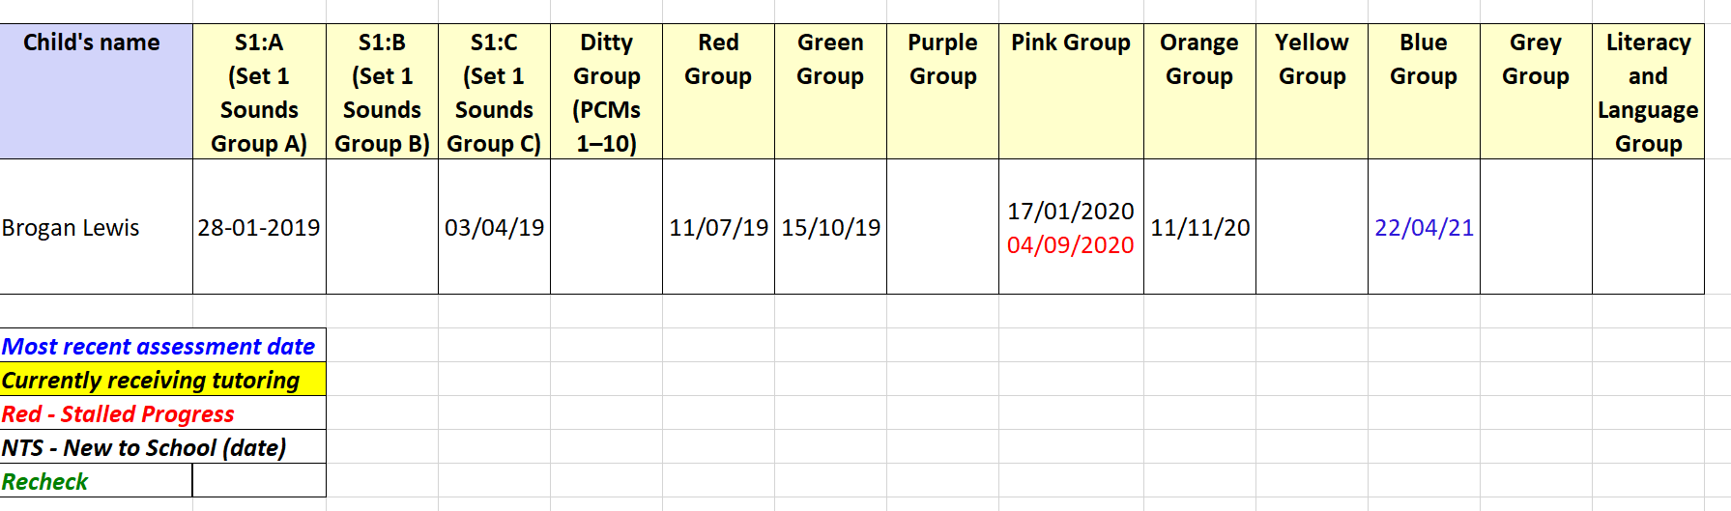
Child A

Child A entered school with a lower than average level so one to one tutoring was offered immediately: This is a copy of the progress targets highlighted and dated. The back of these sheets are where staff are asked to record notes of daily support provided.
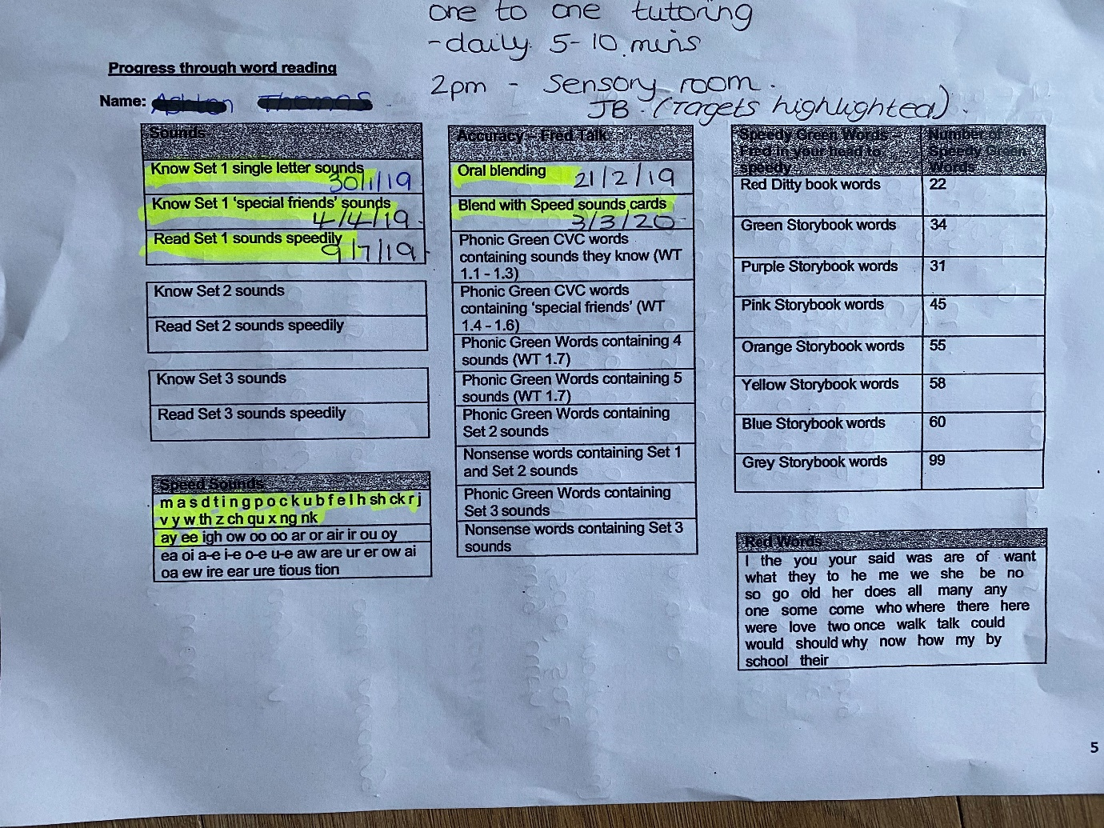

An example of notes for one to one tutoring.
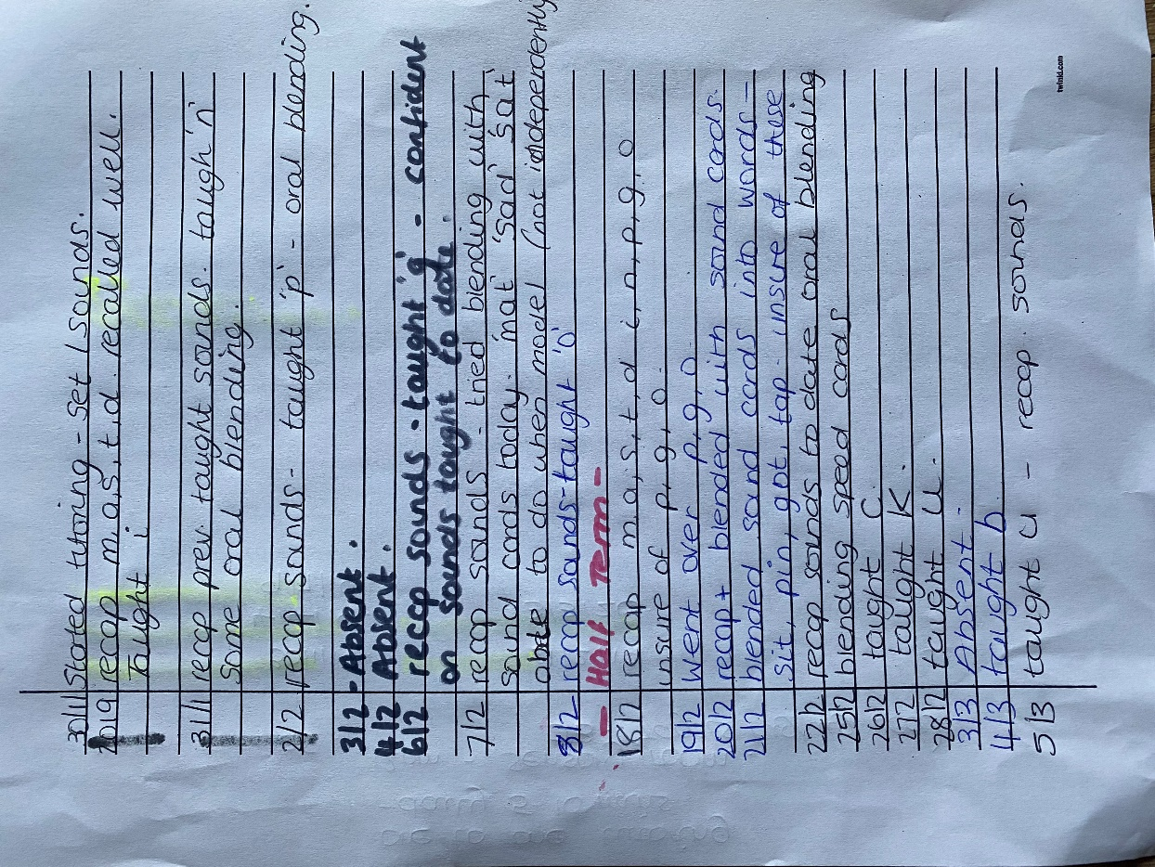

Progress grids included in RWI overall data. Copies provided to staff that are providing one to one tutoring so that they are clear of targets. Child A had low reading ability on entering school therefore was initially supported to learn all his set 1 sounds.
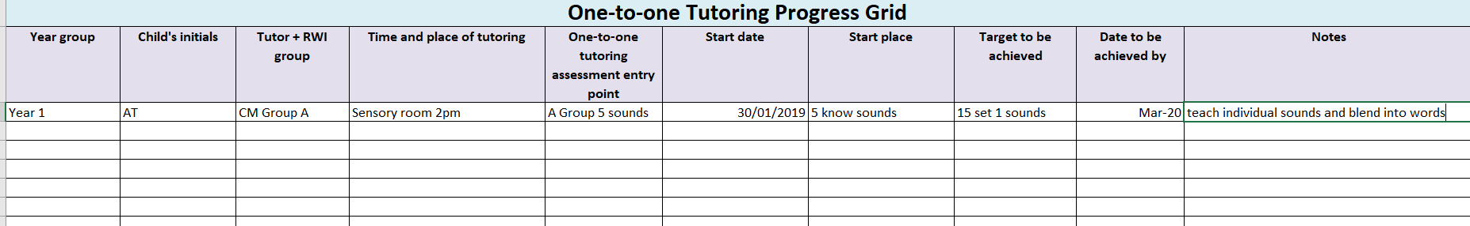

Child A was then supported one to one when had stalled progress (see first image, dates highlighted in red) Daily tutoring was provided to teach set 2 sounds and words in order to progress to the next level.
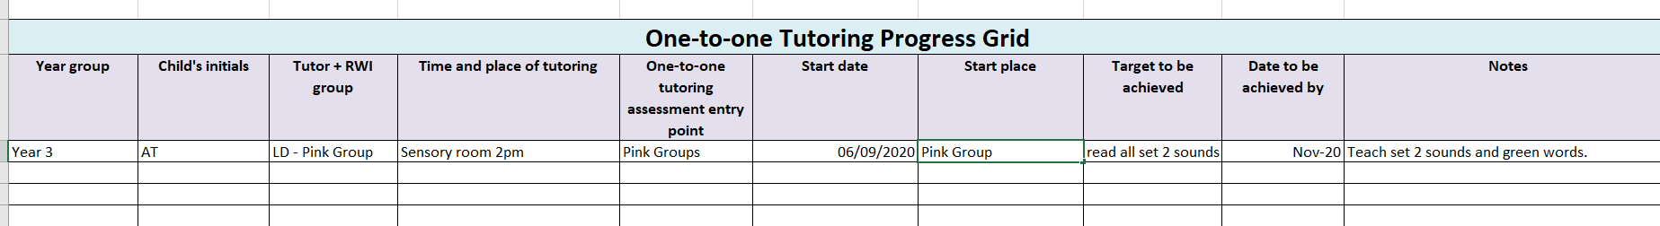

Reflective Placement Diary

What happened?

What went well? | The child able to make steady progress has engaged in lessons and taken well to tailored individual support.
What were the main challenges / problems/ difficulties you faced? | The child started school at a lower than expected academic level. In the initial stage the child was unable to concentrate within a group of children. Child also had stalled progress through one stage of the programme, due to missed schooling.
How did you react to the challenges? | Offered one to one daily tutoring for five to ten minutes every day. This was a specific targeted approach. As reading leader the training was initially offered by myself and the classroom LSA observed this tutoring for a week and continued the tutoring within class time. With a clear focus and ensuring a consistent approach. The challenges were addressed immediately on entry as was at such a low attainment level.
How did you feel? | It caused some worry that we were able to provide the correct support to timetable in individual support into already a busy schedule. Ensuring that staff members were confident in delivering the support and monitoring the effectiveness of this.
What surprised you? | A child who has an attention disorder able to participate in an intense programme that involves a huge amount of concentration levels also that the time it took to support and train other staff members was hugely worth it in the long run as it enabled them and myself to offer support to more children.
What were you familiar with? | Initially it was just the concept off the reading scheme. It has taken time and training and support and mentoring from other providers and schools. Even when I was familiar and confident with the scheme it took time to ensure all others that needed to provide this was too.
Have your beliefs and expectations changed or been challenged? | The initial belief that it is an easy quick process to get a child to read and be naïve that all children will respond in the same way. I now know that even with a planned regime you may need to adapt teaching styles or resources to suit individual learners.

Critiquing your experience

How well did you think you managed the challenging situation? | Initially I needed to be more confident at leading other staff members to support my role and end goal to support the individual child. Telling them what they needed to do to ensure the child The progress chart displays what has been achieved and therefore I am confident that I have managed the situation to the best of my ability but it did not come with hard work and determination.
Has this experience changed your mind or opinion in any way? | The experience of delivering one to one support and seeing the success it has offered made me more passionate about ensuring all staff were offering this to all pupils.
Were you given any feedback (formal or informal)? Can you seek further advice from anyone in order to give you another perspective? | Training advisor on development days and correspondence through email and telephone. Data analysed. Teamed up with another school initially to set up running the programme frequently contacted asking questions even came in to support setting up with assessments and grouping. Since we began our journey and received training this support has not been required it may be beneficial to seek this help again to look how we can continue to improve our provision.
Is there any other reading or research you could follow up regarding the subject matter? | Research into how children with additional needs are best supported through such regimented schemes. If there are additional universal approaches that can be used alongside the Read Write Inc scheme. Wider research into other schools successful provision of RWI to ensure offer best practice.
What skills do you need to develop to address this incident more effectively in the future? | The parent/school relationship - If parents were more involved in our reading scheme process, we could offer more support to the pupils. This could be done by offering parent workshops, leaflets or information on the school website. I could also develop leadership skills further in order to best support my team of staff to support children. Also develop skills through training courses to support those with additional needs further.
What conclusions have you drawn? | That we are offering a successful scheme of learning to read and write but it is important to continue to observe practice, analyse data and offer additional support in order to achieve best practice.

What next?

Given the same event; would you do anything different next time? | Ensure that the tutoring is timetabled in to the day and request brief notes for each session so that there is written evidence that the support is offered and able to track the progress. Ensure there is organised resources so that it is a quick and simple process when offering the daily one to one session. Not rushing around daily looking through group resources for resources to use in the individual sessions.
What are the key lessons learned for future use? | - Develop strong leadership.  - Trained staff or support those who are not trained.  - Ensure consistent approach.  - Organise resources.
How might your learning feed into your assignment/s? | To always continue to better my practice, whether that be through teaching children to read and write or in my written assignments, reflect and think what I could do better next time in both contexts.

References:

- Alexander, R. (2012) Policy and Practice in Primary Education. London: Routledge.
- Bentham, S., Hutchins, R. (2012) Improving Pupil Motivation Together: Teachers and Teaching Assistants Working Collaboratively. London: Routledge.
- Jolliffe, W. (2004) Paper presented at the British Educational Research Association Annual Conference, University of Manchester, 16-18 September 2004.
- John, M. (1996) Children in Charge: The Child’s Right to a Fair Hearing. London: Jessica Kingsley Publishers.
- National Literacy Trust (2017) Phonics – methods of teaching. Available at: http://www.literacytrust.org.uk/resources/practical_resources_info/1035_phonics(Accessed 26th April 2021).
- Oxford University Press (2017) Read Write Inc: Raising standards in literacy for every child. Available at: https://global.oup.com/education/content/primary/series/rwi/?region=uk (Accessed 19th April 2021).
- Papen, U. (2015) Literacy and Education: Policy, Practice and Public Opinion. London: Routledge.
- Pound, L. (2005) How Children Learn. Step Forward Publishing.
- Ruth Miskin Training (2017) Ruth Miskin. Available at: http;//www.ruthmiskin.com/en/ (Accessed 19th April 2021).
- Thompson, G., Nicholson, T. (1999) Learning to Read. New York: Teachers College Press
- Vygotsky, L. (1978) Mind in society: The development of higher psychological process. Cambridge: Harvard University Press.
- Waugh, D., Carter, J., Desmond, C. (2015) Lessons in Teaching Phonics in Primary Schools. London: SAGE

