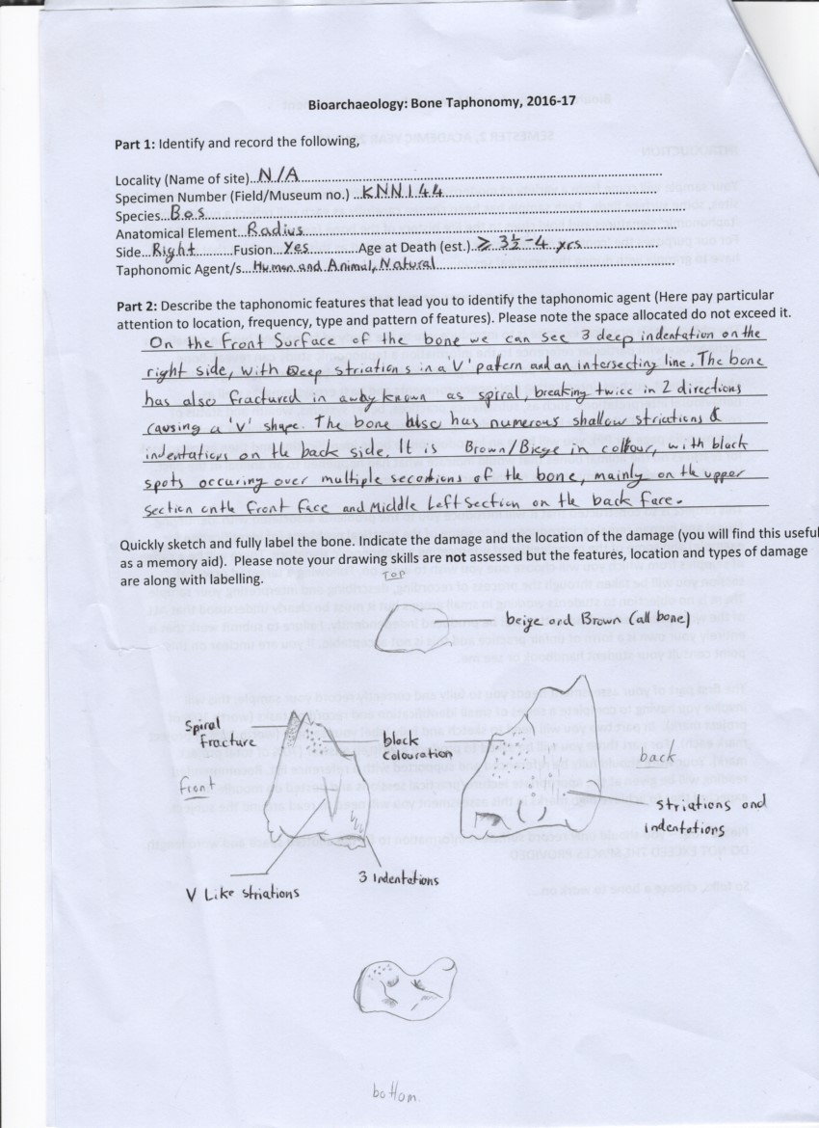
Issues and Difficulties in assigning Taphonomic history to bone: A case study using KNN144

When looking at a Taphonomic history of objects it is important to know the fauna, as this can give us some indication of age, and location where it was found and be able to recognise damage and be able to associate the damage with some source. In this write up I shall be focussing on how analysis is made, in terms of identifying both species and Taphonomic features.

When examining the bone piece we chose, KNN144, we first needed to identify the species of animal. It has been suggested that “each bone has a specific characteristic by which the animal can be recognised” (Schmid 1972: 26) and thus there is not such thing as an ‘unidentifiable bone’ (Binford 1981) .This could have proven very difficult as we had a small end piece of what looked to be a long bone, though luckily, we had a large array of other bones available and thus we were able to identify this bone as part of the Radius of one Bos, the shaft and proximal end are missing leaving us with only the distal end for analysis. When making observation of this bone we only had the distal radius for analysis, though this is still useful as pointed out by Schimd (1972) each bone still has some feature which can identify it as some species. Thus, there are distinguishing features in the shape of the distil which allows for specific identification as Bos. Though this was easier for us, it could have proved very difficult when identifying this bone for species level if we did not have such a wide array, or noticeably unique section of the bone thus we need to keep in mind this as a problem when identifying not only the bone itself but also Taphonomic history. We can see it is small (in comparison to other Bos) yet there is complete fusion on the Distal epiphysis, thus we know this must mean that the animal was at least 3 ½ - 4 years old when it died [Figure 1] (Silver 1963: 285). From this we can infer some information about the species and/or the Bos population. Smaller species size could be an indicator that this particular species is, on average, smaller than other species of Bos however alternately when lots of an animal inhabit the same area the overall average size is decreased (Hanken and Wake, 1993), so this could be an indicator of a higher population of Bos in the area at this time. We can see indentations on the lateral sides of the bone, with 3 distinctive deep markings on the left lateral, there are also many striations on the piece with 2 deep striations forming a ‘V’ pattern on the top surface, with a horizontal striation going through the right most mark. The break itself is what is known as a spiral break (Lyman 1994: 319) [See figure 2], in fact two of these spiral breaks have occurred causing a ‘V’ shape break where the shaft once attached. In colour the bone was a mixture of brown and beige, with black spots and sections covering the piece. In using these features of breaks, indentations, striations and fusions of bone one should be able to create a Taphonomic history of an artefact, however this is not as simple as it may seem.

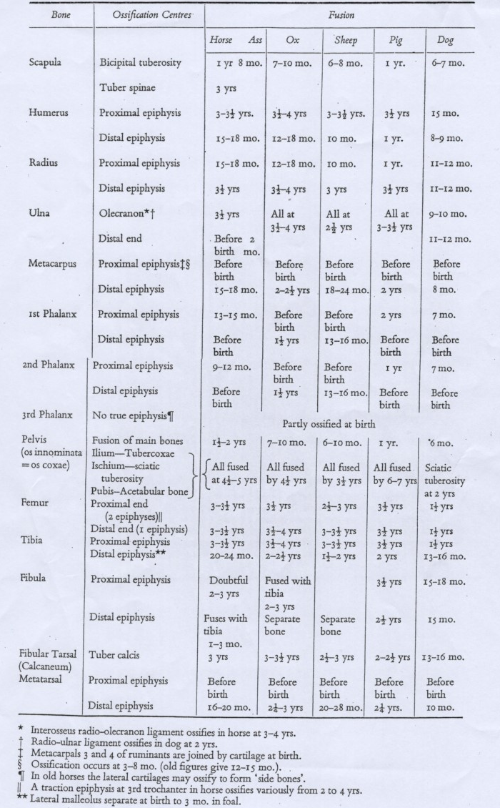
Figure 1: Fusion rates in Animals (Silver 1963)

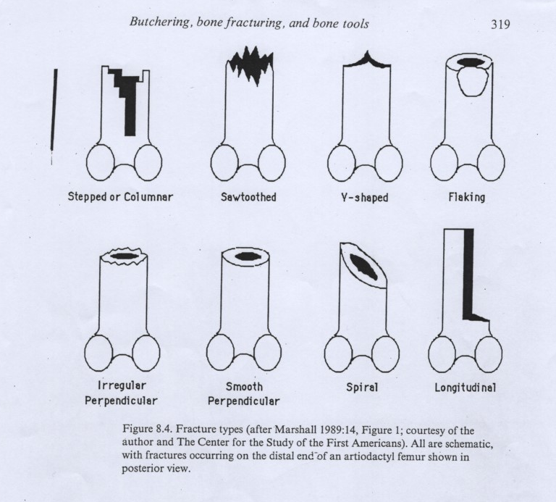
Figure 2: Types of fractures (Lyman 1994)

When discussing the Taphonomic history of an object, it is vital to consider as many perspectives as possible when considering the origins of striations, indentations, fractures, discolouration etc. these are vital to consider, as it is very easy for people to immediately attribute most damage or markings to human activity (which is a very human aspect, as it is easier to visualise human interaction with artefacts), however this could exclude immediately many other factors which could lead to very similar, if not the same, types of damage and markings. On our bone fragment there are many shallow indentations and striations, however there are deep striations forming a ‘V’ mark on the surface with a striation intersecting, and 3 deep indentations on the right side of the front face. When looking at these markings it was very easy to jump to conclusions of human interaction with the bone piece, especially when considering the spiral fracture. However, it is almost as likely that these could have been caused by some kind of wild predator, as the 3 indentations could easily be by some sort of biting action as an animal bit down on the end of the radius to twist and break open the bone, gnawing on the bone could also have made the distinctive ‘V’ formation on the surface and also the many shallow striations and indentations on the back surface. Equally to this theory it is possible that these marks and fracture pattern could have been made by Human interaction with the bone, breaking to access marrow in a twisting fashion is not unique to one species of animal, and gnawing/butchery marks could have easily formed the striations and indentations. I believe that it is in the Human Psyche to immediately attribute physical changes on artefacts, bones and environments to Human activity, as it is much easier to visualise, thus we must be mindful of this when creating a Taphonomic History .Therefore, when considering the Taphonomic history of the artefact it is important to keep a keen mind on multiple possibilities for the physical remains, rather than homing in on one specific idea.

In conclusion, I believe that there are many difficulties when ascribing a Taphonomic history to artefacts, including base analysis of the object (species) and certain cause of damage to the artefact (human, animal or even natural). When considering a Taphonomic history it is important to keep an open mind to many possibilities as, I believe when one is too narrow in ones focus, it is easy to ascribe the Taphonomic features to fit one’s idea.

Word count: 981

References
Binford, L. R. (1981) Bones: Ancient men and Modern Myths New York: Academic Press

Hanken, J. and Wake, D. (1993). Miniaturization of Body Size: Organismal Consequences and Evolutionary Significance. Annual Review of Ecology and Systematics, 24(1), pp.501-519.

Lyman, R. L. (1994) Vertebrate Taphonomy. Cambridge: C.U.P.

O’Connor, T. (2004) The Archaeology of Animal Bones Stroud: Sutton

Schmid, E. (1972) Atlas of Animal Bones. Amsterdam: Elsevier Pub. Co.

Silver, I. A. (1969) The ageing of domestic animals. In (eds) D. Brothwell and E. Higgs, Science in Archaeology. pp 283-302.

