UNIVERSITY OF WALES TRINITY SAINT DAVID
Faculty of Computing
MSc Computing
Literature Review
Development of a Rule-Based Digital Forensic Investigation Platform for Automated Evidence Analysis
Submitted in Partial Fulfilment of the Requirements for the Degree of Master of Science (MSc Computing)

ACKNOWLEDGEMENT

The work “would not have been possible” without the contribution of Mr. Dipo of the University of Wales Trinity saint David.
I am also grateful to all those with whom I had the opportunity to do the work and complete the project. Each member of the dissertation committee has offered and provided professional guidance and has given me great advice while completing the project.
On a personal note, I am also grateful to my family members who have offered me continuous support while I was completing the project. Without their help and support, this project would not have been completed.

ABSTRACT
The amount and nature of digital evidence collected with today's information systems is increasing and rendering digital forensic investigations increasingly difficult. This research introduces the development of a Rule-Based Digital Forensic Investigation Platform which automates the evidence analysis process and provides transparency and control in the investigation process. It has been built in Python, Flask, SQLite, Pandas, HTML, CSS and Bootstrap, and features secure case management, CSV evidence processing, rule-based detection, timeline reconstruction, and auto-generated PDF reports. Functionality, efficient evidence processing and transparency of decision-making based on predefined rules were verified in the experiments. The suggested platform offers a cost-effective innovative approach for making digital forensic investigations more efficient, standardised, and trustworthy.

TABLE OF CONTENTS
Chapter 1: Introduction 9
1.1 Background of the Study 9
1.2 Problem Statement 9
1.3 Research Aim 10
1.4 Research Objectives 10
1.5 Research Questions 10
1.6 Scope of the Study 10
1.7 Significance of the Research 11
1.8 Dissertation Structure 11
Chapter 2: Literature Review 13
2.1 Introduction 13
2.2 Overview of Digital Forensics 13
2.2.1 Definition of Digital Forensics 13
2.2.2 Digital Evidence 14
2.2.3 Challenges in Modern Digital Forensics 14
2.3 Digital Forensic Investigation Process and Frameworks 14
2.3.1 Digital Investigation Process 14
2.3.2 Existing Investigation Frameworks 15
2.3.3 Critical Comparison 15
2.4 Automated Evidence Analysis in Digital Forensics 15
2.4.1 Traditional Manual Evidence Analysis 16
2.4.2 Automated Forensic Analysis 16
2.4.3 Timeline Reconstruction and Critical Evaluation 16
2.5 Artificial Intelligence in Digital Forensics 17
2.5.1 Artificial Intelligence in Cybersecurity 17
2.5.2 Machine Learning for Forensic Analysis 17
2.5.3 AI-Assisted Evidence Interpretation 18
2.5.4 Benefits and Limitations 18
2.6 Explainable Artificial Intelligence (XAI) in Digital Forensics 18
2.6.1 Explainable Artificial Intelligence (XAI) 19
2.6.2 Black-Box versus Explainable AI 19
2.6.3 Explainability in Digital Forensics 19
2.6.4 Human-in-the-Loop Investigation 20
2.7 Existing Digital Forensic Investigation Tools and Platforms 20
2.7.1 Commercial Tools 20
2.7.2 Open-Source Tools 20
2.7.3 Comparative Analysis 21
2.8 Research Gap and Justification of the Proposed System 21
2.8.1 Identified Research Gaps 21
2.8.2 Justification for the Proposed Research 22
2.9 Chapter Summary 22
Chapter 3: Research Methodology 23
3.1 Introduction 23
3.2 Research Philosophy 23
3.3 Research Approach 23
3.4 Research Strategy 24
3.5 Research Design 24
3.6 Data Collection 25
3.7 Development Tools and Technologies 26
3.8 Evaluation Methods 27
3.9 Ethical Considerations 28
3.10 Chapter Summary 29
Chapter 4: System Design and Implementation 30
4.1 Introduction 30
4.2 System Requirements 30
4.2.1 Functional Requirements 30
4.2.2 Non-Functional Requirements 31
4.3 Overall System Architecture 31
4.4 System Workflow 32
4.5 Use Case Diagram 33
4.6 Database Design 33
4.7 Algorithm Design 34
4.8 System Implementation 35
4.9 Chapter Summary 40
Chapter 5: Results and Discussion 42
5.1 Introduction 42
5.2 Experimental Setup 42
5.3 Functional Testing 43
5.4 Performance Evaluation 44
5.5 System Transparency and Explainability 45
5.6 Comparative Analysis 46
5.7 Discussion of Findings 47
5.8 Chapter Summary 48
Chapter 6: Conclusion 49
6.1 Introduction 49
6.2 Summary of Research 49
6.3 Achievement of Objectives 49
6.4 Conclusion 50
Chapter 7: Reflection and Future Work 51
7.1 Introduction 51
7.2 Skills Developed 51
7.3 Challenges Faced 51
7.4 Lessons Learned 51
7.5 Future Work 52
Reference List: 53

Chapter 1: Introduction

1.1 Background of the Study
The fast-changing digitalisation of organisations, governments and individuals has complicated reliance on interconnected information systems, Cloud computing, mobile technologies and devices that are connected to the Internet. As a result, these technological advancements have introduced new avenues of communication and increases in operational efficiency, but have also created new formative opportunities for cyber-criminal organisations to carry out ransomware attacks, data breaches, identity theft, insider threats and other advanced cyber offences. As a result, the volume, variety and complexity of digital evidence created during a cyber incident has increased significantly, making the identification, preservation, analysis and presentation of legally admissible evidence a greater challenge for forensic investigators. How digital ecosystems have rapidly developed into more complex yet modern environments, leading to ever-growing forensic challenges that demand digitally driven methods capable of dealing with heterogeneous data sources without compromising evidence integrity [29].
In recent years, the volume of digital evidence has grown further, resulting in 'Digital Forensic Investigation' becoming a key part of the developing cyber security and criminal justice landscape. Traditional forensic analysis practice involves a lot of manual analysis of system logs, browser history, file metadata attributes and network artefacts. While they work well, in larger data sets they need specialised knowledge and a significant amount of time to provide results. AI technologies could benefit digital forensic investigations by allowing investigators to make intelligent use of evidence, decrease the analytical workload, and be more efficient [44]. These technological advances have not dispelled the doubts yet about the transparency and reliability of automated forensic decisions.

1.2 Problem Statement
As the prevalence and complexity of cybercrime have gathered pace, digital evidence is now being accumulated in greater and greater numbers, often far beyond the ability of conventional forensic investigation techniques to analyse. Today's investigators will have to be able to investigate a large amount of system logs, browser history, file metadata, network logs and other digital artefacts, while ensuring evidence is preserved and that legal procedure is followed appropriately. Currently, the complexity of file system log data is increasing, and there is a need to establish more sophisticated log-based analysis frameworks that can detect suspicious behaviour in the log efficiently while maintaining a high level of authenticity in the analysis performed [27].

1.3 Research Aim
The main objective of this research is to create an “Explainable Digital Forensic Investigation Platform” that can automatically process digital evidence and offer explainable and understandable explanations for all the episodes of the digital forensic investigation.

1.4 Research Objectives
- To explore the available techniques of the "Digital Forensic Investigation" and their advantages and disadvantages.
- Establish and build a digital forensic investigation platform to assist automated evidence analysis, with explainability.
- To assess the functionality of the developed prototype for the examination of representative forensic data to assess the usability and explainability of the prototype.
- The effect of the "Human-in-the-Loop" validation on investigators' trust in the system and decision-making process.

1.5 Research Questions
- What are the current digital forensic investigation procedures dealing with the issues of the growing amount and complexity of digital evidence?
- What must the design of a forensic investigation platform with some explainability be like to make the investigation more effective and transparent?
- What are the strengths of the prototype developed to facilitate evidence analysis, the reconstruction of a work timeline, and decision-making that can be explained?
- What impact does "Human in the Loop" validation have on investigators' confidence in forensic work?

1.6 Scope of the Study
This research aims to design, develop, and evaluate a prototype "Digital Forensic Investigation Platform" to aid in automated evidence analysis. The proposed system only addresses Forensic Artefacts that are previously exported, such as Event Logs, Browser History, etc., which are provided in CSV format. The platform features rule-based anomaly detection, chronological timeline generation, and investigator validation, allowing for transparent forensic. Intelligent forensic platforms have the potential to greatly facilitate digital communication analysis, as well as structured evidence analysis, and that they will assist with investigations [47] .

1.7 Significance of the Research
As digital technologies have become more crucial to our everyday lives, the need for efficient forensic investigations is critically important for the discovery of cyber threats and involves legal action. The importance of this research comes from the "Explainable Digital Forensic Investigation Platform," which is a novel solution that integrates intelligent automation with explainable decision-making to overcome the drawbacks of traditional digital forensic investigations. The proposed platform, through its incorporation of explainable analytical processes in the evidence examination, could enhance the efficiency of investigative procedures while ensuring that the analytical results are trusted by investigators. Explainable AI (XAI) enhances in the area of cybersecurity applications, guaranteeing more transparency, representativeness and trust between an AI and a user of an autonomous decision-support system [48].

1.8 Dissertation Structure
This dissertation assumes a logical progression of the different chapters and a reflective section for evaluation of the developed prototype starting from the identification of the research problem.
The research is introduced in Chapter 1 where the background of the study, problem statement, research aim, objectives, research questions, scope, significance, and overall structure of the dissertation are presented. The motivation for the development of an explainable AI-based digital forensic investigation platform is described in this chapter.
The literature on "Digital Forensics", automated evidence analysis, digital forensic investigation frameworks, and software tools is reviewed in Chapter 2. It shows existing gaps in the literature within the field and stresses the need for the study. Modern forensic approaches need to evolve and keep pace with continually complex digital environments and the growing privacy, security, and investigative issues [13].
Chapter 3 details the research methodology of the study, which focuses on the research philosophy, research approach, research development, data collection, research tools, research evaluation, and ethics of research. Chapter 4 introduces the system requirements, architecture, database design, system implementation, and prototype development. In Chapter 5, the developed platform is tested, analysed, and discussed in terms of the research goals.

Chapter 2: Literature Review

2.1 Introduction
It is important to conduct a literature review to critically analyse the existing research that forms the foundation for the development of a digital forensic investigation platform for automated evidence analysis. The need for previous studies arises because they help to provide the theoretical and technological basis to explore past practices in the field of digital forensic investigation, the development of emerging artificial intelligence applications, and explainable decision support mechanisms. The adoption of artificial intelligence in digital forensic investigation can be highly beneficial in boosting analytical efficiency and assisting investigators in resource-limited settings [18].

2.2 Overview of Digital Forensics
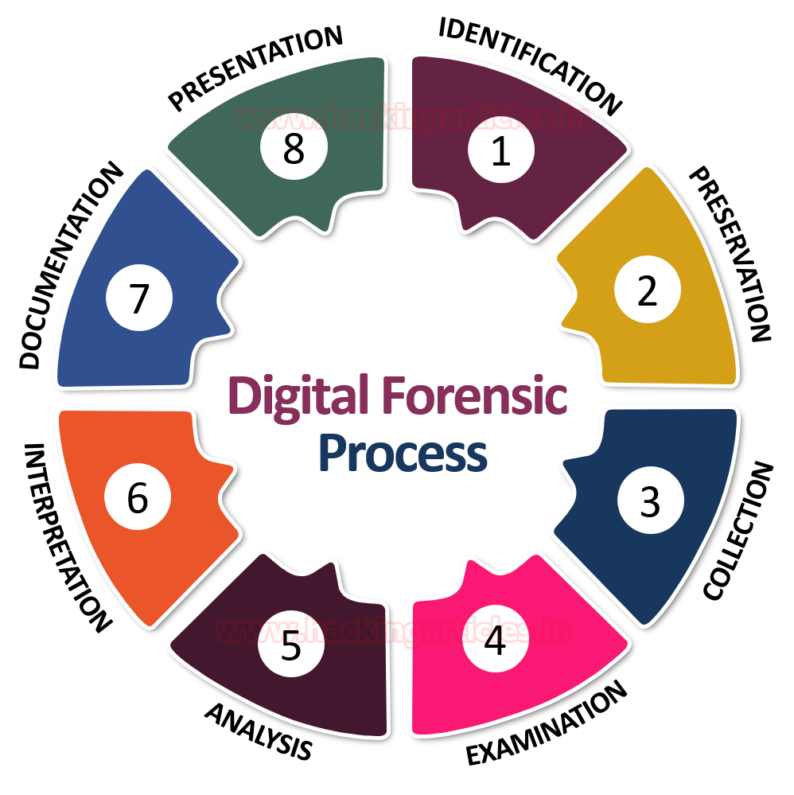
Figure 1: Overview of Digital Forensics
(Source: Raj, 2020)

2.2.1 Definition of Digital Forensics
Digital forensics is the process of collecting, preserving, analysing, and presenting digital evidence in an orderly manner in a way that aids in investigations of cybercrime and legal action. The field has developed in step with the dramatic growth in technology, from traditional computer exams to include cloud environments, mobile devices, Internet of Things (IoT) devices and network infrastructure. Digital forensics is crucial for modern cybersecurity, as it allows for the reconstruction of incidents, the detection of malicious activity and the creation of legally admissible evidence [30].

2.2.2 Digital Evidence
Digital Evidence – Electronic information stored or transmitted by electronic devices that could help support an investigation and establish facts. It can come from system logs, browser histories, file metadata, e-mail, cloud storage, network traffic, and removable storage devices. Preserving the integrity is critical, as any tampering with this evidence could render it legally and factually not admissible or not reliable. According to Salih and Dabagh (2023), maintaining authenticity and chain of custody in digital evidence will guarantee that the proceedings of the investigations will be credible and subject to judicial challenges during the forensic process.

2.2.3 Challenges in Modern Digital Forensics
As data grows exponentially and the sophistication of cyberattacks increases, manual evidence examination of incidents is challenging and can be time-consuming. Investigators have to process a lot of mixed and disorganised data in a limited time, facing the risk of late response and missed evidence. These constraints underscore the need for intelligent automation and artificial intelligence (AI) to enhance the efficiency of investigations and ensure the accuracy and reliability of the investigative outcomes [21]. For this reason, automated techniques are becoming paramount in modern digital forensics to meet the demands of ever-changing investigations [17].

2.3 Digital Forensic Investigation Process and Frameworks
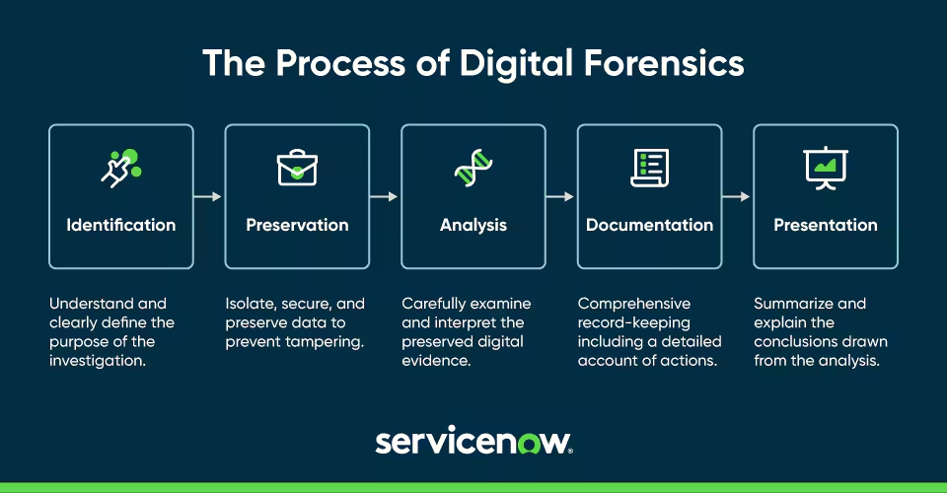
Figure 2: Digital Forensic Investigation Process and Frameworks
(Source: Barlin, 2024)

2.3.1 Digital Investigation Process
Digital forensic investigation has a definite Investigative Process, which is designed to ensure that digital evidence is reliable, authentic, and legally admissible. This usually starts with the identification of possible evidence sources and then moves to collecting the evidence through appropriate forensic methods with as little alteration of the data as possible. Maintaining the integrity of acquired evidence is not something that can be done after examination and analysis have been done in order to identify relevant artefacts and reconstruct cyber incidents [4]. The investigation concludes with detailed reporting detailing findings and contributing to legal and/or organisational decision-making. A structured investigation process would improve the consistency, reliability, and admissibility of digital forensic evidence during the investigative process [20].

2.3.2 Existing Investigation Frameworks
Several known frameworks have been created to standardise digital forensic investigations. The comprehensive model "DFRWS Framework" was developed, including systematic steps of identification, preservation, collection, examination, analysis, and presentation. In the same manner, the "NIST SP 800-86 Framework" is practical guidance to consider forensic procedures when responding to an incident, and the "Integrated Digital Investigation Process (IDIP)" extends existing models with the idea of using a digital investigation model combined with existing physical investigation models. Prakash et al. (2022) proposed that these provide a uniform approach to the process of investigation to facilitate evidence collection and aid good decision-making during the investigation in different computing environments or settings.

2.3.3 Critical Comparison
All the frameworks facilitate methodology uniformity, but they render varying degrees of capabilities for handling the contemporary cyber landscape, driven by phenomena such as cloud computing, artificial intelligence, and big data analytics. Existing concepts focus mainly on evidence collection and legal obligations, leaving little guidance on automated interpretation (of evidence) and explainable decision support. Intelligent automation demands the adaptation of the current forensic systems, and its use must be under the investigator's supervision with transparency, as stated by the arguments of [3]. The proposed platform thus provides automated analysis, "Explainable Artificial Intelligence (XAI)" tools, and combines these with sound forensic principles to improve the effectiveness of investigations that does not lead to the loss of credibility of evidence [23].

2.4 Automated Evidence Analysis in Digital Forensics
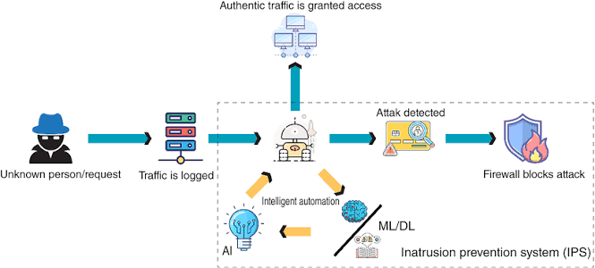
Figure 3: Automated Evidence Analysis in Digital Forensics
(Source: Aaron, 2021)

2.4.1 Traditional Manual Evidence Analysis
Typical digital forensic investigations involve a manual review, whereby investigators look at system logs, file systems, browser history, network artefacts, etc., to find evidence that is pertinent to a cyber incident. This method provides in-depth analysis but can be time-consuming and prone to human mistakes, especially when dealing with massive and varied datasets. Investigators will likely have high workloads that can leave them with longer response times and the risk of missing important evidence. The manual forensic methodology is not well suited to address the significant challenges posed by the amount and complexity of digital evidence that can be created in today's digital world [34].

2.4.2 Automated Forensic Analysis
Automated forensic analysis increases the efficiency of an investigation by applying a set of rules and intelligent algorithms to faster and more efficiently process big data of digital evidence. Event correlation can be used to better piece together cyber incidents; Rule Based Analysis can quickly detect any suspicious activity like repeated failed logins, unusual user activity and unknown device connections can be quickly detected [4]. Automated evidence filtering then helps investigators prioritise the relevant information while eliminating the need to consider unnecessary information. The automation with AI increases the speed and uniformity of evidence collection and analysis, allowing investigators to concentrate on interpreting more valuable forensic evidence instead of doing repetitive manual work [2].

2.4.3 Timeline Reconstruction and Critical Evaluation
Forensic artefacts are present in many places and can be organised into chronological sequences (timelines) to offer insights into the development of cyber incidents over time. A chronological perspective helps identify causal relationships between events and increases investigative accuracy. While offering gains in efficiency, existing automated forensic solutions often lack transparency in their conclusions and reduce investigator confidence and legal defensibility. When integrated with explainable analytical processes, intelligent automation has the potential to improve the efficiency of the processes while also promoting investigation trust, [18]. Thus, the challenge is how to achieve fast yet transparent analysis of evidence to allow for reliable and accountable digital forensic investigations.

2.5 Artificial Intelligence in Digital Forensics
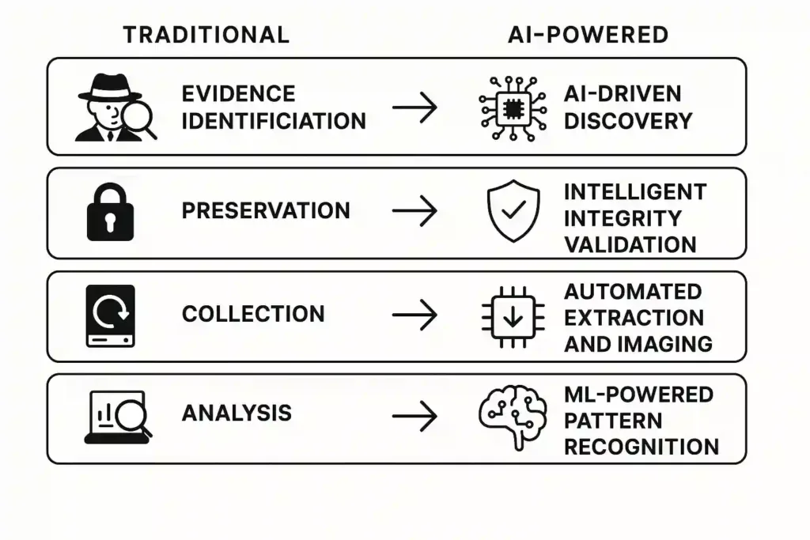
Figure 4: Artificial Intelligence in Digital Forensics
(Source: Manish, 2025)

2.5.1 Artificial Intelligence in Cybersecurity
Due to the capability to detect and analyse and put to rest cyber threats that change quickly, Artificial Intelligence (AI) is turning out to be a groundbreaking technology in cybersecurity. Instead of the traditional ways of using pre-defined signatures, AI can scan through tons of information to identify patterns that haven't been successfully noticed by any package. Unlike traditional security methods based on pre-defined signatures, AI can examine large quantities of information to recognise patterns not successfully captured by any package [46]. This will enhance the speed and effectiveness of incident response, and reduce the number of manual investigations required. Faqir (2023) cites that AI has revolutionized digital crime investigation and allowed investigators to analyze complex forensic data more efficiently and to support the use of evidence to make decisions in changing, complex cyber spaces.

2.5.2 Machine Learning for Forensic Analysis
Machine learning, which is a part of AI, can be used in digital forensic investigations by basing its learning on behavioural evidence of past data, and identifying when an individual acts in ways that are not typical and point to fraud or other criminal behaviour. Algorithms can recognize suspicious logging activity, accessing or altering odd files, odd network activity and other indicators of intrusion that is not recognized by regular analysis [45]. Also, machine learning models are able to evolve and change to new forms of attacks and the digital environments; hence, they can be fine-tuned. In forensic investigations can serve as an important promise of improved analysis of evidence because AI can find patterns and identify the occurrence of anomalies in a smart manner and will help in more accurate and efficient investigations [16].

2.5.3 AI-Assisted Evidence Interpretation
Besides evidence discovery, AI is also being used to aid in making sense of complex forensic evidence in addition to assisting investigators to identify evidence. The AI systems will be able to offer an automated matching of the events and a brief overview of the investigation and clarify any suspicious occurrence discovered in a digital artefact [9]. The features will save the investigators both time and stress and allow them to understand timelines of the incidents and the relationship of evidence at a much faster rate. The hypothesized that the EE investigation could be automated with the help of LLM forensic assistants in providing contextual accounts that contribute to improving the resources in evidence interpretation and making informed decisions during the investigation [37].

2.5.4 Benefits and Limitations
The advantages of AI in digital forensics include the ability to analyze large volumes of data more efficiently, identify subtle patterns of attacks in large volumes of data, etc. The benefits also serve to run investigations more formally and assist organisations to act more efficiently towards cyber incidents. However, AI introduces their own difficulties of transparency, ethical accountability and reliability of the automated decision-making process, however. Often an incomplete justification of the results can result in the production of conclusions that is made by a black-box model which lacks the justification to ensure the confidence of the investigator and even the legal validity. To ensure that analytical results are interpretable, credible and admissible as evidence, the successful application of AI in digital forensic investigations must strike a balance between automation and transparency [19].

2.6 Explainable Artificial Intelligence (XAI) in Digital Forensics
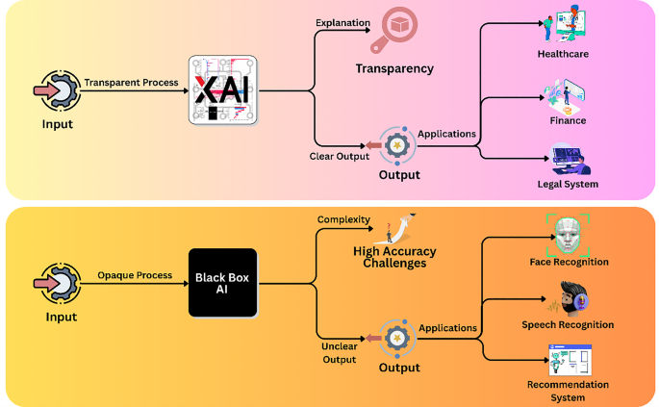
Figure 5: Explainable Artificial Intelligence (XAI) in Digital Forensics
(Source: Ahmed, 2026)

2.6.1 Explainable Artificial Intelligence (XAI)
With the widespread use of Artificial Intelligence in digital forensics investigations, researchers are looking to gain insights into how AI systems derive their conclusions. Explainable Artificial Intelligence (XAI) is a set of techniques used to make AI-generated decisions understandable and subject to interpretation. Unlike traditional AI systems and models, which function as black boxes, XAI can explain the factors that contribute to every prediction or recommendation, making AI more accountable. The AI enhances cybersecurity applications by increasing transparency of intelligent decision-making processes and security personnel's understanding of automated analytical processes [49].

2.6.2 Black-Box versus Explainable AI
Most traditional ‘black-box’ AI models work well and are very effective at predicting the result, but offer little explanation of how the results were obtained. This ambiguity can create a significant problem for a Digital Forensics investigation, where structural decisions of analysis should be explained and justified with sound evidence. By contrast, the outputs of XAI are intelligible, and investigators can assess the reasoning behind the selection of suspected events and evidence in classification. The XAI deepens understanding of cybersecurity mechanisms by promoting both analytics precision and transparency, allowing users to better verify AI-driven decisions [9] .

2.6.3 Explainability in Digital Forensics
One area of digital forensics where the application of XAI is particularly important is in legal proceedings, where forensic evidence is often used to aid in the investigation of crimes. A forensic investigation undertaken in legal proceedings often involves a lot of investigation, which is where the application of XAI in digital forensics gets significant attention. The investigators are required to provide enough information about any events that were determined to be suspicious and explain how the evidence influenced AI-generated conclusions. The reduction of uncertainty in automated decision-making leads to more trust in the process and also enhances the legal admissibility of digital evidence, as it becomes clearer why specific evidence is being considered as part of the analytical reasoning of an investigator. Explainability can help Cyber Security professionals better understand the results, which leads to more reliable investigation results and less reliance on cryptic analytical models [12].

2.6.4 Human-in-the-Loop Investigation
While AI has made great strides, the role of human expertise continues to be vital in the digital forensic investigation process. Other solutions involve the use of “human-in-the-loop”, which entails the forensic specialist inspecting, validating, and, if needed, dismissing the results generated by the Artificial Intelligence before a final determination is made. This is a way of working that helps to minimise false positives and increase the validity of the forensic investigation. According to Qonita, Handayani and Umam (2025), using AI to support forensic systems can be even more reliable if combined with the human validation of evidence interpretation and ongoing human oversight.

2.7 Existing Digital Forensic Investigation Tools and Platforms

2.7.1 Commercial Tools
Most commercial digital forensic software has established wide acceptance owing to its extensive features for acquisition, investigation & reporting of digital evidence. “EnCase” is known for its comprehensive evidence collection and legal compliance capabilities, while “Forensic Toolkit (FTK)” provides the capabilities to efficiently handle large amounts of data by providing advanced indexing and search capabilities. Likewise, “Magnet AXIOM” enables investigations on computers, mobile devices, and cloud environments, as it unifies evidence from various sources into one digital investigation environment. These platforms may increase the efficiency of an investigation, but are mainly powered by preprogrammed forensic worklets and do not make intelligent analytical inferences. Commercial forensic tools are claimed to offer robust evidence acquisition and reporting features, although they rely on investigators' skill and aptitude for the interpretation of electronic evidence, which may be complex [41].

2.7.2 Open-Source Tools
Open-source forensic platforms provide a cost-effective alternative and have evolved to aid the examination of evidence in various forms of digital media. The intuitive interface in “Autopsy” allows for analysing disk images, file systems, and deleted files for both educational and professional investigations. Volatility is a tool that focuses on memory forensics and can be used to analyse memory and locate malicious processes not captured by traditional disk analysis. These tools offer flexibility and a push towards improved community-driven development, yet they are more complex than commercial software. Barik et al. (2022) contended that open-source forensic tools are useful investigative tools but are still reliant on the knowledge of the investigator and manual interpretation of their findings.

2.7.3 Comparative Analysis
While existing forensic platforms have greatly enhanced digital evidence acquisition and examination, the majority continue to focus on collecting evidence rather than intelligent interpretation. Commercial tools offer in-depth reporting and timeline generation, but do not necessarily provide a high degree of transparency; open-source tools can be flexible and transparent, while limited integration has been noted for "Artificial Intelligence (AI)" and "Explainable Artificial Intelligence (XAI)" in providing automated decision support. Thus, investigators must continue to help interpret forensic artefacts and to validate analytical results [8].
Tool | Automation Capability | AI/XAI Integration | Timeline Support | Reporting Features
EnCase | High | Limited | Yes | Comprehensive forensic reports
FTK | High | Limited | Yes | Detailed searchable reports
Magnet AXIOM | High | Limited | Yes | Integrated multi-source reporting
Autopsy | Moderate | None | Basic | Standard forensic reporting
Volatility | Moderate | None | Limited | Memory analysis reports
Table 2.1: Comparison of Existing Digital Forensic Investigation Tools

2.8 Research Gap and Justification of the Proposed System

2.8.1 Identified Research Gaps
Results show that a significant advancement in the field of digital forensic investigation has been made using automation and artificial intelligence for digital forensic investigation. However, previous researchers found a number of interesting trade-offs which remain future challenges for current forensic solutions. Very few digital forensic platforms offer limited integration with "Explainable Artificial Intelligence (XAI)" that allows investigators to understand how and why the AI concluded. In addition, transparency of decision justifications, deficient evaluative feedback loops, and human involvement in the investigations do not get sufficient attention, which decreases user confidence and the legality of automated opinions. Nayak’s (2024) work found that while AI aids in gathering and processing evidence, the processes used for automated forensic investigations need to be further transparent and incorporate greater investigators in order to increase the reliability of automated forensic investigations.

2.8.2 Justification for the Proposed Research
The platform discusses these issues and strives to remove the constraints by combining automated evidence analysis and explainable artificial intelligence with chronological event visualisation and evidence noting by the investigator. The pairing is designed to boost analytical efficiency and maintain transparency, interpretability, and appropriateness of the output generated by AI.

2.9 Chapter Summary
This chapter critically reviewed the literature relating to digital forensics, forensic investigation frameworks, automated evidence analysis, artificial intelligence, explainable artificial intelligence, and existing forensic investigation tools. The salient issues that emerged from the discussion were the increasing relevance of intelligent automation and the importance of transparency, explainability, and the involvement of investigators in AI-enabled forensic investigations [8]. The results identified these gaps in the research and provided a theoretical basis for the methodology used later in this study.

Chapter 3: Research Methodology

3.1 Introduction
This chapter details the methodological framework followed for the design, development, and evaluation of the proposed “Explainable AI-Assisted Digital Forensic Investigation Platform” for automated evidence analysis. The methodology is clearly identified, systematic, and transparent in approach in addressing the aim and objectives of the research set in Chapter One. The chapter justifies the chosen research philosophy, research approach, research strategy, and research design before outlining the methods employed for conducting data collection, system development, system implementation, and evaluation. When choosing a research methodology, it is important to guarantee that software development projects yield valid, viable, and high-quality research results [35].

3.2 Research Philosophy
Research philosophy and its philosophical basis act as a theoretical bedrock for the generation and interpretation of knowledge during the research process. The choice of a philosophical position is significant as it will have an impact on the research design, data collection, statistical processes used, and interpretation of results. Three philosophies are commonly used for computing and information systems research: "Positivism," "Interpretivism," and "Pragmatism. According to Saunders, Lewis, and Thornhill (2023), research philosophy indicates the assumptions of a researcher in learning to know and how the research problem will be investigated.

3.3 Research Approach
Research approach is the description of a logical procedure for investigation of a research problem and for the establishment of a relationship between theories and the evidence obtained from the experiments. The two major methods recognised are "Deductive" and "Inductive. Saunders, Lewis and Thornhill (2023) pointed out that the deductive approach starts with theories already in place and moves on to observation and collection of data in a systematic way, while the inductive approach constructs new theories on the patterns observed and data gathered.
The “Inductive” approach (inductive observation) is widely used in an exploratory study in which the researcher aims to reveal new phenomena by qualitative observations. The approach described would work well in theory generation work, but may not be as appropriate when trying to test an existing software system.

3.4 Research Strategy
The research approach gives a practical way of achieving the research goals. As this study will put more emphasis on the design and development of a software solution than human behaviour, Design and Development Research (DDR) has been chosen. It is an effective strategy in computing research, providing a blend of theory and system building to generate creative technology solutions. According to Rukhiran, Buaroong and Netinant (2022), structured software development methodology can help researchers design dependable information systems that can help create a solution for the organisational and technical issues identified.
After implementing the prototype, an "Experimental Evaluation" strategy is used to judge whether the platform obtained is successful in achieving the intentions of the research. The evaluation is based on certain criteria such as detection accuracy, processing efficiency, explainability, and investigator validation to measure system performance. The importance of system-level evaluation in establishing whether explainable AI systems are giving transparent and trustworthy advice on decision-making, without compromising performance levels unduly [5].
Research Strategy | Purpose | Application in This Research | Expected Outcome | Justification
Design and Development Research | Develop a practical solution | Design AI-assisted forensic platform | Functional prototype | Supports software innovation
Prototype Development | Build and implement the system | Develop web-based investigation platform | Working application | Validates theoretical concepts
Experimental Evaluation | Measure system performance | Evaluate prototype using predefined metrics | Objective performance results | Confirms system effectiveness
Table 3.1: Research Strategy Adopted for the Study

3.5 Research Design
The research design outlines the systematic procedure for designing, executing, and validating the suggested forensic investigation platform design. Because the study is in software engineering and implementing systems, the study adopts a method that allows logical and efficient system development, which is called "System Development Lifecycle (SDLC)". Ndlela and Tanner (2023) claim that structured development processes produce quality software because "system requirements, activities of implementing the system, and the processes of measuring the system are aligned in the software life cycle.
Then comes the stage of "System Implementation," where the platform is constructed using the following languages: Python, Flask, SQLite, Bootstrap, HTML, CSS, and supporting libraries for data analysis. Once implemented, all systems are tested extensively to ensure system reliability, functionality and performance. There is unit testing to test each module in isolation, integration testing to test how the system's components communicate with each other, and system testing to test the entire system as one unit to ensure it meets its design specifications. Systematic evaluation, the identification of weaknesses that can be achieved in the system implementation before it is used to enhance the reliability of the system [28].
SDLC Stage | Main Activities | Expected Output | Validation Method | Contribution to Research
Requirements Analysis | Identify functional and non-functional requirements | System specification | Requirement review | Defines project scope
System Design | Database, architecture, UI design | System blueprint | Design verification | Guides implementation
System Implementation | Develop software modules | Functional prototype | Code testing | Produces working platform
System Testing | Unit, integration, and system testing | Verified software | Test cases | Ensures reliability
Evaluation | Performance measurement | Evaluation results | Experimental testing | Validates research objectives
Table 3.2: System Development Lifecycle Adopted in the Research

3.6 Data Collection
Data collection is an essential part of the research as the performance of the proposed "Explainable AI-Assisted Digital Forensic Investigation Platform" highly relies on the quality, consistency, and relevance of the forensic artefacts used in its development and evaluation. Such personal information of human subjects as may be collected in this study will not be taken. Rather, it features a digital forensic dataset comprising evidence which is routinely analysed in cybercrime investigations. Tthe quality and preparation of the data used in the development of intelligent systems, as well as during system assessment, has a strong influence on the reliability of such systems [43].
There are also “Public Datasets” and “Simulated Datasets” to bolster the evaluation process. Publicly available forensic data sets are provided for validating scenarios of quality and use in the different contexts of effectiveness of the proposed platform, while simulated data sets are created as an alternative when there is a lack of sufficient representative publicly available forensic data sets in the different sectors/scenarios of interest. This combination allows the prototype to be tested with a variety of configurations and to maintain equal testing of automated evidence analysis. Kashkevich et al. (2024) suggested the use of various data sets to diversify artificial intelligence systems, as it allows them to be exposed to several operational scenarios when they are being developed and tested.
Data Source | Description | Purpose within the Platform | File Format | Expected Output
Event Logs | System and application activity records | Detect suspicious system events | CSV | Event timeline
Browser History | Website visits and download records | Identify browsing behaviour | CSV | Browsing analysis
File Metadata | File properties and timestamps | Support evidence correlation | CSV | Metadata summary
Public Datasets | Open-source forensic datasets | Validate prototype performance | CSV | Benchmark evaluation
Simulated Datasets | Artificially generated forensic evidence | Test additional investigation scenarios | CSV | Controlled testing
Table 3.3: Digital Evidence Sources Used in the Research

3.7 Development Tools and Technologies
The implementation of the envisioned “Explainable AI-Assisted Digital Forensic Investigation Platform” involves various software applications and technologies that interact to facilitate evidence processing, intelligent analysis, data management, and the interface with the user. The technologies used were selected based on the sheer extensiveness of their use in software engineering and their extensibility, flexibility and compatibility to develop intelligent web-based applications. The fact that they significantly contribute to the software quality, software maintainability, and long-term software system performance is significant when choosing between various software development technologies [40].
Using Python as the main programming language, the application is mainly developed with "Python" because of its many capabilities in the field of artificial intelligence, machine learning, and data processing. The web app was created on the basis of a framework known as 'Flask ', as it enables the combination of an easy user interface and a back-end portion of an app. The relational database management system is SQLite, which offers an efficient storage of local data, and it is easy to deploy during the prototype phase.
The user interface of the platform is developed based on the tool of "HTML," CSS and Bootstrap, which guarantees a flexible and user-friendly interface that enables users to upload evidence, perform investigation, and visualisation of forensic results. Pandas’ library provides an easy tool to read, filter, transform and analyse forensic artefacts in CSV files effectively. The successful use of explainable AI has highly depended on effective data processing procedures and effective communication between the AI models and end users [22].
Technology | Primary Function | Role in the Proposed Platform | Benefits | Justification
Python | Programming Language | Backend system development | Flexible and AI-friendly | Core application development
Flask | Web Framework | Develop web application | Lightweight and scalable | Rapid prototype development
SQLite | Database | Store investigation data | Fast and portable | Simple database management
Pandas | Data Processing Library | Process forensic datasets | Efficient CSV analysis | Supports evidence analysis
HTML, CSS & Bootstrap | Front-end Technologies | Develop responsive user interface | Improved usability | User-friendly interaction
Gemini/OpenAI API | AI Service | Generate explainable investigation summaries | Transparent AI explanations | Supports explainable AI functionality
Table 3.4: Development Tools and Their Roles

3.8 Evaluation Methods
The achievement of the research goals will then be verified by the evaluation of the proposed research "Explainable AI-Assisted Digital Forensic Investigation Platform" and will be used to evaluate effectiveness in real-world forensic investigation settings. The systematic evaluation process is important since it provides credible evidence regarding the apprehensiveness, effectiveness, openness, and usability of the platform. Bennetot et al. (2024) argue that to be capable of preserving trust and understanding of automated decisions, EAI systems should be tested, not only based on the performance but also based on the degree of explainability.
The “Detection Time” feature is also assessed for the platform, as it represents the length of time it takes to upload data sets and to produce investigation results. The quicker evaluation of the evidence is efficiency in investigations that is particularly useful when it is a large quantity of digital evidence to be examined. Furthermore, the Explainability metric is considered as the understanding of the AI-generated summaries on the basis of understanding whether the forensic activities discovered and anomaly logistics. Ganatra et al. (2024) highlighted that clear explanations are key to enhancing users' trust in EAI systems.
Evaluation Metric | Purpose | Measurement Method | Expected Outcome | Contribution to Research
Accuracy | Measure correct detection of forensic events | Compare detected events with expected results | High detection accuracy | Evaluates analytical performance
Precision | Measure correctness of detected anomalies | Calculate proportion of true positive detections | Reduced false positives | Improves investigation reliability
Detection Time | Measure processing efficiency | Record execution time for dataset analysis | Faster evidence processing | Evaluates system efficiency
Explainability | Assess clarity of AI-generated explanations | Review explanation quality and transparency | Understandable AI decisions | Builds investigator trust
User Validation & Investigator Feedback | Evaluate practical usability | Expert review of outputs and interface | Positive user acceptance | Confirms practical applicability
Table 3.5: Evaluation Metrics Used for Prototype Assessment

3.9 Ethical Considerations
In this research there will be no need to have human subjects, but ethical considerations are very critical when handling Digital forensic investigations because it will most likely be founded on secret Digital evidence and confidential information. Data publicly available and simulated are employed to minimize privacy risks, and they do not gather personal or legally-protected data [7]. Ethical and responsible management of electronic information is crucial to guarantee privacy and safety and ethical principles in intelligent information systems [25]. In addition, the principles of Responsible AI are supported through the use of the explainable artificial intelligence (XAI) to ensure transparency, accountability, fairness, and informed decision-making. This has led to ethics being part of the system development as opposed to its appraisal.

3.10 Chapter Summary
This chapter explained the methodology that was used in developing and evaluating the proposed "Explainable AI-Assisted Digital Forensic Investigation Platform. The discussion included a justification for the choice of research philosophy, research approach, research strategy, research design, data collection techniques, development technology, evaluation criteria, and ethical considerations. These methodological choices create a systematic and predictable means of implementation for prototypes.

Chapter 4: System Design and Implementation

4.1 Introduction
This chapter elaborates the proposed architecture and implementation of the "Digital Forensic Investigation Platform" and showcases how the proposed system takes forensic evidence information to come up with proper and meaningful investigation outcomes. The chapter explores the architecture, database structure, workflow, algorithms, and implementation of the prototype created with modern Web technologies. While investigating a crime, a well-designed forensic investigation platform should include evidence acquisition, processing, analysis, and reporting, integrated into a structured platform workflow to boost investigation efficiency and preserve evidential integrity, [10. Therefore, this chapter demonstrates the use of the proposed platform through the use of Rule-based Evidence Analysis and Automated Timeline generation to facilitate transparent and reliable Digital Forensic investigations.

4.2 System Requirements
System requirements indicate the activities, functions and properties the proposed "Digital Forensic Investigation Platform" must be capable of performing to make it work. The requirements ensure the platform's sturdiness, reliability, and efficiency whilst allowing investigators to guide through the digital forensic investigation cycle. According to Javed et al. (2022), an effective digital forensic system includes a safe and systematic holistic combination of evidence management, analysis, and report assisting in ascertaining the accuracy in the investigations and guarantees integrity of digital evidence.

4.2.1 Functional Requirements
It offers an error-proof mechanism for logon authentication of the user which ensures only authorised user access to the system and it allows role-based user management for administrative control. Users have the ability to create and manage investigation cases, upload evidence files in CSV format, and start the automated processing of evidence with the Pandas library. The system also uses pre-defined “rule-based analysis” to detect any suspicious activities such as failed logon attempts, connection to a USB device, access to sensitive files, and anomalies in the browsing history. Processed events are presented in chronological case flow, and investigators can easily reconstruct digital incidents by following the flow of data. The platform also enables the investigator to accept or reject identified events and create an entire investigation report that summarises the analysis results. Rule-based reasoning is a method that also boosts consistency of decision-making by leveraging pre-established knowledge in an automated manner in forensic investigations [38].

4.2.2 Non-Functional Requirements
The platform has been created to offer a high degree of security, performance, reliability, usability, scalability, and maintainability. Guaranteed system response time using CSV processing guarantees no delays in the investigation, and confidential authentication and managed access to the database ensure that sensitive information in the investigation is controlled. The usability of the investigator of varying technical skill is enhanced with the availability of a simple web-logging interface and future enhancements, such as enhancing existing functionality, do not have to be significantly disruptive to the existing system [42]. As a result of these requirements, a reliable, verifiable base platform for digital forensics investigations is worked out.

4.3 Overall System Architecture
Overall system architecture offers a framework that enables the implementation of the proposed “Digital Forensic Investigation Platform” through evidence management, automated analytic functions, data storage integration, and the capability to produce reports in a single place. A development style based on modular components has been chosen, making the system easy to maintain and allowing for independent operation of components in the system. Prakash et al. (2022) outlined that modular forensic architectures enhance the overall flexibility of systems, facilitate the maintenance process, allow easy incorporation of investigation parts, and maintain the integrity of digital evidence during the investigation process.
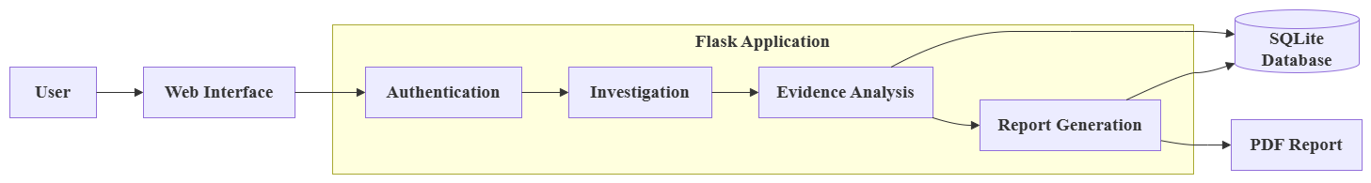
Figure 6: Overall System Architecture
(Source: Self-Created in Draw.io)
It contains the "Presentation Layer" that includes HTML, CSS, and Bootstrap to visualise the web interface that is required to be interactive and responsive for the investigator's needs. This interface enables authorised persons to log in, manage investigation cases, upload forensic evidence, review the results, view a timeline, and create an investigation report. User requests are securely sent to the Application layer for processing in the system while maintaining confidential information around any forensic data.
The "Application Layer" - The implementation uses the Flask framework and is responsible for coordinating all the interactions in the system and running business logic. The evidence files in CSV format are sent to the “Evidence Processing Module,” which uses the Pandas library for data validation, extraction of the relevant attributes,s and conversion of timestamps into a standard format for analysis. The evidence undergoes further analysis by the "Rule-Based Analysis Engine," which uses a set of predefined forensic rules to recognize any suspicious behavior, such as failed login attempts, connecting with an unknown device, accessing sensitive files, visiting suspicious sites, visiting or deleting frequently asked files, accessing files in a group directory, accessing authentication files, browser browsing, files deleted, and file accesses. Barik et al. (2022) said that rule-based forensic analysis increases the uniformity of investigations; it includes the application of certain predefined detection rules that aid in systematic evidence interpretation.
Processed evidence, the findings generated, timelines of the investigation, user information, and case records are kept in a secure SQLite database, which allows efficient retrieval and management of evidence during the whole investigation life cycle. Finally, the "Reporting Module" generates concise investigation reports based on the findings, including chronologies, that are validated automatically and will assist in forensic documentation of findings and in decision-making. Thus, the design of the architecture provides an integrated architecture that is transparent and reliable for carrying out an automated digital forensic investigation.

4.4 System Workflow
The “System Workflow” represents the flow of activities carried out with the proposed Digital Forensic Investigation Platform starting from user authentication to report generation. Once an authorised investigator logs on to the system, he/she starts a new investigation case and enters the investigation. The digital evidence is then uploaded as a CSV file, and validated and processed using the Pandas library. Artefacts extracted for further analysis are sent to the (predefined) forensic rules of the “Rule Based Analysis Engine”, which detects suspicious movements (attempts of failed logins, connection to USB devices, accessing certain files, browser history events, etc.). Du et al. (2020) pointed out that computer processing of 'forensic artefacts' and associated 'timeline events' enhances the relevance of digital evidence and can assist investigations to be more efficient. After the execution of the rules, the platform constructs a timeline of events and reports investigation findings. The investigators then review and check the results and create a written investigation report. Thus, the workflow provides a systematic and transparent approach in handling and processing forensic evidence and information, and assists in the effective decision-making process for investigators.
Figure 7: Activity Diagram
(Source: Self-Created in Draw.io)

4.5 Use Case Diagram
The flowchart of the ‘Use Case Diagram' defines what each of the authorised users and their interactions with the proposed Digital Forensic Investigation Platform are responsible for in an investigation within the platform. There are two main actors, ‘Administrator' and ‘Investigator'. The Administrator is in charge of user accounts and user role assignments, as well as ensuring secure access to the platform. The Investigator, on the other hand, conducts operations such as the establishment of investigation cases, uploading of digital evidence, launching forensic analysis, reviewing produced findings, visualising the investigation's timeline, and exporting the investigation's report. Such interactions will help maintain the separation of responsibilities and integrity of investigation processes. The user roles and system interactions can be defined with expert system architecture, which would also provide operational consistency, reduce user mistakes,s and aid in a structured approach to decision-making during digital forensic investigations [39]. Thus, the use case model directly gives the necessary clear representation about the interaction of authorised users with the system's individual functions that will facilitate safe, efficient, and transparent evidence analysis treatment.
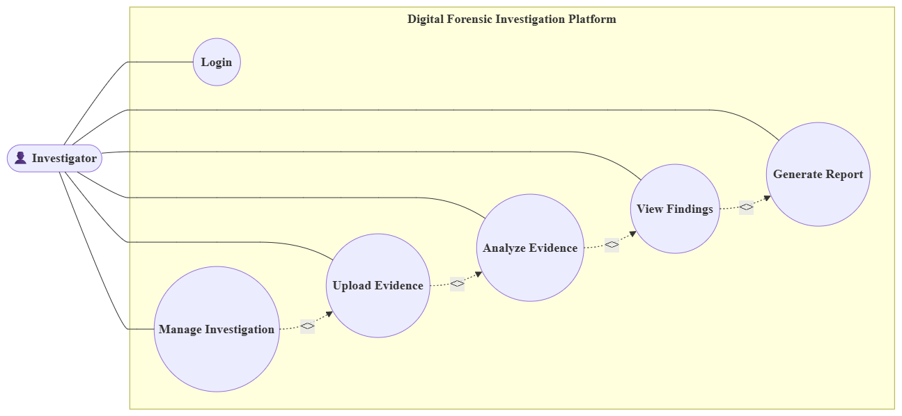
Figure 8: Use Case Diagram
(Source: Self-Created in Draw.io)

4.6 Database Design
The "Database Design" outlines the manner in which investigation data will be stored, organised, and retrieved as part of the digital forensic process. The choice of SQLite as the database management system is due to its lightweight, reliable, and efficient nature being beneficial for prototype development as well as being secure enough to store data and to be easily integrated with the Flask framework. It is presented as a set of tables that are linked together relationally and that allow for managing data in a consistent manner while investigating efficiently and keeping evidence readily available. Javed et al. (2022) explained that a properly organised database is crucial for the preservation of digital evidence, integrity of the investigation, and systematic analysis of the digital evidence.
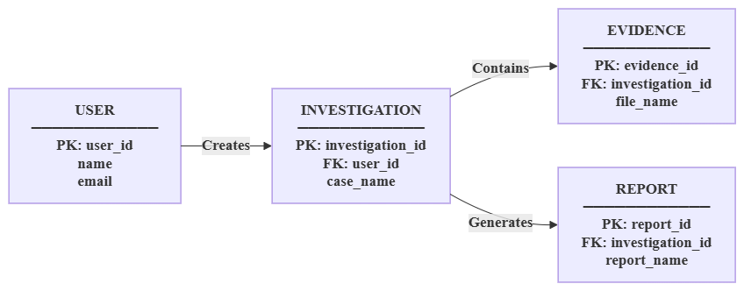
Figure 9: Entity Relationship (ER) Diagram
(Source: Self-Created in Draw.io)
The database functionality entails six primary tables such as Users, Cases, Evidence, Findings, Timeline and Investigator Decisions. Authentication credentials and role info for authorised people are stored in the Users table. Details on investigations (i.e., the number of the investigation and the investigator) are present in the Cases table. Uploaded forensic artefacts are recorded in the Evidence table; the Findings table records potential events which are picked up by the rule-based analysis engine. The Timeline table chronologically sorts the events of investigation that all happened round about digital incidents. Lastly, the table of Investigator Decisions archives the acceptance/rejection acceptance of an individual finding after manual inspection the decision of the investigator during the time the investigation occurred. In the study described that the availability of an organised forensic database could enhance evidence traceability, ensure information is readily accessed, and assist in case management in digital investigations [32].

4.7 Algorithm Design
It gives an understanding of how and why the "Algorithm Design" will facilitate the capability to have the proposed Digital Forensic Investigation Platform in process digital evidence as well as to offer tools that allow suspicious activity to be detected, event timelines to be reformed and investigation reports to be generated. All algorithms use a sequential process, guaranteeing the uniformity of the analysis of the evidence uploaded and keeping the integrity of the forensic data. Barik et al. (2022) in their study discovered that structured investigation algorithms improve capability and quality of digital forensic analysis by providing a systematic method of treating and analyzing digital evidence. The process kicks off with the upload of CSV files from which the "Evidence Processing Algorithm" in PIP, which is loaded by Pandas, reads the data. To ensure that the file structure is right, missing or invalid individual records, standardisation of timestamps and extraction of pertinent forensic attributes are identified using the algorithm and the processed data subjected to subsequent analysis process. The “Rule-Based Detection Algorithm" then compares the processed evidence to the rules which are pre-established by the FORS community. These regulations have a list of what activity they designate as being suspicious such as repeated failed logon attempts, unusual browser history events, access to sensitive files and others. Regarding every identified event, the investigators maintain a record as a possible forensic finding that will allow improving the results in a systematic way. Ramadhani et al. (2021) considers the decisions to be made based on the identified rules by rule-based reasoning in order to classify forensic events in a transparent way and as well as in a consistent way.

4.8 System Implementation
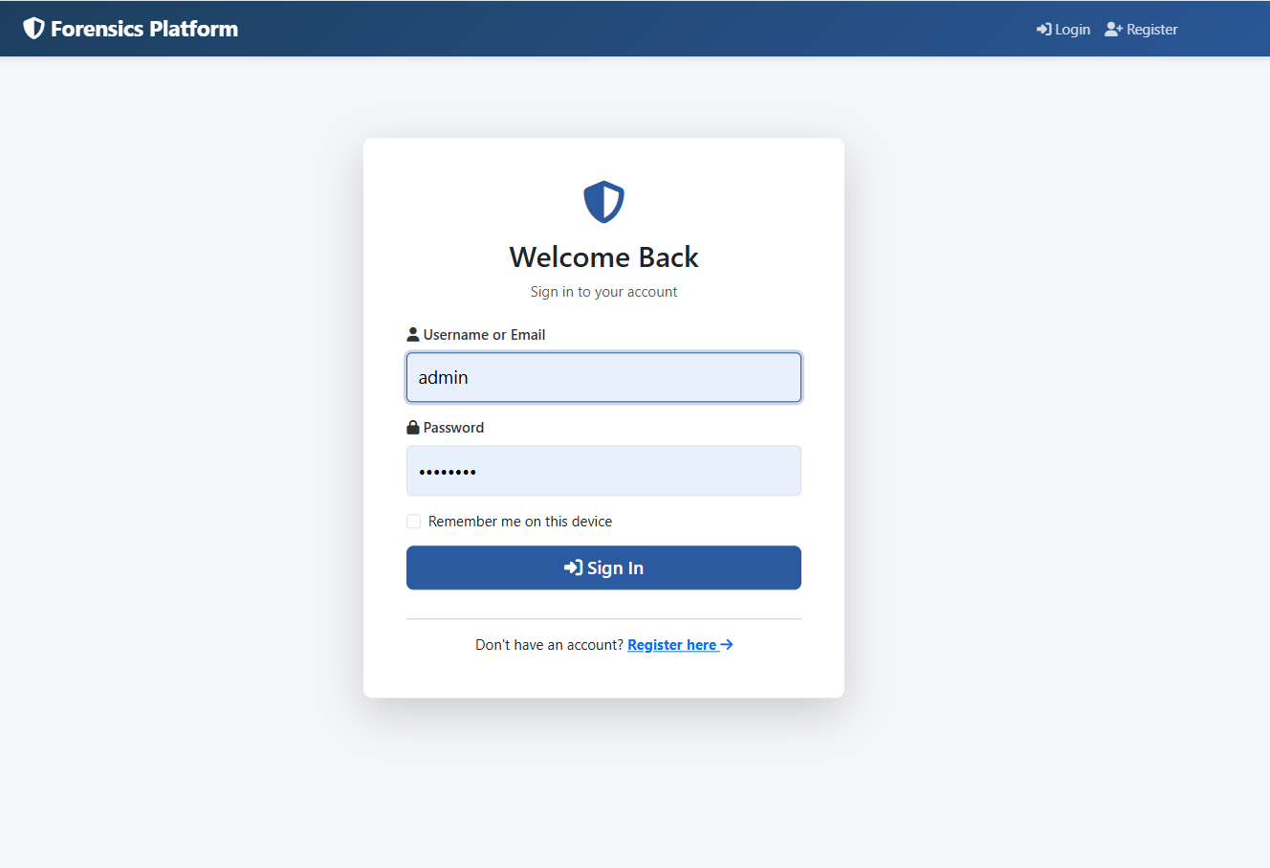
Figure 10: Login Page
(Source: Self-created in Visual Studio Code)
The Digital Forensic Investigation Platform provides a digital platform where investigators can log in as illustrated in Figure 10. The interface will enable registered users to input authentication credentials safely and then have access to the system dashboard, where they will be assured of authorised access to digital forensic investigation capabilities and safeguard sensitive investigation data.

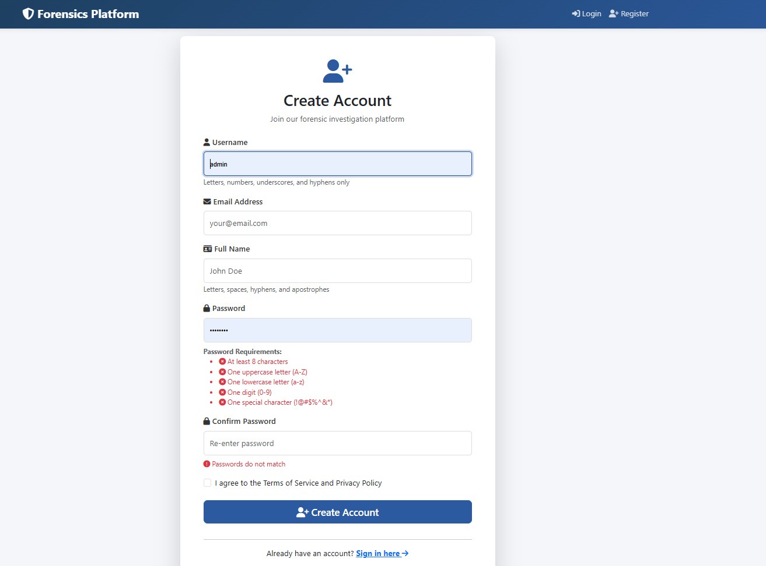
Figure 11: Registration Page
(Source: Self-created in Visual Studio Code)
The call centre can be accessed by creating new user accounts on the Digital Forensic Investigation Platform, as shown in the registration page as shown in Figure 11. The interface gathers user data needed to create accounts and assists in secure user registration, and then provides access to investigation functions by authorised users.

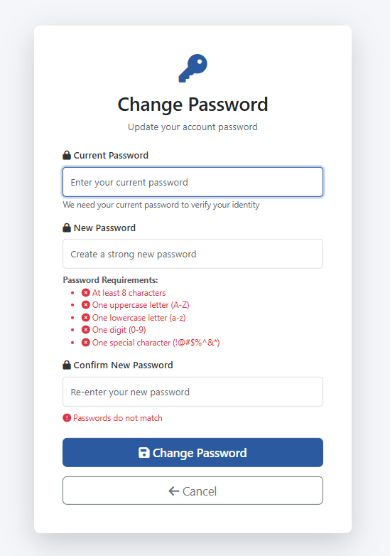
Figure 12: Update Password
(Source: Self-created in Visual Studio Code)
The password update page is illustrated in Figure 12, where users have the ability to update and alter existing account passwords. This feature provides greater account security and allows updating credentials and blocking access to digital forensic investigations and stored case details.
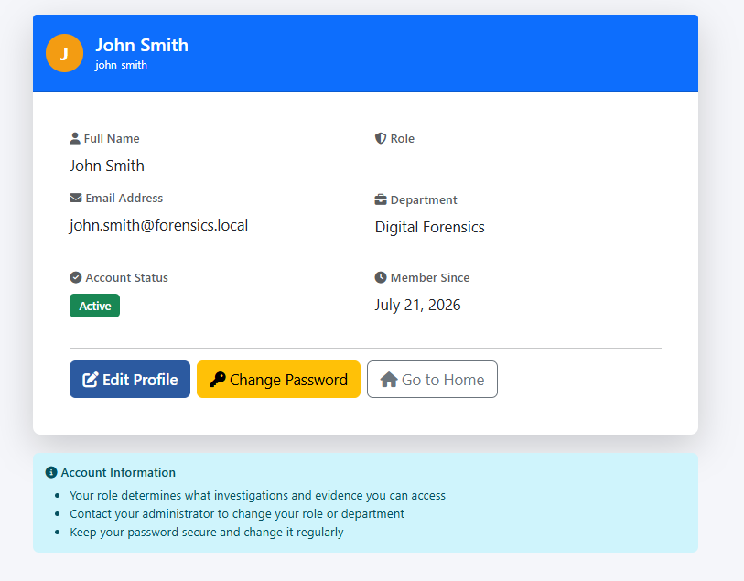
Figure 13: User Details
(Source: Self-created in Visual Studio Code)
Figure 13 shows the user details page with account information registered in the Digital Forensic Investigation Platform. The interface allows a user to view the information stored in the profile and facilitates the proper management of the account, ensuring correct record-keeping of the user during the process of operating the system.
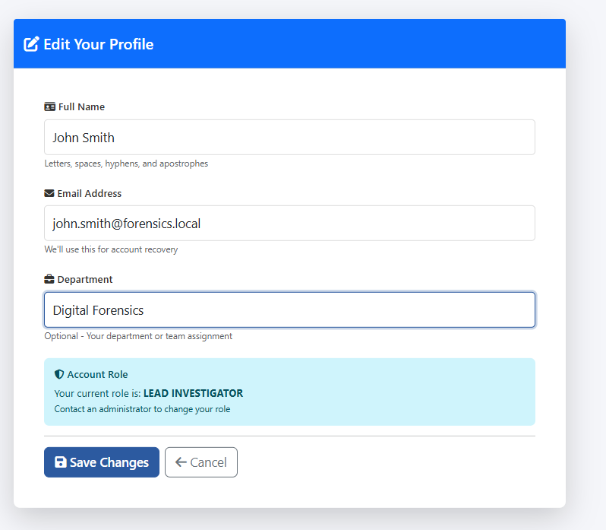
Figure 14: Update Profile Page
(Source: Self-Created in Visual Studio Code)
Figure 14 shows the profile update page, which allows users to correct the personal account information that is saved in the system. The interface provides proper user record management and,d at the same time, maintains record information on updated profiles available during the investigation process.

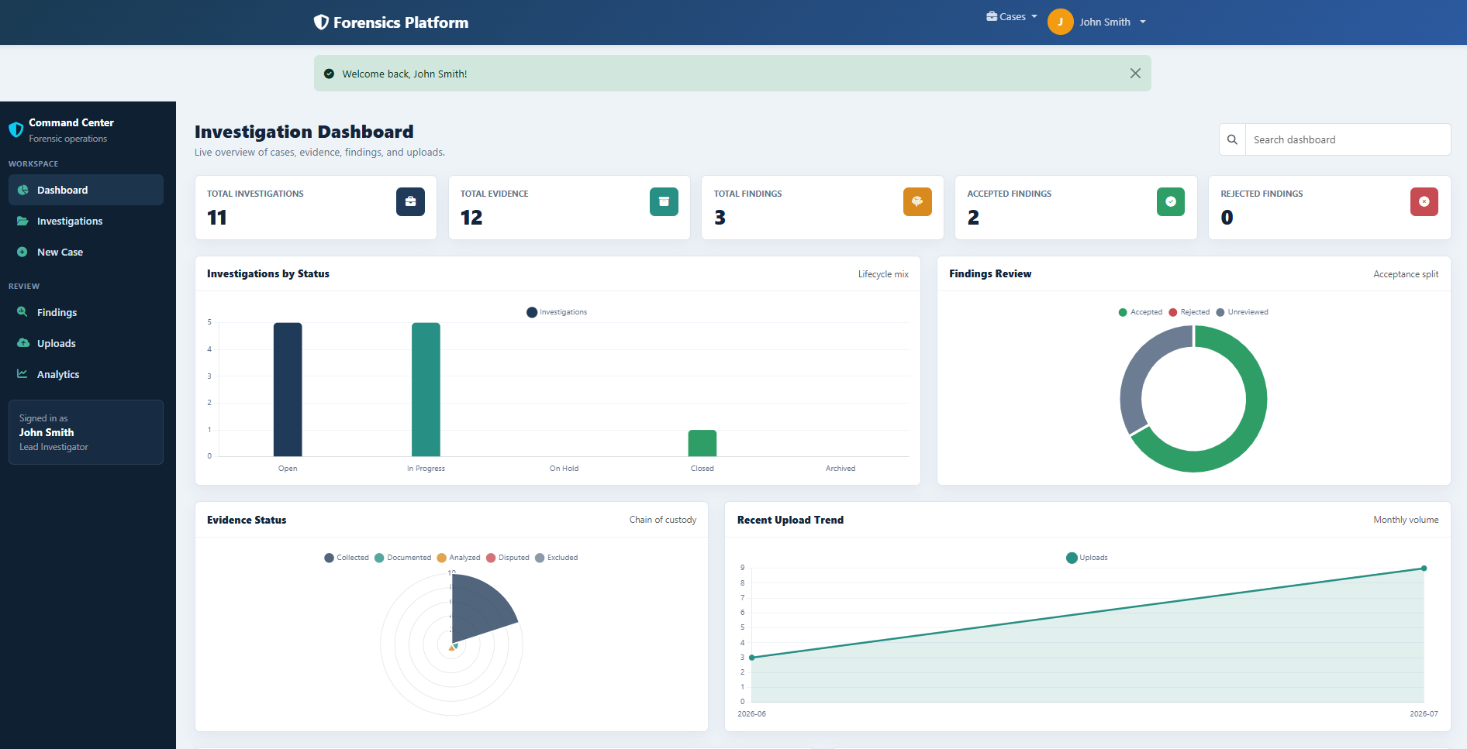
Figure 15: Dashboard Page
(Source: Self-Created in Visual Studio Code)
As Figure 15 shows, the dashboard page is the key interface of the Digital Forensic Investigation Platform. The dashboard offers aast access to the investigation management, evidence repositories, forensic timelines, reports, and other vital investigation functions of the application.
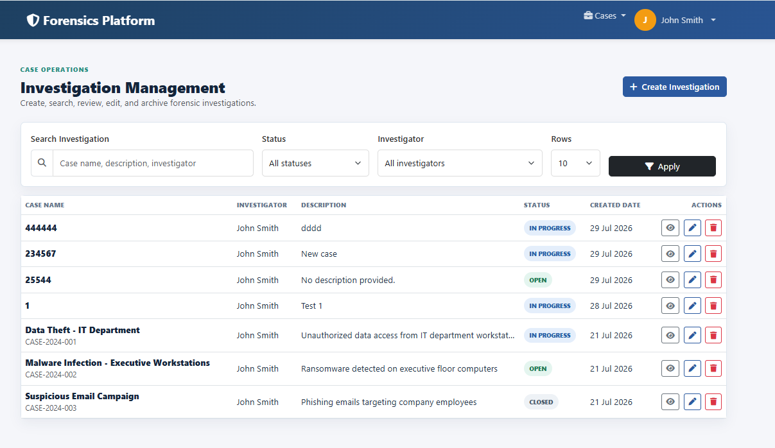
Figure 16: Investigation Management Page
(Source: Self-Created in Visual Studio Code)
Figure 16 demonstrates the investigation management page, in which available investigation cases are organised and managed. The interface will allow easy access to the records of investigations, and thus case administration becomes simpler and assists in the general process of digital forensic investigation on the platform.
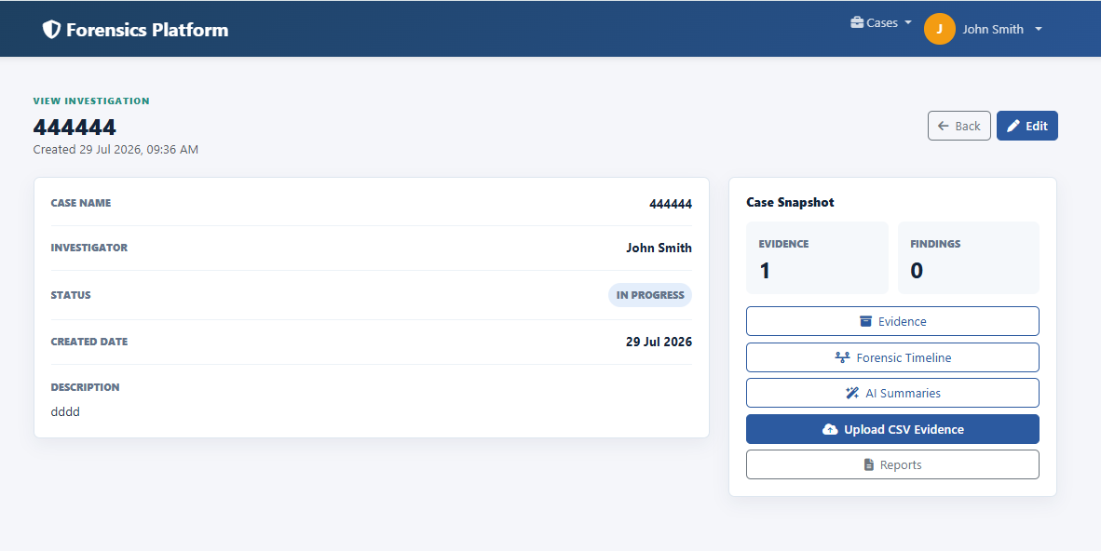
Figure 17: Case administration becomes
(Source: Self-Created in Visual Studio Code)
The details of the investigation page shown in Figure 17 include all details of an individual investigation case. The interface enables the investigators to view the case data, evidence records, and status of the investigation before conducting other forensic analysis tasks.

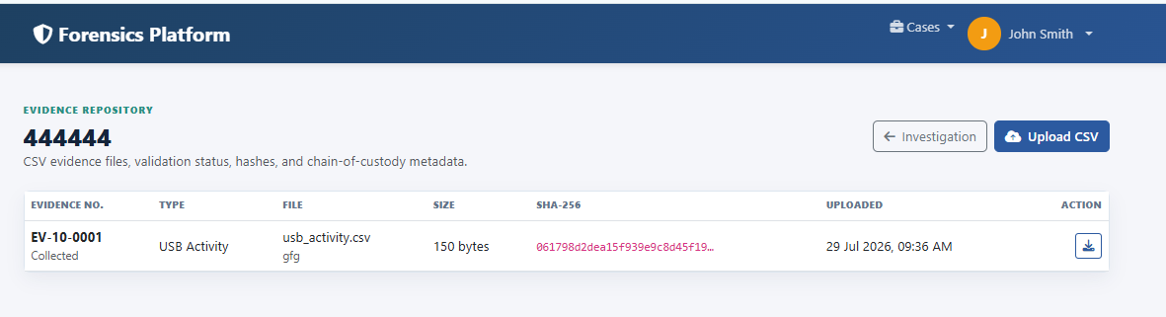
Figure 18: Investigation Evidence Repository
(Source: Self-Created in Visual Studio Code)
Figure 18 shows the repository of investigation evidence wherein uploaded forensic evidence is safely kept and classified. The repository assists in evidence management as files uploaded in the form of CSV are supported and fetched easily when needed in digital forensic investigation and analysis.
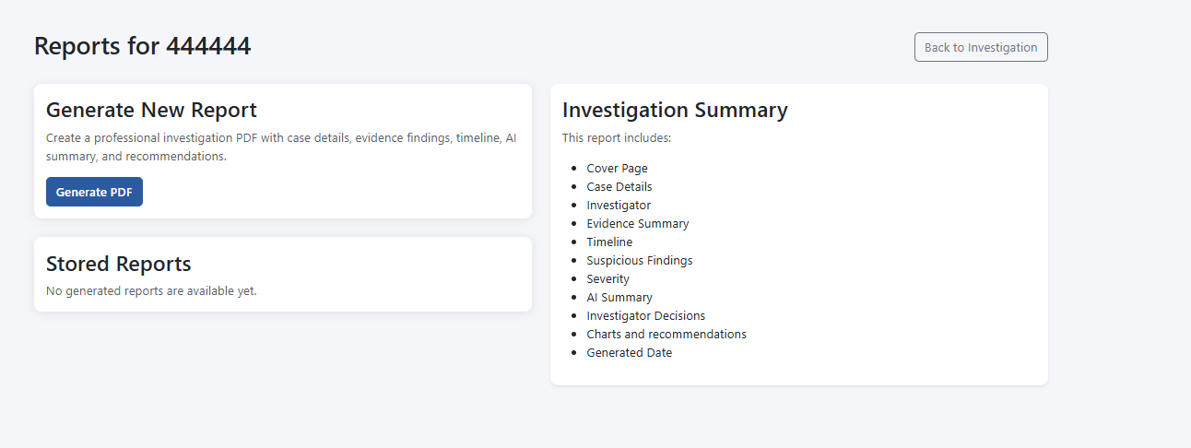
Figure 19: Investigation Report Showing Page
(Source: Self-Created in Visual Studio Code)
The page of analysis of findings generated by the platform, which is an investigation report, is shown in Figure 19. The interface allows investigators to check the outcomes of the investigations, analyse evidence summaries, and see a timeline of the case before the eventual export of the final report of the forensic investigations.

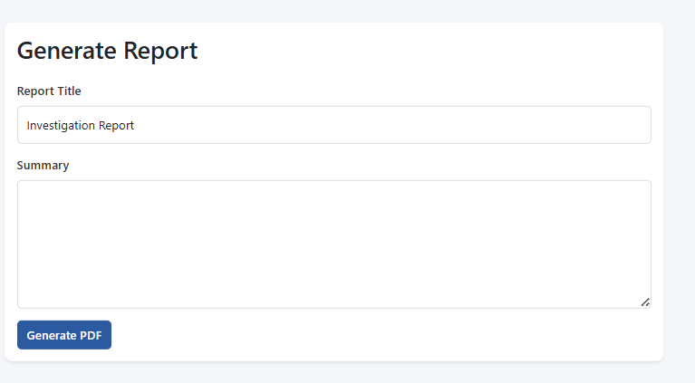
Figure 20: Investigation Generate Report PDF Page
(Source: Self-Created in Visual Studio Code)
Figure 20 is the report generation page that would help to create investigation reports in a PDF file. The interface gathers vetted results, case data, and forensic timelines into a document that can be used to document investigations and reference in the future.

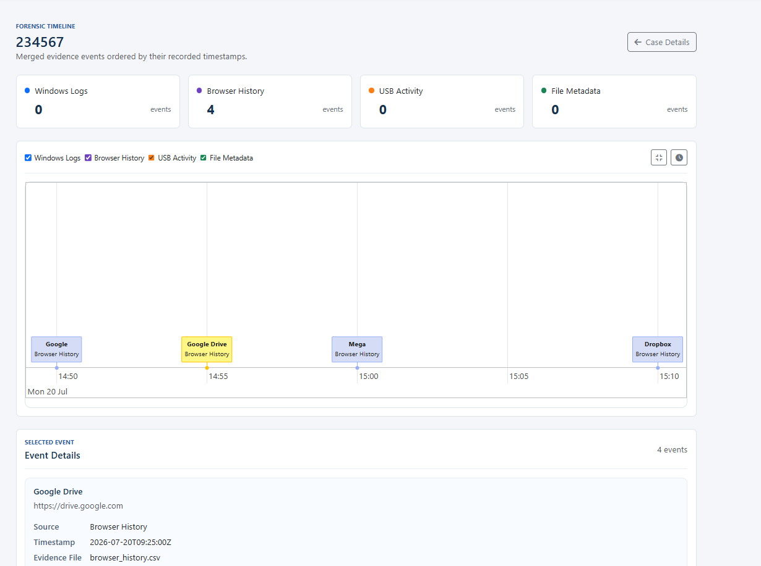
Figure 21: Investigation Forensic Timeline Page
(Source: Self-Created in Visual Studio Code)
Figure 21 is the page of the forensic timeline that shows the events of the investigation systematically over time. The interface helps investigators to reconstruct the digital incidents by showing the evidence based on time, which will enhance comprehension of the forensic activities sequence.

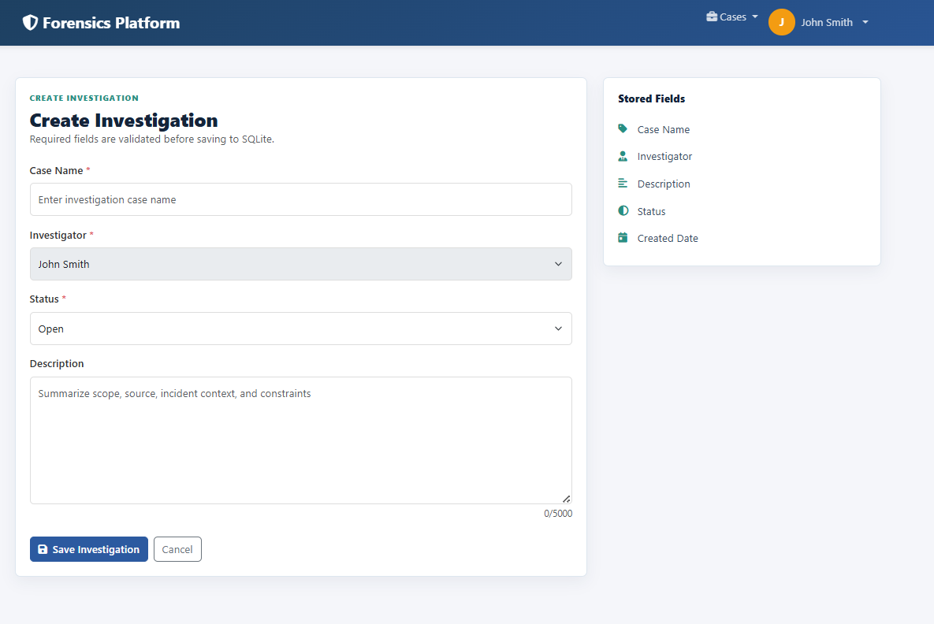
Figure 22: Create New Investigation Page
(Source: Self-Created in Visual Studio Code)
The page to create a new digital forensic investigation is presented in Figure 22. The interface enables the users to add the specifics of the investigation and then proceed with gathering of evidence, analysis and producing a report in the Digital Forensic Investigation Platform.
The system design is finalized with the implementation of the “Digital Forensic Investigation Platform” that can now be used as a working web application that could help digital forensic investigations. It is intended to be a modular architecture with the User Experience, application logic, Evidence Processing, Database Management and Reporting modules being different. This makes the system maintainable and implements its parts in some roles in the investigational process. As Javed et al. , (2022) argue, the isolation of the investigative functions into independent modules that are however interdependent in digital forensic systems makes them efficient, scalable and reliable.
The front-end UI was created with HTML, CSS and the Bootstrap; all of which would accommodate a responsive and easy to use design. The central work area through which investigators can view investigation cases, upload evidence, view results, view timelines and produce reports. Structured navigation enables the investigators to navigate easily among the different investigation modules and the use of the authentication form ensures that only authorised individuals are granted an access to the platform. The interface was designed as a simple interface to ensure that the user will not make mistakes when using the program and to optimise the operation of the program during a forensic investigation.
The backend was developed using the Flask web application framework that redirected requests to the authentication, user session storage and communication with the database. Evidence files are posted on Flask where user queries are accepted and user request processing is done by executing appropriate application logic and analysis results in the form of interactive web pages. A digital investigation platform can be created using lightweight web frameworks since they provide flexibility and simplicity of incorporation of modules forensic processing [36].
Data related to the investigations is included on the platform on an SQLite database in the following sections: data regarding user accounts or cases of investigation, data regarding uploaded evidence to the investigation, data regarding findings made by the investigation, data regarding timeline events, data regarding the decisions of the investigator. Recorded CSV files are extracted, data structures verified, timestamps normalised and evidence of automated analysis is provided to give a consistent structure to the data and give an added layer of validation. The acquired evidence is subsequently forwarded to the Rule-Based Analysis Module which applies a range of rules, to detect suspicious activity- such as when a user repeatedly signs in to a computer, attaches to an USB storage device, accesses sensitive files, browses the web or looks through the browser history. Any known object is put into the database and presented in a chronological fashion, which allows the investigators more easily follow the history of a digital incident. Who elaborated that it will improve consistency in investigation and enable knowledge openness by employing familiar knowledge to examine digital evidence, rule-based reasoning is useful in forensic investigations [38].

4.9 Chapter Summary
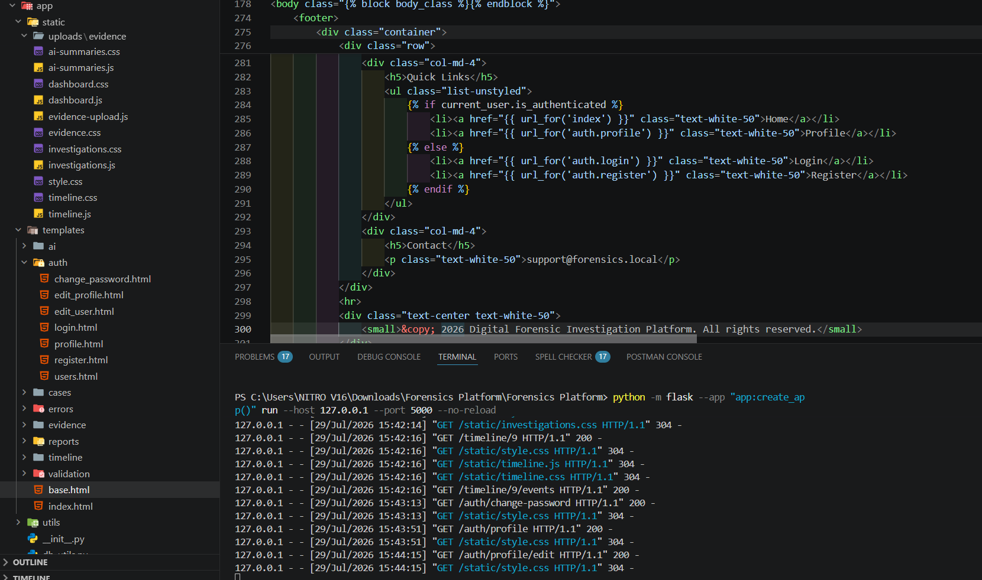
Figure 23: Application Running Process
(Source: Self-Created in Visual Studio Code)
In Figure 23, the running of the application is shown as the system is progressing. The figure illustrates the effective work of the Digital Forensic Investigation Platform to confirm that the developed application is working properly and is able to facilitate the entire process of the process of digital forensic investigation.
The chapter showcases the design and development of the proposed framework, "Digital Forensic Investigation Platform," which demonstrates the unified web-based environment that incorporates every component required to support the process of digital forensic investigation, such as case management, evidence processing, rule-based analysis, timeline construction, and report generation. System requirements, overall architecture, overall workflow, database design, basic algorithms, and technologies used in the implementation are all discussed here that will be needed to conduct efficient forensic investigation. The investigation process is more structured and combining it with automated analysis of the evidence, digital forensic systems will be more reliable, consistent, and effective [10].

Chapter 5: Results and Discussion

5.1 Introduction
The rest of the chapter is dedicated to conducting an evaluation of the proposed "Digital Forensic Investigation Platform" in terms of its functionality, performance, transparency, and contribution towards digital forensic investigations. The centre of the assessment is the prototype developed during the given research and attempts to assess such functions as digital evidence processing, rule-based analysis, development of investigation timeline and structured creation of forensic reports. To judge the viability and reliability of digital forensic systems, it is crucial to evaluate the system [26].

5.2 Experimental Setup
The "Experimental Setup" aimed at conducting experiments with the proposed Digital Forensic Investigation Platform in an experimental controlled setup to assess the functionality and performance of this platform. This test covered and verified the capability of the system to handle forensic evidence, detect suspicious behaviour, reconstruct investigation timelines and generate structured investigation reporting. To assure that the modules were operating as per its functional requirements, a Test environment has been established to test every single module systematically. Barik et al. (2022) claimed that it is imperative to validate the reliability and effectiveness of an investigation system for DF in a structured experimental environment. It was tested on the computer having an AMD Ryzen processor, 8 GB RAM and windows 11 (PC OS). This programming environment included Python 3.x, Flask web framework, SQLite database, and Visual Studio Code programming tool, and the Pandas library to act as the evidence processing engine. The User Interface (UI) otherwise referred to as the screens was created using HTML, CSS, and Bootstrap and will be responsive and user-friendly when engaging with information in an investigation.
Component | Specification | Purpose | Outcome
Hardware | AMD Ryzen Processor, 8 GB RAM | System execution | Stable operation
Operating System | Windows 11 | Development platform | Compatible environment
Software | Python, Flask, SQLite, Pandas | System implementation | Successful integration
Dataset | CSV forensic artefacts | Evidence analysis | Rule validation
IDE | Visual Studio Code | Development and testing | Efficient implementation
Table 5.1: Experimental Setup
The system was tested on several test cases including: user authentication, case management, evidence upload, rule-based detection, timeline generation and report generation. Even the creation of the experimental arrangement, therefore, provided a solid foundation to test the overall efficiency and usability of the proposed digital forensic investigation platform.

5.3 Functional Testing
During the "Functional Testing" phase, the proposed Digital Forensic Investigation Platform was checked to see if it met the functional requirements and functioned properly in normal use. The process of testing the integrated system was needed to make sure that there is no single error in the entire investigation process and every separate module should be tested prior to the end-to-end testing [11]. The main areas that were evaluated were User authentication, Case management, Evidence upload, CSV processing, rule-based evidence analysis, Evidence timeline generation and Evidence report generation. The affirm that before digital forensics can be applied in a digital forensics’ investigation, it is significant to undertake systematic functional testing of digital forensic tools to assure their correctness and reliability when implemented [32]. Testing of the user authentication module was carried out to ensure that the user could log into the system and that the proper screening of authorised users is implemented. The evidence upload module has been tested with a number of CSV-based event logs (Windows, the Web browser, USB activity reports and file metadata). The files uploaded were successfully validated prior to processing them with Pandas. The CSV processing module could also extract evidence-relevant forensic parameters, helpful timestamps and also prepare the evidence to be analyzed using the automated method. Accurate processing of the forensic artefacts is critical to effectively analyse the chain of evidence and build a time framework [16].
Test Module | Test Objective | Expected Result | Actual Result | Status
User Authentication | Verify secure login | Successful authentication | Passed | Pass
Case Management | Create and manage cases | Correct data storage | Passed | Pass
Evidence Upload | Upload CSV evidence | Successful upload | Passed | Pass
CSV Processing | Validate and process files | Correct data extraction | Passed | Pass
Rule-Based Detection | Detect suspicious activities | Accurate detection | Passed | Pass
Timeline Generation | Display chronological events | Correct timeline | Passed | Pass
Report Generation | Generate investigation report | Successful report creation | Passed | Pass
Table 5.2: Functional Testing Results

5.4 Performance Evaluation
The "Performance Evaluation" was used to determine the efficiency of the Digital Forensic Investigation Platform's operation by assessing its accuracy of processing digital evidence and its ability to process it within an acceptable response time. Five key performance indicators were taken into account, namely: Detection Speed, Processing Time, Memory Usage, Response Time, and Accuracy of Rule Detection. These indicators were chosen because they represent the real-life demands of a digital forensic investigation system, on a real-life dataset [11].
With Evidence Analysis, the Rule-Based Analysis Module was capable of detecting predefined suspicious events by using fixed forensic rules. Every event detected was placed in the database and presented to the investigators for checking if they meant to add some or remove some of the events before compiling the final report of the investigation. The created timeline successfully serialised the forensic events by the time received in the events, allowing the accurate reconstruction of the digital incidents. An efficient timeline construction will help investigators to understand the sequence of events and even enhance the interpretation of the digital evidence for the attack during the investigative process [6].
Performance Metric | Evaluation Criteria | Observation | Result | Assessment
Detection Speed | Identification of suspicious events | Fast and consistent | Satisfactory | Efficient
Processing Time | CSV evidence processing | Completed successfully | Satisfactory | Efficient
Memory Usage | System resource consumption | Stable during testing | Acceptable | Efficient
Response Time | User interaction performance | Responsive interface | Good | Efficient
Rule Detection Accuracy | Identification of predefined rules | Correct findings generated | High | Reliable
Table 5.3: Performance Evaluation Results

5.5 System Transparency and Explainability
The "System Transparency and Explainability" evaluation focuses on the ability of investigators looking into a Digital Forensic Investigation Platform to gain insights into the "how" and "why" of each forensic discovery. In contrast to more complex artificial intelligence systems, where the prototype created is based on "rule-based analysis" that detects every suspicious event by applying predetermined rules. Through this, investigators can trace each finding straight back to the evidence that led the investigation. This will increase appraisal assurance by connecting each finding to the evidence that moved the investigation. According to Ramadhani et al. (2021), rule-based reasoning would improve transparency, which would occur by using predefined knowledge or facts to better enable users to understand decision-making processes within digital forensic investigations.
The site includes an “Investigator Validation” option which allows one to “accept” or “reject” individual findings based on the supporting evidence. This can help ensure automated analysis can help, not replace, professional judgment. Investigators will continue to cross-check if each detected event should be part of the investigation report. In digital forensic activities, Barik et al. (2022) stated that digital forensic tools should offer evidence analysis helping to the decision making of the investigator while keeping human intervention in the workflow.

5.6 Comparative Analysis
The "Comparative Analysis" provides an evaluation of the capabilities of the proposed Digital Forensic Investigation Platform with some widely known digital forensic investigation platforms, such as Autopsy, FTK, EnCase, Volatility, and the traditional manual digital forensic investigation approach [17]. The comparison is based on the following evaluation points: automation, timeline generation, reporting, ease of use, cost, and transparency. This analysis has shown the usefulness of the prototype developed and how some commercial forensic tools offer extra functions. Analysing digital forensic tools can be used to identify their strengths, weaknesses, and applicability in different scenarios [24].
Feature | Proposed Platform | Autopsy | FTK | EnCase | Volatility
Automation | Rule-based automated detection | Partial | Advanced | Advanced | Limited
Timeline Generation | Integrated chronological timeline | Available | Available | Available | Limited
Report Generation | Automated investigation report | Available | Advanced | Advanced | Manual
Ease of Use | High | Moderate | Moderate | Moderate | Low
Cost | Low (Open-source prototype) | Free | Commercial | Commercial | Free
Transparency | High (Rule-based reasoning) | Moderate | Moderate | Moderate | Moderate
Table 5.4: Comparative Analysis of the Proposed Platform and Existing Digital Forensic Tools
The suggested platform points to several benefits in the aspects of transparency and accessibility. The developed system is specially designed with a predefined "rule-based analysis", which allows forensic investigators to interpret the reasons behind the identification of each suspicious event, unlike commercial forensic software[17]. Each finding will be tied to the forensic evidence immediately with the associated detection rule, so investigators can verify the forensic evidence before they create such a report. This is a clear strategy that facilitates uniformity in decision-making and enhances users' trust in forensic investigations. According to Ramadhani et al. (2021), the use of a rule-based expert system enhances the transparency of an expert system because it is always possible to trace every conclusion back to a knowledge rule, which itself is explicitly formulated.
These tools, however, may require more technical expertise or commercial licensing, which may make them less attainable in the education space or prototyping research. This new platform targets the main functions needed for forensic investigation, such as upload and support of evidence, automatic rule detection, timeline creation and validation by an investigator, and a structured report, which are the main goals of this research, in a simplified web-based medium. According to Mahdi Salih and Ibrahim (2023), the selection of appropriate forensic tools requires consideration of the functionality, usability, cost, as well as the specific needs of an investigation.

5.7 Discussion of Findings
The results of this study confirm that the main objective of the study, i.e., the development of a web-based system which is able to support automated evidence analysis via “rule-based detection”, was successfully met. The prototype implemented unified case management procedures involving: Evidence upload, user authentication, case management, CSV processing, timeline reconstruction, investigator validation, and report generation. The functional and performance assessments were carried out to validate the platform and verify its investigation outcome in the specified testing conditions. According to cited by Casino et al. (2022), a modern digital forensic system is required to consist of evidence processing, analysis, and reporting to attain efficient investigation and maintain the integrity of the digital evidence.
The results find that the platform was able to meet the research purposes set at the start of the study. The design of a digital forensic investigation platform has been fulfilled with the creation of a modular platform that utilises Flask, SQLite, and Pandas. The first goal, which involved creating a digital forensic investigation platform, was accomplished by developing a modular design using Flask, SQLite and Pandas. The second goal (automated evidence analysis) was achieved through the integration of pre-defined forensic rules to identify failed login attempts, compromised device (USB) connections, evidence from sensitive files, and related events in the browser history. The third objective, timeline reconstruction, was achieved by dictating forensic events of an incident in chronological order to support digital incident reconstruction. The chronological timeline analysis is a method introduced by Bhandari (2022) that can help investigators grasp the sequence of digital events better and thus better analyse the digital forensics evidence.
In addition, the investigator validation capability allows for human judgment to continue to play a role in the decision-making process, thus boosting confidence in the generated findings. The combined features highlight the platform's clean and easy-to-use environment for digital forensic investigations. The investigative lifecycle could assist in making the evidence process more reliable and consistent, as declared by the authors [3].

5.8 Chapter Summary
The chapter has been functionally tested and performance tested to make sure that the proposed "Digital Forensic Investigation Platform" is really useful, transparently tested to check the transparency of the platform, performance assessed, and analysis of this platform was carried out by comparing it with similar platforms and a discussion of the research findings. The results showed that the prototype successfully implemented the four functional requirements that are required for a secure application, which are: secure user authentication, case management, evidence processing, "rule-based analysis," and timeline reconstruction, investigator validation, and automated report generation in the integrated web-based environment. An effective and efficient digital forensic system should incorporate effective and efficient evidence decomposition, and developed investigation process, and effective reporting, which all have a role in supporting investigative decision-making [26].

Chapter 6: Conclusion

6.1 Introduction
This chapter is meant to conclude on the general research findings and assess how effective the proposed rule-based digital forensic investigation platform was regarding its intended goals. In addition, the chapter talks about the research contributions, research limitations, as well as recommendations towards future development. To illustrate the importance and findings of digital forensic research, structured conclusions are needed [1].

6.2 Summary of Research
With the research responding to the increasing necessity of a transparent and efficient method for digital forensic investigations, a framework called a Rule-Based Digital Forensic Investigation Platform to enable automated analysis of evidence was developed. Traditional forensic examinations usually include physical examination of evidence, which can be lengthy and potentially decrease the effectiveness of the investigations. Therefore, the research was aimed at developing a web-based system that would assist investigators with the help of systematic evidence processing, rule-based detection, time reconstruction, investigator validation, and automatic report generation. According to Adam and Varol (2020), the introduction of intelligent processes into digital forensic investigation enhances evidence management and helps decision-making throughout the investigation life cycle.
Flask, HTML, CSS, Bootstrap, SQLite, and Pandas were used in the proposed platform to support a modular architecture, allowing secure authentication, investigation management, evidence upload, CSV processing, and automated analysis with a predefined set of rules used in forensic analysis. System assessment revealed that the prototype was effective in delivering reliable functionality in all implemented modules, which included the generation of timestamps and the creation of a PDF report. The results confirmed that the developed platform is a practical and transparent solution to the backup of digital forensic investigations as well as achieving the objectives of the research provided in the current study. The well-organised forensic analysis enhances digital investigations by aiding in the detection and analysis of events concerning security [15].

6.3 Achievement of Objectives
The study was able to fulfil the goals of the research when starting. The former was achieved by the design and development of a web-based digital forensic investigation platform based on a modular architecture. The second goal was met through the use of rule-based analysis, which is able to detect suspicious activities on uploaded forensic evidence. The third aim was achieved in the form of the creation of chronological forensic timelines, which helped in the reconstruction of the events. Lastly, the automated PDF report generation resulted in greater documentation of investigation findings as well as increased transparency during investigations. According to Dimitriadis et al. (2022), the efficiency of investigations can be enhanced by structured forensic systems that aid in supporting the timeliness of evidence analysis and informed choices.

6.4 Conclusion
The study has shown that the suggested Rule-Based Digital Forensic Investigation Platform offers a viable solution to enhancing efficiency and transparency of digital forensic investigation. The platform has been able to support the entire investigation process by incorporating robust user authentication, case management, evidence processing, rule-based detection, forensic and timeline generation, as well as investigator verification and automated PDF reporting to provide a single web-based platform. The modular architecture also offers a safe bedrock for prospective improvements and remains simple and easy to use on the educational and prototype surrounding. According to Adam and Varol (2020), a successful digital forensic process must combine well-designed evidence management and smart decision-making to enhance the effectiveness of investigations.

Chapter 7: Reflection and Future Work

7.1 Introduction
This chapter will reflect critically on the knowledge, skills, and experience that were gained during the process of formulating the Rule-Based Digital Forensic Investigation Platform. It also talks about future development opportunities and how the platform may be fine-tuned to have new tools and end-state search-and-seizure technology.

7.2 Skills Developed
This project has enabled me to grow tremendously through building my technical and academic skills. I enhanced my research capabilities by reading online material on digital forensics and examining available investigation models to aid in making system design reforms. My understanding of programming was developed by applying the Flask platform based on Python, HTML, CSS, Bootstrap, SQLite, and Pandas. The real-life experience of working with databases and processing evidence enhanced my knowledge about structured development of applications. Moreover, the ability to find solutions to implementation issues that entail rule-based detection, processing of CSV evidence, generation of timelines, and creation of reports enhanced my problem- solving skills and critical thinking. These experiences have helped to form a better base for future software development and digital forensic projects.

7.3 Challenges Faced
The development process included several technical and practical issues, which needed to be planned carefully and improved all the time. Performing solid rule-based detection that could be used to detect suspicious activities using uploaded CSV evidence and provide consistent results in analysis was considered one of the major obstacles to overcome. Further challenges were witnessed in the labelling of forensic timelines, which had to be properly sequenced the events in a chronological manner. In order to test the platform, we had to perform repeated validation to make sure the evidence processing, report generation, and user authentication worked in all investigation scenarios. The value of proper planning, testing, and problem-solving was also underlined due to the need to regulate development activities and responsiveness to the timeframe of the project.

7.4 Lessons Learned
This completed work gave important information about the principles and practice of the so-called digital forensic investigation and the need to create transparent systems of evidence analysis. The project was able to show that methods of conducting investigations based on rules would enhance consistency, but also enable the investigators to have a sense of how the findings were created. Additionally, the software engineering practice that evolved through the process further supported the importance of modular system design, database management, system testing, and documentation [31]. The undertaking of the research also enhanced academic writing, literature review, and analysis as the researchers showed how information on theoretical aspects through research implementation should be relevant and consistent in a practical system to achieve credible and effective research results.

7.5 Future Work
The proposed Rule-Based Digital Forensic Investigation Platform offers a good starting point towards the next level of enriching the platform with upcoming technologies and other extended capabilities of the forensic department. Newer versions will be able to use Deep Learning methods to detect higher-order behavioural trends and novel cyber threats and facilitate smarter evidence analysis. Moreover, it would be possible to incorporate the so-called Cloud Forensics to conduct safe investigations of the cloud-based environment, and the so-called Mobile Forensics could be offered to cover smartphones and other mobile devices. The explainable digital forensic technologies are recommended to deliver human-interpretable evidence to enhance transparency and inform the decisions made during investigations [14].
Moreover, the developmental process might consider applying a quasi-real-time threat detection tool in the future to track digital events in real-time and send timely notifications on suspicious events. Combining several accountable artificial intelligence models can be an additional way to enhance analytical accuracy, retaining clear reasoning that could be comfortably comprehended and confirmed by an investigator. The innovative forensic investigation tools and proactive cyber defence systems will become all the more critical in terms of responding to the changing digital security challenges and contributing to more efficient forensic investigations [33].

Reference List:
[1] Adam, I.Y. and Varol, C., 2020, June. Intelligence in the digital forensics process. In 2020 8th International Symposium on Digital Forensics and Security (ISDFS) (pp. 1-6). IEEE. https://www.researchgate.net/profile/Iliyasu-Adam-2/publication/342193698_Intelligence_in_Digital_Forensics_Process/links/63207908873eca0c0084c707/Intelligence-in-Digital-Forensics-Process.pdf
[2] Ajayi, J.O., Etim, E.D., Essien, I.A., Cadet, E., Babatunde, L.A., Erigha, E.D. and Obuse, E., 2023. AI-Driven Digital Forensics: Automating Evidence Gathering and Analysis. Akinleye, KE, Jinadu, SO, Onwusi, CN, Omachi, A., & Ijiga, OM (2023). Integrating Smart Drilling Technologies with Real-Time Logging Systems for Maximising Horizontal Wellbore Placement Precision. International Journal of Scientific Research in Science, Engineering and Technology, 11(4). https://shisrrj.com/paper/SHISRRJ236530.pdf
[3] Barik, K., Abirami, A., Konar, K. and Das, S., 2022. Research perspective on digital forensic tools and investigation process. Illumination of Artificial Intelligence in Cybersecurity and Forensics, pp.71-95. https://www.researchgate.net/profile/Mathew-Nwanga/publication/359209549_Illumination_in_AI_and_Forensic_1/links/622efd45a39db062db9c384c/Illumination-in-AI-and-Forensic-1.pdf#page=85
[4] Bell, S., 2025. Forensic science: an introduction to scientific and investigative techniques. CRC Press. httpsPressw.researchgate.net/profile/Lyndsie-Ferrara/publication/283269179_Book_Review_-_Forensic_Science_An_Introduction_to_Scientific_and_Investigative_Techniques_4th_ed/links/562fb60508aea4eec6ddca2d/Book-Review-Forensic-Science-An-Introduction-to-Scientific-and-Investigative-Techniques-4th-ed.pdf
[5] Bennetot, A., Donadello, I., El Qadi El Haouari, A., Dragoni, M., Frossard, T., Wagner, B., Sarranti, A., Tulli, S., Trocan, M., Chatila, R. and Holzinger, A., 2024. A practical tutorial on explainable AI techniques. ACM Computing Surveys, 57(2), pp.1-44. https://papers.ssrn.com/sol3/Delivery.cfm?abstractid=4543661
[6] Bhandari, S., 2022. Research and implementation of timeline analysis method for digital forensics evidence (Doctoral dissertation, Kauno technologijos universitetas.). https://epubl.ktu.edu/object/elaba%3A133122013/133122013.pdf
[7] Bouma, J., Jonker, H., van der Meer, V. and Van Den Aker, E., 2023, August. Reconstructing timelines: From NTFS timestamps to file histories. In Proceedings of the 18th International Conference on Availability, Reliability and Security (pp. 1-9). https://dl.acm.org/doi/pdf/10.1145/3600160.3605027
[8] Califf, C.B., Sarker, S. and Sarker, S., 2020. The bright and dark sides of technostress: A mixed-methods study involving healthcare IT. MIS Quarterly, 44(2), pp.809-856. https://www.researchgate.net/profile/Christopher-Califf/publication/341833367_The_Bright_and_Dark_Sides_of_Technostress_A_Mixed-Methods_Study_Involving_Healthcare_IT/links/5eefb4f2299bf1faac6c8833/The-Bright-and-Dark-Sides-of-Technostress-A-Mixed-Methods-Study-Involving-Healthcare-IT.pdf
[9] Capuano, N., Fenza, G., Loia, V. and Stanzione, C., 2022. Explainable artificial intelligence in cybersecurity: A survey. IEEE Access, 10, pp.93575-93600. https://ieeexplore.ieee.org/iel7/6287639/9668973/09877919.pdf
[10] Casino, F., Dasaklis, T.K., Spathoulas, G.P., Anagnostopoulos, M., Ghosal, A., Borocz, I., Solanas, A., Conti, M. and Patsakis, C., 2022. Research trends, challenges, and emerging topics in digital forensics: A review of reviews. IEEE Access, 10, pp.25464-25493. https://ieeexplore.ieee.org/iel7/6287639/6514899/09720948.pdf
[11] Chan, W.P., KXJ, P.M., Croft, E.A. and Masayuki, I., 2020. An affordance and distance minimisation based method for computing object orientations for robot human handovers. International Journal of Social Robotics, 12(1), pp.143-162. https://researchmgt.monash.edu/ws/portalfiles/portal/342367416/274160833_oa.pdf
[12] Charmet, F., Tanuwidjaja, H.C., Ayoubi, S., Gimenez, P.F., Han, Y., Jmila, H., Blanc, G., Takahashi, T. and Zhang, Z., 2022. Explainable artificial intelligence for cybersecurity: a literature survey. Annals of Telecommunications, 77(11), pp.789-812. https://link.springer.com/content/pdf/10.1007/s12243-022-00926-7.pdf
[13] Chaure, S. and Mane, V., 2023. Digital forensic framework for protecting data privacy during investigation. EAI Endorsed Transactions on Scalable Information Systems, 11(2). https://www.academia.edu/download/108995450/2575.pdf
[14] Chen, Y., 2025. Towards Human Explainable Digital Forensics: Generating Human Interpretable Evidence for Semantic Understanding in Manipulated Images and Text. https://scholarsarchive.library.albany.edu/cgi/viewcontent.cgi?article=1134&context=etd
[15] Dimitriadis, A., Lontzetidis, E., Kulvatunyou, B., Ivezic, N., Gritzalis, D. and Mavridis, I., 2022. Fronesis: Digital forensics-based early detection of ongoing cyber-attacks. IEEE Access, 11, pp.728-743. https://ieeexplore.ieee.org/iel7/6287639/6514899/10004506.pdf
[16] Du, X., Hargreaves, C., Sheppard, J., Anda, F., Sayakkara, A., Le-Khac, N.A. and Scanlon, M., 2020, August. SoK: Exploring the state of the art and the future potential of artificial intelligence in digital forensic investigation. In Proceedings of the 15th International Conference on Availability, Reliability and Security (pp. 1-10). https://dl.acm.org/doi/pdf/10.1145/3407023.3407068
[17] Du, X., Le, Q. and Scanlon, M., 2020, June. Automated artefact relevancy determination from artefact metadata and associated timeline events. In 2020 International Conference on Cyber Security and Protection of Digital Services (Cyber Security) (pp. 1-8). IEEE. https://arxiv.org/pdf/2012.01972
[18] Dunsin, D., Ghanem, M.C. and Ouazzane, K., 2022. The use of artificial intelligence in digital forensics and incident response (DFIR) in a constrained environment. In International Conference on Digital Forensics and Security of Cloud Computing (ICDFSCC) (pp. 1-5). https://repository.londonmet.ac.uk/7708/3/Australia_Dip_paper.pdf
[19] Dunsin, D., Ghanem, M.C., Ouazzane, K. and Vassilev, V., 2024. A comprehensive analysis of the role of artificial intelligence and machine learning in modern digital forensics and incident response. Forensic Science International: Digital Investigation, 48(301675), pp.1-22. https://repository.londonmet.ac.uk/8914/2/SSRN-id4554035.pdf
[20] Faizal, A. and Luthfi, A., 2024. Comparison study of NIST SP 800-86 and ISO/IEC 27037 standards as a framework for digital forensic evidence analysis. Journal of Information Systems and Informatics, 6(2), pp.701-718. https://pdfs.semanticscholar.org/4e14/e50e3ebb0618ee84a81e8dd5a46a0609747b.pdf
[21] Faqir, R.S., 2023. Digital criminal investigations in the era of artificial intelligence: a comprehensive overview. International Journal of Cyber Criminology, 17(2), pp.77-94.https://www.cybercrimejournal.com/menuscript/index.php/cybercrimejournal/article/download/189/71
[22] Ganatra, A., Panchal, B.Y., Doshi, D., Bhatt, D., Desai, J., Talati, B., Soni, N. and Shah, A., 2024. Introduction to explainable AI. Explainable AI in Health Informatics, pp.1-31. https://www.researchgate.net/profile/Brijeshkumar-Panchal/publication/382063954_Introduction_to_Explainable_AI/links/66a9eafe4433ad480e87c7c0/Introduction-to-Explainable-AI.pdf
[23] Gupta, B.B., Perez, G.M., Agrawal, D.P. and Gupta, D., 2020. Handbook of computer networks and cyber security. Springer, 10, pp.978-3. https://www.researchgate.net/profile/Usha-Jain/publication/343655796_Underwater_Wireless_Sensor_Networks/links/5f36b0f9299bf13404c1dd1b/Underwater-Wireless-Sensor-Networks.pdf
[24] Hamad, N. and Eleyan, D., 2022. Digital forensics tools used in cybercrime investigation-comparative analysis. Journal of Xiʼan University of Architecture & Technology, 4, pp.113-127. https://www.researchgate.net/profile/Noura-Hamad-3/publication/360463703_Digital_Forensics_Tools_Used_in_Cybercrime_Investigation_-Comparative_Analysis/links/6278d313b1ad9f66c8ad136b/Digital-Forensics-Tools-Used-in-Cybercrime-Investigation-Comparative-Analysis.pdf
[25] Ismagilova, E., Hughes, L., Rana, N.P. and Dwivedi, Y.K., 2022. Security, privacy and risks within smart cities: Literature review and development of a smart city interaction framework. Information Systems Frontiers, 24(2), pp.393-414. https://link.springer.com/content/pdf/10.1007/s10796-020-10044-1.pdf
[26] Javed, A.R., Ahmed, W., Alazab, M., Jalil, Z., Kifayat, K. and Gadekallu, T.R., 2022. A comprehensive survey on computer forensics: State-of-the-art, tools, techniques, challenges, and future directions. IEEE Access, 10, pp.11065-11089. https://ieeexplore.ieee.org/iel7/6287639/6514899/09678340.pdf
[27] Jones, R. and Davies, H., 2024. High-performance digital forensic framework for anomalous ransomware detection in file system log data. Authorea Preprints. https://www.techrxiv.org/doi/pdf/10.36227/techrxiv.172599923.38750111
[28] Kashkevich, S., Plekhova, G., Kuchuk, N., Kuvshynov, O., Veretnov, A., Yefymenko, O. and Shyshatskyi, A., 2024. The development of methods for evaluating the state of complex technical systems using artificial intelligence theory. Information and control systems: modelling and optimisations. Kharkiv: TECHNOLOGY CENTER PC, pp.70-101. https://www.researchgate.net/profile/Svitlana-Kashkevych/publication/383262042_The_developmenoptimisationsfor_evaluating_the_state_of_complex_technical_systems_using_artificial_intelligence_theory/links/66c4c9384b25ef677f72162f/The-development-of-methods-for-evaluating-the-state-of-complex-technical-systems-using-artificial-intelligence-theory.pdf
[29] Kebande, V.R. and Awad, A.I., 2024. Industrial Internet of Things ecosystems, security, and digital forensics: Achievements, open challenges, and future directions. ACM Computing Surveys, 56(5), pp.1-37. https://dl.acm.org/doi/pdf/10.1145/3635030
[30] Khan, A.A., Shaikh, A.A., Laghari, A.A., Dootio, M.A., Rind, M.M. and Awan, S.A., 2022. Digital forensics and cyber forensics investigation: security challenges, limitations, open issues, and future direction. International Journal of Electronic Security and Digital Forensics, 14(2), pp.124-150. https://www.researchgate.net/profile/Asif-Laghari/publication/355183549_Digital_Forensics_and_Cyber_Forensics_Investigation_Security_Challenges_Limitations_Open_Issues_and_Future_Direction/links/64d2166ed394182ab3b2d137/Digital-Forensics-and-Cyber-Forensics-Investigation-Security-Challenges-Limitations-Open-Issues-and-Future-Direction.pdf
[31] Liu, M., Ning, Y., Teixayavong, S., Liu, X., Mertens, M., Shang, Y., Li, X., Miao, D., Liao, J., Xu, J. and Ting, D.S.W., 2025. A scoping review and evidence gap analysis of clinical AI fairness. npj Digital Medicine, 8(1), p.360. https://www.nature.com/articles/s41746-025-01667-2.pdf
[32] Mahdi Salih, K.M. and Ibrahim, N.B., 2023. Digital Forensic Tools: A Literature Review. Journal of Education & Science, 32(1). https://www.researchgate.net/profile/Najla-Dabagh/publication/368966607_Digital_Forensic_Tools_A_Literature_Review/links/669b340b8dca9f441b8a10ba/Digital-Forensic-Tools-A-Literature-Review.pdf
[33] Maqbool, A.L.B.I.A., Slimane, J.B., Khediri, N.O.U.H.A., BEN, M., AMMAR, A.K. and ALSHAMMARI, A., 2024. Proactive cyber defence and forensic investigation techniques for drone operation: a holistic approach. Journal of Theoretical and Applied Information Technology, 102(18). https://www.researchgate.net/profile/Albia-Maqbool/publication/384692343_PROACTIVE_CYBER_DEFENSE_AND_FORENSIC_INVESTIGATION_TECHNIQUES_FOR_DRONE_OPERATION_A_HOLISTIC_APPROACH/links/67041111553d245f9e581f4d/PROACTIVE-CYBER-DEFENSE-AND-FORENSIC-INVESTIGATION-TECHNIQUES-FOR-DRONE-OPERATION-A-HOLISTIC-APPROACH.pdf
[34] Nayak, M., 2024. AI-enhanced digital forensics: automated techniques for efficient investigation and evidence collection. J. Electrical Systems, 20(1s), pp.211-229. https://pdfs.semanticscholar.org/995d/e3f75f341c6f3c510da036610d1979796eab.pdf
[35] Ndlela, M. and Tanner, M., 2023. Business analysts' contributions to the dynamic capabilities of agile software development teams. Information Technology & People, 36(8), pp.1-20. https://www.emerald.com/itp/article-pdf/36/8/1/1226296/itp-08-2021-0656.pdf
[36] Prakash, V., Williams, A., Garg, L., Barik, P. and Dhanaraj, R.K., 2022. Cloud-based framework for performing digital forensic investigations. International Journal of Wireless Information Networks, 29(4), pp.419-441. https://www.researchgate.net/profile/Vijay-Prakash-23/publication/361753529_Cloud-Based_Framework_for_Performing_Digital_Forensic_Investigations/links/662e904a3524304153522641/Cloud-Based-Framework-for-Performing-Digital-Forensic-Investigations.pdf
[37] Qonita, N.N., Handayani, M.R. and Umam, K., 2025. Digital Forensic Chatbot Using DeepSeek LLM and NER for Automated Electronic Evidence Investigation. Jurnal Teknik Informatika (Jutif), 6(3), pp.1203-1216. https://jutif.if.unsoed.ac.id/index.php/jurnal/article/download/4593/847
[38] Ramadhani, E., Pratama, H.R. and Wahyuni, E.G., 2021, June. Web-based expert system to determine digital forensics tool using rule-based reasoning approach. In Journal of Physics: Conference Series (Vol. 1918, No. 4, p. 042003). IOP Publishing. https://iopscience.iop.org/article/10.1088/1742-6596/1918/4/042003/pdf
[39] Ramadhani, E., Wahyuni, E.G. and Pratama, H.R., 2020, July. Design of expert system for tool selection in digital forensics investigation. In IOP Conference Series: Materials Science and Engineering (Vol. 852, No. 1, p. 012137). IOP Publishing. https://iopscience.iop.org/article/10.1088/1757-899X/852/1/012137/pdf
[40] Rukhiran, M., Buaroong, S. and Netinant, P., 2022. Software development for educational information services using multilayering semantics adaptation. International Journal of Service Science, Management, Engineering, and Technology (IJSSMET), 13(1), pp.1-27. https://www.igi-global.com/viewtitle.aspx?titleid=307153
[41] Salih, K.M.M. and Dabagh, N.B.I., 2023. Digital forensic tools: A literature review. Journal of Education and Science, 32(1), pp.109-124. https://www.researchgate.net/profile/Najla-Dabagh/publication/368966607_Digital_Forensic_Tools_A_Literature_Review/links/669b340b8dca9f441b8a10ba/Digital-Forensic-Tools-A-Literature-Review.pdf
[42] Samtani, S., Chen, H., Kantarcioglu, M. and Thuraisingham, B., 2022. Explainable artificial intelligence for cyber threat intelligence (XAI-CTI). IEEE Transactions on Dependable and Secure Computing, 19(4), pp.2149-2150. https://ieeexplore.ieee.org/iel7/8858/9821019/09821359.pdf
[43] Schaffter, T., Buist, D.S., Lee, C.I., Nikulin, Y., Ribli, D., Guan, Y., Lotter, W., Jie, Z., Du, H., Wang, S. and Feng, J., 2020. Evaluation of combined artificial intelligence and radiologist assessment to interpret screening mammograms. JAMA Network Open, 3(3), p.e200265. https://jamanetwork.com/journals/jamanetworkopen/articlepdf/2761795/schaffter_2020_oi_200024.pdf
[44] Sikos, L.F., 2021. AI in digital forensics: Ontology engineering for cybercrime investigations. Wiley Interdisciplinary Reviews: Forensic Science, 3(3), p.e1394. https://wires.onlinelibrary.wiley.com/doi/am-pdf/10.1002/wfs2.1394
[45] Singh, A., Ikuesan, R.A. and Venter, H., 2022. Secure storage model for digital forensic readiness. IEEE Access, 10, pp.19469-19480. https://ieeexplore.ieee.org/iel7/6287639/6514899/09713877.pdf
[46] Stevens, N. and Papavasiliou, A., 2022. Application of the level method for computing locational convex hull prices. IEEE Transactions on Power Systems, 37(5), pp.3958-3968. https://ieeexplore.ieee.org/iel7/59/4374138/09681265.pdf
[47] Sun, D., Zhang, X., Choo, K.K.R., Hu, L. and Wang, F., 2021. NLP-based digital forensic investigation platform for online communications. Computers & Security, 104, p.102210. https://par.nsf.gov/servlets/purl/10281051
[48] Tiwari, S., Sresth, V. and Srivastava, A., 2020. The role of explainable AI in cybersecurity: Addressing transparency challenges in autonomous defence systems.International Journal of Innovative Research in Science Engineering and Technology, 9, pp.718-733. https://www.researchgate.net/profile/Sundar-Tiwari-3/publication/387498220_The_Role_of_Explainable_AI_in_Cybersecurity_Addressing_Transparency_Challenges_in_Autonomous_Defense_Systems/links/68029529df0e3f544f42bd93/The-Role-of-Explainable-AI-in-Cybersecurity-Addressing-Transparency-Challenges-in-Autonomous-Defense-Systems.pdf
[49] Zhang, Z., Al Hamadi, H., Damiani, E., Yeun, C.Y. and Taher, F., 2022. Explainable artificial intelligence applications in cyber security: State-of-the-art in research. IEEE Access, 10, pp.93104-93139. https://ieeexplore.ieee.org/iel7/6287639/9668973/09875264.pdf

Website:
Aaron (2021). The impact of automation and artificial intelligence on digital forensics. WIREs Forensic Science, [online] 3(6). Available at: https://wires.onlinelibrary.wiley.com/doi/epdf/10.1002/wfs2.1418 [Accessed 17 July 2026].
Ahmed (2026). Explainable artificial intelligence (XAI) in medical imaging: A systematic review of techniques, applications, and challenges. BMC Medical Imaging, [online] 26(1). Available at: https://pmc.ncbi.nlm.nih.gov/articles/PMC12809972/ [Accessed 17 July 2026].
Barlin (2024). What is digital forensics? - ServiceNow. [online] ServiceNow. Available at: https://www.servicenow.com/products/legal-service-delivery/what-is-digital-forensics.html [Accessed 17 July 2026].
Manish (2025). AI in Digital Forensics: What’s changing? - Innefu Labs. [online] Innefu Labs. Available at: https://innefu.com/ai-in-digital-forensics-whats-changing/ [Accessed 17 July 2026].
Raj (2020). Digital forensics: An introduction. [online] Hacking articles. Available at: https://www.hackingarticles.in/digital-forensics-an-introduction/ [Accessed 17 July 2026].

