
Programme: BA (Hons) Business Management
Module: Data Handling and Business Intelligence
Module code: LCBB5000

Data Analysis and Visualisation

Student: Florina Carmen Teleoaca
Lecturer: Amitave Banik
Executive summary

Part 1 of the report mainly deals with the various use of excel functions such as VLOOKUP, HLOOKUP table and IF to determine the market benefits and production efficiency of the company. Besides, VLOOKUP, and HLOOKUP table refers to determination of the pre-test, and post-test detailed knowledge based on the frequency performances. Moreover, the IF functions mainly used to evaluate the various product profit and non-profits after selling the commodities at a large scale.

Part 2, of the report, mainly deals with evaluating the various responses and their agreement by facilitating the features of SPSS. Moreover, the study also evaluates the various data and text mining methods to easily manage the company data and information. Therefore, the company needs to use the proper way of excel and SPSS while facilitating the company reports and information to enhance product efficiency.

Table of Contents
Part 1 4
Presentation of IF function 4
Key uses of IF statement 5
LOOKUP Function 6
Part 2 8
1. Number of male and female students 8
2. The number of students qualified and non-qualify for reduced/free lunch 9
3. Mean, and Median of students qualified and do not qualify for free/reduced lunch 10
4. Median and Mean of students' post-test, and pre-test scores 11
5. K-Means Clustering 14
6. Data mining and text mining methods 16
7. Merits and Demerits of SPSS and Excel 19
Reference 21

Part 1

Presentation of IF function
IF function in SPSS, as well as the data handling process, play a significant role to execute specific aspects as well as factors from the entire source of data. As argued by Zou et al. (2020, p.17), it performs logical comparisons between a value, and requirements," determining if a given condition is true or not and returning various values in accordance with the outcome. A "basic programming construct" that is used in numerous programming languages, "including Java, C++, and Python," is the IF statement. By determining if a condition is in the position of true or false conservation, it is also useful in decision-making when writing code.
The IF function generally takes the form, [IF (condition, value_if_true, value_if_false)]
The IF function must have a specific and proper source of data to implement the IF function to obtain the right answer. In addition, "condition" refers to the test that the IF function runs, "value if true" denotes the outcome if the condition is true, and "value if false" denotes the outcome if it is false (Zhan, 2022, p.17). As an illustration, you could utilise a spreadsheet's "IF function" to determine a bonus for salesmen based on their performance.
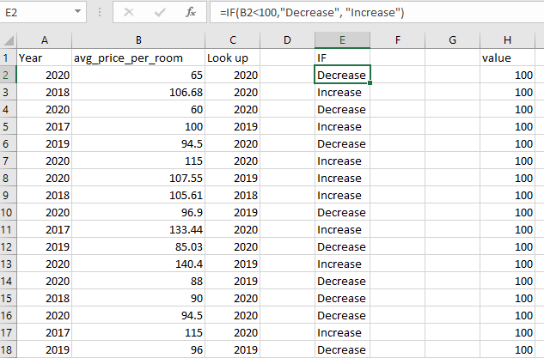
Figure 1: Steps reflecting IF function
(Source: Self-Created)

Key uses of IF statement
An IF statement in Excel is a "logical function" that, according to the analysis, refers to evaluating an expression and defined condition and returns one value if the condition is true and another value at the same time if the condition is false.
Conditional formatting
The "IF statement" in the procedure can be used to format cells based on a certain circumstance. For instance, format cells so that they turn red if the value is "less than 0" or green if it is "greater than 100". The returns are processed by IF functions and a comparison with the relevant alphabetical value is given.
Calculations
the use of a "IF statement" to do computations based on a certain circumstance. As an illustration, use the "IF statement to check if the sales are larger than a specific number" while calculating a bonus based on an employee's sales. As a result, applying the formula in various places may frequently refer to contacting numerical values due to variations in the conditions at various formula-containing cell sites. As opined by AlkAthIry (2021, p.17), Consequently, it is wise to create tables in which all of the cells' numerical values are controlled using values.
Data validation
The IF statement can be used to verify data entered into a cell based on a certain circumstance. By utilising the IF statement to determine whether the value is less than zero, you can, for instance, prevent the entry of negative numbers into a cell.
Nested IF statements
In the section titled "IF statements to test several conditions in a single formula," the application utilises. As a result, grades are assigned using nested IF statements based on a student's or employee's score, where a score of 90 or more is an A, an 80 or higher is a B, and so on.
Through observation of the provided data, it has been determined that utilising the IF statement in calculations allows for the representation of average product prices. Additionally, this calculation evaluates a section of increasing prices with over 100 numbers to determine the corresponding rate of price increase. Similarly, in the event of price levels lower than 100, the calculation represents the lower level of price rates.
Furthermore, it has been recognized that the prices level column represents values lower than 100, leading to the conclusion of decreasing prices. These changes can affect recognized values and impact various assumed values that may not have been considered in changes made during the accounting period.
Consequently, changes in the level of prices have a direct effect on the rate of price changes occurring in the same period. Therefore, changes in the level of prices have been discussed as changes in increasing and decreasing levels of prices at different stages.

LOOKUP Function
Excel's LOOKUP function is a powerful tool that allows users to search for and retrieve corresponding values from different ranges of cells. There are two versions of this function: VLOOKUP and HLOOKUP. VLOOKUP is used to find a value in the first column of a range and return a value from the same row in a specified column. As opined by Pereaet al. (2021, p.13), HLOOKUP, on the other hand, is used to find a value in the first row of a range and return a value from the same column in a specified row. It is important to note, however, that selecting appropriate and well-structured data is crucial to avoid negative impacts on the system's assumptions and overall performance.
Therefore, it is necessary to comprehensively evaluate the accuracy of LOOKUP and the efficiency of LOOKUP algorithms, including the analysis of variations in input parameters and the quantification of affecting calculations. Hence, this process will effectively helpful in making decision to Hotel reservations process. These algorithms refer to data structures that provide constraints to achieve optimal performance using logarithms. According to Awawdehet al. (2022, p.16), observing security procedures based on stored data and keys is an efficient and effective way to calculate security checks.
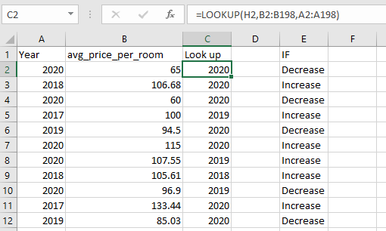
Figure 2: Steps reflecting LOOKUP function
(Source: Self-Created)
After analysing the provided data sets, it has been determined that the entire data is suitable for using the HLOOKUP and VLOOKUP functions of Excel, which operate on horizontal and vertical data sets, respectively. As a result, all calculations have been carried out by resolving the equation from left to right, right to left, upward to downward, and vice versa. As stated by Fachrian and Hidayat, (2023, p.41), this process simplifies the identification and resolution of processes, allowing for easy categorization of identical processes.
Therefore, Hotel reservations process will be taken place at a highly effective requirement to the selection of the meals, and room types. Furthermore, this approach facilitates making various replacements at different sections of the functions, making the calculation process easier and more flexible depending on various factors. Therefore, by using appropriate formulas in a systematic manner, it becomes easier to understand and calculate the exact value required for the given problem.

Part 2

1. Number of male and female students

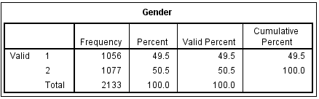
Figure 1: Number of Females, and Males
(Source: Self-Created)
The figure above, labelled as 1, illustrates the number of males and females in a given population. Females are represented by the value of 1, while males are represented by the value of 2. The analysis reveals that there are 1056 female members out of a total of 2133, which represents a frequency of occurrence. Therefore, the remaining members, 1077 in total, are males. In terms of percentile contribution, the values of female and male members are 49.5 and 50.5, respectively.
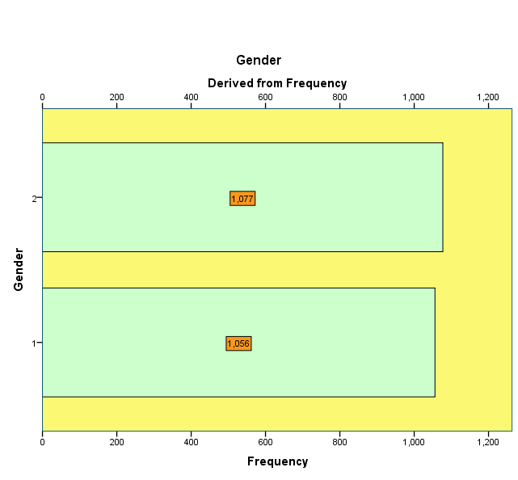
Figure 2: Graphical visualisation of the number of “females, and Males”
(Source: Self-Created)
Based on data visualisation it has been obtained that male students are higher as compared with female candidates. The above graphs also clearly indicate the difference between both genders.

2. The number of students qualified and non-qualify for reduced/free lunch
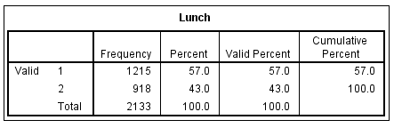
Figure 3: Number of students “qualified or Not Qualified” for reduced/free lunch
(Source: Self-Created)
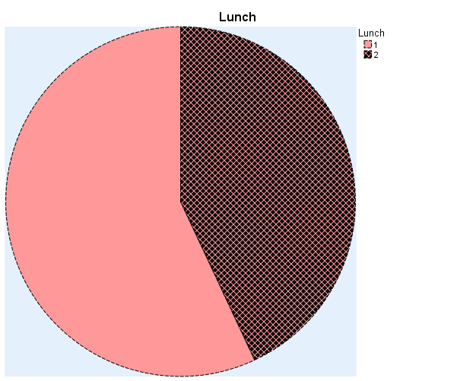

Figure 4: Graphical Representation of the Number of students “qualified or Not Qualified” for reduced/free lunch
(Source: Self-Created)
Based on the observation of the graphical figure 4, the number of students who qualify for reduced or free lunches is represented by the value of 1, while the number of students who do not qualify for reduced or free lunches is represented by the value of 2. Figure 4 shows that out of a total of 2133 students, 918 students (represented by value 1) qualify for reduced or free lunches. Therefore, the remaining students, 1215 in total, do not qualify for reduced or free lunches. This represents 57% of the qualified section of students and 43% of the section of students who do not qualify, as shown in the presented data sets in figures 3 and 4.

3. Mean, and Median of students qualified and do not qualify for free/reduced lunch
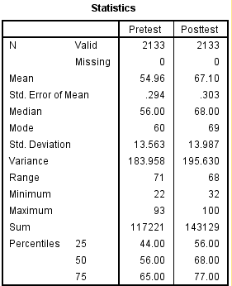
Figure 5: Mean and Median of students qualified, and do not qualify for reduced/free lunch
(Source: self-Created)
Figure 5 represents the evaluation of the provided data set, which is observed to be 1.43. This value is obtained by dividing the total number of data points, which is 3051, by the total number of students in the data set, which is 2133. Additionally, the median is evaluated as the middle value within the data set, which in this case is 1. Therefore, it can be said that the mean value can be misleading in cases of skewed data sets or outliers.

4. Median and Mean of students' post-test, and pre-test scores
Statistics
 |  | Pre-test | Post-test
N | Valid | 2133 | 2133
N | Missing | 0 | 0
Mean |  | 54.96 | 67.10
Std. Error of Mean |  | .294 | .303
Median |  | 56.00 | 68.00
Mode |  | 60 | 69
Std. Deviation |  | 13.563 | 13.987
Variance |  | 183.958 | 195.630
Range |  | 71 | 68
Minimum |  | 22 | 32
Maximum |  | 93 | 100
Sum |  | 117221 | 143129
Percentiles | 25 | 44.00 | 56.00
Percentiles | 50 | 56.00 | 68.00
Percentiles | 75 | 65.00 | 77.00
Table 1: Median, and Mean of pre-test, and post-test Scores
(Source: Self-created)
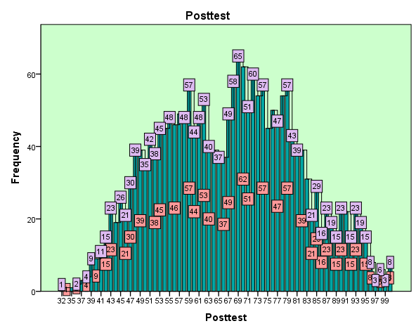
Figure 6: Graphical Visualisation of Pre-test Scores
(Source: Self-created)
The above figure, 5, represents the frequency distribution of students' scores on the pre-test. The X-axis shows the scores on the pre-test, and the Y-axis represents the frequency of those scores. It is observed that the numbers of post-test occurred at 35, and 100 for the cluster 1, and 2 respectively. In other words, the figure illustrates how many students scored within a certain range of scores on the pre-test.
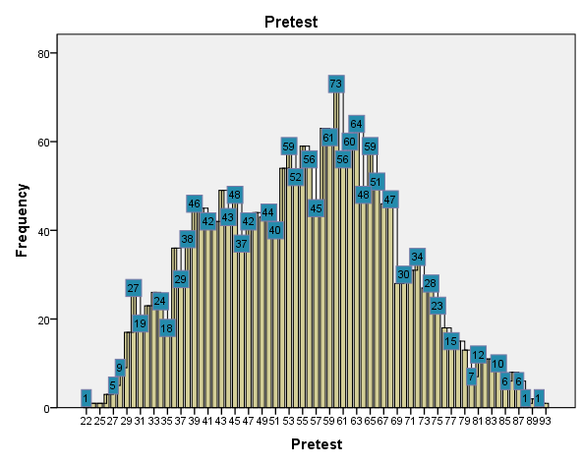Figure 7: Graphical Visualisation of Post-test Scores
(Source: Self-created)
The provided figure, 6, is a representation of the post-test scores equation based on the provided data sets. The visualisation of the Axis-X in the figure denotes the post-test scores of the students, whereas the visualisation of the Axis-Y represents the frequency level. The figure displays the distribution of the post-test scores among the students in the dataset. The range of the post-test scores is plotted on the horizontal X-axis, whereas the frequency distribution of the post-test scores is represented on the vertical Y-axis.
The distribution of the scores can be evaluated to make conclusions about the performance of the students in the post-test. As suggested by Kaewnaknaewet al. (2022, p.15), the post-test scores' distribution can help educators identify students' strengths and weaknesses, which can be useful in designing individualised learning plans to help each student improve in the areas they need assistance in.
In the section to the pre-test, it is occurred at 23, and 93 for the cluster 1, and 2. The visual representation of the post-test scores equation provided in Figure 6 makes it easy for educators to understand the distribution of the scores and make informed decisions about how to improve student learning

5. K-Means Clustering
Initial Cluster Centres
 | Cluster
 | 1 | 2
Pre-test | 23 | 93
Post-test | 35 | 100
Table 2: Pre-test and Post-test Scores Of “Initial Cluster Centre”
(Source: Self-created)

Iteration History
Iteration | Change in Cluster Centres
Iteration | 1 | 2
1 | 30.191 | 33.606
2 | .885 | .791
3 | .611 | .532
4 | .212 | .181
5 | .227 | .200
6 | .150 | .128
7 | .000 | .000
a. Convergence achieved due to no or small change in cluster centres. The maximum absolute coordinate change for any centre is .000. The current iteration is 7. The minimum distance between initial centres is 95.525.
Table 3: Iteration History of “Pre-test and Post-test Scores”
(Source: Self-created)
Table 3 provides a comprehensive overview of the pre-test and post-test scores of students across different cluster centres. It presents a detailed history of the changes in the scores of students in different sections over time. The table includes data for different sections, indicating their corresponding cluster centres. It highlights the pre-test and post-test scores for each section, making it easy to compare and analyse the scores for the respective sections.
As discussed by Rastegar and Hakaki (2020, p.17), the table presents this data in a structured and organised manner, facilitating ease of interpretation and analysis. And, it is also representing tat cluster centre values for representing in Cluster 1, and 2 at the different section. Hence, it is recasting at a pretest value of 43 for the cluster 1, and for cluster 2 at 64. At the same time in the post-test section clusters 1, and 2 occurred at 55, and 78 respectively.

Final Cluster Centers
 | Cluster
 | 1 | 2
Pre-test | 43 | 65
Post-test | 55 | 78
Table 4: Final cluster centres of “Pre-test and Post-test Scores”
(Source: Self-created)

Number of Cases in each Cluster
Cluster | 1 | 993.000
Cluster | 2 | 1140.000
Valid |  | 2133.000
Missing |  | .000
Table 5: Number of cases in each “clusters Pre-test and Post-test Scores”
(Source: Self-created)
Based on the provided data sets, it can be observed that there are changes in the cluster pre-test and post-test scores for different cases. Cluster 1 has a total of 993 valid observations, while cluster 2 has 1140 valid observations. These resulting values are based on the aggregate scores from a total of 2133 cases. Table 4 displays the final cluster centre values resulting in clusters 1 and 2 at different sections. The pre-test value for cluster 1 is 43, while that for cluster 2 is 64. In the post-test section, cluster 1 occurred at 55, and cluster 2 occurred at 78.

6. Data mining and text mining methods
Data mining is a sorting method consisting of large datasets to identify the patterns as well as the relationships to solve business problems through analysing the data. However, it is a mining technique and tool to enable the enterprise's future predictions and trends to make more informed decisions (Antons et al. 2020, p. 33). However, the data has been also transformed into the unstructured text to identify meaningful patterns by depicting the text mining methods.

Real life examples of Data Mining and Text Mining
Text Mining examples
- Risk Management: Irrespective of the nature and size of industry, insufficient analysis of risk leads to failure of business. Especially in the finance and Insurance industry, one can witness the adoption of risk management software which are based on “text mining technology “which enhances the potential of mitigating risk. The text mining software held significance position in recent days business organization so that they can easily access the available resources related to text documents, which ensures aligning right information at the right time.
- Prevention of Cybercrime: The increasing use of internet and digital technology with innovative communicating features resulted in an enhanced risk of cybersecurity. Internet based crimes have been significantly increased after its wide scope of applicability (Loureiro et al. 2019, p.514). However, text mining ensures prevention of cybercrime easier and more efficient. It enables the user to pinpoint real cyber threats and restricts the occurrence of false positives.
- Data clustering methods
Based on clustering methods it is mainly used to identify the recognition of various market segments while processing the employee for learning and extracting the knowledge techniques. It is a systematic process that is learned by anyone while automating the data. For example, a retail company may collect the following information on households: Household income, Household size, Head of household Occupation, Distance from nearest urban area.
- Cluster 1: Small family, high spenders
- Cluster 2: Larger family, high spenders
- Cluster 3: Small family, low spenders
- Cluster 4: Large family, low spenders

Social Media Analysis: Social media have been adopted by many businesses. More and more companies are using social media tools such as Facebook and Twitter to provide various services and interact with customers. The use of text mining is to analyse unstructured text content on the Facebook and Twitter sites of the three largest pizza chains in an effort to assist businesses in understanding how to perform a social media competitive analysis and transform social media data into knowledge for decision makers and e-marketers: Pizza Hut, Domino's Pizza and Papa John's Pizza. The outcomes uncover the worth of social media competitive analysis and the power of text mining as an effective technique to extract business value from the vast amount of available social media data.

Extraction of information: It is an essential technique that has been used to identify the specific pieces of information to track the locations, profiles and dates of the texts and data (Hassani et al. 2020, p. 2). This is because of detecting fraud and errors. Retailers such as Office Depot may able to collect customer information through mobile apps, websites, and in-store transactions. But without a way to migrate and merge all of that data, it’s potential may be limited. Here again, data extraction is the key.
Data Mining examples
- Association: It is also known as relation analysis since it is used to discover correlations between two or more things by locating hidden patterns in the data collection. To forecast client behaviour, market basket analysis uses this technique.
Consider a supermarket marketing manager who wants to know which products are usually bought in together. A classic example of association rule mining refers to a relationship between diapers and beers. The example, which seems to be fictional, claims that men who go to a store to buy diapers are also likely to buy beer.
- Data Classification: The objects in the data sets are divided into classes or groups using this data mining technique. It aids in precisely predicting how members of the group will behave. For instance, a banking company uses to categorise loan applicants at low, medium or high credit risks. Similarly, a medical researcher studies cancer data to predict which medicine to prescribe to the patient.
- Marketing: Data mining can be explored with an increasing rate of large databases to improve market segmentation. This analysis of the relationship depends on various parameters which potency depends on customer age, gender, and tastes. It is possible for the integration of various behavioral changes to intrigue an order to direct a “Personalized Loyalty Campaign”. Data mining is a market prediction that is likely to unsubscribe from a service that does not base on the search or milling of the higher achievement of a higher rate of responses.
- Decision Trees: A decision tree is a tree structure (as its name suggests). The tree government divides citizens into those under the age of 18 and those over the age of 18. They could use this information to determine whether or not a license must be issued to a specific city.
- Banking: It mainly depends on data mining to better understand the risk of the market. It is commonly implemented to credit rating that potbelly depending on the “intelligent Anti-Fraud System”. It is used to analyze “card transactions”, “purchasing patterns’ and “customer financial data”.
Data mining helps the time bank to implement the online preference and habits to optimize the return factor to regulate the market campaign and the overall study of the performance for sales analysis of sales to manage the compliance of the regulatory body (Martínez-Plumed et al. 2019, p.3048). It helps to diagnose the performance of banking transactions that mainly depends on various market risk factors pertaining to the bank. Some of the other examples of data mining are retail, medicine, television, radio etc.

7. Merits and Demerits of SPSS and Excel
Merits of SPSS
- It is a specific design that helps the business to demonstrate the various tests with tools.
- The software SPSS consists of advanced features as compared to excel that make an easy to interfere with technical skills.
- It offers dynamic and useful tools with a wide variety of languages and access to the business.
- The software does not depict a lot of contribution and effort while using the software.
Disadvantages
- The software may be expensive and easy for the users of small businesses and firms.
- The service users need to learn the advanced features of the SPSS.
- It consists of effective complexities and statistical processes while serving the users.
- The software as SPSS consists of specific tools to determine the customised coding systems.

Merits of Excel
- Tools such as Excel consist of a wide variety of packages and features that facilitate easy use by the business staff as well as any individual.
- The tools facilitate easy access to data that is simple to use by anyone without consuming a lot of time (Saura and Bennett, 2019, p. 51).
- Systematic tools such as excel are huge customization and a range of numerical values to do each task daily. Moreover, this is because of several features: graphs, data and analysing capabilities.
Demerits of excel
- It seems to be difficult sometimes to use the excel functions by the users by using Microsoft excel while compelling the reports and transactions.
- Excel has a huge issue as it cannot manage more than a thousand rows and columns.
- Moreover, it seems to be difficult to learn the functions and conditions of excel while comparing it with any other tools.

Reference
Journals

- Zou, D., Lloyd, J.E. and Baumbusch, J.L., 2020. Using SPSS to analyze complex survey data: a primer. Journal of Modern Applied Statistical Methods, 18(1), p.16. (Accessed: March 29, 2023).
- AlkAthIry, A.A., 2021. Effect of Migraine on Functional Performance and Self Reported Symptoms in Children with Concussion: A Cross-sectional Study. Journal of Clinical & Diagnostic Research, 15(5). (Accessed: March 29, 2023).
- Perea-Lowery, L., Gibreel, M., Vallittu, P.K. and Lassila, L., 2020. Characterization of the mechanical properties of CAD/CAM polymers for interim fixed restorations. Dental materials journal, 39(2), pp.319-325. (Accessed: March 29, 2023).
- Fachrian, Z. and Hidayat, W.W., 2023. The Influence of Liquidity Ratio as Current (CR),(DER) Rasio Leverage and Asset Structure to Return on Investment of Coal Companies. International Journal of Accounting and Management Information Systems, 1(1). (Accessed: April 2, 2023).
- Kaewnaknaew, C., Siripipatthanakul, S., Phayaphrom, B. and Limna, P., 2022. Modelling of talent management on construction companies’ performance: A model of business analytics in Bangkok. International Journal of Behavioral Analytics, 2(1). (Accessed: April 9, 2023).
- Rastegar, A.A. and Hakaki, A., 2020. The Impact of Knowledge Management Infrastructure Capabilities on Business Intelligence with Mediatory role of Open Innovation in Manufacturing SMEs. Modern Research in Decision Making, 5(1), pp.119-139. (Accessed: April 13.2023).
- Awawdeh, H., Abulaila, H., Alshanty, A. and Alzoubi, A., 2022. Digital entrepreneurship and its impact on digital supply chains: The mediating role of business intelligence applications. International Journal of Data and Network Science, 6(1), pp.233-242. (Accessed: April 13, 2023).
- Antons, D., Grünwald, E., Cichy, P. and Salge, T.O., 2020. The application of text mining methods in innovation research: current state, evolution patterns, and development priorities. R&D Management, 50(3), pp.329-351. (Accessed: March 26, 2023).
- Hassani, H., Beneki, C., Unger, S., Mazinani, M.T. and Yeganegi, M.R., 2020. Text mining in big data analytics. Big Data and Cognitive Computing, 4(1), p.1. (Accessed: April 17, 2023).
- Saura, J.R. and Bennett, D.R., 2019. A three-stage method for data text mining: Using UGC in business intelligence analysis. Symmetry, 11(4), p.519. (Accessed: April 17, 2023).
- Zhan, Y., 2022, December. Research on the Development Path of Online Internship Normalization Based on SPSS Analysis. In 2022 3rd International Conference on Big Data and Informatization Education (ICBDIE 2022) (pp. 926-935). Atlantis Press. (Accessed: April 19, 2023).
- Martínez-Plumed, F., Contreras-Ochando, L., Ferri, C., Hernández-Orallo, J., Kull, M., Lachiche, N., Ramirez-Quintana, M.J. and Flach, P., 2019. CRISP-DM twenty years later: From data mining processes to data science trajectories. IEEE Transactions on Knowledge and Data Engineering, 33(8), pp.3048-3061. (Accessed: April 20, 2023).
- Loureiro, S.M.C., Guerreiro, J., Eloy, S., Langaro, D. and Panchapakesan, P., 2019. Understanding the use of Virtual Reality in Marketing: A text mining-based review. Journal of Business Research, 100, pp.514-530. (Accessed: April 20, 2023).

International Journal of Information Management Volume 33, Issue 3, June 2013, Pages 464-472. (Accessed: April 20, 2023)

Online site

https://www.educba.com/data-mining-methods/ . (Accessed: April 20, 2023)

https://www.upgrad.com/blog/what-is-text-mining-techniques-and-applications/ . (Accessed: April 20, 2023)

https://www.sciencedirect.com/science/article/abs/pii/S0268401213000030 (Accessed: April 21, 2023)

