The policy of inclusion in schools is seen in countries all around the world, this development encourages teachers to search for pedagogy and practices that will strengthen their professionalism in addressing inclusivity in their classroom.
In recent years, the inclusion of social, technical and cultural change has increased challenges to education within the world. International migration has increased inclusive education and the awareness of diversity within student groups and the hopes and expectation for families and communities. (Guðjónsdóttir & Karlsdóttir, 2009).
A major challenge for teachers in recent decades is the continuous search for pedagogy and the approaches that need to be taken to meet the diversity in inclusive schools. Inclusion is seen as every pupil having equitable access to education and that the school organzas learning spaces to accommodate all pupils in a universal design. School systems and teachers need to take into consideration how they can respond to the growing challenges of inclusion. (Guðjónsdóttir & Karlsdóttir, 2009).
Technology enhances learning is a skill that children need in this day and age, curriculum has been redesigned in order to include technology, teachers are adapting their teaching styles in order to incorporate technology and increasing the use in their classrooms. Inspection bodies look for the use of technology in school while they visit the schools. (Visvizi, A. Daniela, L. 2019)
The following reflective will critically analyse two contemporary issues in education, namely, inclusion, pedagogy and technology enhanced learning and will make reference to relevant literature and placement practice.
As part of my placement, I spent ten days in a primary school supporting children in year 3. The class consisted of pupils with varied abilities and health conditions, this included children with Diabetes, Autism, ADHD and general behavioural difficulties. As such, the placement enabled me to become better aware of these conditions and the ways in which it affects a child.
An average day at my placement involved: signing in, helping to set the classroom up for the day, greeting the children at the door, registration, supporting them with their learning activities during lessons and helping pupils get ready to go home. Having experienced the general day to day life in a year three class, I was able to observe that the teaching methods employed, differed depending on the age group and the age of teachers. I noticed that the more experienced the teacher was, the less they strayed from the curriculum.
When reflecting on the inclusion strategies adopted by the school, I noticed that the school had different ways of including children with health and additional learning needs and that whilst the school had policies in place to support children with additional learning needs and health conditions, each teacher had their own ways of implementing the policy. For example, in nursery, the teachers would ensure that all children had the same opportunities as everyone else. I observed children receiving time alone in the sensory room, while others were given the opportunity to play outside. Seeing the different interpretation of inclusion, has shown me that inclusion is treated differently by different people. The ten days gave me a different perspective to what I believed inclusion should be.
Other forms of inclusion consisted of the newly constructed ramp leading into the main building. The school made it accessible for children and parents who are unable to use the steps. This has made the school a safer environment for children who need to access the buildings. The school is now completely accessible with each building having a ramp to enter, there are also alternative ways in and out of the buildings in case of an emergency. This has demonstrated the school’s intent towards access and inclusion.
I spent the ten days in a year three class where there were numerous children with health and additional learning needs. A number of the children in the class had IEP’s, which were in place to support the child on an individual basis. The IEP is to personify the needs of the child. An individualised learning plan is then put in place to support the child in the best possible way, the IEP is in place to help the child, however, it also helps the teacher and support staff when creating the days teaching plan. Communication is improved, teamwork is developed, and parents are supported through the entire process. (Karata, Suminar, et al. 2018)
During my placement I witnessed the way an IEP is implemented for a child. Attending meetings regarding the child and their progress. I was able to read over lesson plans and see how the class teacher has catered for all the individual needs for all children in her class, I was also able to observe the way that those lesson plans do not always go as planned. For example, during the ten days I seen a child with ADHD behave in a disruptive manner, this evidently led to the class being disrupted. This child’s IEP has changed numerous times due to the change in his needs, however, he eventually got support from an outside agency where he was able to leave the classroom and receive support in his learning, this helped to settle him, making his feel better, which helped to prevent him from disrupting the class. I could see the difference in the child after on session, he was more relaxed and willing to learn.
There were also two children with type one diabetes, these children had IEP’s to accommodate their medical issues. I was also able to sit in on a meeting with the school and diabetic nurse who comes into the school to train the teachers on the correct way to treat the children, how to test their blood glucose levels and how to keep them included in the class sessions. This taught me all about type one diabetes and the relevance in education about the disease. Their IEP’s took into account the possibility of their blood glucose levels dropping and them needing to leave the room to treat or to have food and sugary drinks at the table with them, it also involved the possibility of their glucose levels going high and them having to have water with them and leave to go to the toilet on a regular basis. Both children wore sensors on their arms to read the glucose levels every five minutes, The children’s sensors helped to limit finger pokes and help treat them in a more precise manner, their IEP’s had the information about the sensors and how they needed some form of technology with them constantly throughout the day. For the majority of the day, myself, the class teacher and their support worker would keep the readers for their sensors with us so that we could monitor them and try to prevent low or high blood glucose.
Throughout my ten days at the school I was able to see the difference in the way that they were treated by other children. Often the other children would get jealous about child A and B having a sugary drink, some sweets or some biscuits, this caused child A and B to become very agitated in needing to be treated differently to the others, they also got upset by the stares and comments from the other children. The school does, however, have policies in place to support children with health issues and addition learning needs, the children were able to adapt to their surroundings somewhat easily, the policy was in place to support the children and their families. The policy was there to ensure that the children were protected under the Education Act (2002) in section 175-176, the school has a duty to consult the children involved and safeguard them both physically and mentally. (The National Archives, 2006)
Due to this, any meeting held about the child, their parents were invited to attend on the child’s behalf, this was so that the child was not pulled away from their lessons during the school day, however, if the meeting involves the diabetic nurse, the children with type one diabetes had to attend that meeting along with their parents so that they knew what changes were going to be made to help treat them going forward.
The school that I attended was a fully inclusive school, they supported children with a range of additional learning needs and health conditions, however, they were often unable to manage the behaviour of some children, during the ten days that I spent at the school, I witnessed a child who had severe behavioural issues disrupt class after class, they allowed him to use the small sensory room that the school has, however, that would not help him, he needed physical comfort from someone he trusts to calm down, the child’s parents were called in and told the school could not provide for him and they needed to find a school who could provide the support that he needs. This was something that I could not fathom doing, while the child was disruptive, he was also caring and happy, he would go around the classes to give the teachers hugs and say hello to all the children. Seeing the child leave was upsetting, he wanted an education the same as everyone else. For me, this experience has shown me how far inclusion has to go in providing for children such as this child.
Another situation was with a child who had Autism, he had a 1:1 support worker who was with him continuously throughout the day, they went to lunch together, they spent the lessons separate from the class, doing the lessons in a quiet room, giving the child the chance to work in an environment that he was comfortable in, giving him the security that he needs, however, he would often become so overwhelmed with the noise that he would act out, throwing stationary, pushing children, and even running out of the building, thankfully the school gates get locked and you cannot open them without a key or a code, this prevented the child from leaving the school grounds and walking onto a busy road. The child’s mother later decided that his needs were not being met by the school and that he needed to receive extra support to get the best possible education, the child was then transferred to a different school where he was able to receive specialist support.
The Welsh Government has policies in place to support children with additional learning needs. One policy is a policy specifically designed for inclusion; the policy is set out in sections. 1.1 is the principles of inclusive education, setting out the basic construct of what inclusion is and ensuring that all children are given the same opportunities, the effectiveness of inclusion, laying out strategies. Next 1.2 sets out the overview of the policy and what is going to be mentioned throughout the document. Furthermore, the policy has a number of sections that all link together with other policies and legal documents such as the UNCRC. It sets out different strategies on inclusion and how to help children within schools. The policy itself is not just based around children with additional learning needs but for children who need extra support, children from different ethical backgrounds, children living in poverty, there are a range of scenarios that may present themselves within a school setting that the policy covers, showing schools what should be put into place to support the children. (Welsh Government, 2016)
The Policy was covered in my placement briefly, the school themselves put different groups and support into place for children who need support. I was able to see children in groups to help with their confidence and support them with their maths or English, the groups were tailored to each child’s needs. While at the school a child whose first language was not English joined, the school set a private session up in order to help her with her English, they ensured that she felt comfortable and was happy to participate.
This showed me that the school is trying their best to include all children, I felt like I was able to understand inclusion more and be part of the child’s overall inclusion in the school.
Seeing the children get treated with respect and given the best possible chance at education made me feel excited to experience the day with them, I got to learn all about the different conditions and additional learning needs.
Pedagogy is when a person gains new or existing forms of knowledge from another. (Westbrook, Durrani, et al. 2013). Bernstein (2000) is a theorist whose theory is based on pedagogy. He described it as “ordering and disordering principles of the pedagogising of knowledge as the pedagogic device”. (Singh, P. 2002).
His theory constructed of three fields. Each field is related, they are all forms of knowledge that are linked, one simply cannot work without the other. The first is production of knowledge, this field he believed, covered two worlds, the materiel or mundane world, this term is common, and the immaterial or transcendental world, this is the sacred term, they are horizontal and vertical discourses that Bernstein (2000) theorised to describe the different forms of knowledge that link the worlds. The mundane knowledge refers to the encounters of the world while the immaterial knowledge refers to scientific research. Recent years has had a growth in knowledge, this has given educators a disadvantage, they often do not have time to sort through and dissect the knowledge and pass it on to students, there is a limited amount of information available to students. Public schooling access means a lack of knowledge, Bernstein (2000) believed that the rise in private tutoring and other forms of education, for example private schools, is due to the demands of educators maintain knowledge. (Singh, P. 2002).
Recontextualization of knowledge, this is the primary and secondary forms of knowledge. There are two sub-fields in this field, the official field and the pedagogic field. The official field includes agencies and education boards, along with inspection agencies, the pedagogic field includes universities, journals, and other forms of knowledge-based institutions. (Singh, P. 2002).
Finally, there is the reproduction of knowledge, this includes reproducing the knowledge in the form of curriculum, text books and other educational texts. Teachers share their knowledge in the classrooms while interacting with the children. This field is based around the teachers and peer tutors, also known as. Students with a temporary role that is equivalent of a teacher. (Singh, P. 2002).
In addition to the different fields, there are two main models, the performance model which is described as the teacher spelling out what and how the student learns and the competence model which he describes as an invisible pedagogy, it is a more informal way of teaching. (Westbrook, Durrani, et al. 2013)
My placement involved working in a class with children of all abilities, the teaching and knowledge passed down had to be centred on the children’s needs. Teaching at the school differs depending on the class, for example a class of year one and two was taught at a year one level, they are however given tasks at a higher level but they are all taught at the same level, this is so that the younger children understand everything being taught to them, however, it does not help the children in year two to progress to a higher level of work as they are being taught at a younger level, some of the children were given more tutorship in order to support their education, they had different phonics groups where they were placed in a more advanced class in order to give them the necessary knowledge that they require. Seeing the children who moved into year three this year and moving from a year two/three class, they were working at a lower level to the rest of the class, understanding less of the work and needing extra help. I was asked to sit with this group throughout the day to give them the extra support that they required, allowing them to work at a slower pace that the rest of the class, showing them skills that will help them.
Moreover, I was able to see the difference in teacher’s creative ability, seeing the way that the teachers taught the children differently throughout the different year groups. Children all have different learning styles, the class teacher that I worked with took these styles into account when planning the lessons, taking all their senses into consideration, I seen children learn best through seeing, showing them how to do it rather than simply telling them how to do it, while others were able to understand just from an explanation, for subjects such as maths we often used some blocks to show the children different techniques to calculate. This showed me the teacher’s determination to include all children. Key Stage 2 is different to key stage 1, the teachers need to tailor their lesson plans to accommodate this difference, however, they also need to give children some stimulus throughout the day, I was able to see the way that children were taught through different educational techniques, technology now plays a fundamental role in children’s education. This is just one way that teaching has changed throughout the years, technology is being incorporated more and more in modern day education. It has been seen that incorporating technology into education can make it more appealing to young children, they become more focused and enjoy learning more. Knowledge becomes easier to grasp and children find it more convenient to learn. (Raja, R. Nagasubramani, P.C. 2018)
Throughout my time at the school I seen many forms of technology be incorporated into education, the children were given opportunities to use computers for their work, they were often shown images relating to their topic on the interactive white board and often they played class game relating to their topic on the board. During the sessions that involved technology the children were more engaged in the session. The children found technology to be an inviting part of education, they get more out of the overall experience. The teachers in the school have their own pedagogic approaches, they have their own ways of teaching. I was able to see this during my time at the school, no teacher taught the same, each had their own individualised way of teaching and inclusion. They themselves learn from the children as much as the children learn from them. The school curriculum leaves little room for individually creative teachers, they are not able to manifest all of their pedagogical views in the classroom. By giving children access to technology they feel they have more say in their education, the students get to learn more about the different forms of technology. Pedagogy and technology worked together at my placement, the teacher’s in the school would often link the two, their own pedagogical views push through the curriculum to engage the pupils and help them enjoy the lessons. Alexander (2001/2005) claims that pedagogy is not simply the act of teaching, it involves intervention in a persons individual development. It’s teaching together with different ideas and histories, and being able to explain the act. He had a goal to find out how policies and structures such as curriculum play a role in pedagogy. He was admittedly very critical towards educational policies that failed to connect all recommendations in the settings, he provided a detailed account of the issues of increasing standards, tight political control becoming more and more frustrating, less and less is there being an emphasis on pedagogical development. He claimed that pedagogy is not restrained to the classroom, it is connected to all school boards and everyone must work together, teachers and students need to work with one another in order to reflect pedagogical views off each other. There has been so many times that education has been differentiated towards students from ethical backgrounds, this is often referred to as the hidden curriculum, this however puts the thought into teacher’s heads that some children are simply more able than others. Pedagogy still has some unknown aspects that are being explored even now. (Zyngier, D. 2016)

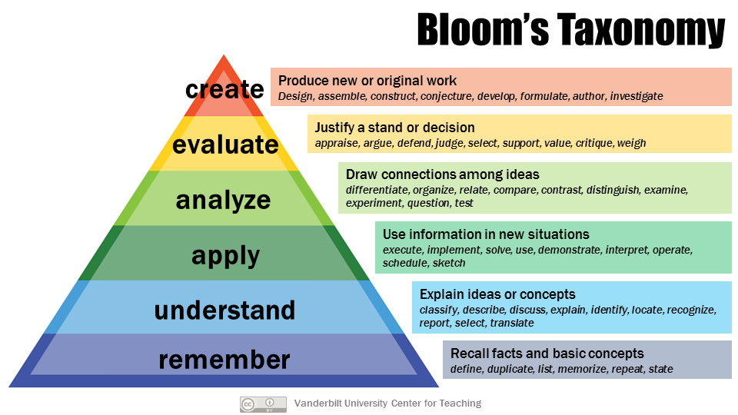
(Vanderbilt University, 2020)
Bloom’s Taxonomy is a perfect construct of pedagogy. The six categories contain sub-categories that explain how pedagogy works. Remember; this is the knowledge you already know, recalling the information. Understand; being able to comprehend and summarize the knowledge that you already know. Apply; implementing the knowledge. Analyse; connect and differentiate to other knowledge. Evaluate; criticising the information. Create; producing your own hypothesis or work. (Armstrong, P, 2020)
This is a great diagram to follow in an educational setting, being able to follow the diagram in order to support children in the setting, being able to build your own pedagogical views throughout, with my placement, they often tried to put their own pedagogical views in their teaching methods. The diagram shows how that is done and how to do it successfully.

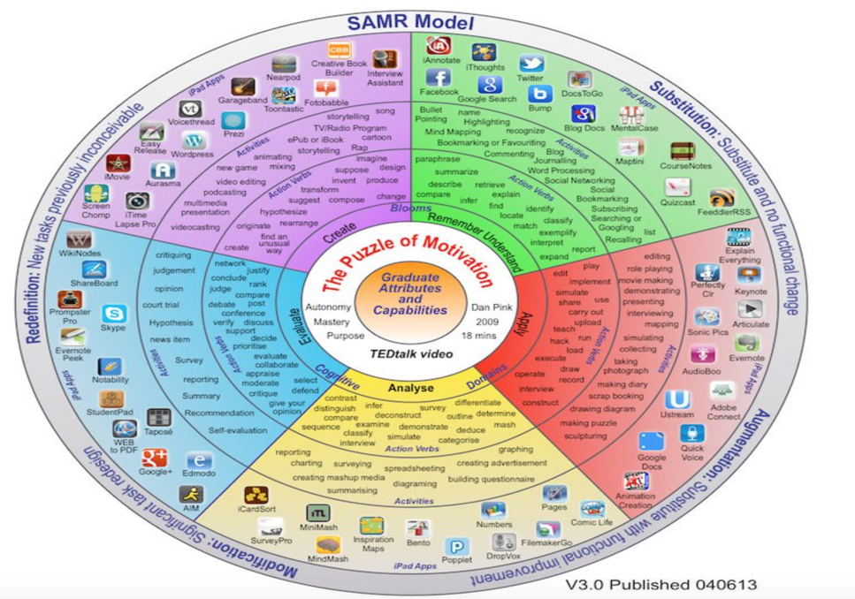
(Techthought, 2018)

Similar to Bloom’s Taxonomy, the Pedagogy wheel is up to date with the technology, taking the concept of Bloom’s Taxonomy and combining it with technology in order for teachers to be able to link technology in their pedagogical teaching strategies. (Techthought, 2018)
These are apps that are often used in an educational setting, my setting used some of the creative apps on the iPad for children, they would give the children some free time in order to have the opportunity to develop their creative skills.
Seeing the way that the teachers incorporated an individual aspect into their ways of teaching showed me that no matter how you look at education and the limits is has, there is always a way to add an interesting and fun aspect that can be added.
Previously, inclusion was something that I looked at in the background, I did not think it was something that I needed to look at as an important part of education due to not having the need myself. My recent experience has shown me that inclusion is one of the most important aspects of education, giving all children the opportunity to learn and have the same experience. My placement experience was able to show me that all children no matter their ability or needs, deserve to access the same education as everyone else.
Until recently I did not know about pedagogy, my experience and research has shown me the amount of work that goes into teaching. The work that goes into adding technology into the curriculum and into the daily sessions is something that I never considered before, seeing it in person has changed my view on technology enhanced learning and the benefits that it has.
To conclude this journal, I have found that my experience has given me a better understanding on inclusion, pedagogy and technology in education. The ten days that I spent at the school give me the opportunity to learn about different theorists and different ways of teaching. Seeing the teacher’s individual ways of implementing policies and strategies was something that I will never forget, seeing how a policy can be interpreted differently by different people give me the motivation to continue on my path to teaching, I will be able to look back on my experience to see how I may be able to support children in similar circumstances as the children that I worked with.
If I was to do the placement again, I would make sure to research more into the different conditions and additional learning needs, I would ensure that I follow instructions even better so that I can get the overall experience to be even better. I enjoyed my time at the school because I was able to experience things that I have never experienced before, I got to meet children that come from all different backgrounds, children with different abilities. The experience taught me to not take things at face value and look into them more, it taught me how to approach different abilities and how to help the children with the work when they need it. Overall the experience is something that I would like to do again, maybe in a different school so that I can learn even more.

References:
Armstrong, P (2020) ‘Bloom’s Taxonomy’ Vanderbilt University, Available at: https://cft.vanderbilt.edu/guides-sub-pageslooms-taxonomy/ (Accessed: 20/01/20)
Gudjonsdottir, H & Óskarsdóttir, E, (2016), Inclusive education, pedagogy and practice, Available at: https://www.researchgate.net/publication/318775330_Inclusive_education_pedagogy_and_practice (Accessed: 6/01/20)

Hinchliffe, G, (2009), ‘Education or Pedagogy?’, Journal of Philosophy of Education, 35. 31 – 45, DOI: 10.1111/1467-9752.00208. (accessed: 15/01/20)

Kartika, A & Suminar, D & Tairas, M & Hendriani, W, (2018), Individual Education Program (IEP) Paperwork : A Narrative Review, International Journal of Engineering & Technology, 7, 682, DOI: 10.14419/ijet.v7i2.29.13997. (accessed: 9/01/20)

Raja, R. & Nagasubramani, P,C. (2018) ‘Impact of modern technology in education’, Journal of Applied and Advanced Research 3 (33), DOI: 10.21839/jaar.2018.v3iS1.165. (Accessed: 19/01/20)

Singh, P. (2002), ‘Pedagogising Knowledge: Bernstein’s Theory of the Pedagogic Device’, British Journal of Sociology of Education 23 (4), DOI: 10.1080/0142569022000038422. (Accessed: 18/01/20)

TeachThought (2018) ‘The Big Picture Of Education Technology: The Padagogy Wheel’ Available at: https://www.teachthought.com/technology/the-padagogy-wheel-convergent-thinking-in-learning-technology/ (Accessed: 20/01/20)

The National Archives, (2006) ‘Main provisions of the Education Act 2002’ Available at: https://webarchive.nationalarchives.gov.uk/20060715145423/http://www.teachernet.gov.uk/educationoverview/briefing/educationact/summary/ (Accessed: 9/01/20)

Visvizi, A & Daniela, L, (2019), Technology-Enhanced Learning and the Pursuit of Sustainability, Sustainability, 11. 4022, DOI:10.3390/su11154022. (Accessed 15/01/20)

Welsh Assembly Government, (2008) ‘Learning and teaching pedagogy’ Available at: https://hwb.gov.wales/storage/8f0b360f-f1f6-4bec-b11a-df88168007f9/learning-and-teaching-pedagogy.pdf (Accessed: 18/01/20)
Welsh Government (2016) ‘Inclusion and pupil support’ Available at: https://gov.wales/sites/default/files/publications/2018-05/guidance-inclusion-and-pupil-support_0.pdf (Accessed:20/01/20)
Wesrbrook, J. Durrani, N. Et al (2013) ‘Pedagogy, Curriculum, Teaching Practices and Teacher Education in Developing Countries’ University of Sussex, Available at: https://eppi.ioe.ac.uk/cms/Portals/0/PDF%20reviews%20and%20summaries/Pedagogy%202013%20Westbrook%20report.pdf?ver=2014-04-24-121331-867 (Accessed: 17/01/20)
Zyngier, D. (2016) ‘Culture and Pedagogy(ies): What have we learned from and since Alexander 2001’ Available at: https://www.researchgate.net/publication/290821185_Culture_and_Pedagogyies_What_have_we_learned_from_and_since_Alexander_2001 (Accessed: 20/01/20)

