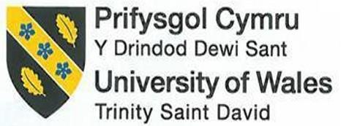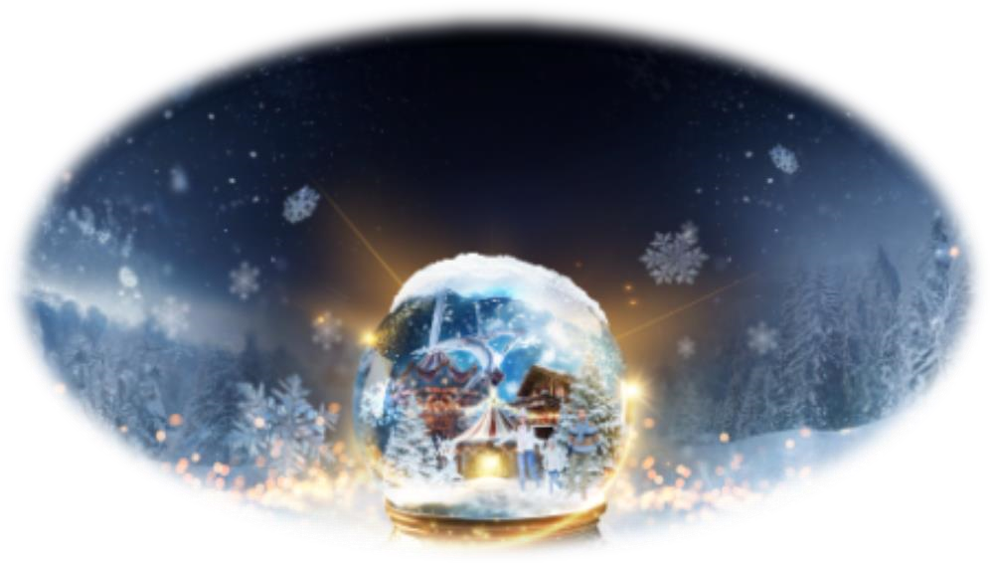
International Meetings
Management for the
Hotel Industry
BMIH6007
Feasibility Plan for an International Meeting. Individual Presentation
Lecturer: Kathryn Flynn
Student id:2216057
Student name: Eliza
Andreea Amanioaei
Kingdom of Winter (2024). Kingdom of Winter.

Introduction

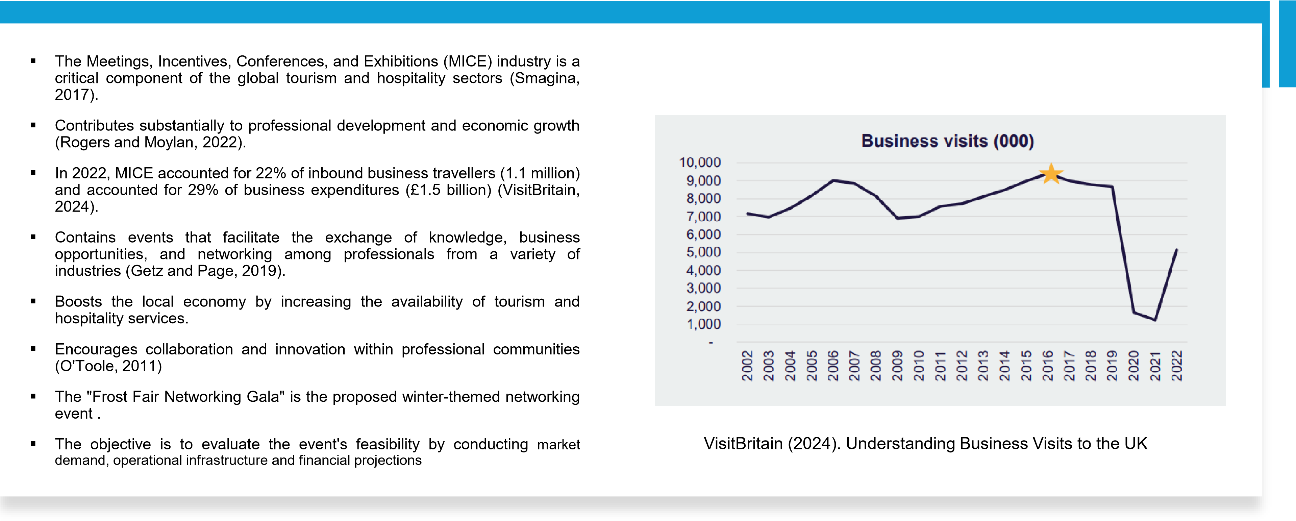
Event Content and Context

- The "Frost Fair Networking Gala" for hospitality professionals is inspired by Thames frost fairs (Smith, 2012).

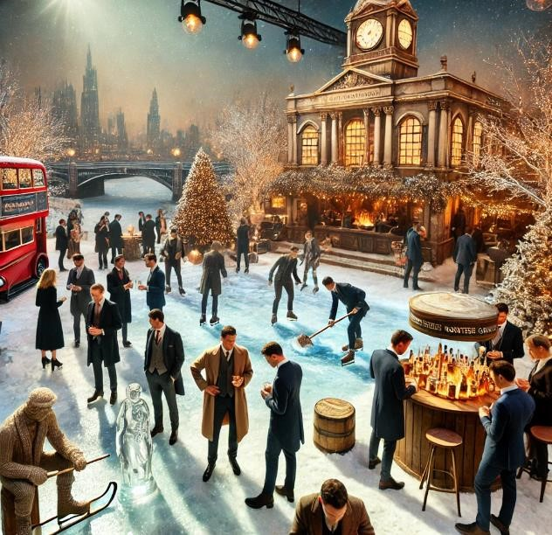
- Ice skating, live music, ice sculpting, and seasonal gourmet winter cuisine recreate the magical atmosphere (Lindahl et al., 2012).
Created by the learned (2024). Frost Fair Networking Gala.
- Improves participant satisfaction and engagement by combining professional networking with a winter festival vibe (Getz and Page, 2019).
- Meets the desire for distinctive, experiential events with higher perceived value and non-traditional formats (Fox et al., 2014).
- Combines historical themes with modern event practises, distinguishing it from traditional networking events and attracting professionals seeking new experiences (O'Toole, 2011).
- Encourages industry innovation by highlighting new winter hospitality initiatives.
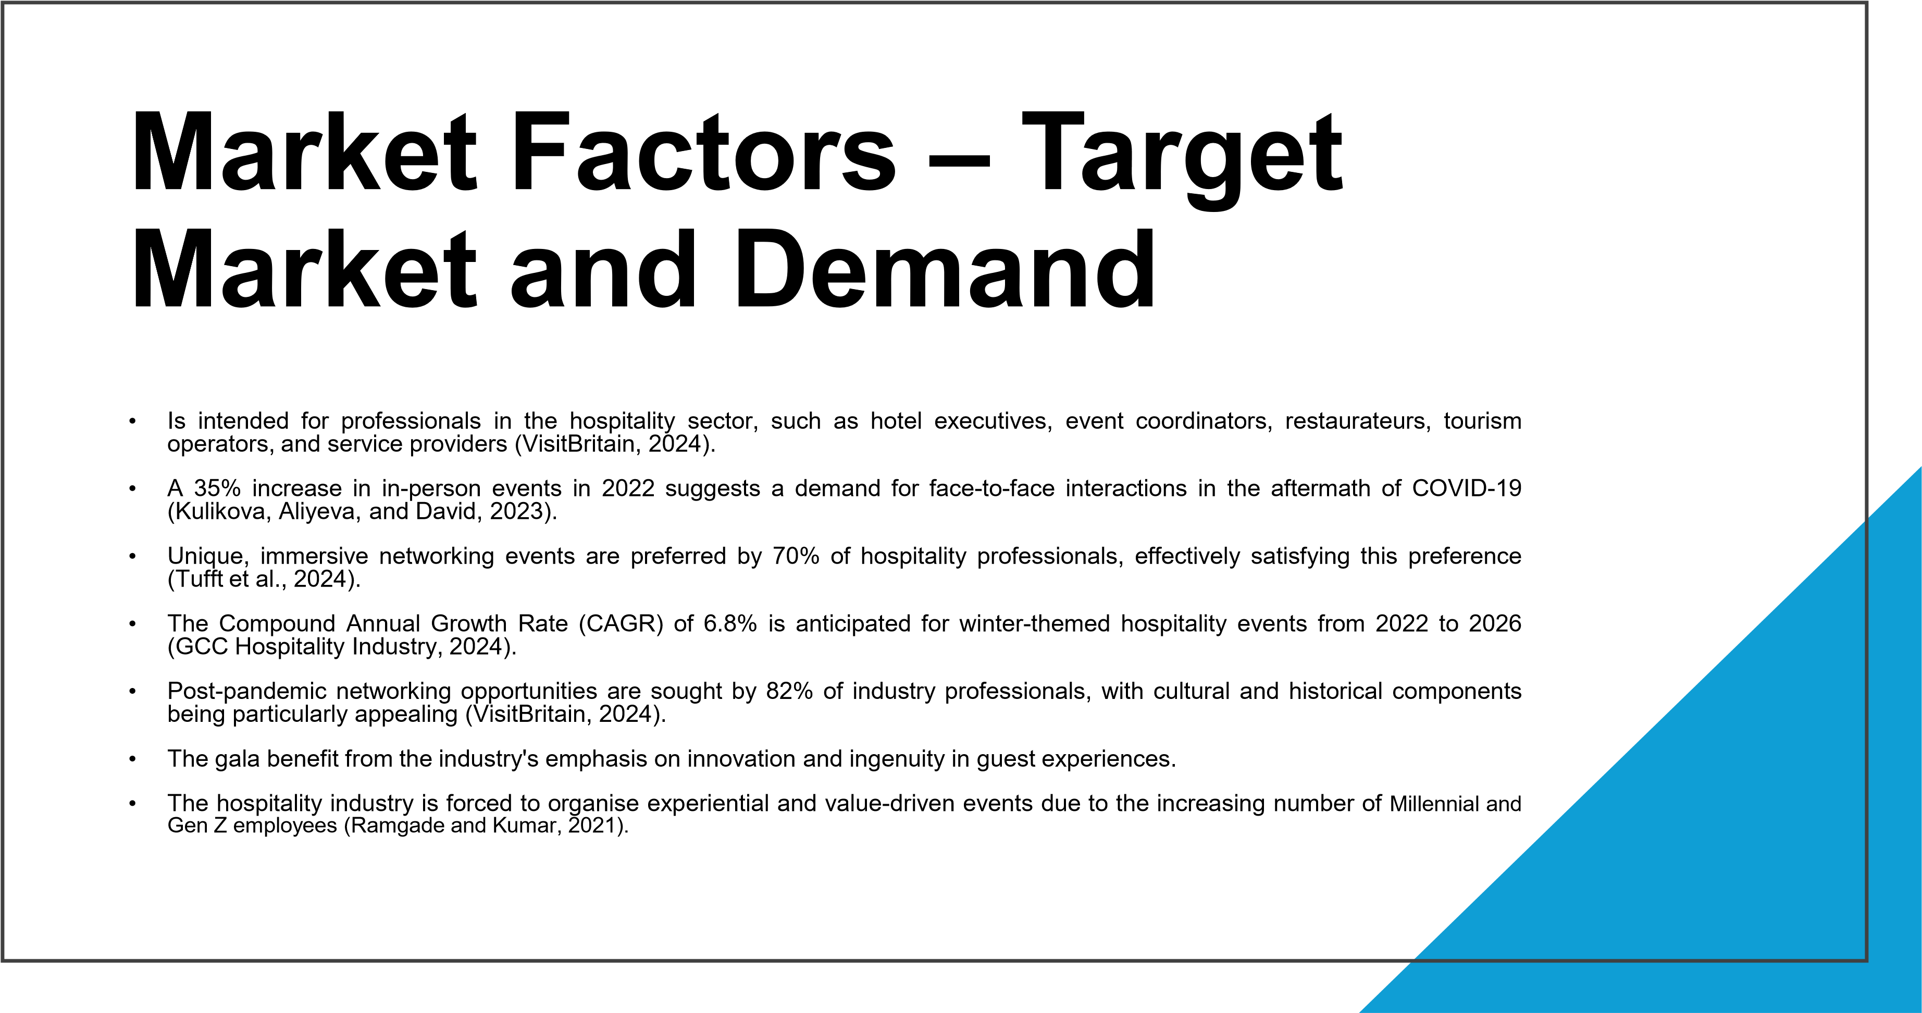


Market Factors
–

Competition and
Marketing Activity
The Frost Fair Networking
Gala is a distinctive event
in the MICE sector of the
hospitality industry,
providing a unique mixture
of networking
opportunities and
historical themes (Fox et
al., 2014).
The demand for themed
events is on the rise, with
professionals preferring
themed events for deeper
engagement.
The gala's potential for
success is enhanced by
the absence of direct
competition, as traditional
networking events lack
thematic innovation. In
contrast, competitors such
as the Annual Hospitality
Networking Convention
and the Global Tourism
Forum offer industry
insights but lack
immersive, experiential
settings
(
Okumus, Tuna
and Guillet, 2023)
.
The marketing strategy
encompasses the
following: targeted
advertising campaigns,
content marketing,
partnerships with industry
associations, email
marketing, influencer
marketing, early bird
registration discounts,
group booking incentives,
and immersive
technologies such as
virtual reality previews. It
also involves the utilisation
of digital and traditional
channels (Nguyen, 2016).
Operational Factors – Venue
- Somerset House, a historic neoclassical structure, is the proposed venue for the Frost Fair Networking Gala.
- The venue aligns with the gala's winter and historical theme, including its ice-skating rink in its central courtyard (Somerset House, 2019).

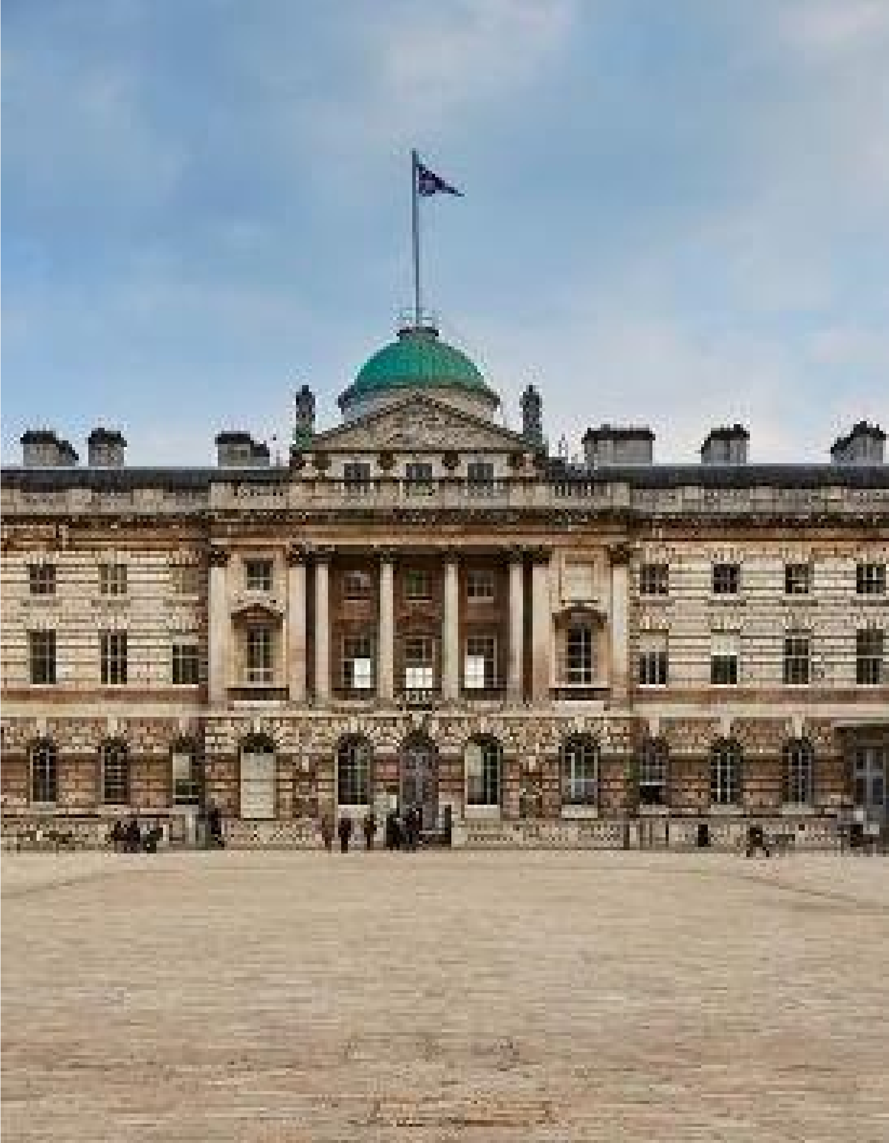
- The Edmond J. Safra Fountain Court and adjacent interior spaces can accommodate up to 500 guests, allowing for both indoor and outdoor activities.
VisitBritain(n.d.). Somerset House
- The venue offers resources such as an ice rink for private events and in-house catering services from accredited caterers.
- The venue's logistics are centrally located with excellent transport links, including Temple and Covent Garden Underground stations (Somerset House, 2016)..
- The venue promotes inclusivity with accessible lavatories and stepfree access.
- Professional event designers will be hired to create an immersive environment, incorporating period-appropriate décor and ice sculptures (Fox et al., 2014).

Operational Factors
–

Staffing and Skills
Event Management
Team:
•
Oversees planning and execution
phases, ensuring the event's
thematic vision and objectives
are met (Anas et al., 2020).
Event Coordinators:
•
Coordinate activities, logistics,
scheduling, and vendor relations.
Hospitality and Catering
Staff:
•
Provides exceptional food and
beverage services, enhancing
the authenticity of the event
experience (Tang, 2014).
Technical and
Production Crew:
•
Expertise in lighting, sound, and
stage production to create a
winter atmosphere (Anas et al.,
2020).
Safety and Compliance
Personnel:
•
Ensures participant safety and
regulatory compliance, including
ice
-
related activities (
Sumithra
and Mishra, 2010).
Volunteer and Support
Staff:
•
Engages volunteers to offer
practical experience and
additional support.
Staff Training and
Development:
•
Provides ongoing training to
ensure service quality and
operational efficiency (Anas et
al., 2020).
Financial Factors – Costs and
Predicted Revenues
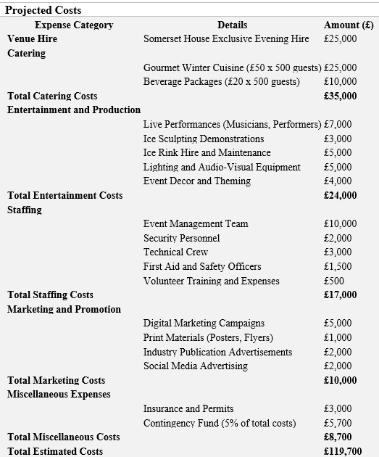 | 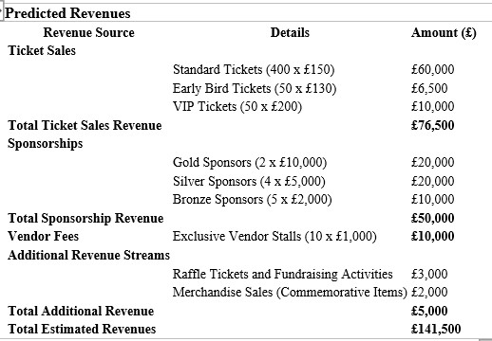
• | Total Estimated Revenues: £141,500
• | Total Estimated Costs: £119,700
• | Estimated Net Profit: £141,500 - £119,700 = £21,800

(Hoggett, et al., 2024)
Conclusion
▪
Unique

winter
-
themed

concept

inspired

by

historical

frost

fairs
.
▪
Addresses

market

gap

with

substantial

demand

for

immersive

events

among

hospitality

professionals
.
▪
Operational

planning

aligns

with

objectives,

including

venue

selection,

resource

allocation,

and

staff

appointment
.
▪
Financial

projections

suggest

profitable

outcome

with

estimated

net

profit

of

£
21
,
800
.
▪
Recommends

continued

development

with

focus

on

operational

execution,

targeted

marketing,

and

early

sponsor

engagement
.
▪
Potential

to

significantly

influence

hospitality

industry's

networking

landscape
.

References
- Anas, M.S., Maddiah, N.A., Noor Eizamly, N.U.E., Sulaiman, N.A. and Wee, H., 2020. Key success factors toward MICE industry: A systematic literature review. Journal of Tourism, Hospitality & Culinary Arts (JTHCA), 12(1), pp.1-34.
- Fox, D., Gouthro, M.B., Morakabati, Y. and Brackstone, J., 2014. Doing events research: From theory to practice. Routledge.
- GCC Hospitality Industry |. (2024). Available at: https://alpencapital.com/research/2024/alpen-capital-hospitality-report-june24.pdf.
- Getz, D. and Page, S. (2019) Event studies: theory, research and policy for planned events. 3rd Edition. Routledge: Oxford
- Hoggett, J., Medlin, J., Chalmers, K., Beattie, C., Hellmann, A. and Maxfield, J., 2024. Financial accounting. John Wiley & Sons.
- Litvinova-Kulikova, L., Aliyeva, Z. and David, L.D., 2023. MICE tourism: How the pandemic has changed it. Journal of Tourism and Services, 14(26), pp.197-218.
- Lindahl, M., Advisors, K., Skard, S. and Thorbjørnsen, H. (2012). Sponsorship as Experiential Marketing A natural experiment on how event experiences transfer to the brand. [online] Available at:
https://core.ac.uk/download/pdf/30840047.pdf [Accessed 4 Oct. 2024].
- Nguyen, T., 2016. Study on the Marketing Strategy for MICE Industry-Case: Pearl River Hotel in Vietnam.
- O’Toole, W. (2011) Events feasibility and development: from strategy to operations. Elsevier: Oxford
- Okumus, F., Tuna, M. and Guillet, B.D. (2023). Proceedings of the Conference on Managing Tourism Across Continents: Volume 3. University of South Florida (USF) M3 Publishing, [online] 16(283447312023). doi:https://doi.org/10.5038/2834-4731-V3.
- Ramgade, A. and Kumar, A., 2021. Changing trends of hospitality industry: Emergence of millennials and gen Z as future customers and their influence on the hospitality industry. Vidyabharati International Interdisciplinary Research Journal, 12(01), pp.336-342.
- Rogers, T. Wynn-Moylan, P (2022) Conferences and conventions: a global industry. 4th Edition. Routledge: Oxford
- Smagina, N., 2017. The internationalization of the Meetings-, Incentives-, Conventions-and Exhibitions-(MICE) industry: Its influences on the actors in the tourism business activity. Journal of Economics and Management, (27), pp.96-113.
- Smith, A., 2012. Events and urban regeneration: The strategic use of events to revitalise cities. Routledge.
- Somerset House. (2016). The Edmond J. Safra Fountain Court. [online] Available at: https://www.somersethouse.org.uk/venue-hire/edmond-j-safra-fountain-court.
- Somerset House. (2019). Skate at Somerset House. [online] Available at: https://www.somersethouse.org.uk/whats-on/skate-somerset-house [Accessed 4 Oct. 2024].
- Sumithra, D. and Mishra, J.M., 2016. Efficacy of MICE tourism industry and supply chain management as an integrated approach. International Journal of Management Research and Reviews, 6(7), p.894.
- Tang, H.W.V., 2014. Constructing a competence model for international professionals in the MICE industry: An analytic hierarchy process approach. Journal of Hospitality, Leisure, Sport & Tourism Education, 15, pp.34-49.
- Tufft, C., Constantin, M., Pacca, M., Mann, R. and Gladstone, I. (2024). The state of tourism and hospitality 2024. [online] Available at: https://www.mckinsey.com/~/media/mckinsey/industries/travel%20logistics%20and%20infrastructure/our%20insights/the%20state%20of%20tourism%20and%20hospitality%202024/the-state-oftourism-and-hospitality-2024-final.pdf.
- VisitBritain(2024). Understanding Business Visits to the UK. Accessed [01/10/2024]

