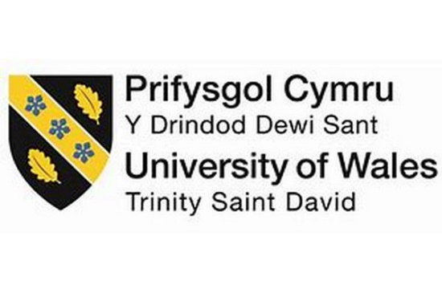

SWOT ANALYSIS ON PERSONAL/PROFESSIONAL DEVELOPMENT PLAN

Keila Ribeiro
1917702
Lecturer: Joanna Walsh
Module code: BMSW4001
2020

Table of Cable

1. Introduction 3
2. Skills 3
3. Consider the different type of skills 3
4. Classification of Skills 4
5. SWOT Analysis 9
6. Conclusion 10
7. References 11
8. Appendices 12

1. Introduction
The SWOT analysis is a process that is understandable of measuring the strengths, weaknesses, opportunities, and threats. Through this SWOT analysis of self, someone can understand his or her strengths and weaknesses, which is helpful for his/her future, especially in a career. This personal development is used as a management tool to improve for one's own, and it helps to minimize the incapacitation, which is needed for personal development. This reflective report is focused on skills that are required for self-development. The different types of skills are considered in this assignment. The classification is considered by academic skills, employability skills, hard skills, and soft skills, along with the definition, explanation, and examples. The SWOT analysis has been evaluated for understanding the basic determination of objectives or the strategy as the reflective report. This assignment has been focused on the personal or professional development.

2. Skills
Skills are defined by capacity and ability that is obtained through the deliberate, systematic, and sustained effort for carrying out the complex activities of job functions. The cognitive skills, technical skills, and interpersonal skills are involved as a certain competence of proficiency. Skills that are typically developed through direct training and experiences (Rubens et al. 2018). Personal skills are used as a possession and consideration of their own strengths. The particular job skills are known as those abilities which allow a candidate for employment to excel in a specific job. The skills which are required for a particular job are known as the skill set. Employers use this set of skills which are required for performing the job in their job designation.

3. Consider the different type of skills
The essential job skills are needed for different types of skills, such as personal skills, teamwork skills, and fundamental skills. Personal skills include active listening, adaptability, interpersonal communication, critical thinking, creativity, customer services, decision making. Personal skills are about maintaining a positive attitude, high ethical standards, and showing initiative and interests for growing employability skills (Jackson et al. 2020). The teamwork skills involve working with others for being supportive and respecting differences. The fundamental skills are knowledge-based and other interpersonal skills, which are also an essential capability to perform an activity in a competent manner. Several types of skills are important for growing abilities, knowledge, and experiences that are required in the performance of the job. The planning of research, accounting, management, leadership, human relations, and computer knowledge is essential for creating specific areas of skill set.
The transferable or the functional is classified as skills that include possession that is useful to employers among various jobs and industries. The transferable or functional skills describe the organizational group work and adaptability (Son, 2018). The knowledge-based skills describe the knowledge of a particular subject and information which is necessary for that specific task or team tasks. This knowledge-based skill is accumulated through education, training, and job experiences. The personal skills that refer to personal traits or attributes of interpersonal abilities, leadership personality, group work skills, attentive mind, cooperation, enthusiasm, and personal drive, management, and organizational skills and willingness to learn.

4. Classification of Skills
This assignment is classified by academic skills, employability skills, hard skills, and soft skills, along with definition, explanation, and examples. The assignment is focused on developing the personal or professional development plan along with SWOT analysis. This assignment has been discussed the skills of myself, who is FB Assistant (at present) and had other job experiences as a Cabin crew, promoter period, commercial delegate, receptionist, and trainee receptionist.

Academic Skills
Definition: Academic skills that refer to effective learning from University level for developing the research and study skills; this academic qualification is needed for developing and achieving academic success, which reflects the person’s potential.
Explanation: This academic skill encourages the student to become more efficient learners. The academic skills include reading proficiency, verbal communication, and written communication, thinking critically, abilities to research, analytical thinking, and problem-solving. An academic setting helps a student to create academic excellence by the organizational and interpersonal skills (Achen et al. 2019). Through these academic skills, the students can make up their core skills like academic writing skills, presentation skills, referencing skills, and reflective practice (Doyle, 2019). The academic skills help to improve time management, reading for information and understanding, essay writing, research abilities, which are required for the students in their high studies.
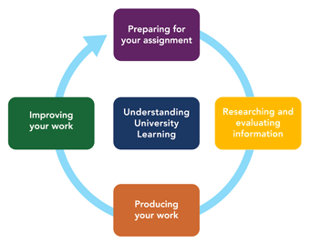
Figure 1: Academic Skills
(Source: Achen et al. 2019)
Example: Academic skill is referred to as education by which the student has qualified his degree or course from School, College, and University. As an example, I am Keila Ribeiro, and I got my academic skills from various schools, academy, and training center. First, I completed my Journalism from the Professional School of Communication and Image in June 2008. After that, I completed a Marketing and Communication degree from the Autonomy University of Lisbon in June 2016. After university, I started my Cabin Crew from New Skills Academy. I got the certificate in the Cabin Crew in April 2017. After this, I got admission for the Cabin Crew Course in British Airways Flight Training Centre. I completed this course in June 2017. In British Airways Global Learning Academy, I completed my Safety Equipment & Procedures (SEP) after my Cabin Crew course. After this, I completed my Cabin Crew Attestation in September 2018 from Irsih Aviation Authority.

Employability Skill
Definition: Employability Skills are defined as transferable skills, and these transferable skills are required by an individual to make them ‘employable.’ The technical understanding of the subject or knowledge that employers often set an outline of skills is required for an employee.
Explanation: The comprehensive employability skills are essential as the competition of the labor market is intense. The employability skill refers to those employers who are flexible and take initiation for having the ability to undertake various tasks in different environments. Employability skills include teamwork, which, along with interpersonal skills such as verbal and written communication (Choate et al. 2016). The employability skills involve the reliability and dependability that the employee has agreed to his or her deadline in his job. The essentiality of employability skills refers most to problem-solving, verbal communication, collaboration, adaptability, resourceful management, technological uses, organizational skills, written communication, and others.
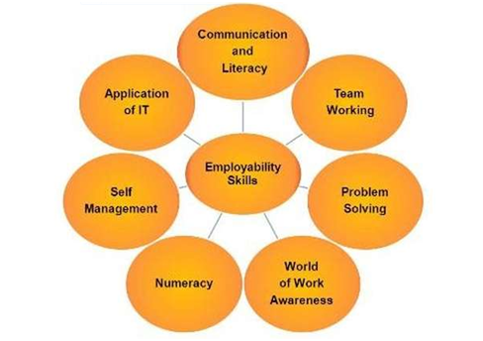
Figure 2: Employability Skill
(Source: Choate et al. 2016)
Examples: The employability skill refers to the strengths, weaknesses which define the performance of an employee. In this assignment, I have been taken as an example to define my employability skills. In March of 2001, I joined as a trainee receptionist at Oassis Hotel, Cabo-Cape Verde. As a trainee receptionist, my work was room reservations, telephone duties, as well as assisting with communication planning. After that, I also worked in Pestana Tropico Hotel, Cape Verde, from May 2003 to July 2005 as a receptionist. As I worked as a receptionist, I am very good at verbal communication, which can be noted as strength in my personal development plan. In Barclaycard - Lisbon, I worked as a Commercial Delegate from July 2011 to July 2012. There I had to promote credit card sales, online payments, shopping facilities, and benefits, which can be considered as technological knowledge.
After these services, I worked as a Promoter Period at EI Corte Ingles-Lisbon from May 2013 to June 2014. As I sell and promote electrical articles, I adapted the knowledge of products, which increased technological knowledge more. After that, I worked as a Restaurant Assistant in Restaurant/Bar Agostinha, Lisbon-Portugal, from July 2014 to November 2016. In this restaurant, I had responsibility for ensuring the orders effectively. In this job, I have experienced leadership and management. At present, I am working in a Cabin Crew position at Ryanair from October of 2018. Here, I have to take responsibility for passenger safety onboard sales. This job has increased the skills of my verbal communication and problem-solving. As the weaknesses, I consider my incapability as I cannot anticipate follow up questions. In my personal growth or professional growth development plan, I need to grow awareness, which is not only needed for my job but also it can help to increase my self-confidence.

Hard Skills
Definition: Hard Skills define the abilities of teachable and measurable skills like reading, writing, computer programming knowledge. These hard skills include computer technology, project management, certifications, and licenses.
Explanation: Hard skills are essential as this skill improves the productivity and efficiency of an employee. Indirectly, these skills help the employees to increase their job satisfaction. The hard skills are about technical knowledge of how these skills are essential to learning through education and training (Vogler et al. 2018). Through cloud computation, data analysis, computer technology, marketing, and so on helps someone to increase the knowledge of hard skills.
Examples: In this assignment, I had to understand the personal and professional development plan. As key skills, it can be said that I have knowledge about Ms-Office's work as well as the hotel and restaurant booking software. I also worked as a commercial delegate so that I have online payments and other online facilities, which can be referred to as the knowledge of hard skills.

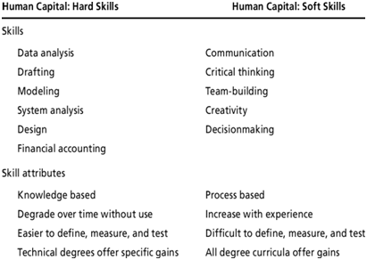
Figure 3: Hard Skills & Soft Skills
(Source: Vogler et al. 2018)

Soft Skills
Definition: Soft skill is about an attentive mind, listening, coordination, presenting ideas, and communicating with other members of a team. The soft skills include the abilities of verbal communication, language skills, personal habits, leadership skills, and teamwork, and time management.
Explanation: Soft communication skills are the tools; that are required to implement not only the collaboration in work but also helps to improve the hard skills. These soft skills define verbal communication and written communication (Nida et al. 2018); these skills are very much needed for the organizational work on a daily basis.
Examples: In this assignment, I been taken to define the personal development plan as well as a professional development plan. As I worked as a receptionist in a hotel in Cape Verde, I have skills in verbal communication. Though I am Portuguese, I can talk in Spanish, English .These skills help me to communicate with many people. At present, I am working as FB Assistant, where my verbal communication is needed very much.

5. SWOT Analysis
SWOT analysis is a tool or framework; which is used to analyze a company’s position in the market, and it helps to improve the strategic plan. SWOT analysis refers to the Strengths, Weaknesses, Opportunities, and Threats, whether it is internal or external, in the personal or professional development plan (Phadermrod et al. 2019). This SWOT analysis is defined as the business analysis, by which the objectives of the project can be understood. All the factors related to the project are properly recognized. Through this SWOT analysis, the business organization can improve the viability of their company. Through the analysis, the opportunities and threats or risks can be predicted.
This SWOT analysis is also helped to evaluate the personal development plan as well as a professional development plan. The purpose of SWOT is to identify the Strengths, reduce the Weaknesses, explore the opportunities, and minimize the threats (Rubens et al. 2018). This analysis is beneficial for personal or professional development, which is required to be successful.
Strengths | Weaknesses
- As I worked as FB Assistant Department, that is why I have to talk with many people. My communication skill is considered as my strengths.  - I have knowledge about computing systems and other online benefits, so my hard skills can be considered as my strengths. | - I do not have time management planning. In my job position, I need to handle many kinds of situations, but due to my lack of time management since it fails sometimes.  - I do not have much self-awareness, which can be considered as a weakness.
Opportunities | Threats
- In my job position, opportunities like ‘Ready Reserve’ Flight Attendant, Senior Flight Attendant, and Base Manager can be considered.  - New technologies like new software usage are used, which can be considered as opportunities. | - In this job, other cabin crews are considered as threats.  - As the competition is growing, the cabin crew skills are getting better day by day.
Table 1: Personal SWOT Analysis
(Source: Rubens et al. 2018)

6. Conclusion
This assignment has been focused on the SWOT analysis; the processes of how this analysis helps to understand the personal development plan as well as the professional development plan. This analysis is helpful in measuring the strengths, weaknesses, opportunities, and threats are analyzed. The skills and the different types of skills are discussed to understand the development plan. The classification of skills such as Academic Skills, Employment Skills, Hard Skills, and Soft Skills are evaluated along with definition, explanation, and example. This assignment has been discussed about the personal and professional development plan through the basic determination of objectives with the help of reflective reports.

7. References
Achen, R.M., Warren, C., Fazzari, A., Jorich, H. and Thorne, K., 2019. Evaluating Graduate Student Out-of-Class Learning: The Professional Field Trip. International Journal of Teaching and Learning in Higher Education, 31(1), pp.96-107.
Choate, J., Green, J., Cran, S., Macaulay, J. and Etheve, M., 2016. Using a professional development program to enhance undergraduate career development and employability. International Journal of Innovation in Science and Mathematics Education (formerly CAL-laborate International), 24(3).
Doyle, S., 2019. Professional learning in the everyday provision of self-management support: situated knowledge and the problem with generic skills development. Health Education in Practice: Journal of Research for Professional Learning, 2(2).
Jackson, M.A., Dillon Jr, G.L., Bennett, K. and Regis, A.K., 2020. Identifying strength-based transferable skills from personal accomplishment narratives to expand educational/career pathways with marginalized youth. Career development interventions for social justice: Addressing needs across the lifespan in educational, community, and employment contexts, pp.25-40.
Nida’a, K.A. and Worley, J.A., 2018. Leading toward new horizons with soft skills. On the Horizon.
Phadermrod, B., Crowder, R.M. and Wills, G.B., 2019. Importance-performance analysis based SWOT analysis. International Journal of Information Management, 44, pp.194-203.
Rubens, A., Schoenfeld, G.A., Schaffer, B.S. and Leah, J.S., 2018. Self-awareness and leadership: Developing an individual strategic professional development plan in an MBA leadership course. The International Journal of Management Education, 16(1), pp.1-13.
Rubens, A., Schoenfeld, G.A., Schaffer, B.S. and Leah, J.S., 2018. Self-awareness and leadership: Developing an individual strategic professional development plan in an MBA leadership course. The International Journal of Management Education, 16(1), pp.1-13.
Son, J.B., 2018. Language Skill-Based Approach. In Teacher Development in Technology-Enhanced Language Teaching (pp. 89-107). Palgrave Macmillan, Cham.
Vogler, J.S., Thompson, P., Davis, D.W., Mayfield, B.E., Finley, P.M. and Yasseri, D., 2018. The hard work of soft skills: augmenting the project-based learning experience with interdisciplinary teamwork. Instructional Science, 46(3), pp.457-488.

8. Appendices
Personal Development Plan
Skills to develop | Action plan | Duration
Communication | I need to improve more communication skills as in FB Assistant,, where verbal communication is very required. | Three months
Time Management | I need to grow my time management skills through work division; it helps me to make a perfect personal development plan. | Two months

