
Programme: MSc Public Health and Social Care in Practice
Module: Health Care System, Organisation and Leadership
Module code: LCHS7002

Comparative report on COVID-19 leadership responses: Spain, South Korea and Canada

Lecturer Name: Shepherd Ziko
Student Name: Darshan Bipinbhai Sarvaiya
Student ID : 2436889

Executive summary
The report is a comparative study of the COVID-19 leadership moments and health system organisation in Spain, South Korea, and Canada. It discusses the impact of the levels of centralisation and decentralisation on preparedness, capacity to monitor and effectiveness of operations during the pandemic. The paper examines leadership of Chung Sye-kyun, Justin Trudeau and Salvador Illa based on the theories of leadership, namely, the trait, behavioural and situation theories. The results suggest that the coordination and successful containment could be fast due to the centralised governance and adaptive leadership in South Korea. To the contrary, the early challenges experienced by Spain and Canada were linked to the decentralised structure but recorded better results as co-ordination and alignment of leadership increased. In general, the report points out that successful response during the pandemic requires congruence among the leadership behaviour, system design, and institutional coordination.

Table of Contents
1. Introduction 3
1.1 Background to COVID-19 and Health System Governance 3
1.2 Centralisation and Decentralisation in Healthcare Systems 3
1.3 Importance of Leadership in Pandemic Response 3
1.4 Aim and Scope of the Comparative Case Study 4
2. Comparative Analysis of Health System Organisation 4
2.1 Theoretical Framework 5
2.2 Spain: Decentralised Health System 5
2.3 South Korea: Centralised Health System 6
2.4 Canada: Federal and Provincial Health System 7
2.5 Cross-Country Comparison 7
2.6 Preparedness, Surveillance, and Public Health Capacity 9
2.7 Health-System Outcomes and Operational Effectiveness 10
3. Comparative Leadership Analysis 10
3.1 Spain – Salvador Illa 10
3.2 South Korea – Chung Sye-kyun 12
3.3 Canada – Justin Trudeau 13
3.4 Cross-Country Comparative Synthesis 15
4. Discussion 15
5. Conclusion 17
References 18

1. Introduction

1.1 Background to COVID-19 and Health System Governance
The COVID-19 pandemic was a severe shock on a systemic level, impacting the resilience, governance capacity, and adaptability of health systems across the globe. It was not merely a public health emergency, but one that demonstrated the failure of models of the surveillance structures, intergovernmental coordination, political decision-making and crisis communication. The experiences of various countries that had similar epidemiological exposure, especially with those alike risks, but very different outcomes, especially those concerning governance structures, policy agility, and institutional preparedness, have been illustrated in international analyses by the World Health Organisation and the OECD (WHO, 2021; OECD, 2021). Multi-country research has also shown that the material resources alone were not sufficient to determine the effectiveness of the response taken by the countries, but the interaction between the system design and the leadership performance (Haldane et al., 2021). These observations demonstrate that there is a need to investigate the intersection of health-system organisation and leadership behaviour in the face of a crisis of such magnitude.

1.2 Centralisation and Decentralisation in Healthcare Systems
This report concentrates on Spain, South Korea and Canada so as to investigate the effects on different national responses to COVID-19 caused by differing governance structures. Spain has a highly decentralised health system whereby autonomous local governments have a high level of control over the delivery of health care as well as emergency response. Such power allocation has always posed coordination issues, and they became more obvious during the pandemic, especially in terms of tracking and the promotion of vaccination. In South Korea, which is significantly different, it is run through strong centralised leaders whose leadership, government coordination and integrated digital models are accelerated. The fact that it has taken decisive action and gained the trust of the populace is the merit of such a powerful coordination of governance structure. Canada would be the third strategy. Since it is a federal system, the role of healthcare belongs to the provinces to a greater extent, and the national government gives strategic direction and coordination. Such separation of power caused mixed reactions in the nation and pointed out the impact of federalism in crisis decision-making.

1.3 Importance of Leadership in Pandemic Response
As a mediator variable, leadership is a crucial factor in the effectiveness of the response to the pandemic. Crises increase the significance of personal leadership qualities, which can be seen as behaviours and the ability to adjust to a fast-changing environment. This report uses three theoretical frameworks to analyse leadership in the three countries that the researcher selected. The Trait Theory is applied to test the consistent personal traits that affect the way that leaders respond to the crisis situation (Dåderman et al., 2023). Behavioural Leadership Theory facilitates the consideration of what the leaders actually did, such as the clarity of communication, transparency of decision-making and consistency of the message to the masses (Eichenauer et al., 2022). The Situational Leadership Theory makes it possible to evaluate how the leaders changed their approaches and strategies as the pandemic progressed and how their adaptive behaviours affected the degree of the people complying and the effectiveness of the systems functioning (Aslam et al., 2022; Pasaribu et al., 2022). The combination of these theories makes it possible to have a multidimensional approach to the issue of leadership in the context of COVID-19.

1.4 Aim and Scope of the Comparative Case Study
The report completes two fundamental tasks in accordance with the module requirements. The former is a comparative evaluation of the ways in which Spain, South Korea and Canada organised and mobilised their health systems to respond to the pandemic, how they designed governance, centralised and decentralised their health systems, and found the capacity and system impact of their health systems. The second is an analysis of the leadership styles of Salvador Illa, Chung Sye-kyun and Justin Trudeau based on the three theories of leadership with the aim of determining how personal characteristics, behavioural selection and dynamic tactics influenced the reaction of each nation. The report continues with a methodological and theoretical framework, the comparative analysis of the three health systems, leadership practices analysis and the final discussion constitute system-level analysis and system-based leadership observations.

2. Comparative Analysis of Health System Organisation
In this report, a comparative case study methodology was used in the investigation of how Spain, South Korea and Canada structured their health systems and political leadership amid the COVID-19 outbreak. The comparative design is suitable since it will enable the study to be done on countries that were affected by the same global threat, yet reacted in different governance frameworks and institutional setups. Comparative case studies will be most appropriate in subduing tendencies of convergence and divergence, especially in examining the interpretation of multilayered health-system operations and crisis governments. COVID-19 provided the possibility to examine the real-time variations in resilience, coordination and institutional performance, and these variations have already been reported in the international studies by the World Health Organisation, the OECD and multi-country studies of system resilience (WHO, 2021; OECD, 2021; Haldane et al., 2021). This study can better realise how the contexts of structural settings influenced the choices of leadership and the actual results operationally by examining three countries with different levels of centralisation and governmental-health capabilities.

2.1 Theoretical Framework
This report has influenced the three developed leadership models in the leadership analysis: Trait Theory, Behavioural Leadership Theory and Situational Leadership Theory. The Trait Theory is an approach that seeks to investigate personal characteristics that are more lasting and affect leadership styles in decision-making during crisis situations, emotional control, and communication style. In modern literature, the traits-based approaches in the case of crisis remain relevant, especially in the sense of composure, empathy and decisiveness (Dåderman et al., 2023). Behavioural Leadership Theory is used to evaluate the visible activities of the leaders, such as transparency, the nature of messages and their ability to be predictable, all of which are important in creating trust in the people during emergencies (Eichenauer et al., 2022). The Situational Leadership Theory can be used to analyse how leaders managed to adjust to the situation changes as the pandemic unfolded. Recent works reveal that more successful performance in changing and uncertain environments is strictly linked to the concept of flexible, adaptive leadership (Aslam et al., 2022; Pasaribu et al., 2022). The rest of the leadership theories were not chosen since other theories have less aptitude in the governance of the national crisis. The Great Man Theory shares numerous archaic assumptions of inherent heroism, whilst conceptualisations like the Five-Level Leadership Model are developed to more accurately apply to the corporate context instead of the crisis management of the public sector.

2.2 Spain: Decentralised Health System
Spain has a model of decentralisation where the seventeen autonomous communities are in charge of the healthcare planning, resource management and full-course execution of their healthcare. The Ministry of Health, in collaboration with the central government, has a coordinating role since they are the ones that determine the frameworks and the surveillance guidelines which have to be implemented, but the decision-making activities are mainly left to the regional authorities. This delegation of authority allows responsiveness to local demands but poses a problem in attaining national strategies in the face of fast-changing crises. The literature on the response to the pandemic in Spain has focused on the impact of regional inequalities and disparities in the infrastructure of the public-health system on the difference in preparedness of different regions (Barcelo et al., 2024), and gaps in communication conditions made integration and coordinated actions more difficult (Catalan-Matamoros and Langbecker, 2023).

2.3 South Korea: Centralised Health System
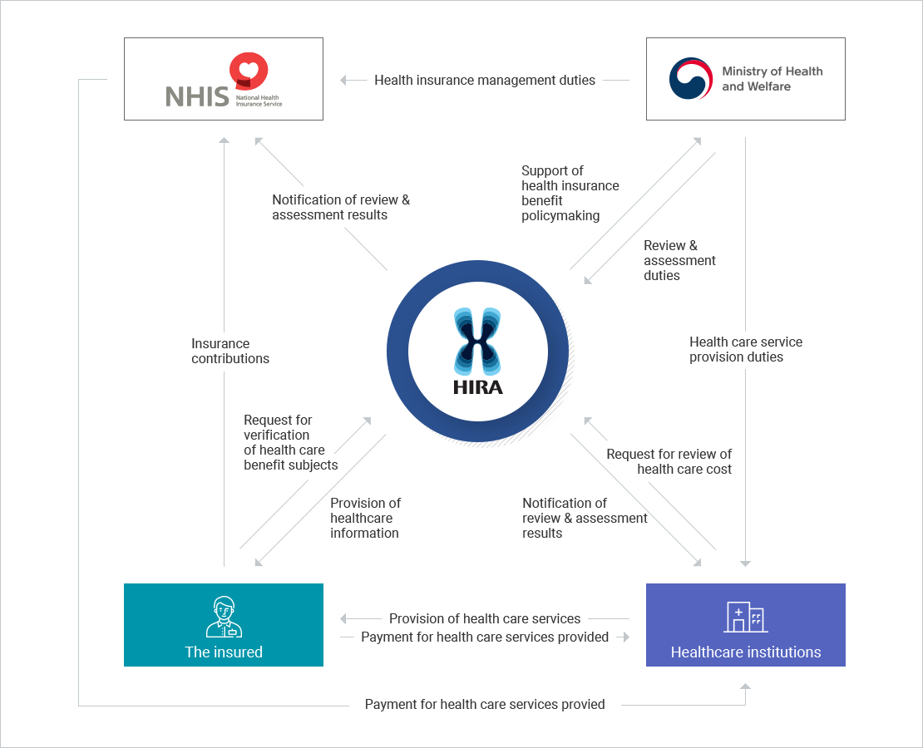
Figure 1: Healthcare System in Korea
(Source: Hira, 2024)
South Korea is a different case study and is a society with centralised leadership in its public health and a high quality of governmental capability in quick coordination across the whole country. The Korea Disease Control and Prevention Agency is a central command institution combining epidemiological surveillance, digitally tracked technologies and decision-making. This framework has been attributed to the facilitation of the rapid execution of containment strategies and regularity in communicating with the people. According to governance studies, the Korean model of hierarchy and partnership collaborations across sectors, including more rapid and unified responses in the early segments of the pandemic, is achieved through a hybrid system of governance (Lee and Wong, 2021; Tejerina et al., 2024).

2.4 Canada: Federal and Provincial Health System
Canada, in its turn, has a federal system whereby provincial and territorial authorities have foremost jurisdiction in delivering health care services, finance and emergency care. The federal government acts as a source of guidance, financing mechanisms and coordination at the national level, but lacks the mandate to take consistent actions throughout the nation. This disposition brought about significant regional disparities in strategies against pandemics, testing policies and vaccination policy. The studies have shown that the disunity of the Canadian federalism created an unequal degree of preparedness because the provinces had varying levels of surveillance capabilities, stockpile reserves, and decision-making channels and schedules (Allin et al., 2022). Such national variations in structure constitute the basis of analysing the different dynamic nature of operations and leadership found in the three countries.

2.5 Cross-Country Comparison
The extent of centralisation in any particular health system was a solid determinant of both the pace of making decisions and the operational coherence and enforcement of the law in the face of the pandemic. The decentralised system of governance in Spain posed a significant problem in the management of coordination, especially in the first few months. Despite the central government's efforts to introduce national policies, they were executed at the regional levels with varying political interests and administrative ability. This disintegration has helped in disparate constraints, variable testing plans and postponements in consolidated surveillance reports. Studies on the sociopolitical environment of Spain also indicate the existence of ideological rifts, which affected the behaviour of subnational responses to the pandemic and factored into the unequal response planning paths (Fontán-Vela et al., 2023). The absence of integrated public-health control retarded crisis escalation control and impeded time-sensitive control.
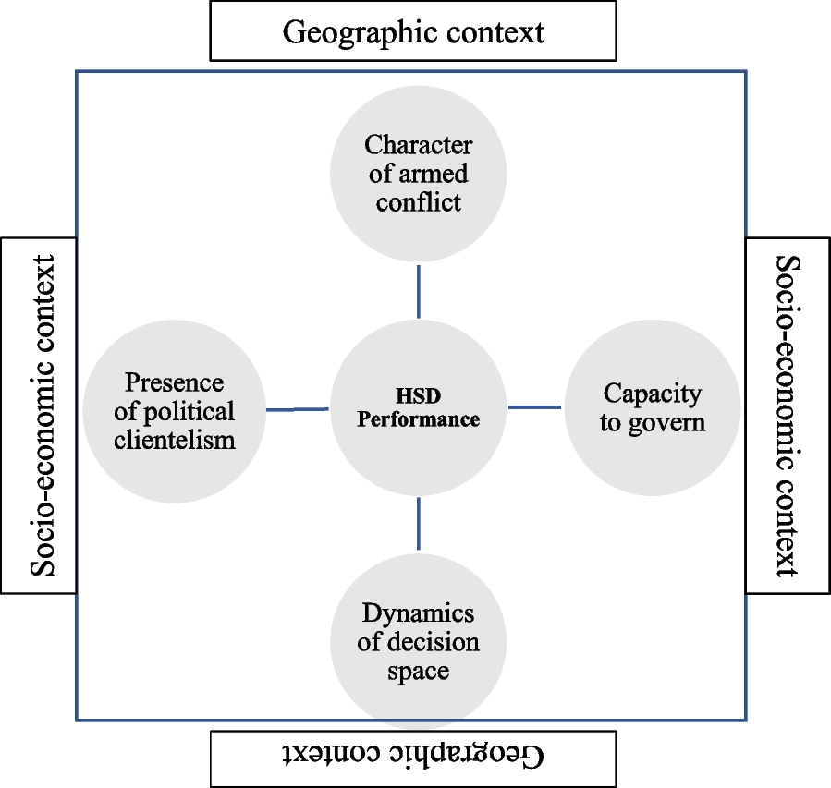
Figure 2: Factors impacting under decentralisation
(Source: Brennan and Abimbola, 2023)
The centralised institutional design of South Korea meant that the public-health authorities of the country were able to establish complete testing, tracing and isolation measures with the minimal amount of delay. The Korea Disease Control and Prevention Agency (KDCA) allowed central control, which facilitated flawless coordination between epidemiological intelligence and digital tracking devices so that authorities could quickly handle cluster outbreaks. The centralised system was such that policy directives were applied in the same way across the country, with a high degree of trust in the government as well as good communication. It has been reported that the governance hybrid in Korea, which combines authority hierarchy with cross-sectoral collaboration, allowed effective vertical coordination due to the pandemic (Lee and Wong, 2021). This centralised ability has also been largely considered as having been the driving force behind the successful containment strategy of Korea.
The federalised system in Canada was a halfway model, but this came with considerable restrictions. Provinces had a high degree of autonomy, and the result of this is that decisions made concerning lockdowns, school closures, vaccination prioritisation and testing strategies differed across provinces. Although the federal government tried to offer a general direction, it did not have the constitutional right to implement uniform national policies (Chen et al., 2021). Subsequently, distribution of the pandemic response was disparate across provinces, with some having exemplary cases of proactive public-health action and others exhibiting slower or more piecemeal responses. Research examining the governance of Canada throughout the COVID-19 pandemic identifies fragmentation as the sole barrier to devising a standardised approach to crisis control and one of the reasons behind the slow rollout of vaccine campaigns (Marchildon, 2021; Allin et al., 2022). In sum, the flexibility inherent in institutions during the outbreak of an epidemic can be underlined by the fact that decentralisation did not allow for the orchestration of interventions.

2.6 Preparedness, Surveillance, and Public Health Capacity
The level of preparedness and the capacity to survey were quite diverse in the three countries. South Korea got into the pandemic with an already developed digital infrastructure that had followed the MERS outbreak and therefore had the capability to conduct real-time data analytics, QR code check-ins, mobile phone check-ins and transaction records with the credit card. Assessments of the contact-tracing adequacy of the system in Korea emphasise the perceived usefulness of the systems in the eyes of the public-health professionals (Gong et al., 2022), but critical reviews of the digital surveillance platform reveal the sociotechnical twists associated with the traceability system in Korea (Yang, 2022). The KDCA electronic resources also demonstrate the high level of control of the country in terms of test activities, risk communication and cluster data analysis (Tejerina et al., 2024). This enabled great integration in the surveillance network.
The preparedness in terms of public health was more unequal in Spain because of the decentralised structure of the country. The regional governments also had their own surveillance systems, and this was prone to delays in reporting and inconsistency in reporting. The facts of spatiotemporal disparities in the vaccination coverage in Catalonia reveal that structural and socioeconomic trends determined the capacity of the population and health in the face of the pandemic (Barcelo et al., 2024). A literature review on vaccine hesitancy also argues that the demographic and social factors which complicated the preparedness of Spain in its readiness and communication campaigns (Falcon et al., 2023). Spain eventually reinforced the coordination in the vaccination stage, yet initially, unequal differences in surveillance identified a weakness in consistency in surveillance.
Canada was partially ready because the jurisdictional roles were not homogeneous. As the country had decent scientific advisory bodies and epidemiological competence, the surveillance systems varied in provinces and territories. Studies indicate that disparities in access to vaccines were partly due to the structural and demographic susceptibility, as well as the inconsistent provincial infrastructures (Kholina et al., 2022; Wanigaratne et al., 2023). This lack of unity in surveillance reporting compromised the integrity of the reporting and resulted in time delays during the first response in identifying the high-risk groups.

2.7 Health-System Outcomes and Operational Effectiveness
During the beginning of the pandemic, South Korea registered relatively low mortality rates, which are substantiated by prompt testing, digital tracing and regular messages to people. The strong immune responses in healthcare workers produce booster studies that support both mixed and homologous vaccine regimens and reinforce the vaccination strategy and surveillance-based approach in Korea (Choi et al., 2023). The first casualties in the outbreak were enormous in Spain, and the pressure on hospitals is high, partly because premature coordination was not made, and there were also regional differences in preparedness. Nevertheless, the nation had a high vaccination coverage, as it was reported to make major drops in hospitalisations and deaths after the vaccination effort (Martínez-Baz et al., 2024). This shows that containment was not easily achieved at the early stages because of system constraints, but the later national coordination efforts achieved better results.
Canada showed inconsistent results in the provinces, which are characteristic of its decentralised structure. Research indicates that groups that had immigrated historically or were structurally vulnerable had lower chances of booster coverage, which hindered the overall system performance (Watigaratne et al., 2023). Even though Canada eventually achieved high levels of national vaccination, equity inequalities during the rollout were still present, and the inability to coordinate federal and provincial efforts was a setback in the early implementation (Kholina et al., 2022). Structural arrangements, surveillance performance and trust of the population. There was a determination of operational effectiveness across the three countries through the combination of structural performances, which defines how health-system design has an impact on crisis performance.

3. Comparative Leadership Analysis

3.1 Spain – Salvador Illa
Spain's Minister of Health, Salvador Illa, was in a focal leadership role at one of the most difficult periods in the COVID-19 crisis in the country. The leadership styles can be explained using Trait Theory, Behavioural Leadership Theory and Situational Leadership Theory, all of which provide some insight into the role of personal characteristics, observable behaviours and adaptive decision making in the national response of Spain. Trait Theory reveals that overall, Illla approached communications rather cautiously and hesitantly, as was experienced in press conferences and statements made by the company. Although these characteristics were at times suitable in extremely uncertain events, they have resulted in an image of indecisiveness during the first few weeks of the commencement of the outbreak, when the number of cases in Spain had been soaring. Trait-based leadership research underlines that confidence and assertiveness are the traits that correlate with better crisis performance when it comes to high-pressure environments (Dåderman et al., 2023). The measured response of Ilila went in accordance with his technocratic character, although not always communicating the definitiveness necessary in a situation that is quickly unravelling.
The Behavioural Leadership Theory offers another interpretation in terms of behaviours and patterns of communication that can be observed in Illa. Transparency and inconsistent communications at the beginning of the pandemic in Spain made their communication approach subject to criticism during the earliest phase of the pandemic. The lack of centralisation in the governance of the country also led to a situation where public-health surveillance and case reporting were uneven across regions, which also impacted the confidence of the populace in the leadership of the country. Research on crisis leadership behaviour demonstrates that establishing transparency is even more crucial in times of crisis, as well as the use of clarity, communication frequency, and openness (Eichenauer et al., 2022). It is also true that Illa has changed substantially in the vaccination phase, as the Spanish government used a more organised national approach, which caused the high uptake of the vaccines and proved to be more coherent in its organisation. The vaccination campaign in Spain eventually emerged as one of the most robust campaigns in Europe, and this change in behavioural shift in terms of leadership messages helped in the change.
The Situational Leadership Theory will be used to explain how Illa realigned herself with the changing course of the pandemic, albeit at different levels. The situational models also focus on the need to change the style of leadership in accordance with the requirements of the specific stage of crisis management (Aslam et al., 2022; Pasaribu et al., 2022). Adjustment to the new environment also took Illa a longer time: the first few months were characterised by an ever-increasing situation that demanded decisive actions and coordination in the centre. The decentralised system of governance in Spain also hampered its capacity to take action uniformly in different regions since autonomous bodies still exercised their authority over important aspects of public health. This disintegration had a negative impact on the ability to implement uniform national interventions and the capacity of Illa to change strategies on the fly. Nevertheless, once the vaccination process started, Illa was more of an adaptive leader as he convened regional forces around a coherent national rollout plan. This phase was characterised by the increase in situational correspondence between the action taken by the leadership and the need for public health. The structuring of the problem by structural constraints in decentralised systems, in general, can be seen in the leadership of Illa in the situations where individual qualities, behaviour, and situational needs intersect.

3.2 South Korea – Chung Sye-kyun
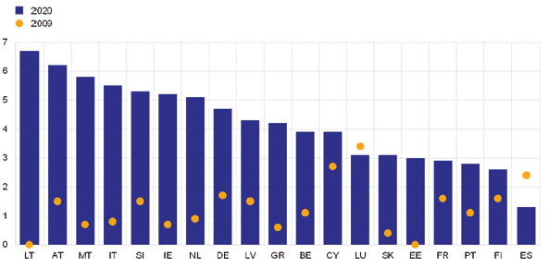
Figure 3: COVID-19 with a budgetary impact in 2020
(Source: Chislett, 2021)
The Prime Minister of South Korea, Chung Sye-kyun, is well known among successful leaders under the circumstances of the pandemic, which happened to develop according to a blend of consistent personality and behaviour and excellent situational adjustment. The traits theory have pinpointed a few qualities that are related to the leadership of Chung. His reflective composure, managerial discipline and determined disposition instilled confidence in institutional actors as well as among the masses. Trait-based research concerning leadership has found traits like composure, assertiveness and clarity of purpose as factors that contribute to decision-making during crisis, and these were also observed in Chung in terms of his presence in the media as well as in crisis-related decisions and crisis responses.
The Behavioural Leadership Theory also provides more insight into the strategy used by Chung based on his practice of clear and open communication. South Korea also conducted regular national briefings, issued comprehensive epidemiological updates and communicated policy changes in a specified way. Such behaviours reaffirmed the trust in the public institutions and even contributed to high compliance by the masses of people. The leadership of Chung also exhibited good operational behaviour, especially the mobilisation of large-scale testing, tracing and isolation systems. Research indicates that digital tracing instruments in Korea were rated as very effective by the professionals working in the field of population health (Gong et al., 2022), and the examination of the governance reveals the presence of cooperation between the office of the Prime Minister and the Korea Disease Control and Prevention Agency (Lee and Wong, 2021). These habits were in line with leadership models that believe in active participation, coordination and transparency in communication.
The Situational Leadership Theory can be used to explain why the leadership of Chung is commonly referred to as exemplary. Since the very beginning of the pandemic, he has proven that he can change his strategies to match the sudden changes in the epidemiological situation. Seeking and finding new tools. Because of variants, Korea introduced border controls at first, followed by swift mass testing and digital contact tracing, and finally adopted targeted cluster-management approaches as time went on. The importance of the ability to change and be flexible in situations of crisis is emphasised by Situational Leadership Theory, and modern studies confirm the association between adaptive leadership and successful crisis results (Aslam et al., 2022). The governance framework of South Korea, where the centralised powers and the fully connected digital systems define South Korea, increased the capabilities of Chung to implement the adaptive strategies as quickly as possible. The connection between the leadership and the response of the people also became stronger due to cultural factors. Extremely high levels of social instances of trust, social cohesion and obedience to the governmental advice presented a permissive condition to situational leadership. The effectiveness of leadership by Chung was therefore realised through the combination of the personality of this man, the selection of behaviour, the adaptive strategy and a centralised system that assisted in bringing the nation together.

3.3 Canada – Justin Trudeau
Justin Trudeau led the federal response to COVID-19 in a decentralised and intricate federal system in Canada. Trait Theory can be relevant in clarifying the influence of his personal traits on his crisis leadership. It is also common knowledge that Trudeau held possessive, empathetic, unifying, and consensus qualities that informed his communicative approach during the course of the pandemic. His social solidarity and collective responsibility appealed to a lot of Canadians. According to the trait-based literature of leadership, empathy and emotional intelligence may serve to increase public trust in the case of a crisis (Dåderman et al., 2023), which was evident in the social speeches by Trudeau. These, however, were the same characteristics that demonstrated that he favoured more joint and not authoritative management of any situation in crisis management, which constrained his capacity to impose federalism policies across the whole country.
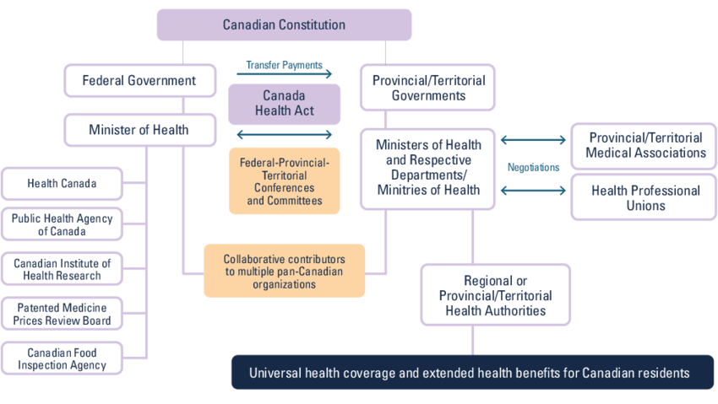
Figure 4: Overview of the health system: Canada
(Marchildon and Allin, 2021)
Behavioural Leadership Theory observes that the communicative approach by Trudeau has been one of the main characteristics of his leadership. Daily, he conducted national briefings in the initial phases of the pandemic, which strengthened the feeling of stability and the presence of the government. His repetitive approach to presenting vaccination and public-health interventions to the narrative did one of equity and social duty, which was consistent with the wider popular beliefs. The behavioural leadership is however, directly related to the institutional environment where behaviours take place. Even though the message Trudeau was conveying was the same, the provincial governments had to implement the measures, which led to a lot of variation in the testing process, restrictions and the vaccination schedule. Analysis of the response to the pandemic in Canada suggests that the operational difficulties introduced by the federation between the provinces and the federal government hindered early vaccination (Marchildon, 2021; Allin et al., 2022). Behavioural leadership in the case of Trudeau was thus of a narrow scope in hourly operation.
The situation leadership theory demonstrates the strong and weak points of the leadership of Trudeau. Situational models state the significance of modifying the leadership style to the changing conditions. Trudeau was trying to adjust by recalibrating and ensuring his policies, and redefining his messaging to the people, as situations shifted. But federalism limited the extent to which he could alter nationally applicable strategies. Canada did not have the centralised scheme seen in South Korea or the partially-centralised coordination in the Spanish vaccination campaign; most of the roles of the Canadian public-health system remained under the control of the provinces. This implied that Trudeau was able to promote certain actions or even make national recommendations but not be able to force the jurisdictions to take the same action. The Theory of Situational Leadership implies that flexibility has to be matched with the real power of making decisions, and situational endeavours of Trudeau were thus partly restrained by the structural constraints. His leadership proved most beneficial in those areas that federal authority was quite obvious, like border controls, financial relief programmes and the purchase of vaccines but failed in those areas where provincial measures were necessary. All in all, his leadership demonstrates how a sympathetic personality, communicative behavioural tendencies, and intent to adapt interact with the limitations of a federal form of government (Parsan and Kim, 2024).

3.4 Cross-Country Comparative Synthesis
An analytical comparison of the three leadership cases indicates that there are important variations in the ways the traits, behaviours and adaptive capacity influenced the responses of nations to the pandemic. Trait Theory brings into focus the fact that Chung was more decisive and calm, which brought a strategic clarity, whilst Illa was cautious, and this gave the initial vulnerability in a crisis that was growing day by day, and Trudeau was more empathetic; however, this characteristic did not support his aggressiveness, considering that the system was in pieces. The Behavioural Leadership Theory demonstrates that transparent, consistent communication and a high level of operational coordination contributed to the success of the leadership in Korea, whereas the behavioural effectiveness in Spain and the leadership in Canada were strong on rhetoric and weak because of the inconsistencies in the provinces, respectively. The Situational Leadership Theory shows that Chung was best suited, as she changed her strategies with changes in time regarding epidemics. Illa eventually managed to adjust to the implementation of the vaccination campaign, but initially had a hard time as a result of system fragmentation. Trudeau tried to adapt to new realities, but he did not have enough institutional powers to adopt a uniform action across the country.

4. Discussion
Comparative analysis of Spain, South Korea and Canada indicates that the effectiveness of the leadership during the COVID-19 pandemic was determined by the compatibility of the play of personal traits of leadership and the political system of a country in which the leader worked. Trait Theory allows one to understand why the early reaction of Spain was inhibited by the guarded and reserved nature of the character of Salvador Illa, because his own style did not align with the urgency that needed to be found in a decentralised environment, which demanded aggressive coordination between autonomous states. The enabling and compassionate approach of Justin Trudeau also boosted the same aspect of messaging and reassurance, but this could not work in operation since power was limited by federalism. On the contrary, the centralising style of governance in South Korea and the decisive and composed characteristics of Chung Sye-kyun were appropriate to influence leadership more directly.
The Behavioural Leadership Theory expounds further on the influence of the observable behaviour of leaders on trust and compliance. It is also in the sense of valuing clarity in behaviour that South Korea has maintained good public adherence due to their consistent communication, frequent epidemiological reporting and overt coordination. Initially, Spain had a problem with a disjointed communication system, which added to the poor compliance rate at the start, but the behavioural cohesion increased as the vaccination process neared. The communicative behaviour between the federal government and provinces in Canada was good, but this led to national disparity due to provincial variance. These trends indicate that the leadership approach based on behaviour is most efficient when provided by the institutional capacity.
The most appropriate explanation of divergent results lies in the Situational Leadership Theory. Chung proved to be very adaptable and changed the tactics with the onset of new epidemiological data, which was enhanced by the single-rule system of South Korea. The studies on crisis resilience justify the idea that adaptive leadership is efficient in the case of well-coordinated and flexible systems (Nakrošis and Bortkevičiūtė, 2022). Similar adaptations were made in Spain and Canada, but these were hampered by the effects of decentralisation, which slowed down performance and also gave uneven results. Literature on health-system resilience supports a wider idea that structural coherence is the principle of empowering the worth of effective crisis management leadership (Nimako and Kruk, 2021; Debie et al., 2024).
Opposing evidence indicates that decentralisation may be effective in circumstances where the regional capacity is high, as demonstrated in the subsequent success of the vaccination in Spain and some successful provincial responses in Canada. It is suggested by scholars that system resilience is not only centralised but largely depends on the power of coordination pathways and subnational capacity (Paschoalotto et al., 2023). These results show that system design and institutional strength cannot exist without leadership performance. Further studies are needed to understand the possibility of hybrid forms of governance, balancing the autonomy and central coordination to allow flexible and coherent crisis leadership.

5. Conclusion
The Spain, South Korea, and Canada comparison reveals that the governments of the countries were substantially influenced in the way they responded to the COVID-19 pandemic because of a specific structure of governance. Spain and Canada faced the problem of decentralisation of powers, and this aspect delayed taking a coherent step because of the delay in making decisions. It is the centralised system that allowed South Korea to mobilise quickly, maintain a consistent flow of communication and implement unified actions, which proves the benefits of institutional coherence in times of crisis.
The effectiveness of the leadership was different. The cautious nature of Illa and the empathetic nature of Trudeau were limited by uneasy systems, but the decisive and adaptive leadership method in the case of Chung fit with a structure of government leading to a quick response. The cases indicate that successful leadership in a crisis does not just depend on proper personal qualities, but also consistency in behaviour and the possibility to change the approach with the changing situation. Most importantly, they demonstrate that one cannot comprehend leadership outside the context of governance design. Enhancement of the coordination process and the overall adaptability of the system will be critical in upgrading the response to future emergencies in the field of health among the population.

References
Allin, S., Fitzpatrick, T., Marchildon, G.P. and Quesnel-Vallée, A., 2022. The federal government and Canada's COVID-19 responses: from ‘we're ready, we're prepared ' to ‘fires are burning’. Health Economics, Policy and Law, 17(1), pp.76-94.
Aslam, S., Saleem, A., Kumar, T. and Parveen, K., 2022. New normal: Emergence of situational leadership during COVID-19 and its impact on work motivation and job satisfaction. Frontiers in Psychology, 13, p.919941.
Brennan, E. and Abimbola, S. (2023). The impact of decentralisation on health systems in fragile and post-conflict countries: a narrative synthesis of six case studies in the Indo-Pacific. Conflict and Health, 17(1). doi:https://doi.org/10.1186/s13031-023-00528-7.
Catalan-Matamoros, D. and Langbecker, A., 2023. How does the public receive information about vaccines during the COVID-19 pandemic? A Nationwide cross-sectional study in Spain. Societies, 13(3), p.62.
Chen, H., Shi, L., Zhang, Y., Wang, X., Jiao, J., Yang, M. and Sun, G. (2021). Response to the COVID-19 Pandemic: Comparison of Strategies in Six Countries. Frontiers in Public Health, [online] 9(708496). doi:https://doi.org/10.3389/fpubh.2021.708496.
Chislett, W. (2021). Challenges and opportunities for Spain in times of COVID-19. [online] Real Instituto Elcano. Available at: https://www.realinstitutoelcano.org/en/work-document/challenges-and-opportunities-for-spain-in-times-of-covid-19/.
Choi, S.H., Park, J.Y., Kweon, O.J., Park, J.H., Kim, M.C., Lim, Y. and Chung, J.W., 2023. Immune responses after vaccination with primary 2-dose ChAdOx1 plus a booster of BNT162b2 or vaccination with primary 2-dose BNT162b2 plus a booster of BNT162b2 and the occurrence of omicron breakthrough infection. Journal of Korean Medical Science, 38(20).
Dåderman, A.M., Kajonius, P.J., Hallberg, A., Skog, S. and Hellström, Å., 2023. Leading with a cool head and a warm heart: trait-based leadership resources linked to task performance, perceived stress, and work engagement. Current Psychology, 42(33), pp.29559-29580.
Debie, A., Nigusie, A., Gedle, D., Khatri, R.B. and Assefa, Y., 2024. Building a resilient health system for universal health coverage and health security: a systematic review. Global Health Research and Policy, 9(1), p.2.
Eichenauer, C.J., Ryan, A.M. and Alanis, J.M., 2022. Leadership during crisis: An examination of supervisory leadership behaviour and gender during COVID-19. Journal of Leadership & Organisational Studies, 29(2), pp.190-207.
Falcon, M., Rodríguez-Blázquez, C., Romay-Barja, M., Ayala, A., Burgos, A., De Tena-Dávila, M.J. and Forjaz, M.J., 2023. COVID-19 vaccine hesitancy in Spain and associated factors. Frontiers in Public Health, 11, p.1129079.
Fontán-Vela, M., Gullón, P., Bilal, U. and Franco, M., 2023. Social and ideological determinants of COVID-19 vaccination status in Spain. Public Health, 219, pp.139-145.
Gong, S., Moon, J.Y. and Jung, J., 2022. Perceived usefulness of COVID-19 tools for contact tracing among contact tracers in Korea. Epidemiology and Health, 44, p.e2022106.
Haldane, V., De Foo, C., Abdalla, S.M., Jung, A.S., Tan, M., Wu, S., Chua, A., Verma, M., Shrestha, P., Singh, S. and Perez, T., 2021. Health systems resilience in managing the COVID-19 pandemic: lessons from 28 countries. Nature medicine, 27(6), pp.964-980.
Hira (2024). HIRA Healthcare System in Korea. [online] www.hira.or.kr. Available at: https://www.hira.or.kr/dummy.do?pgmid=HIRAJ010000006000.
Kholina, K., Harmon, S.H. and Graham, J.E., 2022. An equitable vaccine delivery system: Lessons from the COVID-19 vaccine rollout in Canada. PLoS One, 17(12), p.e0279929.
Lee, S. and Wong, R., 2021. COVID-19 responses of South Korea as hybrids of governance modes. Frontiers in public health, 9, p.654945.
Marchildon, G. and Allin, S. (2021). Health Systems in Transition: Canada, Third Edition. University of Toronto Press. doi:https://doi.org/10.3138/9781487537517.
Marchildon, G.P., 2021. The rollout of the COVID-19 vaccination: what can Canada learn from Israel?. Israel Journal of Health Policy Research, 10(1), p.12.
Martínez-Baz, I., Trobajo-Sanmartín, C., Miqueleiz, A., Egüés, N., García Cenoz, M., Casado, I., Navascués, A., Fernández-Huerta, M., Echeverría, A., Guevara, M. and Ezpeleta, C., 2024. Hospitalisations and Deaths Averted by COVID-19 Vaccination in Navarre, Spain, 2021–2022. Vaccines, 12(1), p.58.
Nakrošis, V. and Bortkevičiūtė, R., 2022. Resilience building during the management of the COVID‐19 crisis in Lithuania: Major breakthroughs and incremental change. Journal of Contingencies and Crisis Management, 30(3), pp.295-306.
Nimako, K. and Kruk, M.E., 2021. Seizing the moment to rethink health systems. The Lancet Global Health, 9(12), pp.e1758-e1762.
OECD (2021). Health System Resilience During COVID-19. https://www.oecd.org/health/health-system-resilience.htm
Parsan, S.J. and Kim, M. (2024). A Reflection of the Canadian Healthcare System. Navigating Strengths and Shortcomings. Navigating Strengths and Shortcomings (July 07, 2024). [online] doi:https://doi.org/10.2139/ssrn.4904375.
Pasaribu, S.B., Goestjahjanti, F.S., Srinita, S., Novitasari, D. and Haryanto, B., 2022. The role of situational leadership on job satisfaction, organizational citizenship behavior (OCB), and employee performance. Frontiers in Psychology, 13, p.896539.
Paschoalotto, M.A.C., Lazzari, E.A., Rocha, R., Massuda, A. and Castro, M.C., 2023. Health systems resilience: is it time to revisit resilience after COVID-19?. Social Science & Medicine, 320, p.115716.
Tejerina, L., Lee, H. and Kang, D., 2024. The Republic of Korea's Digital Tools for Fighting COVID-19.
Wanigaratne, S., Lu, H., Gandhi, S., Shetty, J., Stukel, T.A., Piché-Renaud, P.P., Brandenberger, J., Abdi, S. and Guttmann, A., 2023. COVID-19 vaccine equity: a retrospective population-based cohort study examining primary series and first booster coverage among persons with a history of immigration and other residents of Ontario, Canada. Frontiers in Public Health, 11, p.1232507.
World Health Organization (2021). COVID-19 Strategic Preparedness and Response Plan (2021 Edition). https://www.who.int/publications/i/item/WHO-WHE-2021.03
Yang, C., 2022. Digital contact tracing in the pandemic cities: Problematizing the regime of traceability in South Korea. Big data & society, 9(1), p.20539517221089294.

