Organizational Culture: Individual report 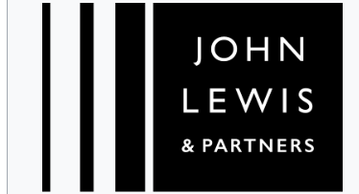
Assessment Component 1

Student Name: Roxana Ciobanu
Student ID: 2323453
Module: LCLM 5005 – Organizational Culture
Lecturer: David Oyebisi
Word Count: 3000
Submission Date: 11 /11/2025

Table of Contents
1.Introduction 3
2.Organisational Culture of John Lewis 3
3.Influence of Culture on Structure and Decision -Making 4
4. Identifying Cultural Types: Models and Frameworks 7
5.Culture and the External Environment 11
6.Organisational Culture as a Barrier 12
7.Impact of Culture on Organizational Performance 12
8. Conclusion 13
9. References 14

1.Introduction

Organizational culture is a foundational aspect of corporate life, shaping the share values, beliefs, attitudes, and behaviors that guide how work is conducted (Schein,2010). It defines ‘how things are done around here’ (Mullins, 2007), influencing leadership style, structure, motivation, and ultimately, performance. As businesses become increasingly global and complex, understanding and managing organizational culture has become vital for sustainable competitive advantages (Miminoshvili, 2016).
This report explores how organizational culture influence’s structure, decision-making, and performance at John Lewis Partnership (JLP)-one of the UK’s most recognized and respected retail organizations which manage to maintain its image over the time. Founded in 1864 and restructured under a partnership model in 1929, John Lewis operates a network of department stores and Waitrose supermarkets. Its defining feature is that it is employee-owned, meaning all staff are ‘partners’’ with shared responsibility for success (John Lewis Partnership, 2023).
The report critically analyses:
- The nature of JLP’s organizational culture.
- How culture influences its structure and decision-making.
- Theoretical models (Schein, Handy, Hofstede, and Denison) used to identify and evaluate culture.
- How culture supports or limits adaptation to external environment.
- The impact of culture on performance and recommendations for improvement.
By exploring these areas, the report demonstrates how JLP’s culture has been both a source of strength and a potential barrier to agility in a fast-changing retail landscape.

2.Organisational Culture of John Lewis
John Lewis’s culture is rooted in democracy, trust, and shared ownership. The organization’s mission’s ‘Happier people make happier customers’ reflects a human -centered philosophy that integrates employee welfare with business performance (John Lewis Partnership,2023).
The company’s Partnership model, established by founder John Spedan Lewis, distributes profits, power, and knowledge among employees. This approach fosters a sense of belonging and accountability, setting JLP apart from traditional profit-driven corporations (Paranque, and Willmott, 2016). The organization’s constitutions legally enshrined its values of honesty, respect, fairness, and empowerment, making culture both a moral compass and management tool.
The visible manifestation of JLP’s culture includes open communication, employee consultation, and strong customer focus. Partners participate in surveys, councils, and the Partnership Board, ensuring that their voices influence key decisions.
This inclusive culture also drives ethical business practices. John Lewis has long been regarded as a leader in responsible retailing, promoting sustainability, diversity, and community engagement (SA Woodward, 2024).
However, the culture also faces pressures from digital transformation, changing consumer behavior, and economic uncertainty, requiring continuous adaptation without undermining the founding principles.
In essence, JLP’s culture combiners traditional British values of service and integrity with modern ideas of empowerment and equality. It provides a strong foundation for loyalty and resilience but must evolve to support efficiency and innovation in a highly competitive market.

3.Influence of Culture on Structure and Decision -Making
Organizational structure and decision-making processes are closely intertwined with culture. According to Mintzberg (1983), structure determines how tasks are divided and coordinated, while culture defines the underlying behaviors that sustain it. In the case of John Lewis Partnership (JLP), its distinctive employee-owned structure is not merely a governance mechanism but a reflection of the company’s long-standing culture of trust, equality, and participation.
The chart in fig 1 shows JLP’s governance structure, including the key bodies: the Partnership Council, the Partnership Board, and the Chairman. These bodies reflect the democratic and participative culture of the organization.

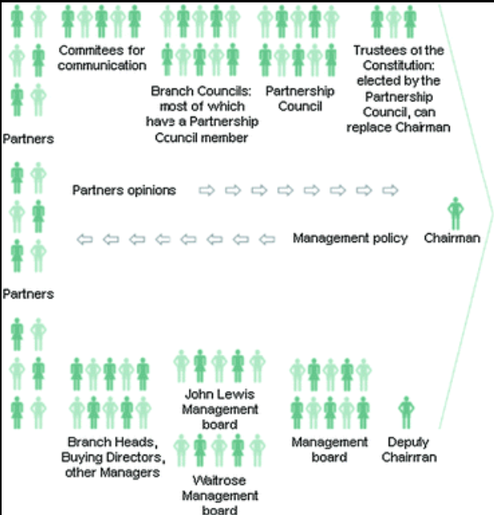
Figure: 1 JLP’s governance structure (JLP, 2024).

John Lewis Partnership governance structure is an essential illustration of how the organisation’s unique culture of employee ownership directly informs its structure and decision-making approach. At the heart of this structure are three main governing bodies — the Partnership Council, the Partnership Board, and the Chairman — each serving a distinct but interconnected role designed to balance democratic participation, strategic oversight, and accountability.
The Partnership Council is a representative body made up of elected employees, known internally as “Partners,” who voice the concerns, suggestions, and feedback of the wider workforce. This council functions much like a parliamentary forum within the organisation, ensuring that every partner has an indirect yet meaningful influence on the company’s strategic and operational decisions. According to the John Lewis Partnership Constitution (JLP, 2024), the council has the power to question or even dismiss the Chairman if it believes leadership decisions contradict the Partnership’s values — a testament to its democratic ethos and low power distance culture (Hofstede, 2001). This participatory structure nurtures a strong sense of belonging and accountability among employees, aligning with Handy’s (1993) concept of a Person Culture, where individuals are central to the organisation’s success.
The Partnership Board, on the other hand, acts as the executive and strategic decision-making body responsible for ensuring that the Partnership remains financially viable and ethically guided. It comprises both elected partner representatives and appointed executives, striking a balance between professional management and employee voice. The inclusion of partners on the board supports Mintzberg’s (1983) notion of a decentralised structure, where decision authority is distributed and not monopolised by senior executives. This structure fosters inclusivity, transparency, and mutual trust — core cultural elements that have long distinguished JLP from traditional corporate retailers (Phillips, and Moutinho, 2018).
At the top sits the Chairman, who embodies the leadership role within this governance model but remains accountable to the Partnership Council and Board. Unlike conventional CEOs, the Chairman operates as a steward of collective ownership, responsible not only for profit but also for upholding the organisation’s purpose and principles. As Kotter (2012) argues, effective leadership within such participative systems relies on vision and collaboration rather than authority and control — an approach that has historically reinforced JLP’s resilience and ethical reputation.
However, while this governance structure reflects the company’s deeply rooted culture of democracy and fairness, it also introduces operational complexities. The requirement for consultation and consensus before major decisions can lead to slower strategic responses, particularly in times of crisis or when rapid innovation is required — such as adapting to digital retail competition. This tension illustrates the need for JLP to continuously evolve its structure, finding a balance between participation and agility.

At John Lewis, culture profoundly shapes structure through its employee-ownership model. The company’s governance is participative, including a Partnership Board, Partnership Council, and Partner Voice forums, which enable bottom-up communication and decision influence. This structure reflects a low power distance culture (Hofstede,2001), where hierarchy is minimal and participation is encouraged. Decisions are not imposed from the top but are instated made through consultation, discussion, and collective agreement, reflecting a belief that share ownership should equate to share decision-making responsibility (Cathcart, 2013).
The decision-making process at JLP is characterized by democracy, Inclusivity, and transparency. The leadership actively seeks input from employees before implementing major strategic or operational decisions. For instance, when JLP underwent organizational restructuring and store closures during the COVID-19 pandemic, consultation processes were conducted to maintain trust and morale (BBC News,2021). This participative style aligns with Handy’s (1993) “person” and “role” cultures which prioritize fairness, consistency, and individual empowerment. As a result, employees feel valued and invested in organizational success, which strengthens organizational commitment and reduces turnover. Decision-making at JLP is highly consultative and consensus driven. This promotes transparency and commitment (Handy,1993). However, while participatory governance has moral and motivational advantages, it also introduces structural complexity and decision-making delays. In periods requiring agility—such as responding to digital retail disruption or economic uncertainty—JLP’s consensus-driven culture can hinder responsiveness. Decisions that might be made rapidly in hierarchical organizations often require multiple layers of consultation and approval within the partnership. This can create strategic inertia, where the desire for inclusiveness conflicts with the need for swift, decisive action.
Structurally, John Lewis operates as a decentralized functional hierarchy, where each business unit—John Lewis and Waitrose—functions semi-autonomously but aligns with the overarching partnership principles. This configuration enables flexibility in day-to-day operations and empowers business units to innovate within a shared cultural framework. However, decentralization can also lead to duplication of effort, inefficient coordination, and occasional conflicts of interest between departments (SA Woodward ,2024). These issues highlight the challenge of managing a large-scale partnership while maintaining the integrity of its cultural philosophy.
Critically, JLP’s organisational culture has historically prioritised stability and consensus over innovation and experimentation. While these cultural strengths have contributed to its reputation for ethical leadership and employee welfare, they may also limit its ability to adapt to the fast-changing retail environment driven by technological advancement and shifting consumer behaviour. As Kotter (2012) emphasises, successful organisations balance strong cultural foundations with flexible, adaptive structures that promote innovation and agility. For John Lewis, this requires integrating its democratic ethos with modern decision-making tools such as data analytics, digital collaboration, and cross-functional leadership teams to enhance responsiveness.
Furthermore, leadership within JLP plays a crucial mediating role between culture and structure. Leaders act as cultural ambassadors, translating partnership values into actionable strategies. Yet, as the company faces new market realities, leadership must also challenge cultural assumptions that inhibit change (Schein, 2010). For example, while consensus is valuable, excessive deliberation may lead to missed opportunities in e-commerce or supply chain modernisation. Thus, fostering a “culture of adaptive democracy”—one that values participation but also empowers leaders to act decisively—is essential.
In conclusion, the culture of John Lewis profoundly shapes its structure and decision-making processes by embedding democratic values into its operational and governance systems. However, as the retail landscape becomes more dynamic and digitally driven, the company must evolve toward a hybrid decision-making model—preserving inclusivity while enabling strategic agility. This cultural evolution would allow John Lewis to remain true to its founding principles while ensuring long-term competitiveness in an increasingly unpredictable market.
Critically, while JLP’s structure aligns with its culture of democracy and inclusivity, it must increasingly balance these ideals with the need for speed and innovation. As Kotter (2012) argues, successful organizations blend strong cultural foundation with flexible, adaptive decision-making frameworks.

4. Identifying Cultural Types: Models and Frameworks

To gain a comprehensive understanding of John Lewis Partnership’s (JLP) organizational culture, it is essential to apply multiple theoretical frameworks that capture both the visible and invisible dimensions of culture. Culture in organizations does not static—it evolves over time, influenced by history, leadership, and environmental pressures (Schein, 2010). The following section applies Schein’s Three-Level Model, Handy’s Cultural Types, Hofstede’s Cultural Dimensions, and Denison’s Traits Theory to critically analyze the distinctive characteristics of JLP’s culture and their implications for performance, adaptability, and strategic direction.
4.1 Schein’s Three-Level Model
Schein (2010) identifies three levels of organizational culture:
- Artifacts: Tangible elements such as store layout, communication style, and employee interactions. At JPL, artifacts include open-plan offices, inclusive communication channels, and recognition events
Here are some examples figure 1, figure 2, figure 3, of visible cultural artifacts at John Lewis Partnership (JLP) that reflect how its organizational culture is expressed in physical form and everyday practice:

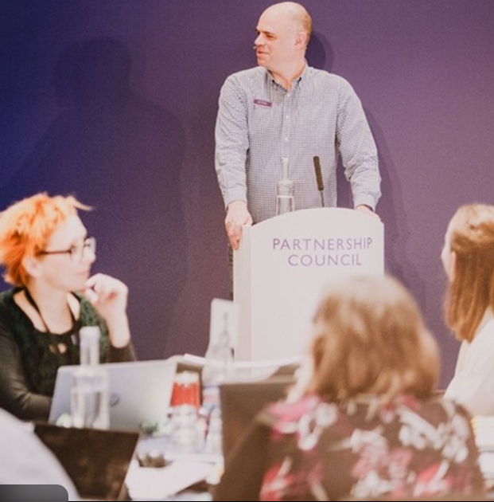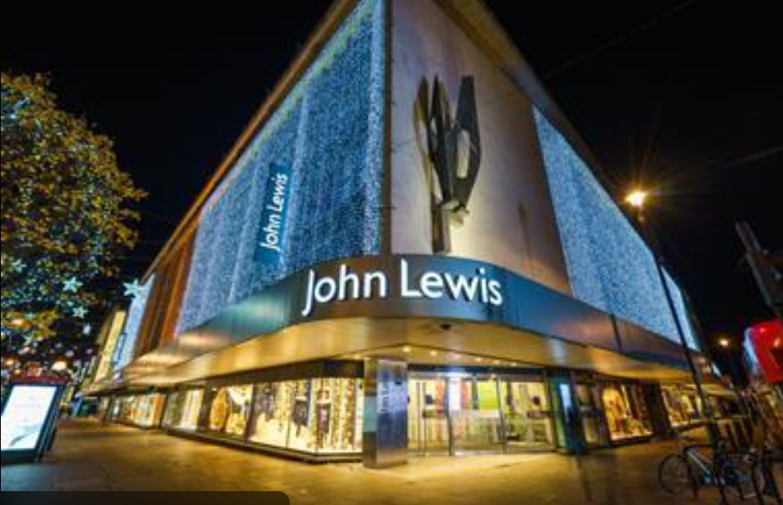
Fig 2 Fig 3 Fig 4 (Author’s own source).
Examples & Commentary
- The open-plan store layout and sales floor, with visible staff collaboration and interactive customer service desks, reflect JLP’s emphasis on accessibility, teamwork and equality among “Partners”.
- The “Partner Voice” communication boards, forums or signage emphasise transparency and bottom-up voice in the organisation, aligning with the culture of shared ownership.
- The distinctive storefronts and brand signage (“John Lewis & Partners”) signal the ethos of “Partners” rather than employees, reinforcing the culture of collective identity and stakeholder status.
- Recognition events or internal ceremonies where partners are celebrated highlight the value placed on employee contribution and shared success.
- Team briefings or store staff huddles reflect routines and behaviours that embody JLP’s norms: collaboration, customer-focus, and mutual respect.
Link to Culture
These artifacts serve as the visible layer in Schein’s model of culture (2010) – the level you can observe directly. They help to reinforce the deeper espoused values (fairness, integrity, shared success) and underlying assumptions (every partner count; success is collective) within JLP’s culture. Because they are tangible, they help embed and transmit culture to new employees, customers and external stakeholders.
- Espoused Values: The company’s stated principles, including fairness, integrity, and customer satisfaction.
- Basic Underlying Assumption: Deep-seated beliefs that guide behavior, such as ‘every partner count’s and ‘shared success benefit all.

At the artifact level, JLP’s culture is visible through physical and behavioral symbols—open-plan offices that promote accessibility, recognition events celebrating staff contributions, and transparent communication systems such as the Partner Voice forums (John Lewis Partnership, 2023). These artifacts reinforce equality and inclusiveness.
At the espoused values level, JLP’s commitment to fairness, integrity, and customer focus defines its ethical and service-oriented brand image. The company’s constitution emphasises that all employees—known as “partners”—share in the profits and decision-making of the business (Cathcart, 2013).
At the deepest level, underlying assumptions such as “shared success benefits all” shape JLP’s enduring culture. These assumptions guide strategic and operational behaviour, ensuring that employee welfare remains central to business success. However, as Schein (2010) warns, deeply embedded beliefs can create “cultural inertia,” where strong values resist necessary transformation. For JLP, this manifests in the difficulty of reconciling traditional partnership ideals with the need for digital agility and competitive responsiveness.
Schein’s framework reveals that JLP’s culture is deeply ingrained and consistently aligned across these levels. However, strong assumption can become rigid mental models, potentially limiting innovation when traditional values conflict with new strategic needs.
4.2 Handy’s Cultural Types
Handy (1993) proposed four primary cultural archetypes—Power, Role, Task, and Person—each influencing behaviour, control mechanisms, and motivation within an organisation.
John Lewis exhibits a hybrid of Role and Person cultures, reflecting a balance between structured fairness and individual recognition. The Role culture ensures procedural consistency, while the Person culture empowers employees by valuing their contributions and ownership. This hybrid supports long-term stability and motivation (Handy, 1993).
However, the limitations are evident during transformation periods. Excessive procedural emphasis may restrict creativity and innovation, while high individual involvement can slow collective decisions. Thus, while this cultural combination has sustained employee engagement, it must evolve to foster greater agility in digital retail contexts (Phillips, and Moutinho, 2018).
Cultural Type | Characteristics | Application to JLP | Impact
Power Culture | Centralised control; quick decision-making | Limited at JLP; decision-making is decentralised | Reduces agility
Role Culture | Defined roles, rules, and procedures | Strongly evident; promotes fairness and accountability | Enhances stability
Task Culture | Focus on teamwork and innovation | Present in project-based initiatives | Encourages collaboration
Person Culture | Individuals valued for skills and input | High: every Partner has a voice | Builds motivation and engagement

Figure 5: Handy’s Cultural Types and Application to JLP (Phillips, and Moutinho, 2018).

4.3 Hofstede’s Cultural Dimension
Hofstede (2001) identified six dimensions that describe national and organizational cultural tendencies: Power Distance, Individualism vs. Collectivism, Uncertainty Avoidance, Masculinity vs. Femininity, Long-Term Orientation, and Indulgence. Applied to JLP, several dimensions are particularly relevant.
Dimension | JLP Characteristic | Cultural Implication
Power Distance (Low) | Flat hierarchy and participative management | Promotes equality and voice
Individualism with Collectivism | Individual accountability balanced by shared goals | Enhances teamwork and motivation
Uncertainty Avoidance (Moderate) | Comfort with ambiguity but cautious decision-making | Can delay strategic shifts
Long-Term Orientation | Focus on sustainability and employee welfare | Supports resilience but slows short-term competitiveness
Masculinity vs. Femininity (Feminine) | Emphasis on care, collaboration, and ethics | Builds trust and loyalty

Figure 6: Hofstede’s Dimensions in John Lewis Partnership (Hofstede,2001)
These dimensions demonstrate how JLP’s culture encourages empowerment, Hofstede’s framework highlights JLP’s culture of low power distance and feminine values, emphasizing care, cooperation, and empathy (Hofstede, 2001). This has resulted in high employee satisfaction and a strong brand identity grounded in ethics and service. However, as SA Woodward (2024) notes, the company’s tendency toward long-term thinking and collective consensus can inhibit rapid responses to market disruptions, particularly in e-commerce and digital innovation.
4.4 Denison’s Traits Theory
Denison (2000) identifies four cultural traits that drive performance: Involvement, Consistency, Adaptability, and Mission (Carnall, 2015).
- JLP excels in Involvement and consistency, as its partnership ethos builds engagement and share value.
- However, it has historically struggled with adaptability, particularly in responding to digital retail disruption.
In conclusion the application of these cultural frameworks demonstrates that John Lewis Partnership’s organisational culture is cohesive, ethically grounded, and highly participative. Schein’s model highlights deep-rooted beliefs in fairness and collective success, Handy’s typology shows a hybrid of role and person cultures, Hofstede’s dimensions illustrate low hierarchy and care-oriented values, and Denison’s traits reveal strength in consistency and involvement but weakness in adaptability.
To thrive in an evolving retail landscape, JLP must recalibrate its culture—maintaining democratic participation while embedding innovation, digital literacy, and adaptability at every level. In doing so, the company can transform its cultural heritage into a competitive advantage that balances tradition with transformation.

5.Culture and the External Environment
Organization operates within dynamic external environment influenced by economic, technological, social, and regulatory factors. As Mullins (2007) note, culture determines how organization interprets and adapts to these external pressures.
John Lewis’s culture of employee engagement and ethical governance has historically enabled it to navigate external challenges effectively. During the 2008 financial crisis and the COVID-19 pandemic, the company prioritized employee welfare and customer trust, even at the expense of short-term profit (BBC News,2021). This approach enhanced its reputation for integrity but required financial sacrifices.
However, the external retail environment has become more volatile due to digitalization and the rise of online competitors like Amazon and ASOS. JLP’s traditional retail model and democratic decision-making have sometimes slowed its adaptation to these changes (SA Woodward, 2024).
Applying Denison’s Traits Theory, JLP shows strong mission and involvement, but lower adaptability. For example, its emphasis on consultation can delay responses to market trends, while competitors with hierarchical culture make quicker decisions.
Nevertheless, JLP’s culture also fosters sustainability and resilience. The organization’s commitment to ethical sourcing, carbon neutrality, and diversity has strengthened its brand in an era where consumers value corporate responsibility (John Lewis Partnership,2023).
Overall, JLP’s culture helps it maintain social legitimacy and trust, key advantages in a competitive and scrutinized retail sector. The challenge is to evolve this culture to enhance agility without compromising ethical identity.

6.Organisational Culture as a Barrier

While organizational culture can drive success, it can also act as a barrier to effectiveness when it becomes inflexible or misaligned with external demands (Schein,2010).
At John Lewis, several cultural characteristics risk constraining innovation:
- Consensus-Driven Decision-Making: While democratic, it slows strategic agility in responding to digital transformation.
- Tradition Over Experimentation: The long -standing partnership values can discourage risk-taking or disruptive thinking.
- Employee-Centric Priorities: Emphasis on staff satisfaction sometimes conflicts with financial efficiency, particularly during restructuring (Frynas. and Mellahi, 2015).
The culture’s strengths-trust, equality, and inclusiveness-can paradoxically hide competitiveness when rapid technological change requires swift decision and risk-taking. As Parnell (2015) notes, organizations that overemphasize stability may experience strategic inertia (Phillips, and Moutinho, 2018).
JLP has attempted to address these barriers through cultural transformation initiatives, such as leadership development programs and digital literacy training (John Lewis Parternship,2023). These aim to maintain democratic principles while introducing accountability and innovation-focused leadership.
Critically, culture becomes a barrier not because of its principles, but because of failure to adapt its interpretation. As Kotter (2012) argues, organizational culture must evolve continuously to reflect changing realities. For JLP, this means integrating its ethical foundation with culture of experimentation, data-driven decision-making, and digital competence.

7.Impact of Culture on Organizational Performance

Organizational culture has a profound impact on performance across financial, operational, and human dimensions. At John Lewis, the partnership culture has historically delivered high employee satisfaction, loyalty, and customer trust (Paranque, and Willmott, 2016). Employees who share in profits and governance exhibit greater motivation and commitment, leading to superior service quality.
However, financial performance has been inconsistent in recent years. The company has faced declining profits due to changing retail trends, increased online competition, and the cost of maintaining employee benefits (BBC News,2021). This highlights that a strong culture alone cannot ensure profitability without strategic alignment.
From theoretical standpoint, Denison’s model suggests that cultures high in involvement and mission correlate with strong internal cohesion but must also demonstrate adaptability to sustain performance (Carnall,2015).
Moreover, John Lewis’s cultural identity enhances brand reputation, attracting customers who value ethical retailing and employee welfare. However, a tension exists between cultural consistency and market responsiveness. Organizations like Amazon thrive on speed and innovation, whereas JLP’s governance model prioritizes stability and deliberation (SA Woodward,2024).
To improve performance, JLP should:
- Foster a learning culture focused on digital innovation and customer analytics.
- Enhance leadership agility while preserving employee voice.
- Encourage cross-functional collaboration to streamline operations.
- Embed data-driven decision-making into the partnership framework.
Ultimately, culture remains JLP’s competitive differentiator- but only if it evolves to meet new performance imperatives.

8. Conclusion

John Lewis’s organizational culture remains one of the most distinctive in the global retail sector. Its foundation of shared ownership, equality, and integrity has created a loyal workforce, ethical brand, and sustainable reputation. The culture profoundly shapes the company’s structure, encouraging democratic governance and participative decision-making.
However, the same attributes that have sustained John Lewis for over a century now challenge its competitiveness in a rapidly digitalizing marketplace. The partnership model, while ethically commendable, can inhibit agility, innovation, and responsiveness.
To maintain long-term viability, JLP must modernize its culture without abandoning its values. This includes embracing data-driven management, fostering innovation, and reinterpreting partnership principles for a digital age.
As Mullins (2007) emphasize, organizational culture is both an enabler and a constraint. Effective leadership lies in balancing stability with adaptability-ensuring that values serve as a compass for change, not a barrier to it. For John Lewis, success will depend on transforming its heritage of trust and democracy into a culture of collaborative innovation.
In conclusion, John Lewis’s future success will depend on transforming its heritage of trust, democracy, and inclusivity into a forward-looking, innovation-driven culture. By blending its ethical foundation with technological modernization, JLP can retain its identity while evolving into a more agile, digitally competent organization. As Schein (2010) emphasizes, culture should be a living system — one that evolves in response to external realities while preserving its core purpose. For JLP, the goal is not merely survival but cultural renewal, ensuring that the partnership remains both principled and progressive in the face of continual change.

9. References

BBC News (2021) John Lewis to close eight more stores as it adapts to online shopping. Available at: https://www.bbc.co.uk/news/business-56511374 [Accessed: 10 October 2025].
Carnall, C., 2015. Organizational culture. Wiley Encyclopedia of Management, pp.1-7. [Online] Available at:https://onlinelibrary.wiley.com/doi/abs/10.1002/9781118785317.weom120035 [Accessed 16 October 2025].
Cathcart, A., 2013. Directing democracy: Competing interests and contested terrain in the John Lewis Partnership. Journal of Industrial Relations, 55(4), pp.601-620. [Online] Available at: https://journals.sagepub.com/doi/abs/10.1177/0022185613489424 [Accessed 10 October 2025].
Frynas, J.G. and Mellahi, K., 2015. Global strategic management. Oxford university press. [Online] Available at: https://books.google.co.uk/books?hl=en&lr=&id=QYJ1BQAAQBAJ&oi=fnd&pg=PP1&dq=Kamel+Mellahi+global+strategic&ots=acy3ZqDspf&sig=nSYdHXyr-Rc9_F6qNPL-oBu_2gQ&redir_esc=y#v=onepage&q=Kamel%20Mellahi%20global%20strategic&f=false [Accessed 20 October 2025].
Handy, C. (1993) Understanding Organizations. 4th end. [Online] Available at: https://books.google.co.uk/books?hl=en&lr=&id=NitYAC2aH2sC&oi=fnd&pg=PT5&dq=Handy,+C.+(1993)+Understanding+Organizations.+4th+edn.+Oxford:+Oxford+University+Press.&ots=hApzvBaqY9&sig=cI73x_qF8Kcs3OthAjYyRbUyZ1U&redir_esc=y#v=onepage&q&f=false [Accessed 17 October 2025].
Hofstede, G. (2001) Culture’s Consequences: Comparing Values, Behaviours, Institutions, and Organizations Across Nations. 2nd end. Thousand Oaks, CA: Sage Publications. [Online] Available at: https://books.google.co.uk/books?hl=en&lr=&id=9HE-DQAAQBAJ&oi=fnd&pg=PP1&dq=Hofstede,+G.+(2001)+Culture%E2%80%99s+Consequences:+Comparing+Values,+Behaviors,+Institutions,+and+Organizations+Across+Nations.+2nd+edn.+Thousand+Oaks,+CA:+Sage+Publications.&ots=lMz8sMtZRP&sig=AcxL4jmZNwsj8AC6t1rn12LrDSg&redir_esc=y#v=onepage&q&f=false [Accessed 14 October 2025].

John Lewis Partnership (2023) Annual Report and Accounts 2023. London: John Lewis Partnership. [Online] Available at: https://www.johnlewispartnership.co.uk/~/media/Files/J/john-lewis/corp/news/2023/jlp-plc-annual-report-and-accounts-2023.pdf [Accessed 26 October 2025].
John Lewis Partnership (2024) The Constitution of the John Lewis Partnership. [Online] Available at: www.johnlewispartnership.co.uk [Accessed 13 Oct. 2025].
Kotter, J.P. (2012) Leading Change. Boston: Harvard Business Review Press. [Online] Available at: https://www.kazmaier-translations.com/human-resource-management/leadership-and-leading-change/ [Accessed 29 October 2025].
Kotter, J.P. (2012) Leading Change. Boston: Harvard Business Review Press. [Online] Available at: https://www.kazmaier-translations.com/human-resource-management/leadership-and-leading-change/ [Accessed 26 October 2025].
Miminoshvili, M., 2016. [Online] Available at: https://epublications.vu.lt/object/elaba:16979856/ [Accessed 20 October 2025].
Mintzberg, H. (1983) Structure in Fives: Designing Effective Organizations. Englewood Cliffs, NJ: Prentice-Hall. [Online] Available at: https://psycnet.apa.org/record/1992-98280-000 [Accessed 16 October 2025].
Mullins, L.J (2007) Management and Organisational Behaviour. 11th end. Harlow: Pearson Education. [Online] Available at: https://books.google.co.uk/books?hl=en&lr=&id=1XEMx7q1RikC&oi=fnd&pg=PR16&dq=Mullins,+L.J.+and+Christy,+G.+(2016)+Management+and+Organisational+Behaviour.+11th+edn.+Harlow:+Pearson+Education.&ots=S9ui4HH7jf&sig=ZZU4mpX_ct9AD7dKpcboiwWKNvs&redir_esc=y#v=onepage&q&f=false [Accessed 08 November 2025].
Paranque, B. and Willmott, H., 2016. Cooperatives–An Alternative to Capitalism? The Case of the John Lewis Partnership☆. In Finance Reconsidered: New Perspectives for Responsible and Sustainable Finance (pp. 263-296). Emerald Group Publishing Limited. [Online] Available at: https://www.emerald.com/books/edited-volume/12323/chapter-abstract/82438644/Cooperatives-An-Alternative-to-Capitalism-The-Case?redirectedFrom=fulltext [Accessed 30 October 2025].

Phillips, P. and Moutinho, L., 2018. Contemporary issues in strategic management (pp. 159-177). [Online] Available at: Routledge.file:///C:/Users/cioby/Downloads/10.4324_9781315674827_previewpdf%20(2).pdf [Accessed 6 November 2025].

SA Woodward (2024) ‘Experiment in Industrial Democracy’ to ‘Driving the Difference’: The John Lewis Partnership [Online] Available at: https://repository.essex.ac.uk/39145/1/S%20Woodward%20Thesis%20for%20Repository%202024.pdf [Accessed 21 October 2025].

Schein, E.H. (2010) Organizational Culture and Leadership. 4th end. San Francisco: Jossey-Bass. [Online] Available at: https://books.google.co.uk/books?hl=en&lr=&id=Mnres2PlFLMC&oi=fnd&pg=PR9&dq=Schein,+E.H.+(2010)+Organizational+Culture+and+Leadership.+4th+edn.+San+Francisco:+Jossey-Bass.&ots=oqhqKc2qKn&sig=ED6o43tK-wF3TfWnTtkJMBvg5lU&redir_esc=y#v=onepage&q&f=false [Accessed 08 November 2025].

