Student Name: Asha Grace Miles Webster
P Number: 1901497
Programme of Study: Film & TV
Module: M4X01560

Tasks in the order I received them:
Task One: Semiotic Analysis (Ryan task) = 569 words
Task Two: Manifesto (Julia Task) = 471 words
Task Three. (Jon Task) = 509 words

Task One: Semiotic Analysis (Ryan’s task)
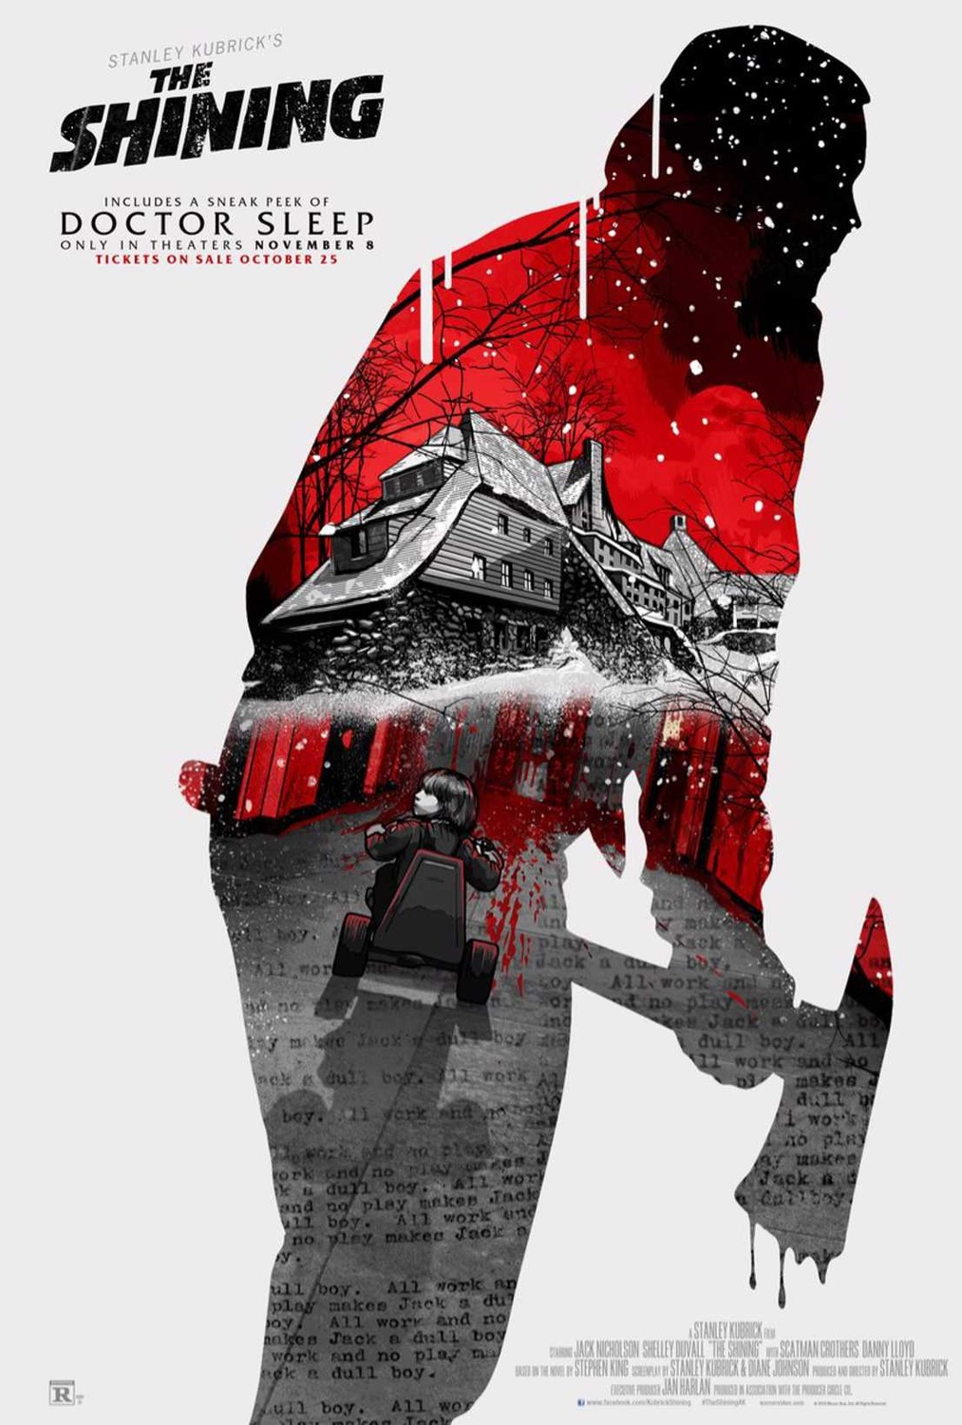
Poster Source: https://www.reddit.com/r/movies/comments/d8dllg/poster_for_the_rerelease_of_stanley_kubricks_the/
This is a re-release of The Shining poster because of the sequel, Doctor Sleep (released October 2019).

Semiotics is ‘the study of signs, signification and signifying systems’ (Stam, Burgoyne and Flitterman-Lewis, 1999, p. 1) – essentially a visual language that is written through signs and symbols. It can be found anywhere there is people in the world and each culture has different interpretations of what these signs and symbols mean. Anything can be a sign or symbol, it is simply ‘something… …that stands for something else’ (Danesi, 2004, p. 4).

Colour is a very good example of semiotics; for example, to me, the colour red means love, danger, stop, passion, bad and blood. Why do we associate this colour with these things? Because in our Western culture, that is how the colour red is presented in the media we are constantly surrounded by. Red is the colour of roses and hearts on valentine’s day yet also the colour on warning signs and traffic lights.

The collage effect and the fact it’s an artistic representation is gives a tangible representation of inside Jack’s head. Showing him in silhouette represents that everything is happening inside his head and no one can be quite sure what is real.

The colour scheme is simplistic, amplifying the images and reflecting the colour palette of the film:
- The colour red means blood and danger. It’s a warning of what is to come and to stay away.
- The colour white acts as blank space (important in any image) as well as representing the snow that isolates the family in The Overlook hotel.
- The colour black represents death and decay – the death of Dick Hallorann and Jack and the decay of Jack’s mental state.

Intertextual references:
For example, the axe (and blood dripping off it) is a typical prop in the horror genre, this denotes to the viewer that it is a Horror Film, as does Jack’s hunched figure as a typical madman pose.
The narrative here is internal turmoil.
The towering combined low-angle and Dutch-angle of the hotel is typical within the Horror genre. The low angle is used to intimidate the protagonists while the Dutch-angle makes everything feel off-kilter. It looks like the typical creepy haunted house.

Polysemous:
The meanings associated with the poster now may change when viewers watch Doctor Sleep because it may change their perspective on characters, locations and events.

Imagery from The Shining may be interpreted differently now than when it first came out in 1980. The Shining is supposedly the first proper Horror film, so the axe-murdering-made-man was lesser known to viewers, having more of an impact on them than today’s Horror immune viewers. The visuals were more shocking then than now and they set a standard for the horrors to come.

Metonym:
In this context, the metonym is the snow and silhouette with its contents.
The snow is in place of Jack’s surroundings; the silhouette of Jack, stands in for Jack; and the contents of the silhouette make up the contents of what Jack becomes.

The viewer decodes it as a warning of events to come – that Jack is spiralling into madness.

In conclusion, my understanding of the image has gone from something that, as a fan, I thought looked pretty cool and was a good update on the original poster to a much deeper understanding of the psychology of the artwork. It is full of foreshadowing of what is to come and is deliberately set up to reflect the mental state of the antagonist.

Bibliography
Stam, R. Burgoyne, R. and Flitterman-Lewis, S. (1999) New Vocabularies In Film Semiotics. London: Routledge.

Danesi, M. (2004), A Basic Textbook in Semiotics and Communication. 3rd edn. Ontario: Canadian Scholars’ Press Inc.

Task Two: Manifesto (Julia’s Task)
My manifesto:
- A director must be fair and will not tolerate any discrimination of any kind.
- Crew and cast are to be treated with the respect they deserve.
- A director must not make their political views known.
- The relationship between director and actor/s is important. Don’t fuck it up.
- A director must always take a specific acting approach or approaches and make these clear to all who it is relevant to.
- Experimentation in planning and rehearsal right up to post is key.
- Theatre practitioners are just as important as film practitioners/auteurs when it comes to creating a story.
- All directors should take some sort of acting classes or workshops to gain an understanding of what the actor is required to do.

I’m going to focus on three of my points and break down the meaning/reasoning behind them. What do they mean for me and my practice as a film maker?
1. The relationship between director and actor/s is important. Don’t fuck it up.
It is the role of the director to bring out the best in their actors. Clear communication is imperative, as is respect. The rehearsal process is key to developing a good relationship with the actors. It ‘is an opportunity to begin developing a rapport.’ (Irving and Rea, 2006, p.129). This rapport is the difference between a good performance and an outstanding performance; a difficult production period and an easier production period. A good director will talk to the actor and figure out what makes them tick.

If you ‘fuck it up’ you risk ruining your reputation because everyone will say, don’t work with her because of this and this. Just as bad, if you do mess up, you risk making a bad film; from a financial point of view and a career point of view, you’ve wasted time and money, might not profit and stay stagnant on the career ladder, if not taking several steps backwards.

2. Experimentation in planning and rehearsal right up to post is key.

A director must have an open mind when working with the production crew and cast. When rehearsing, things happen that weren’t planned for, mistakes are made, energy and interpretation from the actors brings the story to life. ‘The purpose of rehearsal is not to “nail it” but to get ideas about what will work in front of the camera.’ (Weston, 1996, p.247)

This is why a ‘director must be a politician, technician, storyteller, and artist.’ These are all abilities needed to bring the story to life. A director is not simply a storyteller, but a people manager, a negotiator, provider of solutions and a queller of differences of opinion.

Planning is key to provide substantial rehearsal time, yet plans must be flexible and ever-changing as and when needed. Ample time should be allowed for each task where possible while, scheduling tightly enough to stick to budget. It is an experimentation in itself to get this balance right.

3. All directors should take some sort of acting classes or workshops to gain an understanding of what the actor is required to do.

A director must, to fulfil his potential, have at least some acting experience to allow him to step into the actors’ shoes and see things from their perspective. Because ‘It’s hard for a director who has never acted to understand it’s magnitude.’ (Weston, 1996, p.8) This will make the director more empathetic; allow him to understand what is achievable and also better able to direct the actor.
It is important as a director
‘At one period of his growth, he should force himself on stage or before the camera so he knows this experientially, too.’ (Weston, 1996, p.49)

In my personal experience, some of the best directors rarely need to demonstrate how they want something done, but instead use their acting experience and acting methods (such as Stanislavski, Brecht and Artaud) to encourage the actor to find his/her own way fitting with the story being told.

Bibliography
Weston, J. (1996) Directing Actors . Laurel Canyon Blvd: Michael Wiese Productions

Weston, J. (1996) Directing Actors . Laurel Canyon Blvd: Michael Wiese Productions

Dancyger, K. (2006) The Director’s Idea. Oxford: Focal Press

Irving, D.K. and Rea, P.W. (2006) Producing and Directing the Short Film and Video. 3rd edn. Oxford: Focal Press

Task Three. (Jon’s Task)
What was happening to influence the creation of the work when it was made?
YungBlud is a musician on the cutting edge of modern punk-rock with a new flavor. He started out as an artist in 2017 according to Wikipedia, releasing his first album 21st Century Liability in 2018.
(Wikipedia, 2020).

Inspired by today’s youth, his generation (Generation Z) brings to light the struggles of today’s misunderstood youth and challenges the preconceived ideologies of gender and sexuality.

When Yungblud began making music, the world was finally accepting and normalizing that gender and sexuality cannot be defined as heterosexual males and females. He rose to the scene of our enlightened generation and ‘pushes, leap-frogs or bulldozes boundaries’ (Stichbury, 2019, p. 39), diving in headfirst.

At the time (and still now) sadly not everyone is open to the idea of LGBTQ+ (Lesbian, Gay, Bi-sexual, Transgender, Queer and more).

At this time the youth of today were (and still are) underrated (as he sings in his song Hope for the Underrated Youth); seen as lazy, ignorant and self-obsessed by our parents and grandparents. Our generation is often seen as disinterested in politics and over qualified in low level jobs due to ‘a belief that to succeed, you need to go to university’ (Bearne, 2019). We are seen as shallow ‘more narcissistic and selfish’, (Jarret, 2017) but that just isn’t true. We are a new generation who express ourselves and are fluid in our identities regarding gender, sexuality and our fashion statements.

YungBlud challenges these topics in his music, giving his fans the chance to be listened to and understood and (one hopes) to enlighten those with a fixed traditional mindset.

What was the work and how did it fit in, or stand out in its time?
YungBlud’s music fits perfectly into our generations’ need for understanding. We’re not like our parents, we express ourselves more than ever through our visual self-expression and the causes we stand behind. We explore our sexuality and break away from gender roles, redefining social conventions of love, sex and gender and, overall, heterosexual identities that have been held for millennia.

It stands out from other popular music because it deals with the harsh realities of life and doesn’t fit into the stereotype of a typical young, male, pop-artist – he is 100% for ‘individuality and freedom of expression’ (Stichbury, 2019, p. 40). Rather than the perfectly groomed, faced appeal often seen in boybands, YungBlud favors skirts, minidresses, tartan trousers and straight jackets. Add wild hair and heavy eyeliner and you have a unique take on traditional punk-rock.
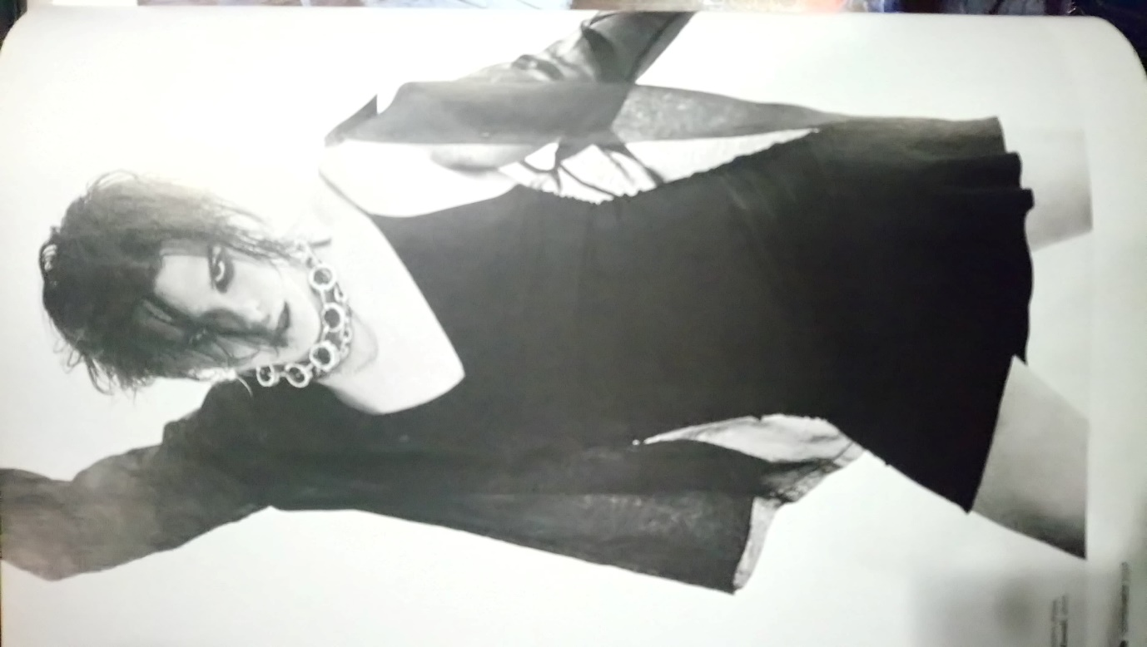
YungBlud breaking gender stereotypes with his fashion choices and song lyrics.
(Yoan, 2019)

What impact did the work have, and does the work have today? (Including the impact upon you of course).

YungBlud gives a voice to our generation. We feel we’re not alone. In his song Parents, he sings about how ‘parents ain’t always right’ and how we’re different to them – we’re open to change, open to experimentation. We love differently, learn differently and fight for what WE believe in.

For me personally, YungBlud speaks straight to my heart. His songs about mental health, sexuality and identity couldn’t be more apt.
Music effects our ‘physiology, movement, mood and behavior’ (Hallam, 2008, p. 65) and for me personally, the lyrics of Medication hold a particularly strong connection for me due to my own mental health battle while Parents rings true about the issues I’m dealing with regarding my own family.

Bibliography:
Stichbury, T. (2019) ‘Blud and Thunder’, Attitude, 09, pp. 39-40.
Yoan, O. (2019) [photograph] (04/01/2020)
Wikipedia (2020) Wikipedia. Available at: https://en.wikipedia.org/wiki/Yungblud (Accessed: 01 January 2020)
Berne, S. (2019) ‘University isn't for everyone: alternatives to going through clearing’, The Guardian, Available at: https://www.theguardian.com/education/2019/aug/10/university-isnt-for-everyone-alternatives-to-going-through-clearing (Accessed: 01 January 2020)
Jarret, C. (2017) ‘Millennials are narcissistic? The evidence is not so simple’, BBC FUTURE, Available at: https://www.bbc.com/future/article/20171115-millenials-are-the-most-narcissistic-generation-not-so-fast (Accessed: 01/01/2010)
Hallam, S. (2008) Music Psychology in Education. 2nd edn. London: Institute of Education

