PassMyFundedAccount.com
BUSINESS PLAN
Prepared by:
Jonathon Forshaw

TABLE OF CONTENTS

Introduction
Financial Information:
Marketing:
  - How will you market your business?
  - What is your USP (Unique Selling Point)?
  - PEST and SWOT analysis
  - Competitor Analysis
  - What is your specific market segment?
  - Who, what, where are you targeting?
  - What is the size of your market?
  - Marketing objectives
Revenue and Pricing Strategy:
- How did you arrive at your pricing strategy?
- How much will you charge for your goods and services?
- How many income streams will you have?
- How much will you get from each income stream?
Operations
- How much will you get from each income stream?
- Locations, premises, equipment
- Production and distribution processes
- People, staff, suppliers
- Systems and processes
- Health & safety, legal compliance
- Executive summary

Introduction
The business, PassMyFundedAccount.com will be a financial advisory and training company dedicated to assisting aspiring forex traders in passing the proprietary trading firms' rigorous evaluations. These firms typically require potential traders to pass a trading test, during which they must show profitable trading over a defined period without breaching any risk parameters set by the firm. The passing of this test ensures traders can manage real money in the actual forex market.
Financial Information
- How many customers or products sold do you need to break even? – I only need one.
- What is the ideal number of customers/products sold you need to make a comfortable living? – having around 25 clients would be a great outcome
- What is the maximum number you can accommodate per session/for size of establishment/per day/week etc.? There’s is no maximum, its infinite scalable as we would just purchase new computers for every 10/15 clients.
- How much profit do you need to make for the business to be sustainable? 1 customer as its home based.

These figures below are on gaining 5 new customers per month.

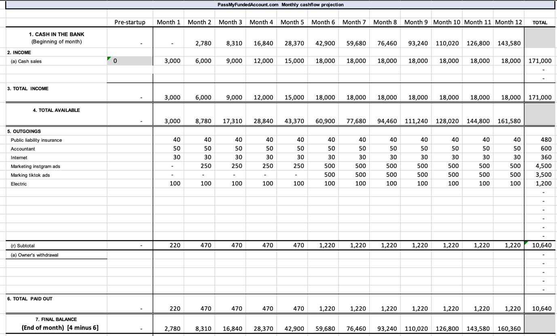

Business Idea
PassMyFundedAccount.com will provide an array of services, including:
- Providing automated trading algorithms to help clients perform better in their evaluation.
- Offering post-evaluation support to help clients maintain their accounts and making money moving forward.
- Charging 15% percent of everything the EA makes for the investor ongoing.

Legal Status
PassMyFundedAccount.com will be registered as a Limited Company (ltd). This type of offers the owners to be protected and give credibility, which can be crucial in financial fields like forex trading.
Owner – Management Team Details
PassMyFundedAccount.com will be owned and managed by Myself, Mr. Jonathon Forshaw. I’m forex trader with 4 years of experience in the trading Gold, GBP/USD. My proficiency in trading has been sharpened by years of working for various proprietary trading firms, and I have extensive knowledge of their evaluation processes. I will be in control of the EA and motoring its actions within live trading.

Product / Service Details
PassMyFundedAccount.com products and services are designed to pass proprietary trading firms tests to gain funding to trade with:
- Trading Tools: Provision of useful tools like charts, indicators, and potentially automated trading algorithms that can help improve trading decision-making.
- Post-Evaluation Support: Continuous guidance even after passing the evaluation, ensuring clients maintain profitable trading habits in the live forex market.
We will ensure that its operations are transparent, ethical, and completely in line with our moral compass.

Location and Facilities

Internet is a crucial part of this business and having 1gps (1000mbs) speed in my home, with a high ping rate (better execution times) will play well for the service. Later, once the business has made money through passing peoples challenges, then we can look at office space.

Internet

The speeds needed will be expensive in a serviced office place due to it being on a commercial internet.

MARKETING STRATEGIES

I will be likely targeting individuals who are interested in Forex trading, particularly those who have a lack of skills to pass or have the time to do it as they have a 9-5 job.

- Content Marketing: Content marketing is a very effective strategy for attracting and educating our target audience.
- SEO: Search engine optimization is key for attracting organic traffic to our website. We will optimize the content for relevant keywords related to Forex trading and funding challenges.
- Social Media Marketing: Use platforms like Facebook and Instagram.
- Email Marketing: Build a mailing list by offering a valuable resource for free (like a guide to Forex trading or tips for passing a funding challenge).
- Partnerships: Partner with Forex trading educators and influencers in the Forex community.
- Paid Advertising: Use Google Adwords, Facebook Ads, LinkedIn Ads, or other relevant ad platforms to target our audience. Our ads could focus on the benefits of the funding challenges, success stories of traders who've been funded, or other relevant selling points.
- Affiliate Program: Consider setting up an affiliate program, where people get rewarded for referring successful traders to our funding challenge services.
- Webinars and Live Events: Host educational webinars or live events that provide value to our audience. We might offer a webinar on strategies for passing a funding challenge or host a live Q&A session with a successful Forex trader. At these events, we can also promote the funding challenge service.

Unique Selling Point
No one else has our software so our USP is that no one else can do what we do. There are other companies out there, but most do it manually and not through a EA.

PEST ANALSIS

- Political
  - Regulatory Environment: The Forex market is subject to various rules and regulations, which vary by country. Changes in these regulations can impact your company.
  - Taxation Policies: Tax laws and policies related to Forex trading profits can affect the appeal of such a funding challenge.
  - Political Stability: Instability can impact the Forex market and influence the success rates of traders.
  - Trade Relations: Forex trading relies heavily on international trade relations. Tensions or disputes can impact the market's volatility.
- Economic
  - Economic Cycles: Recessions, booms, and other economic cycles can affect Forex markets and the performance of traders.
  - Inflation Rates: Changes in inflation can impact currency values, influencing trading strategies and success rates.
  - Interest Rates: Fluctuations in interest rates can cause significant movements in Forex markets, impacting the success of traders.
  - Market Demand: The appeal of Forex trading and interest in funding challenges can be influenced by the overall economic environment.
- Social
  - Education Levels: The degree of understanding of Forex trading in the target audience can impact the number of eligible and interested participants.
  - Attitudes Towards Risk: The willingness of the target audience to take risks in trading can affect participation rates.
  - Trust in the Financial Market: Recent scandals or crises could affect people's willingness to participate in Forex trading.
  - Changing Work Patterns: With more people seeking alternative income sources or working remotely, there might be increased interest in Forex trading.
- Technological
  - Trading Platforms: The quality and ease of use of Forex trading platforms can impact the performance of traders.
  - Technological Infrastructure: Access to reliable internet and technology is crucial for Forex trading.
  - Information Access: Technology affects how quickly traders can access and respond to changes in the market.
  - Automation and AI: The rise of automated trading systems could become the norm, and more competitors.

SWOT ANALSIS

- Strengths
  - Unique Business Model: Providing funds to successful Forex traders is a unique business model that differentiates your company from others in the market.
  - Expertise: If your team has strong expertise and experience in the Forex market, that's a major strength.
  - Strong Network: Having a network of successful Forex traders who have passed your challenge and gone on to generate profits can be a powerful selling point.
  - Technological Infrastructure: If you have a strong tech platform that makes the process of participating in the challenge and trading smoothly, that would be a strength.
- Weaknesses
  - Regulatory Hurdles: As mentioned in the PEST analysis, the Forex market is heavily regulated. Navigating these regulations can be challenging.
  - Dependence on Trader Performance: Your profits are largely dependent on the performance of the traders you fund, which can be risky.
  - Market Perception: Forex trading is often perceived as risky and complex, which can make it challenging to attract participants.
  - Financial Risks: Since you're providing the funds for trading, you bear the financial risks if a trader loses money.
- Opportunities
  - Growing Interest in Forex Trading: With the increasing popularity of remote work and online income generation, more people might be interested in Forex trading.
  - Educational Services: You could expand into offering educational services to help more traders pass your challenge.
  - Partnerships: There may be opportunities to partner with Forex educators or influencers to promote your challenge.
  - Technological Innovation: Advancements in technology could present opportunities for improving your platform or trading strategies.

- Threats
  - Regulatory Changes: Changes in regulations can pose a threat to your business.
  - Economic Instability: Economic instability can impact the Forex market and, by extension, the performance of the traders you fund.
  - Competition: There may be other companies offering similar funding challenges, or other ways for traders to get funding.
  - Technological Risks: Risks related to cybersecurity or technological failure could pose threats to your business.

Competitor Analysis
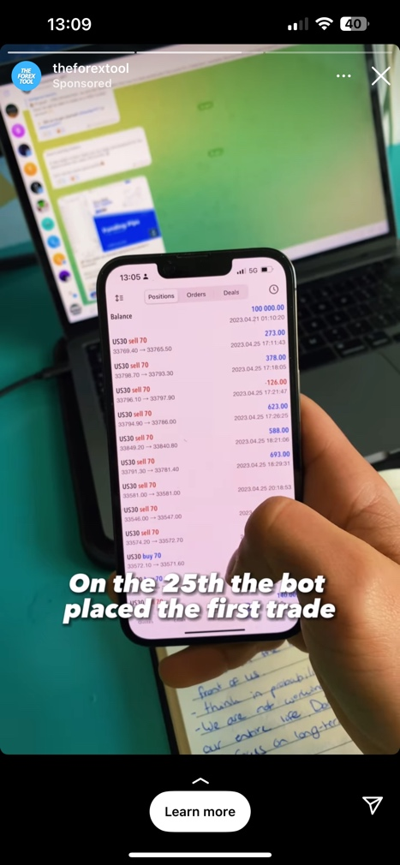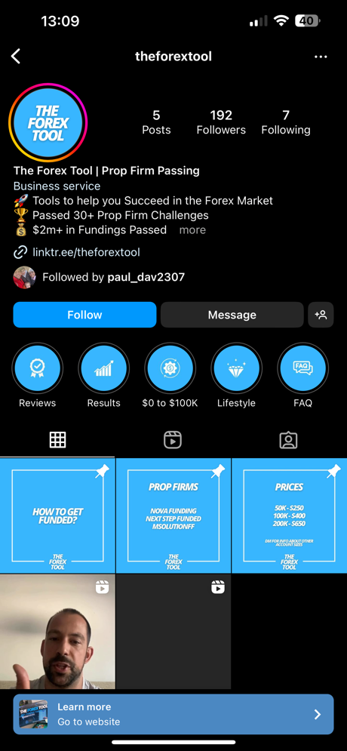


What is your specific market segment?

- Demographic Segment: The demographic could be adult individuals of any age, but likely to be in the age group of 18-40. Education level might be high, given the complex nature of Forex trading, but not necessarily.
- Geographic Segment: The geographic segment could span across the globe.

Who, what, where are you targeting?

- Who: The company is targeting aspiring Forex traders who have the skills but lack the financial resources to effectively trade.
- What: The company is offering funding to these individuals to enable them to participate in the Forex market.
- Where: Given the global nature of Forex trading, the company can target individuals worldwide. However, they may choose to focus on certain regions based on various factors such as the popularity of Forex trading, economic stability, and the regulatory environment.

What is the size of your market?

The Forex funding challenge segment specifically, as this is a very niche market and comprehensive data may not be readily available. However, from the image below there are over 80m to 94m people on Facebook that are interested in investing.
The Forex funding challenge market is only a small fraction of this total market. It includes aspiring Forex traders who are looking for funding and investing long term, as well as established traders who want to leverage additional funds to increase their potential profits.
To get a better estimate of the market size for Forex funding challenge companies, we can find more data, primary research shows that only around 4% of forex traders are obtaining funded accounts. Out of that 4%, only 1% of traders that started the challenge will be trading on the funded capital for the long term.
My forex funds is a large company that funds traders: https://myforexfunds.com/myforexfunds-february-statistics/
They currently have 37,000 active live funded accounts as of February 2023. This is one prop firm. There are around 40 company’s offering these funding accounts. The market is big, as it not only people who are in the know of forex but can expand to people who have money and want to invest it and make even more with a low-risk investment.
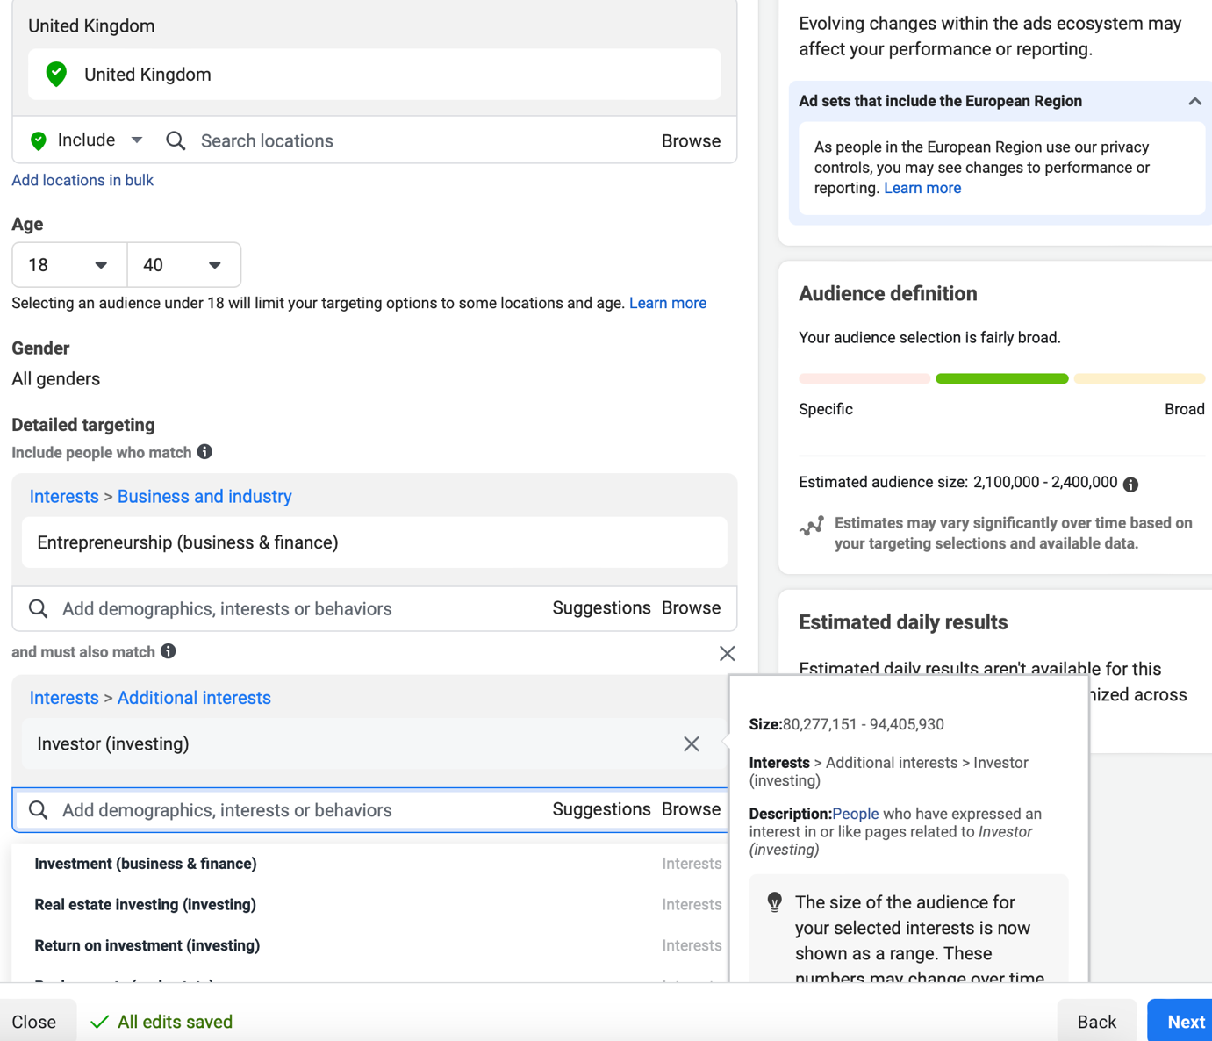

Marketing objectives

Marketing objectives for us would be to increase awareness, attract potential traders, build trust, and ultimately increase the number of traders who pass the funding challenge and generate profits.
- Attract Potential Traders: One key goal would likely be to attract a certain number of participants to the EA.
- Educate Potential Traders: Since the success of the company relies on traders passing the funding challenge, we might have objectives around educating potential traders about the EA and how it was developed.
- Build Trust: Given the financial risk involved in Forex trading, building trust with your target audience is crucial.
- Retain Successful Traders: Once traders pass the funding challenge and start trading with our EA, retaining these successful traders is important for the company's success. Keeping them with us and gaining 15% off the customer per month.

Revenue and Pricing Strategy:

Subscription Model: Our primary source of revenue will be a subscription model where users pay us a recurring monthly fee for access to the EA once they pass. This model provides a steady stream of revenue and allows for better financial forecasting.

Revenue Strategy
Performance-Based Fee: This is a common approach in the financial industry where we charge a fee based on the profits made by the client using our EA. This aligns the interests of our company and the client, as we only make money when the client passes. However, the performance-based fee structure must be clearly communicated and agreed upon with the client we
Management Fee: we are not only providing the EA but also actively managing the clients' accounts, a management fee is acceptable. The 15% fee can be justified by the added value provided by the management services.

Pricing Strategy

One single price

We will offer a fixed fee for the first part of around £600 to pass it. It will then go to Percent based once they have passed the challenge and we help them moving forward on a monthly basis.

How did you arrive at your pricing strategy?

The proposed pricing strategy is based on common practices in the Forex funding industry and the need to balance revenue generation with providing value to traders.
Competitive Pricing: This is informed by the need to stay competitive in the market. We need to price the services in line with or better than our competitors to attract traders.

How much will you charge for your goods and services?

Price for passing it for people will be £600 with no monthly fees.
Once the system has passed, I will then take 15% per month whatever the system makes.

A breakdown

The customer will have the funded account and make $1000 in a month. They receive 80% 20% goes to the prop company. Out of that 80% we then take 15% so they will be left with 65% or $650.

We could also sell the EA to them for a fee of £25,000, potentially. I would not want to go down this route as our USP goes as it’s our main selling point.

How many income streams will you have?

    - Passing the challenge for them
    - Monthly reoccurring fee of 15%
    - Selling courses on how to pass the challenges.
    - One on one mentoring by myself
    - Payment for potential seminars and talks

How much will you get from each income stream?

    - Passing the challenge for them - £597 per person
    - Monthly reoccurring fee of 15% - 15% of what the EA makes per month.
    - Selling courses on how to pass the challenges. - £397 per course
    - One on one mentoring by myself - £3000/5000
    - Payment for potential seminars and talks – Not sure what the rate is but could be anything from £0 to £10,000.

Operations

Locations, premises, equipment
The business will be located from my home for now, once the business makes money, I would look for suitable offices within Wales to hold the computers and have a office presence.

The PCs are my own and only need 3 to start, which I have already.

Production and distribution processes

People, staff, suppliers

No staff would be needed until the business is at a significant level. There are no suppliers.

Systems and processes

Systems
- Trading Platform: We will be using the Metatrader4 platform that’s been around for years. It’s a solid platform to run the EA on.
- Risk Management System: This system will monitor the trades being made by the EA the system has parameters in order not to breach the program.
- Payment System: A secure and reliable payment system to handle subscriptions and other financial transactions.

Processes
- EA Assessment Process: This involves evaluating the skills and strategies of the EA. This process must be robust, fair, and transparent to attract traders.
- Risk Management Process: This process involves setting risk parameters for the EA, monitoring trades to ensure compliance, and taking necessary actions if risk parameters are not breached.
- Customer Support Process: This process involves responding to customer inquiries and support requests, resolving issues, and providing general support customers.
- Marketing and Sales Process: This process involves promoting the EA, attracting new customers, and managing the company's brand and reputation.
These systems and processes should be continually evaluated and improved to ensure they remain effective and meet the needs of the company moving forward.

Health & safety, legal compliance

Health & Safety

- Cybersecurity: Given the digital nature of this business, cyber threats can pose significant risks. It's essential to have robust cybersecurity measures in place to protect the systems and data. This might involve firewalls, encryption, two-factor authentication, and regular security audits.

Legal Compliance

- Data Protection: Forex trading involves handling sensitive personal and financial data. Compliance with data protection and privacy laws, such as GDPR in Europe, is essential. We will need systems and processes to protect data and uphold individuals' privacy rights.
- Financial Regulations: Forex trading is heavily regulated in many countries. We will need to comply with all applicable financial regulations in the countries where you operate. This might involve licensing, reporting, and other requirements.
- Anti-Money Laundering (AML) and Counter-Terrorist Financing (CTF): Financial institutions are required to have measures in place to prevent and detect money laundering and terrorist financing. This might involve Know Your Customer (KYC) checks, transaction monitoring, and reporting suspicious activities.
- Advertising and Marketing Laws: Any promotional materials or claims about our EA must comply with advertising and marketing laws, which typically require that advertising is honest and not misleading.
- Contract Law: When traders sign up for the EA, they'll typically enter a contract with our company. It's important that these contracts are legally sound and enforceable.

EXECUTIVE SUMMARY

PassMyFundedAccount.com is revolutionizing Foreign Exchange (FX) trading by combining Expert Advisors (EAs) with AI technology.

Our EA system provides an edge in volatile markets by automating trading operations. Our analysis includes market trend analysis, predictive analytics, real-time trading decision support, and optimal automated trade execution. These techniques boost profitability and operational efficiency.

Our sophisticated risk management methods protect traders. EA algorithms continuously monitor market trends, risks, and opportunities, helping traders make informed decisions and efficiently manage their portfolios. This strategy ensures long-term profitability and sustainability, protecting traders from market instability.

Our EA can also find patterns in massive trade data, highlighting profitable opportunities that manual analysis may miss. Our EA-driven platform accentuates algorithms and automation. The EA system customizes trading ideas and techniques to individual trading habits and preferences.

PassMyFundedAccount.com transforms foreign currency trading platforms. Expert Advisors are helping us reinvent trading.

