Emily Brown (1900471)

Module Title:
Cycle 1 – Researching the Learning: What, How and Why am I Teaching?

Module Code – ECAD4010-C

Assignment Title:
A critical analysis and evaluation of the observation research tool, ‘Leuven Scale’.
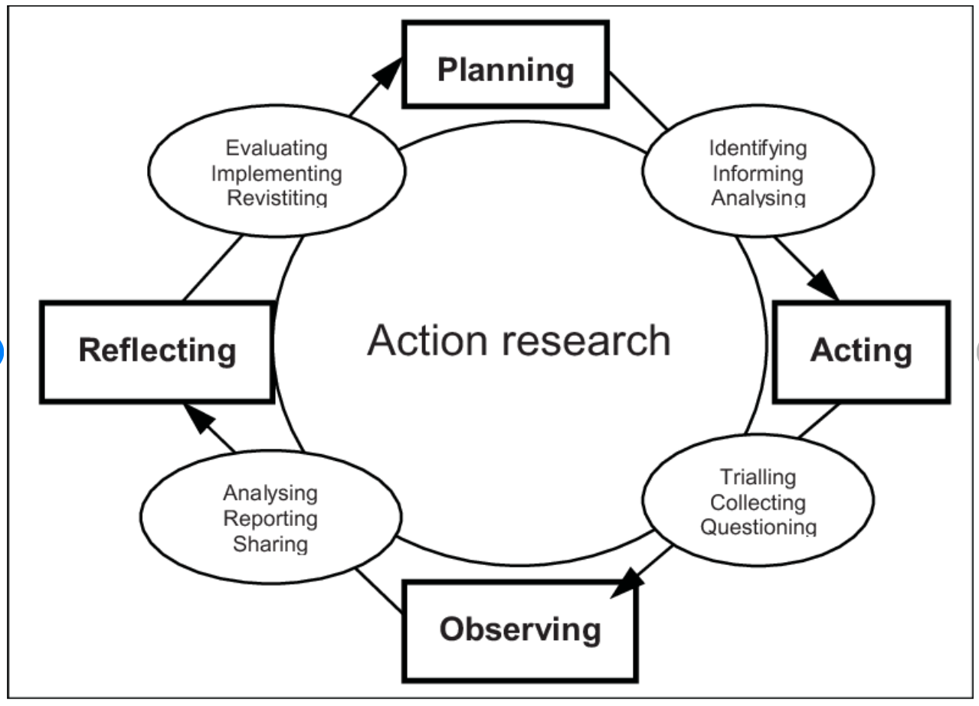
(ResearchGate, 2020)

Module Lead – Alison Evans

Targets

Targed/Target 1 | To ensure all references are accurate and follow the Harvard referencing protocols. Every single document or author mentioned should be followed by a reference. Each reference should then be placed in alphabetical order within the Reference List.
Targed/Target 2 | To ensure you support your views with reference to appropriate literature. Before each assignment, use the module reading list (found within the Module Handbook) to guide your choice of literature.

I intend to analyse and evaluate the “Leuven Scale” as a research tool whilst observing video 4 – “To what extent does a focus group provide opportunities for pupil involvement and learning?”. In this video, both boys and girls in Reception class are sitting opposite their teacher on the carpet. The objective is to sort shapes according to whether they are 2 dimensional or 3 dimensional. Notably, the resources: wooden shapes, laminated shapes and sorting hoops were minimal, so not to overwhelm the children with multiple resources in an introductory activity into 2D and 3D shapes. The cross-curricular activity includes mathematics and science.

Carpets are a familiar learning environment for children (Bird, S. 2015). From experience in Foundation Phase classrooms, I discovered children are engaged during ‘carpet time’ and often reluctant to sit at tables, knowing it meant work rather than play-based learning (Kraus, M,2012). However, I understand table-top learning is more appropriate for written-work.

Literature Review – Pedagogy
Foundation Phase, learning is dependent on practitioners use of pedagogical principles. Schools should offer “exposure to the widest. Curriculum and the most powerful experiences will be much more likely to help children discover their passions and identifying their personal strengths” (Barnes, 2015). Pollard (2010) referred to pedagogy as “art and craft of teaching”, integration of learner knowledge, experiences, intuition and environment. Qualified Teacher Status standards emphasises the importance of teachers having secure subject knowledge in addition to understanding pedagogical principles. This involves remaining up to date with research, and training in order to deliver a wholesome curriculum.

A 2017 Estyn report: “Encouraging independent and inquisitive learners in the Foundation Phase” showed significant development in pupil progress, emotionally and academically after implementing these measures. In Foundation Phase, the 7 Areas of Learning are vital in ensuring children have good social and academic abilities primed for development throughout their education. Department of Education states, a teacher must: “set high expectations which inspire, motivate and challenge pupils” (Gov, 2011). In 1968, Rosenthal and Jacobsen established the “Pygmalion Effect” - “the expectations teachers have of their students inevitably effects the way that teachers interact with them” ultimately leading to changes in children’s behaviour and academic performance (TeacherToolKit, 2017). Positive expectations improve academic performance however the opposite is also true. The “Pygmalion Effects” theoretical counterpart is the “Golem Effect”. In 1982, Babad, Inbar and Rosenthal published a parallel theory stating negative expectations adversely affect childrens academic performance and well-being (Purple Orange, 2019). The Leuven Scale suggests connections between well-being and involvement, reinforcing both theories.

Teachers develop learners existing knowledge through experiential teaching and learning methods. Incorporating interests is an effective way to include the Areas of Learning. In my PTE school, an EPIC board helped engage children in new topics. To communicate the children’s questions and knowledge, focus groups (1:12) were used to hear the children in a controlled way.

Curriculum 2022 outlines Donaldson’s 12 pedagogical principles based on a cyclical process of identifying primary pupil needs, matching those needs to pedagogical approaches and an assessment of teaching approaches through observing pupil progress.

Foundation Phase pedagogy revolves around 4 learning environments. (Appendix 1)
- Continuous provision
- Enhanced provision
- Focused provision
- Outdoor learning

Need for Research
John Hattie established “Visible Learning Research Model” to report learning approaches with the greatest impact. The model clearly demonstrates the influence of teacher efficiency and clarity coupled with parental/guardian involvement and pupil responses to learning and intervention.

The core aim of educational research is to improve practitioners understanding of teaching and learning whilst seeking to benefit others and avoiding physical and emotional harm. Educational research is undertaken varying people for example; higher education learners, lecturers, organisations, medical and subject area specialists and learners - capable of undertaking their own learning enquiries. Researcher’s approach a topic depends on their view of the world – a paradigm, meaning “a set of assumptions and perceptual orientations shared by members of a research community” (Sage, 2008). Negative impacts on research include; bias - a higher/lower academic group was chosen to help achieve desirable outcomes and, holding stereotypical views; girls are more academic than boys, could make for unreliable research.

Methodology
Developed by Ferre Leuven, the ‘Leuven Scale’ is a form of assessment allowing practitioners to measure children’s levels of well-being and involvement. High levels of well-being show the child is comfortable and confident while those with low levels of well-being appear frightened, anxious, and dependent. High levels of involvement are characterised by curiosity and genuine displays of interest in the activity, with low levels being indicated by regularly being distracted, displays of unease and appearing down. The Leuven Scale is determined by five-points; extremely low, low, moderate, high and extremely high, each with identifiable descriptions and characteristics. Making observations and action-plans easier to compile. (Cheqdin, 2020)
Positives | Weaknesses
Assessments of specific children who have displayed low signs of well-being and involvement | Done regularly as children develop quickly
Evaluation of learning and teaching – implementing appropriate provisions | A happy child does not necessarily mean that they are being appropriately challenged
Simple – practitioners can concentrate on the children | Repetitive nature, may mean the observation is not taken seriously

An Estyn report outlines main reasons for observation in education giving first-hand evidence about the quality of teaching and learning. Observation allows the opportunity for teacher appraisal, curriculum assessment, and observing learners in their environment. For example; where children spend their time; why do they spend more time in roleplay and not outdoors? Clearly indicating outdoor learning must be enhanced. Observation can be used to share effective practice among staff. Although important that staff have an awareness of all subject areas, some teachers have particularly effective ways of teaching topics. Observing teachers will help another improve their teaching approaches (Estyn 2014).

Before designing my observation schedule, I evaluated those of prior University students. I chose to observe video 4 - focus group learning. I spent time planning and delivering this during placement. A table to display children’s level of well-being and involvement was used in accordance to the Leuven Scale. I chose to record my observations at 1-minute intervals over the 3-minute period and record children’s level of well-being and involvement at the beginning of the activity to further assess their development. Well-being was recorded using colour-coded numbers and involvement in written form. (Appendix 2).

Discussion and Findings
“Ethics are sets of moral principles or norms that are used to guide moral choices of behaviour and relationships with others” (Gray, 2018). Before researching, ethics must be considered, each organisation will have their own research ethics code of practice. BERA (2019) published guidelines regarding considerations and responsibilities researchers have to participants including their right to privacy, to withdraw, protection from both physical and emotional harm and consent/assent. Informed consent can be provided by anyone over the age of 18 who has been informed of the research aim, signed a consent form and told associated risks. Assent describes a young person’s willingness to participate in research. Although not old enough to give ‘consent’, children must still be made aware of the risks, expectations and purpose of the research (Pyle and Daniels, 2015). In Foundation Phase, gaining assent could be done by asking the children to choose a red or green band to symbolise their participation. Children should not be left out because they did not give assent, instead they should participate in the activity however, their involvement not documented. Consent and assent are ongoing processes; participants have the right to withdraw at any stage. Their data must be erased.

When researching, names of children, school and staff must not be mentioned. Data must be managed with confidentiality and anonymity, once collected must be kept securely and anonymised at the source. “Confidential and anonymous treatment of participants data is considered the norm for the conduct of research” (BERA, 2018:21). Participants must be made aware that research will be shared with the appropriate people. For example, research undertaken in University must be brought before the Ethics Board and shared among practitioners. The University of Wales Trinity Saint David has a code of practice for ethical and integral research, it states all research undertaken must be in accordance with agreed standards of good practice. Core aspects of integral research include honesty in all aspects of research; including with participants, rigour – “in line with prevailing disciplinary norms and standards”, when performing research and adhering to protocol and communicating results. “Transparency and open communication” in research and showing respect for all participants in addition to the environment and resources. (UWTSD, 2020)

The word ‘data’ is subdivided into ‘quantitative’ meaning data in the form of numbers and ‘qualitive’ meaning the opposite. “Quantitative researchers typically conceptualise the world in terms of variables (measurable) and study relationships between these variables. Qualitive researchers, by contrast, typically study cases and processes, rather than variables” (Punch, K and Oancea, A, 2014).

Quantitative | Qualitive
Examines relationships between 2+ variables | Exploration of issues/situations
Testing variables in order to determine patterns/trends | Understand people’s beliefs, experiences, attitudes and behaviours
(Evans. A, 2020)

Mixed methods approach whereby researchers collaboratively collate and analyse both qualitative and quantitative data can prove more effective. Mixed method approach ensures the limitations of one approach can be eliminated by another’s strengths.

From my observation, I found 4/5 children began with high levels of involvement. Less involved child became more engaged when asked to do partner-work also displaying extremely high levels of involvement when celebrating the end of the task. ‘Child 3’ displayed extremely low signs of well-being, often fiddling with resources, indicating low self-confidence or discomfort perhaps as a result of being separated from friends. Evidence from research by Springer et al. (1990) conveys “achievement is promoted, attitude towards learning is improved and willingness to work hard is increased” (The Economics Network, 2020). Group work allows discussion, development of problem-solving and communication skills. I think group work lays good foundations for individual work. Introducing a concept to a class is done in groups, then enhanced/focussed provision consolidates this knowledge. Following Vygotsky’s theory on More Knowledgeable Others, children are able to help each other through discussion and observation. Clearly ‘Child 3’ is unsure about the task however after discussing with ‘Child 4’, this changes. Alternatively, individual work helps to promote independence, develop confidence and independent views. ‘Child 3’ agrees with ‘Child 4’s’ suggestion of where the shape belongs. This is referred to as the “Galatea Effect” where a child trusts in their abilities to perform (O’Brian and Rowe, 2002). The teacher reinforces this by praising the child when correctly answering a question.

Conclusion
This module will have numerous implications on my professional development. Most profoundly is my newfound understanding of the link between well-being and involvement in the classroom. As a teacher it is important that pupils receive a wholesome curriculum however this will not transpire if children are not engaged. If children feel negative or unhappy coming into school, their involvement in class will be reduced. A “checking-in” system is popular in schools; children communicate their feelings at varying intervals in the day. If they feel down, practitioners will observe and speak to them to increase their well-being, thus improving their classroom involvement. In my PTE school we did this in Welsh to improve their language skills. My understanding of other theories shows the importance of maintaining professional standards, displaying positive behaviour and having high expectations of children regardless of academic or behavioural history. Research clearly shows links between expectations and results. Due to Coronavirus, we have been unable to attend placement so had to rely on video observations. Although this has posed limitations regarding the inability to speak to children, it allowed us to watch the video numerous times. Ideally, I would participate in the activity alongside the children to observe signs of well-being and involvement in line with the Leuven Scale. However, difficulties in recording data, often mean information is forgotten, resulting in poor/unreliable research. It may be beneficial for more than one person to observe an activity meaning the chances of something being missed is reduced and allows an observer to ask appropriate questions to further assess the children’s well-being and involvement (McLeod, 2015).

A 2018 mixed methods study into the “impact of research practice on professional teaching practice” found educational policymakers should introduce research practice in teachers by offering “supporting context in which they conduct research about their professional teaching practice and students’ learning”. English as Foreign Language teachers are encouraged to read and conduct research to better deal with classroom issues. Applying this to classrooms, research enables practitioners to find solutions to classroom issues in addition to providing them with new ideas and teaching methods. As Allwright (2003) argues, teachers should engage in research to better understand teaching and learning issues. Agreeing with Allwright (2003), Austin (2016) states research underpins professional knowledge, skills and understanding and help develop “self-efficiency and voice within” schools and “within the profession”. After studying the ‘Leuven Scale’, I would like to research the difference table-top and carpet-based learning has on pupil well-being and involvement. Research like this could change the way classroom environments are designed. For reliable research, I would like to undertake research as part of a group, thus allowing for comparisons between year groups and varying abilities.

References:

Austin, R. (2016) Researching Primary Education. Sage Publications Ltd.
Abstract available at: https://uk.sagepub.com/en-gb/eur/what-are-the-benefits-of-educational-research-for-teachers
(Accessed on 6th May 2020)

Barnes, J. (2015) Cross Curricular Learning 3-14 Third Edition. Sage Publications Ltd.

BERA (2018) Ethical Guidelines for Educational Research, Fourth Edition
Available at: https://www.bera.ac.uk/publication/ethical-guidelines-for-educational-research-2018-online
(Accessed on 28th April 2020)

Bird, S. (2015) Seven reasons I like to gather my students at the carpet
Available at: https://heartandart.ca/?p=3285
(Accessed on 11th May 2020)

Blenheim Primary (2014) Reception 2d and 3d shapes
Available at: https://www.youtube.com/watch?v=pjU9EERoZfk
(Accessed on: 1st May 2020)

Cheqdin (2020) What you Should know about the Leuven Scale for Early Years?
Available at: https://cheqdin.com/leuven-scale-for-early-years/
(Accessed on 27th May 2020)

Cogent Education. (2018) The impact of research practice on professional teaching practice: Exploring EFL teachers’ perception
Available at: https://www.tandfonline.com/doi/full/10.1080/2331186X.2018.1480340
(Accessed on 6th MAY 2020)

Estyn (2014) ‘Effective classroom observation in primary and secondary schools’
Available at: https://www.estyn.gov.wales/sites/www.estyn.gov.wales/files/documents/Effective%20classroom%20observation%20in%20primary%20and%20secondary%20schools%20-%20October%202014.pdf
(Accessed on 4th May 2020)

Evans, A (2020) Session 5 – Becoming a Skilled Researcher – Research Questions and Tools

Exploring your mind, (2019) The Golem Effect: Concepts and Characteristics
Available at: https://exploringyourmind.com/the-golem-effect-concept-and-characteristics/
(Accessed on 5th May 2020)

Gray, D (2018) Doing Research in the Real World. London: Sage Publication Ltd (page 70)

GWE (2017), Foundation Phase Pedagogy
Available at: https://www.gwegogledd.cymru/curriculum-support/cyfnod-sylfaen/?lang=en
(Accessed on 27th April 2020)

JFA Purple Orange (2019) Inclusive School Practices Toolkit – The Pygmalion and Golem Effects: how an educator’s expectations are critical to building inclusive school communities
Available at: https://inclusiveschoolcommunities.org.au/application/files/5915/6653/5275/Pygmalion_and_Golem_Finalx_19.08.2019.pdf
(Accessed on 6th May 2020)

Kraus, M. (2015) Desks? Carpet? Free choice? Oh my! How does student placement in the classroom impact learning?
Available at: https://ed.psu.edu/pds/teacher-inquiry/2012/Kraus_inquiry%20revised.pdf
(Accessed on 11th May 2020)

McLeod, S. (2015) Observation Methods
Available at: https://www.simplypsychology.org/observation.html
(Accessed on 1st May 2020)

McLeod, S. (2018) Lev Vygotsky
Available at: https://www.simplypsychology.org/vygotsky.html
(Accessed on 3rd May 2020)

Pichon, C. (2012) ‘Sitting on the carpet – children’s attitudes to the spaces of the classroom’. University of Cambridge
Available at: https://jotter.educ.cam.ac.uk/volume4/001-032-pichonc/001-032-%20Pichonc.pdf
(Accessed on 2nd May 2020)

Punch, K and Oancea, A. (2014) Introduction to Research Methods in Education. Sage Publications Ltd
Available at: https://books.google.co.uk/books?hl=en&lr=&id=sPSICwAAQBAJ&oi=fnd&pg=PP1&dq=Punch.+K.+F.+(2014)+Introduction+to+Social+Research:+Quantitative+and+Qualitative+Approaches.+3rd+education.+London:+Sage+Publications+Ltd.&ots=9w5rd8msib&sig=LE528A541UmTr-GfV4_WL_i3O5M#v=onepage&q&f=false

Pyle, A and Daniels, E (2015). Using a Book to Gain Assent in Research with Young Children – Early Child Development and Care

Teacher Tool Kit (2020) Great Expectations: The Pygmalion Effect
Available at: https://www.teachertoolkit.co.uk/2017/10/31/pygmalion-effect/
(Accessed on 5th May 2020)

The Economics Network (2020) Choosing whether students work individually, in small groups or as a whole group
Available at: https://www.economicsnetwork.ac.uk/handbook/seminars/44
(Accessed on 4th May 2020)

University of Wales Trinity Saint David (2017-2020). Research Ethics & Integrity Code of Practice
Available at: https://www.uwtsd.ac.uk/media/uwtsd-website/content-assets/documents/research/research-ethics-integrity-code-practice.pdf
(Accessed on 4th May 2020)

Walker, R and Solvason, C. (2014) Success with your Early Years Research Project. Sage Publications Ltd.
Available at:https://uk.sagepub.com/sites/default/files/upm-assets/65675_book_item_65675.pdf
(Accessed on: 6th May 2020)

Welsh Government. (2015) ‘Effective use of data and research evidence’
Available at: https://dera.ioe.ac.uk/24313/2/150814-effective-use-of-data-en_Redacted.pdf
(Accessed on 3rd May 2020)

Appendix 1
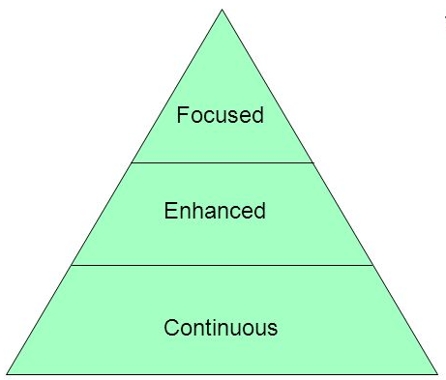

Appendix 2
Complete Observation Schedule:
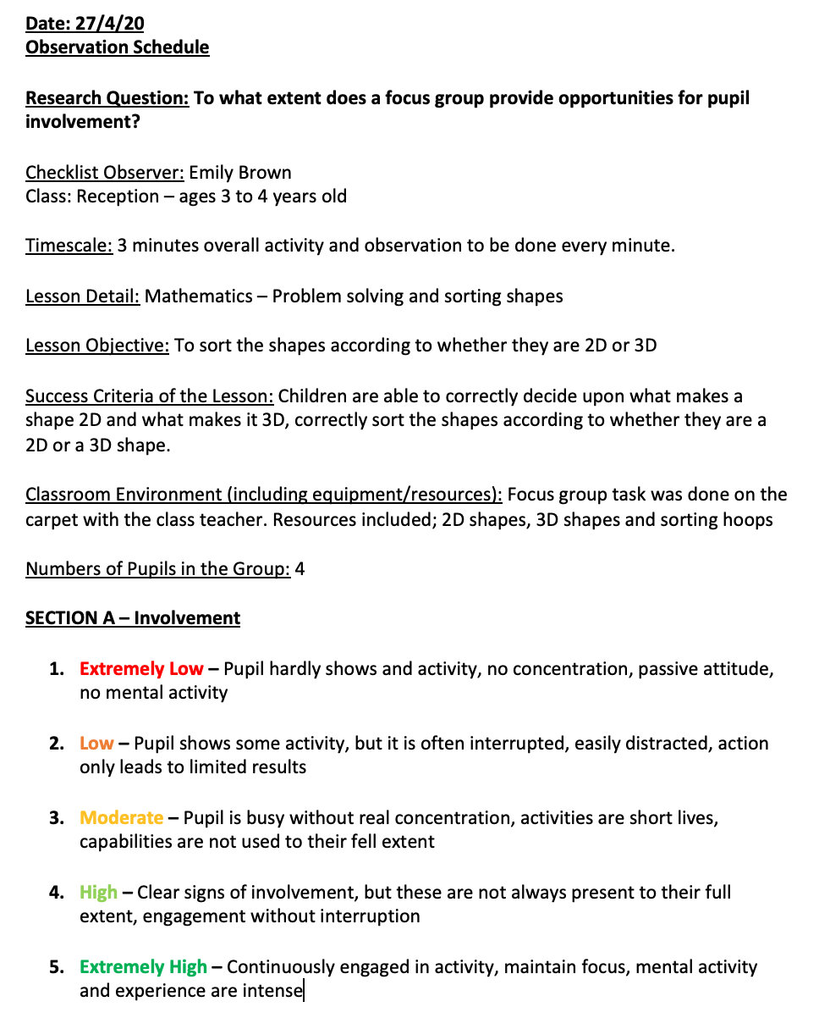

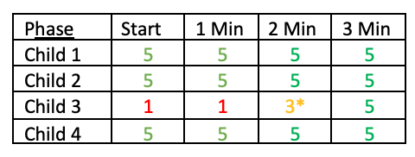

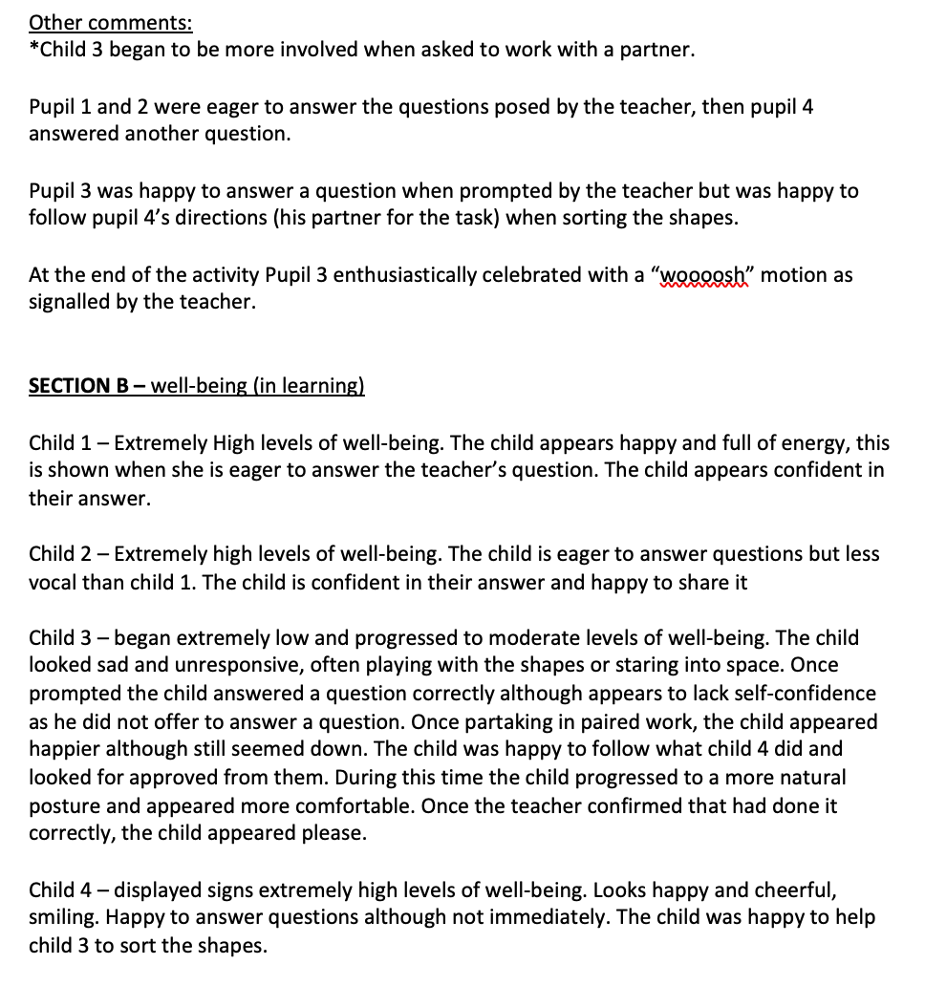

Blank Observation Schedule:


