LEVEL 6 ASSESSMENT SPECIFICATION

Student name: | Katie Gregory | Student ID number: | 1704385
Programme: | BA(Ed) QTS
Module: | Yr Iaith ar Daith 3
Module code: | ECAD6006C | Contribution to Overall Module Assessment (%): | 60%
Lecturers: | Natalie Griffiths / Diane Thomas | Internal Verifier:
Assignment Title: | Present a series of portfolio tasks and professional reflection on the progress made in the development of personal language for speaking, reading and writing. | Word count (or equivalent): | Equivalent – 60%
Submission deadline: | 31st May, 2019; 23.59 | Return date of provisional marks & written feedback: | 1st July, 2019
Submission method: | All written assessments, where practical and possible, must be submitted via Turnitin unless otherwise instructed by the Lecturer. (Please DO NOT put this assessment specification into Turnitin or it will match many similarities with other students’ submissions.)  Alternative submission method (if applicable):  Late submission of the assessment will result in a late penalty mark. Penalties for late submission: Up to one week late, maximum mark of 40%. Over one week late, 0%. Only the Extenuating Circumstances Panel may approve a change to submission dates.
Academic honesty / referencing: | Academic honesty is required. In the main body of your submission you must give credit to authors on whose research and ideas your work is based. Append to your submission a reference list that indicates the books, articles, etc. that you have used, cited or quoted in order to complete this assessment.

This essay will evaluate a Welsh language lesson which has taken place in the Foundation Phase classroom. The first section of this essay will include details of the proposed audience and rationale for the chosen theme and language pattern used in the Welsh language lesson. Section two will contain a written reflection on the Welsh Language lesson, and will introduce literature, which will assist in evaluating the success of the lesson.
Section One- Proposed Audience and Rationale.
The target audience for this Welsh lesson was a reception class. The Welsh Government (2013) outlines the obligation teachers have to ensure Welsh language lessons are exciting and engaging for pupils. Heaney (2012) suggests that for pupils’ to be engaged in language lessons, the teacher must insure the theme is of personal interest to the pupils, while Nunan (1991) furthers this claim stating that they must learn words and phrases they can use in daily conversation. This contributed to the authors choice of language pattern which contained the question ‘beth wyt ti’n gwisgo?’ and the answer using the sentence starter ‘dwi’n gwisgo…..’ during this lesson. The children have also previously learnt about clothing in prior welsh lessons, therefore this lesson provided an opportunity to consolidate and build upon this learning.
Zashchitina and Moysyak (2017) emphasise that when introducing new vocabulary in a second language lesson, it is advantageous if the children have a firm understanding of the subject in their first language. This highlights another reason behind the author choosing the language pattern for this lesson, as this is a subject the children talk about on a regular basis in English. This will help when transferring the vocabulary in to Welsh Language.
As indicated by Cameron (2001) in the primary years, the child is still engaging with learning how to master Literacy skills in their first language, however this provides a fitting time to introduce oracy, reading and writing practise in a second language as skills applied to learning the first language can be easily transferred to learning of the second language. As can be identified highlighted in blue on the lesson plan seen in Appendix 1, the main aims of the lesson was for the children to be able to say the name and colour of items of clothing in Welsh and then putting these in to a sentence orally using ‘dwi’n gwisgo’, as modelled by the teacher. Following this the children were required to write sentences describing what they were wearing, some had resources in order to aid them which can be seen in Appendix 2. These resources acted as a reminder of the names of items of clothing and colours, the children could read the word prior to writing the sentence. The aims therefore indicate that this lesson provided opportunities to use and develop reading, writing and oracy for both pupils and teacher.
Section Two- Reflection on the Welsh Language Lesson.
Khan (2017) suggests that in second language learning, oracy is an essential part of the process in order to lay a foundation for reading and writing as agreed by Clarke and Siraj-Blatchford (2000). The introduction of the lesson provided opportunities for children to recap prior knowledge of the items of clothing and colours in Welsh, McLachlan and Jones (2009) suggests that teachers must be mindful of the quantity of vocabulary introduced at one time. This was considered by the author during this session, there were only 2 items of clothing which were newly introduced to pupils. This was evident as all pupils’ were able to name the items of clothing by the end of the introduction.
During the introduction, when repeating the name of the items of clothing and colour a visual image of the item/ colour was shown to children. Cook (2008) suggests that this is good practise in second language learning as it allows children to link the picture with the vocabulary in their brain, as furthered by Nunan (1991) who claims that this helps in containing information in the memory.
The British Council (2016) communicates that when learning a second language, vocabulary is more memorable when it is learnt in a context which is engaging for the children. The author believes that this is something that may have been a downfall to the lesson, the context of the lesson, although personal and relatable was not particularly engaging and exciting in practice, resulting in some pupils losing concentration. The Welsh Assembly Government (2008) emphasise that role-play is an example of an engaging context for developing Welsh language skills. An example of this that could have been used to support this particular Welsh lesson is a shop role play, where children could try clothes on and use the language pattern, this would have been a more engaging context for the children to learn. Salies (1995) further suggests that learning language through role play aids in preparing pupils’ for conversations in real-life situations. This will be considered by the author as a way to captures pupils’ attention by providing a more engaging context in future Welsh Language lessons.
As spotlighted by Mills and Mills (1993) language learning is more effective when taking place in communicative situations. The introduction of the lesson offered both speaking and listening opportunities for the teacher. The introduction gave the teacher the opportunity to speak in Welsh to the children in order to share key vocabulary, sentence starter and the question. As shared by McLachlan (2009) when speaking in the language being learnt the teachers role is to model correct pronunciation of vocabulary, this was a success of the author when modelling how to pronounce the Welsh words. Munoz (2006) suggests that teacher knowledge about a language is a problem in the teaching of second languages, in future practice the author will ensure that consultation with other teaching practitioners is undertaken to continue to ensure pronunciation is accurate.
In the introduction, pupils had opportunities to practise their speaking skills by repeating key words when shown the picture cards and were asked to practise the language pattern with a partner. As revealed by Barton (2006) and agreed by Baker (2001) in successful language learning, repetition is a key technique used to teach vocabulary in successful language learning. This technique was a success in the Welsh lesson, as it was clear that the repetition aided in children remembering key vocabulary and the language pattern. Clarke and Siraj-Blatchford (2000) adds that repetition of key words is essential in language learning prior to moving on to sentence level, and this was the order used in the author’s lesson, which successfully allowed students to use their knowledge of individual words and string them together in order to make a sentence as the lesson progressed. However, Cook (2008) suggests that repetition may not be a successful technique to use if pronunciation mistakes made by pupils are not instantly corrected by the teacher, this was not evident in the lesson carried out by the author but the awareness of this will ensure it is addressed in future practice.
Tesol (2017) indicates that in order to speak well in a second language, students need lots of opportunities to speak. The Welsh Assembly Government (2008) suggests that to encourage children to use and consolidate their learnt vocabulary, they should be given opportunities to work in small groups or partners. This was evident in the introduction of the lesson where children were encouraged to communicate in the second language with partners using the language ‘dwi’n gwisgo’ and ‘beth wyt ti’n gwisgo?’. As highlighted by Clarke (2009) this not only requires children to speak to one another, but encourages the use of their listening skills. McLachlan (2009) suggests that after such a task, practitioners should allow pupils to show the teachers what they can do. This was implemented in the Welsh lesson, where after practising the language pattern with their partners, the author asked partners to share their sentences with the class. However, the author feels that due to awareness of limited time, this opportunity was not used well-enoug by the author as only two individuals were asked to share. It would have been more beneficial for not only the class, if more partner were asked. As Estyn (2013) spotlight, this is a valid opportunity to develop pupils’ confidence although, this was not used to its full potential within the authors lesson.
The main activity provided opportunities for both teacher and children to develop their speaking and writing in the Welsh language. Garcia (2009) highlights the importance of modelling writing in a new language to the children, this was carried out in the lesson completed by the author. The structure and form was modelled and supported by questions such as, what letter does this word start with? or what word may I write next? in order to gain an understanding of if the children understand how to form the sentence and transfer this in to their writing. However, Garcia (2009) further indicates that in second language learning it is even further beneficial if the teacher explains their thought process whilst writing the sentence, showing thinking such as ‘my next word is dress, what is dress in Welsh?’. This was not evident in the modelling of writing in the lesson which indicates an element that was not as successful as it could have been. This is a technique that the author will use in future practise.
The worksheets for the main task for this lesson can be seen in Appendix 3. The main task required students to write sentences about their what they were wearing using ‘dwi’n gwisgo.’ The differentiation for these sentences are highlighted in green in Appendix 1. Graham et al (2017, p.927) states that in second language learning ‘Vocabulary development also potentially benefits from written input rather than oral input alone’ reflection upon this task by the author, indicates that for some pupils especially those in the higher ability group, the writing task did confirm their knowledge and further benefit their vocabulary development. However, for lower ability pupils of which some are still in the mark making stage of writing and for some pupils that demonstrated in the introduction that they needed further practise using ‘dwi’n gwisgo’ and adding the clothes and colour to the sentence; it may have been more beneficial for these pupils to continue to practise orally rather than moving on to the writing task which simply resulted in confusion for some pupils. However, not providing children with the opportunity to write due to placing an emphasis on oracy may have resulted in the findings indicated by Estyn (2013) which suggest that pupils’ reading and writing are generally less developed than their speaking and listening skills.
The plenary of the Welsh lesson allowed a final consolidation of children knowledge through the use of the game bingo. The description of this game can be seen highlighted in Yellow in Appendix 1.
The bingo game was successful within the Welsh language lesson carried out by the author as it allowed a fun way for the children to consolidate their learning in the lesson, as shared by Estyn (2013) using games may motivate less confident pupils to get involved in group activities where they use the second language. This was evident in the lesson carried out by the author where many of the children who are usually disengaged in plenaries, were focused in order to try and win with their partner. This meant that this was an engaging opportunity for children to use their listening skills in order to be able to cross off the item from their bingo card. It also allowed opportunities for the author to assess pupils by observing who was able to listen and cross off the correct items, and identifying those who need further support.
As can be seen in the reflection, the Welsh language lesson carried out by author had both negative and positive aspects. The author will aim to use the research carried out for this essay in order to inform and improve in future teaching practice.

Reference List
Baker, C. (2001) Foundations of Bilingual education and Bilingualism. Clevedon: Multilingual Matters.
Barton, A. (2006) Getting the Buggers into Languages: How to motivate students to speak, listen, read and write in a modern foreign language. 2nd Ed. London: Continuum International Publishing Group.
British Council. (2016) Content and Language Integrated Learning. [website] Available at: https://www.teachingenglish.org.uk/article/content-language-integrated-learning (Accessed: 25th May 2019).
Cameron, L. (2001) Teaching Language to Young Learners. Cambridge: Cambridge University Press.
Clarke, P. and Siraj-Blatchford, I. (2000) Supporting Identity, Diversity and Language in the Early Years. Berkshire: Open University press.
Clarke, S. (2009) Talking Partners. [website] Available at: https://www.shirleyclarke-education.org/research/talk-partners-2009-year-5-4th-grade-us/ (Accessed: 27th May 2019).
Cook, V. (2008) Second Language Learning and Language Teaching. 4th Ed. London: Hodder Education and Hachette UK Company.
Estyn. (2013) Welsh Language Development in the Foundation Phase. Available at: https://www.estyn.gov.wales/sites/default/files/documents/Welsh%20Language%20Development%20in%20the%20Foundation%20Phase%20-%20January%202013.pdf (Accessed: 22nd May 2019).
Garcia, O. (2009) Bilingual Education in the 21st Century: A Global Perspective. Chichester: Wiley-Blackwell.
Graham, S. et al. (2017) ‘Early Language Learning: The Impact of Teaching and Teacher Factors. Language Learning, 67(4), pp. 922-958. DOI: https://doi.org.ezproxy.uwtsd.ac.uk/10.1111/lang.12251 (Accessed: 27th May 2019).
Heaney, L. (2012) ‘Promoting language learning in the primary classroom and beyond: A case study’ Gifted Education International, 28(2), pp. 161-170. DOI: 10.1177/0261429411434987. (Accessed: 23rd May 2019).
Khan, H. (2017) ESLarticle: The Importance of Speaking in Second Language Acquisition. [website] Available at: http://eslarticle.com/pub/english-as-a-second-language-esl/139477-The-Importance-of-Speaking-in-Second-Language-Acquisition.html (Accessed: 25th May 2019).
McLachlan, A. and Jones, J. (2009) Primary Languages in Practice: A Guide to Teaching and Learning. Berkshire: Open University Press.
Mills, R, W. and Mills, J. (1993) Bilingualism in the Primary School: A Handbook for Teachers. London: Routledge.
Moysyak, G. and Zashchitina, G. (2017) ‘Some Aspects of Developing Background Knowledge in Second Language Acquisition Revisited’ Current Business and Economics Driven Discourse and Education: Perspectives from Around the World, 15, pp. 265-270. Available at: https://files.eric.ed.gov/fulltext/ED574201.pdf (Accessed: 23rd May 2019).
Munoz, C. (2006) Age and the Rate of Foreign Language Learning. London: Multilingual Matters Ltd.
Nunan, D. (1991) Language Teaching Methodology: A textbook for teachers. Wiltshire: Redwood Books.
Salies, T. (1995) Teaching Language Realistically: Role Play is the Thing. [Online Journal] Available at: https://files.eric.ed.gov/fulltext/ED424753.pdf (Accessed: 25th May 2019).
Tesol. (2017) Principles of Language Learning and The Role of The Teacher. Available at: https://www.tesol.org/docs/default-source/books/14077_sam.pdf?sfvrsn=2&sfvrsn=2 (Accessed: 26th May 2019).
Welsh Assembly Government: Department for Children, Education, Lifelong Learning and Skills. (2008) Welsh Language Development. Available at: https://gov.wales/sites/default/files/publications/2018-02/welsh-language-development.pdf (Accessed: 22nd May 2019).
Welsh Government. (2013) One language for all: Review of Welsh second language at key stage 3 and 4 report and recommendations. Available at: http://moodlearchive.uwtsd.ac.uk/moodle1718/pluginfile.php/97413/mod_resource/content/1/One%20language%20for%20all.pdf

Appendix 1

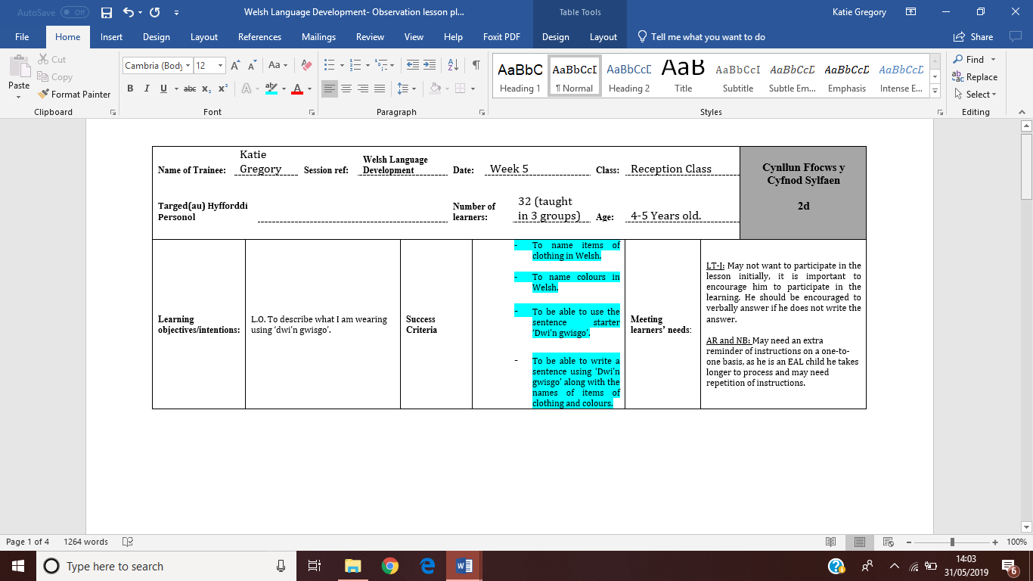

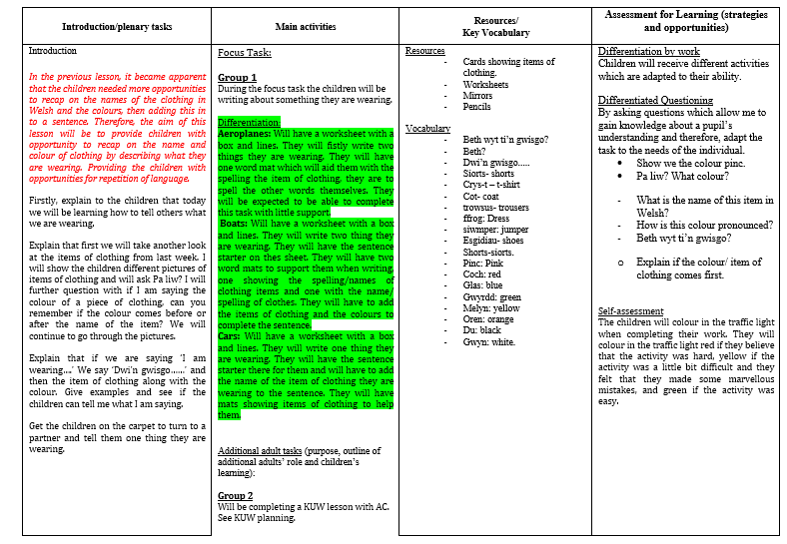

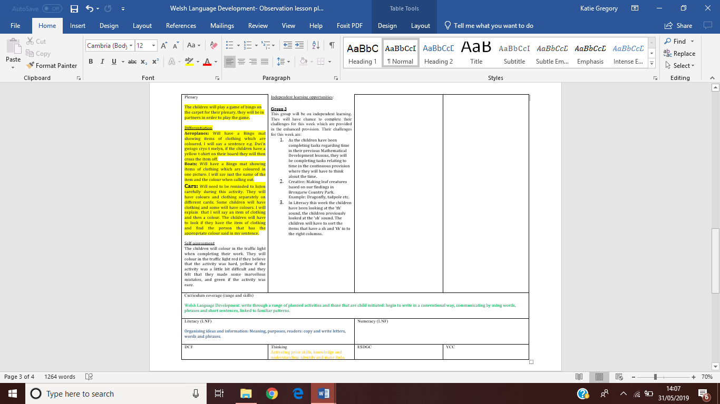

Appendix 2
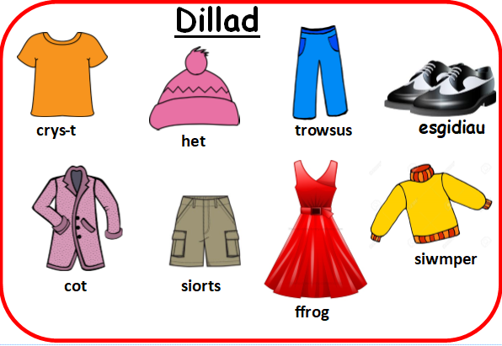

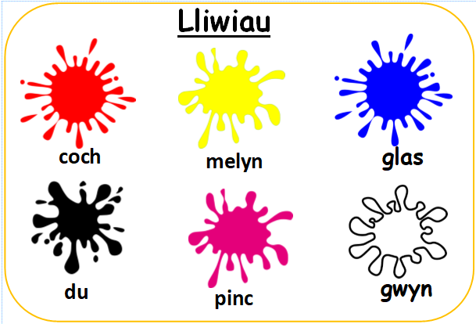

Appendix 3

This shows the work template provided for aeroplanes, the higher ability group. They were required to write the sentence starter ‘Dwi’n gwisgo….’ and add the name of an item of clothing and colour in the correct order.


This shows the work template provided for Boats, the middle ability group. They had the sentence starter and had to finish the sentence off with the name of the item of clothing and the colour, placing them in the correct order. They could use the ‘Dillad’ and ‘Lliwiau’ language mats shown in appendix 2 to help them with their work.


This shows the work template provided for Cars, the lower ability group. This group had the sentence starter and had to add just the name of the item of clothing they were wearing. They had the ‘Dillad’ language mats to help support them with their work.

Generic Assessment Criteria | Marks available | Marks  awarded
1. Engagement with Literature Skills  . | 10
2. Knowledge and Understanding Skills | 10
3. Practical Application Skills | 10
4. Transferable Skills for Life and Professional Practice | 10
5. Transferable Skills for Life and Professional Practice: Language | 60

Assessment Mark (Assessment marks are subject to ratification at the Exam Board. These comments and marks are to give feedback on module work and are for guidance only until they are confirmed. ) | Late Submission Penalties (tick if appropriate) |  | %
 | Up to 1 week late (40% Max) |  | %
 | Over 1 week late (0%) |  | %

