

CertHE Computing Skills for Workplace
Computer Architecture and Operating Systems
ACCA4022
Operation Systems Assignment

Name : BEREN
Surname : EREN
ID: 2525363

University Of Wales Trinity Saint David
London Campus

Table of Contents
Introduction 3
Key Functions of General Operating Systems 3
Implementation of Linux Bash Commands 11
File Management 15
Windows Batch Script 19
Linux batch Script 24
References 30

Introduction
Operation systems or OS is an essential system software for managing computer hardware as well as software resources whole proving a proper platform for the users. With an effective OS, the user can make interaction with the computer in their own language [1]. OS helps in understanding applications and perform each task efficiently as per needs. The Operating systems are highly responsible for process management, memory management, file sharing and system development, organising files and folders, device control, user account management, and security assessment and handling. It helps the user and enterprise in handling security environment and business enterprises. Some of the popular operating systems include Microsoft Windows and Linux [2].
This report not only talks about the modern operating systems but also how they work and perform in different enterprise settings. Command Line Interfaces or CLI are used to execute commands, automate repetitive tasks, manage users, troubleshoot system problems, and monitor network and system performance more efficiently than graphical interfaces. Windows and Linus both use CLI to carry out effective tasks and manage system. While Windows is a bit slow in developing a terminal command, Linux does it very efficiently and with flexibility [2].
This report examines the key functions of general operating systems, demonstrates the use of Windows and Linux command-line commands, develops simple Batch and Bash scripts for automation, and evaluates how these tools support effective operating system administration through practical examples and command execution.

Key Functions of General Operating Systems
Operating systems have different features that make one ahead of other in terms of flexibility and accessibility. Soe operating systems develop new features every year. As said earlier, OS is an essential system software for managing computer hardware as well as software resources whole proving a proper platform for the users [3]. Based on user need, features of operating systems are widely developed in modern world. With an effective OS, the user can make interaction with the computer in their own language. OS is effectively the core system for managing system applications, hardware devices and many as such [4]. Modern operating systems such as Microsoft Windows, Linux, and macOS perform several essential functions that enable computers to operate effectively. There are common features of Windows and Linux including file system management, process management, memory management and so on [5].
File System Management:
File system management is an important function of both Windows and Linux. Windows mostly uses file systems like NTFS and FAT32 to organise, store and manage data on storage devices. It offers a simple graphical interface for managing files and folders. Linux mostly uses file systems such as XFS, Breda, and ext4, providing greater control and flexibility. Linux manages files by a hierarchical directory structure, beginning from the root directory . Both Windows and Linux operating systems support file creation, copying, permission, deletion, and storage management. It can be stated that Linux offers more advanced permission controls, whereas Windows deals with accessibility and ease of use [6].
Windows File Explorer:
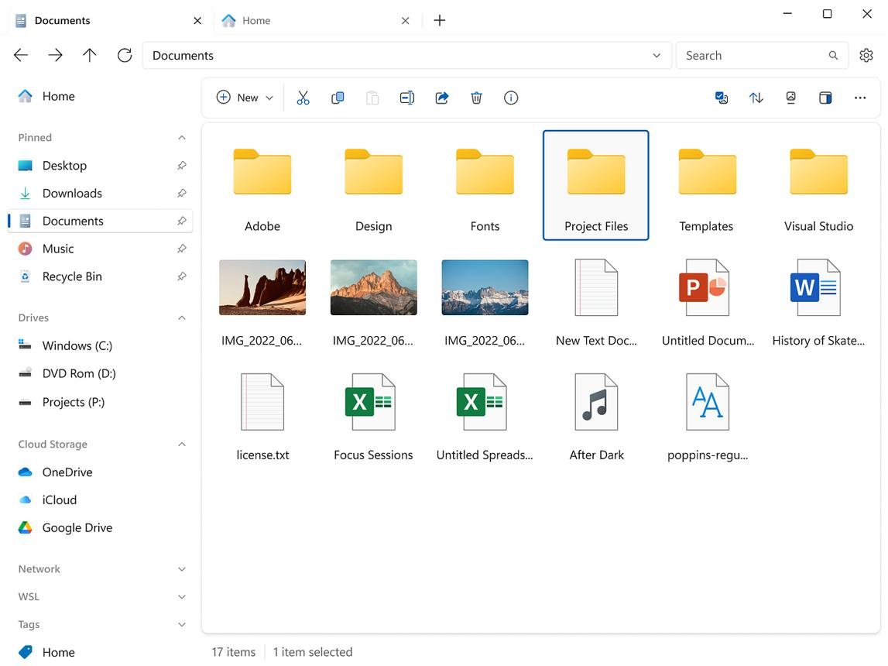
Linux Directory Listing:
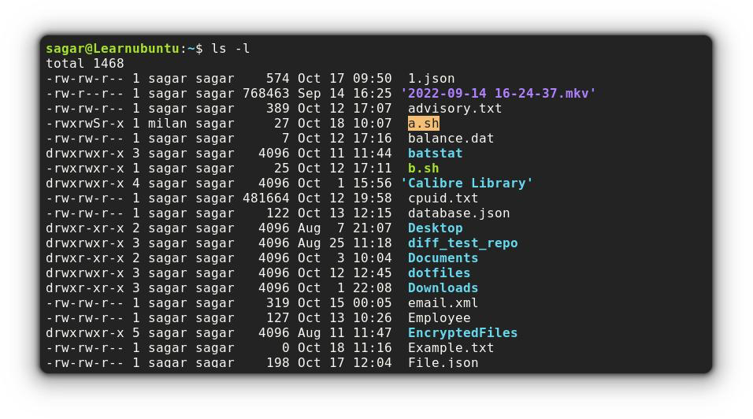
Process Management:
It is one of the primary job of an operating system that processes programs that is currently executing in memory. The operating system builds a proper material for running the programs effectively and gathering and terminating information using CLI as well. Modern operating systems are useful for multi-tasking that also allows users to run several programs at the same time. Most of the OS runs programs simultaneously achieving multi-tasking features through process management. Windows and MacOs has strong Task manager and Activity Monitor for handling CPU health and processes [6].
Windows Task manager screenshot:
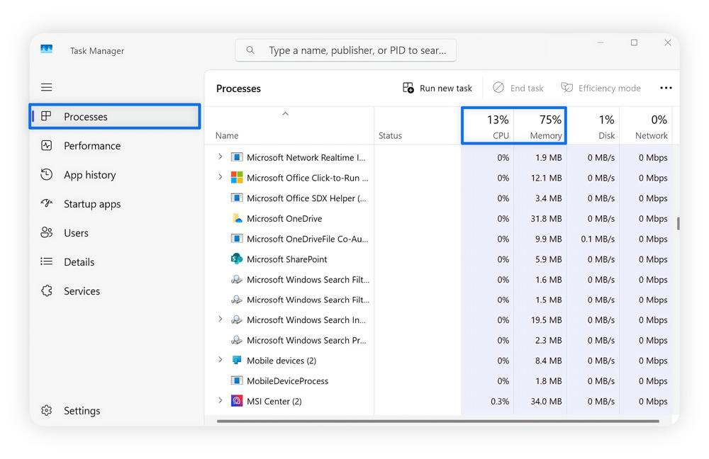
Linux top Command:
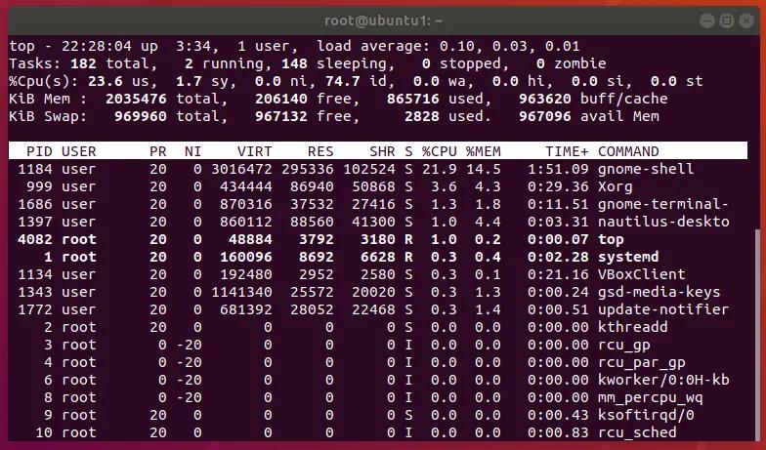
Memory Management:
In OS, memory management plays an important role in ensuring efficiency within a computer system. Memory is often used by Random Access Memory (RAM) through allocating memory to active programs while associating with certain applications [7]. RAM is used to allocate virtual memory as well while allowing secondary storage to extend available memory within a computer. Windows OS uses memory management system to improve performance, flexibility and accessibility of the programs. Linux also uses free -h command to allocate memory [8].
The screenshot of Windows Task manager is shown below.
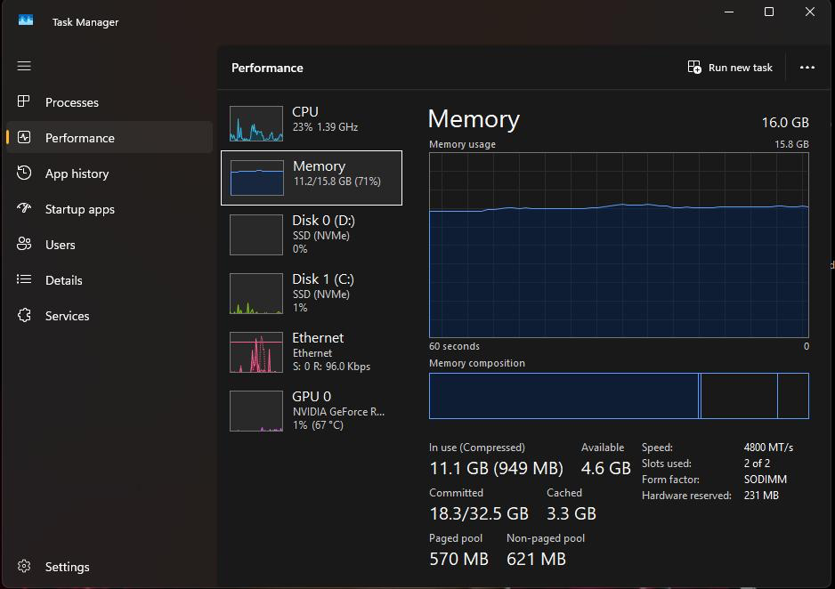
Linux free -h command is shown below.
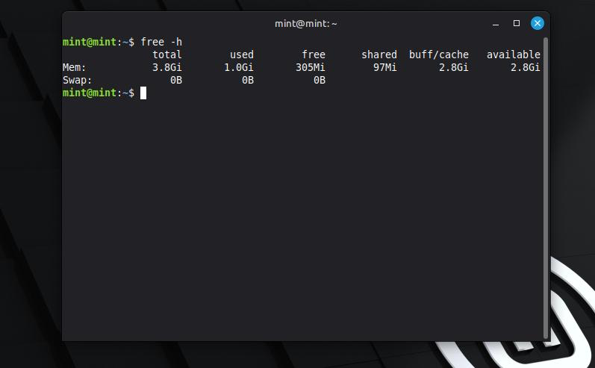
Device management:
The operating system manages communication between hardware devices and application software through device drivers. In modern operating systems, it is important to focus on detecting connected devices like printers, key board, etc [9].
In Windows, device management is dealt differently.
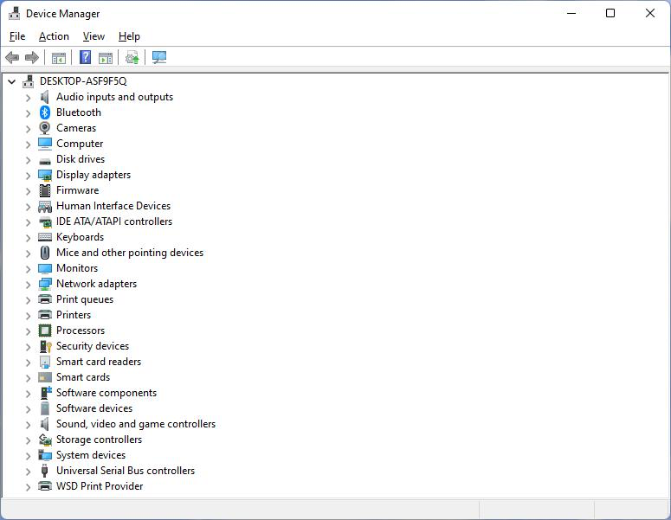
User and Security Management:
OS provide user account management to be completely secured. OS adds simple security features that are in-built within the system. It assigns permissions, create secured user accounts, and so on. It also effectively handles cyber threats through encryption and decryption [10].
Windows User Account:
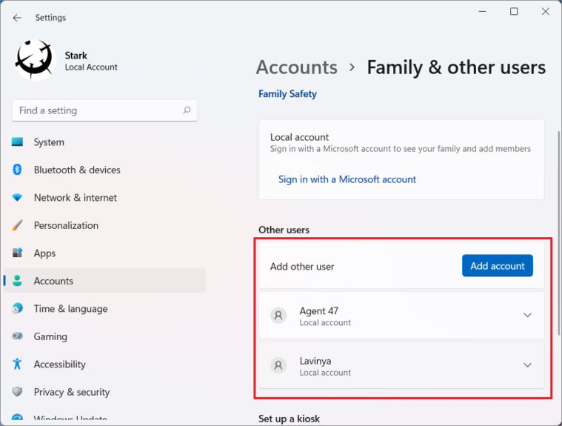
Windows Security:
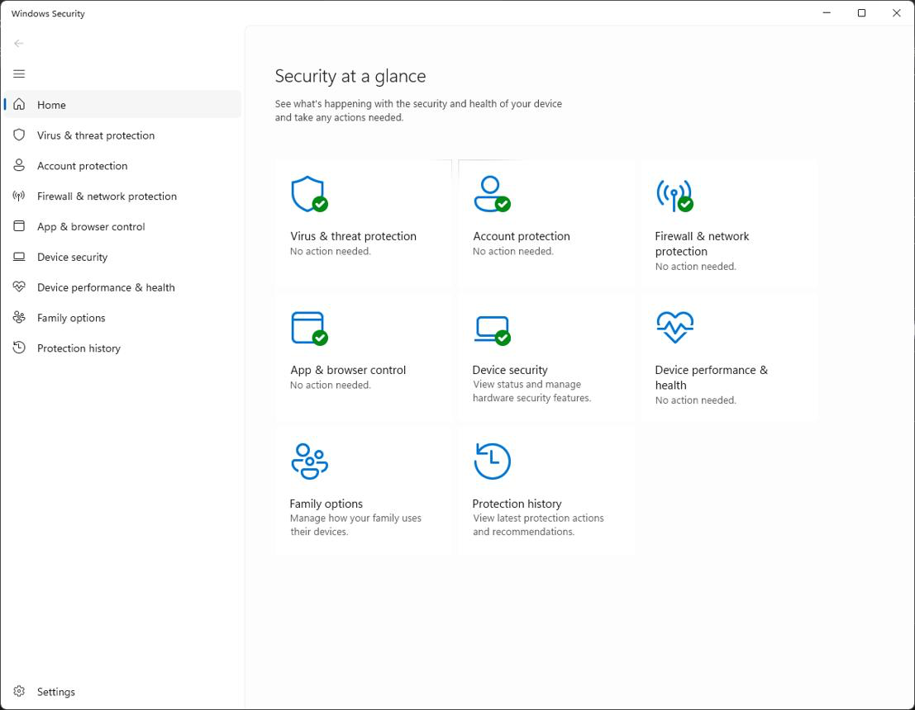
Network Management:
Network management enables computers to communicate with other devices through protocols such as TCP/IP. Operating systems automatically configure network settings, manage wireless and wired connections, support file sharing, and provide diagnostic tools including ping, ipconfig, and netstat [10].
Windows Networking Settings:
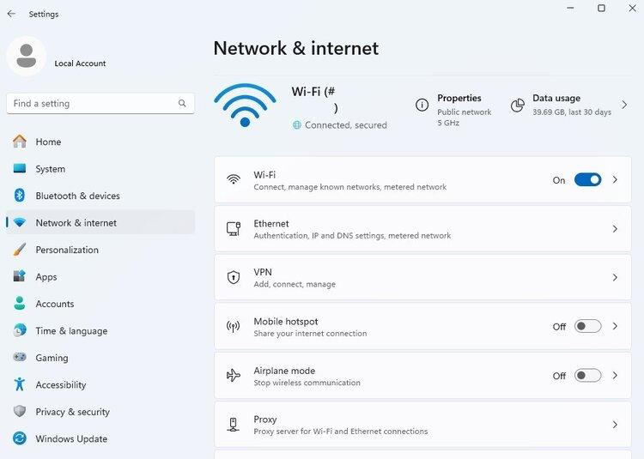
Command Prompt:
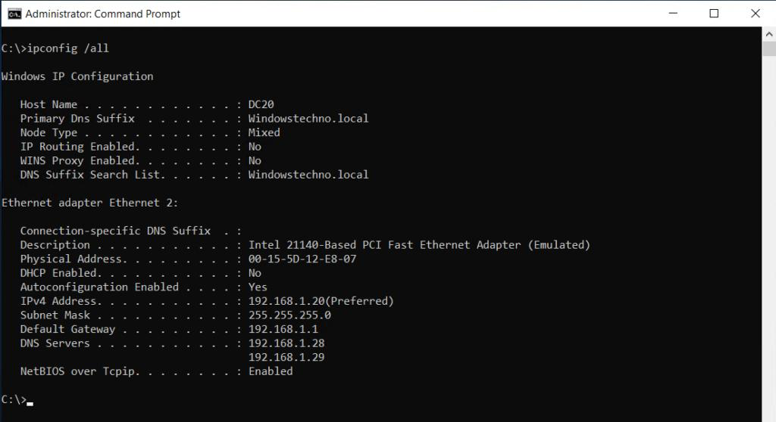

Implementation of Linux Bash Commands
ps Command:
For Linux, the following process management command is used.
ps [options]
Option | Description
-e | Display all running processes
-f | Show full-format listing
-u username | Show processes of a specific user
-aux | Display detailed information for all processes

Screenshot:
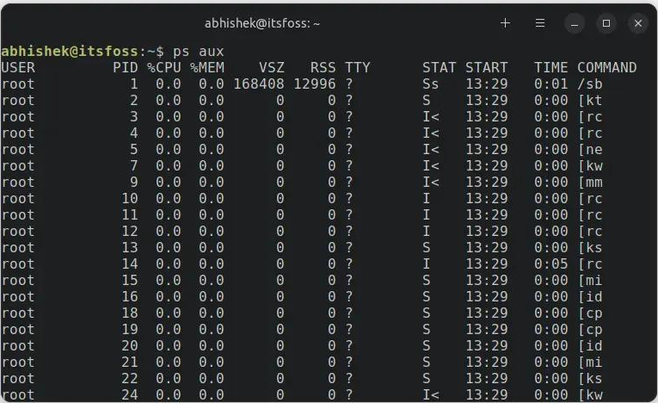
Output:
$ ps -aux

USER PID %CPU %MEM VSZ RSS TTY STAT START TIME COMMAND
root 1 0.0 0.2 169344 11220 ? Ss 10:02 0:01 /sbin/init
john 1256 0.1 1.5 578920 61200 ? Sl 10:05 0:03 firefox
john 1478 0.0 0.3 18264 4028 pts/0 R+ 10:15 0:00 ps -aux

Explanation:
The ps command plays an important role in displaying information about all the active processes run by the system. The activity shows CPU health, PID, CPU usage, memory usage, terminal and current status within the OS. Here, ps is basically administrating the system and monitoring application status. It helps in troubleshooting the system when there is active issue present [10].
top Command
The syntax is
top
Option | Description
-u username | Display processes of a specific user
-p PID | Monitor a specific process
-n number | Exit after a specified number of updates
-d seconds | Set refresh interval

Screenshot:
Output:
$ top

top - 10:35:21 up 3 days, 2:12, 2 users, load average: 0.45, 0.39, 0.41
Tasks: 185 total, 1 running, 184 sleeping
%Cpu(s): 4.3 us, 1.2 sy, 94.5 id
MiB Mem : 7982 total, 3220 free, 2450 used, 2312 buff/cache

PID USER PR NI VIRT RES SHR S %CPU %MEM TIME+ COMMAND
1256 john 20 0 579M 612M 21M S 12.5 1.5 3:24 firefox
Explanation:
The command, “top” provides real-time view of the Linux system that helps in continuous support to the CPU usage, memory usage and analysing running tasks and evaluating system uptime. The top command is used to monitor system performance. In Linux, there is excessive resource consumption in the system.
kill Command
The syntax for kill command is –
kill [signal] PID
Common options:
Option | Description
-9 | Forcefully terminate a process
-15 | Gracefully terminate a process (default)
-l | List all available signals
-s SIGNAL | Specify a signal by name

Output:
$ ps

PID TTY TIME CMD
2456 pts/0 00:00:01 firefox

$ kill 2456

$
Explanation:
The kill command sends a signal to a running process using its Process ID (PID). It is commonly used to terminate unresponsive or unnecessary processes. By default, it sends the SIGTERM (15) signal for graceful termination, while SIGKILL (9) forcefully stops a process that does not respond.

File Management
ls
syntax:
ls [options] [directory]
Common options:
Option | Description
-l | Display files in long listing format
-a | Show hidden files
-h | Display file sizes in human-readable format
-R | List subdirectories recursively
Screenshot:
$ ls -l

total 20
-rw-r--r-- 1 user user 1024 Jul 30 report.txt
drwxr-xr-x 2 user user 4096 Jul 30 Documents
-rwxr-xr-x 1 user user 2048 Jul 30 script.sh
Explanation:
The ls (List) command displays the contents of a directory. It is one of the most commonly used Linux commands for viewing files and folders. The -l option provides detailed information, including file permissions, owner, size, and modification date.
pwd
syntax:
pwd
Common options:
Option | Description
-L | Display the logical current directory (default)
-P | Display the physical directory, resolving symbolic links
Screenshot:
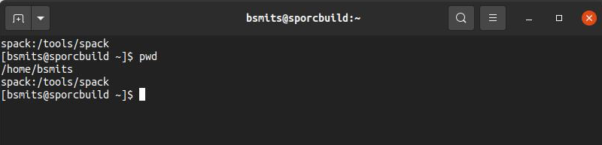
Output:
$ pwd

/home/user/Documents
Explanation:
The pwd (Print Working Directory) command helps users identify their current location in the Linux file system.
cp
Syntax
cp [options] source destination
Common options:
Option | Description
-r | Copy directories recursively
-i | Ask before overwriting files
-u | Copy only newer files
-v | Display detailed copy process
Screenshot:
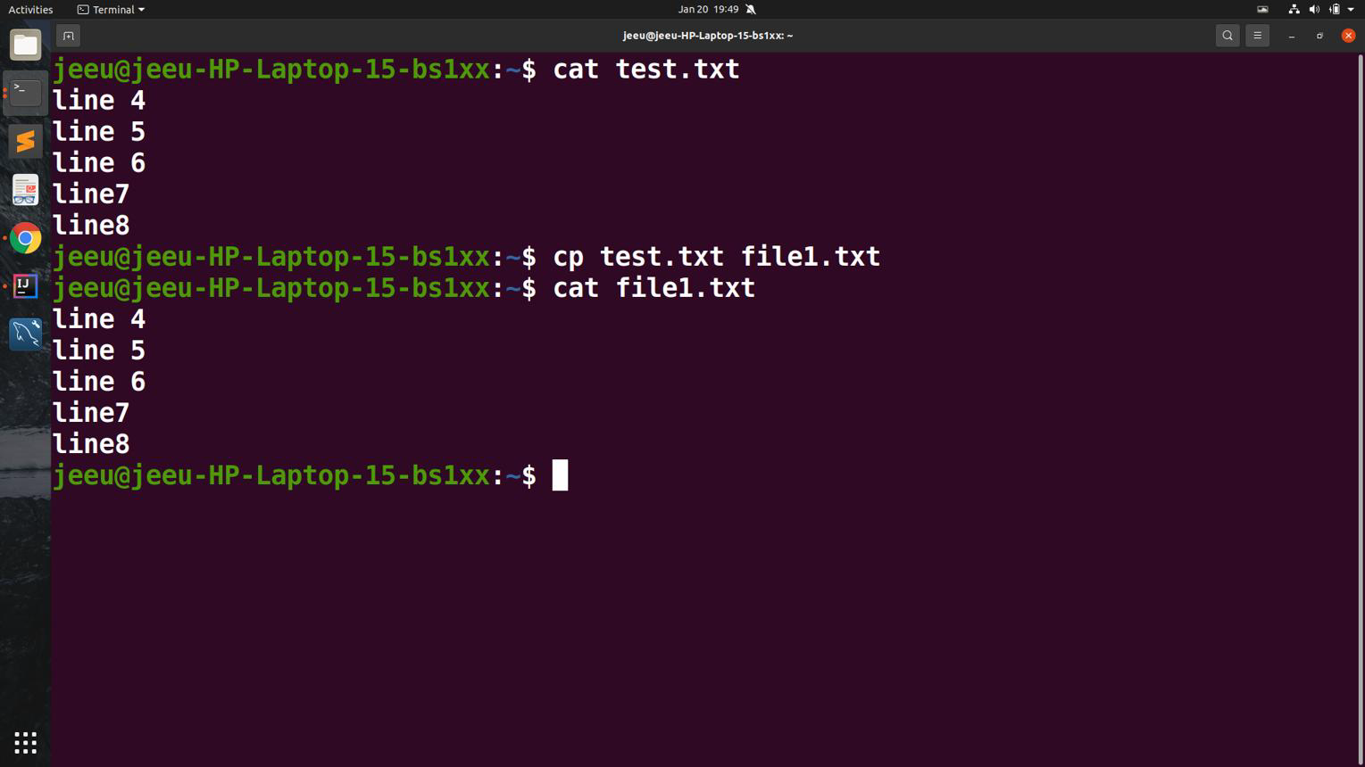
Output:
$ cp report.txt backup.txt

$ ls

backup.txt report.txt
Explanation:
The cp command is used for identifying duplicate files and directory. Cp is associated with preserving original file in the administration system.
mv
Syntax
mv [options] source destination
Common options:
Option | Description
-i | Ask before overwriting files
-v | Display detailed moving process
-n | Do not overwrite existing files
-u | Move only newer files
Screenshot:
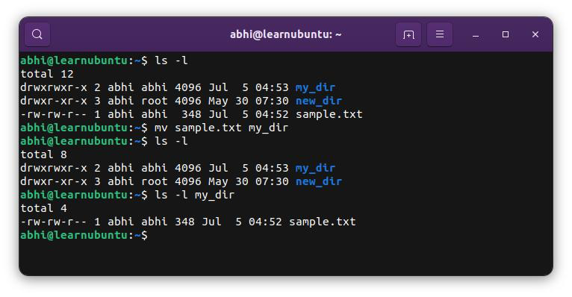
Output:
$ mv report.txt reports.txt

$ ls

reports.txt
Explanation:
The mv (Move) command is used to move files or directories from one location to another. It is also commonly used to rename files and folders without changing their contents.
rm
Syntax
rm [options] file
Common options:
Option | Description
-r | Remove directories and their contents recursively
-f | Force deletion without confirmation
-i | Ask for confirmation before deleting
-v | Display deleted files
Screenshot:
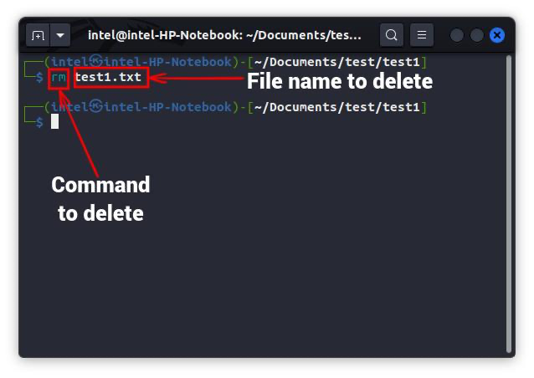
Output:
$ rm backup.txt

$ ls

reports.txt
Explanation:
The rm (Remove) command deletes files and directories from the Linux file system. It permanently removes data unless a recovery mechanism is available.

Windows Batch Script
Script 1: System Information Report
The objective is to collect system information, takes user input, uses variables and an IF statement, and saves the output to a text file.
The code is give below.
@echo off
title System Information Report

echo ==========================
echo System Information Report
echo ==========================

set /p username=Enter your name:

if "%username%"=="" (
echo Name cannot be empty.
pause
exit
)

echo Creating report...

echo System Information Report > report.txt
echo ------------------------- >> report.txt
echo User Name: %username% >> report.txt
echo Computer Name: %COMPUTERNAME% >> report.txt
echo User Account: %USERNAME% >> report.txt
echo Operating System: %OS% >> report.txt
echo Date: %DATE% >> report.txt
echo Time: %TIME% >> report.txt

echo.
echo Report successfully created as report.txt
pause

Execution screenshot:
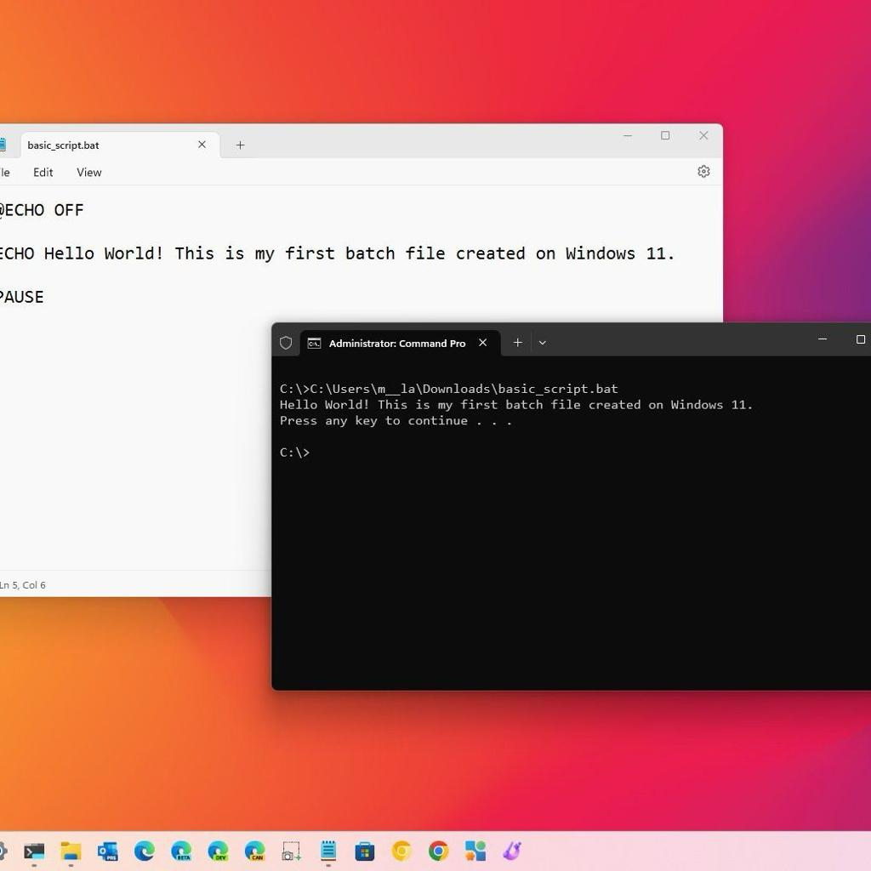
Output:
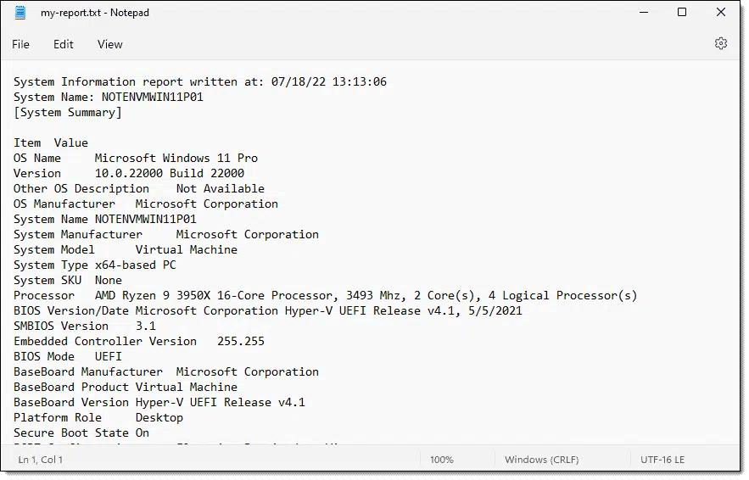
Script 2: Multiplication Table Generator
The objective is to collect information about the system while also taking user inputs and evaluating outputs.
The output is then given back in text file.
Batch code:
@echo off
title System Information Report

echo ==========================
echo System Information Report
echo ==========================

set /p username=Enter your name:

if "%username%"=="" (
echo Name cannot be empty.
pause
exit
)

echo Creating report...

echo System Information Report > report.txt
echo ------------------------- >> report.txt
echo User Name: %username% >> report.txt
echo Computer Name: %COMPUTERNAME% >> report.txt
echo User Account: %USERNAME% >> report.txt
echo Operating System: %OS% >> report.txt
echo Date: %DATE% >> report.txt
echo Time: %TIME% >> report.txt

echo.
echo Report successfully created as report.txt
pause
Output:
Enter a number: 7

Multiplication Table of 7

7 x 1 = 7
7 x 2 = 14
7 x 3 = 21
7 x 4 = 28
7 x 5 = 35
7 x 6 = 42
7 x 7 = 49
7 x 8 = 56
7 x 9 = 63
7 x 10 = 70

Press any key to continue . . .

Linux batch Script
Script 1 – User Information Script
The objective is to display information about the current user, today's date, and the number of files/directories in the current working directory.
Script / code:
#!/bin/bash

echo "=============================="
echo " User Information Report"
echo "=============================="

USERNAME=$(whoami)
TODAY=$(date)
DIRCOUNT=$(ls | wc -l)

echo "Username : $USERNAME"
echo "Current Date & Time: $TODAY"
echo "Current Directory : $(pwd)"
echo "Number of Files : $DIRCOUNT"

echo "=============================="
Screenshot:
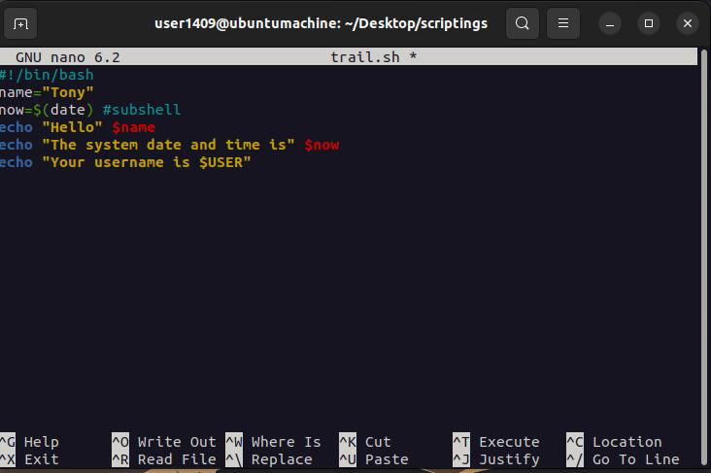

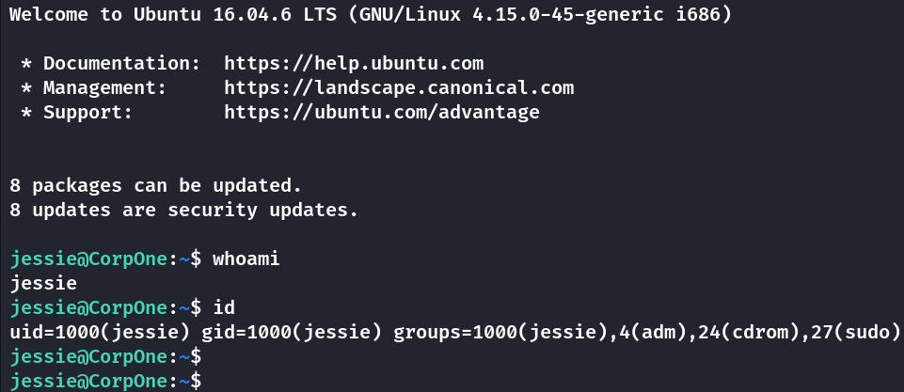
Script 2 – Calculator Script
Objective
This Bash script performs basic arithmetic operations based on user input using a while loop, if statement, read command, and arithmetic operations.
Code/ Script:
#!/bin/bash

choice=1

while [ $choice -eq 1 ]
do
echo "Simple Calculator"

read -p "Enter first number: " num1
read -p "Enter second number: " num2
read -p "Enter operator (+ - * /): " op

if [ "$op" = "+" ]
then
echo "Result = $((num1 + num2))"

elif [ "$op" = "-" ]
then
echo "Result = $((num1 - num2))"

elif [ "$op" = "*" ]
then
echo "Result = $((num1 * num2))"

elif [ "$op" = "/" ]
then
echo "Result = $((num1 / num2))"

else
echo "Invalid Operator"
fi

echo
read -p "Run again? (1=Yes, 0=No): " choice
done

echo "Calculator Closed."
Screenshot:
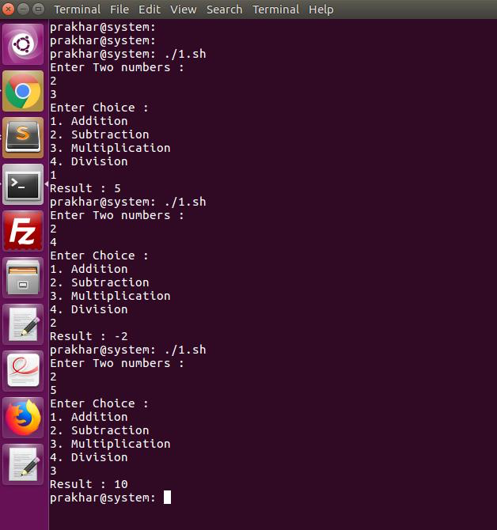

References
[1] A. Silberschatz, P. B. Galvin and G. Gagne, Operating System Concepts, 10th ed. Hoboken, NJ, USA: John Wiley & Sons, 2018.
[2] W. Stallings, Operating Systems: Internals and Design Principles, 10th ed. London, U.K.: Pearson, 2018.
[3] A. S. Tanenbaum and H. Bos, Modern Operating Systems, 5th ed. Boston, MA, USA: Pearson, 2022.
[4] Microsoft, "Windows Commands," Microsoft Learn. [Online]. Available: https://learn.microsoft.com/windows-server/administration/windows-commands/. [Accessed: Aug. 3, 2026].
[5] Microsoft, "PowerShell Documentation," Microsoft Learn. [Online]. Available: https://learn.microsoft.com/powershell/. [Accessed: Aug. 3, 2026].
[6] Canonical Ltd., "Ubuntu Server Documentation," Ubuntu Documentation. [Online]. Available: https://ubuntu.com/server/docs. [Accessed: Aug. 3, 2026].
[7] GNU Project, "Bash Reference Manual," Free Software Foundation. [Online]. Available: https://www.gnu.org/software/bash/manual/. [Accessed: Aug. 3, 2026].
[8] The Linux Foundation, "Linux Documentation." [Online]. Available: https://training.linuxfoundation.org/resources/. [Accessed: Aug. 3, 2026].
[9] Red Hat, "Red Hat Enterprise Linux Documentation." [Online]. Available: https://access.redhat.com/documentation/en-us/red_hat_enterprise_linux/. [Accessed: Aug. 3, 2026].
[10] Cisco Networking Academy, Linux Unhatched Course. [Online]. Available: https://www.netacad.com/. [Accessed: Aug. 3, 2026].

