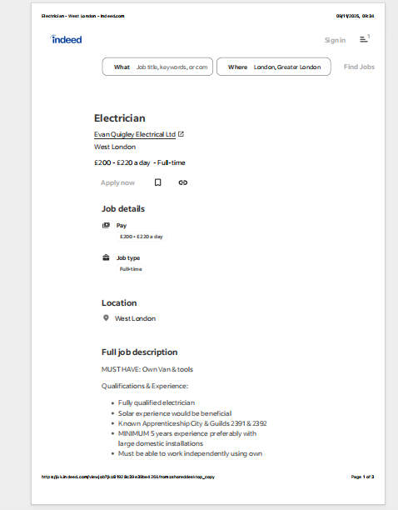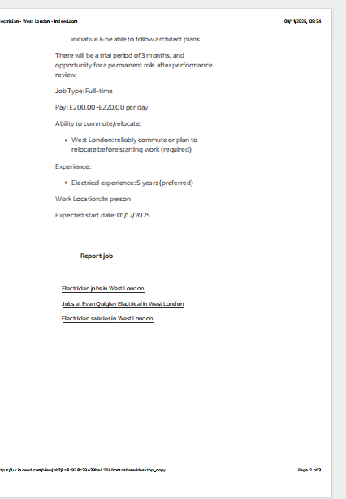

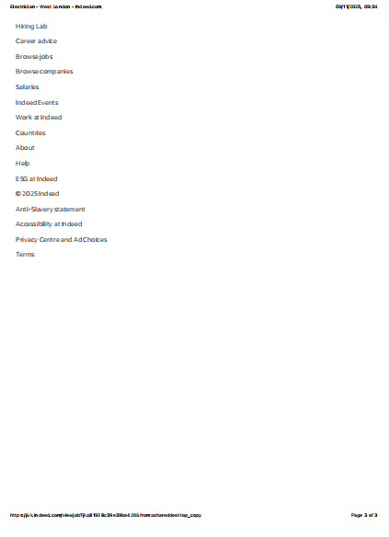

"""ABC
163 trafalgar road se10 9tx
11 Templedene Ave

Staines
TW18 1LH

09/11/2025

Dear Mr/Mrs/ Manager,

I wish to apply for the role of Electrician, currently being advertised on Indeed. Please find enclosed my CV for your consideration.

As you can see from my attached CV, I have over 15 years of experience in domestic and commercial electrical installations, which I believe aligns well with the requirements listed for this role. I am confident that my industry experience and skill set make me a strong candidate.

In my current role as an Electrician at Redline Electrical Contractors, I have been responsible for carrying out full property rewires, consumer unit upgrades, fault finding, testing and certification, and ongoing maintenance work. I am experienced in working independently, following architectural plans, and managing jobs from start to finish. I have worked closely with landlords, estate agencies, and contractors, ensuring clear communication and consistently safe, compliant results on every project.
All of this, coupled with my enthusiasm and dedication, [insert skills relevant to the role, e.g., strong problem-solving ability, excellent attention to detail, ability to work efficiently under pressure], has helped me achieve a high standard of work throughout my career.

I am confident that I can bring this same level of reliability and professional performance to your organization, and contribute positively to your team’s continued reputation for quality and efficiency. I would welcome the opportunity to discuss how my experience and skills can support your business, and I am available to start as required.

Thank you for your time and consideration.
I look forward to the possibility of discussing my application further.
Yours sincerely,
ABC

_MY CV

CV – ABC

Full Name: ABC
Date of Birth: 31/10/1982
Address: 163 Trafalgar Road, SE10 9TX, London
Phone: +44 7399 647118
UK Driving Licence: Full, Clean Licence

Profile

Electrician with over 15 years of experience in domestic and commercial electrical work. Qualified to City & Guilds Level 3 and certified in both 17th and 18th Edition Wiring Regulations. Experienced in full rewires, consumer unit upgrades, fault finding, emergency call-outs, and solar power system installation and maintenance. Fully insured (Public Liability: £2 million) and experienced working with private clients, landlords, estate agencies, and companies.

⸻
Key Skills
• Electrical installation and maintenance
• Solar panel system installation and troubleshooting
• Consumer unit upgrades and testing
• Full and partial rewiring
• Fault finding and emergency repairs
• Inspection, Testing & Certification
• Working independently or in teams
• Clear communication with clients and contractors

⸻

Education & Certifications

Level 3 Electrical Installation
Collège Jean-Baptiste de La Salle, Saint-Denis, Paris

City & Guilds 17th Edition (Wiring Regulations) – UK Learning Centre, Wembley – 2018

City & Guilds 18th Edition (Wiring Regulations) – UK Learning Centre, Wembley – 2021

⸻

Professional Experience

Redline Electrical Company – Electrician
London
Responsibilities:
• Domestic and commercial electrical installation and maintenance
• Solar installation assistance and maintenance work
• Carrying out electrical testing, inspection, and certification
• Emergency call-out and fault diagnosis
• Working with landlords, estate agents, and building contractors
• Ensuring compliance with UK safety and regulatory standards

