Process Improvement Methodologies.

Student:
Thomas Hughes

Student Number:
1909575
Lecturer:
Richard Morgan
Course:
Level 4-Quality & Business Improvements.

Introduction
The contents of the report focuses on the main stages of Lean & Six Sigma methodologies.
Some might ask which method is the most effective; this would depend on its intended use. Both Lean & Six Sigma have their strengths and weaknesses. Lean methods tend to concentrate on the elimination of waste, whereas Six Sigma’s purpose would be to reduce variation within a process to provide stability.
The report will discuss both Six Sigma and Lean elements separately and how these elements were introduced to improve Operational Performance at the Zimmer Biomet site located at Bridgend.

Six Sigma.
What is Six Sigma?
Six Sigma is a rigorous, focused, and highly effective implementation of proven quality principles and techniques. Six Sigma measures variation within a process with the aim to reduce defects, cycle time and improve customer requirements.
The term Sigma is taken from how many Defects per Million Opportunities (DPMO) found within a process. The lower the amount of DPMO, the higher Sigma level, with 6 Sigma equating to 3.4 DPMO.
The below table equates yield, equivalent DPMO and the sigma level.
99.99966% Yield – 3.4 DPMO – 6 Sigma
99.9767% Yield – 233 DPMO – 5 Sigma
99.379% Yield – 6210 DPMO – 4 Sigma
93.32% Yield – 66807 DPMO – 3 Sigma
69.1% Yield – 308,537 DPMO – 2 Sigma
(Ficalora & Cohen 2010 p.12)
The higher level of Sigma at which a company operates usually has a direct impact on performance and profit. This should be simple to understand as Sigma levels are measured by defects, and as in any business, defects cost money.
“General Electric estimated that the gap between three or four sigma and Six Sigma was costing them between $8billion and $12 Billion per year” (Pyzdek & Keller 2014 p.5)
Although it is beneficial to have up to date equipment and software, small or large companies do not have to invest huge financial amounts to improve their processes. Following proven Six Sigma methodologies involving the correct personnel can cost very little.
Six sigma has a variety of tools and methods to follow, the most common and effective known as DMAIC (Define-Measure-Analyse-Improve-Control) approach.

What is DMAIC?
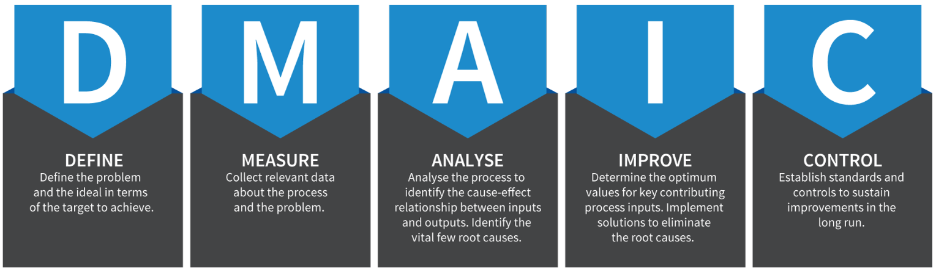
https://traccsolution.com/wp-content/uploads/2012/09/dmaic_1.png
DMAIC is a data driven, quality-improvement tool used for improving and optimizing the business processes. The contents of DMAIC provide a structured approach to problem solving.
Whether you are starting or a seasoned Black belt the use of the tools will only have a positive impact on the business. While some tools are simple and straightforward, others seem difficult to follow and implement. With correct training and practice, these tools are hugely effective.
These tools are worth the effort. They have been proven in practice, time and time again. They are tools that can achieve breakthrough performance improvement in quality, cost, and lead time. (George, 2002)
At Zimmer Biomet, this cycle is widely used for all A3 business improvement activities to gather data before making decisions on whether to commit business resources.
Example of where DMAIC was used to improve a process at Zimmer Biomet
The DMAIC methodology was used to improve delivery times to the customer.
On Time in Full (OTIF) is one of many KPIs Zimmer Biomet have to achieve to remain competitive. To gain credit for OTIF product must reach the customer on exactly the given date with no more than 5% scrap of product throughout the process.
Historically the Bridgend site has scored poorly on this Key metric against other plants within the business. To gain access to the new SAP upgrade, Zimmer Biomet Bridgend had to increase its current OTIF scoring from 2% to 85% by year-end 2020.
Below is some detail that went in to each stage of DMAIC and how it was used to improve operational performance.

Define:
Define the problem.
- Work currently moves through the factory with little consideration to completion dates, resulting in an OTIF score of 2%. Customer completion dates are placed on tote boxes; however, there is a gap in the understanding of their importance.

Target Improvement.
- Target set to improve the top-level OTIF score for the site to greater than 30% by the end of 2019 with a view to achieving 95% by the end of 2020.

Measure:
Gather data to measure the current state of the process using analytical, statistical driven tools to understand the variation within the process.
Data was gathered for each major brand to understand average lead-time to the End of Line business unit. The primary purpose of the Measure phase is to answer the question, “how are we doing”? (McCarty et al, 2005)
At the start of the project OTIF was hovering around 5%
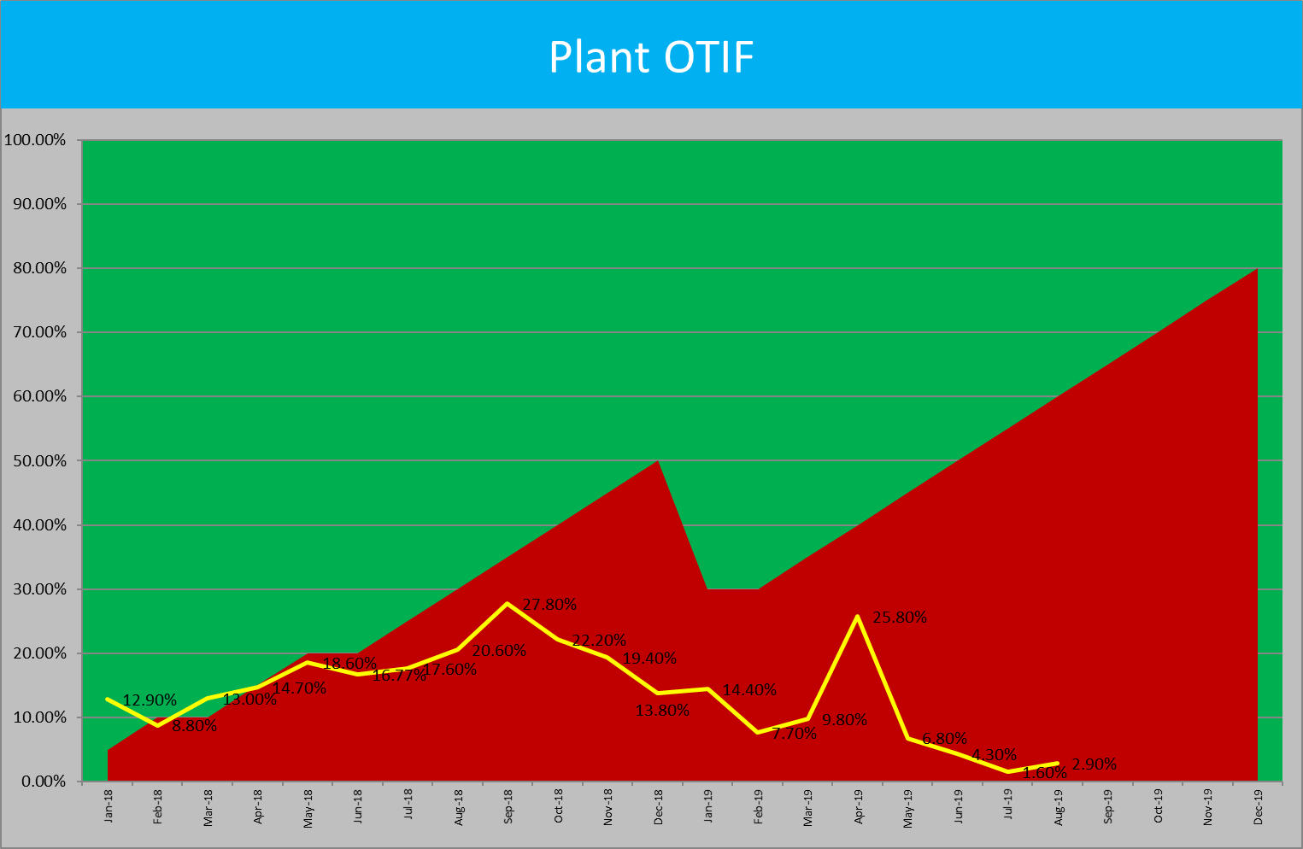

The average lead-time (time taken for a part to go through the manufacturing process) this year is currently 18 days.
However, the variation around this average is significant. Approximately 95% of orders will take anything between 1 day and 55 days to complete.

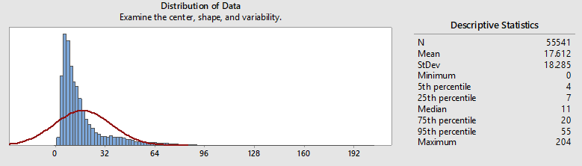
Graphical summaries were taken for the top five brands, these SKUs result in over 80% of the total plant output. Identifying gains through these brands would give us the best opportunity to improve our OTIF score sooner.

G7 PPS.

Average lead-time 23 days. StDev 19 days

Taperloc Stems.

Average lead-time 16 days, StDev 14 days

Vanguard

Average lead-time 16 days, StDev 9 days

Oxford Cementless

Average lead-time 58days, StDev 17 days.

Large number of items delivered within lead-time. Outliers skew the average days. A significant number of outliers and a large “tail” highlighted the process was lacking control.
A WIP count was taken at the End of Line (EOL) wash area to see what product required focusing on the most.
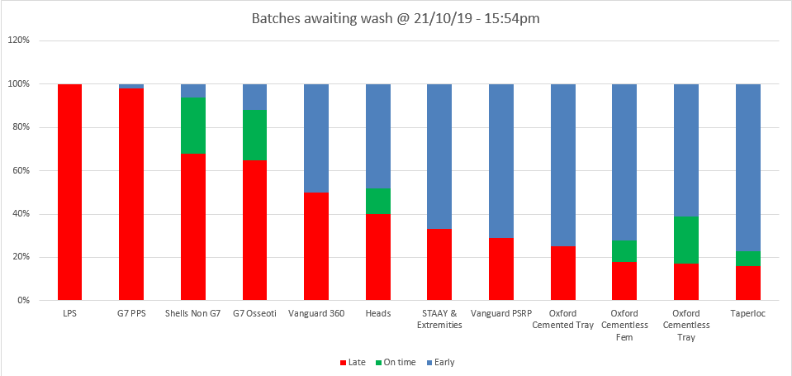

Analyse.
During a team brainstorming with the use of an Ishikawa diagram, a number of variables were identified. Those highlighted in red were prioritised.
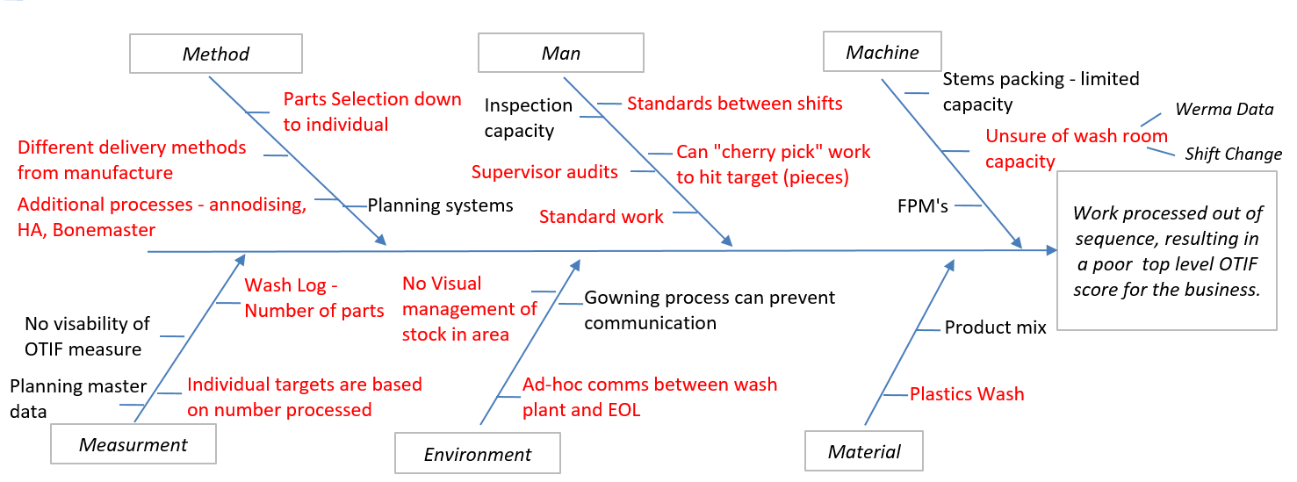

Improve
The target of the improve phase should be to implement a new system based on the findings of the previous stages.
The initial improvement focused on the correct sequencing of work before the EOL washroom and at final booking to the customer.
The final booking area has been re-organised to allow work to be sequenced and held in place until required; only processing what is required by the customer date each day.
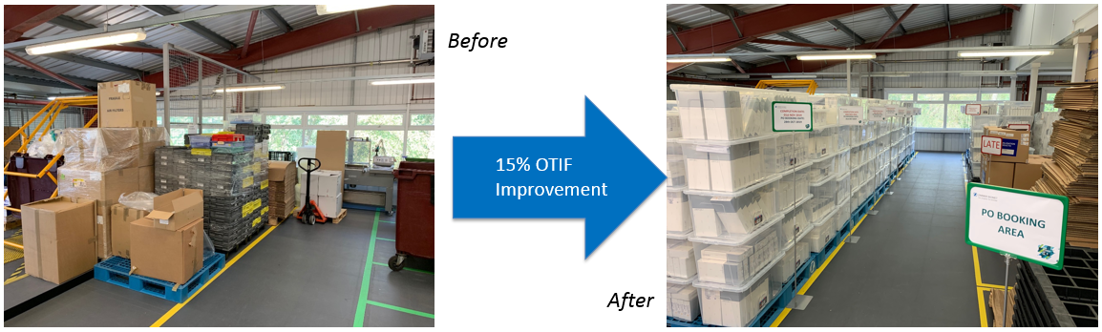

There was no stock management in the final booking area, work was being processed and sent out as soon as it arrived with no regard for due dates.
Implementing a new control system allowed stock to be held at this point and only sent to the customer when required, aligning with the due dates.

A similar sequencing process was rolled out before the wash plants, a natural break point in the process where work moves from the manufacturing area to end of line

Stock was being dropped off in one small area, poorly lit and difficult to work in. Work was stacked on top of each other making it difficult to select any other batch than the one on top, creating a natural LIFO system.
A new stock location was sourced with racking to allow easy access and organisation of stock. Items can now be sequenced through the wash plant in line with the customer-required date.

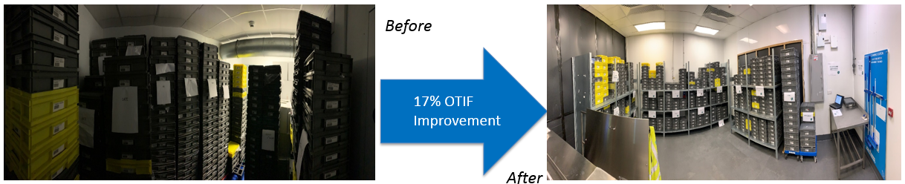
The new sequencing system has resulted in work being processed on time, early work is being held until the required date.

Before

After

As can be seen from the graphs, there was a higher percentage of work that is ahead of plan before the wash. This demonstrates the teams were now processing batches in date order.

Over a short period, the mix of batches (early vs late) has shifted significantly in the correct way.

The system has been maintained in spite of breakdowns and stock building up in front of the wash. Previous responses would have seen work pushed through the wash due to the volume in spite of the fact that it was not be needed.

Control:
In order to help us sustain the improvements made, a number of tools have been utilised:
- Implementation of Leader Standard Work (LSW) for the teams involved. This contains a list of critical tasks that must be performed on an hourly or daily basis.
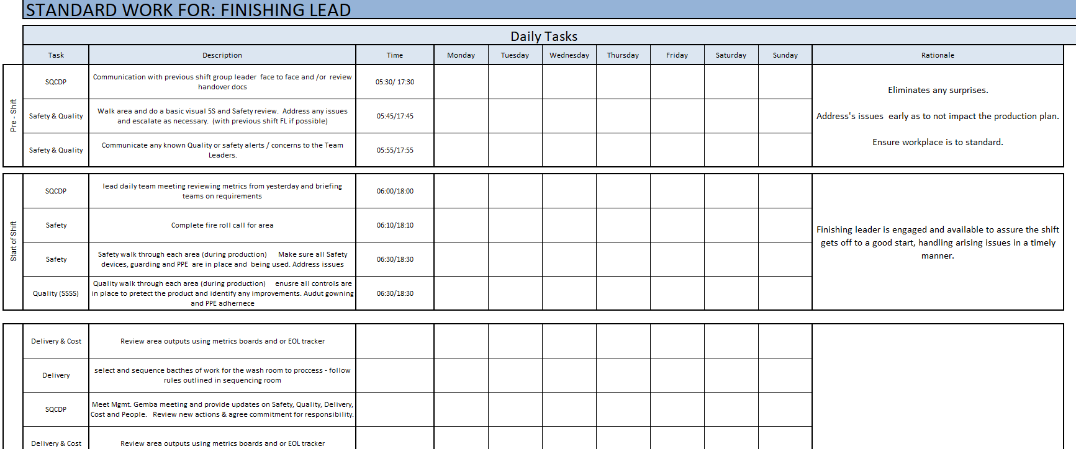
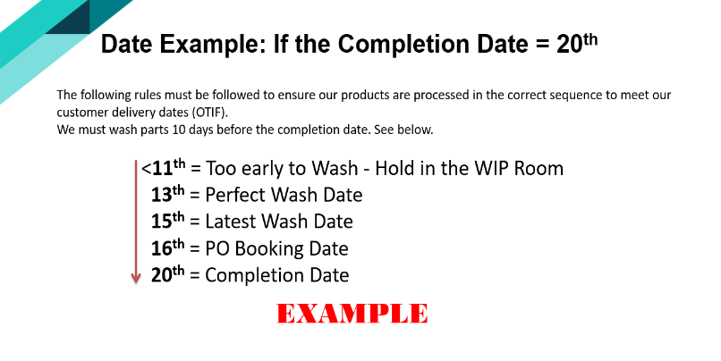
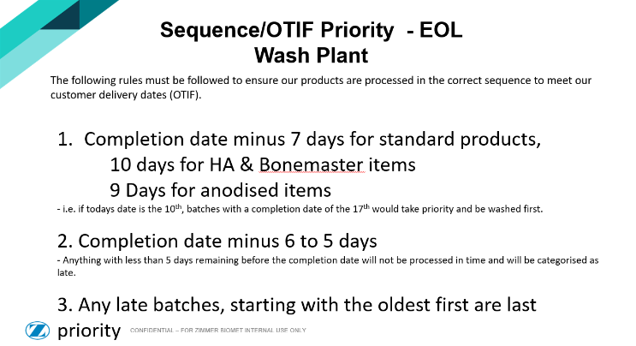
A set of clear rules and process steps to follow have been developed in order to support the correct selection of stock to be processed:
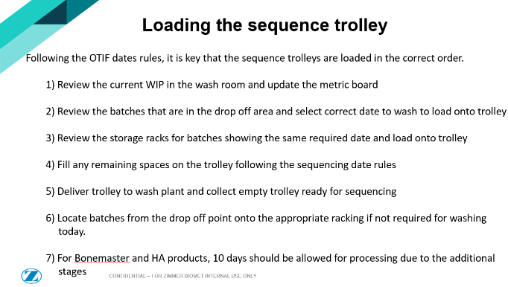
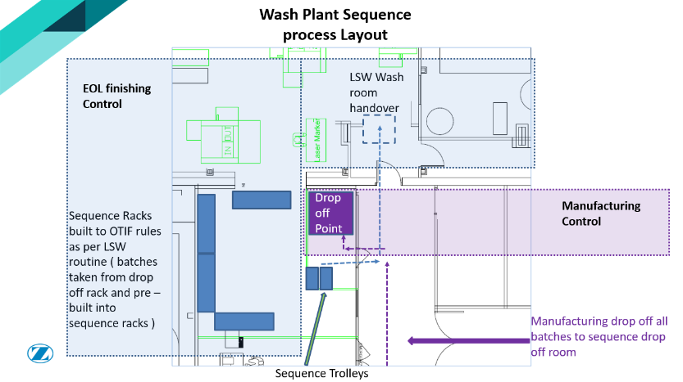

A new metric board was launched in the area to help measure performance against a target number of batches:
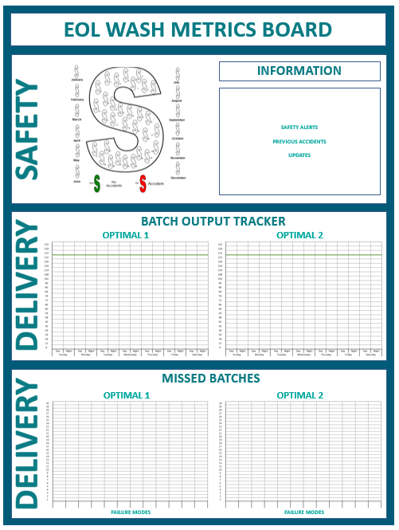

Output tracker to measure the number of batches processed each hour:
- Updated hourly by team
- One measure per line
- Target per shift

Pareto included capturing reasons why the output was missed:
- Help identify gaps in systems
- One measure per line
- Completed live by teams

Summary:
The use of DMAIC during this improvement project has been a great success, immediate gains were seen and the company are on their way to achieving the goal of 85% by year-end.
Below is some detail of how the company are performing during February.
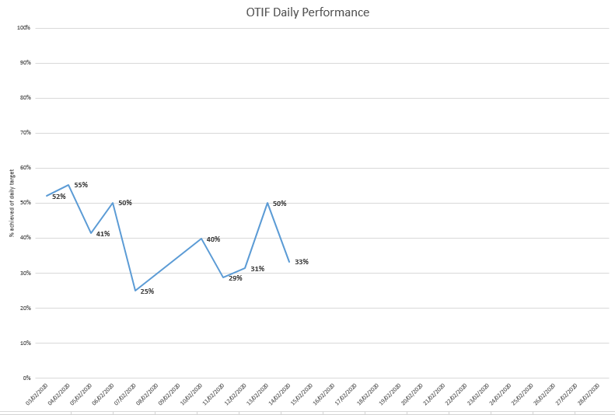
As seen below very little batches are now being processed late. The OTIF data is skewed slightly, currently batches are still being sent early. The reason behind this is to fulfil priority 1 backorders; if patients do not receive the products ASAP, it could delay their Operation.

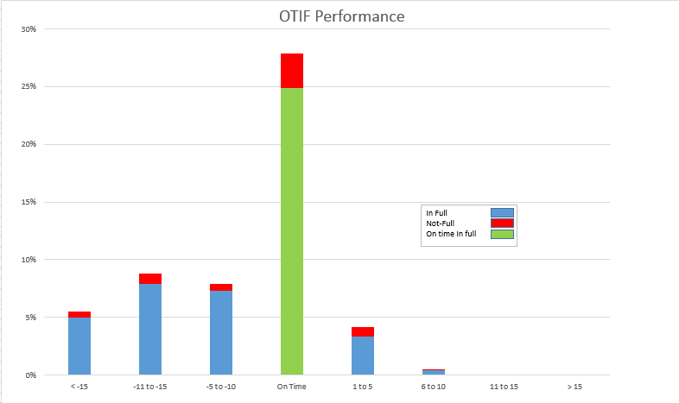

Lean.
What is Lean?
Lean production are management systems that focuses the organisation on continuously identifying and removing sources of waste so that processes are continuously improved. (Nicholas, 2011)
A lean business prioritises customer value and focuses its key processes on improving continuously. The ultimate goal is to provide excellent value to the customer, creating processes that have zero waste.
What is Waste?
Waste or muda as its known, muda being the Japanese term for waste, is anything that is non-value added to the final item sold to the customer. Removing any un-necessary waste is critical to any business wanting to improve its operational excellence and profit margins.

The seven wastes of Manufacturing.
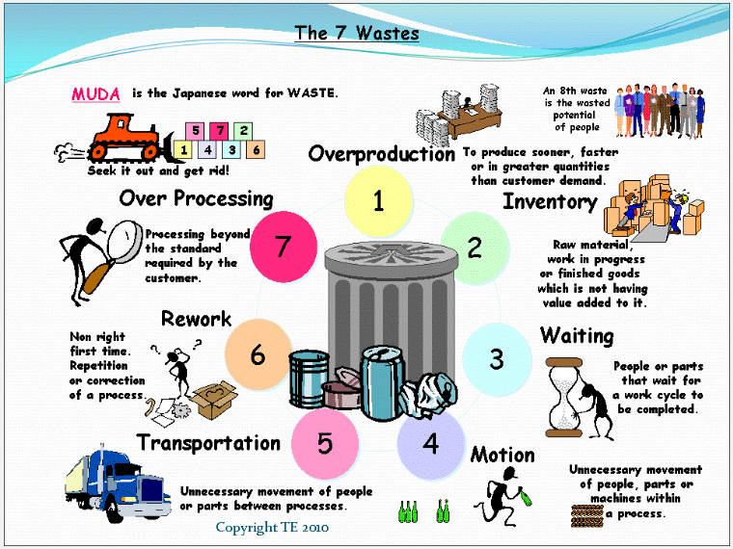
https://leanmanufacturingtools.org/77/the-seven-wastes-7-mudas/

The five principles of Lean
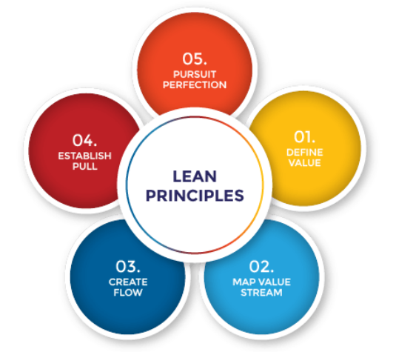
https://theleanway.net/The-Five-Principles-of-Lean
The five Principles of Lean Explained.
Define the value.
The customer determines how much value an activity or production part has. Value is what the customer wants and he will pay for. It is said that up to 95% of process activities are non - value adding. This is probably true, depending on your definition of value adding. Real value can usually be defined as the direct materials and direct labor to produce the product. (Womack & Jones, 1996)
Map the Value stream.
Commonly known as Value stream mapping (VSM). Value stream mapping is a manufacturing technique used to analyse, design, and manage the flow of materials and information required to bring a product to a customer. VSM helps identify waste and streamline the production process.
Create Flow.
Lean Flow, to give it its full title has several aims, notably to reduce lead-time. Every effort should be made to eliminate obstacles and bottlenecks that prevent the flow of product from each work center to the customer.

Establish Pull.
A true pull system should be established by customer demand. Product should therefore be made, only when a customer requires it. In most organisations, work is pushed through work centres eventually leading to waste by over producing.
Pursuit perfection
A perfect process is almost impossible to achieve, this should not stop you seeking such perfection. The perfect process should aim for all steps within the process to add value, should contain zero waste and be able to produce a good part every time, at the correct amount. It is important to look to continuously improve the process where possible reacting to customer opinion.

Elements of Lean
There are many elements of Lean production that can be used to optimise operation performance, many of which are currently in use at Zimmer Biomet. These tools have been hugely succesful in reducing lead times, reducing defects and improving productivity.
Below are some examples of these elements and examples of where these tools have made a positive impact to the shop floor.
Gemba Walk.
The Gemba walk is an essential part of the Lean management philosophy. The purpose of the Gemba walk is for managers and leaders to observe the actual work process, engage with employees, gain knowledge about the work process and explore opportunities for continuous improvement.
https://kanbanize.com/lean-management/improvement/gemba-walk/

Gemba Walk Structure.
Providing structure to these meetings would ensure that only relevant information would be discussed and ensure consistency between shifts. The structure of the meeting are detailed below.
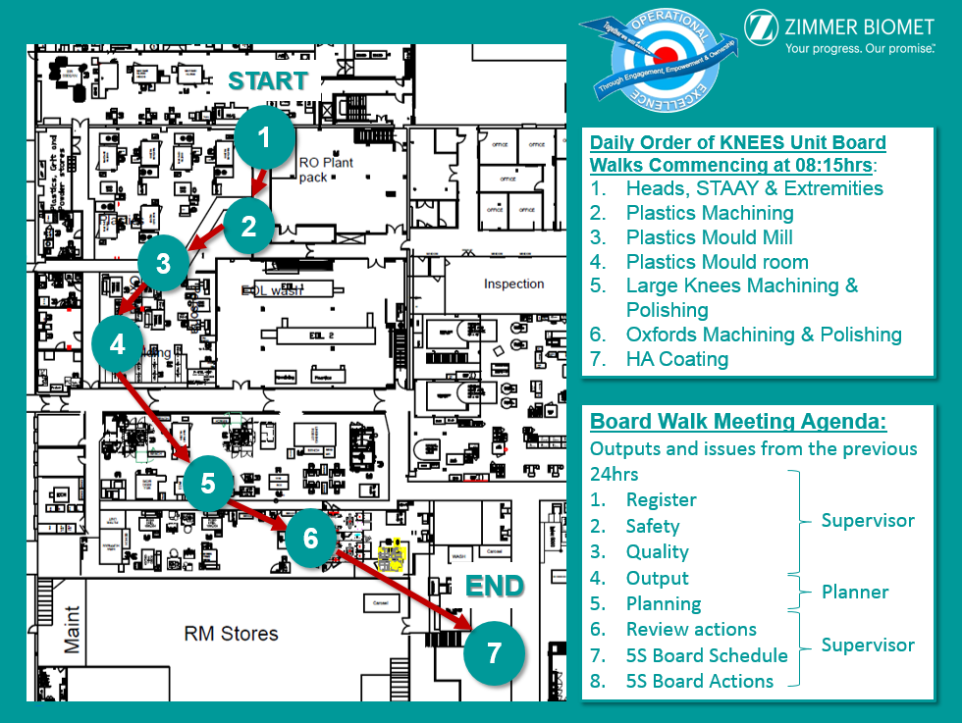
Example of current Output board for each area.
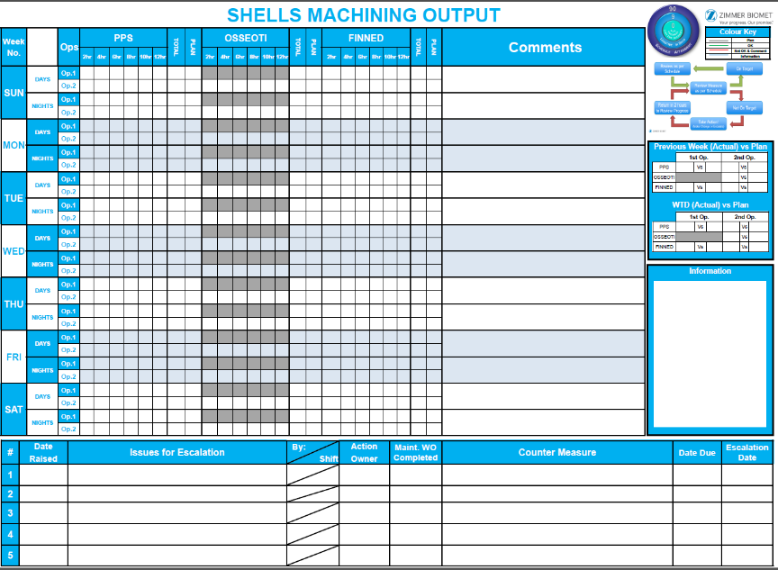

On the back of each board was a Lean Six Sigma driven problem solving tool. These were used to work with operators to problem solve higher level issues raised at the Gemba meetings.
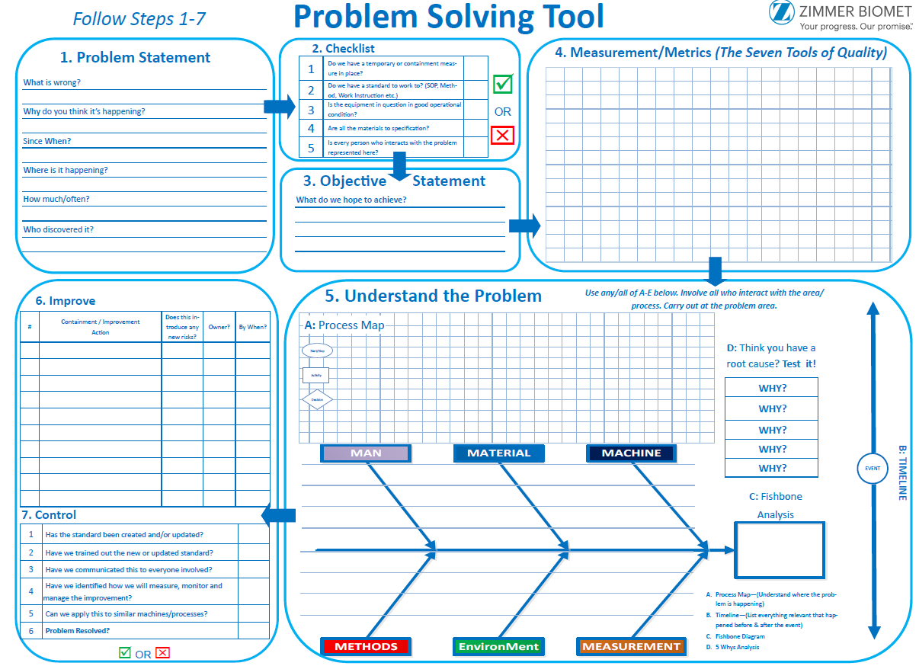
The introduction of the Gemba walks proved highly successful with the biggest gain being the level of interaction between the shop floor and the leadership team.

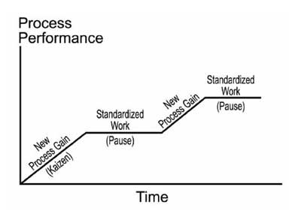
Standard work.
What is the purpose of standard work.
- It clarifies the process
- Documents the current best way
- Ensures we all operate consistently
- Simplifies & accelerates employee training
- Provides the baseline for improvement

Through the introduction of Standard Work we will improve the flow of parts through the manufacturing cells whilst reducing WIP and improving our lead times.

What is Standard work?
- Standard work supports stability and reduces variation because the work is performed the same way each time. Moreover variations (defects, deviations, discrepancies) are easier to recognise.
- Standard work is the essential foundation for continuous improvement – moving from one standard to a better standard without slipping back.
- Standard work is not static, so if a better way is found the process is updated.
- Standard work is an effective way for all employees to get involved and provides a solid basis for new employee training

With a 10% increase in demand, Standard work was inroduced to the Oxford machining cell. A structured method was created on how the project would commence.
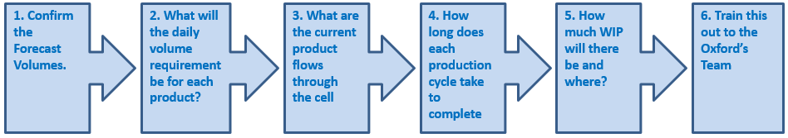

Additional Lean principes were used throughout the project to achieve the final goal, such as VSM, Process flow diagrams, time study/Takt time & Kanban. Examples of these are shown below.

Value stream map & Process flow diagrams.
During step three a Value stream map was created as well as a process flow diagram, this helped identify any non-value added waste and help the team have a better understanding of the process flow.

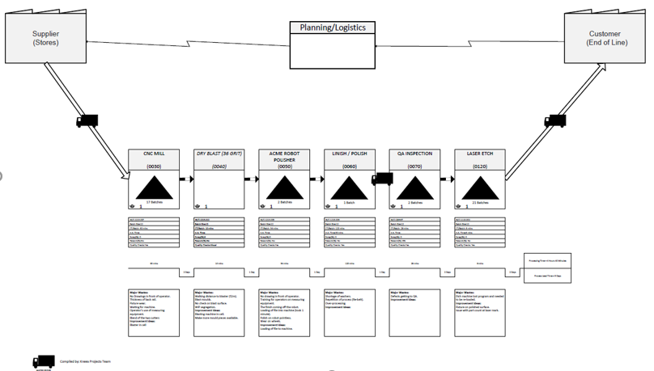

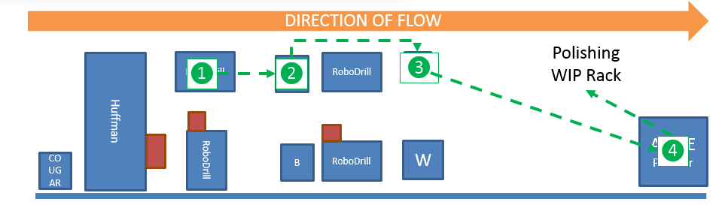

Time Study
At step four, a time study was taken with the purpose of establishing a standard time for each process to understand cost of manufacturing with the added benefits of increasing productivity.
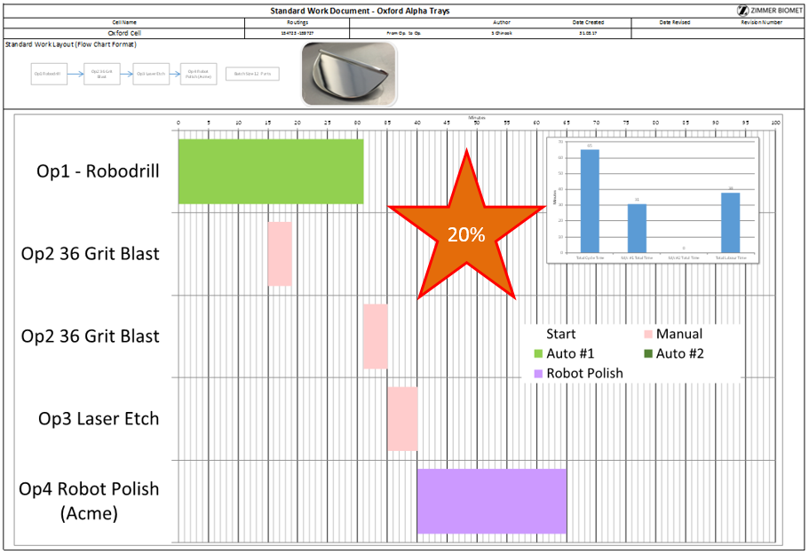
KANBAN/WIP Level Management.
A KANBAN system was introduced to minimise shop floor WIP and create a pull system from Raw materials stores. This would ensure that only the required amount of parts for the given shift would be on the shop floor. Min/Max WIP level rules were implemented to support this change.
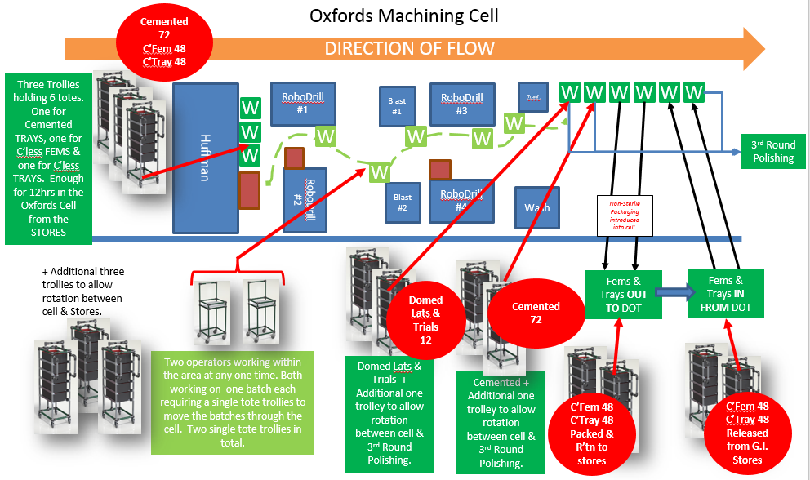

The introduction of Standard work was a huge success. Scrap levels reduced from 7% to 3%, this saving equates to a cost reduction of £60,000 in the first full year.
Productivity increased from 86% to 99%, this was due to us being able to achieve the 10% increase in loading with no additional labor.

5s
5s is a Lean methodology following 5 steps to remove waste and provide an organised workplace to improve standards and operational performance.
Many of us can easily find products in a supermarket. It is a clean and safe environment, with no dirt and clutter, where everything is clearly identified and signposted. Following the same principles within manufacturing can have the same positive outcome.

See below, where an example of 5s was implemented to improve the Zimmer Biomet Bridgend site.
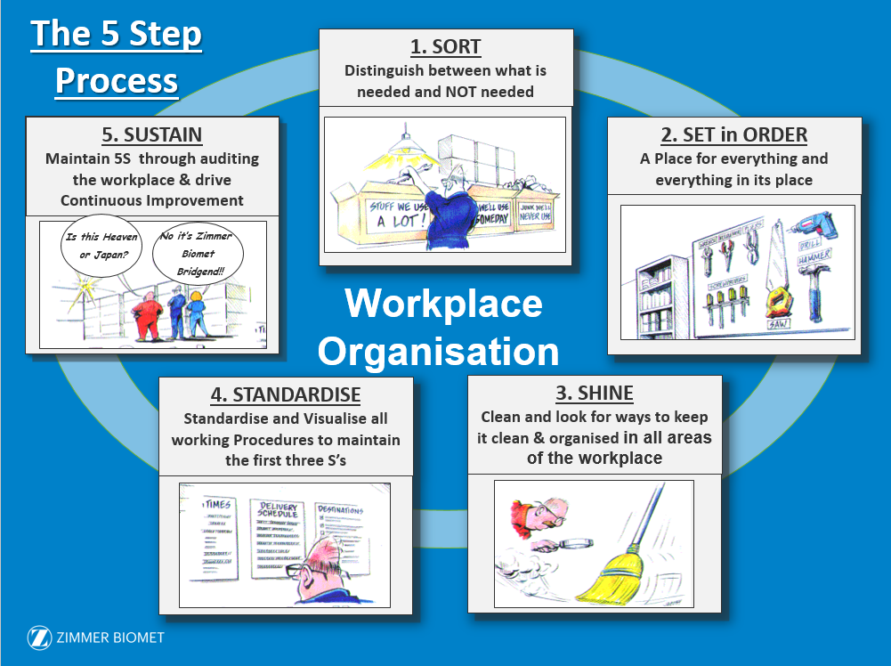

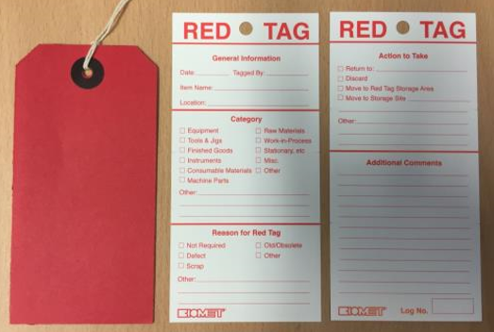
Seiri/Sort- Distinguise what is needed and what is not. A red tag event was set up to remove any equipment deemed not needed for the area. These items were then reviewed by the team and removed if neccasary.

Seiton/Set in order- A place for everything and everything in its place. Equipment should be located close to the task as possible. Organising equipment clearly shows if anything is missing and makes it quicker and easier to find missing items.

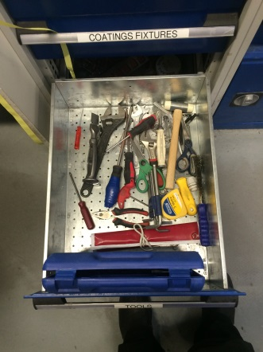
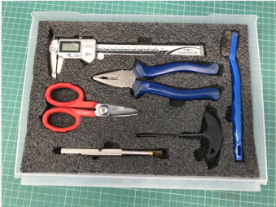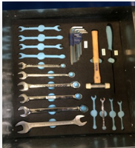

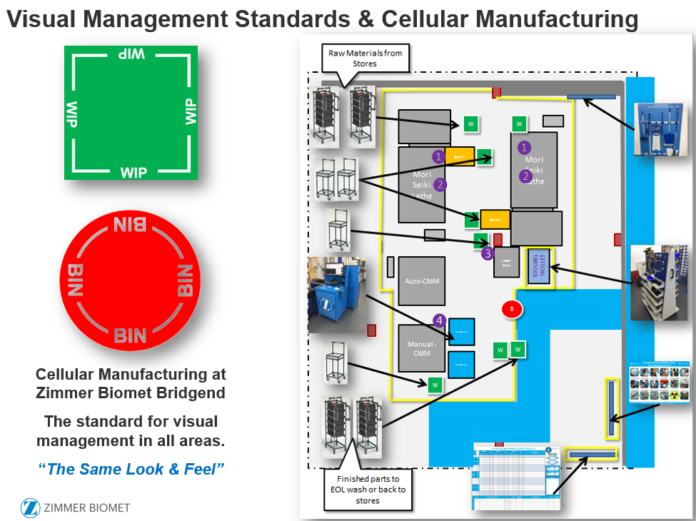

Seiso/Shine- Deep clean of the area and keeping it clean by providing new cleaning equipment and boards in each area.
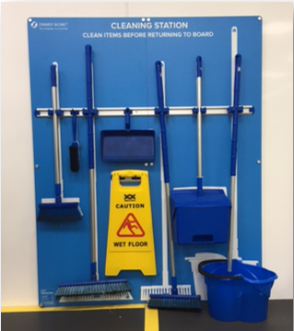

Seiketsu/Standardise - This step involves creating a consistent way of implementing the first 3s’s. Done correctly everyone who uses the area will know what the standards are. Visual management is key to ensuring standards are met. Each area would have a cleaning schedule that required completing on a shift by shift basis.
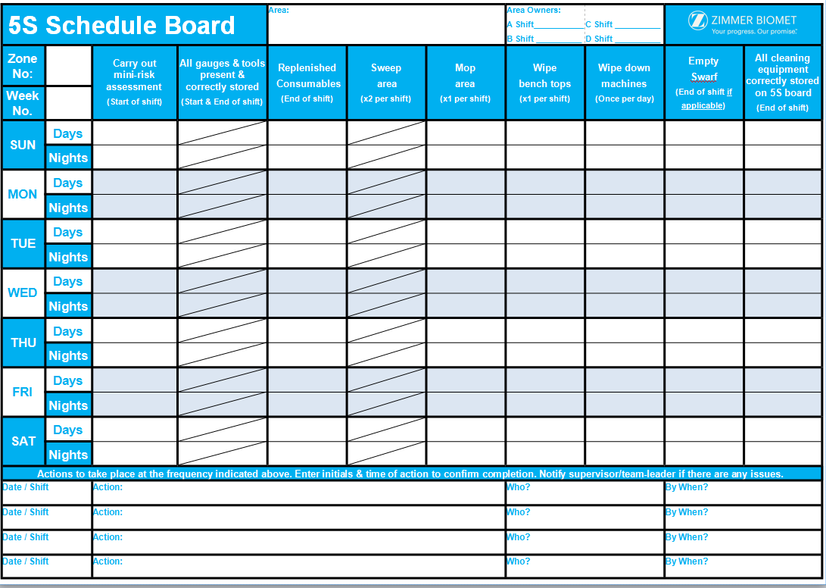
Example of 5s Schedule board at Zimmer Biomet

Shitsuke/Sustain- At this stage, measures are put in place to ensure all levels are sustained to the set target. To sustain 5S Level you have to maintain discipline & continuously improve through regular, effective weekly auditing and following actions through to completion. Sort, Set in Order, Shine and Standardise should become part of our culture so it is understood and
followed in our daily work.

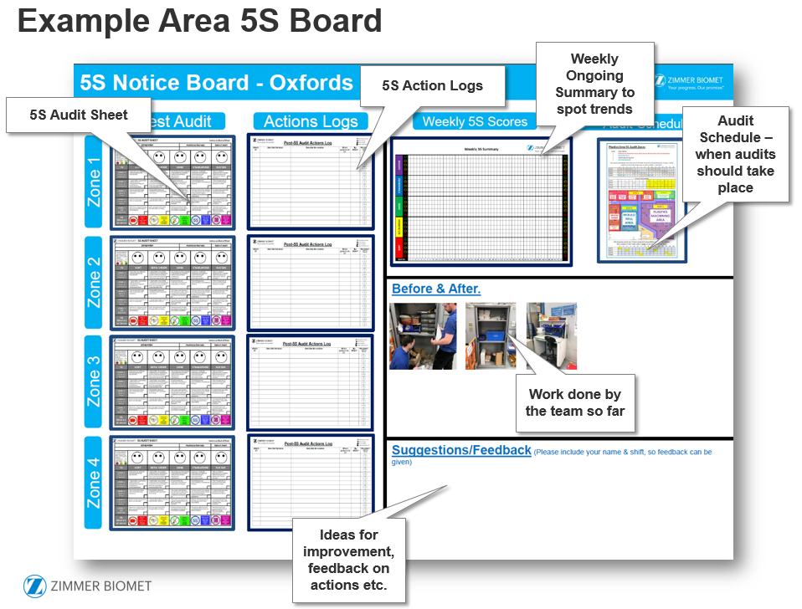

References
Womack, J.P., Jones, D.T. (1996) Lean Thinking - Banish Waste and Create Wealth in your Corporation. New York: Free Press
Womack, J.P. et al (2007) The machine that changed the world: How Lean Production Revolutionized the Global Car Wars. London: Simon & Schuster
George, M.L (2002) Lean Six Sigma: Combining Six Sigma with Lean Speed. New York: McGraw-Hill.
McCarty, T el al (2005) The Six Sigma Black Belt Handbook. New York: McGraw-Hill.
Pyzdek, T & Keller, P (2014) Six Sigma Handbook 4th ed. New York: McGraw-Hill.
Nicholas, J (2011) Lean Production for Competitive Advantage. New York: Taylor and Francis Group.
Ficalora, J.P & Cohen, L (2010) Quality Function Deployment and Six Sigma: A QFD Handbook 2nd ed. Boston. Pearson Education, Inc.

