acba4006 material science and building services
Lighting Layout and Sound Index calculation

Contents
Task A 2
Room Index (RI) 2
Utilisation Factor 2
Lamps Required 3
Suitable Layout 3
Task B 5
Transmission coefficient for Brick work 5
Transmission coefficient for Window 5
Using averaging formula and substituting for Brickwork and Window 5
Using SRI formula and substituting 5

Task A
A production area in a factory measures 60 metres x 24 metres x 8 metres in height.
The factory’s work benches are set at a height of 1m above the floor level.
The area’s reflectance’s are 0.3 for the ceiling and 0.5 for the walls.
The Lighting design specifies Fluorescent lamps in recessed louvre with DLOR of 50%.
(The actual size for the luminaires is 1200mm (1.2m) in length and 200mm (0.2m) wide.)
A Lighting Design Lumen (LDL) output of 18,000 lumens is required.
The illumination required for the factory area is 200 lux at the working plane and there is a Light Loss Factor of 0.75.

Room Index (RI)
Room areas are described by a Room Index (RI) which is given as:
Room Index (RI) = (L*W)/(Hm(L+W))
Length = 60m, Width = 24m, Height = 8m – 1m = 7m: Given these figures we can calculate the RI
Room Index (RI) = (L*W)/(Hm(L+W))
RI = (60*24) / (7(60+24))
RI = 2.448979592
RI = 2.448

Utilisation Factor
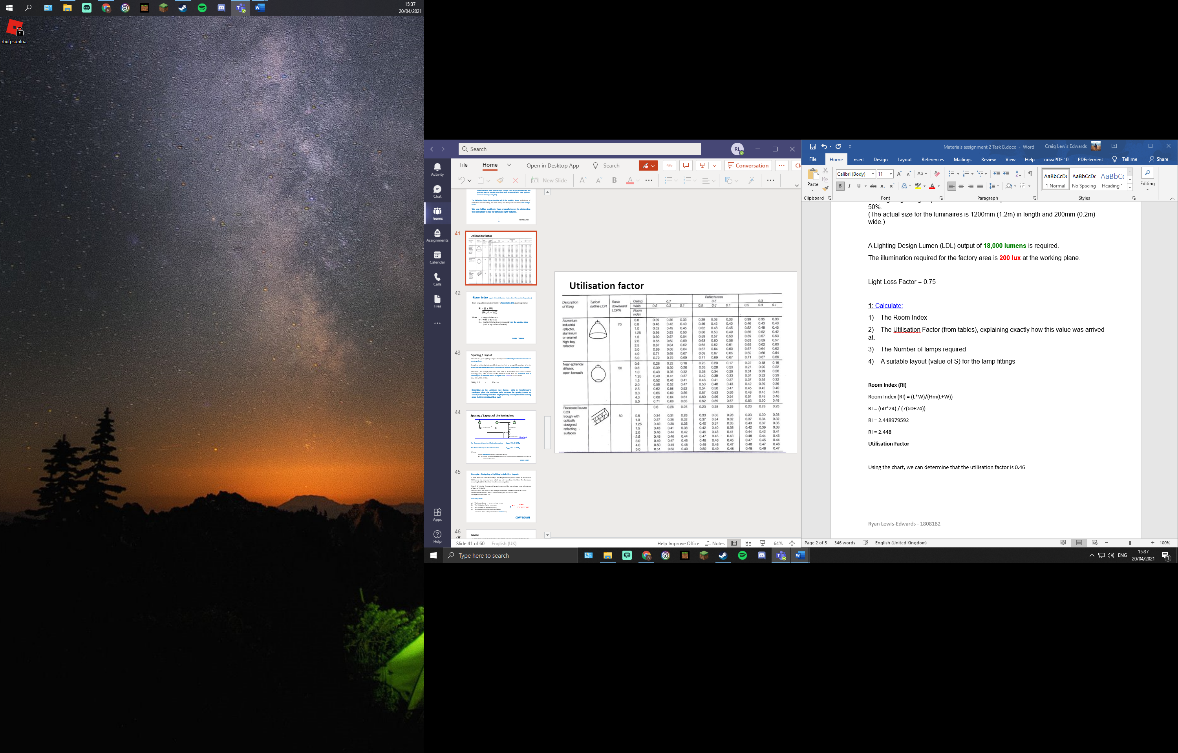
The lights design that we are using specifies the use of Fluorescent lights in recessed louvre with a DLOR of 50% and the wall and ceiling areas reflectance are 0.5 and 0.3. Using this information, we can follow the Utilisation factor diagram, rounding up the RI figure from 2.448 to 2.5 to find the utilisation factor of our room to be 0.46 UF reflectance.
Using the chart, we can determine that the utilisation factor reflectance is 0.46 UF

Lamps Required
The production area requires an illumination of 200 lux in the working place, using the figures we have calculated such as the area, UF, LLF we can work out the specific number of lamps required to achieve the 200-lux illumination.
N= E*A/F*UF*LLF
E=200lux, A=60mx24m = 1,440m, F= 18,000lm, UF = 0.46, LLF = 0.75
Substituting values
N= 200lux*1,440m/18,000lm * 0.46UF * 0.75LLF
N= 288,000/6,210
=46.3768
=48 lamps required

Suitable Layout
Smax = 1.5*H_{m}
= 1.5*7 = 10.5m apart.
Seeing as we require 47 lamps, my suggested layout of lamps is 4 rows of 12 lamps.

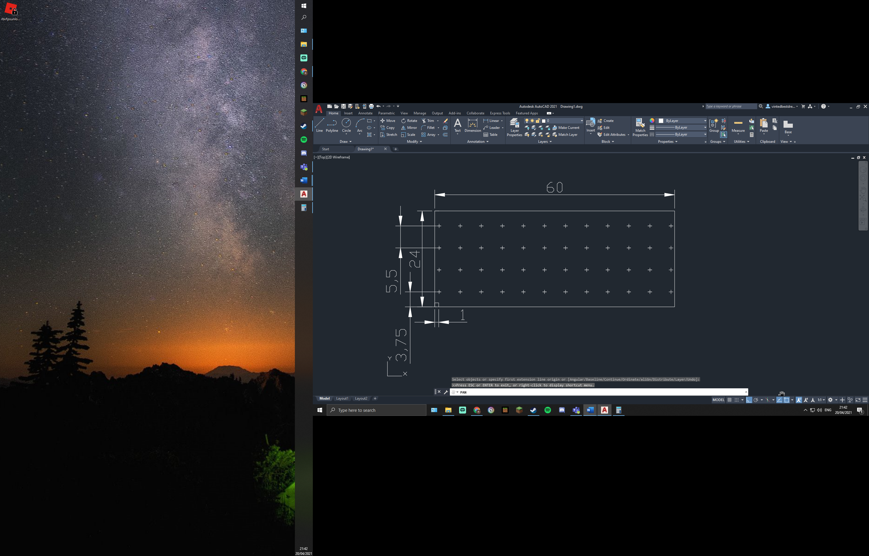
1:1 Scale
5.5m width between lamps
4.83m length between lamps
1m space from wall to lamp as required

Task B
A brick wall of area 20m² contains a window of area 4m². The values of sound reduction indexes are: 50dB for the brickwork and 10dB for the window. Calculate the overall sound reduction index for the entire wall.

T₀ = Overall transmission coefficient
T₁ = Transmission coefficient of one component
T₂ = Area of the component

Brick work = T₁ = ? A₁ = 20-4 = 16m2 SRI = 50dB
Window = T₂ = ? A₂ = 20-16 = 4m2 SRI = 10dB
Using the SRI formula SRI = 10x(log10(1/T))
T₀ = (_{T1xA1}) + (_{T2xA2})/A₁+A₂
Transmission coefficient for Brick work
= 50 = 10(log10(1/T₁))
5 = log10(1/T₁)
1/T₁ = 10⁻⁵
T₁ = 10⁻⁵
Transmission coefficient for Window
= 10 = 10(log10(1/T₂))
1 = log10(1/T₂)
1/T₂ = 10⁻¹
T₂ = 10⁻¹

Using averaging formula and substituting for Brickwork and Window
= (10⁻⁵ * 16) + (10⁻¹ * 4)/16+4
= 0.40016/20
= 0.02008
Average Transmission Coefficient = 0.02008

Using SRI formula and substituting
SRI = 10x(log10(1/T))
= 10 x (log10(1/0.02008))
= 10 x (log10(49.8007))
= 16.97235447
= 17dB
SRI for the Composite partition = 17dB

