INFLUENCE OF DIVERSITY MANAGEMENT ON ORGANISATIONAL PERFORMANCE: A CASE STUDY OF SEPHORA

Full name: HOUDA BENOUKAISS
Student ID: 2322918

Table of Contents
Introduction 3
Aims, objectives, and research questions 4
Methodology 6
Literature Review 9
Limitations 12
Ethical considerations 13
Time frame 13
Conclusion 14
References 15

Introduction
Background
Diversity management can be defined as the systematic process of promoting diversity and inclusivity for achieving strong organisational resilience in an organisation. In view of Mousa et al. (2020), diversity management includes practices, protocols and policies regarding the improvement of organisational inclusivity. The integration of diversity management helps companies to maintain the organisational sustainability through ethical practices and fair protocols towards the stakeholders during business operations. Consequently, this can help in meeting customers expectations by catering to the interest of buyers. In this context, diversity management activities of Sephora have been taken into consideration for enhancing organisational performances.
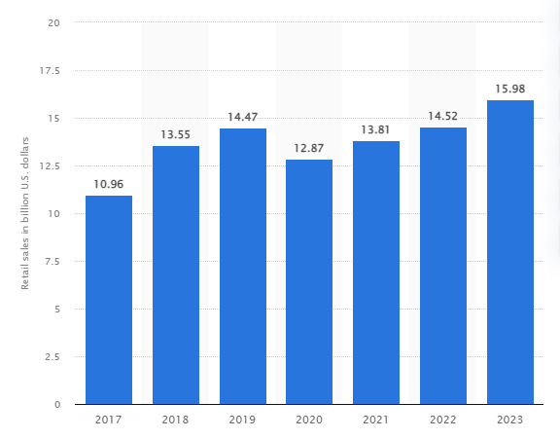
Figure 1: Sales margin of Sephora
(Source: Statista, 2024)
Sephora is one of the largest beauty and personal care companies across international regions focusing on diversity and discovery for every individual. Sephora operates in omni-retail with the aim of creating a welcoming beauty shopping experience for individuals through 2,700 stores in 35 countries in the global market (Sephora, 2024). Higher number of stores in the international market reflects on the competitive advantage of Sephora in the beauty and personal care industry. Similarly, Sephora works with multiple brands such as Rare Beauty by Selena Gomez and Fenty Beauty by Rihanna for selling the beauty products across the globe (Sephora, 2024). It implies that working with popular brands impacts on the product and brand visibility of Sephora in the beauty and personal care industry. On the other hand, bringing diversity, inclusion and equality is the core mission of Sephora for achieving strong competitive advantage in the beauty and personal care industry (Sephora, 2024). Focusing on diversity and inclusivity provides advantages to Sephora in increasing organisational performances by including sustainability in the beauty and personal care business. Based on figure 1, the retail sales of Sephora was 16 billion US dollars in the year 2023 (Statista, 2024). Thus, the higher sales margin has helped Sephora in assessing competitive advantage and brand success in the personal care and beauty industry with the focus of diversity and inclusivity.

Aims, objectives, and research questions
Aim
The aim of the research is to evaluate the significance of diversity management to increase organisational performance in Sephora to meet customer expectations
Objectives
- To analyse the importance of diversity management for enhancing the organisational performance of Sephora to meet customer expectations
- To evaluate the factors of diversity management that helps in enhancing organisational performances in Sephora to meet customer expectations
- To identify the barriers that can be faced by Sephora during the diversity management activities in the workplaces
- To recommend the strategies that can help Sephora to enhance the diversity management process to achieve higher organisational performances to meet customer expectations
Research questions
- What is the importance of diversity management for enhancing the organisational performance of Sephora to meet customer expectations?
- What are the factors of diversity management that helps in enhancing organisational performances in Sephora to meet customer expectations?
- What are the barriers that can be faced by Sephora during the diversity management activities in the workplaces?
- What are the strategies that can help Sephora to enhance the diversity management process to achieve higher organisational performances?
Rationale
Poor linguistic understanding among the employees is considered as the major issue for companies to maintain the organisational productivity during business operations. As per the observation by Cherian et al. (2021), lack of cross-cultural activity in the workplaces impacts on the employee productivity level. In this context, lack of cross-cultural policies in the workplaces creates challenges for organisations to mitigate the linguistic barriers among the employees. Based on 40% respondents in the survey of 2024 global companies face difficulty to hire people due to lack of diversity (Statista, 2024). As a result, the inclusion of diversity is necessary for the UK companies to mitigate the linguistic barriers and cross-cultural issues for maintaining organisational performances. As a result, this can also help in serving customers effectively and catering to the expectations of the customers. On the other hand, the global recruitment process is also a major factor for companies to focus towards diversity management in maintaining organisational performances. In a survey of 2021, 47.9 percent of the respondents said that maximum UK companies are focusing on enhancing the diversity approaches in the workplaces (Statista, 2024). Hence, it can be highlighted that the adoption of the research topic is justified due to the focus on diversity management to enhance organisational performance of Sephora.
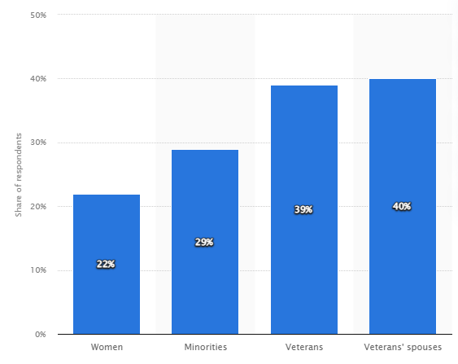
Figure 2: Difficulty in diversity hiring
(Source: Statista, 2024)

Methodology
Research onion
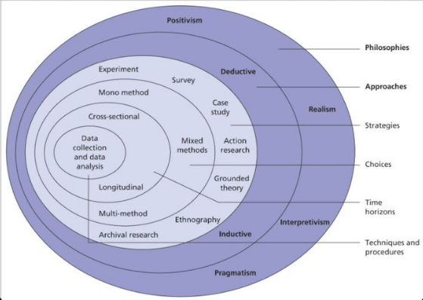
Figure 3: Research onion
(Source: Saunderset al. 2019)

Research philosophy
The research will focus on the “interpretivism philosophy” for analysing the impact of diversity management to enhance the organisational performances of Sephora. “Interpretivism philosophy” helps to identify the existing phenomenon and characteristics in a research (Noriey, 2022). Thus, the adoption of “interpretivism philosophy” is justified for the research to identify the phenomenon of diversity management impact on organisational performances.
Research design
Integration of “descriptive design” will be followed in this research regarding the observation of existing variables on diversity management in Sephora. Using “descriptive design” in research helps to understand the framework for data collection (Wisenthige, 2023). Therefore, the inclusion of “descriptive design” will help to access a structured framework to assess qualitative data on the research topic.
Research approach
Following “deductive approach” will be validated to analyse the objectives and questions of the research regarding diversity management on Sephora. In view of Sinagaet al. (2022), “deductive approach” helps in examining the cause or results of variables to include positive outcomes in a research. The integration of “deductive approach” will help to measure the effectiveness of research variables on the results and outcomes of the specific objectives.
Research strategy
“Qualitative strategy” will be focused to adopt in this research to access existing knowledge on the impact of diversity management on Sephora. Utilising “qualitative strategy” will help to bring existing ideas on the diversity aspects in Sephora to enhance organisational performance by theoretical perspectives.
Data collection process
This research will examine the “secondary qualitative” data to interpret the key ideas of diversity influence in the organisational performance of Sephora. Based on the discussion by Enoch et al. (2024), “secondary qualitative” includes subjective phenomena in a research for bringing existing stances to interpret a specific topic.Therefore, the collection of “secondary qualitative” will be focused from reliable databases like “Google Scholar” for interpreting the factors of diversity management to enhance the organisational performances of Sephora.
Data analysis process
Analysis of the collected findings will be based on “thematic analysis” procedures regarding the inclusion of accurate results on the research objectives. As opposed to Braun and Clarke (2023), “thematic analysis” helps to analyse the research findings with the establishment of relevant themes. Accordingly, four themes will be made based on the objectives to interpret the “secondary qualitative” findings regarding the specific topic.
Sampling
The integration of “purposive sampling” would be effective to include secondary journals during the interpretation of the research. “Purposive sampling” helps to gather information in the context of a research purpose and hypothesis. In turn, the utilisation of “purposive sampling” will help to collect the 12 journals from “Google Scholar” based on the research objectives.

Literature Review
Diversity management to enhance organisational performance of Sephora to meet customer expectations
Diversity management is organisational action that allows the inclusion of employees from different cultures and backgrounds into organisational structure depending on particular regulations and policies. As stated by Van Knippenberg et al. (2020), the diversity management process helps organisations bring together numerous perspectives and ideas to generate creativity and innovation to attract customers. Accompanied by recognising individual preferences, diverse workplace can help organisations to serve diverse customers with the help of diverse employees. For example, Sephora is identified as a leader in prestige omni-retail that targets “to create a welcoming beauty shopping experience for all and inspire fearlessness in the community” (Sephora, 2024). The management team of Sephora practices hiring employees from diverse cultures to create diverse teams to serve all over the world. Sephora community has 187 nationalities including 80% of women managers that influence inclusive behaviours across the company (Sephora, 2024). The management team is always ready to celebrate diversity by embracing unique and innovative approaches through reducing cost and increasing efficiency to meet customers’ expectations.
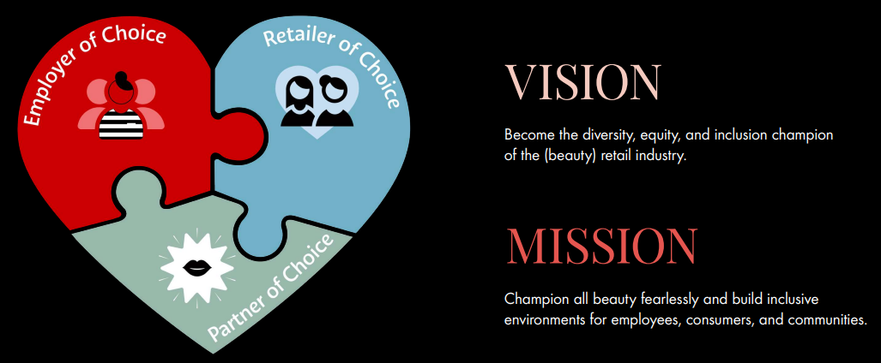
Figure 4: Sephora’s mission and vision towards diversity
(Source: Sephora, 2024)
Significance factors influence diversity management to support Sephora’s organisational performance to meet customer expectations
Managing diversity in the workplace needs several factors to ensure its sustainability within organisational performance. According to Mikkelsen and Wåhlin (2020), tolerance of ideas and thoughts with different backgrounds, perspectives, and life experiences continuously influences the diversity management process. Experiencing a spike in a diverse workplace, Sephora developed a number of Hispanic and Black employees in the past years 16% and 8%respectively (Burton and Confino, 2022). It highlights having a diversity and inclusion (D&I) objective associated with performance reviews. For instance, Sephora’s allyship training and employee resource groups assist in cultivating inclusive workplaces that make it comfortable for its employees (Sephora, 2024). The inclusion mindset of the team members is reflected in the customer attendance process that makes them happy and satisfied.
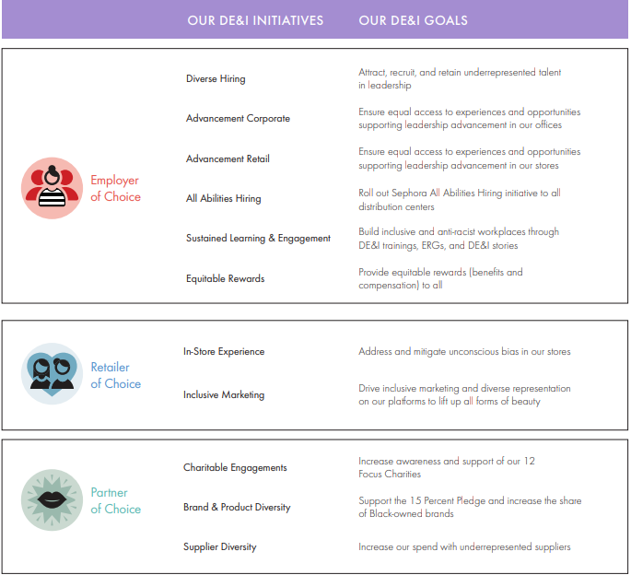
Figure 5: Sephora’s three key pillars of diversity
(Source: Sephora, 2024)
According to Figure 5, Sephora’s diversity management process depends on three key pillars: employer of choice, retailer of choice, and partner of choice. Based on the record of 2020, Sephora has increased 6% of its Black and African American leaders' hiring process and 12% of Hispanic/Latino leaders' hiring process across the organisation (Sephora, 2024). Sephora incorporates DE&I goals into its different programs to improve employee performance levels to meet customers’ expectations. However, the management team tries to provide equal opportunities to its diverse workforce to make feel them equal to serve customers effectively. Therefore, by promoting diverse factors such as increase revenue, reducing cost, and increasing performance Sephora also developed its management efficiency productively.
Challenges faced by Sephora during the diversity management activities in the workplaces
The current customer preferences are changing rapidly, that is a major issue for retail organisations to keep pace with the demands. Similarly, Sephora also faces challenges regarding continuously changing demands and preferences of its diverse customers. As opined by Abolfathiet al. (2022), businesses that cannot adopt sudden market changes or customer preferences can lose market share as well as advantageousness. The diversity management process of Sephora needs a wide range of funding to ensure its digital marketing initiatives. Sephora earned 14.5 billion U.S. dollars in 2023 that is not enough to support its digital marketing initiatives (Petruzzi, 2024). In addition to this, Sephora also faces competition from traditional and internet stores that indicate a serious challenge for the company to keep its market position in different countries. New players in the digital space are capable enough to handle changing consumer preferences and behaviours that are identified as a major disturbing factor for retail organisations to maintain its leadership position in the competitive market.
Effective strategies to develop diversity management process within organisational performances to meet customer expectations
Following the challenges of diversity management process in the workplace needs adoption of effective and suitable strategies to ensure organisational development process to meet customer expectations. In the realm of the diversity management process, the role of transparent leadership is crucial to encourage diverse teams to reach organisational objectives and goals. Transparent leaders can inspire trust among diverse employees to create a positive workplace for improving employee morale (Modise, 2023). However, policy evaluation is another effective strategy that can implement a zero-tolerance policy in the workplace to embrace changes to make customers happy and satisfied. According to Wolbring and Nguyen (2023), effective policies can generate inclusive and equitable workplaces that maintain equality among employee power and responsibilities. For instance, as Sephora is suffering from a lack of financial support to influence its digital approach, partnership with financially stable companies can help in this factor. The “National CARES Mentoring Movement”, the “National Association for the Advancement of Coloured People (NAACP)”, and the “National Coalition on Black Civic Participation” are equity partners of Sephora (Sephora, 2024). The diversity training process needs positive financial support to bring a tremendous transformation in the workplace to improve customer satisfaction level. Fostering diverse thinking processes also can assist the diversity management process within the organisational motive to reach its target.
Theoretical underpinning
Cultural iceberg theory
Cultural iceberg theory is considered an effective diversity management theory that makes clear sense for understanding cultural differences. In the workplace, working with diverse employees, thoughts, ideas, and perspectives, this theory application process can help in explaining a specific culture that is used to follow the organisational operations to meet customers’ expectations. According to Liu et al. 2021), cultural iceberg theory helps people understand the complexities of different cultures and highlights both hidden and visible aspects to ensure the easiest way to accept a new culture. Leading any organisational operations effectively, this theory is very significant for avoiding ethnocentrism and judging a culture based on its requirements to accept new approach. Therefore, the application of cultural iceberg theory can help Sephora to analyse underlying causes and influence cultural diversity to manage diverse customers.
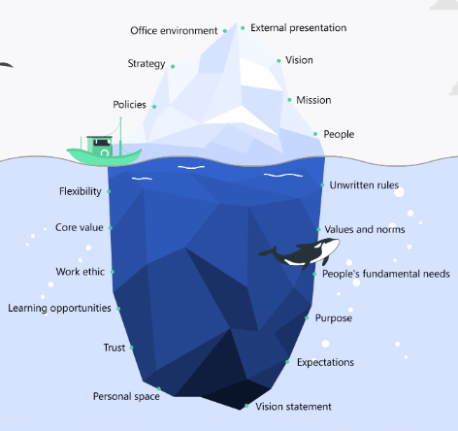
Figure 6: Cultural iceberg theory
(Source: Influenced by Liu et al. 2021)

Limitations
The research process will only led through the secondary data collection technique and not using primary data is recognised as a limitation of this research as it could serve real-time data with evidence. Based on first-hand and large-size data the research could be more authentic and valid. Additionally, another limitation of this research is the lack of a proper explanation of diversity management strategies to enhance organisational performance. Short of availability of existing data regarding diversity management makes this research limited to serve all the information to make it valuable.

Ethical considerations
Leading this research properly, all the potential ethics related to secondary data collection process will be followed. For example, the “Data Protection Act 2018” of UK legislation will be followed to improve the confidentiality of personal information (Gov.uk, 2024). This research will not be interested in demeaning any community or manipulating any information as it will be conducted only for academic purposes and will focus on the business management process. Additionally, the “Copyright, Designs, and Patents Act 1988” of UK legislation also will be followed to protect research from copyright issues (Gov.uk, 2024). Maintaining authenticity and reliability of the articles by including journals from 2020 would be beneficial to meet the research ethics appropriately. In addition, the provision of research acknowledgement to the authors will be appropriate due to the fact that the collection of articles will maintain the ethics and reliability of the research. Following this approach, the research can avoid any kind of issue regarding plagiarism and copyright. However, Following the PRME Corner, the research process needs to reach a conclusion depending on the proper moral and accountable way (Itb.ac.id, 2024). Therefore, all the potential ethical considerations will be followed to maintain the sustainability and validity of this research.

Timeframe
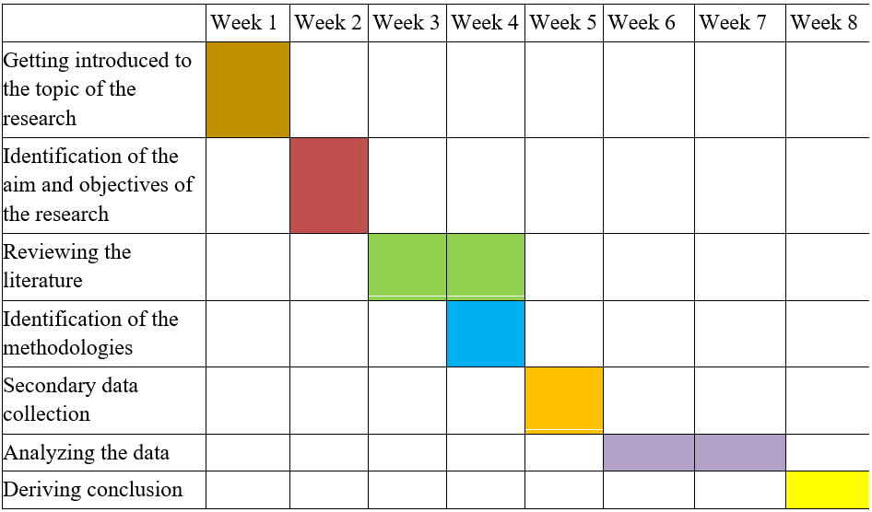
Table 1: Research timeline
(Source: Influenced by Alghamdi et al. 2020)
Based on Table 1, this research will take a total of eight weeks to complete and generate a meaningful conclusion. Thus, reviewing the literature process and data analysis process will take the longest time compared to other research activities. All the mentioned research steps are valuable to keep the reliability and validity of the research paper.

Conclusion
Creation of a diverse and inclusive environment is one of the major objectives of diversity management for an organisation to enhance staff engagement along with organisational performances. Accordingly, I think the initiatives of companies towards sustainability influenced through the integration of diversity management by reframing fair policies and practices. Employee engagement is likely to be enhanced by international organisations regarding the promotion of diversity management in the workplaces.

References
Abolfathi, N., Fosfuri, A. and Santamaria, S., (2022). Out of the trap: Conversion funnel business model, customer switching costs, and industry profitability. Strategic Management Journal, 43(9), pp.1872-1896.
Alghamdi, H., Alsubait, T., Alhakami, H. and Baz, A., (2020). A review of optimization algorithms for university timetable scheduling. Engineering, Technology & Applied Science Research, 10(6), pp.6410-6417.
Braun, V. and Clarke, V., (2023). Toward good practice in thematic analysis: Avoiding common problems and be (com) ing a knowing researcher. International journal of transgender health, 24(1), pp.1-6.
Burton, A. and Confino, P., (2022). Sephora spent the past two years quietly boosting its diverse representation in leadership. Available at:https://fortune.com/2022/12/01/sephora-boosting-diverse-representation-leadership/ [Accessed on: 5th November, 2024]
Cherian, J., Gaikar, V., Paul, R. and Pech, R., (2021). Corporate culture and its impact on employees’ attitude, performance, productivity, and behavior: An investigative analysis from selected organizations of the United Arab Emirates (UAE). Journal of Open Innovation: Technology, Market, and Complexity, 7(1), p.45.
Enoch, J., Subramanian, A. and Willig, C., (2024). How do research participants with age-related vision loss talk about their experiences? A secondary discourse analysis of published qualitative extracts. Ageing & Society, pp.1-39.
Gov.uk, (2024). Copyright, Designs and Patents Act 1988. Available at:https://www.legislation.gov.uk/ukpga/1988/48/contents [Accessed on: 5th November, 2024]
Gov.uk, (2024). Data Protection Act 2018. Available at:https://www.legislation.gov.uk/ukpga/2018/12/contents [Accessed on: 5th November, 2024]
Itb.ac.id, (2024). PRME Corner: Ethics in Research, Do We Concern?. [Online]. Available at:https://www.sbm.itb.ac.id/2019/06/04/prme-corner-ethics-in-research-do-we-concern/ [Accessed on: 5th November, 2024]
Kasihono, S.C. and Suwito, S., (2024). Research Budget Improves National Product Independence: A National Resilience Perspective. International Journal Of Humanities Education and Social Sciences, 3(6).
Liu, T., Yang, X. and Guo, Y., (2021). Research on influencing factors of technological independent innovation of equipment manufacturing enterprises from the perspective of iceberg theory. Complexity, 2021(1), p.2551680.
Mikkelsen, E.N. and Wåhlin, R., (2020). Dominant, hidden and forbidden sensemaking: The politics of ideology and emotions in diversity management. Organization, 27(4), pp.557-577.
Modise, J.M., (2023). Leadership Philosophies and How They Relate to the Composition, Demographics, Character, Effectiveness, and Efficiency in an Organisation: The Literature Review. International Journal of Innovative Science and Research Technology, 8(7), pp.3413-3434.
Mousa, M., Massoud, H.K. and Ayoubi, R.M., (2020). Gender, diversity management perceptions, workplace happiness and organisational citizenship behaviour. Employee Relations: The International Journal, 42(6), pp.1249-1269.
Noriey, I., (2022). The Significance of Research Methods with Reference to Language Education in Higher Education. Available at SSRN 4208189.
Petruzzi, D. (2024). Worldwide retail sales of Sephora from 2017 to 2023. Available at:https://www.statista.com/statistics/1445562/retail-sales-of-sephora-globally/ [Accessed on: 5th November, 2024]
Saunders, M., Thornhill, A. and Lewis, P. (2019). Methods for Business Students (8th edition). Pearson Education: London.
Sephora, (2024).About Sephora. Available at:https://www.sephora.com/beauty/about-us [Accessed on: 5th November, 2024]
Sephora, (2024).DE&I Heart Journey Report. Available at:https://www.inside-sephora.com/sites/default/files/2024-07/2024-SephoraDEIHeartJourneyReport.pdf [Accessed on: 5th November, 2024]
Sephora, (2024).Diversity Equity & Inclusion. Available at:https://www.inside-sephora.com/en/commitments/diversity-equity-inclusion [Accessed on: 5th November, 2024]
Sephora, (2024).Diversity, Equity & Inclusion. Available at:https://www.inside-sephora.com/en/usa/diversity-equity-inclusion [Accessed on: 5th November, 2024]
Sinaga, N.A., Ningtiyas, F.A., Mahmuzah, R., Zahara, Y. and Fatwa, I., (2023). The Effect of Deductive-Inductive Learning Approach on Creative Thinking Ability and Learning Motivation.
Statista, (2024). Global companies' difficulty in diversity hiring for IT staff 2024. Available at: https://www.statista.com/statistics/1317816/global-companies-challenges-on-it-employment-diversity[Accessed on: 5th November, 2024]
Statista, (2024). Perception on improvements in diversity and inclusion at the workplace UK 2021. Available at: https://www.statista.com/statistics/1257404/perception-on-improvements-to-diversity-and-inclusion-uk/#:~:text=In%20a%20survey%20conducted%20in,of%20respondents%20said%20that%20it[Accessed on: 5th November, 2024]
Statista, (2024). Sephora's retail sales worldwide 2017-2023. Available at: https://www.statista.com/statistics/1445562/retail-sales-of-sephora-globally/#:~:text=As%20of%202023%2C%20Sephora%20generated,approximately%2014.5%20billion%20U.S.%20dollars[Accessed on: 5th November, 2024]
Van Knippenberg, D., Nishii, L.H. and Dwertmann, D.J., (2020). Synergy from diversity: Managing team diversity to enhance performance. Behavioral Science & Policy, 6(1), pp.75-92.
Wisenthige, K., (2023). Research design. In Social Research Methodology and Publishing Results: A Guide to Non-Native English Speakers (pp. 74-93). IGI Global.
Wolbring, G. and Nguyen, A., (2023). Equity/equality, diversity and inclusion, and other EDI phrases and EDI policy frameworks: A scoping review. Trends in Higher Education, 2(1), pp.168-237.

