
Module Name: Introduction to Health and Social Care
Module Code: LCHS 4003
Student Name: Sawkat Ali
Student ID:2442955
Lecturer’s Name: Mark Kane
Submitted On:14/12/25.

Ambulance services
Introduction:
Ambulance services is one of the most important healthcare services in the United Kingdom. Ambulance services are the life blood of modern health care systems providing essential emergency medical assistance and transportation across the UK. I have chosen this topic because it has played a vital role to keep Health care system effective, accurate and transparent.
Explanation of Ambulance Services:
Ambulance services help in emergencies. They send ambulances with paramedics to provide first aid and take patients to the hospital if needed. These services are available 24/7 and are free in the UK (NHS, 2021).
A Brief History of Ambulance Services:
Ambulance services have evolved significantly from their military origins to the highly professionalized emergency medical sems in place today.
In the UK ambulance service have been evolve from horse-drawn cart for the poor to National `NHS services by 1948.
- The first recorded use of ambulances in medical contexts occurred during the Napoleonic Wars (1799–1815), where the French army utilized horse-drawn carts to transport injured soldiers from the battlefield (Pormann & Savage, 2007). Ambulance services started a long time ago. In the UK, ambulance services were officially introduced with the creation of the NHS in 1948. Before that, ambulances were mainly private or run by charities (Jones, 2019). It has a long history to serve the nation since 1799 to till today. It has been going through a lot of struggles and challenges till today. Ambulance has huge impact on National health care system. It has been known as the modern life blood of NHS. There are different types of ambulance services across the UK. Some of them are private and some of them are running by NHS. The NHS and Modern Ambulance Services: In the UK, the London Ambulance Service was officially established in 1829, followed by the creation of regional services across the country. By the mid-20th ambulance service evolve into Paramedics which has significant role in modern day health care. The formation of the NHS in 1948 integrated ambulance services into the public healthcare system, making emergency medical care more widely accessible (NHS, 2020).

Current Functioning of Ambulance Services:

Present day ambulance services are available in every single part of the UK. Which known as one of best service provider across the globe. Today, ambulance services in the UK are part of the NHS. When someone calls for help in an emergency, ambulances are sent to provide immediate care and take patients to hospitals. Ambulances are free for people in the UK (NHS, 2021).
In any kind of emergency, we need dial 999 and within few minutes London ambulance services will knocking at the door. From cardiac arrests to severe trauma in any kind of emergencies (EMS) ambulance respond very fast. In life threatening situation the NHS aims for an eight -minute response time for critical situation.Which is one of the fastest responding ambulance services on this planet. London ambulance service NHS trust is biggest ambulance service in the whole UK. There different ambulance services in Scotland, Wales and Northern Ireland.
Ambulance services divided into many different parts which play different role when it needed. Different ambulance services are named below:
1.Emergency Medical Services which is known as EMS. EMS is the most effective ambulance services which respond faster than any other ambulance services in the UK.
2. Response and Triage: that’s another important service. In many cases, ambulance crews are equipped with advanced tools like defibrillators, cardiac monitors, and oxygen supply systems to provide life-saving interventions while en route to medical facilities (Royal College of Paramedics, 2021).
3.community Paramedicine: It has immense role in some areas in the UK. In some areas, paramedics are tasked with non-urgent responsibilities such as providing home-based care, monitoring chronic conditions, and reducing hospital admissions through preventive care. This innovative approach helps alleviate pressure on emergency departments (NHS Confederation, 2021).
4.Non-emergency Medical Transport: Ambulance services also provide transportation for non-emergency patients who need regular medical care, including those with mobility issues or chronic health conditions. This helps ensure access to essential medical services without relying on emergency resources (NHS, 2020).
5. Technology Integration: Modern ambulances are equipped with cutting-edge technology, such as mobile data terminals, patient monitoring devices, and GPS navigation systems, enabling more efficient operations and better patient care during transit (NHS, 2020).

Two Challenges Faced by Ambulance Services:

Challenge 1: High Demand – Ambulance services get a lot of calls, especially during busy times like winter. This makes it harder for them to respond quickly to every emergency (Brown, 2020). The demand for ambulance services has risen sharply, partly due to an aging population and a higher incidence of chronic conditions. This places additional strain on ambulance teams, often resulting in delayed response times, particularly for less urgent cases (Klein, 2013).
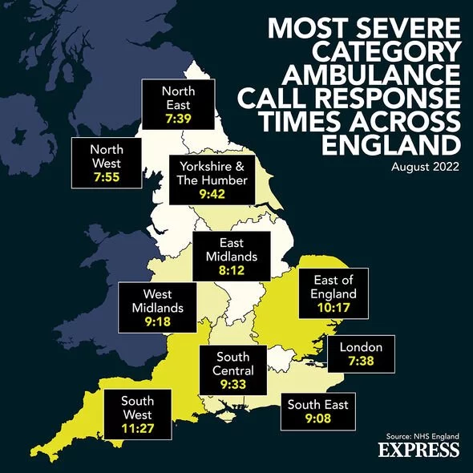

Challenge 2: Budget Cuts – The money available to run ambulance services is being reduced. This means fewer staff and resources, which can make it harder to provide care (Williams, 2021).
The ambulance service workforce is under immense pressure. There are growing concerns over staff shortages, high turnover rates, and burnout. Paramedics and EMTs often work long hours in high-stress situations, leading to exhaustion and job dissatisfaction. This can impact both the quality of care provided to patients and the overall efficiency of ambulance services (Royal College of Paramedics, 2021).

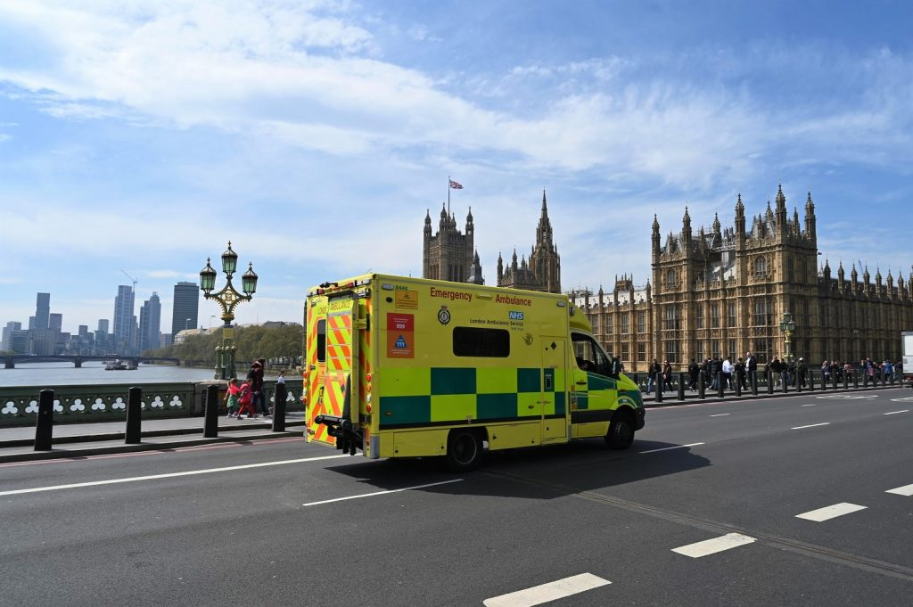

Essay on the NHS

Origins of the NHS:
The National Health Service (NHS) was created in the UK in 1948. Before this, healthcare was expensive, and many people couldn’t afford it. The NHS was set up to make sure everyone could get medical treatment for free, no matter how much money they had. The idea for the NHS came from the Beveridge Report in 1942, which said healthcare should be available to everyone (Beveridge, 1942). The NHS was created by Aneurin Bevan, the first Health Minister (Morris, 2020). 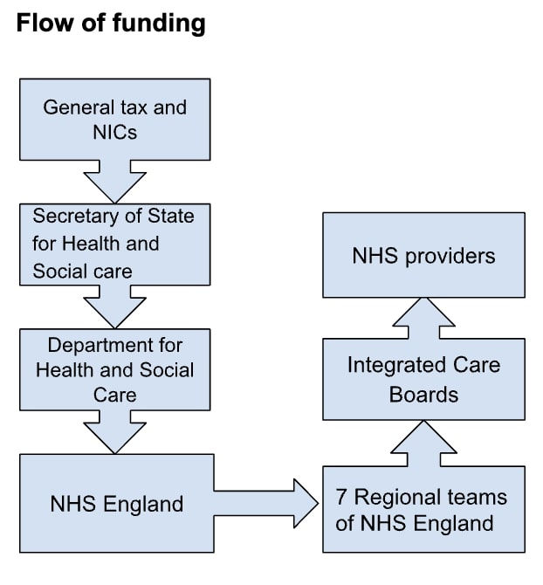 Key services function within this framework:
- Community antenatal midwifery services: These are often managed by NHS Trusts or Local Health Boards (in Wales) and work closely with primary care networks and local authorities to provide care for expectant mothers.
- Ambulance services: These are provided by dedicated NHS Trusts (e.g., the NI Ambulance Trust) and are an essential part of the urgent and emergency care system, with demand a constant challenge.
- Pharmacy services: Pharmacists operate as independent contractors within the NHS, dispensing prescriptions and offering advice. Prescription charges apply in England, but not in Scotland, Wales, or Northern Ireland.
- Dentistry services: Like general practitioners, dentists are typically independent contractors. Access has been a persistent challenge, with many people struggling to get NHS dental appointments.

Key Principles of the NHS
The NHS is based on three main ideas:
- Healthcare for everyone: Everyone can get treatment, no matter their income.
- Comprehensive care: The NHS provides all kinds of healthcare, from seeing a doctor to getting surgery.
- Free at the point of use: You don’t have to pay when you need healthcare. The NHS is funded through taxes (NHS, 2021).
Current Structure of the NHS
Today, the NHS is still providing free healthcare. It is made up of different services like hospitals, doctors' offices, and emergency care (like ambulances). It is funded by the government through taxes. However, there are many challenges today, such as:
- Staff shortages: There aren’t enough doctors, nurses, and other workers in the NHS, which leads to longer waiting times for patients (Barker, 2022).
- Rising costs: The NHS costs a lot to run, and there isn’t always enough money to pay for everything, especially as the population gets older (Smith, 2023).

References
For the Poster
- Brown, A. (2020). Challenges Facing Ambulance Services in the UK. Health Journal, 12(3), pp. 45-52.
- Jones, R. (2019). A Brief History of Ambulance Services. Medical History Review, 28(1), pp. 8-12.
- NHS (2021). Ambulance Services Overview. Available at: www.nhs.uk/ambulance-services (Accessed: 12 December 2025).
- Smith, J. (2022). The Role of Ambulance Services in Emergency Care. Emergency Medicine Today, 16(4), pp. 33-39.
- Williams, M. (2021). Funding Issues in Emergency Medical Services. Journal of Healthcare Policy, 22(5), pp. 67-72.
For the Essay
- Barker, T. (2022). The Impact of Staff Shortages on the NHS. Healthcare Quarterly, 15(2), pp. 50-58.
- Bevan, A. (1948). In Place of Fear. London: Heinemann.
- Beveridge, W. (1942). Social Insurance and Allied Services. London: HMSO.
- Morris, L. (2020). Aneurin Bevan: The Founder of the NHS. Historical Review of Healthcare, 34(1), pp. 12-18.
- NHS (2021). About the NHS. Available at: www.nhs.uk/about-the-nhs (Accessed: 12 December 2025).
- Smith, P. (2023). Funding Reforms and Challenges for the NHS in 2023. Journal of Public Health, 18(3), pp. 61-68.

