2022
Steve James (1810370)
Supervising Lecturer (TBD)
AWE plc / UWTSD
1/11/2022
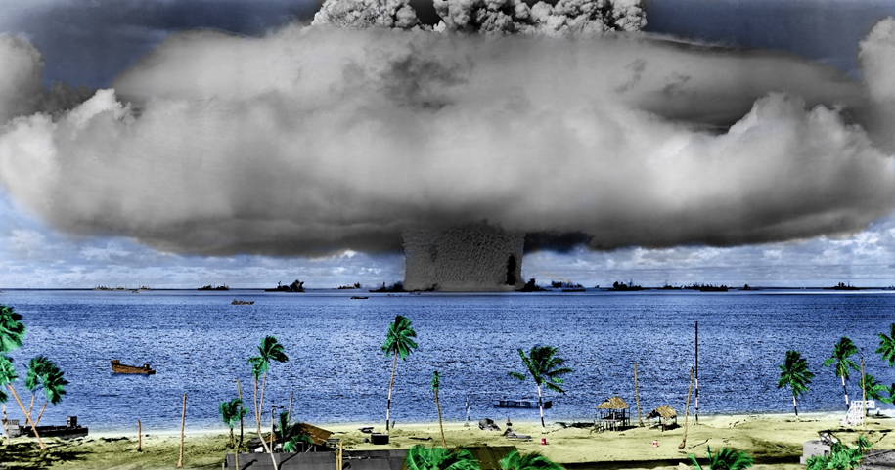
Project Proposal LAboratory Scale Spigot Intrusion Test
(LASSIT)
Contents
Table of figures 2
Glossary 2
Introduction 3
Background to the proposed research 3
Project design 5
Resource and Planning 6
Expected outcomes 6
Time plan 6
References 7
Bibliography 8
Appendix 1 – Prospective timeline of proposed works 9
Appendix 2 – Ethics form 10

Table of figures
Figure 1 - Example of ammunition lighter, showing non perfect surfaces [8] 4
Figure 2 - EMTAP Small Scale Spigot Test design [3] 4
Figure 3 - AWE Spigot Intrusion Test design [3] 5
Figure 4 - AWE Small Scale Spigot Intrusion Test design [10] 5
Figure 5 - Time plan 9

Glossary
AOP | Allied Ordnance publication
AWE | Atomic Weapons Establishment
CAD | Computer Aided Design
CADMID | Concept, Assessment, Demonstration, Manufacture, In service, Disposal
COTEC | Cranfield Ordnance Test and Evaluation Centre
EMTAP | Energetic Materials Test and Assessment Policy committee
FEA | Finite Element Analysis
FMEA | Failure Modes and Effects analysis
HSE | Health and Safety Executive
HSV | High Speed Video
LASSIT | LAboratory Scale Spigot Intrusion Test
MoD | Ministry of Defence
NATO | North Atlantic Treaty Organization
The Orange Book | The United Nations Transport of Dangerous Goods Model regulations
QFD | Quality Function Deployment
SME | Subject Matter Expert
SQEP | Suitably Qualified and Experienced Personnel
SSST | Small Scale Spigot Test
STANAG | NATO Standardized Agreement
TCO | Trials Conducting Officer

Introduction
Spigot intrusion tests are critical safety tests used to show how munitions/explosive materials will react should they be penetrated by a spigot. Current tests require a large quantity of material.
This project aims to investigate whether a low-speed spigot intrusion test can be performed at a laboratory scale, reducing the need for (and cost of) offsite testing and large-scale formulation.
The project goal is to perform several spigot drop tests onto encased explosive samples no more than 25 g. A 30 kg spigot will be dropped from a maximum height of 1 m.
The project will require design and manufacture of:
- Explosive sample
- Housing and case
- Spigot penetrator
- Test assembly
- Weight drop assembly
Manufacture should be complete by May 2022, testing shall be completed at an offsite location by August 2022.
A successful outcome would be the test meeting design intent of weight drop at correct height, piercing the case, penetrating the explosive and recording any explosive event. The deliverable will be issue of a technical report [1].

Background to the proposed research
HSE reported 12 accidents involving explosives in UK ports between 1950 and 1995 [2]. MoD use the EMTAP manual of tests [3] to consider how the material will react to accident stimuli.
As part of NATO, the munitions utilised by the UK must meet certain criteria before they can enter service. The criteria are laid out in STANAG 4170 [4] which is bound with AOP 7 [5] [1].
‘The Orange Book’ [6], is used to determine the hazard category of a material or munition for transport. It requires a munition to be dropped in its packaging from 12 metres. The HSE [2] accept this does not provide evidence of a worst-case accident scenario. At some ports, the lifts are greater than 12 metres. There are many protrusions on on which the falling munition can land, hence it is unlikely that the munition will impact a flat surface. With a bare munition, casing failure may result in metal being pushed into the explosive, i.e. a spigot intrusion. Tests showed that some munitions, when subject to spigot intrusion, show explosive reactions [2] [1].
Mawbey [7] explains that dropping munitions has created severe damage, but no explosive events. The best way to assess a munition to impact, is to test through trial. Mawbey states it is:
“the most satisfactory method of assessing its safety.” [7]
Wallace [8] proposes that drop tests onto a flat surface do not represent how naval munitions are handled, suggesting they will more likely land on edges, corners or protrusions. Between 1980 and 1994, 40% of accidents involved a drop/impact, of which many resulted in a spigot intrusion of the explosive material [8] [1].
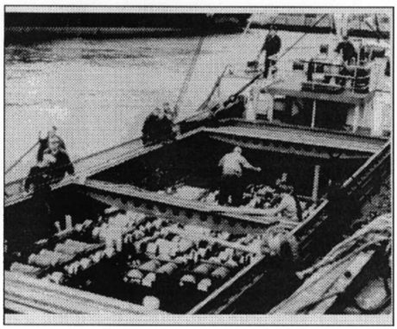
Figure 1 - Example of ammunition lighter, showing non perfect surfaces [8]
Wallace pointed out that on some occasions, ‘modest’ drops produced violent results. Where a response was seen, steel casings were more susceptible than other metals. A flat cylindrical spigot was found to be best for the test, therefore the standard test is configured with a 1 inch diameter steel cylinder [8] [1].
UK tests include the SSST and the AWE spigot intrusion test [3]. SSST requires a spigot to be dropped from up to 10 m onto the sample, fore this test approximately 15 kg of material must be manufactured.
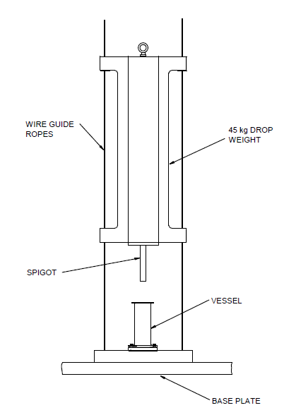
Figure 2 - EMTAP Small Scale Spigot Test design [3]
The AWE spigot intrusion test requires a ~3.2 kg explosive charge encased in a Jabroc holder, with spigot, to be dropped from 140 ft (42.7 m) onto a flat target surface. 32 kg of explosive is required to complete the test [1].
Figure 3 - AWE Spigot Intrusion Test design [3]
AWE small scale spigot intrusion test [9], requires a minimum of five tests to be performed with 180 g per sample. 900 g of explosive is required to complete the test.
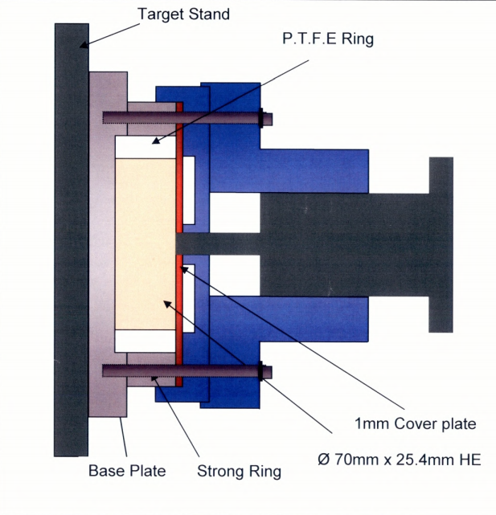
Figure 4 - AWE Small Scale Spigot Intrusion Test design [10]
LASSIT takes examples of spigot tests, as found in this literature review, and designs a smaller lab scale test [1].

Project design
The project will begin using the MoD’s CADMID cycle. CADMID is a sensible way to design the explosive test as it is a through life vision. The concept is put forward as well as the disposal route. In today’s engineering society, it is good practice to not produce anything unless you have a disposal route.
As the concept will be concept designs, further decisions will be based upon QFD and V model systems decisions. QFD will be used to consider the benefits of each sketch/test idea, until a suitable idea has been down-selected. Following this, the V model can be employed. The V model is suitable as the design is looked at as a whole, then broken down into individual parts at different levels to the components. It is then brought back up to the final design, however it is assessed at each level where corrections can be made to solidify the design before being re-assessed, this continues until the final design is complete. To ensure the system has a lower chance of fault occurring, FMEA will be used during the finalisation, assessing/removing fault situations from happening [1].
During detailed design CAD will be used to produce realistic sketches. The sketches can be put into a FEA programme. This will ensure that the structure of the design will meet the requirement and the FEA will also predict if an explosive event will occur [1].
The data will be captured using HSV. The HSV will be analysed to look for signs of ignition including smoke and flash [1].

Resource and Planning
Three weeks of testing shall take place between June and August of 2022.
For this project to be completed the following resources are required [1]:
- Explosive samples.
- Test consumables.
- Three weeks at offsite location:
  - Drop tower and release mechanism.
  - TCO.
  - Required safety paperwork.
- Phantom 2512/1610 High Speed Camera and associated software.
- Laptops for recording data.
- Funding (£75,000 has been set aside for this project).
Deliverables of the project, to be delivered by November 2022 are [1]:
- Design and manufacture of test pieces, explosive samples and drop rig.
- Physical experiment including data capture.
- Written report covering the outcomes of the experiment.

Expected outcomes
- Research into the use of a laboratory scale spigot intrusion test.
- Determine whether a laboratory scale spigot intrusion test is feasible.
- If the test proves of no significant use, determine why this was and how it could be improved to become a viable test.
- Explain how the test can be fully implemented into the required facility, should results show the test is worth pursuing.
- Conduct tests with further variations, based on the requirements of the high explosives safety study team, highlighting process considerations and how the results can assist in accident scenario models [1].

Time plan
A time plan has been created using Microsoft Project and can be found in Appendix 1.

References

[1] | S. James, "Project Proposal LASSIT test (Research Methods Assignment)," University of Wales Trinity St David, Swansea, 2020.
[2] | Health and Safety Executive, Risks of handling explosives in port, Sudbury: Health and Saftey executive, 1995.
[3] | Ministry of Defence, Energetic Materials Test and assessment Policy Comitee manual of tests, Bristol: Ministry of Defence, 2016.
[4] | North Atlantic Treaty Organisation, STANAG 4170, Brussels: NATO.
[5] | North Atlantic Treaty Organisation), AOP 7, Brussels: NATO.
[6] | United nations, United Nations Transport Of Dangerouse Goods Model Regulations, New York: United Nations.
[7] | M. W. S. Mawbey, "Assessing the response of naval armament stores in credible accident environments," Journal of Energetic Materials, vol. 7, no. 4-5, pp. 231-232, 1998.
[8] | D. I. G. Wallace, "Spigot Intrusion," in Proceedings of the Twenty-Sixth DoD Explosives Safety Seminar, Miami, Fl, 1994.
[9] | M. Cartwright and A. Lewis, "Use of a compressed Gas Gun to Investigate Response of Explosive to a Range Of Initiation Stimuli," Central European Journal of Energetic Materials, vol. 4, no. 4, pp. 33-43, 2007.
[10] | T. Stewart, "AWE Small Scale Spigot Test Live Prove Out Notes," AWE Internal report, Reading, 2004.

Bibliography
S. K. Chidester, I. G. Green, C. G. Lee, “A Frictional Work Predictive Method for the Initiation of Solid High Explosives from Low-Pressure Impacts”, Tenth International Detonation Symposium, Boston, MA, July 1993
P. J. Rae, P. M. Dickson, “Some Observations About the Drop-weight Explosive Sensitivity Test”, Journal of Dynamic Behavior of Materials, Springer, October 2020
D. Ma, P. Cen, K. Dai, Q. Zhou, “Specimen size effect of explosive sensitivity under low velocity impact”, Journal of Physics, vol. 500, iss. 5, IOP, 2014
J. E. Reaugh, J. P. Curtis, M. A. Maheswaran, “Computer Simulations to Study the Effects of Explosive Energetic and Constitutive Properties on the Deflagration-to-Detonation Transition (DDT)”, Fifteenth International Detonation Symposium, San Francisco, CA. July 2014
M. D. Holmes, P. A. Schultz, M. A. E. Erickson, G. R. Jr. Parker, “Case Penetration and Detonator Crush FY2019 Report”, Los Alamos National Laboratory, November 2019
M. D. Holmes, G. R. Jr. Parker, P. Dickson, E. M. Heatwole, R. M. Broilo, “Low-velocity impact ignition of thin metal-cased charges of PBX 9501”, AIP Conference Proceedings, vol. 1979, iss. 1, St Louis, Mi, September 2017
M. D. Holmes, P. Rae, G. R. Jr. Parker, “Viscous Heating via Low-Velocity Crushing Impact of High Explosives”, Sixteenth International Detonation Symposium, Cambridge, MD, 2018

Appendix 1 – Prospective timeline of proposed works
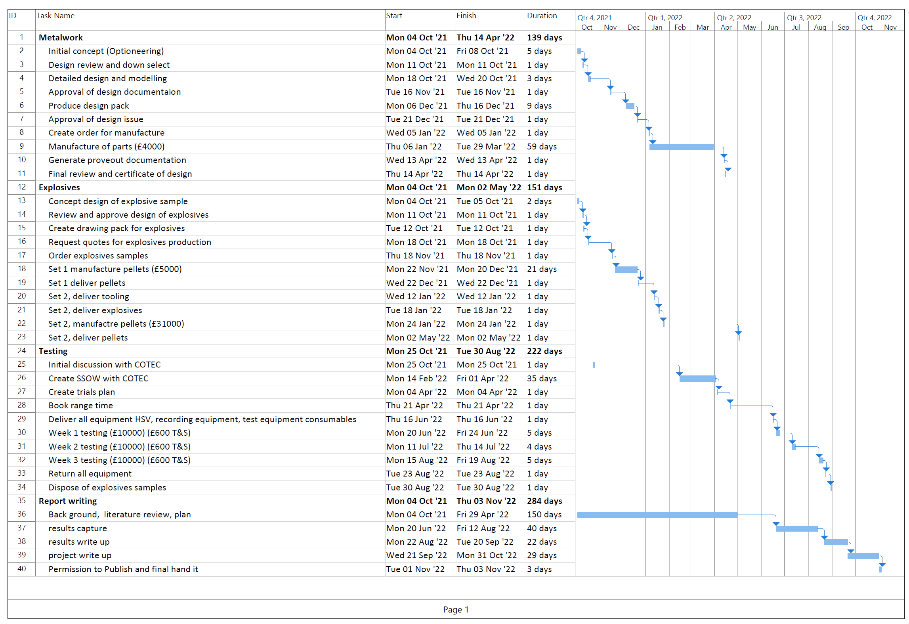
Figure 5 - Time plan

Appendix 2 – Ethics form
APPLICATION FOR ETHICAL APPROVAL

In order for research to result in benefit and minimise risk of harm, it must be conducted ethically.

The University follows the OECD Frascati manual definition of research activity: “creative work undertaken on a systematic basis in order to increase the stock of knowledge, including knowledge of man, culture and society, and the use of this stock of knowledge to devise new applications”. As such this covers activities undertaken by members of staff, postgraduate research students, and both taught postgraduate and undergraduate students working on dissertations/projects.

The individual undertaking the research activity is known as the “principal researcher”.

This form must be completed and approved prior to undertaking any research activity.

SECTION A: About You (Principal Researcher)
1 | Full Name: | Steven James
2 | Student Number: | 1810370
3 | Email address: | 1810370@student.uwtsd.ac.uk
4 | Programme of Study: | OME Advanced apprenticeship BEng
5 | Director of Studies/Supervisor: | None assigned (Kapilan Radhakrishnan – temporary)

SECTION B: Internal and External Ethical Guidance Materials
 | Please list the core ethical guidance documents that have been referred to during the completion of this form (including any discipline-specific codes of research ethics, location-specific dodes of research ethics, and also any specific ethical guidance relating to the proposed methodology). Please tick to confirm that your research proposal adheres to these codes and guidelines. You may add rows to this table if needed.
1 | UWTSD Research Ethics & Integrity Code of Practice | ☒
2 | UWTSD Research Data Management Policy | ☒
3 | AWE plc code of ethics | ☒

SECTION C: Details of Research Activity
1 | Indicative title: | Laboratory Scale Spigot Intrusion test
2 | Proposed start date: | October 2021 | Proposed end date: | November 2022
Introduction to the Research (maximum 300 words in each section)
Ensure that you write for a Non-Specialist Audience when outlining your response to the three points below:
- Purpose of Research Activity
- Proposed Research Question
- Aims of Research Activity
- Objectives of Research Activity
Demonstrate, briefly, how Existing Research has informed the proposed activity and explain
- What the research activity will add to the body of knowledge
- How it addresses an area of importance.
3 | Purpose of Research Activity  The purpose of this research is to identify if it is possible to create a low-speed spigot intrusion test on explosives materials that can be performed using a minimal quantity of explosives  (this box should expand as you type)
4 | Research Question  Is it possible for a low-speed spigot intrusion test be a valid experiment when performed on a laboratory scale sample?  (this box should expand as you type)
5 | Aims of Research Activity  Existing spigot intrusion tests require a significant amount of material to be used. The aim of this research is to ascertain whether spigot intrusion testing can be carried out using less material than is currently required. This research shall be used to validate whether an expensive standard test, completed at a large test facility, can be brought into an on-site location allowing the test to be economic both timewise and financially. Spigot intrusion testing is done for safety. The research will also provide evidence that testing on a small scale will allow explosive formulations in early development to be cancelled, should they be reactive, without the need for large quantities of material being produced.  (this box should expand as you type)
6 | Objectives of Research Activity  The objective of the research is to:  - Design and manufacture a suitable test vehicle and target housing.  - Design and manufacture a suitable explosive sample.  - Generate contract with offsite location where trials can take place.  - Generate trials documentation (process and safety), in conjunction with test facility.  - Generate test plan with subject matter expert (weights, heights, spigot types).  - Book time at offsite location.  - Transport all required materials to location.  - Carry out testing using High Speed video to detect for explosives reaction  - Once testing is complete, dispose of all materials using approved disposal method  - Write up results and conclusions  (this box should expand as you type)
Proposed data collection methods (maximum 600 words)
Provide a brief summary of all the methods that may be used in the research activity to collect data, making it clear what specific techniques may be used. If methods other than those listed in this section are deemed appropriate later, additional ethical approval for those methods will be needed. You do not need to justify the methods here, but should instead describe how you intend to collect the data necessary for you to complete your project.
7 | Collection of data will be via HSV (high Speed Video) and of sample inspection after test.  HSV will be Vision Research Phantom cameras and their associated software. AWE plc owned HP laptops that carry the software will be used.  Each drop/firing will be recorded using the HSV hardware/software.  Extra lighting will be used to enhance the view as HSV shows a darker image with the higher speeds.  The plan for firings will be completed with assistance form AWE subject matter expert.  The research is to look for explosive reaction. Should reaction be recorded, a lower height shall be chosen. No reaction shall result in a higher height being used. The aim being to find the threshold of reaction. In accordance with the firing plan, the weight can be adjusted. Should the primary aim of the research be successful, further drops will take place using a different type of spigot  (this box should expand as you type)

SECTION D: Scope of Research Activity
 | Will the research activity include: | YES | NO
1 | Use of a questionnaire or similar research instrument? | ☐ | ☒
2 | Use of interviews? | ☐ | ☒
3 | Use of focus groups? | ☐ | ☒
4 | Use of participant diaries? | ☐ | ☒
5 | Use of video or audio recording? | ☒ | ☐
6 | Use of computer-generated log files? | ☐ | ☒
7 | Participant observation with their knowledge? | ☐ | ☒
8 | Participant observation without their knowledge? | ☐ | ☒
9 | Access to personal or confidential information without the participants’ specific consent? | ☐ | ☒
10 | Administration of any questions, test stimuli, presentation that may be experienced as physically, mentally or emotionally harmful / offensive? | ☐ | ☒
11 | Performance of any acts which may cause embarrassment or affect self-esteem? | ☐ | ☒
12 | Investigation of participants involved in illegal activities? | ☐ | ☒
13 | Use of procedures that involve deception? | ☐ | ☒
14 | Administration of any substance, agent or placebo? | ☐ | ☒
15 | Working with live vertebrate animals? | ☐ | ☒
16 | Procedures that may have a negative impact on the environment? | ☒ | ☐
17 | Other primary data collection methods. Please indicate the type of data collection method(s) below. | ☐ | ☐
 | Details of any other primary data collection method:  (this box should expand as you type) | ☐ | ☐

If you have ticked NO to every question then the research activity is (ethically) low risk and you may skip section E and continue to section F.

If YES to any question, then no research activity should be undertaken until full ethical approval has been obtained.

SECTION E: Intended Participants
 | Who are the intended participants: | YES | NO
1 | Students or staff at the University? | ☐ | ☒
2 | Adults (over the age of 18 and competent to give consent)? | ☐ | ☒
3 | Vulnerable adults? | ☐ | ☒
4 | Children and Young People under the age of 18? (Consent from Parent, Carer or Guardian will be required) | ☐ | ☒
5 | Prisoners? | ☐ | ☒
6 | Young offenders? | ☐ | ☒
7 | Those who could be considered to have a particularly dependent relationship with the investigator or a gatekeeper? | ☐ | ☒
8 | People engaged in illegal activities? | ☐ | ☒
9 | Others. Please indicate the participants below, and specifically any group who may be unable to give consent. | ☐ | ☒
 | Details of any other participant groups:  Complete this only if your participants cannot give consent. This includes animals  (this box should expand as you type) | ☐ | ☒

Participant numbers and source
Provide an estimate of the expected number of participants. How will you identify participants and how will they be recruited?
10 | How many participants are expected? | N/A  (this box should expand as you type)
11 | Who will the participants be? | N/A  (this box should expand as you type)
12 | How will you identify the participants? | N/A  (this box should expand as you type)

 | Information for participants: | YES | NO | N/A
13 | Will you describe the main research procedures to participants in advance, so that they are informed about what to expect? | ☐ | ☐ | ☒
14 | Will you tell participants that their participation is voluntary? | ☐ | ☐ | ☒
15 | Will you obtain written consent for participation? | ☐ | ☐ | ☒
16 | Will you explain to participants that refusal to participate in the research will not affect their treatment or education (if relevant)? | ☐ | ☐ | ☒
17 | If the research is observational, will you ask participants for their consent to being observed? | ☐ | ☐ | ☒
18 | Will you tell participants that they may withdraw from the research at any time and for any reason? | ☐ | ☐ | ☒
19 | With questionnaires, will you give participants the option of omitting questions they do not want to answer? | ☐ | ☐ | ☒
20 | Will you tell participants that their data will be treated with full confidentiality and that, if published, it will not be identifiable as theirs? | ☐ | ☐ | ☒
21 | Will you debrief participants at the end of their participation, in a way appropriate to the type of research undertaken? | ☐ | ☐ | ☒
22 | If NO to any of above questions, please give an explanation
There will be no participants in this explosives research

(this box should expand as you type)

 | Information for participants: | YES | NO | N/A
24 | Will participants be paid? | ☐ | ☐ | ☒
25 | Is specialist electrical or other equipment to be used with participants? | ☐ | ☐ | ☒
26 | Are there any financial or other interests to the investigator or University arising from this study? | ☐ | ☐ | ☒
27 | Will the research activity involve deliberately misleading participants in any way, or the partial or full concealment of the specific study aims? | ☐ | ☐ | ☒
28 | If YES to any question, please provide full details
N/A

(this box should expand as you type)

SECTION F: Anticipated Risks

 | Outline any anticipated risks that may adversely affect any of the participants, the researchers and/or the University, and the steps that will be taken to address them.
1 | Risks to participants  For example: sector-specific health & safety, emotional distress, financial disclosure, physical harm, transfer of personal data, sensitive organisational information. If you have identified in section D that there are no participants then enter N/A and go skip to question 3.
 | Risk to participants:  N/A  (this box should expand as you type) | How you will mitigate the risk to participants:  N/A  (this box should expand as you type)
2 | If research activity may include sensitive, embarrassing or upsetting topics (e.g. sexual activity, drug use) or issues likely to disclose information requiring further action (e.g. criminal activity), give details of the procedures to deal with these issues, including any support/advice (e.g. helpline numbers) to be offered to participants. Note that where applicable, consent procedures should make it clear that if something potentially or actually illegal is discovered in the course of a project, it may need to be disclosed to the proper authorities
N/A

(this box should expand as you type)
3 | Risks to the investigator  For example: personal health & safety, physical harm, emotional distress, risk of accusation of harm/impropriety, conflict of interest
 | Risk to the investigator:  Working with explosive materials always carries a risk. Personal health and safety is major factor. An incident may risk accusation of harm  (this box should expand as you type) | How you will mitigate the risk to the investigator:  Trials conducted at suitable off-site location. Trials undertaken by suitably qualified person (trials conducting officer)  Suitable risk assessment to be carried out.  Suitable COSHH assessment to be carried out  (this box should expand as you type)
4 | University/institutional risks  For example: adverse publicity, financial loss, data protection
 | Risk to the University:  Adverse publicity  Data protection  (this box should expand as you type) | How you will mitigate the risk to the University:  UWTSD accepts that, in providing the course to the explosives industry, there may always be the chance of general adverse publicity.  The trials conducted will only be published for use in the proposed research to UWTSD, offsite location and AWE plc.  Risk to the investigator is listed above and is mitigated, this mitigation should prevent adverse publicity from injury of investigator.  Only data relevant to the research shall be recorded and published. No personal data is required for the research  (this box should expand as you type)
5 | Environmental risks  For example: accidental spillage of pollutants, damage to local ecosystems
 | Risk to the environment:  Damage to local eco system  Pollutants released into environment  (this box should expand as you type) | How you will mitigate the risk to environment:  Testing will take place at a suitable off-site facility. This facility is licensed for the testing of explosives. Testing of explosives naturally can have an effect on the local ecosystem and can release pollutants into the environment.  It is accepted that due to the nature of the explosive trial, these risks cannot be mitigated fully.  This trial is to minimise the explosives used, therefore the trial itself is the mitigation, by lowering the volume of explosives used  (this box should expand as you type)

SECTION G: Feedback, Consent and Confidentiality

If you have identified in section D that there are no participants then enter skip this section and continue to section H.

1 | Feedback  What de-briefing and feedback will be provided to participants, how will this be done and when?
N/A

(this box should expand as you type)
2 | Informed consent  Describe the arrangements to inform potential participants, before providing consent, of what is involved in participating. Describe the arrangements for participants to provide full consent before data collection begins. If gaining consent in this way is inappropriate, explain how consent will be obtained and recorded in accordance with prevailing data protection legislation.
N/A

(this box should expand as you type)
3 | Confidentiality / Anonymity  Set out how anonymity of participants and confidentiality will be ensured in any outputs. If anonymity is not being offered, explain why this is the case.
N/A

(this box should expand as you type)

SECTION H: Data Protection and Storage

 | Does the research activity involve personal data (as defined by the General Data Protection Regulation 2016 “GDPR” and the Data Protection Act 2018 “DPA”)? | YES | NO
1 | “Personal data” means any information relating to an identified or identifiable natural person (‘data subject’). An identifiable natural person is one who can be identified, directly or indirectly, in particular by reference to an identifier such as a name, an identification number, location data, an online identifier or to one or more factors specific to the physical, physiological, genetic, mental, economic, cultural or social identity of that natural person. Any video or audio recordings of participants is considered to be personal data. | ☐ | x
 | If YES, provide a description of the data and explain why this data needs to be collected:
2 | N/A  (this box should expand as you type)
 | Does it involve special category data (as defined by the GDPR)? | YES | NO
3 | “Special category data” means sensitive personal data consisting of information as to the data subjects’ –  (a) racial or ethnic origin,  (b) political opinions,  (c ) religious beliefs or other beliefs of a similar nature,  (d) membership of a trade union (within the meaning of the Trade Union and Labour Relations (Consolidation) Act 1992),  (e) physical or mental health or condition,  (f) sexual life,  (g) genetics,  (h) biometric data (as used for ID purposes), | ☐ | x
 | If YES, provide a description of the special category data and explain why this data needs to be collected:
4 | N/A  (this box should expand as you type)

 | Will data from the research activity (collected data, drafts of the thesis, or materials for publication) be stored in any of the following ways? | YES | NO
5 | Manual files (i.e. in paper form)? | ☒ | ☐
6 | University computers? | ☒ | ☐
7 | Private company computers? | ☒ | ☐
8 | Home or other personal computers? | ☒ | ☐
9 | Laptop computers/ CDs/ Portable disk-drives/ memory sticks? | ☒ | ☐
10 | “Cloud” storage or websites? | ☒ | ☐
11 | Other – specify: | ☐ | ☒
12 | For all stored data, explain the measures in place to ensure the security of the data collected, data confidentiality, including details of backup procedures, password protection, encryption, anonymisation and pseudonymisation:
Data kept in paper form will require no specific security measures.
Data kept on the university system and private company system are password protected and shall not be shared. USB device used to transfer the data is encrypted, however the data gathered is of no consequence and does not require password protection. Home laptop is password protected, and research shall be uploaded to the cloud one drive used by the university

The proposal, project and all data will be at OFFICIAL level and requires no specific security procedures

(this box should expand as you type)

 | Data Protection
 | Will the research activity involve any of the following activities: | YES | NO
13 | Electronic transfer of data in any form? | ☒ | ☐
14 | Sharing of data with others at the University outside of the immediate research team? | ☐ | ☒
15 | Sharing of data with other organisations? | ☐ | ☒
16 | Export of data outside the UK or importing of data from outside the UK? | ☐ | ☒
17 | Use of personal addresses, postcodes, faxes, emails or telephone numbers? | ☐ | ☒
18 | Publication of data that might allow identification of individuals? | ☐ | ☒
19 | If YES to any question, please provide full details, explaining how this will be conducted in accordance with the GDPR and Data Protection Act (2018) (and/or any international equivalent):
No data collected during the research will be of a personal data nature. All data collected for the purpose of the research will be at an OFFICIAL security level. The data transferred electronically will be of video of the experiment. The USB data transfer will be encrypted, this is accepted as standard practice at AWE plc for this type of electronic transfer to the specific network. There are no participants in this research

(this box should expand as you type)
20 | List all who will have access to the data generated by the research activity:
Principal researcher, AWE subject matter expert, AWE line manager, AWE mentors, UWTSD project supervisor

(this box should expand as you type)
21 | List who will have control of, and act as custodian(s) for, data generated by the research activity:
Principal researcher

(this box should expand as you type)
22 | Give details of data storage arrangements, including security measures in place to protect the data, where data will be stored, how long for, and in what form.
All data will be stored on AWE internal secure network. Required results will be at an OFFICIAL level and will be processed on AWE network, personal laptop and UWTSD computer system. All systems are password protected. There will be no personal data collected and the data will be kept on AWE secure system in line with standard AWE procedure. Data will only be of video of explosive testing

(this box should expand as you type)
22 | Confirm that you have read the UWTSD guidance on data management (see https://www.uwtsd.ac.uk/library/research-data-management/) | ☒
23 | Confirm that you are aware that you need to keep all data until after your research has completed or the end of your funding | ☒

SECTION I: Declaration
The information which I have provided is correct and complete to the best of my knowledge. I have attempted to identify any risks and issues related to the research activity and acknowledge my obligations and the rights of the participants.

In submitting this application I hereby confirm that I undertake to ensure that the above named research activity will meet the University’s Research Ethics and Integrity Code of Practice which is published on the website: https://www.uwtsd.ac.uk/research/research-ethics/
 | 1 | Signature of applicant: | 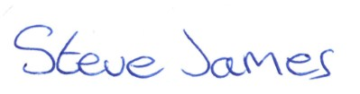 | Date:  10/1/22
2 |  | Director of Studies/Supervisor: |  |  | Date:
3 |  | Signature: |  |  | Date:

FOR INTERNAL USE ONLY:
 | Ethical approval given
1 | Signature of assessor: |  | Date:
2 | Name:
3 | Role:

