Business Issues and the Context of Human Resources

Report Title: The evolving role of HR in the contemporary business world

Name: Richard Blakeley

CIPD Membership Number: 47374456

Date: 11.01.18

Word count (max: 3900 words)

I declare that this assignment is my own work and that any information obtained from books and other sources have been appropriately referenced.

Signed.....R.A.Blakeley.................................. Date......11.01.18............................

Contents

Introduction 3
Forces shaping the HR Agenda 4
Models of HRM function 4
Supporting business performance 6
Business environment scanning tools 7
SWOT analysis 7
Porter’s 5 forces 8
STEEPLE 8
Factors impacting on business and HR functions 9
Globalisation 9
Immigration 9
Robotics and automation 10
Organisational Culture 11
Strategy formulation and implementation 12
Business ethics and accountability 13
Evaluating business performance 13
Assessing and utilising business and contextual data 14
Conclusion 16
References 17

Introduction

This paper has been produced for inclusion in the delegate pack for the South West Wales CIPD branch conference on ‘The evolving role of HR in the contemporary business world’. It explores the key forces shaping the HR agenda and opposing views on strategies to support business performance. There is consideration of how combinations of HRM policies and different strategies can contribute to business performance. The SWOT, Porter’s 5 forces and STEEPLE business scanning tools are compared. Globalisation, immigration, robotics and automation and organisational culture are assessed as factors impacting on an organisation’s business and HRM. Rational, emergent and symbolic business strategies are considered and the proactive and reactive responses of HRM. Finally, there is consideration of how HRM data from internal and external sources can strategically contribute to both business evaluation (e.g. business scorecard) and planning (e.g. workforce planning and change management).

Forces shaping the HR Agenda

Models of HRM function
The evolution of HRM function has been well documented (Farnham, 2015; Wilkinson & Taylor, 2016; Marchington, et al., 2016) as the table captures below.
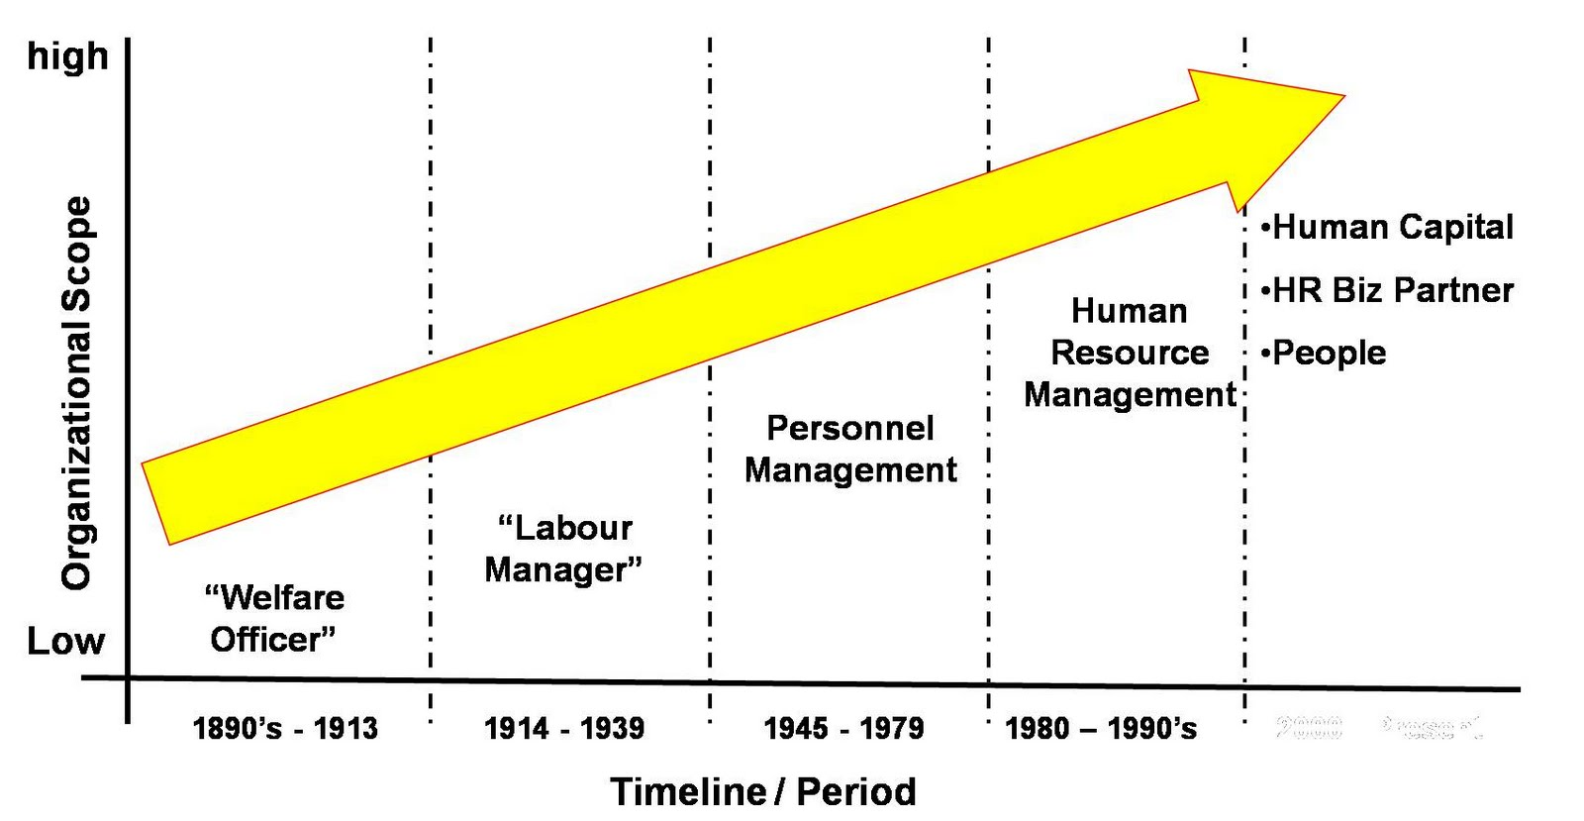
Diagram 1: Evolution of HRM (Blogspot.com, 2017)
The pace of change in HRM reflects the economy with greater expectations to contribute to strategy and meeting the demands of accelerating competition and cost efficiency (CIPD, 2014). Models of HRM function have evolved with organisations as structures become more complex and new organisational norms of outsourcing, divisionalisation and networked structures are established. HRM function and roles can be categorised by the following table.
Function | Role(s)
Generalist and specialist | Depending upon the size of the organisation, Strategic HRM will offer generalised or specialised support to the business with regard to (1) resourcing, recruitment and talent planning (2 learning and talent development (3) organisation development (4) employee engagement (5) performance and reward
Line management | Allocating work, monitoring performance, day to day contact, managing problems, implementing policies and procedures
Shared services | Routine HR Administration, Tailored service focus
Outsourcing | Payroll, basic training, basic recruitment
HR consultancy | Contracted and timebound specialist advice and developing strategies or policies

Table 1: Models of HRM function (Wilkinson & Taylor, 2016)
Ulrich’s model of HR function is influential (Marchington, et al., 2016; Wilkinson & Taylor, 2016) with around 40% of large organisations adopting it (CIPD, 2014) and important for introducing the “business partner” role. In this model, HRM business partners work closely with business leaders to influence and steer strategy and implementation. Centres of excellence house specialist and shared services houses routine functions. Challenges to this model include the risk of developing HR silos or conversely too much overlap between the functions and specific risks attached to being too prescriptive on how the model is implemented in SMEs (CIPD, 2014).
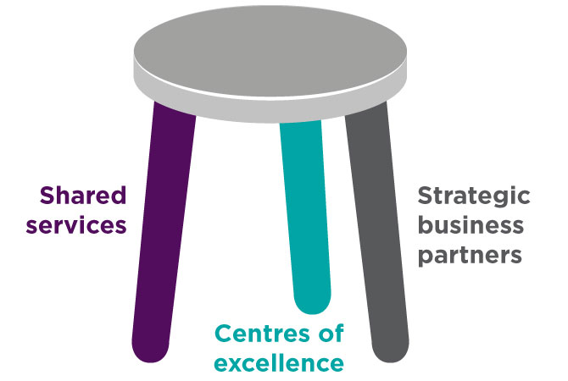
Diagram 2: Ulrich’s three legged stool (CIPD, 2017)
An alternative model is the Harvard model of “soft” HRM which focuses more on HRM strategy being determined by internal stakeholders particularly employees to achieve well-being and commitment through involvement and reward (Farnham, 2015) and it not being determined by shareholder interest (Beer, et al., 2015).
Ulrich is now discussing a “new wave” of HRM evolution whereby the function will
- develop more services aligned to the external context to bring added value to organisations such as contributing to positive employer brand to attract both talented employees and loyal customers (Marchington, et al., 2016)
- use business environment scanning tools; manage stakeholders, organisational culture and leadership; align HR structures to business structures and align performance , rewards and compensation, communication and workflow with the expectations of the customer (Ulrich, 2016).
- require new competencies of HR professionals including analytics (ibid)
It is not clear yet that HRM functions can take on all of the above functions successfully. Overemphasis on influencing business leaders may have led to a short term performance focus at the expense of HRM’s unique insights on longer term sustainability and fairness: leading to growing risks of dividing the broader workforce from the “talent” and core workers from supply staff (Marchington, 2015). There may be a present existential threat to HRM if it cannot convince business leaders of its value in talent management, performance management, recruitment and mastering human capital data (HRE Daily, 2015; Boudreau, 2014) and effectively partner with other business functions (Boudreau & Lawler, 2015), although this is probably more a “cyclical” response to tightening and loosening labour market conditions (Capelli, 2015). It is clear however, that HRM must continue to evolve and adapt to business challenges and models will be debated according to different value systems and the competing priorities of stakeholders.

Supporting business performance
Interest is high in how HRM solutions can contribute to overall organisational performance (Wilkinson & Taylor, 2016). A study (Huselid, 1995) in America matched HR practices against performance measures such as growth, productivity and profits and found that significant above average scores on using HR practices brought an extra market value of between $10,000 and $40,000. Another study in the UK found that HR practices accounted for 19% of the variation on profitability and 18% of the variation on productivity (West & Patterson, 1998).
The term “high performance workplace” has been coined by Governments (Wood, et al., 2013) to promote a broad swathe of employee engagement practices. HR practices that are associated with engendering high levels of commitment include (Kew & Stredwick, 2016)
- Employee involvement (e.g. briefing groups, staff surveys and focus groups, employee share ownership)
- Employee voice (e.g. trade unions, employee forums, informal mechanisms for raising issues)
- Harmonisation of terms and conditions (e.g. employee benefits, leave etc)
- Employment security (e.g. retraining, redeployment, voluntary redundancy schemes)
- Sophisticated recruitment and selection (e.g. psychological tests, structured interviews)
- Extensive training and development (e.g. self-directed learning within the framework)
- Self-managed teams (e.g. team solutions for work rotas, breaks, leave and sickness arrangements
- Extensive systems of flexibility (e.g. customer focused, multi skilled, flexible hours)
- Performance pay (e.g. bonuses and other incentives)
However, there are competing perspectives as to how best to combine HRM policies for organisational success when there is such a diversity of sectors, cultures, organisational sizes and business conditions. Three key perspectives on HRM strategy are listed in the table:
Perspective | Description
Best practice | This perspective suggests that there are a set of HR practices that will create high performance in all organisations and contexts and they are concentrated on a “high involvement” philosophy that workers will contribute more if they care about the company’s prospects.
Best fit (contingency) | This perspective suggests that HR should seek the mix of HR practices that are most appropriate to their specific context.
Resource based view | This perspective rejects comparisons with other organisations and instead suggests that policies should be shaped to maximise returns from the skills and knowledge of their workforce as this is not easy to replicate in other organisations.

Table 2: perspectives on HRM policy combinations (Wilkinson & Taylor, 2016)
The weakness of the ‘best practice’ approach is that it doesn’t take account of the cost and feasibility of policies in different contexts (e.g. sectors, size of organisation). The weakness of the ‘best fit’ approach is that the context can be an inhibitor to HRM practice: for example, improvements to pay in social care may improve retention and performance but trends in the sector prohibit this (Hussein & Manthorpe, 2014). The weakness of the “resource based view” is that this risks organisations not recognising external competition threats or perhaps failing to identify transformative technologies. Ultimately, all organisations have to decide what is in their own best interests as they see it.

Business environment scanning tools
Strategic analyses without consideration of human capital is arguably not comprehensive enough in the modern marketplace. Some tools and their HRM input are compared below: Johnson et al (Kew & Stredwick, 2016) propose that all of the models can be accommodated in a five stage model of business planning which naturally must fully include HRM input:
- Audit of environmental influences
- Assessment of the nature of the environment
- Identification of key environmental factors
- Identification of the competitive position
- Identification of the principal opportunities and threats

SWOT analysis
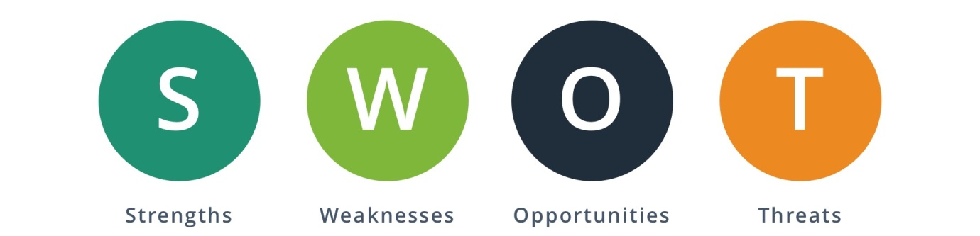
Diagram 3: SWOT (Bing.com, 2017)
This business planning tool is a simple, respected and extensively used internationally and across sectors (Helms & Nixon, 2010). It relies on the balance of knowledge of all constituent parts of a strategic management team, which used on its own may at times be insufficiently rigorous and undisciplined in building the analysis (Kew & Stredwick, 2016). However, it does have the advantage over ‘Porter’s 5 forces’ of potentially being both present and future facing and being inclusive of internal and external considerations. The tool helps organisational understanding of how strengths can be used to develop opportunities and mitigate threats to weaknesses. It benefits from the input of other business planning tools (Helms & Nixon, 2010) such as STEEPLE for balancing external factors and PRIMO-F for balancing internal factors (Kew & Stredwick, 2016):

HRM may consider strengths and weaknesses such as the skills base and turnover rates and opportunities and threats such as holding on to talent.

Porter’s 5 forces
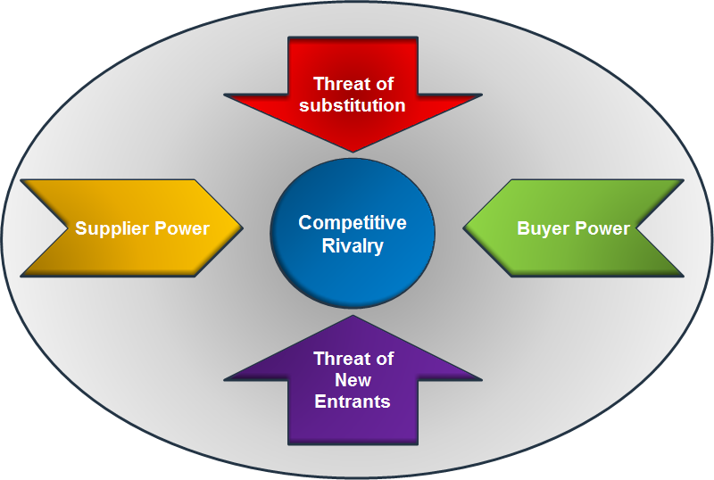
Diagram 4: Porter’s 5 forces (Bing.com (2), 2017)
This model offers ways of understanding the external business environment by analysing competitive power (Mindtools, 2017). It is easy to understand like SWOT but it is entirely externally focused. Whilst very popular with corporate strategists until the 2008 financial crash (Denning, 2012), its overemphasis on positioning in the marketplace for profit was an important influence in corporate business failure, particularly because internal factors such as HRM and business ethics were not given sufficient consideration (ibid). Criticisms also include its inability to forecast, low levels of understanding of societal factors and the role of government and low theoretical development (ibid). It has had less applicability to the public sector but market reforms and privatisation since the 1980s have changed that.

STEEPLE
The gap on societal factors left by Porter’s model is addressed by this model.
Field | Examples of key drivers of strategy
Socio cultural | Demography e.g. age, gender, ethnicity, education, religion and social values
Technological | E.g. ICT, biotechnology, medical advances, nanotechnology, robotics
Economic | E.g. Market prices, structure and profit; Government taxation and spending; Public consumption, employment levels and wage demands; International exchange rates and balance of imports and exports
Environmental | E.g. Global warming, sustainable development, pollution, protecting eco systems
Political | E.g. Political complexion of government and structures (internationally, nationally, regionally and locally); Public Policy
Legal | E.g. Contract, employment, health and safety, consumer, companies, regulation and courts
Ethical | E.g. balancing stakeholder interests, ethics in the workplace and business practice, employee welfare, corporate social responsibility

Table 3: STEEPLE (Farnham, 2015)
The STEEPLE tool is more prescriptive with regard to societal influences than SWOT. However, strategic management must ensure that data is sufficiently thorough and conversely that there is not “paralysis by analysis” (CIPD (2), 2017).

Factors impacting on business and HR functions

Globalisation
Globalisation is the process of national markets integrating across the world (Taylor & Wilkinson, 2016). Initially driven by trading relationships, it has intensified in recent decades as telecommunications drive instantaneous transactions and capital, labour and knowledge moves across boundaries. Nation states have consolidated in to supra-national trading and governmental blocs such as the EU (Kew & Stredwick, 2016), although Brexit is arguably a counter response that will carry huge challenges for organisations.
For all companies, globalisation represents a challenge. There are opportunities to expand markets across the world, form new business relationships and expand through mergers with foreign companies but there are threats of new competition in home markets from foreign competitors, overexposure in foreign markets that damages the business and potential takeover by larger foreign companies.
HRM must provide strategic input in to business decision making on global markets, particularly talent planning, building the right culture and capabilities and preparing leadership. (Ulrich, 2016). In home markets, HRM must steer talent management and create a change ready workforce to face competition from new entrants from other countries.

Immigration
6.3 million UK residents were born abroad: around 5 million “ethnic minorities” live in towns and cities across the UK (Kew & Stredwick, 2016). Immigration rates have been very contentious and keenly debated in recent elections. It is said to be a root cause of the Brexit referendum decision which is anticipated to reverse immigration rates.
For | Against
Need to access global talent | Dense populations and growing pressure on housing and public services
Migrants have high levels of motivation | Large sources of cheap labour may be discouraging employers from investing in technology
Migrants tend to be younger which helps in an ageing population | The “black economy” grows with immigrant populations
Where populations are static, migrants are an alternative source of labour | Managing migration flows is expensive and difficult to get right
Their loss will lead to a contraction of the economy(migrants make up 10% of the labour force) | Integration of migrants can be difficult and failure to do so causes social problems
Migrants take up difficult to fill and low skill jobs | There are some links between mass migration and extremism
Migrant entrepreneurs develop new markets | Migrants that stay till old age could be net claimants (take out more from the public purse than they put in)
Better to receive migrants than work be outsourced abroad
Britain cannot walk away from its imperial legacy
Wages sent back to poor countries are an effective form of aid
Migrants are tax contributors

Table 4: Arguments for and against immigration (Kew & Stredwick, 2016)
HRM must advise business on retaining talent and skills or construct new means of recruiting or training replacements, particularly as Brexit seems set to drive down immigration levels which may be more pronounced in some areas more than others.

Robotics and automation
Technological advances are a major external driver of competition as they contribute to reduced cost bases, increased productivity and failure to keep up can lead to loss of market share (Taylor & Wilkinson, 2016). The worldwide economy is entering a “fourth industrial revolution” driven by the energy and climate change challenge, biotechnology, robotics and artificial intelligence that will transform industry, society, human potential and the planet (World Economic Forum, 2016). The implications of this are massive but the real impact is still a public debate.
1 out of 2 jobs that currently exist could be automated and frequent, high volume and routine tasks could be done by robots (Goldbloom, 2016). Human beings will continue to be needed for “novel situations” and where “cross pollinating” knowledge streams are needed (ibid). Economists and futurologists express varying degrees of confidence that our economies can recreate jobs and sustain livelihoods. There is an argument that the introduction of such significant new technologies to market processes will follow historic patterns leading to new industries emerging that cannot be predicted (Autor, 2017). Alternatively the negative impact of robotics on jobs will be on such an “unprecedented scale” that this will lead to a retraction of demand because of less money in the economic system requiring “unprecedented economic policies” from governments including a “guaranteed basic income” (Ford, 2016).
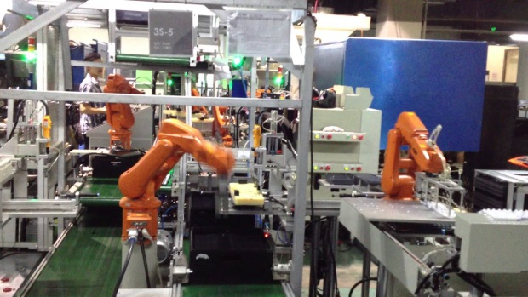
Pictures of robots doing routinised tasks: (1) robotic arm in assembly line (Bing.com\images(3), 2017); (2) amazon delivery drone (Bing.com\images(4), 2017)
Businesses will need to respond to such an unpredictable future, form new strategies to access the opportunities to enhance competitive edge whilst spotting threats to the marketability of their products. HRM will need to address workforce technology skills, job design and ethical treatment of employees during change and redundancy processes.

Organisational Culture
All Internal factors impacting on the business and HR functions can be categorised by CLIPS (Farnham, 2015):
Culture | (1) artefacts: interior design, dress codes, architecture (2) values: norms and beliefs when discussing internal matters (3) basic assumptions underpinning an organisation: e.g. public service values (Schein, 1997)
Layout | location, workspace
Innovation | adapted technology, human creativity
Power, conflict and control | status individuals and groups; competing over values and resources; managerial activity to exert control over workplace groups
Social components | people, positions, working groups

Table 5: CLIPS; (Farnham, 2015)
Overlapping all the other categories is culture. It is a major factor in determining organisational success but it can be very difficult to capture and takes a great deal of resource to change (Gwynn, 2017). HRM insights and methods of intervention are valuable to helping an organisation overcome cultural issues that damage the ability to adapt to the external environment. For example, HRM in British Airways identified a lack of openness as a cultural barrier to the improved communications and innovation demanded within the marketplace and then organised a carefully constructed project to implant value statements in to the organisation’s working to influence changes in behaviour (Binder, 2016).

Strategy formulation and implementation
Organisational strategy is formulated and implemented in response to the contingencies of organisational and market complexity and the pace of change, particularly in technology (Mintzberg, 1994).
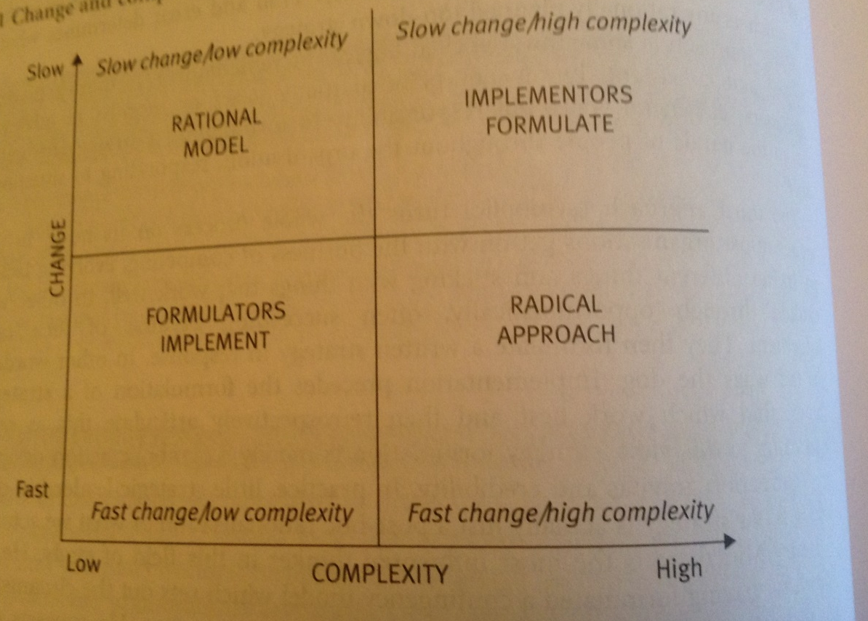
Diagram 5: Mintzberg’s contingency model (Taylor & Wilkinson, 2016)
The “rational” approach of senior managers formulating strategies based upon business environmental scanning tools before appraising implementation methods is most appropriate in slow change and low complexity environments (Taylor & Wilkinson, 2016) . The “emergent” approach (ibid) has senior managers incrementally formulating strategy in response to
- a mix of environmental scanning information and the feedback loop from implementation of strategy: appropriate in slow change, high complexity environments such as the National Health Service
- Or as part of necessary quick implementation of ideas in response to the pace of change, particularly in small tech companies
The “symbolic” approach (ibid) is where managers opportunistically make decisions in a fast pace, high complexity environment where “planned” approaches would be insufficiently agile and then rationalise post hoc in to “strategy”.
Regardless of how the strategy is arrived at by senior management, HRM must respond (ibid). With regard to the “rational” approach, HRM may need to contribute labour demand and supply forecasting and HRM metrics on current staff capabilities to indicate the feasibility of a number of different scenarios (Farnham, 2015) and then devise a strategy for implementation of changes to performance management, communication to and motivation of employees. The “emergent” and “symbolic” approaches may see the HRM function working in a more reactive way to varying degrees, perhaps advising on practical recruitment plans, supporting managers to motivate and communicate with staff through changes or in some cases challenging plans that threaten business ethics (e.g. equality of opportunity, safeguarding the environment) and accountability to stakeholders (e.g. employees, communities, consumers).

Business ethics and accountability
With regard to ethics and accountability, HRM professionals that are members of the CIPD have obligations under the code of conduct that state they must maintain (i) professional competence and behaviour (ii) ethical standards and integrity, (iii) being representative of the profession and (iv) stewardship of human capital in organisations (CIPD (3), 2017). The “stewardship” role has growing recognition with the profession and HRM can contribute insights in to the behaviour of employees that may prevent corporate negligence or help prevent long term interests being superceded by the short term profit gain that has undermined the economic system in recent years (ibid). HRM can provide specialist support with regard to specific situations in which ethical controversy arises (e.g. dismissal, retraining) and implementing the principles of appropriate behaviour to an organisation (Chryssides & Kaler, 1993). An example of implementing principles of appropriate behaviour can be found in Hywel Dda Health Board’s Organisational Development programme which is driving improvements in customer care, team working and leadership through training, mentoring and performance management systems (Hywel Dda Health Board, 2017).

Evaluating business performance
Business performance is typically evaluated in terms of profitability, efficiency and employee performance and HRM can contribute valuable data. Turnover and recruitment figures can be useful indicators of employee performance and benchmarked internally and externally. SMART KPIs can be used to identify aspects of HR performance that are most critical to efficiency. For example, the DVLA adopted a KPI of reducing staff absence by 0.5% (DVLA, 2016).
Other HR contributions to efficiency can be succession planning, flexible working and job design (CIPD, 2016) in order to have the right skills and people in place to deliver organisational objectives with minimised delay or compromise on standards of delivery. With regard to workforce planning, HR can design and manage assessment processes and information support, including the development and maintenance of databases (CIPD (5), 2017). There are however more complex interactions between external service demands, investment in technologies and recruiting new professionals that require more detailed planning from HRM. For example, a recent study revealed that breast screening services could extend the age range of users with limited extra investment if this was balanced by an investment in employee skills related to the use of radiology equipment and ongoing workload modelling (Mchugh, et al., 2015).
The contribution of HRM to successful workforce changes can be critical as there are high levels of failure (CIPD (6), 2017). HRM professionals can prepare an organisation for resistance to change through employee consultation and prepare leaders through learning and development programmes. An organisation that is preparing for the introduction of new technologies may make retraining rates a business performance indicator. For example, the DVLA had to plan for their workforce to have the digital skills to meet the transfer of customer interactions to the organisation’s website (DVLA, 2016).

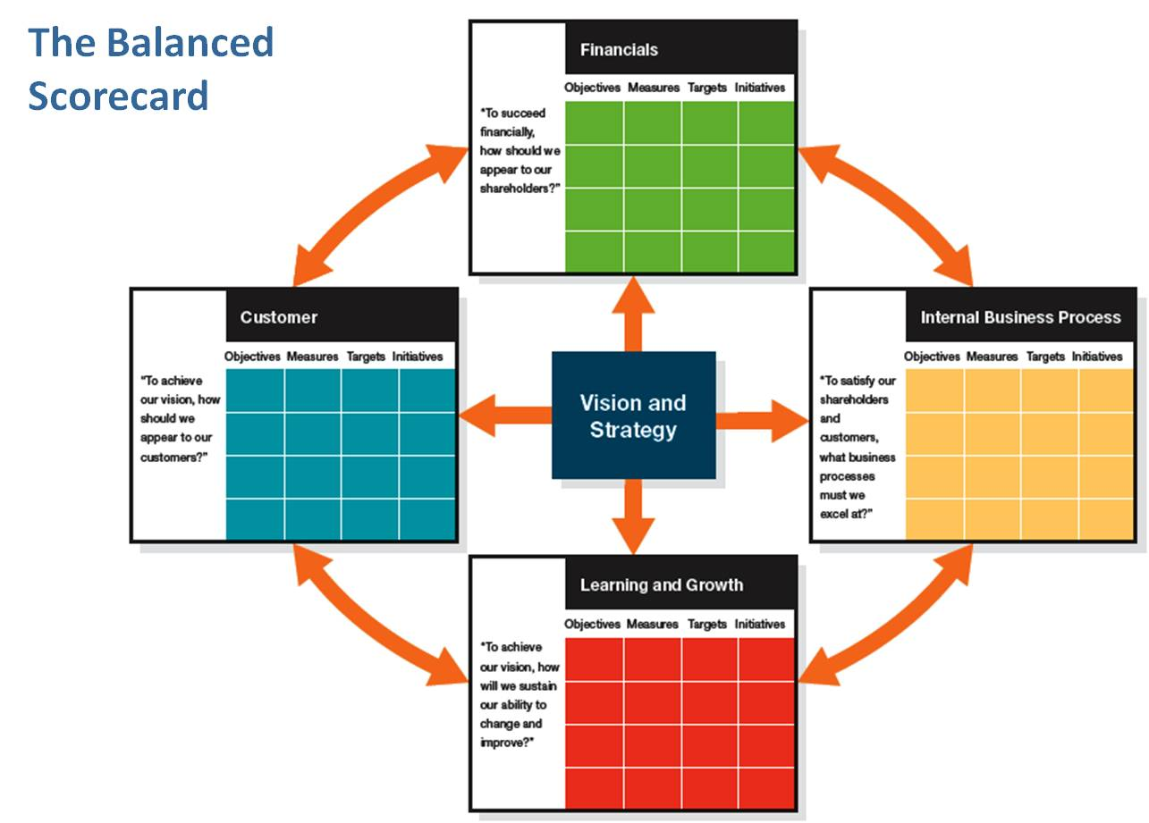
Diagram 6: The Balanced Scorecard (Pinterest, 2017)
HRM should always have a contribution to make to Balanced Scorecard performance measures as the four perspectives of (i) customer, (i) financial, (iii) internal business process and (iv) learning and growth all have particular people dimensions. The balanced scorecard is a model for balancing short term profit considerations with the long term sustainability of the organisation (Kaplan & Norton, 2007). HRM can contribute performance management and staff engagement data to the ‘internal business process’ perspective, data from mechanisms such as learning and development logs, staff surveys and exit interviews to the ‘learning and growth’ perspective and data on customer service competencies to the ‘customer’ perspective.

Assessing and utilising business and contextual data
The prospects for “big data” (volume, variety and velocity of data) from a HRM perspective are exciting but yet to be fully realised (CIPD podcast 77, 2013; CIPD, 2015). This is partly because HRM as a profession has yet to establish full command and use of quantitative and predictive data for business planning purposes. Yet according to Robert Bolton at KPMG (CIPD podcast 77, 2013), HRM could be very influential with senior management if it were to consistently offer and present persuasively its valuable insights in to employee behaviour in the same way that marketing offers insight in to customer behaviour. However, too many HRM professionals offer subjective contributions based upon their operational experience, which will be assessed as not carrying the same weight as data from other professionals at a strategic level.
Bolton says that in his assessment HRM internal quantitative data insights connected to business issues such as talent management (eg career development plans, salary aspirations) would be greatly valued by chief executives who are considering opportunities for business growth. In contrast, another report on data analytics in Asian markets suggests that “constraints such as investment, leadership understanding and overall HR maturity are holding back development at the strategic level, while at the operational level technology and the analytics skills gap are holding back development of the function” (CIPD (2), 2015). Therefore, HRM has to patiently build the ground for investments in technologies to support internal data collection: e.g. talent management data suites such as Oracle and Hadoop (CIPD (2), 2013).
Peter Cheese, CE of CIPD advises that HRM must build respect for their insights by utilising data on employee characteristics, turnover and recruitment rates to gain influence in business planning processes (CIPD podcast 77, 2013) whilst another CIPD report suggests that collecting data such as sickness absence to contribute to smaller operations or projects with the balanced scorecard could build up the influence of HRM (CIPD, 2015).
Taking Ulrich’s “outside – in” (Ulrich, 2016) analagy, HRM professionals can provide a wealth of data from external sources that can be essential to business planning. An organisation that is looking to contain costs in its business planning, will find external data on wage demands useful: for example a UK report at the end of 2017 revealed 24% of employers in the private sector felt pressure to raise wages but 38% say they face no pressure at all (CIPD (7), 2017). A company that is looking to compete with global competitors, would benefit from the insights of global consultancies to guide its strategy and investments. For example, a report on global trends in the retail sector (Deloitte Global Human Capital Trends, 2017) revealed investment priorities in training in the use of cognitive tools, systems level change for diversity and inclusion, people analytics, digital engagement of employees, platforms for employee driven learning, digital recruitment, “holistic” understanding of the employee experience at work, leadership development and aligning performance management with business strategy.

Conclusion
This paper has considered the evolving role of HR in the contemporary business world. It considered the key forces shaping the HR agenda such as growing business complexity, models of function and role and strategies to support business performance. The paper looked at Ulrich’s ‘business partnering’ and HRM “outside-in” as drivers of greater influence over business strategy and the criticism that focusing too much on short term profitability and too much sensitivity to the criticisms of other stakeholders can be damaging to HRM and human capital. The impact of HRM policies on business performance and the pros and cons of best practice, best fit and resource based strategy were considered and it was concluded that all organisations have to take approaches in their own interests as they see it. The SWOT, Porter’s 5 forces and STEEPLE business scanning tools were compared and shown to be best used together as part of comprehensive strategic analysis that considers internal and external factors in a detailed way. Globalisation, immigration, robotics and automation and organisational culture are huge challenges for the economy and society today and therefore very important factors impacting on an organisation’s business and HRM must offer solutions to ensure that organisations have the quality of human capital that they need in such a dynamic, volatile and unpredictable environment. The different processes by which business strategies are reached are all challenging for HRM whether they be “rational”, “emergent” or symbolic and often reflective of their external environment but HRM must respond with strategies to engage decision makers, particularly with regard to business ethics. Finally, there is much excitement regarding the potential for HRM ‘big data’ to strategically contribute to both business evaluation (e.g. business scorecard) and planning (e.g. workforce planning and change management) but the profession needs to demonstrate persistently and consistently the added value that HRM insights can bring.

Works Cited
Autor, D., 2017. Will automation take away all our jobs?. [Online]
Available at: https://www.youtube.com/watch?v=th3nnEpITz0
[Accessed 23 December 2017].
Beer, M., Boselie, P. & Brewster, C., 2015. Back to the Future: Implications for the Field of HRM of the Multistakeholder Perspective Proposed 30 Years Ago. Human Resource Management, Volume 54, pp. 427-428 .
Binder, C., 2016. Integrating Organisational Cultural Values with Performance Management. Journal of Organisational Behaviour Management, Volume 36, pp. 185-201.
Bing.com (2), 2017. Images. [Online]
Available at: https://www.bing.com/images/search?q=Porter's+5+forces+image&id=AE7A03906C0341C718B8DB15315533DB337AAD76&FORM=IQFRBA
[Accessed 21 December 2017].
Bing.com\images(3), 2017. Robotic arm production line. [Online]
Available at: https://www.bing.com/images/search?view=detailV2&ccid=RDiNppRX&id=016A8E7D7D9E1EDA0C1DEEC0E3CA2779C05E90C9&thid=OIP.RDiNppRXzlfiCEVg2qUF-QHaEK&q=robotic+arm+production+line&simid=607990830736607965&selectedindex=6&mode=overlay&first=1
[Accessed 23 December 2017].
Bing.com\images(4), 2017. Amazon drone. [Online]
Available at: https://www.bing.com/images/search?view=detailV2&ccid=XaSBmRzq&id=F2F6734471E3ADBF28337B5427E3362DB40B5EDA&thid=OIP.XaSBmRzq0r4Dnay1L0evagHaEK&q=amazon+drone&simid=608023708741142221&selectedIndex=15&ajaxhist=0
[Accessed 23 December 2017].
Bing.com, 2017. Images. [Online]
Available at: https://www.bing.com/images/search?q=SWOT+Graphic&FORM=RESTAB
[Accessed 21 December 2017].
Blogspot.com, 2017. Evolution of HRM. [Online]
Available at: http://4.bp.blogspot.com/-3FZFZTWxXXw/TcVhVEhMbVI/AAAAAAAAAE4/Mq9B6H8O2uI/s1600/Evolution+of+HRM.jpg
[Accessed 21 December 2017].
Boudreau, J., 2014. It's time to retool HR, Not split it. [Online]
Available at: https://hbr.org/2014/08/its-time-to-retool-hr-not-split-it
[Accessed 21 December 2017].
Boudreau, J. & Lawler, E., 2015. A strategic HR function. [Online]
Available at: https://www.cipd.co.uk/knowledge/strategy/hr/operating-models
[Accessed 21 December 2017].
Capelli, P., 2015. Why we love to hate HR and what HR can do about it. Harvard Business Review.
Chryssides, G. & Kaler, J. H., 1993. An introduction to business ethics. London: Chapman and Hall.
CIPD (2), 2013. Talent Analytics and the Challenge for HR, London: CIPD.
CIPD (2), 2015. Evolution of HR analytics: Perspectives from Singapore, Hong Kong and Malaysia. [Online]
Available at: https://www.cipd.asia/knowledge/reports/hr-analytics-asia-perspectives
[Accessed 3 January 2018].
CIPD (2), 2017. PESTLE Analysis. [Online]
Available at: https://www.cipd.co.uk/knowledge/strategy/organisational-development/pestle-analysis-factsheet#7992
[Accessed 21 December 2017].
CIPD (3), 2017. Code of Professional Conduct. [Online]
Available at: https://www.cipd.co.uk/Images/code-of-professional-conduct_tcm18-14510.pdf
[Accessed 3rd November 2017].
CIPD (4), 2017. HR Professonalism: What do we stand for?, London: CIPD.
CIPD (5), 2017. Succession planning. [Online]
Available at: https://www.cipd.co.uk/knowledge/strategy/resourcing/succession-planning-factsheet#7322
[Accessed 3 January 2018].
CIPD (6), 2017. Change Management. [Online]
Available at: https://www.cipd.co.uk/knowledge/strategy/change/management-factsheet
[Accessed 3 January 2018].
CIPD (7), 2017. Labour Market Outlook 2017. [Online]
Available at: https://www.cipd.co.uk/knowledge/work/trends/labour-market-outlook
[Accessed 4 January 2018].
CIPD podcast 77, 2013. Data influence over strategy, London: CIPD.
CIPD, 2014. HR Business Partnering. [Online]
Available at: http://aspirehrbp.org.uk/wp-content/uploads/sites/51/2016/11/HR-business-partnering-Factsheets-CIPD.pdf
[Accessed 21 December 2017].
CIPD, 2015. Investment in HR analytics remains strong in Asia but progress is held back by a lack of skills and standardisation challenges. [Online]
Available at: https://www.cipd.co.uk/about/media/press/300915-analytics-asia
[Accessed 3 January 2018].
CIPD, 2016. Workforce planning factsheet. [Online]
Available at: https://www.cipd.co.uk/knowledge/strategy/organisational-development/workforce-planning-factsheet
[Accessed 3 January 2018].
CIPD, 2017. HR Business Partnering. [Online]
Available at: https://www.cipd.co.uk/knowledge/fundamentals/people/hr/business-partnering-factsheet#25671
[Accessed 21 December 2017].
Deloitte Global Human Capital Trends, 2017. Rewriting the rules for the digital age: 2017 Deloitte Human Capital Global Trends: Retal perspective , s.l.: Deloitte Global Human Capital Trends.
Denning, S., 2012. What killed Michael Porter's Monitor Group? The one force that truly mattered. [Online]
Available at: https://www.forbes.com/sites/stevedenning/2012/11/20/what-killed-michael-porters-monitor-group-the-one-force-that-really-matters/#2e08e2ff747b
[Accessed 11 December 2017].
DVLA, 2016. Business Plan 2016-17. [Online]
Available at: https://www.gov.uk/government/publications/dvla-business-plan-2016-to-2017/business-plan-2016-to-2017#plans-for-2016-to-2017
[Accessed 3 January 2018].
Farnham, D., 2015. Human Resource Management in Context. 4 ed. London: CIPD.
Ford, M., 2016. Rise of the Robots - Technology and the Threat of a Jobless Future: an interview with Martin Ford. [Online]
Available at: https://www.youtube.com/watch?v=Z3EPG-_Rzkg
[Accessed 23 December 2017].
Goldbloom, A., 2016. TED Talks. [Online]
Available at: https://www.youtube.com/watch?v=gWmRkYsLzB4
[Accessed 23 December 2017].
Gwynn, P., 2017. Culture: the power of getting it right. Swansea: CIPD West Wales Branch.
Helms, M. M. & Nixon, J., 2010. Exploring SWOT analysis - where are we now?: A review of academic research from the last decade. Journal of Strategy and Management, 3(3), pp. 215 - 251.
HRE Daily, 2015. It's time to 'Blow Up' HR. [Online]
Available at: http://blog.hreonline.com/2015/06/25/hbr-its-time-to-blow-up-hr/
[Accessed 21 December 2017].
Huselid, M., 1995. The impact of human resource management practices on turnover, productivity and corporate financial performance. Academy of Management Journal, Volume 38, pp. 400-22.
Hussein, S. & Manthorpe, J., 2014. Structural marginalisation among the long-term care workforce in England: evidence from mixed-effect models of national pay data. Ageing and Society, Volume 34, pp. 21-41.
Hywel Dda Health Board, 2017. Values and Behaviours Framework: Staff Development Framework. [Online]
Available at: http://www.wales.nhs.uk/sitesplus/documents/862/Values%20Booklet%20Proof%2012%20-%20Final.pdf
[Accessed 3 January 2018].
Kaplan, R. & Norton, D., 2007. Using the balanced scorecard as a strategic management system. [Online]
Available at: https://hbr.org/2007/07/using-the-balanced-scorecard-as-a-strategic-management-system
[Accessed 3 January 2018].
Kew, J. & Stredwick, J., 2016. Human Resource Management in a Business Context. 3 ed. London: CIPD.
Marchington, M., 2015. Human Resource Management: too busy looking up to see where it is going longer term?. Human Resource Management Review, 25(2), pp. 176-187.
Marchington, M., Wilkinson, A. & Rory Donnelly, A. K., 2016. Human Resource Management at Work. 6 ed. London: CIPD.
Mchugh, S. et al., 2015. Health workforce planning and service expansion during an economic crisis: A case study of the national breast screening programme in Ireland. Health Policy, Volume 119, pp. 1593-1599.
Mindtools, 2017. Porter's Five Forces. [Online]
Available at: https://www.mindtools.com/pages/article/newTMC_08.htm
[Accessed 11 December 2017].
Mintzberg, H., 1994. The rise and fall of strategic planning. New York: Prentice Hall.
Pinterest, 2017. The balanced scorecard. [Online]
Available at: https://www.pinterest.co.uk/pin/73253931412758104/?autologin=true
[Accessed 3 January 2018].
Schein, E., 1997. Organisational Culture and Leadership. San Francisco: Jossey Bass.
Strategic Direction, 2015. Is SWOT still fit for purpose?. 31(4), pp. 13-15.
Taylor, S. & Wilkinson, K., 2016. Business Issues and the context of human resources. In: S. Taylor & C. Woodhams, eds. Studying Human Resource Management. London: CIPD, pp. 43-66.
Ulrich, D. D., 2016. The future of HR. [Online]
Available at: https://www.bing.com/videos/search?q=youtube+ulrich+hRM&view=detail&mid=6AEEF547512F855FC2036AEEF547512F855FC203&FORM=VIRE
[Accessed 21 December 2017].
West, M. & Patterson, M., 1998. Profitable personnel. People Management, pp. 28-31.
Wilkinson, K. & Taylor, S., 2016. Managing and co-ordinating the HR Function. In: C. W. Stephen Taylor, ed. Studying Human Resource Management. London: CIPD, pp. 21-35.
Wood, P. S. et al., 2013. High Performance Working in the Employer Skills Surveys, London: UK Commission for Employment and Skills.
World Economic Forum, 2016. https://www.bing.com/videos/search?q=world+economic+forum+youtube+fourth+industrial+revolution&&view=detail&mid=507C3279C327E513DF50507C3279C327E513DF50&FORM=VRDGAR. [Online]
Available at: https://www.bing.com/videos/search?q=world+economic+forum+youtube+fourth+industrial+revolution&&view=detail&mid=507C3279C327E513DF50507C3279C327E513DF50&FORM=VRDGAR
[Accessed 23 December 2017].

