Site Investigation Case Study
Student: Olivia Regan
Module/Course- Fundamentals of Construction Technology
Word Count: 2224

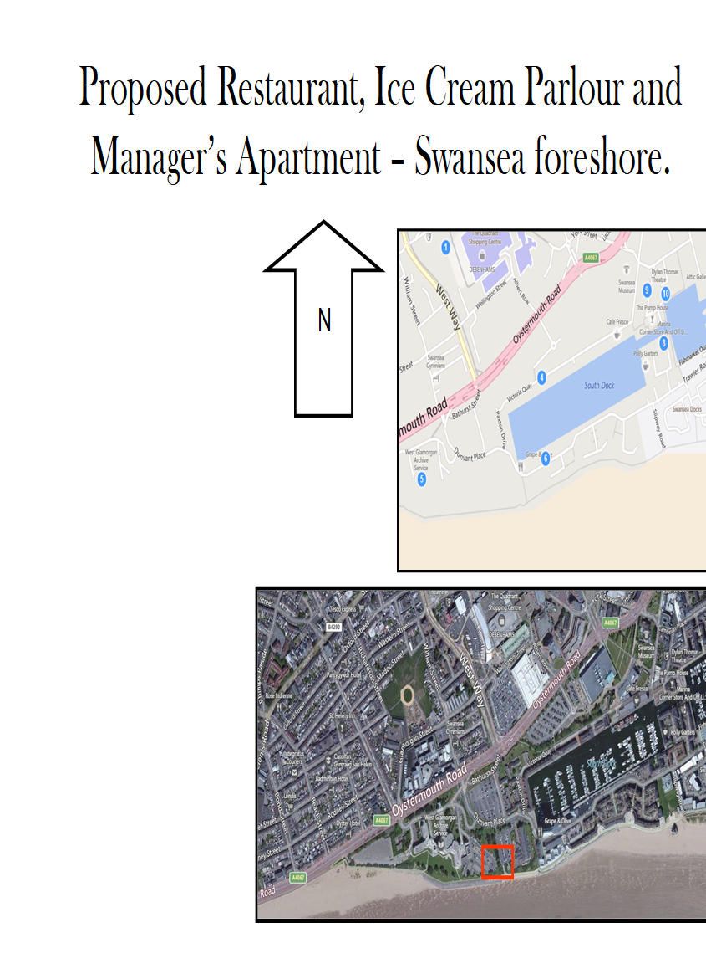

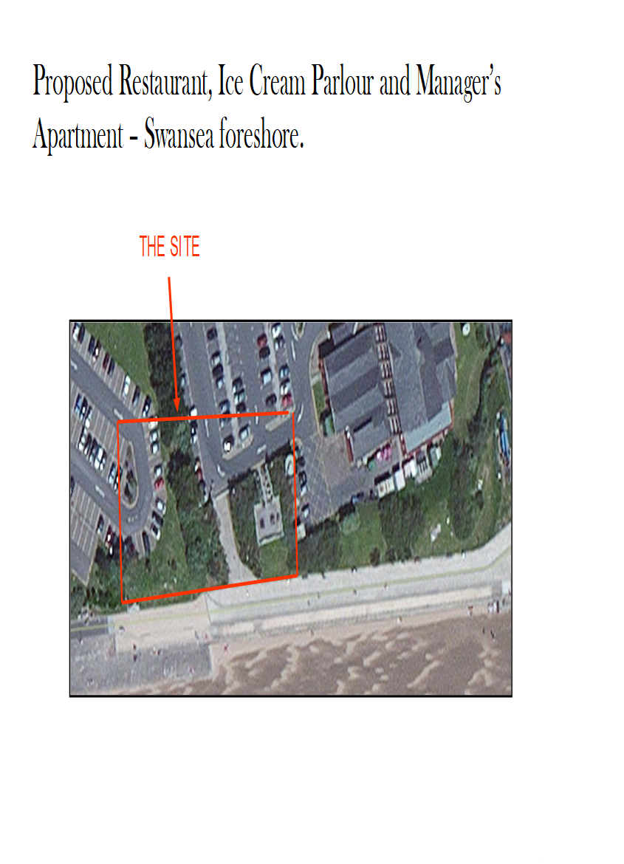

Table of Contents
- Executive Summary
- Introduction
- Historical & Archival Study of Swansea Foreshore
  - Early Development (1850s-1900s)
  - Foreshore Transformation Through the 20th Century
  - Contemporary Site Use and Planning Evolution
- Site Investigation Recommendations
  - Key Geotechnical and Environmental Risks
  - Recommended Site Investigation Programme
  - Reasons for Each Investigation Element
  - Principal Areas of Risk
- Regulatory and Local Authority Framework
  - Building Regulations
  - Codes of Practice
  - Local Authority Involvement & Contacts
- Foundation Recommendation
  - Anticipated Ground and Environmental Conditions
  - Lessons from Comparable Projects ( Meridian Tower, Arena, Others)
  - Evaluation of Foundation Options
  - Justification of Best Solution
  - Foundation Detailing and Construction Risks
- Conclusion
- References

- Executive Summary
This report critically evaluates ground risks and investigation requirements for the proposed restaurant and ice-cream parlour on Swansea foreshore. The site’s industrial history and costal location present challenge, including potential contamination, high groundwater, and variable ground conditions. A staged site investigation is proposed, targeting areas of concern, to inform a robust, complaint foundation solution. The recommended approach algins with the best practise and local policy, optimising both safety and value for the client.

- Introduction
The Swansea foreshore site, located between County Hall and the Marriott Hotel, is earmarked for mixed hospitality and leisure use. Given its complex history as a brownfield area, a focused approach to ground risk is essential to ensure safety, compliance, and the cost efficiency. This report outlines the main challenges and details a recommended investigation strategy delivering robust data to support foundation design and delivery.

- Historical & Archival Study of Swansea Foreshore
  - Early Development (1850s-1900s)
Historic records and mapping show the Swansea foreshore site was previously used for industrial and landfill activities. This legacy increases the likelihood of contaminants in both soil and groundwater. No protected heritage features were identified that would affect development. Historic fill and proximity to the river pose potential hazards, confirming the need for targeted ground investigations

Swansea Foreshore, Ordnance Survey 1898 Swansea in 1898, showing the town and the surrounding area – Old Map Downloads
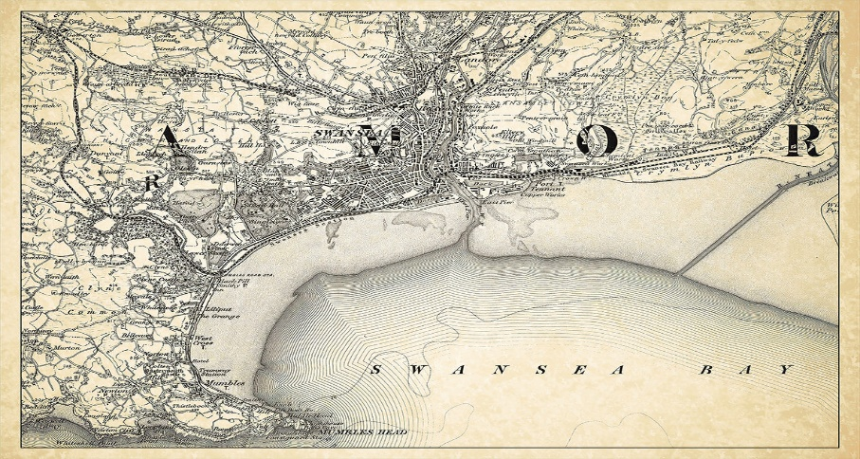

  - Foreshore Transformation Through the 20th Century
The first half of the 20th century saw some consolidation of land use, but the foreshore remained dominated by older infrastructure, railway tracks, and light industry. Following the Second World War, Swansea’s port and industrial base entered decline, and by the mid-1960s, aerial photographs (Swansea Museum Archive, ref. SM/A/3521) and planning records describe wide areas of dereliction—
Unused hardstanding, informal tipping, and isolated remnants of former industrial buildings.

Major civic interventions began with the construction of the Civic Centre and County Hall (opened 1982 and 1988, respectively). Local authority records (City and County of Swansea, 1987) detail an eclectic approach to ground preparation: new fill was placed atop unconsolidated old fill and soft alluvial clays, with minimal documentation—a common feature in many UK urban reclamation sites (Potts & Ankrah, 2014).

Modern mapping shows the plot became a redundant car park, itself likely resurfaced several times but never subject to significant substructure remediation:

The image below shows the most recent satellite of the proposed development site between County Hall and the Marriott Hotel, Swansea foreshore (Source: Google Maps, accessed April 2026) :
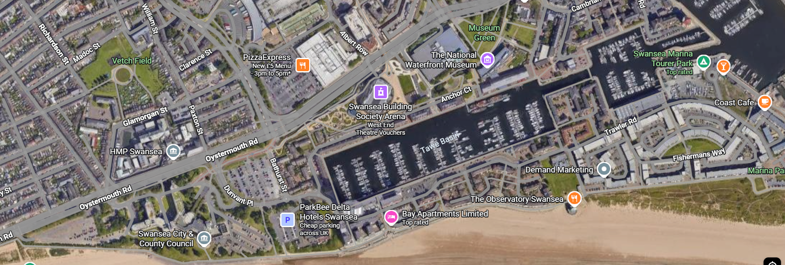

  - Contemporary Site Use and Planning Evolution
From the 1990s onwards, regeneration efforts recast the foreshore as a civic and leisure corridor. Projects like the Merdian Tower (completed 2009), Swansea Arena (2022), and adjacent hotel and plaza schemes permanently altered the skyline- and posed major foundation challenges. Engineering logs from these projects (WSP, 2011) document up to 6 meters of made ground, variable organic inclusions, extensive debris, frequent groundwater inflow, and extended site remediation for contamination.

Today’s project site is bounded by modern, piled structures; surface conditions are dominated by bituminous and concrete hardstand, and all archival evidence suggest the original estuarine and reclamation sequence continues beneath. The area is also categorised as Flood Zone 2 by Natural Resources Wales (NRW), requiring both civil engineering and insurance safeguards.

Key points for the developer:
- Ground likely includes both historic and modern fill, with highly changeable engineering properties
- Unknowns about depth, type, and compactness of fill material under the site
- High probability of contamination and groundwater complications
- Proximity to marine influence, which affects both long-term settlement and corrosion risk.
- Site Investigation Recommendations

  - Key Geotechnical and Environmental Risks
From historical and recent evidence, the following site-specific risk must be addressed before design can progress:
- Contaminated land: Former landfill and industrial activity raise the risk of hazardous substances in the ground.
- Higher groundwater: Coastal position and fill material make elevated groundwater likely, impacting foundation choice.
- Flooding potential: Tidal influence and surface water management require attention.
- Buried obstructions: Presence of past structures or services may affect piling or excavation.

  - Recommended Site Investigation Programme
A phased investigation is essential for managing ground risks:

Phase 1: Desk Study & Walkover
- Review historical maps, prior investigations, and conduct a site walkover to identify visible risks.
Phase 2: Intrusive Investigation
- Targeted boreholes and trial pits in high-risk areas assess ground variability, contamination, and groundwater. Laboratory tests will confirm geotechnical properties and chemical hazard.
Phase 3: Reporting & Recommendations
- Results will inform design options – ensuring foundation proposals suit site conditions and regulatory requirements.
Phase 4: Supplementary Investigations
- Ground-penetrating radar (GPR) or resistivity for large obstruction’s/services
- Inclinometer or settlement marker installation for long-term behaviour modelling, if indicated
Each phase priorities compliance with BS5930 and EC7, targeting investigation where risks are highest.

  - Reasons for each Investigation Element
- Windowless boreholes and CPT: Address heterogeneity of made ground/fill and improve confidence in depth to ‘good’ founding layer
- Deep boreholes: Necessary to determine if and where competent bearing stratum exists for piling
- Trail pits: Locate shallow obstructions, sample utility location, and visually examine fill character
- SPTs, Plate Loads: Provide settlement and strength data for both foundations and service support
- Contamination suite: Early risk mitigation- protects contractor, aligns with statutory Part C compliance (Building Regs)
- Monitoring wells: Detects depth and fluctuation of water table, critical for both construction methodology and durability assessment
- GPR/inclinometers: Reduce post-construction liability from unforeseen movement or service clash
  - Principal Area of Risk
Based on archival review and best practice (Eggers & Jennings, 2020)
- Areas near historical refuse deposits ( typically at site boundaries or former dock perimeters)
- Zones close to County Hall/Marriot piles-possible remoulded or weak ground due to historic construction
- Locations where site levels have been ‘made up’ to accommodate car parking- risk of uncompacted fill layers

- Regulatory and Local Authority Framework
  - Building Regulations
The project is subject to the Building Regulations 2010 (as amended), notably,
- Part A – Structure- Specifies requirements for stability, settlement/clay protection, and safe load, transfer into ground (refer to BS 8004:2015 for detail)
- Part C – Site Prep and Contaminated Land: Demands both risk assessment and duty to remediate hazardous or unsuitable ground before any permanent work. Full compliance with local Environmental Health team and Environment Agency Wales guidance is mandatory (Environment Agency, 2016).
- Part E – Noise/Sound Resistance: Especially for the manager’s flat and where the structure abuts existing properties.
- Part H – Drainage and Wastewater Disposal: Impacted by high groundwater, fill variability, and historic unexploded voids.

  - Codes of Practice
Comprehensive adherence to these British and European Standards is required:
- BS 5930:2020 – Ground Investigation: Desk study, intrusive investigation, reporting, and interpretative analysis.
- BS EN 1997 (Eurocode 7): Standard for geotechnical design, requiring quantified risk assessments and verification in design; essential for piled foundation schemes (BSI, 2020).
- BS 8004:2015 – Foundations: Best practice for selection, design, construction of shallow and deep foundations on variable or reclaimed ground.
- NHBC Standards (2024): ‘Chapter 4’ covers supplementary housing/flat requirements if any apartment or leasehold element sought.

Clients should be made aware that these standards are legally and contractually binding, and non-compliance may invalidate insurance or future sales (Cartlidge, 2022).

  - Local Authority Involvement & Contacts
Early and clear dialogue with local statutory bodies is recommended:
- City & County of Swansea Building Control:
Civic Centre, Oyster mouth Rd, Swansea SA1 3SN
Tel: 01792 636000
Email: building.control@swansea.gov.uk
- Environmental Protection ( Land Contamination):
Environmental Health, Tel: 01792 635600
https://www.swansea.gov.uk/environmentalhealth

- Drainage/Water Regulations:
Welsh Water (Dwr Cymru), Developer Services – www.dwrcymru.com

- Natural Resources Wales (NRW)
Required if piling or dewatering will affect watercourses or protected zones; www.naturalresources.wales

It is recommended to issue draft SI and remediation strategies for commend before formal building submission, ensuring design meets both national and local risk criteria.

- Foundation Recommendation
  - Anticipated Ground and Environmental Conditions
Desk studies and previous major developments (WSP, 2011; Potts & Ankrah, 2014) show typical ground profile as:
- Top: Tarmac/concrete hardstand (0-0.2m)
- Made ground: rubble, broken brick, ash, filled pockets, up to 6m – often poorly compacted and moisture sensitive
- Soft, compressible estuarine clays/slits: 2-8m, with SPT N values <5 in some areas
- Occasional organic or peat lenses in low areas
- Below: dense glacial sand/gravel or weathered rock (depth varies locally, averages 10-20m below surface)
- High and variable groundwater, with risk of perched water atop unbroken slit/clay layers

In addition, intrusive SI for Swansea Arena and Meridian Tower documented:
- Pockets of hydrocarbon and heavy metal contamination
- Ground gas ( > 1% methane in some areas- highlighting need for active ventilation in below or ground-level rooms)
- Buried infrastructure and obstructions

  - Foundation Recommendation
Based on the ground risks identified, a piled foundation is recommended, as it will avoid placing loads on variable and potentially contaminated shallow soils. Piling reduces the risk of future settlement and limits direct contact with potential contaminants, supporting long-term structural integrity.

All site investigation works will be undertaken in accordance with BS 5930 (Site Investigations) and Eurocode 7 (Geotechnical Design), ensuring compliance with recognised industry standards.

Geological map extract highlighting coastal sediment deposits, Swansea (I had to search this image on my phone as it was restricted on my computer)
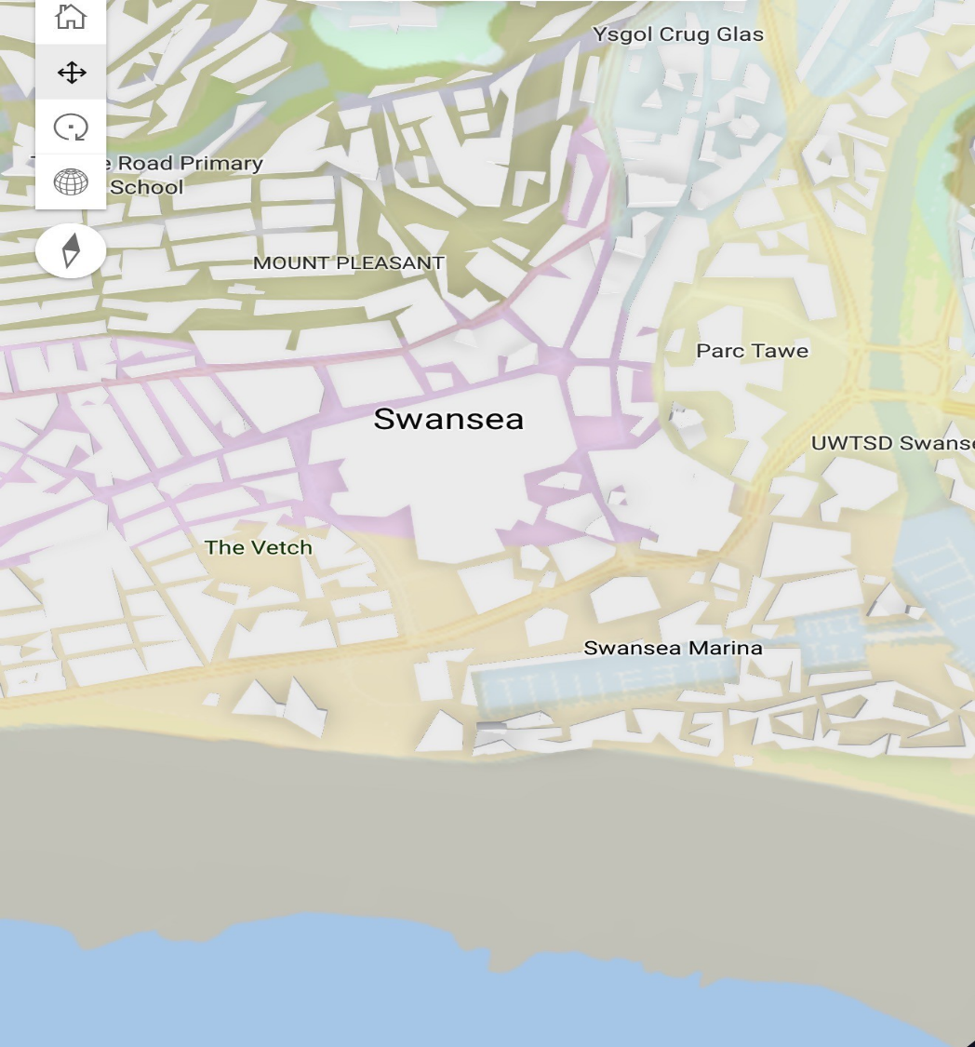

  - Lessons from Comparable Projects (Meridian Tower, Arena, Others)
The region’s most high-profile development used:
- Deep CFA ( Continuous Flight Auger) piles, cast-in-situ, founded on competent glacial deposits or weathered bedrock
- Extensive pre-boring and obstruction removal/ remediation
- Pile caps and ground beams to distribute load and counteract short
- And long-term settlement

- Active monitoring for settlement and groundwater through both construction and operation, with many schemes requiring post-construction ground improvement, or retrofitting of gas barriers
Alternative (unsuccessful or high-risk) foundation solutions (rafts, shallow pads, ground improvement) were shown to be costlier or post greater risk of uneven or excessive settlement, especially where the architectural concept priorities glass facades or minimal movement tolerances (NHBC, 2014).
  - Evaluation of Foundation Options
- Shallow Foundations (Rafts, Strip, Pad):
- Only feasible where made ground thickness is low and undisturbed natural alluvium is near the surface – i.e, not applicable for this site.
- Prone to uneven settlements, especially if fill is of inconsistent vintage/compaction (BS 8004:2015)
- Not recommended where new foundations are immediately adjacent to
piled hotel and offices – risk of differential movement
- Piled Foundations (Driven, CFA, Precast):
- Driven (precast): suitable where vibration is not a concern, but in the city centre, vibration and noise are unacceptable; also prone to refusal in hard debris.
- CFA (bored, cast-in-situ): preferred due to minimal vibrations, ability to penetrate obstructions, adaptability to variable ground, and lowest impact on surrounding buildings (WSP, 2011).
- Ground Improvement Techniques (Stone Columns, Grouting):
- Sometimes used to densify very thick fill, but less control over settlement, contamination risk, and not favoured for hight tolerance glazed structures (Eggers & Jennings, 2020).

  - Justification of Best Solution
Based on the above, deep CFA bored piles offer the optimum combination of performance and risk management for this site.
- Load is transferred to proven competent strata: avoids load on soft, compressible and potentially unstable fill
- Systems can be designed to minimise effect on adjacent structures (County Hall, Marriott), important where ground is already ‘worked’
- Vibration and noise minimised: city centre/business environment maintained uninterrupted
- Contamination/hazardous fill remains in situ: only minimal arisings generated, simplified Material Management Plan (MMP)
- Allows for flexibility in pile length/layout: key, given foundation much accommodate both standard frame and heavily
Typical arrangement
- Pile diameter 400-600mm, lengths 12-20m; extended to ground demonstrated to have SPT N > 15 or to known rockhead
- Pile caps at key column lines, with ground beams spanning between

Environmental design:
- All ground-level and subsoil spaces constructed with gas barriers and active venting ( see NHBC, 2024)
- Suitable for TCB (trench cut-off beam) at boundaries if adjacent contamination risked migration
Type | Feasibility on Site | Cost Implication | Programme Risk | Impact Adjacent | Contamination Management | Typical Use
CFA Bored Pile | Very High | Moderate | Low | Low | Good | Most city-centre & brownfield
Driven Pile | Moderate | Low | Moderate | High | Moderate | Industrial/remote
Raft | Low | Varies | High | Moderate | Low | Greenfield/low fill
Pads/Strips | Very Low | Low | Very High | High | Low | None on this site
Table: Summary Comparison of Foundation Types

  - Foundation Detailing and Construction Risks
Professional detailing and sequencing is crucial:
- Pre-boring at each pile: to identify/cut through obstructions, confirm competent stratum
- Pile layout to avoid known old service runs ( from GPR/records)
- Allowance for ground gas protection at lowest occupied floor
- Contingency in programme for removal of unforeseen large debris (concrete lumps, rails, etc.)
- Settlement monitoring points to be installed before main works, remain during/after construction (BS 5930:2020)
- Coordination strategy for working in proximity to live County Hall/Marriott Hotel Services

- Conclusion
The Swansea foreshore presents clear ground risks, including contamination, variable soils, and groundwater. A phased, risk-driven site investigation – combined with a piled foundation solution – offers the best route to a safe, cost-efficient development. Early engagement with regulators and use of lessons from similar sites will ensure a robust, compliant outcome.

- References
- BSI (2020) BS 5930:2015+A1:2020 Code of practice ground investigations. London: BSI Standards BS 5930:2015+A1:2020 | 31 May 2020 | BSI Knowledge
- Cartlidge, D. (2022) New Aspects of Quantity Surveying Practice. 3rd edn. Routledge New Aspects of Quantity Surveying Practice
- City and County of Swansea (1987) Sustainable development policy - Swansea
- Eggers, J & Jennings, A. (2020)
- Environment Agency (2016) The Environmental Permitting (England and Wales) Regulations 2016
- NHBC (2014) NHBC Standards 2014. National House-Building Council NHBC Standards - NHBC

