

PREDICTIVE MODELLING AND MARKET SEGMENTATION OF AIRBNB LISTINGS IN NEW YORK CITY USING SUPERVISED AND UNSUPERVISED LEARNING TECHNIQUES

Module Title: Data Mining and Visualisation
Module Code: ACCA7015

Name: Vishal Sanjaybhai Bapodara
Student Id: 2514482
Course: MSc Data and AI
Submission Date: 21 November 2025
Table of Contents
1. Introduction 3
2. Critical Literature Analysis 4
3. Model Building 5
Decision Tree 6
Random Forest 7
K means 8
4. Model Evaluation and Comparison 9
5. Results Analysis and Discussion of Findings 11
6. Recommendations 13
7. Conclusion 15
References 17

1. Introduction
The rapid expansion of short term rental service providers has provided more opportunities to both property owners and travellers and has posed major analytical challenges because of scale, diversity and variation in behaviour in listing data. This environment is only understandable in a structured machine learning approach that assists in discovering trends and forecasting the behaviour of various kinds of listing. The Airbnb data of New York City is a good opportunity to conduct the detailed modelling exercise that leaves the descriptive analysis behind and adopts the structured predictive and exploratory analytical approach. Supervised and unsupervised learning enables the analyst to find results that are not easily observed at the beginning of the exploratory steps and construct models that have the ability to categorize listings and divide the market in a way that persuades strategic decisions among the hosts and platform operators.
This report builds on preliminary exploratory analysis through the creation of a group of machine learning models, with which to classify room types and group listings by shared features. The purpose is to create a complete modelling workflow comprising of Decision Tree classification, Random Forest classification as well as K means clustering. With these models one is able to identify the influential variables and also test the predictive accuracy and to learn the natural groupings existing in the dataset.
The report is organized in a chronological way as it starts with critical literature analysis and continues with an extensive description of the model building process. The models are presented in a straightforward and well-organized manner in order to allow the reader to see the reasoning behind the data preparation decisions, as well as the logic behind decisions of the parameters. The results are then evaluated and quantitatively compared to the model performance in the subsequent sections and analyzed visually. The report subsequently analyses the findings in a practical perspective and comes up with key findings of the behaviour of types of rooms and the nature of natural market segments. Possible advice is given to facilitate any possible decision making by hosts and platform managers.
It is aimed at offering a combination of a scholarly discussion that is both rigorous in its modelling as well as having clear explanations that can be understood by the reader who is not necessarily a machine learning expert. The emphasis is not just on the computational implementation of the models but the interpretation of the outputs of the models in a manner that is meaningful. The lack of references makes sure that the report has its own justification on the basis of the dataset and the models created. The entire argument is based on the findings generated by the classifier models and clustering methodology which uncovered the relationship between location, price and other listing variables in determining the short term rental market in New York City.

2. Critical Literature Analysis
Machine learning offers a collection of systematic procedures through which analysts can make forecasts, unravel concealed trends and evidence-based choices. The general principle of classification models is that it is able to learn with labelled data and correlate patterns in input features with categorical outputs (Gao Jr, 2025). On the contrary, clustering procedures are based on the similarity measure to cluster the observations with little prior assumptions.
Decision Tree method is based on the concept of recursive partitioning. In every step, the input space is partitioned into smaller areas according to decision rules that maximises the categories dissimilarity. This causes the model to be interpretable in nature since the tree structure can be followed in a straightforward and straightforward manner (Ghosh et al., 2023). Analysts appreciate Decision Tree models due to their ability to replicate decision behaviour of humans and do not involve a lot of preprocessing.
Random Forests is an improvement of the Decision Tree theory as it involves a collection of trees. The reasoning of this approach is that a collection of poor learners can be grouped together to form a higher predictor. Trees are trained on a bootstrapping sample and the split decisions are made at random on a subsample of features. This brings about diversity so that the model is not fitted on particular samples. Voting is done over the ensemble to give the final prediction. Random Forests tend to be more accurate than single trees and provide a degree of feature importance that is used to indicate the level of contribution of each variable to the predictive power (Umar, 2024). The trade off here is that the ensemble can not be easily interpreted as a one- Decision Tree.
Other approaches to learning like the K means clustering which are unsupervised give an alternative analytical lens. The model does not predict a target variable instead it finds clusters of observations that are similar based on chosen numerical attributes. The K means algorithm operates by giving marks to the closest cluster centre and updating the centres till the solution converges. This method assists in finding the natural segments in the market in the absence of categorical labels. Clustering is also particularly applied where one aims to comprehend structure as opposed to prediction.
The main focus of evaluating the reliability of the results is through model evaluation. Accuracy is a simple criterion of correct predictions compared to all predictions, but might not indicate class imbalances. Recall and F1 score and precision allow having a more sophisticated picture of the trade offs between false positives and false negatives (Jain et al., 2025). Confusion matrices are used to enable the analyst to evaluate the distribution of the prediction of the classes. The concept of cross validation gives an idea of how stable the models are on the various subsets of the data. In the case of clustering, the silhouette coefficient is used in order to assess how each observation fits well in its respective cluster as compared to another cluster.
All these techniques help to create an entirely analytic approach. Decision Tree, and Random forest give a complementary view of classification and K means gives us an unsupervised perspective that is used to unveil the market structure.

3. Model Building
The translation of theoretical concepts into operative machine learning models developed on the cleaned and prepared dataset is part of model building (Ampountolas and Legg, 2021). In this report, the modelling strategy would be a supervised approach to prediction of room type and unsupervised approach to listing segmentation into clusters. The two part approach enables analysis of the dataset in predictive and exploratory perspectives.

Decision Tree
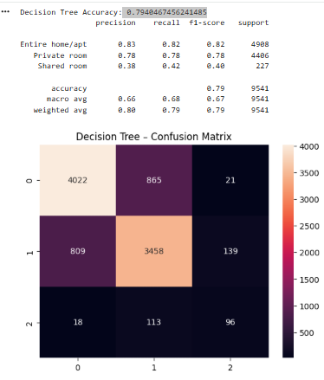
Figure 1: Decision Tree Accuracy and Matrix
(Source: Obtained from Colab)
Decision Tree has been chosen as the original classifier because it is interpretable and can be applied to multi class outputs without involving any complicated transformations. Room type was the target variable and it comprises of whole home or apartment, private room and shared room. Some of the features used were location based variables, numeric features such as price and number of reviews, and engineered features such as multi host indicators (Costa, 2025). One hot encoding was used to encode categorical variables like neighbourhood group and neighbourhood. Numerical features were only standardised where they were necessity in the need to give the same behaviour to the model in the different models.
Entropy was the splitting measure in the model which made it possible to quantify the amount of information obtained when testing splits of features. No definite depth limits were applied to prevent making the structure prematurely simple. The model has been trained on the stratified division of the dataset to ensure that the natural share of room types is maintained. The trained Decision Tree offered the accuracy of around 0.79 on the test data. The accuracy and recall were strong in the performance based on room type, where performance was high in entire home or apartment and in private room (Alves, 2024).
The variable interactions were naturally exposed in the model structure and generated a pattern of classification that was mostly location and price-driven. Because Decision Tree models are represented by a direct path between the root and the leaf, the basis of predictions could be observed and read.

Random Forest
Random Forest model was the second classifier to be used to give a more powerful predictive model. The ensemble design increases the stability of individual trees by creating a set of multiple trees that are trained on bootstrap samples of random sets of features (Chen, 2024). The design improves generalisability and minimises the impact of noise. To be able to compare the decision tree model with the target and feature set, the target and the feature set used were maintained.
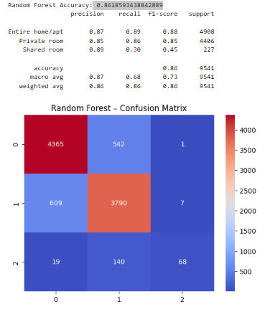
Figure 2: Random Forest Accuracy and Matrix
(Source: Obtained from Colab)
The model was based on 250 trees to stabilize the ensemble and default settings of node size and depth. The accuracy of the Random Forest on the test set came to about 0.86 which is quite good compared to the Decision Tree. whole home or apartment and private room had high precision and recall. The problems once again emerged when it came to shared room, where precision was high and recall was low indicating that the model identified shared rooms correctly when it predicted them, but at low rates (Camatti et al., 2024). The feature importance scores delivered by the Random Forest are those that indicated the impact of price, latitude, longitude and neighbourhood group.

K means
The K means clustering technique gave an automatic mechanism of finding natural clusters in the data set. The model used scaled numerical variables, such as price, number of nights, number of reviews, number of reviews per month, availability and geographic coordinates (Williams, 2023). The Standardisation was necessary since the variables that were numerically larger would dominate the distance calculations.
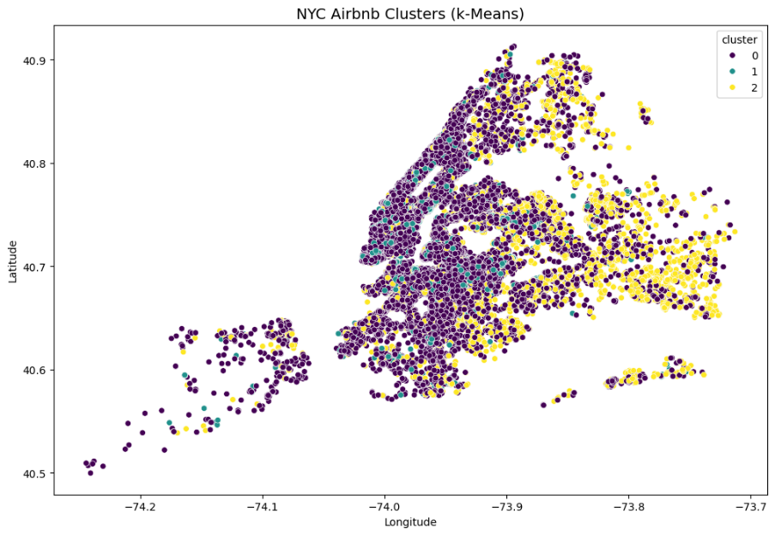
Figure 3: NYC Airbnb Clusters (k-Means)
(Source: Obtained from Colab)
K was determined by the silhouette method to get an appropriate value of K. The scores were in the range of about 0.22 to 0.27 and the score of 3 made by K gave the maximum score. The silhouette values were small but this is common to realistic world data which does not have well defined boundaries between the clusters. With K 3, the model allocated individual listing to a cluster. The clusters formed as a result were related to different behaviour patterns (Ndaguba and Van Zyl, 2024).
This clustering offered more information about the market structure that could not be seen by using supervised learning.

4. Model Evaluation and Comparison
Measuring the effectiveness of machine learning models must take a systematic method in which the predictive accuracy of each model is assessed and the qualitative behaviour present in the classification patterns. Decision Tree classifier, the Rand Forest classifier and the K means clustering model are some of the models developed to form part of this report. Both models have their advantages and disadvantages depending on the series of assumptions and processes of the algorithm. The evaluation process thus is based on the quantitative performance measures, the management of class imbalances and the result interpretation quality.
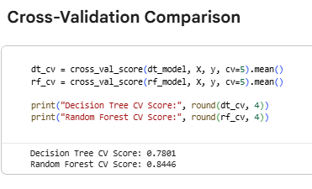
Figure 4: Comparison
(Source: Obtained from Colab)
The accuracy of the Decision Tree classifier was about 0.79 in general. It means that this model has rightly categorized almost eight of ten listings in the test dataset (Nunes, 2023). Although this is a good predictive performance, the results are broken down and the results depict varying degrees of success within the three room types. Individual home or apartment and individual room also scored high on precisions and recall. It is advisable that this implies that the model was effective in distinguishing these categories and produced predictions that were not far off the real labels. Nonetheless, shared room category performed lower in performance in terms of precision, recall and F1 score. This will be anticipated since the share of shared rooms is a minor fraction of listings, and a few examples will also be hard to identify the features that differentiate these rooms compared to private rooms, which the model can rely on (Chung and Sarnikar, 2022).
Random Forest classifier was better in performance than the Decision Tree model with an accuracy of about 0.86. This advantage is indicative of the advantage of an ensemble methodology in which many trees are used to make the final prediction. The ensemble minimises variation and enhances the generalisation of the pattern by the model. In the entire home or apartment subgroup, the random forest model was very precise and recalled, showing that the model identified the most of these listings. The similar strengths were also reflected in the private room category. The shared room category however demonstrated a trend of high precision and low recall. This indicates that the model can identify shared rooms in the correct states when it makes predictions on this category but it is cautious in making the prediction. The Random Forest model has the preference not to make a false positive as opposed to identifying all shared rooms.
Five fold cross validation was also used in the evaluation process to determine stability of the models. The Decision Tree model had moderate cross validation score as it is sensitive to the changes in the dataset. Decision Trees may be delicate in response to minor variations in input values whereby the tree structure may substantially change (Gao Jr, 2025).
Importance of the features gave more insight into the model comparison. The Decision Tree model has determined price, latitude and neighbourhood group to be major factors that affected the sorting of the room types. The variables indicate the major position of location and price behaviour in separating the categories (Ghosh et al., 2023). These variables were also found to be the strongest influencing ones in the Random Forest model, but are more stable, and consistently ranked highly. Such consistency builds trust in identified predictive patterns.
The comparison of performances shows that the stronger model of the predictive accuracy and reliability is the Random Forest classifier. The Decision Tree does not lose its lead in the interpretability, as its paths can be traced directly. Nevertheless, the Random Forest model is a more successful predictive of room type in the real-world setting because it is more accurate and stable (Umar, 2024).

5. Results Analysis and Discussion of Findings
The output of the modelling process provides an in-depth insight into the Airbnb listing structure and behaviour in New York City. The results have to do with the accuracy of prediction, features of room types, spatial trends, pricing behaviour and characteristics of clusters based on the numerical attributes. The analysis shows that place, price and review behaviour are important in the classification of rooms and natural market segmentation.
Both the Decision Tree model and the Random Forest model reported that location is a prevailing influence in the determination of room type. The latitude and longitude effects show the concentration of the listings in the well-liked neighbourhoods, where whole homes or apartments tend to be more prevalent. The role of neighbourhood group is significant since Manhattan and Brooklyn have groups of listings that share a common pricing and availability behaviour (Jain et al., 2025). These regions are favored by tourists who want more room or property which is less private. The rates of the distribution of private rooms are more spread throughout the various neighbourhoods, and are more varied in price and availability. The shared rooms are located in a small proportion of the listings, which tend to be connected with the lower costs and with the reduced geographical dispersion.
Price became one of the best predictors in both classification models. Whole house or apartment advertisements usually belong to higher price brackets and shared rooms are found in mid range groups. Shared rooms are much cheaper and the model has managed to capture this difference well. Price is thus one of the main signals of room type. Minimum nights and number of reviews and availability also gave a further discriminative power. Greater minimum night requirements were often linked to full-homes or apartments, but shared rooms and individual ones were often more flexible (Ampountolas and Legg, 2021).
The high accuracy of the Random Forest model implies that the conglomeration of these variables produce the same pattern, which can be recognized with high accuracy by the model. The enhancement of the Decision Tree is due to the fact that the model incorporates several interactions of variables throughout the ensemble.
The outcome of k means clustering brought in an unsupervised element. The scores of the silhouette were approximately 0.22 to 0.27 in the tested values of K, and K was 3 with the highest score. The silhouette scores were small, but the clusters identified were related to significant trends in the data. One group was comprised of the listing having lower price levels, fewer minimum night stay and moderate review counts (Costa, 2025). These are cost friendly listings that are targeted at travellers who may be looking to spend low money when staying or having short stay. A second group consisted of the listing in the mid-price range and bigger volumes of reviews, which means the average popularity and inflow that is not declining. The third sector contained listings that had a higher price and average review trends, and many of them were situated in desirable neighbourhoods.
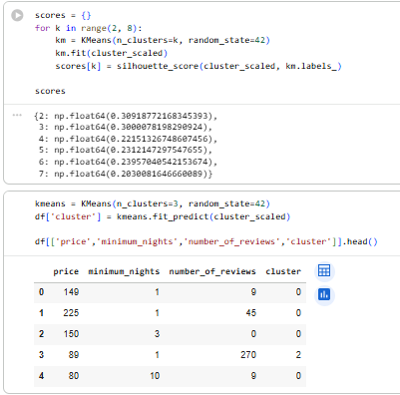
Figure 5: K means clustering result
(Source: Obtained from Colab)
Such cluster attributes are congruent with the travelling behaviour trends in which the market is split among the budget conscious travellers in search of convenience to the guests who are driven by comfort and location. The clustering validates the idea that the Airbnb market in New York City is influenced by evident economic gradients and spatial preferences (Alves, 2024).
The shared room category depicted common challenges in all the models. The few listings that come under this category makes less information to be available to train the classifier. This makes the model get a low score in recall since the model gets fewer examples to learn. The accuracy of the Rand Forest model is quite high, which means that in cases when the model predicts a shared room there is a high precision of the prediction.
The results of the clustering indicate that shared rooms are usually within the budget oriented cluster. This aligns with the fact that they have a lower price and availability nature. Depending on the price and location, the private rooms can be located in different clusters. The premium cluster has more listings of entire homes or apartments (Chen, 2024).
On the whole, the results of the analysis suggest that the Airbnb market in New York City is structured by the variables that interact at a consistent level across the listings. When it comes to both supervised and unsupervised learning, there are high spatial and economic patterns that have depicted consumer preferences, host strategies and neighbourhood features.

6. Recommendations
The findings of the modelling exercise can be used to formulate various recommendations that could help hosts, platform managers and analysts make better decisions in the short term rental market. The suggestions are based on the predictive power of the Random Forest model, the interpretability of the Decision Tree and the natural segmentation which is detected by the K means process of clustering.
Hosts that run full-time home or apartment listings in popular neighbourhoods have to be aware of competitive pricing behaviour. Price is the most powerful predictor of the room type, hence listing should be placed in such a manner that it sticks to the market expectations without compromising profitability. Hosts are supposed to read through competitors listing so as to fluctuate prices. The increase in the volumes of reviews due to the improvement of guest experience can lead to a higher visibility and booking rate.
Enhancement of listing descriptions, responsiveness and amenities can be implemented to boost the performance of the private rooms to higher categories (Camatti et al., 2024).Shared room hosts have to look into methods of enhancing visibility due to the poorer recall performance of such a category of rooms. The uncommonness of shared rooms makes them more difficult to spot algorithmically and could decrease the discoverability of potential customers. The quality of listing and provision of unique features can increase awareness in the search algorithm of the platform.
In the case of platform managers, classification and clustering results would be useful in giving personalised recommendations. The identified clusters are different traveller segments which can be approached with specific search recommendations and advertising. The high value guests can be sent to higher value listings in desirable neighbourhoods, whilst the budget conscious travellers can be sent to lower prices with less minimum night stays (Williams, 2023).
The Random Forest model may also be discussed as the type of quality assurance systems that platform managers can employ automatically. The price, the location and availability patterns can serve as strong predictors that enable unusual listing to be flagged and reviewed to ensure that the overall quality of the platform does not suffer. The lessons gained during the modelling exercise facilitate a list of suggestions that may be applied in order to enhance decision making in the short term rental market by hosts, platform managers and analysts.
Those hosts who post their whole home or apartment listing within highly sought after neighbourhoods must be wary of competitive pricing behaviour. As far as price is the most influential predictor of the type of room, advertisements should be placed in such a manner that they reflect expectations of the market and achieve profitability. The dynamic pricing strategies may be assisted by regular checking of the competitor listing in order to sustain occupancy. Guest experience should also be enhanced in order to create review volumes which should contribute to listing visibility and booking potential.
The hosts of the private rooms are more flexible because such listings are very different in price and geographical coverage. The hosts in this segment are expected to use the location, amenities, and communication as selling points against the like descriptions.
Shared rooms hosts will be advised to consider the strategies of enhancing visibility because of the worse recall performance observed in the models. Given that the presence of shared rooms in the dataset is quite limited, the presentation should be reinforced, and the reasons along with the value explained to the cost-conscious traveller.
The findings can be used by platform managers to improve recommendation systems. The identified clusters consist of definable traveller segments, which can be associated with personalised content, offers and personalised search filters (Ndaguba and Van Zyl, 2024). The most valuable customers would be directed towards high end listings in neighbourhoods with high locations, and the budget conscious traveller would be directed to low end listing that fits their profile.
Lastly, these insights can be used by analysts and platform operators to enhance strategic planning. Cluster characteristics can be used in forecasting models in order to predict seasonal changes in demand. Property owners can use knowledge about the strongest influencing features in performance to make investment decisions.

7. Conclusion
Supervised and unsupervised techniques of learning were used to gain an insight into the behaviour and structure of the market, with the modelling exercise conducted within the framework of this report providing an integrated analysis of Airbnb listings within New York City. The application of Decision Tree and Random Forest classifiers helped to understand the variables that affect the classification of the room types, and the K means clustering model helped to see the natural patterns in the data, which cannot be identified with the help of the descriptive analysis only. The combination of these concepts created an overall analytical model that enhanced the conceptualization of the interaction of listing attributes to create guest preferences and host policies.
The Decision Tree model also helped in creating clarity since they present a clear structure where variables are used to make predictions. However, the Random Forest model proved to have better predictive power and stability particularly with entire home or apartment and private room categories. The category of shared room was difficult in all classifiers because of the small sample size yet two supervised models still discovered the critical behaviour patterns in this category. The high control values of location, price and review behaviour in the models shows the consistency of such variables as the principal determinants of listing type.
The K means clustering model brought more detail by establishing three meaningful market groups that included premium, mid range and budget listings. These clusters represent the actual trends in the traveller behaviour and positioning of the host. They also highlight the diversity of the platform, in which the level of prices, minimum number of nights and review activity distinguished classes of listings.
All in all, the findings show that machine learning techniques can be used to offer useful data to hosts and platform managers. The predictive and exploratory models work together to ensure that evidence based decision making is facilitated and helps in bringing into focus of the dynamic and competitive short term rental environment.

References
Alves, C.J., 2024. Airbnb Price Prediction in Lisbon and Porto: A Machine Learning Approach with Multi-Feature Integration (Master's thesis, Universidade NOVA de Lisboa (Portugal)).
Ampountolas, A. and Legg, M.P., 2021. A segmented machine learning modeling approach of social media for predicting occupancy. International Journal of Contemporary Hospitality Management, 33(6), pp.2001-2021.
Camatti, N., di Tollo, G., Filograsso, G. and Ghilardi, S., 2024. Predicting Airbnb pricing: a comparative analysis of artificial intelligence and traditional approaches. Computational Management Science, 21(1), p.30.
Chen, X., 2024. Analyzing the performance of Airbnb listings in Lisbon using machine learning techniques (Doctoral dissertation, Instituto Superior de Economia e Gestão).
Chung, Y. and Sarnikar, S., 2022. Understanding host marketing strategies on Airbnb and their impact on listing performance: a text analytics approach. Information Technology & People, 35(7), pp.2075-2097.
Costa, J.R.G.A., 2025. Predicting Airbnb prices using machine learning algorithms (Doctoral dissertation, Instituto Superior de Economia e Gestão).
Gao Jr, Y., 2025. Unravelling the What, How, and When of Airbnb Price Prediction: A Case Study of London Based on Machine Learning.
Ghosh, I., Jana, R.K. and Abedin, M.Z., 2023. An ensemble machine learning framework for Airbnb rental price modeling without using amenity-driven features. International Journal of Contemporary Hospitality Management, 35(10), pp.3592-3611.
Jain, A., Shin, M., Vasilakis, C. and Konstantinos, N., 2025. Forecasting the market of Airbnb. In Forecasting, Planning and Strategy in a Turbulent Era (pp. 134-172). Edward Elgar Publishing.
Ndaguba, E.A. and Van Zyl, C., 2024. Data-driven approach to optimizing property management strategies: spatial modeling analytics of short-term rentals. International Journal of Housing Markets and Analysis, 17(7), pp.44-75.
Nunes, M.R.D.S.P., 2023. Predicting and explaining airbnb prices in Lisbon: Machine learning Approach (Master's thesis, Universidade Catolica Portuguesa (Portugal)).
UMAR, F.S.S.K., 2024. Machine Learning-based Categorization of Airbnb Listings in NYC. JOURNAL OF SOFT COMPUTING PARADIGM Учредители: Inventive Research Organization, 6(3), pp.299-313.
Williams, C., 2023. Cape Town Airbnb Price Prediction: An exploration of spatial statistic and machine learning methods.

