Suspension Investigation
Angus Rankin
1904244


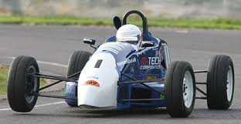

Contents
Title Page 1
List of Figures 3
Introduction 4
Equipment 4
Methodology 1 5
Methodology 2 6
Analysis 1 7
Analysis 2 7
Comparison graphs 8
Equations 9
Roll centres 10
Conclusion 11
References 12

List of Figures
- Figure 1 measuring edge of wheel hub.
- Figure 2 drawing X-axis.
- Figure 3 measuring height of rose joint.
- Figure 4. measuring the distance between the nut and end of the rod.
- Figure 5. toe span gauge and hub plate.
- Figure 6. inclinometer attached to brake disc.
- Figure 7. coordinate table
- Figure 8. Toe vs Ride Height Graph
- Figure 9. Ride height vs camber graph
- Figure 10. Diagram showing roll centre
- Figure 11. Diagram showing roll centre
- Figure 12. Diagram showing roll centre

Introduction
This report will be looking at vehicle dynamics by measuring, modelling and analysing a vehicle chassis. The chassis that will be analysed is the front end of a 1997 Van Diemen Formula Ford car mounted on a level bed. The front right suspension corner will be used to take measurements for Suspension co-ordinates, Kinematic Behaviour, sprung and unsprung mass. The collected data will be compared to data in the formulaford.GEM file and used in WinGeo3 to display schematic vehicle diagrams displaying kinematic force characteristics such as suspension frequency.
Equipment
Vernier callipers: used to measure small distances such as bolt heads, using an analogue Vernier scale it can be misinterpreted easily if not used correctly. An alternative could be a digital version which allows clearer reading of measurements. (The editors of Encyclopaedia of Britannia. 2017)
Engineer squares: made up of a body and a blade it can be used to transfer the position of components to the bed, also used to keep equipment straight such as a ruler.
Ruler: used to draw straight lines and measure distances that callipers cannot. Used with an engineer square to keep it straight it is accurate.
Pencil, tape, paper: used together to provide a cheap and simple way to record measurements and reference points, however can be easily compromised by human error.
Level bed: This keeps the car level and provides an accurate base to take measurements. Provided the bed is set up correctly and it is not disturbed by external forces like people leaning on it then it is accurate.
Digital height gauge: used to measure vertical distances, clear screen allows for easy reading of the measurement and reduces human error.
Engineer block: a simple piece of equipment used to extend the reach of the digital height gauge.
Toe span gauge: Measures small steering movements as ride height changes, features two DTI gauges 13.4375 inches apart resting up against a metal plate attached to the wheel hub. The analogue DTI gauges can be misread not helped by the imperial scale, digital ones would be an improvement.
Inclinometer: An accurate way of measuring inclines the clear screen is hard to misinterpret.
Coil Spring tester: Measures spring rate using a bottle jack to compress the spring, digital scale and a DTI gauge. This can be inaccurate because it is hard to precisely stop the jack at the measurement desired on the DTI gauge.
WinGeo3: A suspension modelling software which allows you to input different suspension parameters and shows how it affects aspects of the vehicle.

Methodology Session 1
- Find the Y-axis, this is the centre line of the chassis from front to back, it is important to not lean on or kick the bed to insure it stays level and measurements are not compromised.
- Using tape stick paper to the bed to for measuring.
- Centralise the steering by using a Vernier calliper to measure each side of the steering rack and lock the steering to stop it from moving.
- Using a Vernier calliper measure the diameter of the wheel hub, half the measurement to find the centre.
- Using an engineer square place it against the edge of the wheel hub and mark its position on the paper using a pencil. (fig.1)
- Add on half the diameter of the wheel hub to find the X-axis and mark it on the paper as a reference point.
- Using a meter ruler and two engineer squares, one against the bed and one against end of the first square. This is to keep the ruler straight.
- Line up the ruler making sure it goes through the X-axis reference point, draw a line using the ruler making sure to only draw one line to make it more accurate. (fig.2)
- Put an engineer square on the outer tie rod, using a Vernier calliper measure the distance between the square and the bolt.
- To find the centre of the bolt measure the length of the head using Vernier callipers and half the overall measurement.
- Add half the bolts head measurement and the distance between the outer tie rod and the bolt. Add the measurement from the edge of the engineer square and mark its position.
- Measure the distance between the X axis and the mark, this is the x co-ordinate.
- Measure the Y-axis by measuring the distance between the centre point of the bolt and the centreline. This is the Y co-ordinate.
- To measure the Z co-ordinate, use a Vernier calliper to measure the thickness of the tie rod rose joint and half it to find the centre point.
- Using an engineering block and a digital height gauge, zero the height gauge on the bed and measure the height of the engineering block. Move the engineering block to the tie rod.
- Place the digital height gauge on top of the engineering block and zero it again, measure the to the bottom of the tie rod (fig.3) Add the measurement of the engineering block, the block to the tie rod and half of the rose joint to find the Z co-ordinate.
- With the co-ordinates found open up WinGeo3 using the FormulaFord.GEM file.
- Open up a table in WinGeo3 and enter in the ride height measurements in increments of 5 starting at -20mm to 25mm.
- Compare them to the ones already on the WinGeo3 to see how accurate they are. The measurements entered can also be used to simulate the vehicles suspension movements.

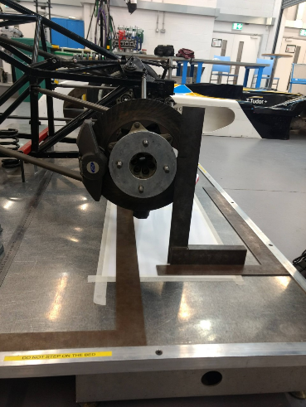
- Repeat this to find the X, Y, Z co ordinates of the inner tie-rod and the steering tie-rod
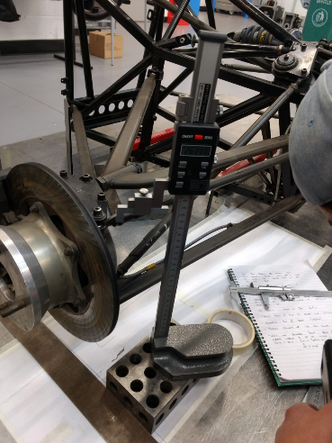
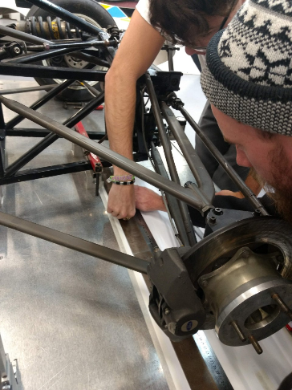

Figure 3. measuring the height of rose joint
Figure 2. drawing the X-axis
Figure 1. measuring edge of wheel hub

Methodology Session 2
- Centralise the steering using a Vernier calliper on the steering rack make sure the steering is straight but do not lock it off.
- Using a toe span gauge set both of the dial gauges to zero against the plate attached to the wheel hub. Also measure the distance between both dial gauges (Fig.5)
- Make sure to not kick or lean against the bed as these gauges are very sensitive and the results will be compromised.
- Using a digital height gauge zero it against the bed then measure to the bottom of the plate attached to the wheel hub.
- Secure a digital inclinometer using a G clamp to the inboard side if the brake disc to measure wheel camber, zero the inclinometer (Fig.6).
- In the place of the damper there should be an adjustable rod with a nut on it used to change wheel height. There should also be two reference marks on the bar to show when the rod has completed one full rotation.
- Using a Vernier calliper measure the distance between the end of the rod and the nut (Fig.4)
- Turn the nut two revolutions using the marks as a reference to the change wheel height.
- Measure the new distance between the nut and the end of the rod. Also measure the new wheel height, camber change and toe change.
- Repeat this process every two revolutions of the nut to gain 10 different sets of data.
- Use a spring tester to measure spring rate, compress the spring for one full revolution of the DTI gauge and record the measurement on the scale, Repeat this 10 times.
- Unsprung weight is measured by placing scales underneath the wheel of the car and recording the results. Then unbolt the suspension corner and everything that the damper has to control, weigh it off the car to find the true unspring mass.

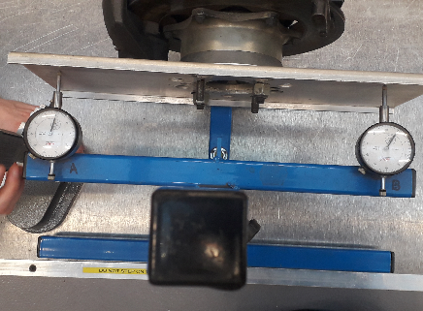
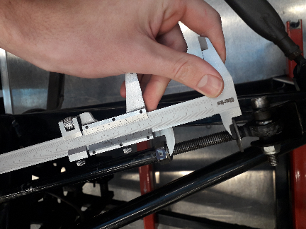
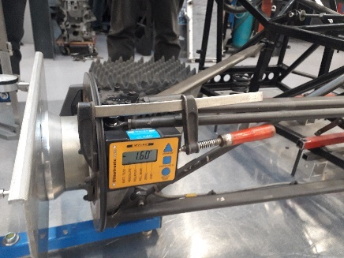
Figure 6. inclinometer attached to brake disc.
Figure 5. toe span gauge and hub plate.
Figure 4. measuring the distance between the nut and end of the rod.
Session 1 Analysis
 | X coordinate | Y coordinate | Z coordinate
Outer tie rod | -64.201 | 744.50 | 308.400
Inner tie rod | -150.34 | 186.90 | 310.810
Figure 7. coordinate table.

The incline angle produced from session 1 was -0.245 whereas the incline angle in the WinGeo software was -0.09, this difference was due to human error when measuring. Inaccuracies where likely created by disturbances made to the bed and incorrect use of measuring equipment.
Session 2 Analysis
Figure 8 graph compares collected toe to WinGeo toe. The graph shows that the collected toe remains the same as WinGeo toe from -20mm ride height up to 15mm. From 15mm to 20mm ride height collected toe increases from 0.135 degrees to 0.204 degrees compared to WinGeo toe which increases from 0.135 to 0.176. This difference of 0.028 degrees between collected and WinGeo remains the same from 20mm ride height to 25mm. This shows the ride height was not correctly measured or the nut was turned incorrectly on the adjustment rod resulting in an error that was then carried forward.
Figure 9 graph shows the collected data and WinGeo both go from negative camber to positive camber as ride height increases, however the curve is different. The difference is due to human error creating measuring inaccuracies.

Figure 9. Ride vs Camber Graph
Figure 8. toe vs Ride height Graph

Equations
$\frac{wheel displacement }{damper displacement }=suspension ratio$ $\frac{57.69}{26}=2.21$
spring rate = 396lbs/in

Lbs to kg = divide by 2.2 396$÷$2.2= 180 kg 180 x 9.81= 1765.8
1765.8$÷$0.0254= 69519.68mm

$$\frac{spring rate}{suspension ratio }=wheel rate$$

$$\frac{69519.68}{2.21^2}=14233.877n/m$$
Mus= 26.9 MS=425
$$\frac{ms+60}{x 4}-unsprung mass=coorner mass$$

$$\frac{425+60}{4}- 26.9= 94.35$$

$$\frac{1}{2π}\sqrt{\frac{WR}{suspension coorner-unsprung mass}=vehicle frequency }$$

$$\frac{1}{2π}\sqrt{\frac{14233.877}{94.35}}=1.95 Hz$$

$$\frac{1}{2π}\sqrt{\frac{wheel rate+256000}{unsprung mass}=wheel frequency }$$

$$\frac{1}{2π}\sqrt{\frac{14233.877+256000}{26.9}=15.95Hz}$$
(Jeong and Suh, 2001 p.104)
Roll Centres
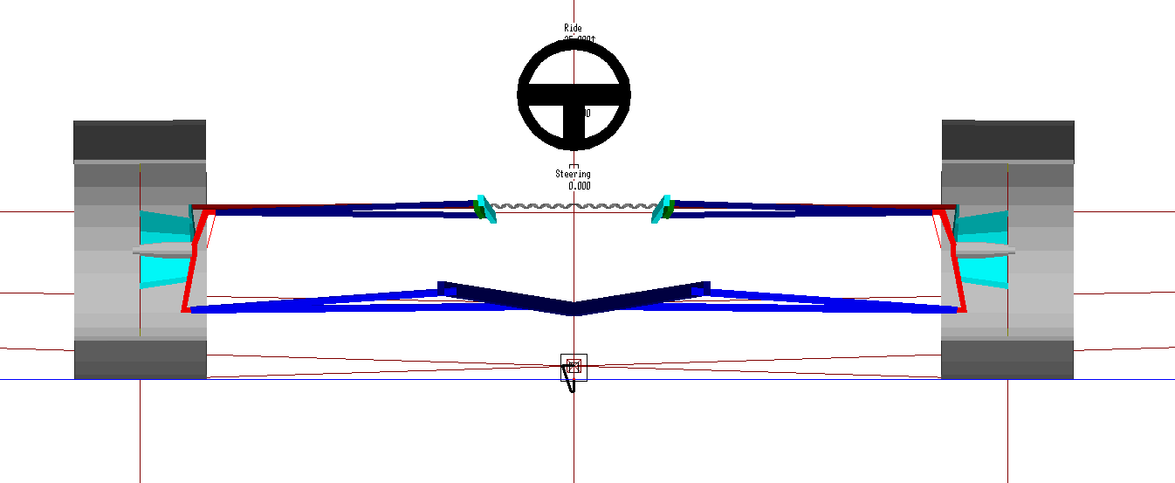
Figure. 10
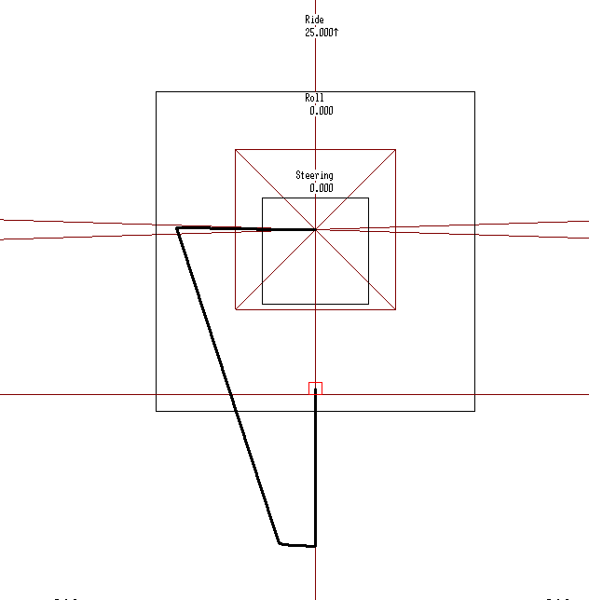

Figure. 11

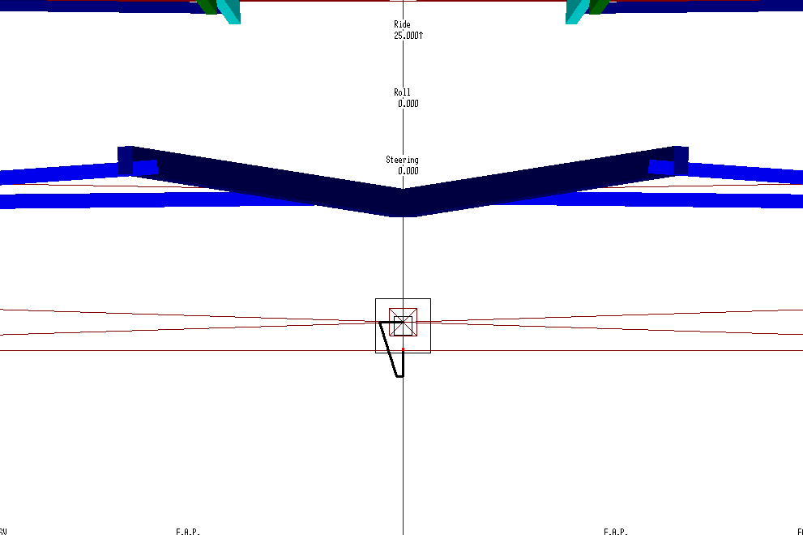
Figure. 12
A locus of the roll centre position is created by opening up WinGeo 3 using the FormulaFord.GEM file. Ride height is set to 25mm while adding a total of 3 degrees of body roll in 0.1 degree increments. Reduce ride until zero degrees of roll occurs making sure to press compute before each command.

Conclusion
To conclude the practical sessions showed that measurements taken were not completely accurate to the data in WinGeo however they are relatively similar. The first practical session which measured tie rod coordinates produced a tie rod angle of 0.245 degrees, 0.028 degrees off of the WinGeo data. This difference was a result of human error when measuring due to a combination of inexperience using the equipment and disturbing the bed. The second session measured camber and toe change over suspension compression. Toe change over ride height was measured accurately due to the toe span gauge leaving little room for human error however camber change did not follow closely with the WinGeo data. These changes may not completely down to measuring errors as the car may have been dismantled and then assembled multiple times resulting in slight movement of components, other factors may include temperature changes expanding or contracting the car. WinGeo3 successfully produced schematic vehicle diagrams and graphs to compare recorded results against and was a useful tool in interpreting suspension behaviour.

References
(Jeong and Suh, 2001 p.104) steering and suspension technology symposium
The editors of Encyclopaedia of Britannia (2017) Vernier Caliper. Available at https://www.britannica.com/technology/vernier-caliper (Accessed: 02 December 2019)

