Boycho Nikolov
2115531@student.uwtsd.ac.uk
Boycho Nikolov
Student ID: 2115531
Cloud Computing,
05/04/2022

Software Development (ACCB4017_LON)
Assignment 1- research report

Contents
Introduction: 2
A survey found that it was the of second-most popular programming language among developers in 2021 is Python. [2] 2
Part A1: Variable 3
Part A2: if/else statement 4
Part A3: Loops 5
Example of script for while used, figure 9: 5
Example of script for for used showed on figure 11: 6
Part B: Implementation 6
Exercise 1: 7
Exercise 2: 7
Exercise 3: 9
Conclusion: 11
References 12

Introduction:

The main purpose of this research is to teach you to think such as a computer scientist. This way of thinking combines some of the best features of maths, engineering, and natural science.
One of the most important skills for a computer specialist is problem solving. This means the ability to formulate problems, think about solutions, and give a solution.
The process of learning to program and Scripting is a brilliant opportunity to practice problem-solving skills. [1]

A survey found that it was the of second-most popular programming language among developers in 2021 is Python. [2]

What can you do with python? Some things include:

- Data analysis and machine learning
- Web development
- Automation or scripting
- Software testing and prototyping
- Everyday tasks

Part A1: Variable

One of the most important things of the programming language is the ability to manipulate variables. A variable is a name that refers to a value.
The assignment statement makes new variables and gives them values:
Variables are containers for storing data values.
In this research will be explain Python. He has no such a command to put a variable.
A variable is created the moment you first assign a value to it.
Variables do not need to be declared with any type and can even change type after they have been set. [3]

Example:
As could be seen in Figure 1:

a = 5
b = "Boycho"
print(a)
print(b)

Figure 1
Output:
After Run could be seen output in Figure 2:

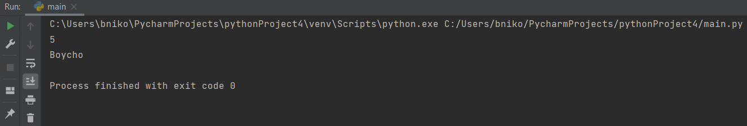
Figure 2

could be seen on Figure 3:

a, b, c = "London", "Portsmouth", "Sofia"
print(a)
print(b)
print(c)

Figure 3

And Output showed on Figure 4, variables a, b, c is executed and can be seen the result
London, Portsmouth, Sofia.

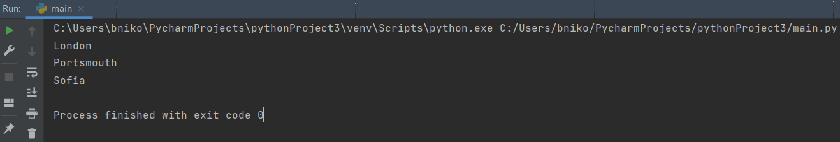
Figure 4

Part A2: if/else statement

The else catches everything which is not caught by the previous conditions. [3]

Example for if of script could be used below at figure 5:

a = 100
b = 400
if b > a:
print("b is greater than a")

Figure 5
output, can be seen the script execute b is greater than a, showed at figure 6:

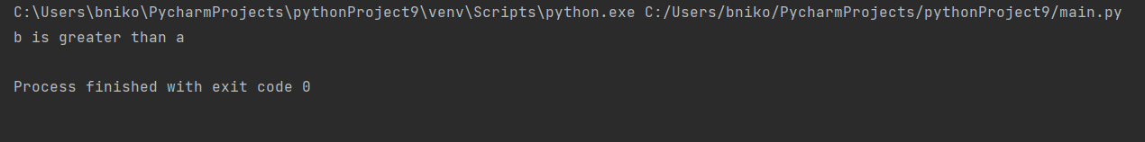
Figure 6

Example for else of script could be used below, figure 7:

a = 2000
b = 100
if b > a:
print("b is greater than a")
else:
print("b is not greater than a")

Figure 7
Output of the script using else and if could be seen here, figure 8.

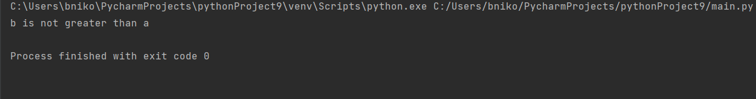
Figure 8

Part A3: Loops

With the while loop we could execute a set of statements as long as a condition is true.
Example of script for while used, figure 9:

i = 1
while i < 6:
print(i)
if i == 3:
print(i)
i += 1

Figure 9
output data could be seen below on figure 10:
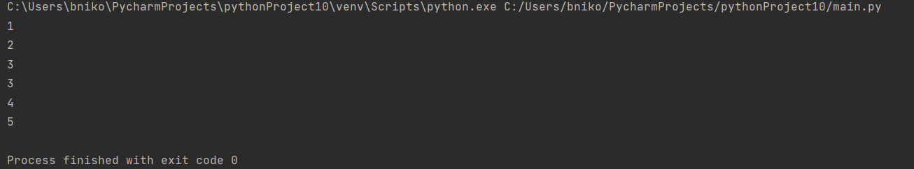

Figure 10

A for loop could be used for iterating over a sequence (that is either a list, a tuple, a dictionary, a set, or a string).
Using the for loop, we could execute a set of statements, once for each item in a list, set etc. [3]

Example of script for for used showed on figure 11:

fruits = ["Kiwi", "Grape", "Orange"]
for x in fruits:
print(x)

Figure 11
output data on figure 12:

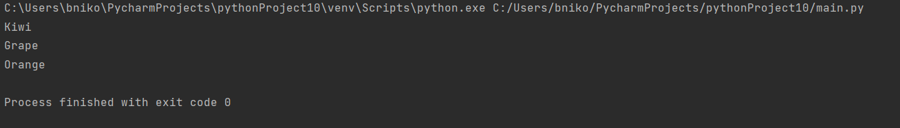

Figure 12

Part B: Implementation

Exercise 1:

Show how variables can contain different types of values by declaring three variables that will contain a name, a measure of height (e.g., 1.84m) and a person's age (e.g., 26). Prompt the user to input these values and display them on the screen. The variables should be appropriately typed for the data required.

Input script on figure 13, variables name, age, height:
name = input ("Enter your name:")
age = input ("Enter your age:")
height = input ("Enter your height:")
print ("Thanks, you entered:" + name + ", and I am " + age + " years old," + height + "cm”, "tall")

Figure 13
Output on figure 14 :

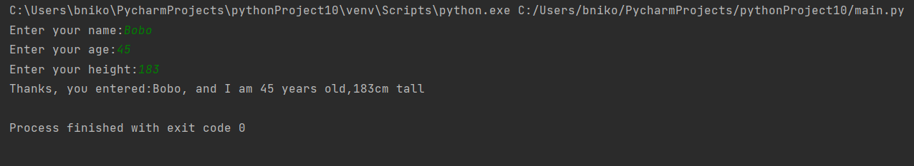

Figure 14

Exercise 2:

A Task is given to enter the dimensions of shapes shown below (in cm), then calculate the area of the blue shaded part. Note: The square and rectangular areas are empty.

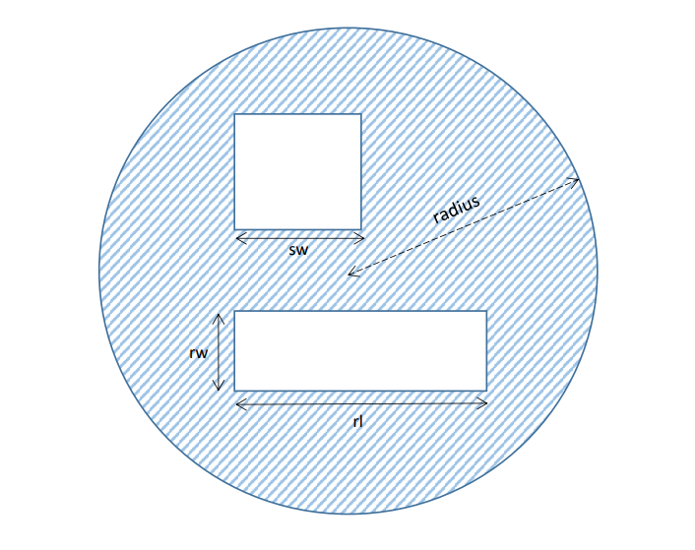

Input script figure 15 to calculate the task, first defined PI, calculation for circle, after that calculated area of Squad and Rectangle.
Then Shared area formula, such as variable with formula and execute with print:

PI = 3.14
radius = float(input(' Please Enter the radius of a circle: '))
circlearea = PI * radius * radius
side = int(input("Enter the side of the square:"))
squarearea = side*side
a = float(input(' Please Enter the length of a Rectangle: '))
b = float(input(' Please Enter the width of a Rectangle: '))
rectangleArea = a * b
sharedarea = (circlearea - squarearea - rectangleArea)
print(" The sharedarea is:", sharedarea, "cm ")

Figure 15

Output, figure 16:

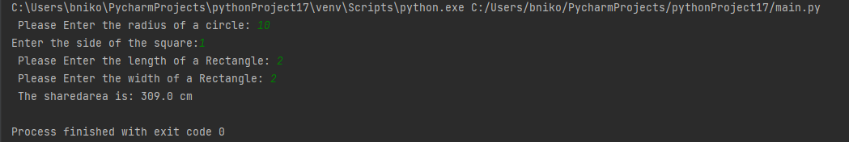

Figure 16

Exercise 3:
The Task was given to
Write a program that allows the user to car mileage (per day) for a week. When the mileage has been entered, calculate the total mileage. Finally, calculate the total cost of petrol for the week, at the rate of £1.35/litre and 11.2 miles to the litre. Use a list/array and loop(s) where appropriate.
Input variables for 7 days from Monday to Friday, input variable for tank, how much fuel is added.
Formula for Total Mileage, Cost and LPM/Litre per mile/.
Executed with Print to show the message and the calculated data.

Input script example showed at figure 17:

Mon_mileage = float(input("Enter miles Monday:"))
Tue_mileage = float(input("Enter miles Tuesday:"))
Wed_mileage = float(input("Enter miles Wednesday:"))
Thu_mileage = float(input("Enter miles Thursday:"))
Fri_mileage = float(input("Enter miles Friday:"))
Sat_mileage = float(input("Enter miles Saturday:"))
Sun_mileage = float(input("Enter miles Sunday:"))
Tank = 45
Total_mileage = Mon_mileage+Tue_mileage+Wed_mileage+Thu_mileage+Fri_mileage+Sat_mileage+Sun_mileage
cost = Tank*1.70
LPM = Total_mileage/Tank
print("Total mileage was :", Total_mileage)
print("The cost of petrol is :£" , cost)

Figure 17
Output requested could be seen below at figure 18:

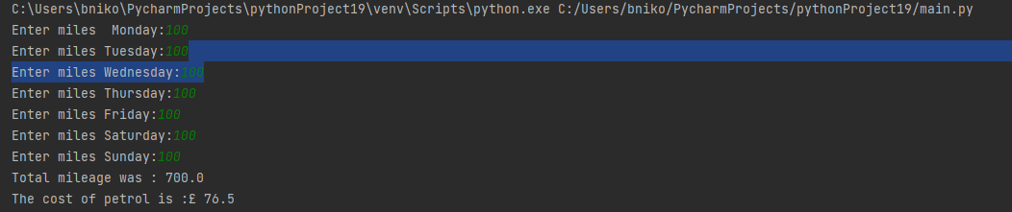
Figure 18

Conclusion:

Python is a popular programming language that can be used to create websites and software, automatic, and data analysis. Python is a powerful language that can be used to create a variety of different programs. It isn't specifically designed for any one task, which makes it well-suited for a lot of things.

Python is a programming language that is used in a wide range of roles, from software engineers and web developers to research scientists and data analysts.

It could be notice is one of the easiest programming languages to study, because the Python syntax are very similar to English. This allows learners to start writing scripts quickly.

References

[1] | A. B. D. a. C. M. Jeffrey Elkner, “http://www.openbookproject.net,” 21 April 2012. [Online]. Available: http://www.openbookproject.net/thinkcs/python/english2e/ch01.html.
[2] | S. O'Grady, “https://redmonk.com/,” August 2021. [Online]. Available: https://redmonk.com/sogrady/2021/08/05/language-rankings-6-21/.
[3] | “https://www.w3schools.com/,” W3.CSS., [Online]. Available: https://www.w3schools.com/python/python_conditions.asp.
[4] | “https://www.citylit.ac.uk/,” Februari 2021. [Online]. Available: https://www.citylit.ac.uk/blog/best-programming-languages-learn-this-year?gclid=Cj0KCQjwma6TBhDIARIsAOKuANyROOnXzLuocdCp44s6V5LsB8ZYfuRD3NjJSWxB3pPaY3e7EJREZnEaAm3DEALw_wcB.

