A handbook for key workers in early years settings during childhood transitions.

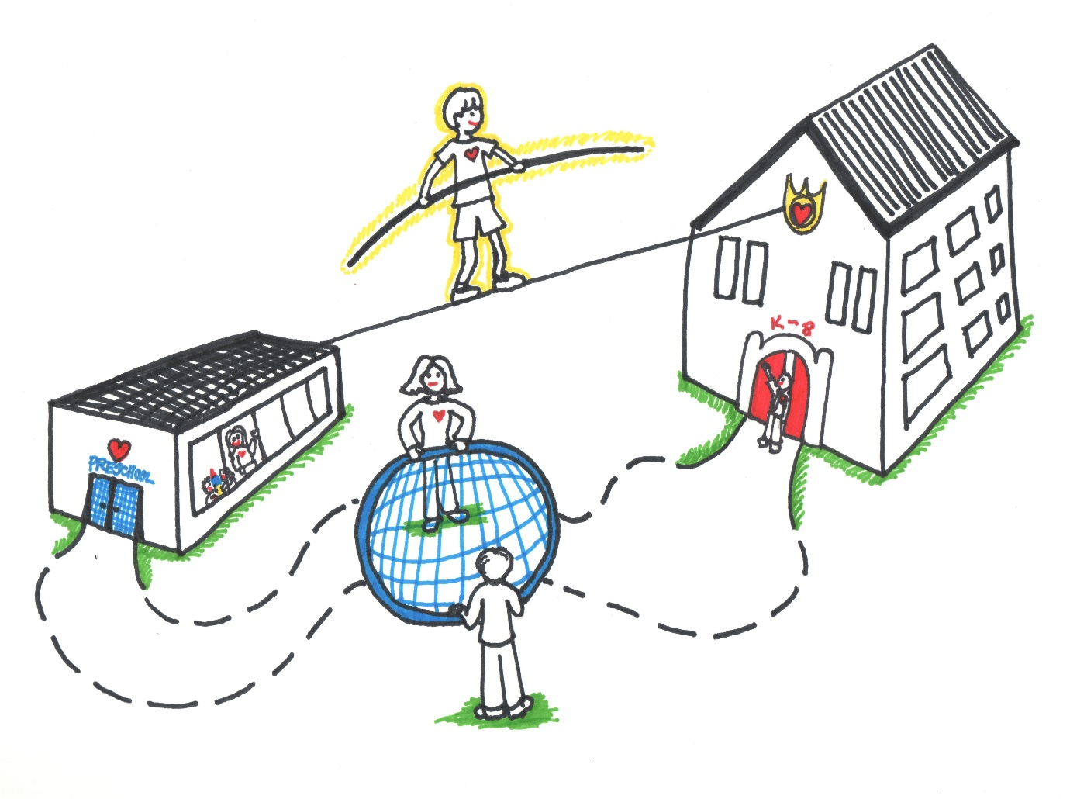
(Source: confident parents confident kids, 2023)

Word count-
Contents
Reference list Page
Proprosed outcomes Page
Interventions Page
Partnerships Page
The role of the adult Page
The needs of the child Page
Transitions Page 4
Introduction Page 3

Introduction

This handbook’s objective is to support keyworkers as they assist children during developmental transitions. The handbook is intended for young children ages three to four, who are making a transition from home to school. The keyworker should utilise this guide to assist educate themselves on the value of excellent communication through the transitional time, in order to make sure it goes as smoothly as possible for the child. It will benefit children’s outcomes as keyworkers will become more aware of what is expected of them but also how they should deal with each individual child and their personal needs.
After reading this handbook, practitioners should have a deeper understanding of the significance of effective communication and how it impacts young children’s learning and development during transitions. The handbook was created to increase keyworkers awareness of this impact. Oxfordshire County Council (2019) describe how proactive planning, sharing information, and reciprocal visits between parents, carers and professionals can help to ease children into their new transition. Working with one another such as cooperation between childminders, settings and schools is crucial to a successful transition because it allows everybody to clearly grasp each other’s goals, motives, and philosophies. This highlights and acknowledges the significance of keyworkers functioning well during childhood transitions.
This handbook covers a wide range of topics including the needs of the child, interventions, and partnerships. The handbook will also cover the role of the adult and proposed outcomes. These sections constitute necessary reading for keyworkers to comprehend the impact of communication upon how children learn and during transitions.
Keyworkers should be able to handle transitions well while realising the value of continuous, effective communication by following advice and generally applying best practises. Transitions should be thoughtfully planned while keeping in mind that every child is an individual.
Transitions

A transition is “a change from one form or type to another, or the process by which this happens.”
(Cambridge Dictionary, 2023)
Transitions are not an event but a process. They can also be known as change, and regardless of age or the individual, it is an unavoidable part of everyone’s life. Transitions can be small like altering a child’s daily schedule, or they can be bigger, like a child going from home to school. These transitions are well known as horizontal and vertical transitions. Vogler et al. (2008) was able to differentiate horizontal and vertical transitions by associating them with certain activities. Horizontal transitions are frequent occurrences that typically relate to movement or a shift in your day-to-day schedule. Activities such as children moving from the classroom to the playground is an example of a horizontal transition. Vertical transitions on the other hand, are significantly more sustainable and associated with particular, infrequent events. It significant to consider that we frequently talk about children moving up from nursery to primary school and from primary school to secondary school in order for them to adjust to this and realise what is going to be happening soon. In the vertical transitions children undergo when they move “up” from one school to another the role of the parent is crucial but so is the role of the teachers, teaching assistants and key workers. While transitions that are vertical and horizontal are the most commonly discussed, there is another kind of transformation that is related to schooling called education associated transitions. This is a reference to the less formal modifications that take place outside of institutional settings in children’s lives and routines. These shifts could take place in a child’s daily life outside of school, but they still have the power to impact and mould their lives and general well-being. (OpenLearn Create, 2023).

In order to guarantee that the children are able to learn and develop during these transitions, practitioners must work closely with the children and their microsystem. Journal of Family Theory & Review (2013) state that Bronfenbrenner first presented the biological theory of human development, which was first referred to as an ecological model or approach. The theory primarily focused on the influence of context. According to Bronfenbrenner’s theory, a child’s development is influenced by a variety of contexts throughout their life, such as biological, interpersonal, sociological, and cultural elements. The Psychology Notes HQ (2021) discusses how children usually find themselves entangles in multiple ecosystems starting from the most person ecological system which include the immediate contacts in a child’s life, then moving on to the bigger school system, and finally reaching the broadest system that encompasses society and culture, as per Bronfenbrenner’s ecological systems theory. Children will each react to change in different ways, therefore it’s critical that everybody in the child’s microsystem are aware of this to benefit the child. Given that Bronfenbrenner (1979) also mentions that a child’s surroundings affect their ability to learn, it is imperative that practitioners provide a pleasant, welcoming environment. According to him, a child’s capacity for successful learning will be greatly impacted by the environment they are entering therefore it is vital that where children attend is suitable and welcoming.

Below is a schematic illustrating the ecological system theory proposed by Bronfenbrenner (2019).

(Source: Bronfenbrenner, Pinterest, no date)
Though many babies and children cannot prevent them, transitions/changes can be very frightening. Such as the first weeks in a new school can be difficult regardless of the situation. It can also be difficult on parents and families, however there are a numerous number of methods that can be put in place in order to support children and their families during the transitions. A smooth transition can be aided and supported by interacting with parents and having open and honest communication with them. Assist in positive transitions by informing families about the settling in procedures and cultivating strong ties with both them and the child. A child’s initial positive transition is crucial because a bad experience could traumatise them and how they act and behave going forward.

The needs of the child

The role of the adult

Partnership

Interventions

Proprosed outcomes

Reference list

