Business Plan: Japanese Restaurant Suhan

Module title: Managing Enterprise in the 21st Century
Module code: BMSW4006
Assignment title: Managing Enterprise in the 21st Century

Name of the Students:

Pamini Uthayarajah (2029001)
Filofteia Mirela Cantemir (2021793)
Edina Nagy (2028774)

Lecturer: Mushfiqur Rahman



Cover Letter

Japanese Restaurant Suhan
Address: 37-39 Heathcoat Street, Nottingham, NG1 3AA
Date: 14.12.2021

Dear Ms.: Mushfiqur Rahman

We are submitting our commercial plan to you in the sureness of getting a start-up loan for £50,000. I learned of your past regarding the funding recycling centre, and my suggestion is to take the commercial to a higher level. We will be a significant foundation for additional organizations that use waste materials or recycled products. According to research we conducted, we found that consumers prefer organizations, which use products that are environmentally friendly. We have considered the needs of the business and I am sure it would be a significant investment for your company.
Japanese Restaurant Suhan is a project started by four individuals who are working to ensure the success of the business. The restaurant does not have a true bistro restaurant, and we wanted to bring a huge city appeal of the restaurant to Suhan. I have significant experience in cooking, and I am sure I could create a profitable and unique restaurant experience. The business plan shows that we have $150,000 to invest in remodelling the restaurant. I believe that the restaurant can make a profit of at least $320,000 by the end of the first year after opening the door to the public.
Thank you for your consideration and interest in the project. I hope you will review the business plan. We are always available if you wish to discuss more the business plan with the members in person. Thanks again.

Sincerely,
Edina Nagy
General Management

By Filofteia Mirela Cantemir

Executive Summary

This business plan is a ground-breaking idea of Japanese Restaurant Suhan with service delivery. Currently, in different parts of the world, including China, Indonesia, Japanese food has been trending in society. Japanese cuisine has significant doles to customers. For instance, the well-known Sushi has omega-three because it originates from seafood which is good and healthy for the intelligence of the brain. There are numerous eateries, which serve Japanese food. Most of these restaurants offer similar products. Japanese Restaurant Suhan as a newcomer in the business and culinary food firms provides special services to the customers, where they can either consume the food from the restaurant or order through service delivery. The restaurant delivers the customer’s orders directly to their destination. For example, at home, office, or school. More so, with the traffic conditions of Nottingham, it is an opportunity for Suhan Restaurant to attract the market of County. The menu that the restaurant offers is almost similar to other restaurants in Japan. Japanese Restaurant Suhan divided its menu into 11 categories, which entails udon, ramen, salad, sashimi combo, sushi combo, dessert, fried, ship, sushi roll, sashimi, and Sushi. The main target customer of the firm includes middle-class earners and above who enjoy Japanese cuisine. The pricing strategy of Japanese Restaurant Suhan is based on pricing, and the target customers can still afford it.
Japanese Restaurant Suhan was founded by three members, who started the project with an initial capital of $150,000 which was funded by the owners. The company operates in Nottingham. To ensure the successful running of the business, Japanese Restaurant Suhan ensures it has a legal entity and ensures that it is registered to hale certification. This is essential as it improves the trust of consumers regarding the company’s services and products.

By Filofteia Mirela Cantemir
Table of contents

Cover letter…………………………………………………………………………2.
Executive summary …………………………………………………………….…3.
Business description and history ………………………………………..……….5.
I. Industry background……………………....…………………….…………….5.
Business structure …………………………………………………………………6.
- Swot Analysis………..…………………………………………………7.
- Pestle Analysis…...…………………………………………………….8.
- Evaluation……………………………………...………………………..8.
Product or service description ………………………….…………………………9.
Market analysis and trends ………………………………………………………10.
Operations………………………………………………………………………….11.
Technology plan……………………………………………………………………12.
Management and organization…………………………………………...………14.
Social responsibility and suitability ……………………………………………...15.
Development milestones and plan exit …………………………………………16.
Financial data………………………………………………………………………16.
Conclusion ………………...………………………………………………………17.
Reference List……………………………….……………………………….18.
Appendix: Presentation Business Plan Suhan Restaurant …………..………19.
Business description and history

The Japanese Restaurant Suhan is a start-up business in the nutrition business. The company was recognized in August 2020. It is run by four stockholders with an equivalent partnership. The restaurant offers Japanese cuisine, especially affordable and high-quality Sushi. Japan Restaurant Suhan offers a unique concept if they target consumers who want to eat Sushi. Individuals can enjoy Sushi everywhere, either at the office, school, or home. The chief impression of forming this commercial originated when the investors wanted to eat
Sushi, as they had to always move to find in the nearest mall to look for a Japanese eatery (Huang et al. 2020). This moment was an eye-opener for the new idea that it would be efficient if the consumers were delivered Sushi directly. It is efficient and easier to satisfy the needs of the consumers. Thus, the owners have been challenged to establish a business, which meets the customer needs. Sushi was the main target as it is one of the famous foods in Japan. Nowadays, Sushi has become a significant trend in Japanese society. A lot of individuals like to take Sushi as it has a significant benefit for their body. Thus, it is a promising business.
Mission
The mission of Japanese Restaurant Suhan is “to provide Japanese cuisine with a delivery
service, which provides excellent and best quality service that suits the market of Nottingham. The vision of the company is to ensure they have become the biggest restaurant in London.
Vision
- To take the customer's love for Japanese food seriously and create menus that encompass exceptional and well-presented seasonal dishes.
- To provide fresh food every day that will add value to the customer experience
- To give the customer a feel of Japan with a haven of the traditional design and mix of modern ambience.
- To make the employee's journey memorable joyful.

I. Industry background

Asia-pacific, especially the south-eastern part, is one of the fastest-growing markets in the world. The area has plenty of businesses related to the food industry. This shows that there is still high demand, and it can be promising if the business could be managed well (PAN et al., 2008). Every individual definitely needs to eat, and nowadays, individuals are looking for unique and new types of food to consume. This has promoted an increase in the culinary especially for the Japanese Restaurant Suhan that delivers new ways of enjoying food. The management believes that the firm will meet the needs of the market and it will achieve the set success.
In most parts of South-eastern Asia, Sushi became most popular when the famous sushi restaurant was introduced in 2003. Since this period, it has turned out that society is enthusiastic about food. Most organizations have stood to follow Sushi’s success, such as Kiyadon Sushi, Sushi Groove, and other small organizations that operate installs or food courts whose prices are lower. Many merchandises are becoming creative by modifying the types and flavours of Sushi making it more suitable for the taste of Japanese ( Colakhodzic, 2020). This is influenced by the fact that most local individuals tend to follow the eating trend of Sushi.
By Filofteia Mirela Cantemir
Business structure

The business structure of Japanese Restaurant Suhan is a partnership business. Opening a business has several legal considerations. The restaurant has a legal entity that developed as a Limited Liability Company, where the company delivers a distinct lawful object and can help in protecting the individual possessions of the founders from risks (Ivanovic et al., 2019).
Japanese Restaurant Suhan is located at the heart of Nottingham. Nottingham is widely identified as one of the most vibrant cities in the UK, with a large student population. With the culture of the society, it is easier for Japanese Restaurant Suhan to enter the market. Transportation of the company’s food, Suhan Restaurant uses motorbike because it is convenient. The mode is equipped with special delivery boxes and containers. The box is designed to maintain the freshness of the food and protect it from contamination during delivery (Allen and McCluskey, 1991). The courier or the messenger of Japanese Restaurant Suhan will wear proper attire and will be supported with the knowledge of the product and their ways of handling the consumers.
The consumer is not limited by age or gender. Every individual can enjoy the products provided by the company. The selling price of the company ranges between IDR 15 to 60. Thus, the main target include is middle and upper-income earners. The company has two distinct systems of order, including online and offline modes. The consumers can order the products directly from the store. On the online platform, the company builds its website where consumers could leave feedback regarding their experience and any suggestions to continue providing special and products that meet the need of the consumers (Xu et al., 2016: 225). To maintain the quality of the products in the restaurant, the company will incorporate the supply of raw materials. Japanese Restaurant Suhan ensures individuals use only the guaranteed quality fresh and best ingredients. The raw material used to make Sushi include dried seaweed, nori or seafood, Japanese rice, fish eggs, vegetables, and vinegar.

By Filofteia Mirela Cantemir
I. Swot Analysis

Strengths:
- Japanese Restaurant Suhan has several strengths that promotes its operation. The restaurant provides quality service to the customers. They also set competitive price and provide consistent, fast, and friendly services.
Weakness:
- The company lacks human resources. Besides, they have few consumers, as the business are new (Huang et al., 2020). Since it is a new company, it has less experience in the industry.
Opportunities:
- The main opportunity of Japanese Restaurant Suhan includes fewer competitors that offer additional delivery service. Besides, the delivery service is an opportunity and alternative in Nottingham, which is a dense city. Another opportunity is improving the living standards of individuals in Nottingham’s society (Wang and Wang, 2020). More so, the growth of trends of Japanese food.
Threats:
- The threats of Japanese Restaurant Suhan include increase the price of gasoline, unpredictable infrastructure condition in Nottingham, and the competition from other established restaurants. Other threats include the increased price of raw materials that are imported, especially in the wake of coronavirus pandemic (Galbraith, 2014).

Strengths | Weakness
- Quality food  - Decorative interior  - Strategic location | - Limited seating  - High cost of dishes  - Maintenance of the place is high
Opportunities | Threats
- Can bring another cuisine  - Expanding to another market  - Starting third party delivery | - Similar restaurants in the market  - Other Restaurants provide the same with low price  - Pandemic
Table 1: SWOT analysis

By Filofteia Mirela Cantemir
II. Pestle Analysis
Political: Suhan has the opportunity to grow its global organization by enhancing the supply chain through improved global trade. Government rules for health and nutrition are also identified as a danger and an advantage for the restaurants business. This external strategic element, for example, poses concern since it clamps down on Suhan which was criticised for the health implications of its goods.
Economic: Suhan sees the sluggish but steady growth in the economy of industrialized nations as a way to advance and stabilise its restaurant group business. The current GDP of the UK is £ 553,412 million (ons.gov.uk, 2021). The firm's revenues are still primarily derived from the UK, but also benefits from the European industries' steady recovery and expansion. On the other side, the Chinese economic growth slowing is seen as a danger
Social: Suhan has the possibility to develop given the growing habit of customers to buy fast food rather than cooking from scratch, as just a consequence of various factors of increased discretionary income. This inclination is also connected to the hectic lifestyles of city dwellers (Vallati and Grassi, 2019). Consumers are more likely to eat at Suhan's rather than eating at home as a result of their habits. In this setting, however, increased cultural variety is seen as both a danger and an advantage.
Technological: Suhan’s has the option to enhance its research and design spending in an attempt to optimise the effectiveness and efficiency of its operations. The stated objective in this study example would be to achieve a better level of Innovation activities than opponents. Focuses on the external aspect of increased business technology, the organisation also can put additional mechanisation to enhance efficiency.
Legal: Suhan while operating in the UK has to abide by the Equality act 2010 and ensure no employees is discriminated against on the basis of caste, creed, religion or sex (gov.UK, 2021). In addition to the health safety of the workers are also the concern of the restaurants.
Environmental: in regards to the environmental programme, Suhan’s aim will be to improve the sustainability will strengthen the brand’s performance and the brand. The changing climatic condition will also act like a threat to the business of Suhan.

III. Evaluation
Suhan restaurant is a part of ethnic Japanese traditional culture but yet changing their wat to fulfil the need of the modern times. The restaurant has decoration that depicts true Japanese culture and their way of life. The restaurant is beautiful, light and airy along with a lot of oak tables. The wall of the places has sake bottles at the entrance and an open sushi counter. The place has the facility that t customers can see the chefs at work. Suhan has the right amount of bustle and nobody will rush one during their meal. In regards to the pandemic to the outbreak of the pandemic, Suhan has a contactless payment option, tables are rearranged so that social distancing is made and people use chopsticks to eat and serve. Thereby the hygiene factors are the top priority of the place. The temperature of each employee is checked on a daily basis and they have to wear gloves and mask during their customer service.

By Pamini Uthayarajah

Product or service description

The main services and products that the company offer include Japanese food—for instance, ramen, udon, and Sushi. The advantage of the products is that it is delicious and fresh food, and provision of delivery services to satisfy the needs of the consumers. The company also offers affordable prices, which meet the target market, including the upper and middle-income earners.
The menu that Japanese Restaurant Suhan offers includes Sushi, sashimi, sushi roll, fried Sushi, dessert, sushi combo, sashimi combo, salad, udon, and ramen. The company also provides special packages on the menu with special meals for vegetarians. For their services in delivery, the company strives to provide good services to the consumers. Prior to the case, the company also provides night services before the day of delivery.
Sushi. This product is made of rice and on the top with nori, avocado, squid, or egg. It costs approximately 28 £/3pcs.
Sashimi. This entails a thinly sliced raw material like seafood. It is different from Sushi as it is prepared raw. It also includes sauce dressing like wasabi paste, grated fresh ginger, and soya stance. It costs 25 £/3pcs.
Nigiri. It entails fish, rice, and nori. As well as avocado, chicken, shredded, cucumber or others. The only difference with Sushi is on the norm of the products. It costs between 25 – 35 £/5pcs.
Dessert. The firm also offers sweet dishes such as mochi, ice cream, and sorbet. The price of the product is approximately 15 to 25 £.
Udon. This is Japanese noodles. The sizes of the noddle are often thicker than usual. Its flavour of topping and broth varies, for example, with vegetables, mushrooms, chicken, and seafood. Its cost is 30 £.
As observed in the menu, Japanese Restaurant Suhan offers another special package. The company offers favourite products that include ramen and udon.
To create a better relationship with the customers, Japanese Restaurant Suhan offers consistent, fast, and friendly service to the customers. The firm also accommodates the employees by giving them the best training, such as interpersonal and literacy skills training, which are both significant to create a strong and solid team within workers and will definitely impact the views of the employees regarding better customer service (Zhang et al., 2021). This can include providing loyalty cards programs and promoting them in the area of bonuses and benefits of products or merchandise by spending the minimum amount.

By Filofteia Mirela Cantemir
Market analysis and trends.

Marketing mix:
Products: Suhan as the fine dining specialises in Japanese cuisine. They have a menu separate from kinds, vegan and vegetarian people. They have famous for their sushi and starters menu. In addition, this wide range of wine and other Japanese drinks. The unique deserts and other condiments are also part of their products.
Price: Since Suhan is a fine dining restaurant they pricing strategy is a premium one. This premium pricing policy separates them from other competitors from the market. This pricing strategy will act as the differentiation policy for Suhan. The benefit of following the premium pricing policies it gives them a high-profit margin and, in many cases, this attracts the customers (Nyaga and Muema, 2017). The factors Suhan will consider a number of factors within the pricing strategy promotional budget, consumer demographic and the image Suhan wants to build in the market.
Place: At present Suhan is located in the UK and plans to open is in strategic locations. This will make customers easily accessible. In addition to this, they also have taken away option for those who do not have the time to dine in. Suhan will be situated in the city centre of UK and plans to expand later.
Promotion: Suhan has invested much amount for their promotional events. They use TV, radio, press like Newspapers to promote the restaurants. In fact, they are also stressing on promoting it on social media platforms like Facebook, Instagram and Twitter (Arora et al., 2019). Leaflets are also one of the promotional means that is followed by Suhan.
People: There are about 50 people working at Suhan. They all are highly trained and knowledgeable. Employees of Suhan are responsible for the service, food delivery, cleanliness and other duties within the restaurants. They are the guiding force of the place.
Process: The kitchen is the core area for the Suhan. The foods are being prepared in the area and the serves then serve the food to the customer. The customer is able to see the whole process.
Physical evidence: The physical evidence for Suhan will be the staff's members, the restaurant itself, interiors and appearance.

By Pamini Uthayarajah

Trends

Suhan is known for the service and the extensive menu they provide. They are among fine dining restaurants that aim to give the customer the best quality foods, equipment and ambience. They have serving protocols and processes that they are needed to be followed. Fine dining like Suhan has popular establishments that only hire experienced people so that they are able to deliver the fancy service. In fact, Suhan has special training programmes where they train the staff about how to treat the customers and ways to behave with them. Due to the pandemic situation, the employees of Suhan are retrained so that no contact and touchless concepts are followed. In terms of the menu, they do have authentic traditional Japanese cuisine and also serve food depending on the special dietary needs. Suhan has special dishes for kids, vegan and vegetarian. The restaurant took efforts to bring special menus apart from the basic menu they serve (Filimonau et al., 2020). Since they are a fine dining restaurant a proper dress code is being followed by the employees, they are expected to wear kimonos. They are ordered to greet the customer with professional greetings.
The employees are expected to follow a procedure during the service.
- Taking the customer's love for Japanese food seriously and create menus that encompass exceptional and well-presented seasonal dishes.
- Providing fresh food every day that will add value to the customer experience
- Giving the customer a feel of Japan with a haven of the traditional design and mix of modern ambience.
- Making the employee's journey memorable joyful.

Operations

The operation of Suhan will include:
Management of inventory: It is where Suhan will manage the process of ordering, storing raw material, and using the resources as per the requirement (Wild, 2017)
Preparation of the foods: It is the core activity of the firm, and they do this on the basis of the customer and the need.
Customer service: Serving the customer is their main operation and ensuring they have a happy time while visiting Suhan’s

By Pamini Uthayarajah
Technology plan

The companies like restaurant industries has traditionally been slow to adopt technology and innovative digital solutions. But in 2020 and 2021, the COVID-19 pandemic changed that and forced food and beverage outlets to look beyond the traditional. They had to get read of the nerve and start to modernise the own. Many restaurants have turned to tech in the last couple of years. One which includes more contactless technology, ways to keep guests separated from other guests and lots of additional sanitary measures.

Technology and innovation are what have helped, even saved, restaurants as they transform how they operate to not just survive, but thrive, in this new connected and contactless era. From online ordering, self-checkouts and touchless payments to delivery and pick-up, the F&B industry can no longer afford to ignore the trends that are helping businesses reinvent themselves to remain relevant and competitive
.
Technology is something we use every single day. Smartphones, computers, data networks, mobile apps, software, and any number innovative solutions that we just can’t live without.
To meet the constantly changing preferences of guests Suhan Restaurant always invest in new technologies to stay up to date.
We looking to develop a more modern business plan on fact that we are increasingly adopting technology as an important part of our business.
We also made sure we have social distance; we follow and keep updating with the government rules. We require our stuff to wear face covering, and we try to lover the contact with our customers by giving them the chance to order and pay by they own phone by scanning the QR code on the tables.

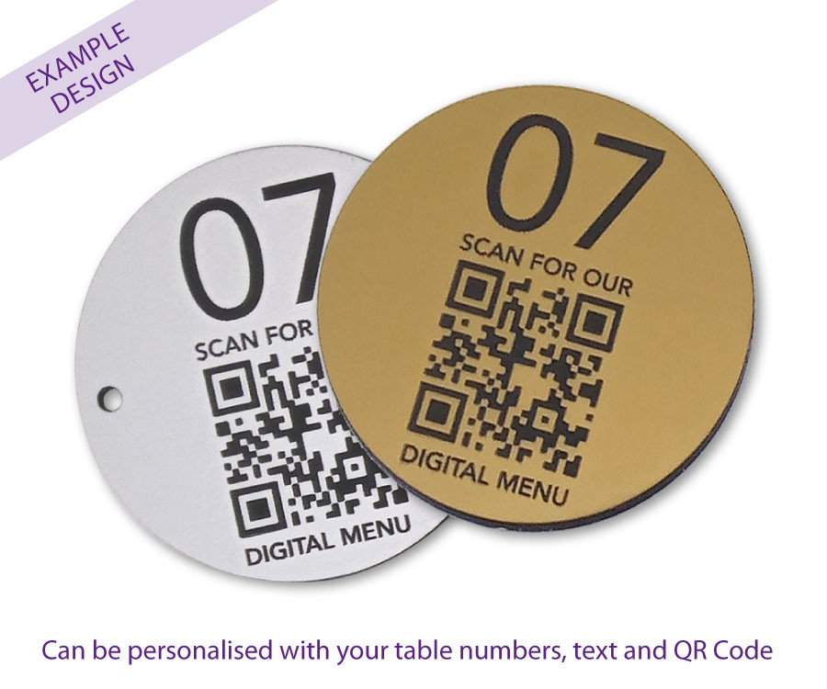

By Edina Nagy
Our customers also can enjoy Suhan restaurant also by using online ordering systems and food delivery apps like UberEATS, Just Eat. They can order online and pick up in our branch. So we can make sure they can enjoy or food and service an any preferred ways.
We have Online table reservation system and by phone reservation system also. Booking a table via a phone call is becoming a thing but next to it we have online table reservation technology also. Providers like Eat App, Tablein or OpenTable give customers the freedom to see available slots and make their own booking on-the-go. In turn, by using technology-enabled reservation systems, in Suhan can manage seating, waitlists, customer loyalty and dining preferences as well as collect vital client data be it for contact tracing or market insights. We try to make sure our customers have everything they need for the lunch, dinner or for the event.
In our kitchen we have Digital kitchen boards so when our waiters are taking orders the just write in their tablets, or when the customer order by via phone or online our kitchen stuff get the orders straight away int the kitchen board so they can see clearly hat is the order there is no misunderstanding, and they also can see how long the order has been taken and how many same order the have so they can do same time not just one by one, for example they have five times the Salmon Maki Susi than the can make for all the five orders on the same time, so in this way the can save time also.
At Suhan restaurant Automated inventory management software in order to automating our inventory management means tracking food and beverage stocks, anticipating quantities and even scheduling reorders so no longer need to be time-consuming tedious tasks. Very importantly using such a software in our working process because it’s can also reduce food wastage, which can be very high in a restaurant industry. Partnerships with innovative platforms like Too Good to Go also save restaurants from wasting their food surplus, instead making it available to users looking for a meal-deal. Saving time and money all while helping the planet – sounds like a no-brainer with sustainability being at the forefront of the global agenda.

By Edina Nagy
Management and organization

It is estimated that Japanese Restaurant Suhan needs seven workers. Two of the workers will work for couriers, one individual for coordinator administration, three in the kitchen, and one individual for finance and sales. As the company continuously improves and grows, the organization will demand more workers.
The head of the restaurant is the General manager Edina Nagy. Her job is coordinating work tasks of both front and back house operations, She have to make sure both sides are working together smoothly, maximizing customer satisfaction, responding to customer’s inquiries, reviewing product quality, supervising shifts, estimating supply needs, ensuring compliance with safety and health standards, controlling operational cost, preparing reports, training staff and professionalize then, implementing effective protocols and being responsible for health and safety.
The assistant managers job is to help the general manager job, is similar like the general manager job just vit less responsibility. The assistant managers are Filofteia Mirela Cantemir and Pamini Uthayarajah.
And the kitchen manager the Head Chef in our kitchen is El Mehdi Ayad.
His responsibility is same like the general managers, just in the version if the kitchen. He have to make sure everything is working smoothly, he have to control and direct the food preparation process, approve and polishing dishes before they reach the customer, managing and working closely with other Chefs of all levels, creating menu items, recipes and developing dishes ensuring variety and quality, determining food inventory needs, stocking and ordering, ultimately responsible for ensuring the kitchen meets all regulations including sanitary and food safety guidelines, being responsible for health and safety, being responsible for food hygiene practices.
Our front of house team under the general and assistant managers hands are including 10 waiters, these persons must learn all the stage of the front of house job how to server how to work as a host, to work in the bar, and how to work on the section of teak away and delivery.
Our kitchen stuff head is the Head Chef under this position there is the line chef, prep chef, kitchen assistant and the kitchen porter.

By Edina Nagy

Social responsibility and suitability
Social responsibility is the duty of business to do no harm to society that means in our daily operations, we should be concerned about the welfare of society and mindful of how our actions could affect society as a whole.
The “green movement” is a popular social and environmental cause, and our consumers are attracted to supporting companies with ethical practices. Ethical corporations are vital to our society.
Suhan Restaurant can use CSR plan to increase our social capital and attract customers who support green initiatives. By making these green changes, we gain an edge in the community and make us more marketable, increasing social power.

By Edina Nagy

Development milestones and exit plan
Milestone is a significant measure of the goals and vision of the business becoming the biggest restaurant in Nottingham. To achieve these objectives, Japanese Restaurant Suhan has to expand its branches with more known and accessible by the consumers.
The milestone is the marker that will signify the change or phase of the development of the project. It is a critical component since it will show vital events for further developments.
A milestone is a marker in a project that signifies indicates a change or stage in of development. Milestones are powerful components in project management because as they show key indicate important events and map forward movement the further development in your project plan.

No | Details | Completion
1. | Open a branch in West Nottingham. | 8 months
2. | Open a branch in South Nottingham | 8 months
3. | Open a branch on East Nottingham | 8 months
4. | Open a branch in North Nottingham | 18 months
5. | Open a branch in the areas of London | 18 months
6. | Expanding the business throughout the Java stores. | 18 months
We develop an exit strategy before going into business because the choice of exit plan has a significant influence on business development choices. In order to follow certain accounting regulations we early planning process:
- Long-Term Involvement
- Short-Term Involvement

Financial data

Elements or groups of data on a company's financial performance make up financial information. The cash flow, operating income, and income statement all have their own set of information that is vital to our Suhan Restaurant. The three segments taken together give a complete view of the firm's management.

By Filofteia Mirela Cantemir
Conclusion

The investors started building the businesses with an initial capital of $150,000. This amount was distributed to purchase operational leases, vehicles, raw materials, and equipment, as well as pay salaries. The capital was contributed by the four founders, with each contributing an equal amount. Every individual was responsible for ensuring the company ran successfully.
It can be concluded that opening a restaurant can be a risk but within proper planning, much of the risk can be avoided. The analysis of the external and internal environment will give the firm some competitive advantage and ensure the decision on the right strategic measures. The prospect of Suhan is to attract customers with its fine dining experience and quality food and professional service.

Reference List

Allen, D.N. and McCluskey, R., 1991. Structure, policy, services, and performance in the business incubator industry. Entrepreneurship theory and practice, 15(2), pp.61-77. Arora, A., Bansal, S., Kandpal, C., Aswani, R. and Dwivedi, Y., 2019. Measuring social media influencer index-insights from Facebook, Twitter and Instagram. Journal of Retailing and Consumer Services, 49, pp.86-101.
Colakhodzic, E., 2020. The Restaurant Industry and COVID-19. Perspectives on the New Normal: Post COVID-19, p.261.
EHK Insight 2022 “7 restaurant technology trends to watch in 2022” https://hospitalityinsights.ehl.edu/restaurant-technology-trends (accessed: 20.11.21)
Filimonau, V., Todorova, E., Mzembe, A., Sauer, L. and Yankholmes, A., 2020. A comparative study of food waste management in full-service restaurants of the United Kingdom and the Netherlands. Journal of Cleaner Production, 258, p.120775.
Galbraith, J.R., 2014. Designing organizations: Strategy, structure, and process at the business unit and enterprise levels. John Wiley & Sons.
Huang, Z., Wu, C., Teng, M. and Lin, Y., 2020. Impacts of tree canopy cover on microclimate and human thermal comfort in a shallow street canyon in Wuhan, China. Atmosphere, 11(6), p.588.
Mileta signs and products ltd https://www.miletasigns.co.uk/product-range/cafe-bar-restaurant-signage/menu-holders-table-numbers/qr-code-table-number-60mm-disc.html (accessed: 20.11.21)
Nyaga, P.K. and Muema, M.W., 2017. EFFECT OF PREMIUM PRICING STRATEGY ON THE PROFITABILITY OF INSURANCE FIRMS IN KENYA. International Journal of Finance and Accounting, 2(3), pp.107-118.
PAN, S.L., ZHANG, S.F. and LIU, J., 2008. SWOT Analysis in the Application of Tourism Programming——A Case of Beihai, Guangxi [J]. Journal of Liuzhou Vocational & Technical College, 2.
Siyun, H., 2020, December. Analysis of the strategy for the transformation of Wuhan fast food business from" offline" to" online" Thinking based on the impact of the new crown epidemic. In Proceedings of the 2020 3rd International Conference on E-Business, Information Management and Computer Science (pp. 370-375).
Wang, J. and Wang, Z., 2020. Strengths, weaknesses, opportunities and threats (Swot) analysis of China’s prevention and control strategy for the covid-19 epidemic. International Journal of Environmental Research and Public Health, 17(7), p.2235. Wild, T., 2017. Best practice in inventory management. Routledge.
Xu, T., Zhang, M. and Aditjandra, P.T., 2016. The impact of urban rail transit on commercial property value: new evidence from Wuhan, China. Transportation Research Part A: Policy and Practice, 91, pp.223-235.
Zhang, H., Xue, L., Jiang, Y., Song, M., Wei, D. and Liu, G., 2021. Food delivery waste in
Wuhan, China: Patterns, drivers, and implications. Resources, Conservation and Recycling, 177, p.105960.

Appendix:

Suhan Restaurant Business Plan Presentation.
Slide 1


Group 6
Title:
Suhan
Restaurant
Name of the Students:
Pamini
Uthayarajah
(2029001)
Edina Nagy (2028774)
Filofteia Mirela Cantemir (2021793)
Lecturer:
Mushfiqur Rahman
07.12.2021

Slide 2

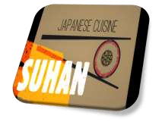
Table of Contents
27/12/2021
➢
Introduction
➢
Business Description and History
➢
Aim and objectives
➢
Mission and vision
➢
Business structure
➢
Product or Service Description
➢
Marketing Analysis and Trends
➢
Swot Analysis
➢
Pestel Analysis
➢
Operations
➢
Technology Plan
➢
Management and Organization
➢
Social Responsibility and Sustainability
➢
Development, Milestone and Exit Plan
➢
Financial Data
➢
Profit and Loss Account
➢
Cash Flow Statement
➢
Balance Sheet
➢
Conclusion
➢
Reference

Slide 3

Introduction
27/12/2021
❑
Imagine you are invited to a nice Japanese restaurant
to have dinner with your good friends. What kinds of
utensils are you going to use when you start to enjoy
your meal? A fork and a knife? Or chopsticks? Do you
know some kinds of foods taste better when you use
the right utensil? Japanese foods are exception, they
taste better when you eat them with chopsticks.

Suhan is a place where the peoples are coming to eat a meal which is a joyous and enjoyable experience providing not only sustenance for the body but nourishment for the soul. Is a place for family for friends and everyone who which an enjoyable time is a family place with smiling peoples .
In our business the Suhan restaurant we delivers the highest standards of workmanship for the clients. We offer a wide range of transferable skills, including staff management, decision making, building a strong business partnership and negotiation.

Slide 4
Business Description and History
27/12/2021
•
Suhan
Restaurat
is actually part of a tradition that is very old, yet
relatively modern.
•
The skilled workers and employees in the organisation strive
to meet
the customer demands and are committed to serving
them the best.
​
•
Contactless payment facilities to deal with the pandemic
situation.
​
•
Suhan
is devoted and dedicated to maintaining high levels
of
cleanliness and hygiene within the restaurant.
​
•
Maintains high standards of safety and hygiene in preparing
the
dishes.
​

Human beings have always eaten, but the business of selling food to customers who order off a menu is a phenomenon dating back to the French Revolution. Before that time, guests would buy food from street stalls and restaurants.

Slide 5
​
Aim and Objectives
27/12/2021
Aim
:
The
aim
of
Suhan
is
to
provide
the
customers
with
a
relaxing
environment
and
enjoyable
and
best
quality
food
to
increase
their
level
of
customer
satisfaction
.
​
Objectives
:
​
•
To
increase
customer
base
by
25
%
within
2023
​
•
To
start
online
promotion
and
delivery
services
by
the
end
of
2021
.
​

​

Slide 6
​
Mission and Vision
27/12/2021
Mission
​
The
mission
of
Suhan
is
to
make
and
serve
the
best
quality
food
to
the
customers
and
provide
the
customers
with
a
heart
-
warming,
welcoming
and
relaxing
ambience
.
​
Vision
​
Increase
the
economic
or
revenue
growth
of
the
organisation
and
its
customer
base
through
enhancing
and
improving
the
customer's
services,
offerings
and
quality
of
food
served
by
Suhan
.
​

Slide 7
Business Structure
27/12/2021
We will typically do same of the following steps:
•
Appoint members or directors.
•
Establish bylaws that outline the corporation’s operating rules
•
File articles of incorporation or organization.
•
Issue stock certificates to shareholders
•
Obtain relevant licenses and permits.

Slide 8

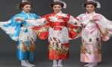
Product or Service Description
27/12/2021
Suhan
products
Menu
Starters: Susi:
Edamame chilli garlic or salt. Crunchy California
Roll.
Prawn
kushiaki
. Cucumber Maki.
Chicken Yakitori. Salmon Maki.
Salmon tartare cucumber bites. Avocado Maki.
Tsukune
Japanese meatballs. Dragon Roll.
Miso soup. Dynamite Roll.
Ramen:
Spicy Chicken Katsu Roll.
Chicken ramen.
Yasai
Roll.
Chilli Chicken.
Yo
Roll.
Chilli beef.
Desert:
Miso cod. Warabi Mochi.
Kariborosu
. Matcha Butter
Cookie.
Tempura:
Yatsuhashi
Pancake.
Vegie tempura. Castella Cake.
Prawn tempura Mochi Balls.
Shrimp tempura.
Gyozas:
Chicken gyoza.
Prawn gyoza.
Duck gyoza.
Yasai
gyoza.
Suhan
service:
Suhan
restaurant
is
based
on
a
strict
company
policy
.
All
the
employees
are
trained
and
ready
to
serve
our
customers
by
the
highest
standard
.
Our
waiters
wearing
traditional
Japanese
Kimono
.

The Suhan restaurant products are for everyone, from vegan to vegetarian and from adults to kids. Next to the basic menu we have separate vegan, vegetarian and children menu in this way everyone can found they own bowl to they soul. In our service we offer our customers the higher service by the restaurant strict standard. We offer our customer to travel to Japan by visiting our restaurant.

Slide 9

Marketing Analysis and Trends
27/12/2021
P’S OF MARKETING ANALYSIS
7
7
-
PEOPLE
1
-
PRODUCT
2
-
PLACE
3
-
PROMOTION
4
-
PRICE
5
-
PHYSICAL
EVIDENCE
6
-
PROCESS

Slide 10

SWOT Analysis
27/12/2021
Strengths
Weaknesses
Good location
Poor customer relations
Fresh menu items
High operating costs
Quick service
Limited seating
Opportunities
Threats
Expansion
Too many similar
restaurants
New menu
No opportunity for growth
Availability of servers
Lower priced alternatives

Slide 11
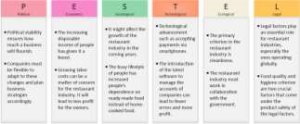
P
E
S
T
L
E
Analysis
27/12/2021
Mary March

Slide 12

Operations
27/12/2021
The operation of SUHAN restaurant main needs are:
✓
Good management.
✓
Aver of needs.
✓
Preparation of food.
✓
Customer service
✓
Cleaning
✓
Accounting
✓
Reporting.
✓
Checking.
✓
Teamwork.

To operate in the baseness of food, we need to be very specifically averred of the needs of peoples. We need to know what the peoples want and how they want. Been aver of the rules to meets the law.

Slide 13

Technology Plan
27/12/2021
ONLINE SHOP
POINT OF SALE
TICKETS
ACCOUNTS
KITCHEN DESPLAY
SCREENS
CONTACTLESS
PAYMENTS

Technology is something we use every single day. Smartphones, computers, data networks, mobile apps, software and any number innovative solutions that we just can’t live without.
In order to meet the constantly changing preferences of guests Suhan Restaurant always invest in new technologies to stay up-to-date. We looking to develop a more modern business plan on fact that we are increasingly adopting technology as an important part of our business.

Slide 14
Management and Organization
27/12/2021
General Management:
Edina Nagy
Asst Manager:
Pamini
Uthayarajah
Asst Manager:
Filofteia Mirela Cantemir
Kitchen Manager:
El Mehdi Ayad
Position Staff:
Servers
Hosts
Bussers
Position Staff:
Bartenders
Bar Backs
Position Staff:
Line Cooks
Prep
Dishwashers
Pantry

In order to contact the right person in case of any problem Suhan Restaurant implement a management hierarchy and kitchen hierarchy, to identify everyone’s responsibility and duties and clarify the authority to make sure there are no conflict or chaos.

Slide 15

Social Responsibility and
Sustainability
27/12/2021

Slide 16

Development, Milestone, and
Exit plan
27/12/2021
Milestones
Start Date
End Date
Budget
Installing all bar
equipment
01/09/2021
01/10/2021
5
,000 £
Installing kitchen grill,
good, and flattop
01/09/2021
01/10/2021
7
,000 £
Painting interior
03/10/2021
05/11/2021
1
,500 £
Production and
completion of menus
15/10/2021
01/11/2021
500
£
Installing booths
01/10/2021
15/10/2021
,00 £
10
Build and launch new
website
02/10/2021
20/10/2021
1
,000 £
Acquire all food
20/10/2021
01/11/2021
3
,000 £
Acquire all alcohol*
01/10/2021
01/11/2021
4
,000 £

Slide 17

Financial Data
27/12/2021

Slide 18

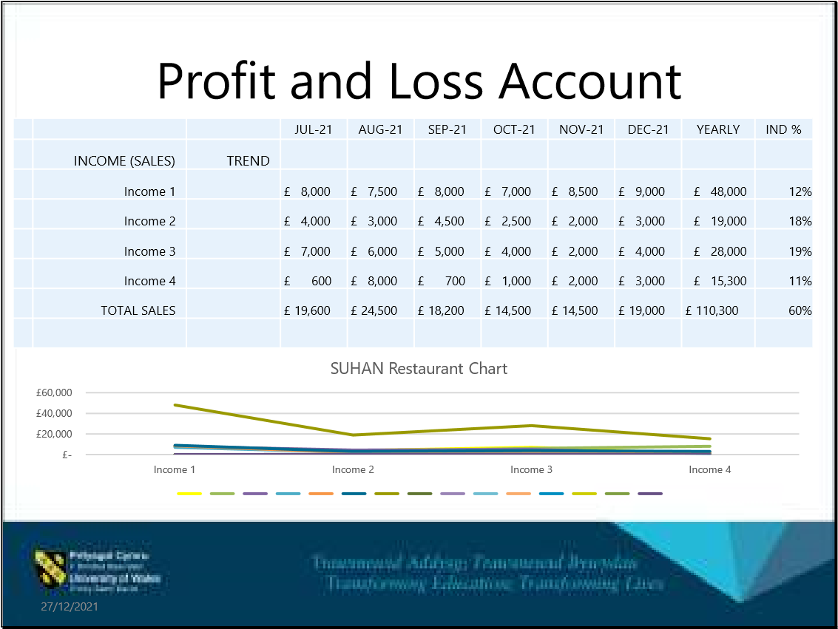

Slide 19

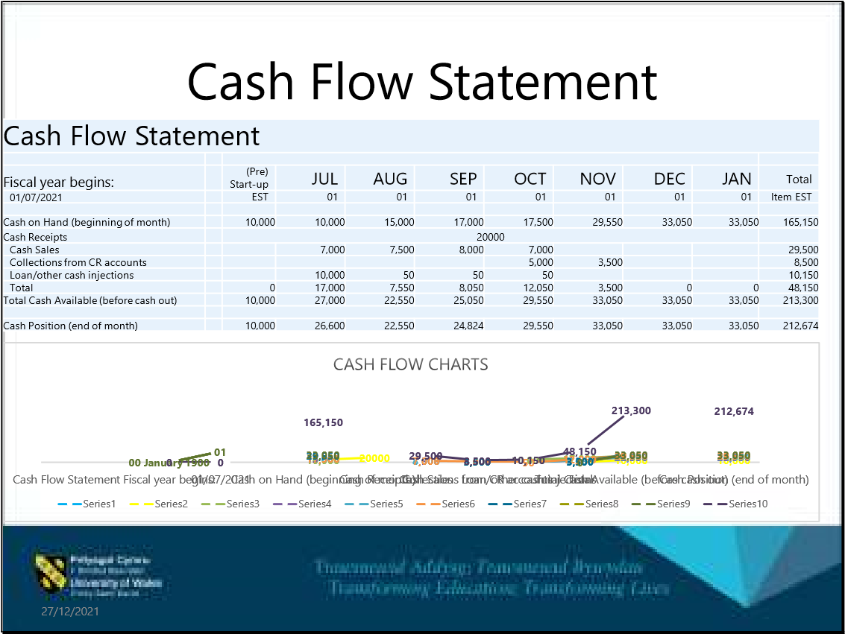
Slide 20

Balance Sheet
27/12/2021
0
5,000
10,000
15,000
20,000
25,000
30,000
35,000
Current Assets
Fixed Assets
Other Assets
Current Liabilities
Long-term Liabilities
Owner Equity
Suhan
Restaurant Chart
Previous Year
Current Year

Slide 21

Conclusion
27/12/2021
•
In conclusion, choosing a restaurant can be tricky when there
are so many options.
•
Of course, you want to enjoy a pleasant dining experience that
appeals to everyone in your group
•
Suhan
restaurant attracts prospective customers by offering
an exciting and unique dining experience with high quality
food‚ friendly and professional service
•
So you’ve decided what you’re going to use the fork and a
knife? Or chopsticks?

Slide 22

References
- Grain Sustainability. 2021. Grain Sustainability | Sustainability Consultancy, Strategy, and Marketing. [online] Available at:
<https://grain-sustainability.com/> [Accessed 2 November 2021].
- Edrawsoft. 2021. Restaurant Organizational Chart Examples | EdrawMax. [online] Available at: <https://www.edrawsoft.com/restaurantorganizational-chart-examples.html> [Accessed 2 November 2021].
- The Balance Small Business. 2021. Why Every Business Plan Needs an Exit Strategy. [online] Available at: <https://www.thebalancesmb.com/writinga-business-plan-planning-your-exit-strategy-1200841> [Accessed 8 November 2021].
- Guest Innovations, I., 2021. Understanding Restaurant Financial Statements. [online] Rezku. Available at:
<https://rezku.com/blog/understanding-restaurant-financialstatements> [Accessed 13 December 2021].
27/12/2021

