Business Report -
Comparison of Two
Hospitality Organisations: Ibis and Corinthia
Catalina Gabriela Dumitru
2209716
Financial Management for the Hotel Industry (BMIH5007,BMIH5002)
Lecturer : Tristan Hawkins
2038 words

Content table

Front page 1

Content table 2
Introduction 3
Presentation of players 3
Growth 3
Financial data, position on market, strategies 4
Sustainability 7
Conclusion 9
Recommendation 10
Reference list 11-12

Introduction
The aim is to analyse and evaluate management of two companies in hospitality through financial information of last years, considering revenues, growth, costs, pricing, even sustainability and CSR implications.
Presentation of the players
First to introduce the players, 1 Ibis Hotel, part of Accor Group and 2 Corinthia Hotels.
Accor has a various class of hotels, 20% of total rooms are in Ibis group. Classified as three stars, economic / business class. Ibis has established a strong position in the hotel market with a focus on simplicity, comfort, and affordability. Their unique selling point revolves around providing economical, yet comfortable accommodations, primarily targeting the Bed and Breakfast (B&B) model.
This approach is evident in their room facilities which include essentials like 24-hour hot water, clean lavatories, and comfortable furniture, while keeping entertainment options minimal to reduce costs. As capital, chain contain 1269 hotels (in last financial report) located as in next picture, more than half in Europe, mainly converted in 2011 from rebranding of Ibis Styles from All Seasons and Ibis Budget from Etap Hôtel.
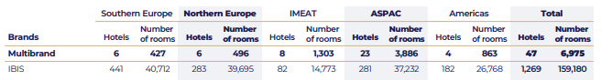
(Ibis, 2024)
On contrary, Corinthia Hotels is a luxury hotel brand with a unique history and presence in the hospitality industry. Founded in the 1960s by the Pisani family of Malta. The brand started with the opening of a fine-dining restaurant, which eventually led to the establishment of their first hotel, the Corinthia Palace Hotel and Spa in Malta.
Growth
Over the years, Corinthia has expanded to various locations, known for its grandeur and luxury. The hotels often combine local character with the group's philosophy of providing top-notch service and luxurious experiences.
For instance, the Corinthia Hotel in London, situated in a Victorian building, is famous for its elegance, historical significance, and high-end facilities, including a renowned spa and several upscale restaurants. What sets Corinthia Hotels apart is their commitment to preserving the historical and cultural significance of their properties while offering luxurious and modern amenities.
They tend to be in landmark buildings rich in history and are often renovated to combine luxury with heritage, providing guests with a unique blend of historical charm and modern comfort.
If many years company has as capital just nine big hotels, in last decade they invested a lot, with important acquisitions in few relevant locations, before 2020 counting 16 hotels, in 2022 last list contain 14 hotels:
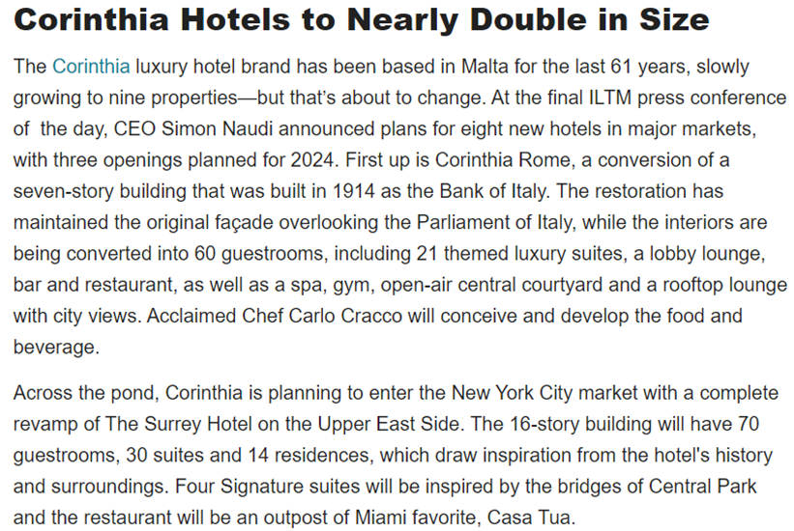
(Goldfisher, 2023)
This is a big decisional step and was need years of studies and considerate, Corinthia Group announced New York intentions with 4-5 years in advance, proving one more time a mature management, decision in investment of capital in hospitality, demanding a large amount of resources, on long term and giving to buildings a designated speciality, hard to reconvert, all these involve risks and role of management is to predict the evolution and to reduce friction (Atrill, 2021, p. 287).
Financial Data, position on market, strategies
For financial analyse, data were collected from last five years, yearly reports for 2019-2022 and partial report yet published for 2023, very interesting because are odd years, containing historical period of 2020.
Analysing period from 2019 to 2022, especially considering the COVID-19 pandemic's impact on the hotel industry, majority of hotels worldwide experienced a decrease in demand due to travel restrictions, lockdowns, and reduced tourism during the pandemic. A part of hotels temporarily closed or reduced their operations, leading to a decrease in the overall supply of hotel rooms. With a decline in demand and increased competition for the limited number of travellers, hotels, including those under the Accor brand like Ibis, may have adjusted their pricing strategies. Price discounts, promotions, and special offers were common to attract customers and stimulate demand.
For case studied, Ibis had been affected by crisis less than Corinthia, hotels still been in use except closure quarantine by low, still guesting business travellers, local tourists and workers (next picture from Ibis internal report), meantime Corinthia was directly affected by cancel of international flights and holidays annul.
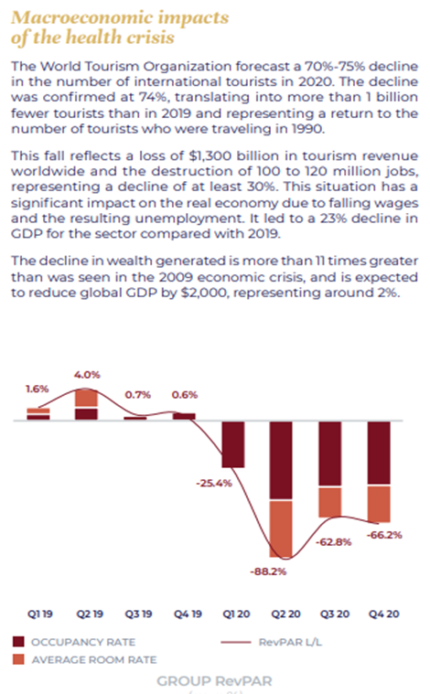
(Accor Group, 2023)
In post pandemic era, which could be considered an economic crisis, in last years, general tendencies are for whole hospitality sector to recover, to come back in ascendent trend, one by one companies are expected to hit the revenues of 2019, and eventually to overpass. Anyway, the capital in this sector continues its appreciation, and tendencies indicate a continuous growth in global economic reports, this fact shows potential, not valued yet, waiting for investors.
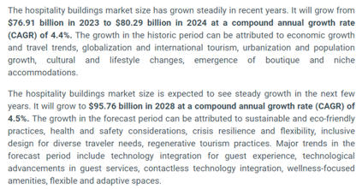
(The Business Research Company, 2024)
In Ibis case, financial data are for Accor group as whole, still considering data for Premium, Mid-scale and Economic, could estimate Ibis has less loss in 2020 as the other Accor departments, proving once again that more opportunities and versality of a business give more chances to survive in crisis, when luxury closed, economic still bring revenues, improving company image per ensemble in financial report. Occasion to prove Drury (2021, p.223) theory of constraint, decision-making on limit situation. Anyway, financial reports combine various type of data, achievements, budgets and capital amortisements, collaborative data, divisional performance measurement, as been part of strategic marketing accounting ( Seal, 2019, p.695-696).
Results are promising, financial data has shown significant growth and potential in the hospitality industry. “For the third quarter of 2023, Accor Group reported a revenue of €1,286 million, a 13% like-for-like “( Accor, 2023) increase compared to the same quarter in 2022. Same growth was seen across the board, including the Premium, Midscale, and Economy Division, which encompasses the Ibis brand. The Group's strong performance indicates a robust business stage for all markets, particularly in Asia, also for its various brand segments. Additionally, the Group has been consistent in expanding its network.
The growth opportunities for Ibis Hotels could be to enhance guest experiences This focus on innovation and customer-centric services positions Ibis well for future growth in the highly competitive hospitality sector. Moreover, Ibis has been leading in the European hotel market, indicating its strong market position and potential for further expansion.
The strategic marketing and operational approaches of Ibis, combined with the overall growth trajectory of the Accor Group, suggest a positive outlook for the brand's future growth and expansion opportunities. In terms of outsourcing potential, while specific details are not readily available, the hospitality industry, in general, has been exploring various outsourcing opportunities to streamline operations and reduce costs. This can include outsourcing areas like IT services, customer service, and even some aspects of hotel management.
As the industry evolves, Ibis Hotels might also explore these avenues to optimize operations and focus on core competencies like guest experience and hotel management. The growth potential for Ibis Hotels appears strong, driven by strategic brand positioning, focus on customer experience, and the backing of the Accor Group's robust performance and expansion strategies
For Corinthia Group (2019), on that time financial results looking very promising, as next graphic
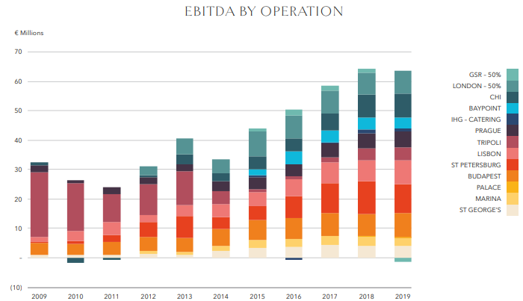
(Corinthia, 2020)
After 2020, deep loss, and 2021, intermediate but coming back in profit, 2022 year has again a good trend, double revenue and double profit as 2021, these numbers promising that business is successfully came back in market
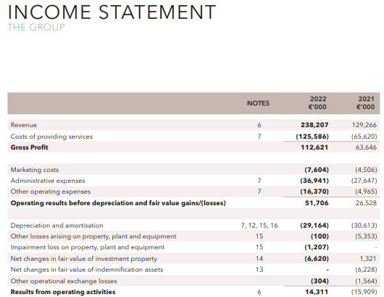
(Corinthia 2023)

Sustainability
As Accor CEO Denis Hennequin commented: ”we will revolutionize our economy brand portfolio around the ibis brand, which benefits from unrivalled worldwide notoriety” (Hospitality site, 2022) with references on social responsibility commitment.
Corinthia made a big step, since financial reports before 2020 have at beginning incomes and revenue numbers, in last reports, first are numbers connected with economy of fuel, energy and reduce of emissions of CO2, reductions of energy or water consumption per room, also waste reducing; this is a different approach, more modern because “Sustainable event tourism not only provides environmental advantages, but financial returns as well” (Walker, 2021, p.333) in two ways, once because are reducing costs and also educating people in right practice of reducing waste and pollution which also bring money. And a third aspect is putting the brand in a good light, improving public perception as committed to etic values.
Government create the legal status, is the main decisional forum, but agencies and chartered accountants associations ( on own initiative and voluntarily) could stipulate own limits more strict than legal requirements for hospitality activities, (EMA as Environmental Management Accounting), so “In addition to national regulations and accounting standards, accountants are also bound to abide by the ethical guidelines instituted by their professional bodies” (Bhimani, 2006, p. 405)
Hospitality site (2024) in an article dedicated to Corinthia highlighted how Alfred Pisani, the creator of Hotel chain presented his book in Lifetime Award Ceremony, precising :” our journey began from a tiny Island with no natural resources which, back, in the 1960s, some people had not even heard of. This made our mission doubly difficult.” The four pillars of Corinthia Sustainability are:

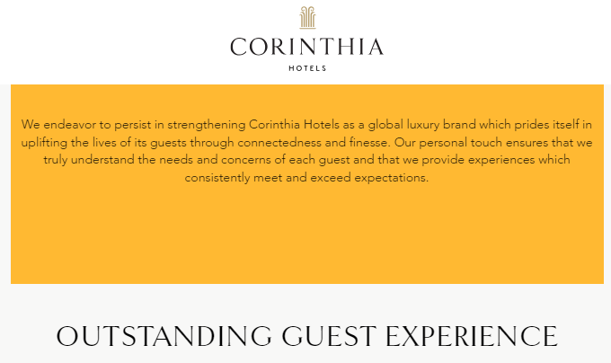
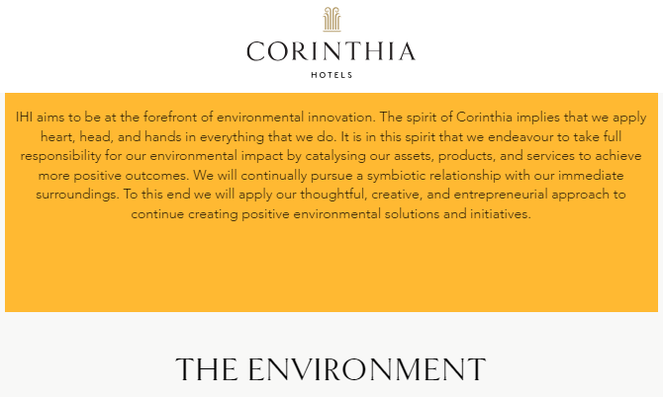
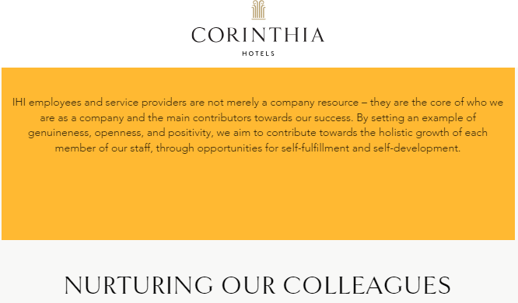
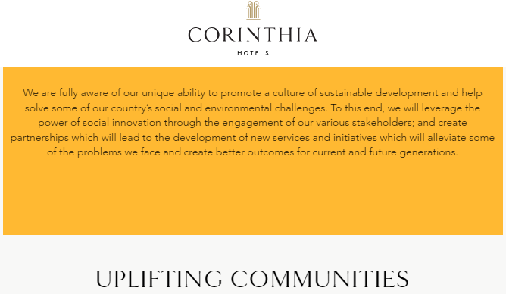
(Corinthia Group, 2024)

Conclusion
The two companies considered are in their sector, leaders, one being biggest agent in Europe in economic class, the other one of the top players in luxury class. Was interesting the way they grown, how adapted in hostile conditions of the pandemic period and successfully passed through, how continue to grow in a competitive market, Ibis with a intensive policy, to perfection its services and image, in fixed place and space, conquering a bigger part from a shared market; and Corinthia to expand, to reinvest capital, to acquire sensational hotels in hottest points of the planet, to extend the market but to remain classy and special in own offer, keeping the line and characteristics which pushed company on top.

Recommendations

Ibis
Ibis has the recipe for success. They should expand. To reinvest to acquire more units / hotels/ available rooms. On the map, no important city in the world without at least one Ibis hotel.
Ibis Hotels, as part of the Accor Group, has been actively involved in various initiatives aimed at improving guest experiences and enhancing sustainability. Some of the areas where Ibis Hotels could potentially focus on for further improvement include:
Guest Experience and Technology: Ibis has introduced new concepts that transform guest experiences, particularly by utilizing mobile technology. Further enhancing these areas, such as through more personalized guest interactions via technology, or introducing more advanced room automation systems, could elevate the guest experience even more.
Interior Design and Local Cultural Integration: With new design concepts like Agora, Plaza, and Square, Ibis Hotels has embraced expressiveness and a sense of home. They could further improve by integrating more local cultural elements into their hotel designs, thereby offering guests a unique and immersive experience that reflects the local environment and culture.
Operational Efficiency: Continuously improving operational efficiency, especially in areas such as energy management, waste reduction, and sustainable sourcing, can not only reduce environmental impact but also lead to cost savings, to reinvest into guest services and facilities.
By focusing on these areas, Ibis Hotels can continue to improve its offerings, ensuring that they remain competitive and appealing to environmentally conscious and tech-savvy guests​.

Corinthia
Corinthia Hotels, known for its commitment to luxury and quality service, has various avenues where it could further improve and innovate. Here are some suggestions based on current industry trends and the hotel's existing strategies:
Sustainability Initiatives: Corinthia is already making strides in sustainability, for instance, with its Corinthia Oasis project which focuses on eco-friendly practices like eco-gardens, natural climatization solutions, and green roofs. To further this commitment, Corinthia could explore new sustainability innovations such as advanced energy-efficient technologies, more extensive use of renewable energy sources, and deeper integration of sustainable practices in their supply chain and operations.
Expanding Wellness Offerings: With a growing global emphasis on wellbeing, Corinthia could enhance its wellness programs. This could involve expanding its spa and health services, integrating wellness into the overall guest experience, and offering more personalized health and wellness packages.
Employee Development and Satisfaction: Continuing to invest in employee training and development, particularly in areas of sustainability and guest service, can further enhance the quality of service and staff satisfaction, which in turn positively impacts guest experiences.
By focusing on these areas, Corinthia Hotels can continue to elevate its luxury offerings, ensuring they stay ahead in a competitive and fast-evolving hospitality industry. These improvements and innovations can help Corinthia maintain its position as a top choice for luxury travellers looking for unique, authentic, and high-quality experiences

References List
Atrill, P. and McLaney, E.J. (2021) Management accounting for decision makers. Tenth edition. Harlow, England: Pearson.
Bhimani, A. (ed.) (2006) Contemporary issues in management accounting. Oxford ; Oxford University Press.
Drury, C. (2021) Management and cost accounting. Eleventh edition. Australia: Cengage.
Seal, W.B. et al. (2019) Management accounting. Sixth edition. London: McGraw-Hill Education.
Walker, J.R. (2021) Introduction to hospitality. Eight, Global edition. Harlow, England: Pearson.
Accor (2023), Third-quarter 2023 revenue of €1,286 million up 13% like-for-like available at: https://press.accor.com/third-quarter-2023-revenue-ofe1286-millionup-13-like-for-like/?lang=en
Accor Group (2023), Financial report available at: https://group.accor.com/en/finance/results-and-publications/ financial-result last accessed 27/01/2024
Accor, Société Anonyme, (2023), Interim_Financial_Report_2023_Accor available at: https://group.accor.com/-/media/Corporate/Investors/Documents-financiers/2023/07-27-H1/Interim_Financial_Report_2023_Accor_vDef.pdf (last accessed 25/01/2024)
Accor, Société Anonyme, (2023), ACCOR_DEU_2022 available at: https://group.accor.com/-/media/Corporate/Investors/Documents-de-reference/ACCOR_DEU_2022_US_PDF_UA.pdf (last accessed 25/01/2024)
Accor, Société Anonyme, (2022), OPT_ACCOR_DEU_2021_MEL_US_300322 available at: https://group.accor.com/-/media/Corporate/Investors/Documents-de-reference/ OPT_ACCOR_DEU_2021_MEL_US_300322.pdf (last accessed 24/01/2024)
Accor, Société Anonyme, (2021), 2020_ACCOR_URD available at: https://group.accor.com/-/media/Corporate/Investors/Documents-de-reference/2020_ACCOR_URD_VeDef.pdf (last accessed 25/01/2024)
Accor, Société Anonyme, (2020), 2019_ACCOR_URD_DEF available at: https://group.accor.com/-/media/Corporate/Investors/Documents-de-reference/2019_ACCOR_URD_DEF.pdf (last accessed 25/01/2024)
Accor, (2024) Financial Reports available at: https://group.accor.com/en/finance/results-and-publications/financial-result (last accessed 25/01/2024)
Corinthia (2020) 2019 Annual Report available at: https://www.corinthiagroup.com/wp-content/uploads/2020/08/Corinthia-Annual-Report-2019-web.pdf
Corinthia (2021) 2020 Annual Report available at: https://www.corinthiagroup.com/wp-content/uploads/2021/04/Corinthia-Annual-Report-2020.pdf
Corinthia (2022) 2021 Annual Report available at: https://www.corinthiagroup.com/wp-content/uploads/2022/05/Corinthia-Annual-Report-2021.pdf
Corinthia (2023) 2022 Annual Report available at: https://www.corinthiagroup.com/wp-content/uploads/2023/06/37547-CORINTHIA-ANNUAL-REPORT-2022_WEB-min.pdf
Corinthia (2023) 2023 Interim Report available at: https://www.corinthiagroup.com/wp-content/uploads/2023/08/IHI-Interim-Financial-Statements-30-June-2023.pdf
Corinthia Group, (2024) Sustainability 4 pillars available at: https://www.corinthia.com/en-gb/sustainability/
Goldfisher, Emily, (2023), ILTM Day 2: Booking Pattern Trends and Sustainability Initiatives available at: https://www.luxurytraveladvisor.com/your-business/iltm-day2-booking-pattern-trends-and-sustainability-report last accessed 28/02/2024
Hospitality site, 2022, Accor unveils new marketing strategy for its Ibis brand , article available at: https://hospitality-on.com/en/marketing/accor-unveils-new-marketing-strategy-its-ibis-brand last accessed 27/01/2024
Hospitality site ( 2024) The Corinthia Spirit, a tale of a lifetime achievement by founder Alfred Pisani article available at: https://hospitality-on.com/en/development/corinthia-spirit-tale-lifetime-achievement-founder-alfred-pisani last accessed 29/01/2024
Ibis (2024) official site available at: https://group.accor.com/en/finance/results-and-publications/ financial-result last accessed 02/02/2024
The Business Research Company, (2024), Hospitality Buildings Market Trends, Growth Analysis, Scope to 2033 available at: https://www.thebusinessresearchcompany.com/report/ hospitality-global-market-report
Worldwide Hospitality Awards, (2023) Ibis reinventing guest experience article available at: https://hospitality-on.com/en/worldwide-hospitality-awards/ibis/ibis-reinventing-guest-experience last accessed 01/02/2024

